**PUBLIC TRANSPORTATION EFFICIENCY ANALYSIS**

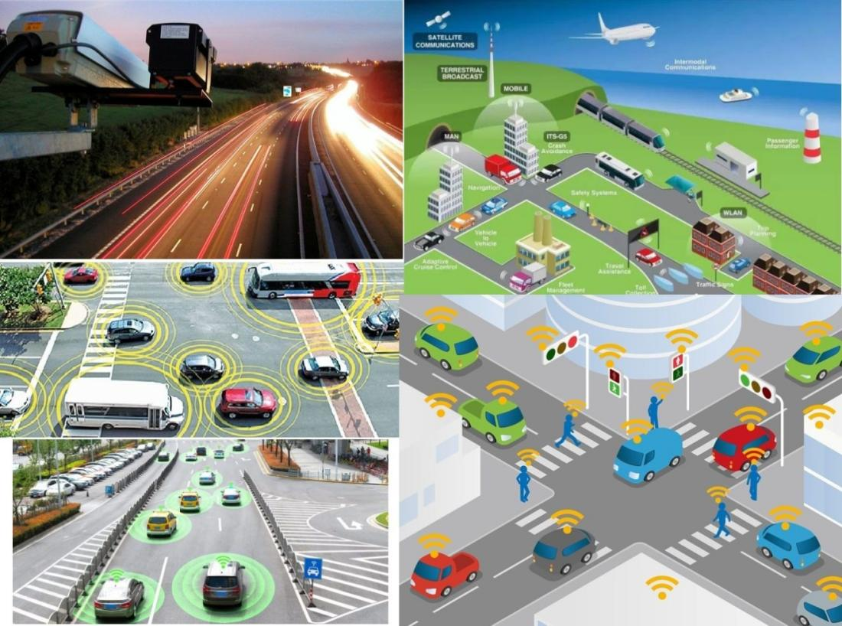

**Objective:**

The aim is to perform an in-depth evaluation of the existing public transportation system to identify strengths, weaknesses, opportunities, and threats for the purpose of enhancing overall efficiency and effectiveness. This analysis will focus on assessing key performance indicators, such as punctuality, frequency, accessibility, affordability, safety, and environmental impact. The objective includes exploring innovative technologies, infrastructure enhancements, and operational strategies that can elevate the quality of service, increase ridership, optimize route planning, reduce operational costs, and promote sustainability. The ultimate goal is to propose data-driven recommendations and actionable insights to stakeholders that will lead to an improved, seamless, and sustainable public transportation system that better serves the community's needs.

**Design Thinking Process:**

Empathize:

User Research: Engage with commuters, drivers, and stakeholders to understand their needs, challenges, and aspirations regarding public transportation.

Create Personas: Develop personas representing different user groups to empathize and understand their specific requirements and pain points.

Define:

Point of View: Synthesize gathered information to define the core issues and challenges faced by users and the transportation system.

Problem Statement: Craft a clear problem statement that encapsulates the identified issues and the needs of the users.

Test:

Gather Feedback: Collect feedback from users, stakeholders, and data analytics on the performance of the implemented solutions.

Iterate: Based on the feedback, refine and improve the prototypes or solutions. Make necessary adjustments to enhance efficiency and address any unforeseen challenges.

**Implementation Steps:**

Data Collection and Analysis:

Gather data on existing transportation operations, including routes, schedules, ridership statistics, and performance metrics.

Analyze data to identify inefficiencies, peak usage times, underutilized routes, and other areas for potential improvement.

Stakeholder Engagement:

Engage with key stakeholders such as commuters, transportation authorities, city planners, and local government representatives to understand their perspectives and concerns.

Performance Metrics Identification:

Define key performance indicators (KPIs) specific to public transportation efficiency, such as on-time performance, frequency, capacity utilization, cost per passenger, and environmental impact.

Technology and Innovation Assessment:

Explore innovative technologies or systems that could enhance efficiency, such as real-time passenger information systems, predictive maintenance, or automated fare collection.

Evaluate the potential integration of eco-friendly options like electric buses or other sustainable modes of transportation.

Cost-Benefit Analysis:

Conduct a cost-benefit analysis to determine the feasibility and economic impact of proposed changes.

Assess the potential ROI (Return on Investment) for any infrastructure or technology upgrades.

Continuous Monitoring and Improvement:

Establish a system for continuous monitoring of the implemented changes to measure their impact on efficiency.

Gather feedback from stakeholders and users to identify further areas of improvement and ensure the system adapts to changing needs.

**Dataset Link:**

<https://www.kaggle.com/code/dk008652/comprehensive-bus-boarding-analysis-3ef5e4>

**Data Collection Process:**

Identify Key Data Points:

Determine the specific data points required for the analysis, such as ridership numbers, route information, scheduling data, on-time performance, maintenance records, and financial data.

Utilize Existing Data Sources:

Access data from transportation agencies, transit companies, or local governments. This may include historical ridership data, schedules, operational reports, maintenance logs, and financial records.

Surveys and Feedback:

Conduct surveys among commuters, drivers, and other stakeholders to gather qualitative insights about their experiences, preferences, and challenges related to public transportation.

Use feedback mechanisms such as suggestion boxes, online forums, or dedicated feedback apps to gather continuous inputs.

Field Observations:

Perform on-site observations to assess the actual operations, such as station/stop activity, bus/train frequencies, passenger flow, and overall system performance during peak and off-peak hours.

Data Validation and Cleaning:

Ensure the collected data is accurate and reliable by validating it against multiple sources. Clean and organize the data to remove any inconsistencies or errors.

Documentation and Record Keeping:

Maintain a record of the data collection process, including sources, methods, and any transformations applied to the data. Proper documentation ensures transparency and reproducibility of the analysis.

**Python Code for Visualization:(ex)**

%matplotlib inline  
import numpy as np *# linear algebra*  
*import* pandas as pd *# data processing, CSV file I/O (e.g. pd.read_csv)*  
*import* matplotlib.pyplot as plt  
import datetime  
import os  
from math import sqrt  
import warnings  
  
## For Multiple Output in single cell  
from IPython.core.interactiveshell import InteractiveShell  
InteractiveShell.ast_node_interactivity = "all"  
warnings.filterwarnings('ignore')

new_data = data[data['StopName'].isin(aa)]  
new_data.shape  
print("data without stopage removing: ", data.shape)  
print("data, after removing stoppage not having the data of whole 54 weeks: ", new_data.shape)

fig,axrr=plt.subplots(2,2,figsize=(15,15))  
  
ax=axrr[0][0]  
ax.set_title("No of Boardings")  
data['NumberOfBoardings'].value_counts().sort_index().head(20).plot.bar(ax=axrr[0][0])  
  
ax=axrr[0][1]  
ax.set_title("WeekBeginning")  
data['WeekBeginning'].value_counts().plot.area(ax=axrr[0][1])  
  
ax=axrr[1][0]  
ax.set_title("most Busiest Route")  
data['RouteID'].value_counts().head(10).plot.bar(ax=axrr[1][0])

**Data Visualization:**

Boarding with in a week

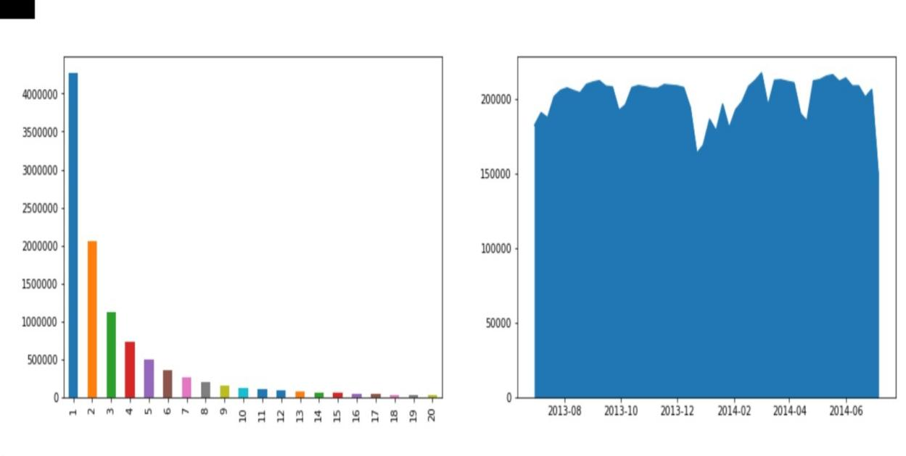

Distance and Number of boarding

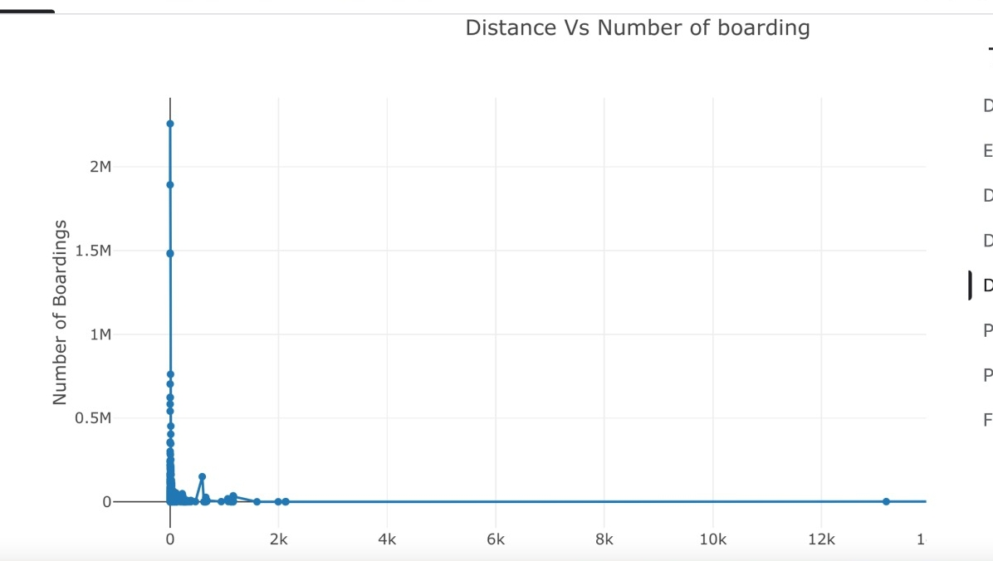

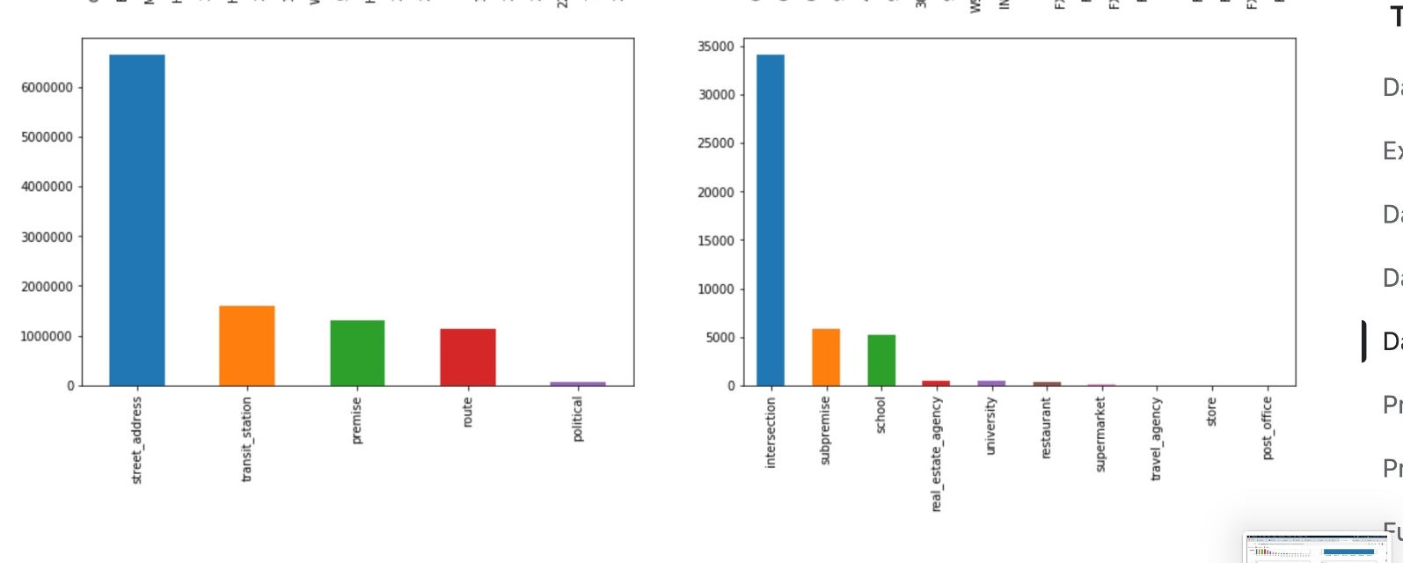

Weakly Analysis of Traffic

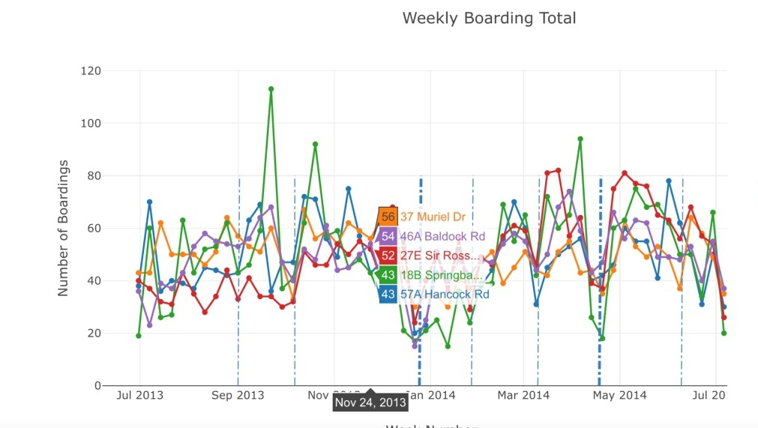

Visualization based on Postcode

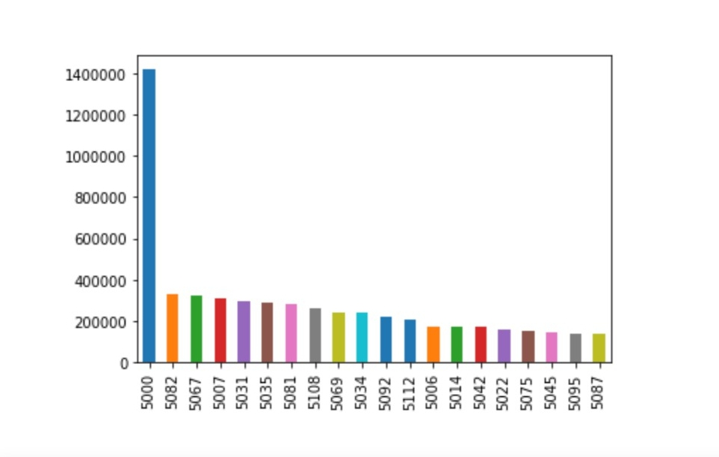

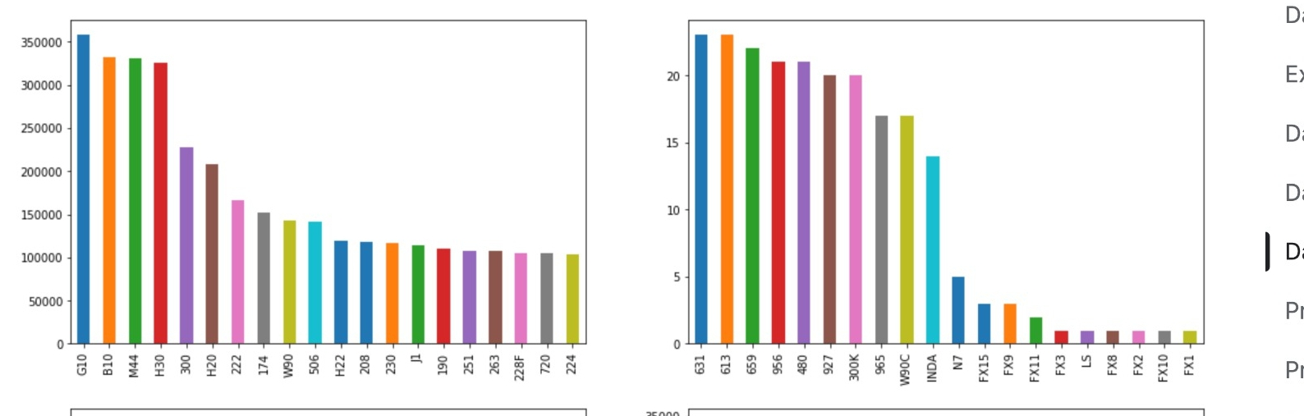

Frequency Analysis

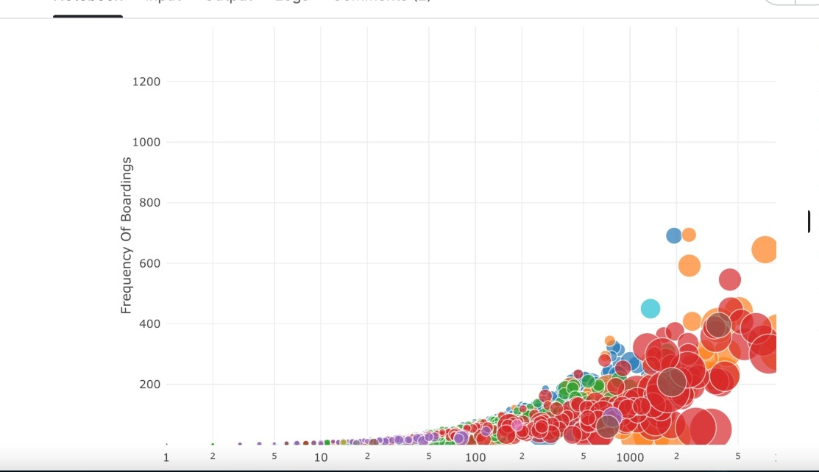

Weakly boarding analysis

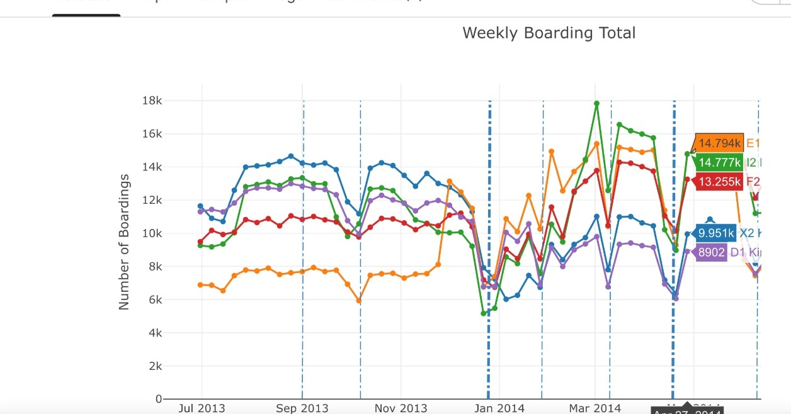

3D View

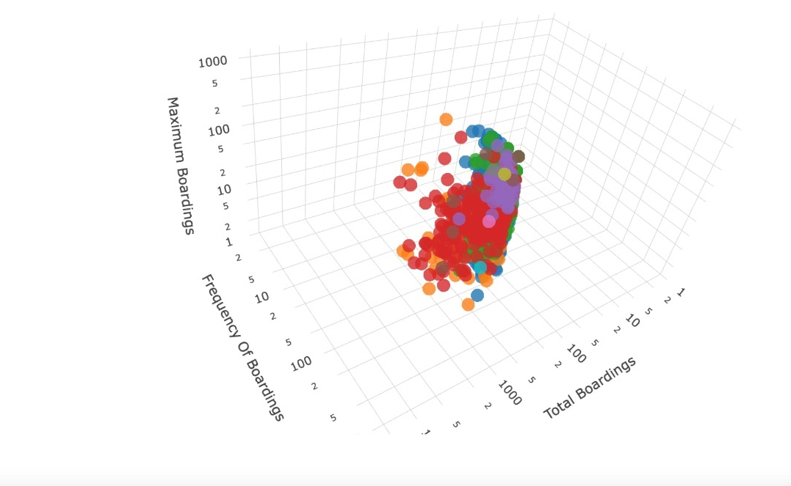

Public Opinion:

**Technology and Innovation:**

There is often positive feedback regarding the integration of technology in transportation systems, including real-time updates, mobile apps for ticketing and information, and smart solutions that streamline the commuting experience.

**Affordability and Cost:**

Affordability is a crucial factor in public opinion. Users often advocate for reasonable fares and cost-effective passes, especially for regular commuters.

**Safety and Security:**

Public transportation users emphasize the importance of safety and security measures, such as well-lit stations, surveillance systems, and visible staff presence, to ensure a secure travel experience.

**Conclusion:**

In everyday terms, when it comes to improving public transportation, it's important to listen to what people need and want. By taking a closer look at how buses, trains, or other transit options work, we can figure out what's not working so well and what could be better. People often want buses and trains to run on time, be safer, less crowded, and more frequent. They also want the systems to be eco-friendly and easy to use.