**Project Objective:**

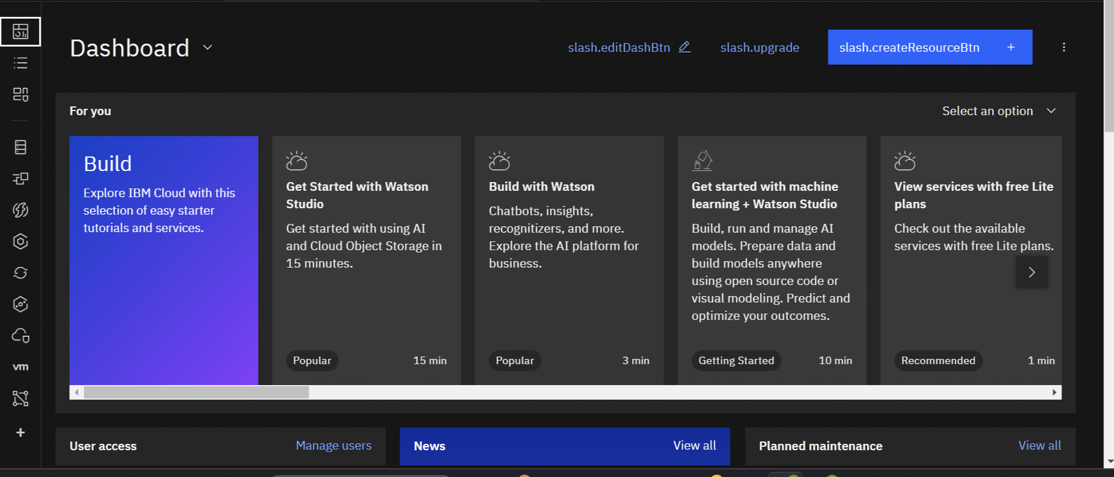

“To develop a media streaming platform that allows users to securely upload, store, and stream their media content with a user-friendly interface, reliable video playback, and scalability on IBM Cloud.”

**Design Thinking Process:**

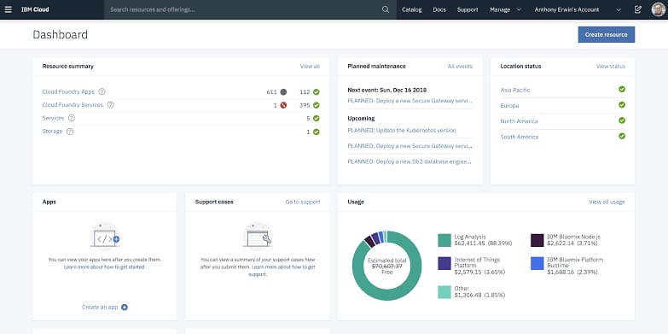

Design thinking is a human-centered approach to problem-solving and product development. It involves several phases to ensure that the final solution is user-centric. These phases can include:

1. **Empathize:**

Understand the needs and preferences of your target audience, such as content creators and viewers.

Conduct user research to identify pain points and opportunities.

1. **Define**:

Clearly define the problems and opportunities based on your empathy research

Create user personas to represent different user types, their goals, and challenges.

1. **Ideate:**

Generate a wide range of ideas and solutions to address the defined problems and opportunities.

Use brainstorming sessions to encourage creativity.

1. **Prototype**:

Create prototypes or wireframes to visualize your ideas and test them with users.

Build low-fidelity mockups and gather feedback for improvement

**Development Phases:**

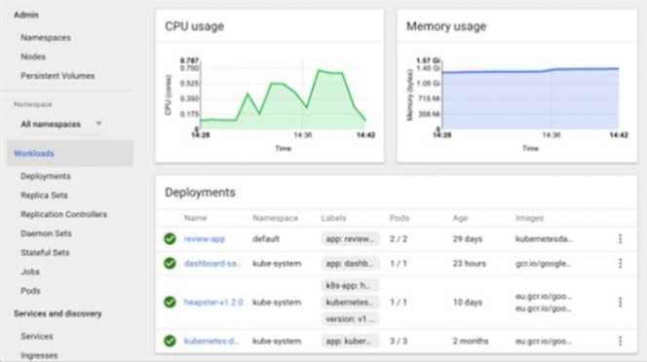

The development phases are the steps you’ll take to build your media streaming platform. These phases can be broken down as follows:

1. **Planning**:Define the project scope, goals, and requirements.

Create a detailed project plan with timelines and resource allocation.

Identify the technology stack and tools to be used.

1. **Design**:Create wireframes and mockups to visualize the user interface.

Plan the architecture of your platform, including data storage, server setup, and video streaming integration.

1. **Development**:Implement the backend and frontend of your platform.

Integrate IBM Cloud Video Streaming services and other required APIs.

Develop features like user registration, media upload, on-demand playback, and search functionality.

1. **Testing**:Conduct thorough testing, including functional, usability, security, and performance testing.

Identify and resolve any bugs or issues.

1. **Deployment**:Deploy your platform on IBM Cloud or other hosting environments.

Configure DNS settings for your domain or subdomain.

1. **User Testing**:Invite a group of users to test your platform in a real-world setting.

Gather user feedback and make final adjustments based on their input.

1. **Launch**:Officially launch your media streaming platform to the public.

Promote your platform and attract users and content creators.

1. **Ongoing Maintenance:**Continuously monitor and maintain your platform, addressing any issues and updates.

Collect and implement user feedback for improvements and new features.

This comprehensive project plan combines your project objectives, the design thinking process, and the development phases, providing a structured approach to create a successful media streaming platform on IBM Cloud.

To describe the media streaming platform’s layout, features, and technical implementation details, we can break down each aspect as follows:

**Layout**:

The platform’s layout should be user-friendly, intuitive, and visually appealing. Here’s an overview of the layout components:

1. **Homepage**:

- The homepage serves as the entry point for users. It may feature trending or recommended content, search functionality, and links to user profiles and settings.

2. **User Dashboard:**

- Registered users have a personal dashboard where they can manage their uploaded media content, view statistics, and access settings.

3. **Media Catalog:**

- A catalog or library of available media content, displayed in a grid or list view.

- Each media item should include a thumbnail, title, description, and user-provided metadata.

4. **Media Player:**

- When users select a media item, a video player or audio player should appear for playback.

- The player may include controls for play, pause, volume, and fullscreen mode.

**5. Search and Filtering:**

- Implement search functionality allowing users to find specific media content by keywords, tags, or categories.

- Add filtering options to sort and narrow down search results.

**6. User Profiles:**

- User profiles display information about content creators.

- Include a user’s uploaded media, bio, profile picture, and social links.

**Features**:

The platform should offer a range of features to enhance user experience and engagement:

1. **User Registration and Authentication:**

- Allow users to create accounts, log in, and manage their profiles.

- Implement authentication mechanisms to protect user data.

2. **Media Upload:**

- Users should be able to upload their media content, including videos, audio files, and images.

- Implement validation for file types, sizes, and content metadata.

3. **Secure Storage:**

- Use IBM Cloud Object Storage to securely store and manage media files.

- Ensure data encryption and access control.

4. **On-Demand Playback:**

- Enable users to play their uploaded media content on-demand.

- Implement adaptive bitrate streaming for optimal quality.

**5. User Interaction:**

- Allow users to like, comment, and share media content.

- Implement recommendation algorithms to suggest related content.

6. **Search and Discovery:**

- Provide a robust search engine to help users discover content.

- Include content categorization, trending sections, and personalized recommendations.

7. **User Notifications:**

Notify users about new content, comments, or interactions.

- Send email or in-app notifications based on user preferences.

**Technical Implementation Details:**

The technical implementation of the media streaming platform involves using various technologies, services, and frameworks. Here are some key technical components:

1. **Backend**:

- Develop the backend using a programming language like Node.js, Python, or another suitable choice.

- Create RESTful APIs to handle user authentication, media upload, and content retrieval.

2. **Database**:

- Use a database system (e.g., IBM Db2, PostgreSQL) to store user data, media metadata, and interaction data.

3. **User Authentication**:

- Implement user authentication using IBM Cloud IAM or OAuth2 for security.

- Use secure password hashing techniques.

4. **Media Storage:**

- Integrate IBM Cloud Object Storage for secure media file storage.

- Implement CDN for efficient media delivery.

**5. Video Streaming Service**:

- Use IBM Cloud Video Streaming services to handle video playback.

- Configure access controls and encryption.

6. **Frontend**:

- Develop the frontend using HTML, CSS, and JavaScript.

- Use frontend frameworks or libraries (e.g., React, Angular) for dynamic user interfaces.

7. **Responsive Design**:

- Ensure a responsive design for mobile and desktop users using CSS media queries.

8. **Search and Recommendations**:

- Implement search using Elasticsearch or a search-as-a-service solution.

- Use recommendation algorithms, possibly involving machine learning.

9. **Monitoring and Analytics**:

- Utilize monitoring and analytics tools to track platform performance, user behavior, and engagement.

10. **Security**:

- Implement security measures like data encryption, access controls, and regular security audits.

11. **Testing**:

- Conduct thorough testing, including unit testing, integration testing, and user acceptance testing.

12. **Deployment**:

- Deploy the platform on IBM Cloud, configure environment variables, and set up domain or subdomain settings.

13. **Documentation and Support:**

- Create user documentation and support channels for user assistance.

**CONCLUSION :**

In this phase the cloud video streaming has revolutionized the way we access and enjoy multimedia content. Its scalability, flexibility, and accessibility have opened up new possibilities for both content providers and consumers. The ability to stream videos from the cloud has not only enhanced convenience but also offered cost-effective solutions for businesses and individuals alike.