PHASE 3: Media Streaming with IBM Cloud Video Streaming

INTRODUCTION: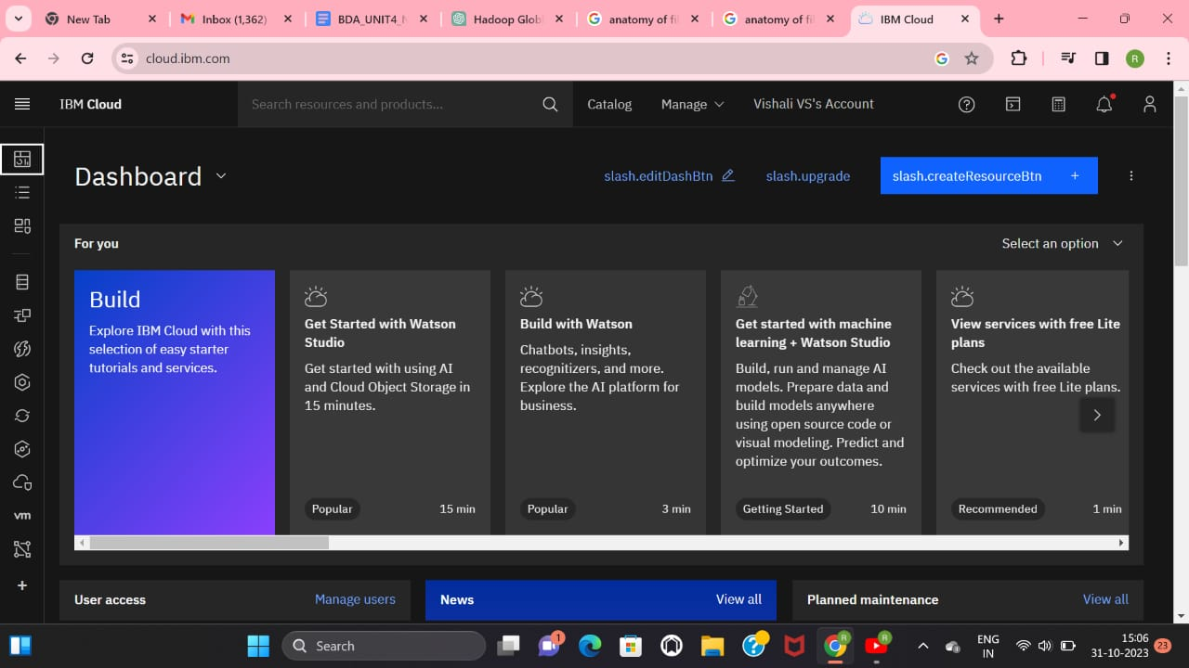

In the digital age, media streaming has become an integral part of how we consume content. This project aims to harness the capabilities of IBM Cloud Video Streaming to create a robust and efficient media streaming solution. We'll be focusing on the delivery of live and on-demand video content to end-users. By leveraging IBM's state-of-the-art cloud infrastructure, we intend to provide a seamless streaming experience, ensuring high-quality video delivery and user satisfaction. This project showcases the power of IBM Cloud in the world of media streaming.

ABOUT PHASE 3:

In this phase, we embark on building our media streaming solution using IBM Cloud Video Streaming. We will set up an IBM Cloud account, select the appropriate video streaming service, and configure a streaming instance. Our focus will be on developing the necessary tools and scripts for media content ingestion, transcoding, storage, and streaming.

DATA VISUALIZATION:

I LIVE STREAMING STATISTICS

The graph you are referring to is likely a line chart or bar chart, commonly used for visualizing data related to live streaming statistics. It displays various metrics associated with live streaming, such as the number of viewers, streaming quality, and viewers' interaction data, including likes, comments, and shares. The x-axis typically represents time, showing the streaming duration, while the y-axis represents the specific metric being measured. This type of graph is essential for monitoring the real-time performance of live streaming events, making it easier to detect issues, optimize user engagement, and make data-driven decisions.

II VIDEO ON-DEMAND (VOD) USAGE

The graph you mentioned is likely a bar chart or line chart, often used for visualizing data related to video on-demand (VOD) usage statistics. It can show metrics such as the number of VOD views, popular content, user engagement, or even revenue generated from VOD content. The x-axis typically represents time or specific content titles, while the y-axis shows the metrics or data being tracked. This type of graph is vital for assessing the success and popularity of VOD content, enabling content providers to make informed decisions regarding content creation and monetization strategies.

III GEOGRAPHICAL DISTRIBUTION OF VIEWERS

The map you referred to is likely a geographical heat map, a valuable tool for visualizing the geographical distribution of viewers for your media streaming service. It can provide insights into where your audience is located and where the content is most popular. Heat map colors or shading represent viewer concentration, with darker areas indicating higher viewer density. This visualization can be crucial for tailoring content delivery, targeting specific regions, and optimizing server locations for efficient content distribution.

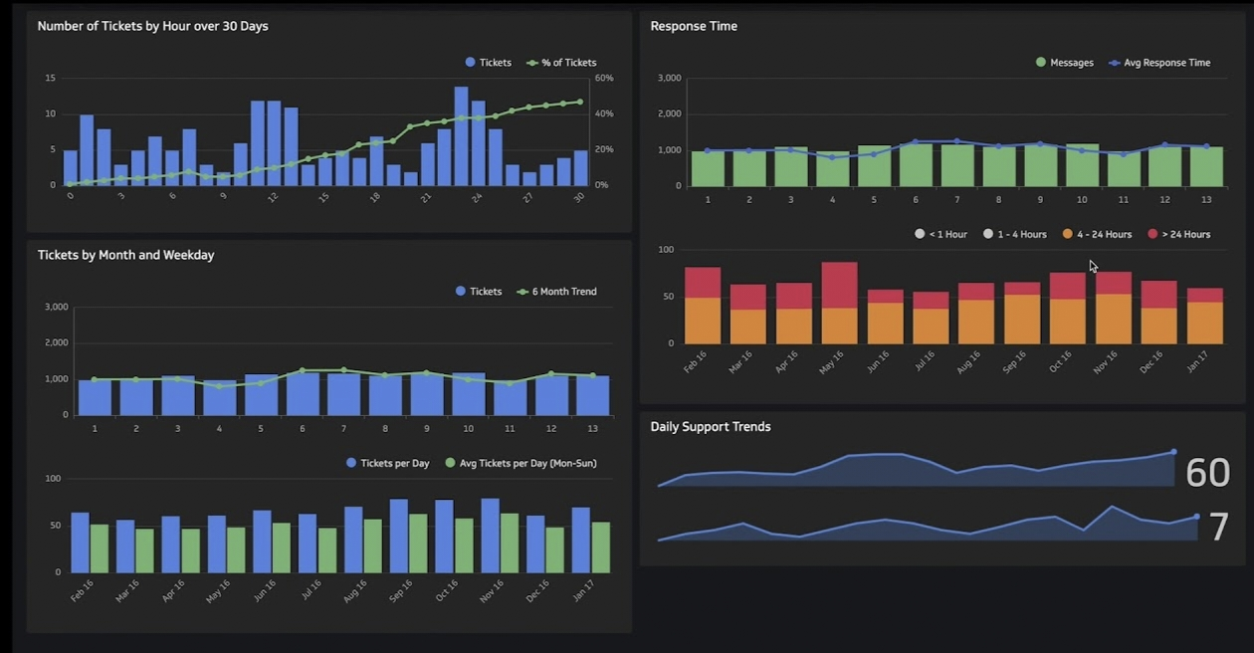

IV DEVICE USAGE STATISTICS

The graph you're mentioning might be a bar chart or pie chart illustrating the device usage statistics for your media streaming service. It shows the distribution of viewers across various devices, such as smartphones, tablets, smart TVs, and desktop computers. This visualization can help you understand how your audience accesses content, enabling you to optimize your streaming platform for different devices, develop responsive designs, and improve user experience.

DATA PREPROCESSING:

The data preprocessing stage for media streaming involves several key steps:

1. Ingestion: Collect data from various sources, such as server logs, user interactions, and content statistics. This data may include details on the number of viewers, their locations, device types, and interaction data.

2. Cleaning: Remove any inconsistent or erroneous data points that could affect the accuracy of your statistics. This may involve handling missing data, removing duplicates, and resolving discrepancies in viewer location data.

3. Transformation: Organize the data into a format suitable for analysis. This may involve aggregating data by time intervals, mapping viewer locations to geographical regions, and categorizing device types.

4. Integration: Combine data from different sources to create a comprehensive dataset for analysis. This can include merging live streaming statistics with VOD usage data and user device statistics.

5. Analysis: Apply statistical methods and machine learning algorithms to extract insights from the preprocessed data. This may include identifying trends in viewer behavior, assessing content popularity, and optimizing content delivery strategies.

Overall, data preprocessing is a crucial step in ensuring the accuracy and reliability of your media streaming analytics, enabling data-driven decision-making and improving the user experience.