HOMEWORK # 5

Reading and Research Assignment

A) The 2 of the most predominant forces in providing for the cloud services in machine learning are

* Amazon Web Services (AWS)
* Google Cloud Platform (GCP)

Comparing AWS and GCP

AWS was started in 2006 and is currently the leader in providing cloud services. AWS was the pioneer to start the IAAS. The services provided by AWS is overwhelming. AWS provides services only after signing for 1-year contract and paying the amount in advance, and there is no option to change the plan. Whereas this is not the case with GCP, as they provide with the flexibility to change the plan as per the customer requirements.

AWS is the leader in providing services regarding the big data and the machine learning, since it provides many features for fast and parallel computing and provides in depth integration with many popular devops and provides many services for serverless computing. GCP provides many features to fast processing of the big data it has the worlds highest data with the google chrome.

|  |  |  |
| --- | --- | --- |
| Services | AWS | GCP |
| classification | yes | yes |
| Regression | yes | yes |
| Clustering | no | yes |
| Anomaly detection | no | yes |
| Recommendation | no | yes |
| Ranking | no | yes |
| Algorithms | unknown | Tensorflow based |
| Frameworks | no | Tensorflow |
| Graphical Interface | no | no |
| Automation level | high | low |

I would be choosing the GCP because it has higher services provided for the machine learning framework and also uses tensorflow framework which is specially designed for the vector calculations

------------------------------------------------------------------------------------------------

B)

Ping command from bird library to [www.mit.edu](http://www.mit.edu) at 10:30 am on 04/24/2018

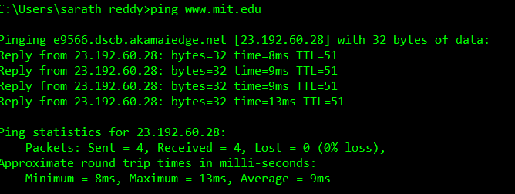

Ping command from bird library to [www.mit.edu](http://www.mit.edu) at 7:13 pm on 04/25/2018

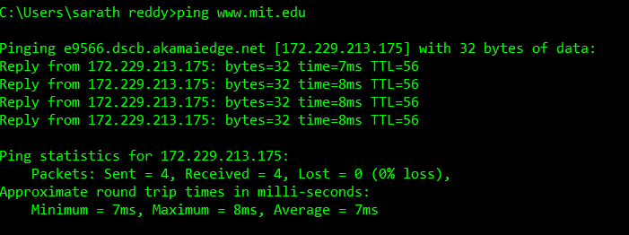

ping command from bird library to [www.intel.com](http://www.intel.com) at 10:30 am on 04/24/2018

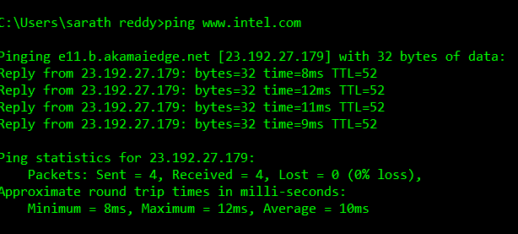

ping command from bird library to [www.intel.com](http://www.intel.com) at 4:30 pm on 04/25/2018

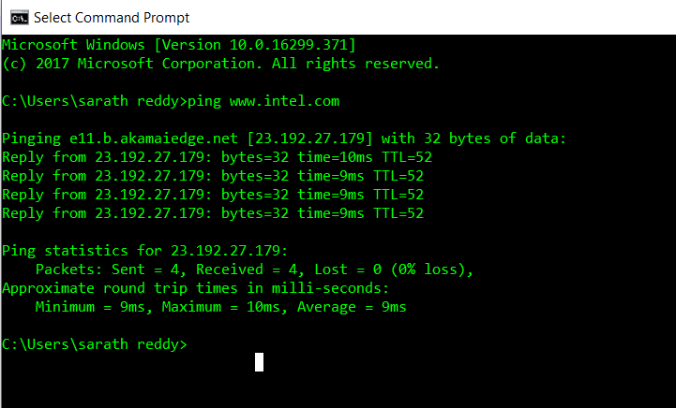

Tracert command from bird library to [www.mit.edu](http://www.mit.edu) at 7:23 pm on 04/25/2018

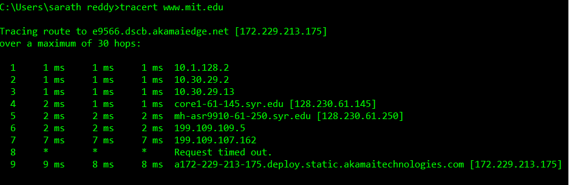

Tracert command from bird library to [www.mit.edu](http://www.mit.edu) at 10:30 am on 04/24/2018

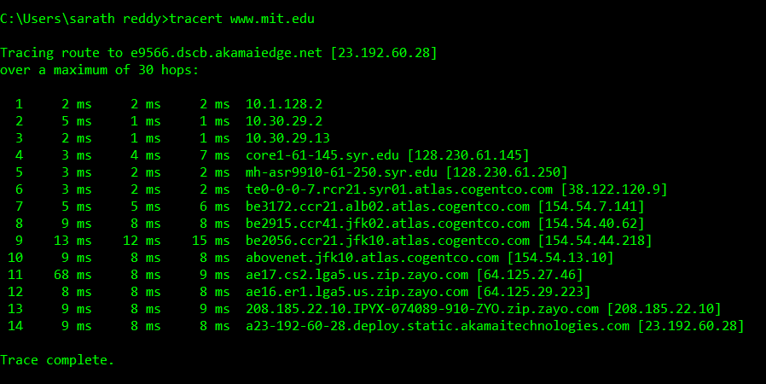

Tracert command from bird library to [www.intel.com](http://www.intel.com) at 10:30 am on 04/24/2018

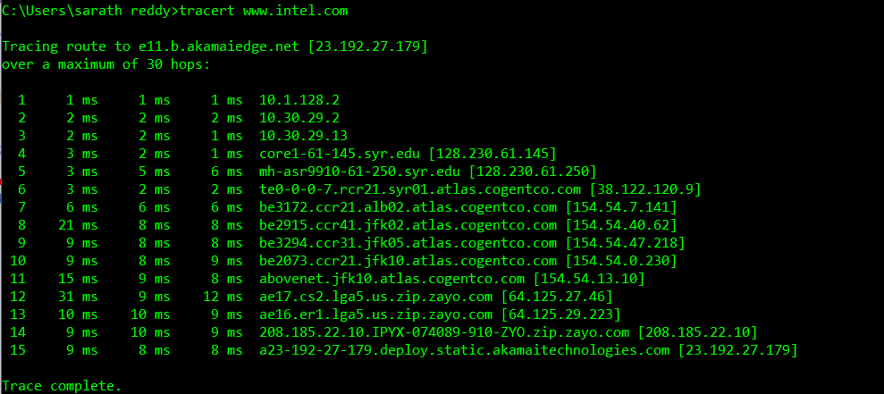

Tracert command from bird library to [www.intel.com](http://www.intel.com) at 4:31pm on 04/25/2018

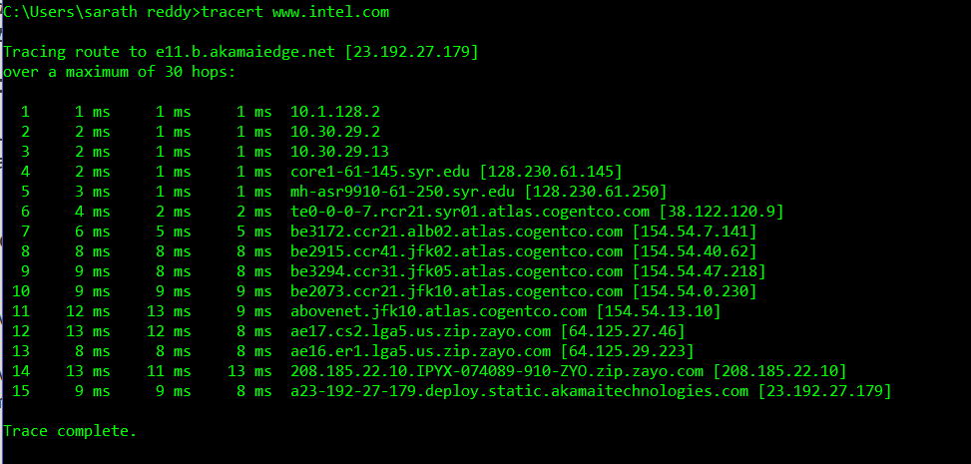

Summary

Summary:

1. [www.mit.edu](http://www.mit.edu)

|  |  |  |  |
| --- | --- | --- | --- |
|  | RTT | Number of hops | Distance (approximate) |
| 10.13 am | 7 ms | 09 | 320 miles |
| 7.23 pm | 9 ms | 14 | 320 miles |

1. [www.intel.com](http://www.intel.com)

|  |  |  |  |
| --- | --- | --- | --- |
|  | RTT | Number of hops | Distance (approximate) |
| 10.30 am | 10 ms | 15 | 2832 miles |
| 4.31 pm | 09 ms | 15 | 2832 miles |

The difference in the RTT, and the number of hops is dependent on the internet traffic and the geographic location as the geographic location is at a high distance the RTT time taken is high and the number of hops for the routing also takes more time

------------------------------------------------------------------------------------------------

C) Given data:

Speed of propagation = 2.3*10^8 m/s

Link speed = 2 Gbps = 2*10^9 bps

1 bit on a 2 Gbps link is (1/2 Gbps) = (1/ (2*(10^9))) = 0.5*10^ (-9) wide

Given propagation speed = 2.3*10^8 m/s

Speed of Propagation =(distance) / (Propagation time)

* Distance = (Speed of Propagation) * (Propagation time)
* Length of a bit = (2.3 * (10^8) m/s) *(0.5*10^(-9) s) = 0.115m

------------------------------------------------------------------------------------------------

Exercises

1) There are 2 diverse ways to store multi-dimensional arrays in linear storage in memory:

* Row major order: Here consecutive elements of the array of rows are stored in contiguous array
* Column major order: Here consecutive elements of the columns of the array are stored in contiguous memory.

Now, analysing the given 2 conditions we get,

When the data is stored in row major order,

Parallelization is better in accessing the elements row by row, a thread can take advantage of the spatial locality property of the caches. However by accessing the elements column-wise there is more possibility of the cache misses.

Therefore, whenever the elements are stored in the column major order parallelization (2) is a better approach.

----------------------------------------------------------------------------------------------

2 a) P0:read 120 => P0.B0: (S,120,0020) returns 0020

----------------------------------------------------------------------------------------------

2 b) P0: write 120 <= 80 =>P0.B0: (M,120,0080)

P3.B0: (I,120,0080)

------------------------------------------------------------------------------------------------

3 a) P0,0: write 100 <=80, Write hit only seen by P0,0

------------------------------------------------------------------------------------------------

3 b) P0,0: write 108<=88, Write “upgrade” received by P0,0; invalidate received by P3,1

------------------------------------------------------------------------------------------------