Product Design Specification

Project: VBooks
Project Id: VT0001

Prepared by: Sateesh T
Date: 7/1/2013

Project Sponsor: Indoafrica Group
Client Acceptor: Vijay Reddy, Director
Project Manager: Sateesh T

Document Number: VT/VB/PDS
Security Classification: Low
Version: 1.1
TABLE OF CONTENTS

1 Introduction 3
1.1 Purpose of The Product Design Specification Document 3
2 Architecture Design 3
2.1 Hardware Architecture 3
2.2 Software Architecture 5
3 System Design 5
3.1 Use-Cases 5
3.2 Database Design 6
3.3 Application Program Interfaces 6
3.4 User Interface Design 6
3.5 Performance 6
4 Product Design Specification Approval 7

Introduction

Purpose of The Product Design Specification Document
The Product Design Specification document documents and tracks the necessary information required to effectively define architecture and system design in order to give the development team guidance on architecture of the system to be developed. The Product Design Specification document is created during the Planning Phase of the project. Its intended audience is the project manager, project team, and development team. Some portions of this document such as the user interface (UI) may on occasion be shared with the client/user, and other stakeholder whose input/approval into the UI is needed.

Architecture Design

Hardware Architecture
Server Based

A Server at the office where individuals can connect to the server to Use the Interface to add data
or for operations intended for the user..

User will only have limited access of the system where he cant be able to view/edit/delete master data from the server which is unauthenticated.



- In this model complete data will be stored in encrypted format on a server,
- User has only access to the system through user interface where he can view/add only data which he has permissions to view.
- Admin / User / Third-party User can not login to the server unless he has admin user credentials.
- As data is stored in encrypted formats, Logged in user cant trace the data.

Flow:
- All the data will be stored in a system which will be located at one place.
- User connects to the system using a web-browser to enter details for sale-book and day-book.
- As data is updated by user to the server a master copy is generated and now the user can view his part of desired data for his operations.

Cloud Based

Cloud based model would be same as Server based model, but in this case we would be using a cloud server.

Standalone Based

A Master System will be holding the complete data dump.
A Client System will be having only the part of data which he needs to be accessed.

Here we can have some predefined Excels to update the Master and the Client Systems based on time intervals as desired.



- In this model master data will be available in Master System in encrypted formats.
- On a particular time frequency Master and Client systems will be synced for the latest data.
- As master data is available with Master System only these is no way of data loss / fraud.

Flow:
- Software is installed on the Master Systems, and a client is installed on the client Machines.
- Master System sends all the desired information to the client Machine on desired time frames.
- client Machine sends all the collected information to the Master System on desired time frames.
- Once master system receives the data from clients, master system updates all the received data to the master data, and sends the desired data to the clients.
- Now client system will have the desired data.

Software Architecture
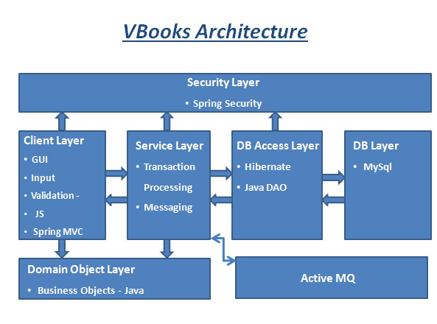

System Design

Use-Cases
Please refer 'VB_UC_v1.1.doc' document.

Database Design

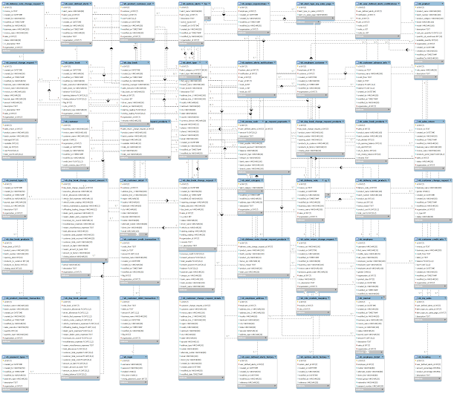

Application Program Interfaces
- ActiveMQ

User Interface Design
Please refer the 'Vbooks User Interfaces' documents.

Performance

Product Design Specification Approval
The undersigned acknowledge they have reviewed the VBooks Product Design Specification document and agree with the approach it presents. Any changes to this Requirements Definition will be coordinated with and approved by the undersigned or their designated representatives.

Signature: |  | Date:
Print Name: | Sateesh T
Role: | Technical Manager

Signature: |  | Date:
Print Name: | Pavan Reddy
Role: | Director

Document Revision History

Date | Version | Description | Author
29/03/2013 | VB-PDS1.0 | First Version of Product Specification document. | Sateesh T
04/04/2013 | VB-PDS1.1 | Included the Datebase design and User Interface Design of the project. | Sateesh T

