Main.java:

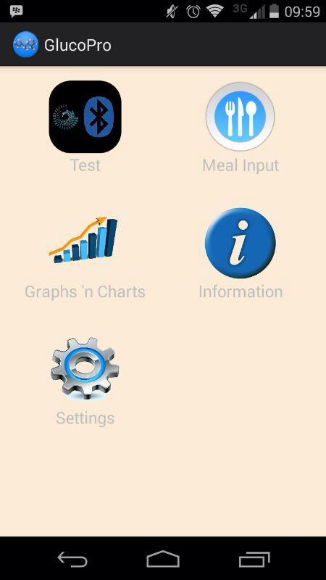

Meal Input - package hippocraticapps.glucopro.activities; - MealInput.java

MealInput.java:

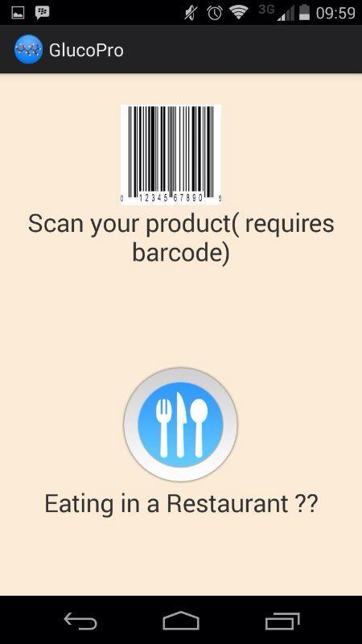

R.layout.meal_input

Scan your product - camera

Eating in a restaurant - package hippocraticapps.glucopro.activities; - RestInput.java

RestInput.java:

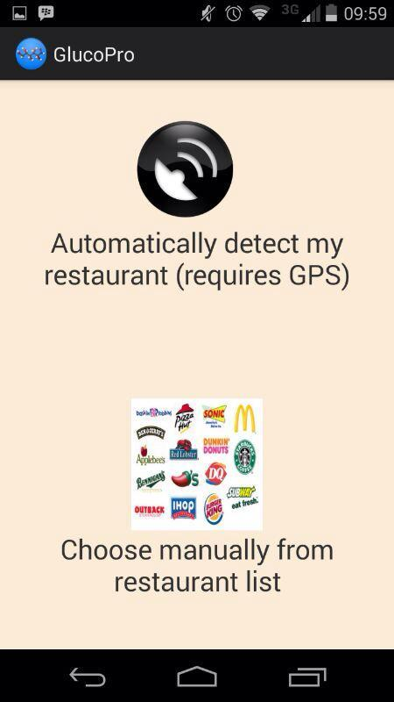

R.layout.rest_menu_f

Automatic - packagehippocraticapps.glucopro.gps; - Resturants_gps.java

Manual - package hippocraticapps.glucopro.resturant; - Rest_menu_f.java

Resturants_gps.java:

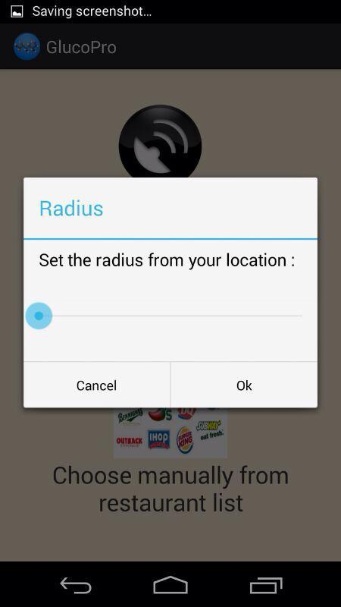

Rest_menu_f.java (package hippocraticapps.glucopro.resturant;)

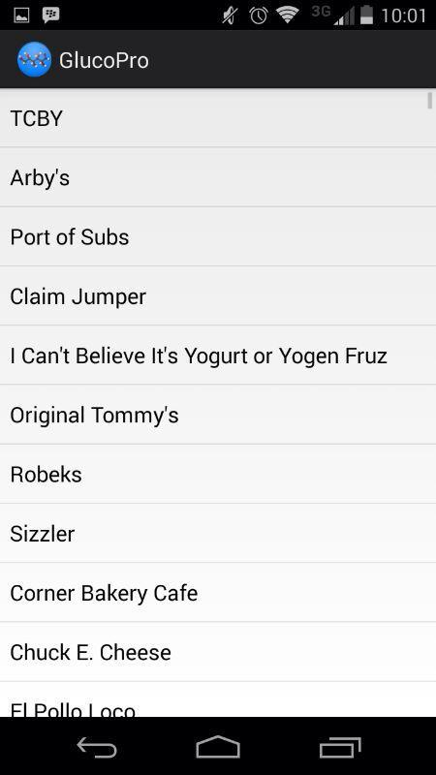

Category_menu.java (package hippocraticapps.glucopro.resturant)

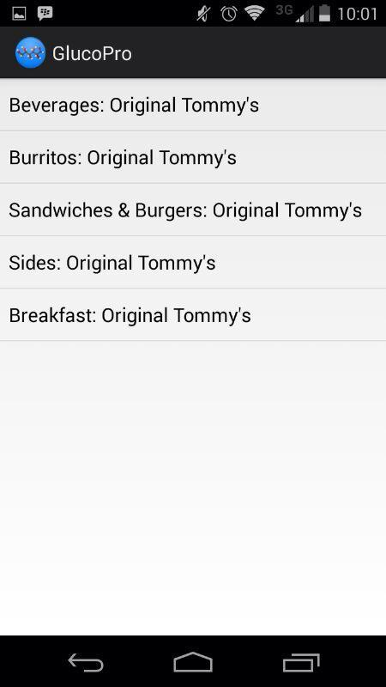

Product_menu.java (package hippocraticapps.glucopro.resturant)

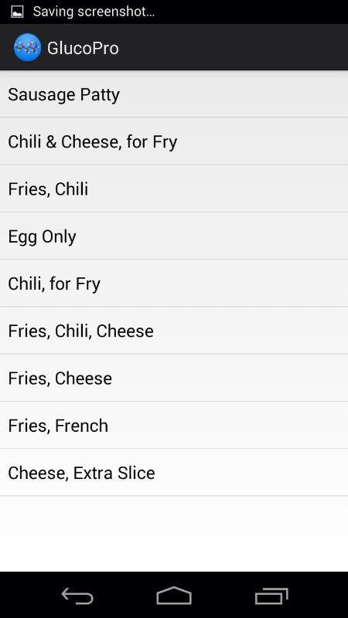

Product_view.java (package hippocraticapps.glucopro.resturant)

