The data that has been used to generate this visualisation is wildfire data of USA. The data has been collected from 1992 to 2015. It is the third update of a publication originally generated to support the national Fire Program Analysis system. This data includes 1.88 million geo-referenced wildfire records, representing a total of 140 million acres burned during the 24-years period.

The table that has the geospatial data with details of the wildfire is ‘Fires’ table and I used that table to visualize the data.

The first visualization is the number of wildfires occurred in each year from 1992 to 2015. When you look at the graph we can see the year 1997 had the lowest number of fire which is less than 60,000 and the year 2006 had the highest number of fire which is more than 100,000.

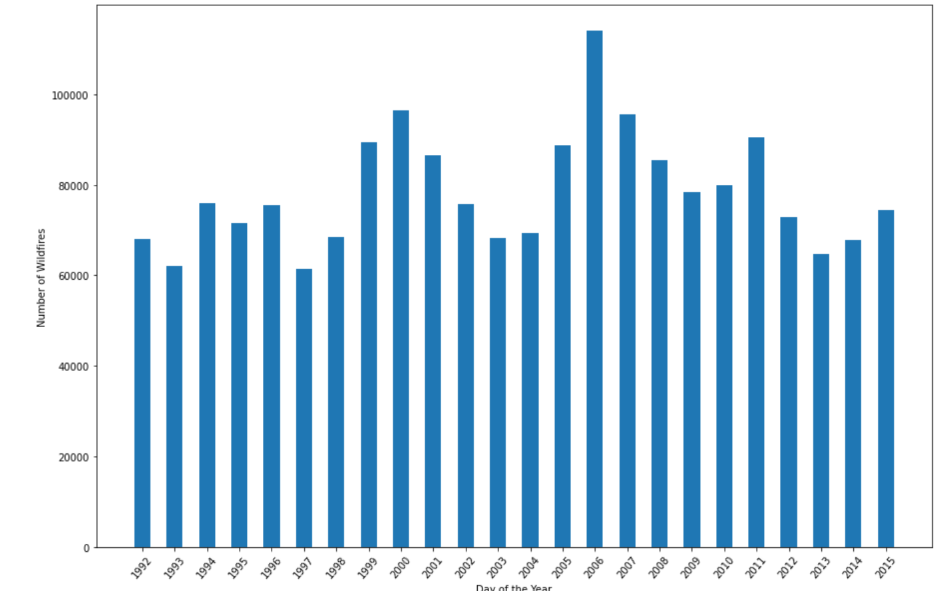

The second visualisation varies on a specific day of a year, in the range of 365 days. From the data, we infer it has maximums number of fire around March to April and May to July. We have minimums fire around December.

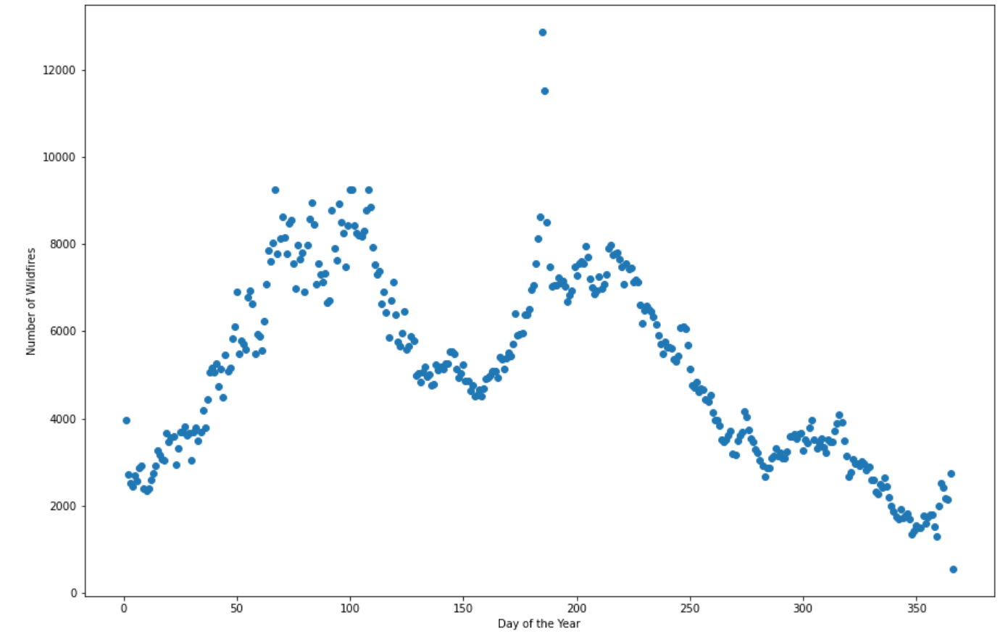

The third visualisation is relation between the cause of fire within a specific year. This tells us which reason has caused how much wildfires in a specific year. As we can see debris burning has resulted more in wildfires specificly in years 2006, 1999, 2000. Also, we can conclude that children and campfires are minimal to cause a wildfire

Also miscellaneous is the second highest caused of wildfire from 2005 to 2015

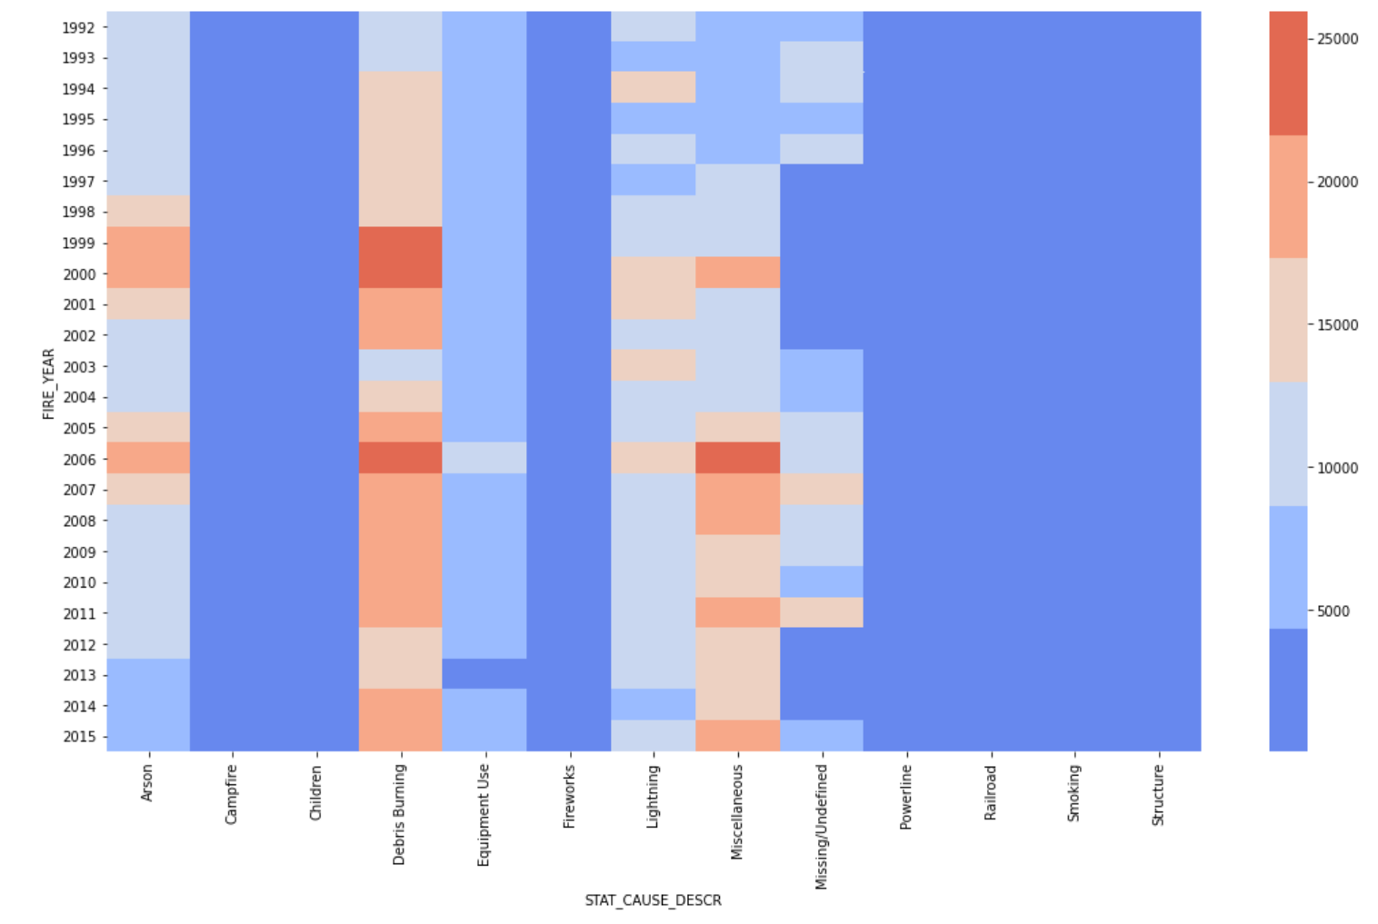

Problem

There is some missing data and the data is hard to interpret the first time. But by looking at the data in any DB Browser, we can get clarified about the data and the data structure.

Lesson

They key point to perform any data visualisation is understanding the data and its structure. That’s the most important thing I learned.

I have also learned to use modules like seaborn and Geopandas.