South China University of Technology
《Operating System》
Module Practice Report
Experiment Title： Unix File System Implementation in C++
Name： Sara Sajid Undre 映月 Student ID： 201969990298
Class： CST2019 Group： Group 2
Collaborator： Lam Sung Foon Ryan 林君海 201969990099 &
Vondrea Cassey Andoko 孙秀凤 201969990084
Teacher： Prof. Zhong Jinghui
Description
Requirements
- Review Unix file system design and i-node usage.
- Design and implement an i-node-based Unix-style file system.
- Implement basic functionalities specified in the following section.
- The task needs to be completed using C++ ONLY
Tasks/Functionalities
The following functions are required in your file system:
- Allocate 16MB space in memory as the storage for your file system. The space is divided into blocks with block size 1KB
Assume address length is 24-bit，please design your virtual address structure.
Design what information should be contained in an i-node
The i-node should support 10 direct block addresses, and one indirect block address

- The first a few blocks can be used for storing the i-nodes, and the first i-node can be used for the root directory (/).
(You can design the structure as you like, as long as it is reasonable and well explained in your report.)

- Using random strings to fill the files you created. It means you just need to specify the file size (in KB) and path+name.
- Following commands should be supported in your system：
  - A welcome message with the group info (names and IDs) when the system is launched. It is also the claim of your ‘copyright’
  - Create a file：createFile fileName fileSize
i.e.：createFile /dir1/myFile 10 (in KB)
if fileSize > max file size, print out an error message.

  - Delete a file：deleteFile filename
i.e.：deleteFile /dir1/myFile

  - Create a directory：createDir
i.e.：createDir /dir1/sub1 (should support nested directory)

  - Delete a directory：deleteDir
i.e.: deleteDir /dir1/sub1（The current working directory is not allowed to be deleted）

  - Change current working directory：changeDir
i.e.: changeDir /dir2

  - List all the files and sub-directories under current working directory：dir
You also need to list at least two file attributes. (i.e., file size, time created, etc.)

  - Copy a file: cp
i.e.: cp file1 file2

  - Display the usage of storage space：sum
Display the usage of the 16MB space. You need to list how many blocks are used and how many blocks are unused.

  - Print out the file contents: cat
Print out the contents of the file on the terminal
    - e: cat /dir1/file1
【Environment】
Oracle Virtual Box, Linux (Ubuntu), Visual Studio Code, C++
Content
[Abstract]
In this report paper, we discuss Unix-style file system design, principles of I-node manipulation, and our implementation of this file system in a Linux environment (Ubuntu) using visual studio code IDE and C++. All the required functionalities are operational such as memory allocation, creating and deleting files and directories, etc. All diagrams were made using www.lucidchart.com and all screenshots were taken from the virtual Linux OS terminal.
[Background]
Unix file system is a logical method of organizing and storing large amounts of information. The greatest advantage of this file system is that it makes it easy to manage. In Unix, everything is considered a file, including devices such as DVD-ROMS, USB devices, and floppy drives. In addition, a file is the smallest unit in which the information is stored. All files are organized into directories and these directories are organized into a tree-like structure called the file system.

Files in Unix systems are organized into a multi-level hierarchy structure known as a directory tree. At the very top of the file, the system is a directory called “root” which is represented by a “/”. The root contains other files and directories. Each file or directory is uniquely identified by its name, the directory in which it resides, and a unique identifier called I-node. Finally, a Unix file system is self-contained. There are no dependencies between one filesystem and another.

Early versions of Unix filesystems were referred to simply as FS. FS only included the boot block, superblock, a clump of I-node, and the data blocks. This worked well for the small disks early Unix operating systems were designed for. However, as technology advanced and disks grew larger, moving the head back and forth between the clump of I-node and the data blocks they referred to caused thrashing.

To solve this issue, Marshall Kirk McKusick optimized the BSD 4.2's FFS (Fast File System) by inventing cylinder groups, which break the disk up into smaller chunks, with each group having its respective I-node and data blocks. The intent of BSD FFS was to try to localize associated data blocks and metadata in the same cylinder group. Thus, it would reduce fragmentation caused by scattering a directory's contents over a whole disk.

[Project design]
In this experiment, we first wrote pseudocode, which we referred to as we code along. The pseudocode is shown in the following sections with its respective functions. For the memory allocation, 16MB of memory is allocated to the file system as storage. This space is further divided into blocks of 1KB size, resulting in a maximum of 16,384 blocks. Following a small file system standard, our inode is 128 bytes in size. Further, the cylindrical group is partitioned into Superblock, Inode Bitmap, Block Bitmap, Inode space, and Data space. In the first block, the Superblock contains filesystem metadata, which describes the organization of the filesystem and how much disk space is being used.
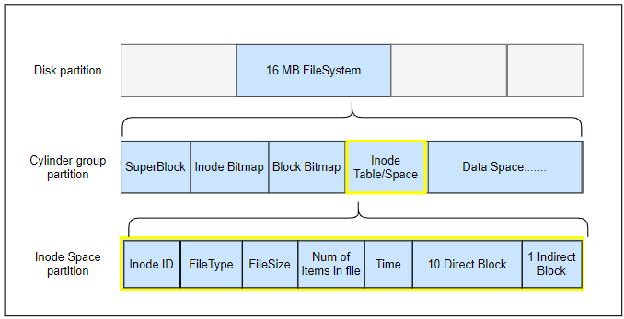
The I-node table/space contains the metadata of the file and it is used to map to the data blocks using pointers. It is composed of 10 direct pointers, which point to blocks of the file's data, and 1 indirect pointer, which points to an inode without information headers before pointing to data blocks.
I-node bitmaps occupy a part of the memory and are a sequence of 0s and 1s where 0 indicates a free I-node and 1 indicates an I-node that is already in use. This technique is used to quickly find the free location on the inode table when modifying the file system. On-disk these sections can be illustrated as follows.
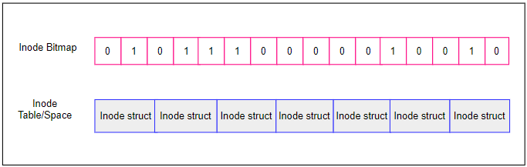
Similarly, in the block bitmap, each bit represents a specific block and indicates whether it is available or not. After the file system allocation, all pending space goes into the data space, which contains the raw data stored in the blocks.

Assuming that the address length is 24 bits and that the inode supports 10 direct block addresses and one indirect block address, the addressing structure can be designed and calculated as such:

Max file size = No of direct disk block pointer +
(DBS/DBA) + (DBS/DBA) ^2 + (DBS/DBA) ^3+ (DBS/DBA) ^N) *DBS

DBS = Disk Block size= 1024 bytes = 1KB
DBA = Disk Block address size = 24 bits = 3 bytes
The number of disk block pointer that can fit in one block pointer = DBS/DBA = 1024/3 = 341.3333 = 341

The number of block 10 direct address entries can address = 10
The number of block one primary indirect block can address = 341
Max file size = (341+10) *1KB = (351) * 1024 = 359424 bytes

[Implementation]
We first define the header files and some constant variables as shown in figure1.1. In this program, we allocate 1024 bytes as block size, and 16384 bytes as block number. This maintains the 16MB storage capacity of the file system based on BLOCK_NUM x BLOCK_SIZE. Considering we are implementing a small file system, INODE_SIZE is assigned 128 bytes as per standards, and the INODE_NUM is 1024.

The Flag bit indicates if the object is a file (0) or a directory (1) and is used to initialize the number of direct blocks in the inode, as well as maximum values for the name, file size, and the number of directories.

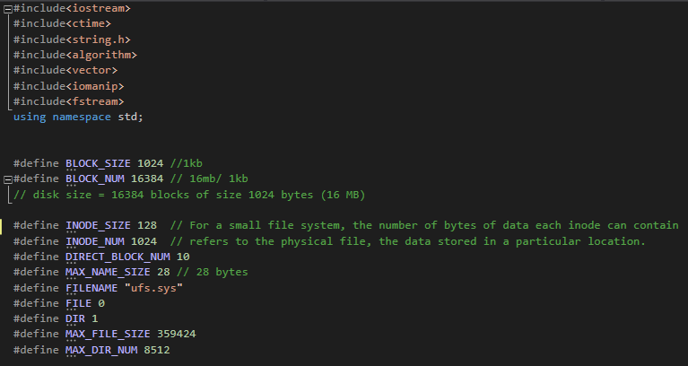
Figure 1.1.

The program consists mainly of two parts: the data structure and the functions. The three main data structures defined are Superblock, inode, and DirItem as shown in the figure1.2. The superblock struct contains the disk usage data and the block’s start address. Inode structs contain information such as unique inodeID, file sizes, types, number of items, and direct and indirect block addresses. The file types include directories and files. The dirItem struct contains the name of a directory item, which can either be a file or a subdirectory, as well as the inodeAddress of the item.
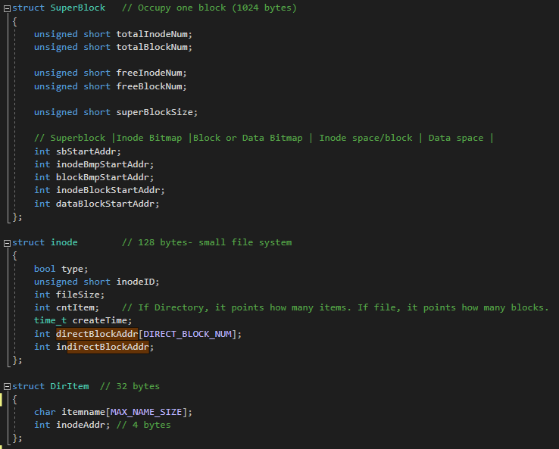
Figure 1.2.

Then we initialize the objects for the superblock of the filesystem and the file stream so that we can create, read, and write data to the file. This is followed by the initialization of block and inode bitmaps, current directory path and address, and global variables as shown in Figure1.3.
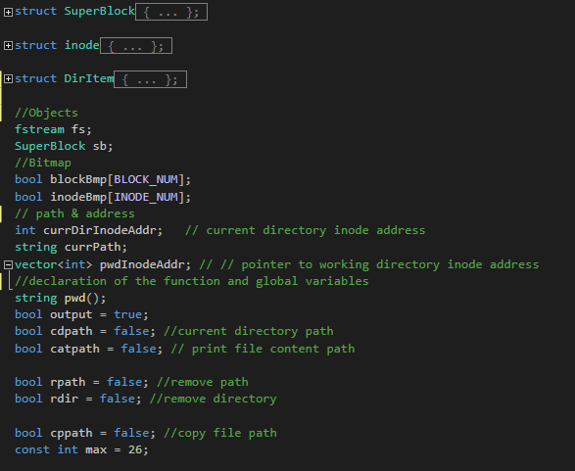
Figure 1.3.

The functions are divided into the following subsections according to their functionalities so they can be easily understood and read.
- Allocation
- Update Functions
- Get Addresses
- Block Functions
- Check Functions
- Formatting & Disk usage
- Directory Functions
- Current Directory Functions
- Remove Functions
- File Functions

- Allocation
This section defines the ialloc () and balloc () functions as shown in the figure1.4. The inode allocation function assigns an inode to a newly created file, whereas the block allocation function assigns a block to the data of the newly created file.
If the function is unable to allocate successfully, it returns -1 otherwise it returns the inode/block address.
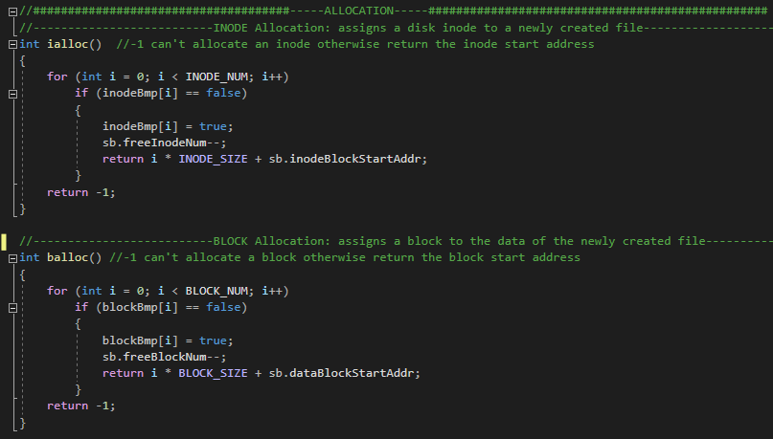
Figure 1.4.

- Update Functions
In this section, the functions update the inode bitmap, the block bitmap, and the super bitmap as shown in figure1.5. It utilizes the file stream methods; seekp () and write (). In the seekp () method, the pointer is set to the start of the inode/block bitmap address and the stream is modified from the beginning, and in the write () method, the value of the inode/block bitmap is inserted into the constant pointer to the inode bitmap address. The updateSuperblock () works similarly
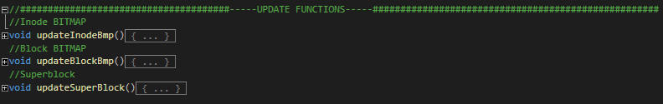
Figure 1.5.

Get Addresses
This section contains three functions; getDirAddr (), getPathInodeAddr (), and getBlockAddr () which return the location of our directory/file so that the system can find them based on user input as shown in the figure1.6.
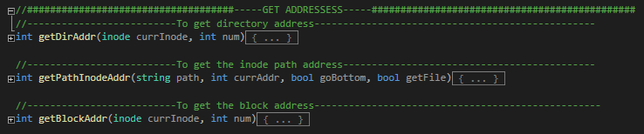
Figure 1.6.
The getDirAddr () returns the directory item address using either the direct or indirect addressing. If the path cannot be explored further, getPathInodeAddr () returns the inode path address for the current working directory, if path == "/" it returns the root. We iterate over the path size if the path is not root and if the global variables for the respective functions are set to true, we execute an if statement that returns the address as per the file type. The getBlockAddr () maps to the block address from the current inode.

Block Functions
A block address can be read and written using the bwrite () and bprint () functions.
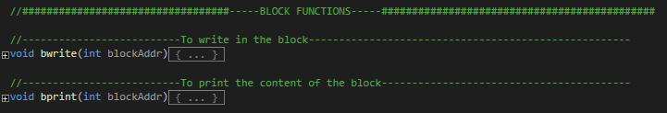
Figure 1.7.

- Check functions
The isvalid () function checks if the file and the directory name are valid by checking if the given characters are alphanumeric or not. If it is, then it returns true or else false. Whereas the check () function checks whether the given path is in the “/string/” format.
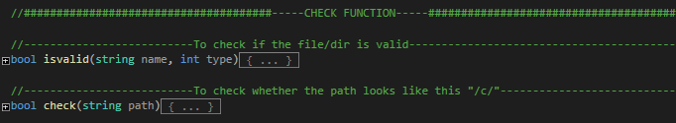
Figure 1.8.

- Formatting & disk usage
The formatting of the filesystem path, disk, and data can be achieved using the functions listed in the figure1.9. The formatpath () function is used to return the passed path string according to the system default. In order to maintain the integrity of the database, every file system must be able to restore the original state of the files (default state), so the format () function is defined to delete all files and directories within the database.

The load () function loads the previously loaded memory and facilitates the loading of the superblock, inode, and block bitmaps. This loads the data from the previous run, which is called on program execution to update the database if any changes were made prior to running the system.
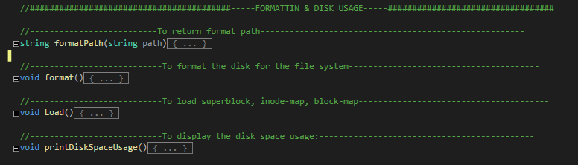
Figure 1.9.
The printDiskSpaceUsage () functions prints the Inode and block usage on the disk by the filesystem. It includes the total number of inode/blocks on disk, the number of free inodes/blocks on disk, and the number of used inode/blocks by the filesystem.

Pseudocode for printing disk space usage
FUNTION printDiskSpaceUsage ()

Totalblocknum = Total block number in the superblock
Freeblocks = Number of free blocks
Usedblocks = Totalblocknum - Freeblocks

TotalInodenum = Total number of inodes
FreeInodes = Number of free inodes
UsedInodes= TotalInodenum - FreeInodes

PRINT “Totalblocknum “
PRINT “Freeblocks “
PRINT “Usedblocks “

PRINT “TotalInodenum “
PRINT “FreeInodes “
PRINT “UsedInodes “

ENDFUNCTION printDiskSpaceUsage

- Directory functions
The Unix filesystem is initially configured with a root directory "/", it is the first and topmost directory in the filesystem hierarchy. The program facilitates easy navigation and manipulation of the file system by enabling users to create directories, delete existing directories except for the current working directory, display items in the working directory, and change the current working directory.
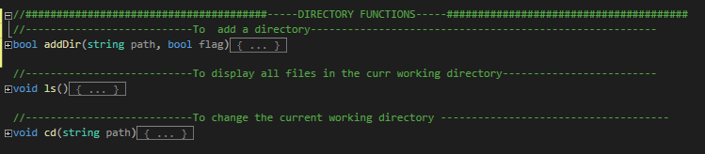
Figure 1.10.
The addDir () function is used to add directories, where a flag is used to determine if it is the first directory in the system's database. In the case that it is not the first directory, it will determine if the inputted directory has similar names, the correct path, free space, and so on. When all criteria are met, a new directory is created from DirItem to find and read its inode address, then update its last inode address, which is then passed to be updated to the superblock, inode bitmap, and block bitmap.

Pseudocode for Adding a directory
FUNTION addDir (path: string)
IF (flag == true) THEN
Allocate inode
Add directory named “/”
SET Filetype = DIR
SET createTime = time (NULL)
SET Filesize= 0
SET NumofItems= 2
SET inodeID
Current Directory InodeAddress = inodeAddress;
Allocate block
SET inodeAddr = inodeAddress
Add item name
seekg & write in the inode
Update superblock
Update inode bitmap
Update block bitmap
ELSE

IF Inode Address cannot be allocated THEN
PRINT “path error “
ENDIF
FOR i->pathsize-2 to i>=0
IF path [i] is not equal to "/"
Dirname + path[i]
ELSE break the loop
ENDIF
ENDFOR
IF Dirname size >= MAXFILENAMESIZE THEN
PRINT “name is too long “
ENDIF
IF Dirsize >= MAXFILESIZE THEN
PRINT “file is too long “
ENDIF
IF Dirname is not valid THEN
PRINT “name is not valid “
ENDIF

//To check if the name is same
check & read lastinodeAddress
FOR i->0 to i< numberofitems
getdirectoryAddress for the inode
check & read dirItemAddress from the Filesystem
check & read inodeAddress
IF directoryitemname is equal to filename THEN
PRINT “has the same name “
ENDIF
ENDFOR
IF numberofdiritems is equal to MAXDIRNUM THEN
PRINT “up to limit of DIR_NUM “
ENDIF
IF NUM of freeblocknum in superblock is equal to 0 OR
NUM of freeInodenum in superblock is equal to 0) THEN
PRINT “not enough space “
ENDIF
//Allocate file to a new inode
//Allocate a block for data
//Create a new dirItem
//Update the last node
//Update Superblock
//Update Data Block Bitmap
//Update Inode Bitmap
ENDIF
ENDFUNCTION addDir

Using the ls () function, the user can output the list of files and directories from the current working directory in the file system along with their file type, size, and date/time created. The system will check the inode address of the current directory and seek the items that have been saved in the database from that address. When the item name is a directory, it will check for its subfiles and then update the directory size accordingly.

Pseudocode for displaying all files in the current working directory
FUNTION ls (path: string, size: int)
seekg & read inode
PRINT “File Name Type File Size Date/Time “
FOR i->0 to i< num of datablocks occupied
seekg & read the directory items
seekg & read the inode
PRINT “Item name “
str = item name
IF filetype == File THEN
PRINT “FILE “
PRINT “FILE size “
ELSE
PRINT “DIR “
ENDIF
//++++++++++++++++++++++++++++++++++++++++
IF (str == "dir1") THEN
seekg & read the inode
FOR i->2 to i< num of items
getdirectoryAddress for the dirItem
check & read dirItemAddress from the Filesystem
check & read ItemInode from the Filesystem
PRINT “FILE size “
ENDFOR
ENDIF
//++++++++++++++++++++++++++++++++++++++++
ELSE IF (str == "dir2") THEN
seekg & read the inode
FOR i->0 to i< num of items
getdirectoryAddress for the dirItem
check & read dirItemAddress from the Filesystem
check & read ItemInode from the Filesystem
PRINT “FILE size “
ENDFOR
ENDIF
//++++++++++++++++++++++++++++++++++++++++
ELSE IF (str == "dir3") THEN
seekg & read the inode
FOR i->2 to i< num of items
getdirectoryAddress for the dirItem
check & read dirItemAddress from the Filesystem
check & read ItemInode from the Filesystem
PRINT “FILE size “
ENDFOR
ENDIF
//++++++++++++++++++++++++++++++++++++++++
ELSE IF (str != "/" && str != "dir1" && str != "dir2" &&
str != "dir3" && Filetype != FILE) THEN
seekg & read the inode
FOR i->2 to i< num of items
getdirectoryAddress for the dirItem
check & read dirItemAddress from the Filesystem
check & read ItemInode from the Filesystem
PRINT “FILE size “
ENDFOR
ENDIF
PRINT “date & time “
ENDFOR
Close file
ENDFUNCTION ls

The cd () function allows the user to change directories. Upon first boot, the system will begin from the root directory "/". Invocation of this function searches for the inode address of the inputted path and sets the current directory inode address to the new one. It then updates the pwd () function, which serves as a pointer to the working directory, which is called from the main function.

Pseudocode for changing the current working directory
FUNTION cd (path: string)
Path = formatPath(path)
Changedirectory = true
newInodeAddress = getPathInodeAddress ()
Changedirectory = false
IF Inode Address cannot be allocated THEN
PRINT “path error “
ELSE
Current Directory InodeAddress = newInodeAddress;
ENDIF
ENDFUNCTION cd
- File Functions
The program allows users to create files, delete existing files, copy files to another location, and read the contents of files by printing the file on the terminal.
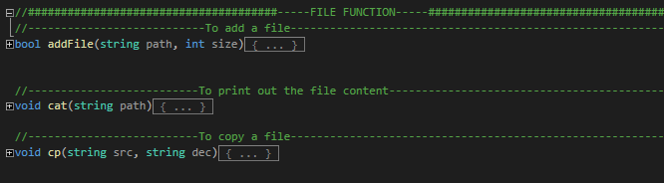
Figure 1.11. The File functions
To add files to the current directory, we implemented the bool addFile () function that first checks whether the user input path is absolute or relative. Further, the program will check whether the file name and size entered meet all the required specifications such as name, size, and free space. On success, the last inode address will be updated, and a new inode address will be created in the current working directory.

Pseudocode for Adding a file
FUNTION addFile (path: string, size: int)
IF path [0] is equal to "/" THEN
Inode Address = getPathInodeAddr ()
ELSE
path = "/" + path;
Inode Address = getPathInodeAddr ()
ENDIF
IF Inode Address cannot be allocated THEN
PRINT “path error “
ENDIF
FOR i->pathsize-1 to i>=0
IF path [i] is not equal to "/"
Filename + path[i]
ELSE break the loop
ENDIF
ENDFOR
IF filename size >= MAXFILENAMESIZE THEN
PRINT “name is too long “
ENDIF
IF filesize >= MAXFILESIZE THEN
PRINT “file is too long “
ENDIF
IF filename is not valid THEN
PRINT “name is not valid “
ENDIF
//To check if the name is same
FOR i->0 to i< numberofitems
getdirectoryAddress for the inode
check & read dirItemAddress from the Filesystem
IF directoryitemname is equal to filename THEN
PRINT “has the same name “
ENDIF
ENDFOR
IF numberofdiritems is equal to MAXDIRNUM THEN
PRINT “up to limit of DIR_NUM “
ENDIF
IF NUM of freeblocknum in superblock< ((filesize+BLOCKSIZE-1/BLOCKSIZE) OR
NUM of freeblocknum in superblock is equal to 0) THEN
PRINT “no enough space “
ENDIF
//Allocate file to a new inode
//Allocate a block for data
//Update the last node
//Update Superblock
//Update Data Block Bitmap
//Update Inode Bitmap
ENDFUNCTION addFile

The user can read the content of an existing file, using the cat () function. This function seeks the current inode address of the file and using the 26 alphabets array, generates a random string output based on the file size using srand (). If the inode address for the file cannot be found, the program prints an error message on the terminal.

Pseudocode for printing the file content on the terminal
FUNTION cat (path: string, size: int)
Contentpath = true
currentInodeAddress = getPathInodeAddress ()
seekg & read the inode

FOR i->0 to i< filesize
Generate random string output
ENDFOR
IF Inode Address cannot be allocated THEN
PRINT “path error “
ENDIF
ENDFUNCTION cat

Next, void cp () allows the files to be copied to another location in the system. It takes two user inputs, one for source and one for destination. It then checks both inode addresses to see if they are valid. If the destination file is valid, then that file will be removed using the rmFile () function and then a new fille will be created under the same name of the destination file and the filesize of the source file will be copied to the destination file.

Pseudocode for copying a file
FUNTION cp (source: string, destination: string)
sourceInodeAddress = getPathInodeAddress ()
destinationInodeAddress = getPathInodeAddress ()
IF Source Inode Address cannot be allocated THEN
PRINT “path error “
ENDIF
IF Inode Address cannot be allocated THEN
delete destination File
ENDIF
seekg & read the source inode
copy file to the destination path
seekg & read destination inode
FOR i->0 to i< num of datablocks occupied
sourceBlockAddress = getBlockAddress ()
destinationBlockAddress = getBlockAddress ()

FOR j->0 to i<blocksize
Destinationblock [j] = Sourceblock [j]
ENDFOR
ENDFOR
ENDFUNCTION cp

- Current directory functions
The string pwd () function is implemented to detect the current directory users are using and return the path when the system is run/executed, allowing the user to better navigate the system. The ispwd () function checks if the pointer is pointing to the current working directory.
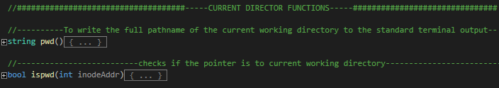
Figure 1.12.
- Remove Functions
This section deals with removing the existing file and directories using the rmFile () and rmDir () function.
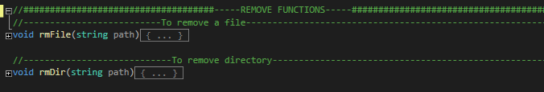
Figure 1.13.
In the rmFile () function, we check the current inode address of a path by getting its last directory to determine its current directory address. Once the file is successfully deleted the free block number is updated.

Pseudocode for deleting a file
FUNTION rmFile (path: string)
WHILE
//get last directory
//get current directory name
FOR i->0 to i< num of datablocks occupied by the file
getdirectoryAddress for the dirItem
check & read dirItemAddress from the Filesystem
IF directoryitem inodeAddress is equal to inodeAddress THEN
Name = directory item name
Path = "/" + name + path;
ENDIF
ENDFOR
ENDWHILE
//++++++++++++++++++++++++++++++++++++++++
IF (str == "/") THEN
IF CurrentinodeAddress is equal to -1 THEN
PRINT “path error “
ENDIF
FOR i->0 to i< num of datablocks occupied by the file
getdirectoryAddress for the dirItem
check & read dirItemAddress from the Filesystem
IF directoryitem inodeAddress is equal to inodeAddress THEN
directoryitem-1
ENDIF
ENDFOR
FOR i->0 to i< num of datablocks occupied by the file
blockAddress = getBlockaddress;
count = (blockAddress - superblockStartAdd)/ BlockSize
blockBitmap [count] = false;
NUM of freeblocknum in superblock +1
ENDFOR
IF num of datablocks occupied by the file > DIRECTBLOCKNUM THEN
count = (IndirectblockAddress - superblockStartAdd)/ BlockSize
blockBitmap [count] = false;
NUM of freeblocknum in superblock +1
ENDIF
ENDIF
//++++++++++++++++++++++++++++++++++++++++
ELSE IF (str == "/dir1/) THEN
IF CurrentinodeAddress is equal to -1 THEN
PRINT “path error “
ENDIF
FOR i->0 to i< num of datablocks occupied by the file
getdirectoryAddress for the dirItem
check & read dirItemAddress from the Filesystem
IF directoryitem inodeAddress is equal to inodeAddress THEN
directoryitem-1
ENDIF
ENDFOR
FOR i->0 to i< num of datablocks occupied by the file
blockAddress = getBlockaddress;
count = (blockAddress - superblockStartAdd)/ BlockSize
blockBitmap [count] = false;
NUM of freeblocknum in superblock +1
ENDFOR
IF num of datablocks occupied by the file > DIRECTBLOCKNUM THEN
count = (IndirectblockAddress - superblockStartAdd)/ BlockSize
blockBitmap [count] = false;
NUM of freeblocknum in superblock +1
ENDIF
ENDIF
//++++++++++++++++++++++++++++++++++++++++
ELSE IF (str == "/dir2/") THEN
FOR i->0 to i< num of datablocks occupied by the file
getdirectoryAddress for the dirItem
check & read dirItemAddress from the Filesystem
IF directoryitem inodeAddress is equal to inodeAddress THEN
directoryitem-1
ENDIF
ENDFOR
FOR i->0 to i< num of datablocks occupied by the file
blockAddress = getBlockaddress;
count = (blockAddress - superblockStartAdd)/ BlockSize
blockBitmap [count] = false;
NUM of freeblocknum in superblock +1
ENDFOR
IF num of datablocks occupied by the file > DIRECTBLOCKNUM THEN
count = (IndirectblockAddress - superblockStartAdd)/ BlockSize
blockBitmap [count] = false;
NUM of freeblocknum in superblock +1
ENDIF
ENDIF
//++++++++++++++++++++++++++++++++++++++++
ELSE IF (str == "/dir3/") THEN
FOR i->0 to i< num of datablocks occupied by the file
getdirectoryAddress for the dirItem
check & read dirItemAddress from the Filesystem
IF directoryitem inodeAddress is equal to inodeAddress THEN
directoryitem-1
ENDIF
ENDFOR
FOR i->0 to i< num of datablocks occupied by the file
blockAddress = getBlockaddress;
count = (blockAddress - superblockStartAdd)/ BlockSize
blockBitmap [count] = false;
NUM of freeblocknum in superblock +1
ENDFOR
IF num of datablocks occupied by the file > DIRECTBLOCKNUM THEN
count = (IndirectblockAddress - superblockStartAdd)/ BlockSize
blockBitmap [count] = false;
NUM of freeblocknum in superblock +1
ENDIF
ENDIF
//Update Superblock
//Update Data Block Bitmap
//Update Inode Bitmap
ENDFUNCTION rmFile

In the rmDir () function, the user cannot delete the current working directory. First, it checks whether the user input path is absolute or relative, then it checks its validity. If it is valid, the system will look up the inode address of that directory and update its last inode, which will then delete the directory from the system and free a block number. Then, the superblock, inodebmp, and blockbmp are updated with the new addresses

Pseudocode for deleting a directory
FUNTION rmDir (path: string)
IF path [0] is equal to "/" THEN
Removedirectory = false
ELSE
path = pointertoworkingdirectory() + path;
Removedirectory = true
deleteInodeAddress = getPathInodeAddr()
Removedirectory = false
ENDIF
IF Inode Address cannot be allocated THEN
PRINT “path error “
ENDIF
IF pointer points to the current working directory THEN
PRINT “can't delete the current working path “
ELSE
FOR i->2 to i< num of directory items
getdirectoryAddress for the dirItem
check & read dirItemAddress from the Filesystem
check & read ItemInode from the Filesystem
ENDFOR
FOR i->0 to i< num of directory items
getdirectoryAddress for the dirItem
check & read dirItemAddress from the Filesystem
IF directoryitem inodeAddress is equal to inodeAddress THEN
directoryitem-1
ENDIF
ENDFOR
inodeBitmap[Inode] = false;
NUM of freeblocknum in superblock +1
blockNumber = (Number of items in Inode + 31) / 32;

FOR i->0 to i< num of datablocks occupied
blockAddress = getBlockaddress;
count = (blockAddress - superblockStartAdd)/ BlockSize
blockBitmap [count] = false;
NUM of freeblocknum in superblock +1
ENDFOR
//Update Superblock
//Update Data Block Bitmap
//Update Inode Bitmap
ENDIF
ENDFUNCTION rmDir

- MAIN FUNCTION
This function provides the user with an interface through which they can interact with the program. Upon execution, the superblock is loaded first, then the filesystem. A welcome message is displayed followed by a copyright mark with the name and student ID of the group member and a /help command prompt to introduce the available commands.
When the user enters a command into the program, the corresponding function is invoked to produce the output During program execution, the while(true) loop loops the codes continuously, allowing users to continue using the UNIX filesystem until the program is terminated by the exit command. This is shown in the following figure that illustrates the program flow.
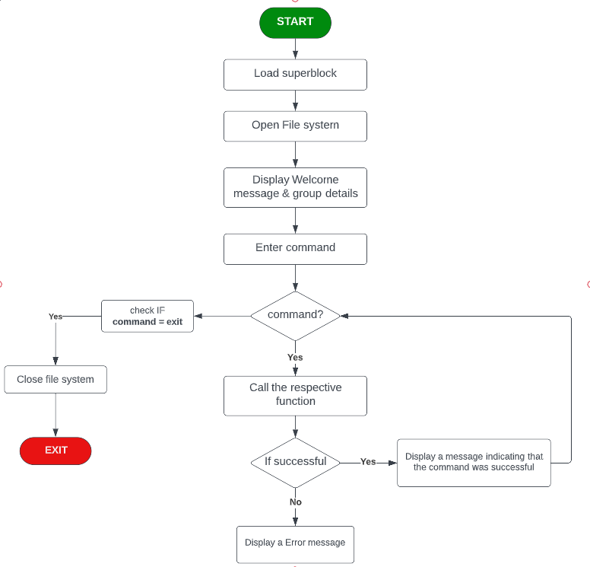
Program Flowchart

[Program Test Run]
We tested the program's functionality and command execution on the terminal to ensure the program worked. When the program is launched, the program name, group member details and a prompt for help and exit is displayed as shown below.
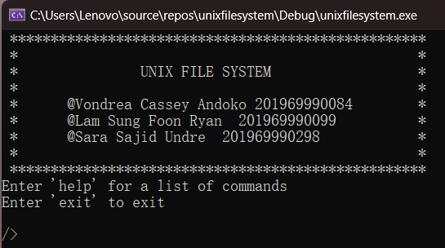
The help command, lists down all the commands supported in our file system.
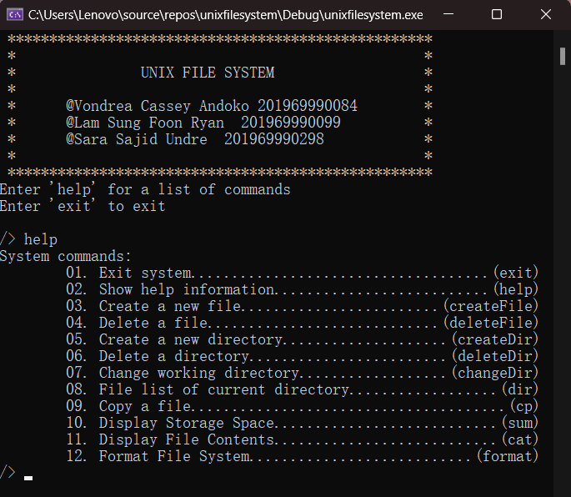
The following are the test run to check the working of the supported file system commands:
- Create a File – createFile filename filesize
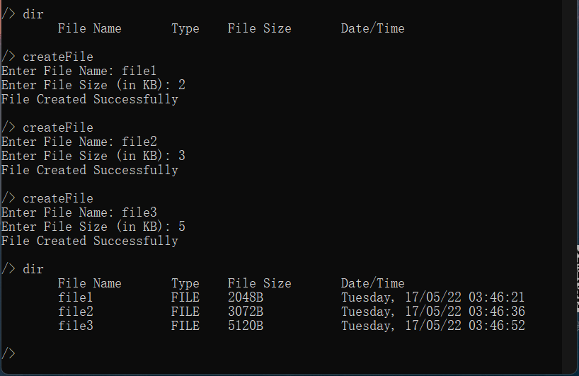
- Delete a File – deleteFile filename
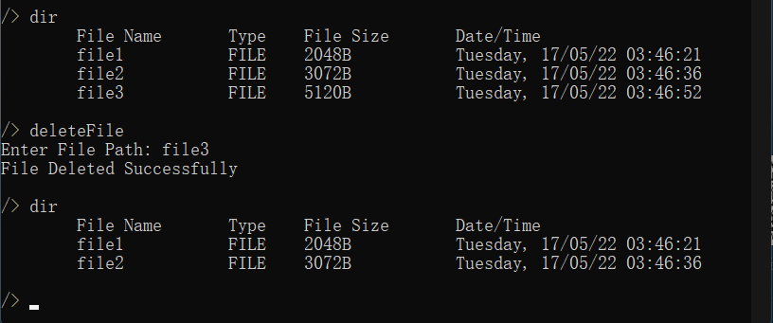

- Create a Directory – createDir directoryname
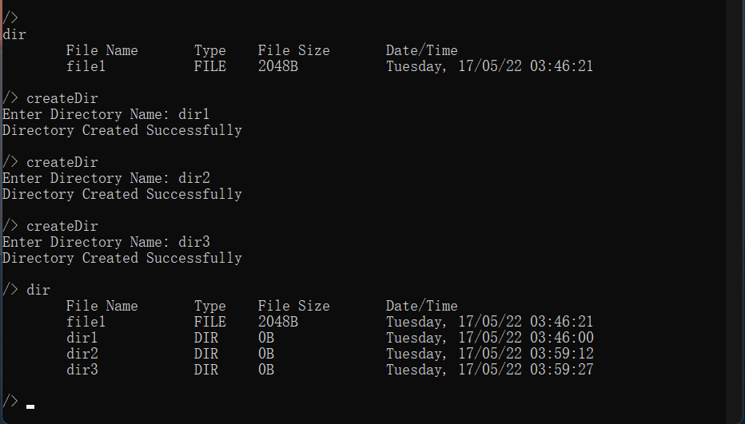
- Delete a Directory – deleteDir directory name
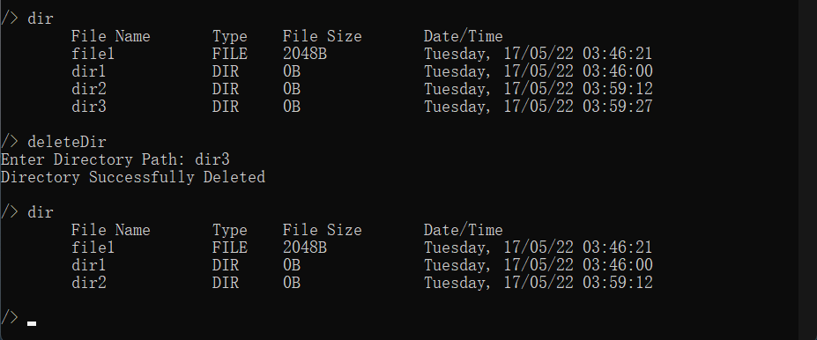
The user cannot delete the current directory as shown below:
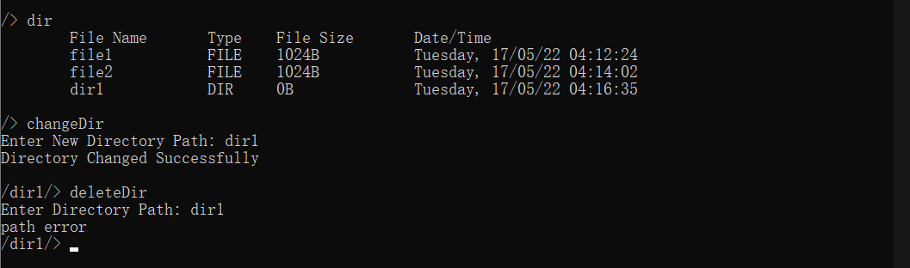
However, if the user returns to the root directory and tries to delete the same directory, the directory can be succesfully deleted:
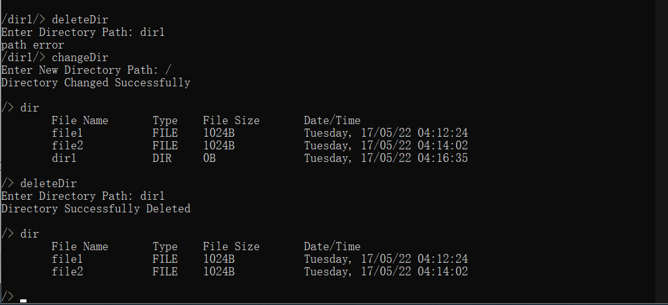
- Change current working directory – changeDir directoryname
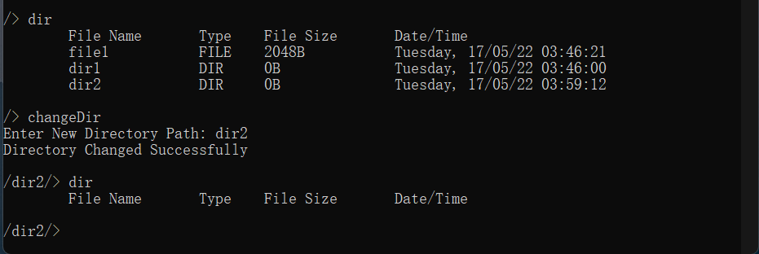
- List all the files and sub-directories under current working directory– dir
Change from root directory to dir2:
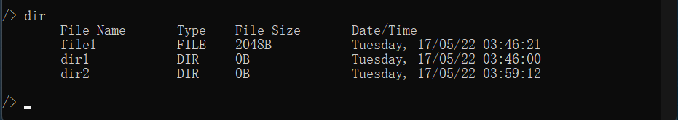
Change from dir2 to root directory:
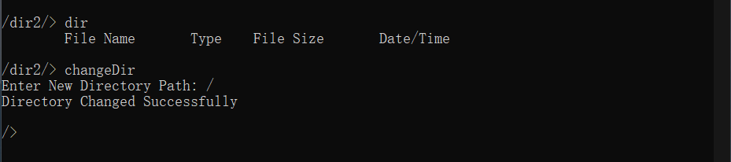
- Copy a file – cp filename1 filename2
Before copy:
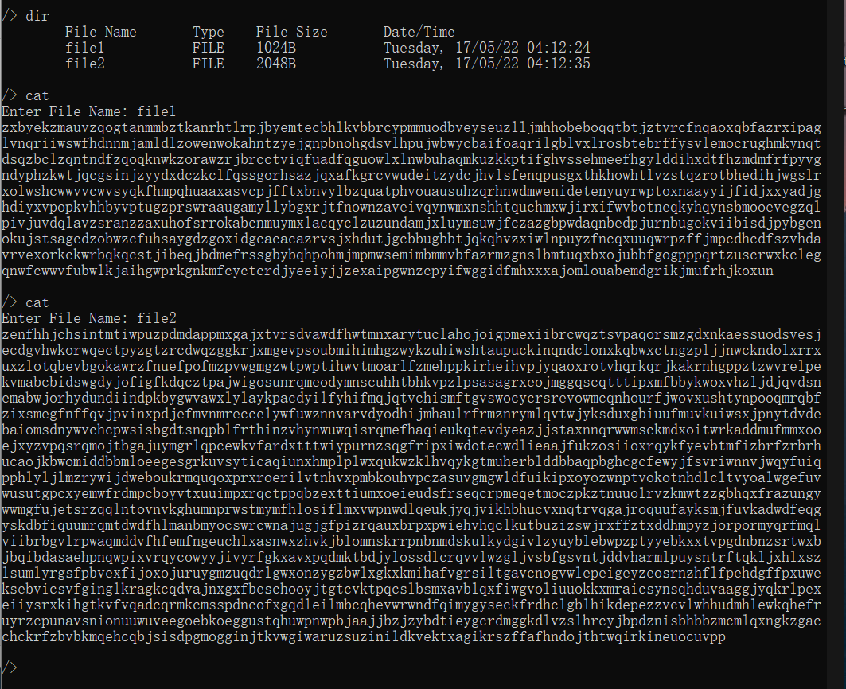

After Copy:
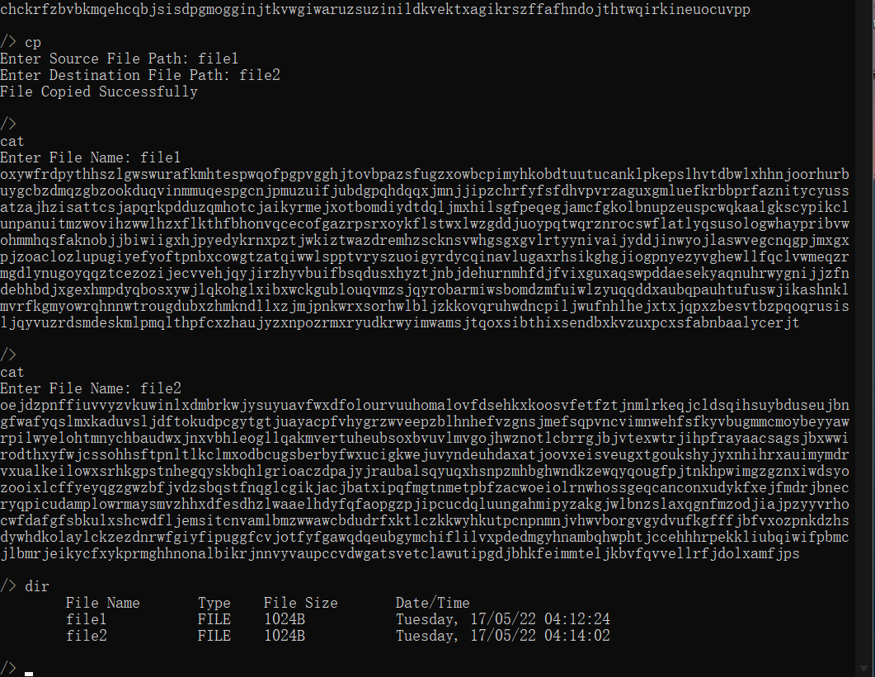
- Display the usage of storage space – sum
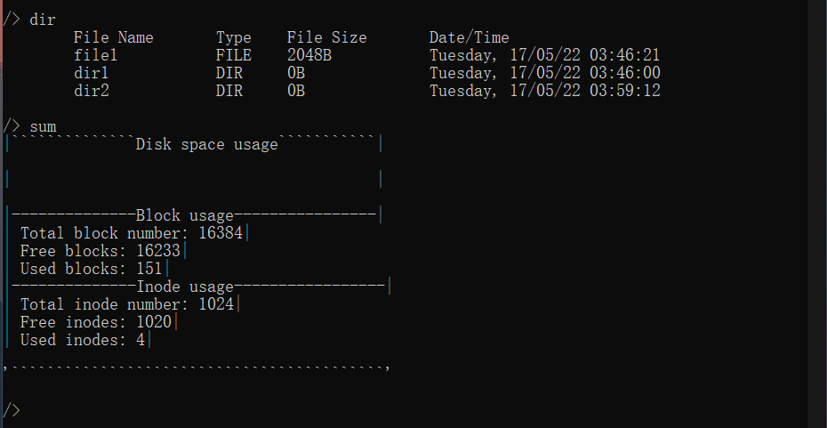

- Print out the file contents - cat filename
Printing file content for the file “file1” of size 2KB:
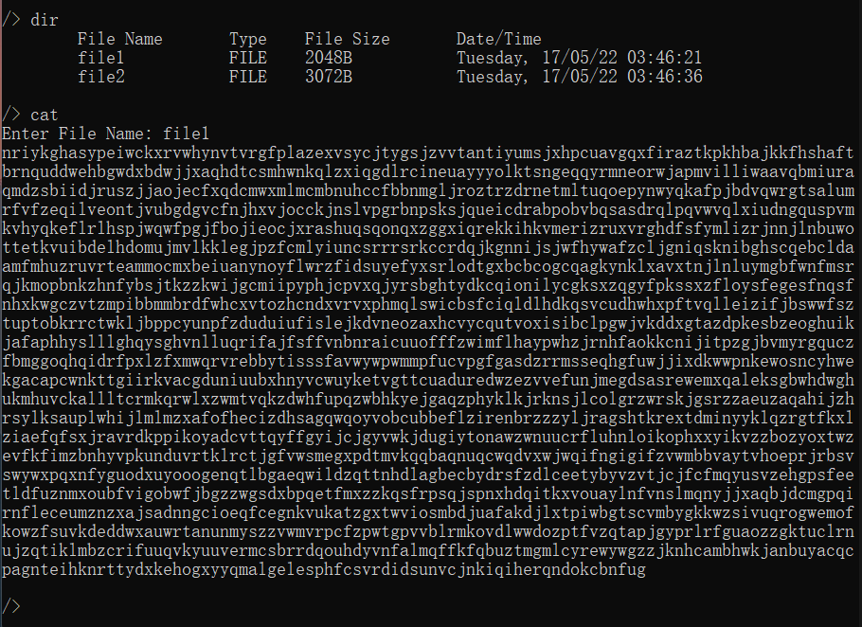
Printing file content for the file “file2” of size 3KB:
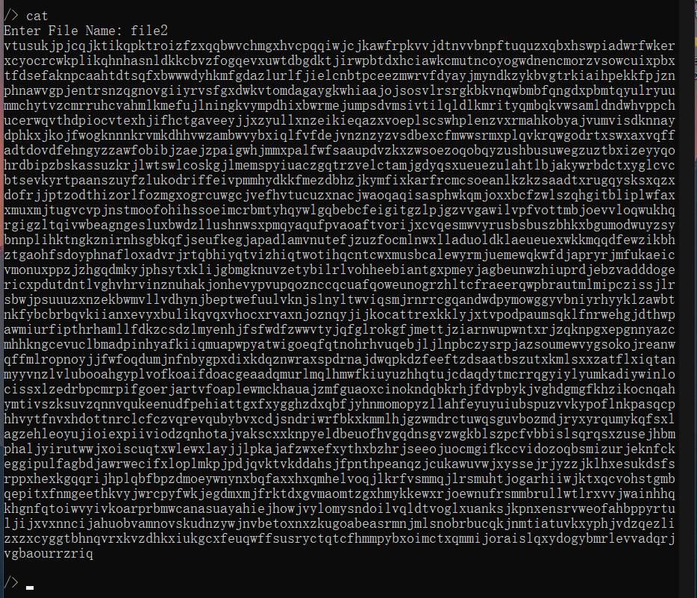
- Loading, Exiting and Formatting using format command:
On Exit the program all the occupied memory is released:
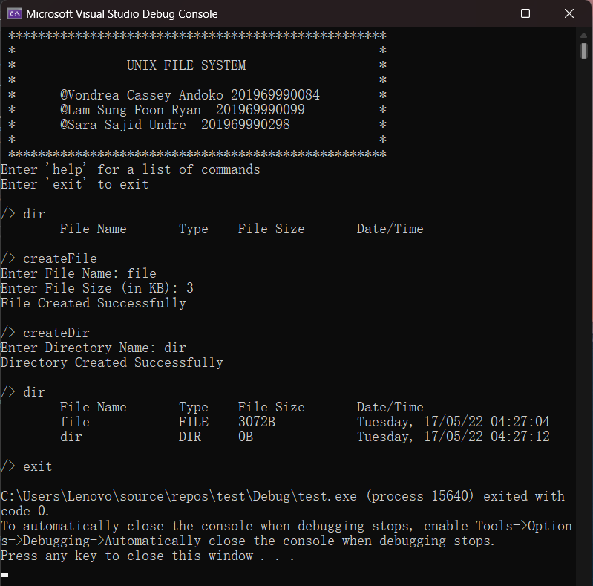
When the program is relaunched, the data from the previous run is loaded as shown below.
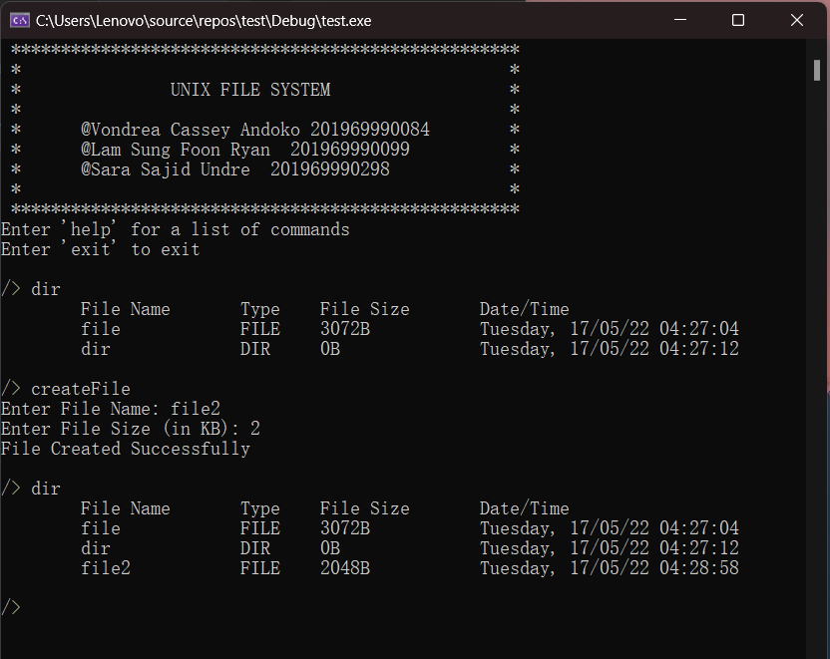
Finally, the user can format the disk back to its default state by using the format command.
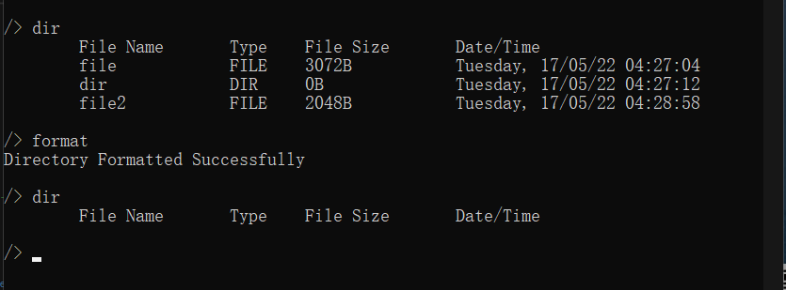

[Personal contribution]
- Sara Sajid Undre 201969990298
In this project, I am responsible for the program design, and the creation of the underlying data structure including superblock, data blocks, inodes, and memory allocation. The project designing task includes the virtual addressing design which was implemented by calculating and allocating the appropriate values to initialize the following variables at the start of the program BLOCK_SIZE, BLOCK_NUM, INODE_SIZE, INODE_NUM, DIRECT_BLOCK_NUM, MAX_NAME_SIZE, MAX_FILE_SIZE, MAX_DIR_NUM. The BLOCK_SIZE and BLOCK_NUM are used to maintain the 16Mb space for the Unix file system. While the MAX_FILE_SIZE limits the size of the newly created files in the filesystem.

The three main important data structures in this program are the superblock, inode, and the dirItem. The superblock struct holds the filesystem metadata while the inode contains the metadata of the file. The dirItem on the other hand contains the directory item name and its inode address.

The memory allocation is implemented using the two allocation functions: namely Inode allocation function ialloc () and block allocation function balloc (). Block functions that further support the program are bwrite () which enables data blocks to be written and bprint () which prints the contents of the blocks. The update functions updateInodeBmp (), updateBlockBmp (), updateSuperBlock () which updates the superblock, inode and block bitmaps.

Further, I worked on the Load (), format (), printDiskSpaceUsage () and the main () functions.
The Load () function loads the data from the previous run into the superblock, inode, and block bitmap. While the Format () resets the disk of the file system to its default state. The printDiskSpaceUsage () function displays the total number of inodes and blocks, as well as the number of used and free inodes & blocks.

The main () function provides a simple user interface for the user to interact with the filesystem and with additional help and exit functions. The help function lists down the supported commands, and the main function reads the user input and executes the corresponding functions to provide the desired output. Finally, the exit command terminates the program.

- Lam Sung Foon Ryan 201969990099
In this project, I was responsible for the functions that create and delete files and directories and the supporting functions that get addresses and format paths. This program supports the following commands for creating and deleting files and directories.
- To Create a file：createFile
This command calls the addFile () function, which allows the user to create a new file with fileName and fileSize as the parameter. First, it checks if the file name falls within the 28-character limit, and if it does, it will output an error message indicating that the name is too long, invalid, or that an identical file already exists. It then determines whether or not the inputted file size is too large by checking the size of the file. Then it allocates it to a new block and inode, checks if there is enough space, and finally updates it to the superblock, inodebmp, and blockbmp.
- To Create a directory：createDir
This command calls the addDir () functions, which allows the user to create a new directory. The function takes file name as parameter and initializes the size of the file to zero. Prior to saving, the function checks if it's the first directory. If it's not the first directory, then it traces the parent directory and the path. Then it checks the directory name for errors, such as invalid names, the length of the name, or if it has the same name as another directory.
- Delete a file：deleteFile
This command calls the rmFile () function which takes the name of the file to be deleted as a path parameter, then searches for its inode address from the current directory.
- Delete a directory：deleteDir
This command calls the rmDir () function which takes the name of the directory to be deleted. However, this function can only be successfully executed when the directory to be deleted is currently not in use. If the user tries to delete the current working directory it will run into an error and print an error message “can't delete the current working path”.

There are three functions defined to retrieve addresses that are getDirAddr (), getPathInodeAddr () and getBlockAddr (). The getDirAddr () retrieves the directory item address, while the getPathInodeAddr () function returns the inode path address based on the path and the current Address. Lastly the getBlockAddr () maps the data block address for the current inode.

- Vondrea Cassey Andoko 201969990084
In this project, I am responsible for the functions that change and listing directories, copy files and printing out file. This program supports these commands for changing and listing directories, copy files and printing out file contents.

For the update function, this project supports changeDir and cp commands.
  - Change current working directory：changeDir
This command will call the cd () function that allows the user to change from the current directory to another. An input of the destination directory name is required, so that the pointer can be set to point to the selected directory.
  - Copy a file: cp
This command will call the cp () function that will take as inputs the source file and destination file. This function will delete and create a new file that shares the same name, while copying the size of the source file to the new file.

For read function, this project supports dir and cat commands.
  - List all the files and sub-directories under current working directory：dir
This command will call the ls () function that allows user to be able to see a list of all the directories and files of the system under the current working directory. This function can also list out three file system attributes such as the name, the type whether it is a file or directory, the size and the date/time it is created. In addition, it also updates the size of a directory if it has a subfiles.
  - Print out the file contents: cat
This command will call the cat () function, which allows the user to read or print the content of a specific file. The content of the file is basically a set of letters that are randomly generated according to the file size while also utilizing the srand () function.

In our filesystem, the current working directory plays a crucial role, so we defined two functions for it; pwd () and ispwd (). The pwd () function returns the path to the current working directory, while the ispwd () function checks if the pointer points to the current working directory. Furthermore, check functions such as isvalid () and check () are defined to check for file/dir name and format at creation, and to check the format of path to a file/dir, respectively.

Conclusion
Through this project, we gained a deeper insight into the internal design and functionality of Unix file systems. We also learned how to use data structures to implement inode based file systems in C++. I believe this knowledge will prove valuable in the future.
Teacher’s Comments and Score
Comment：

Score： Signature：
Date：

