* **SUBJECT PM**
* **TOPIC: Product Management System(using Heap Sort)**

**GROUP NO A_12**

* **MEMBERS:**

**MAYUR KASWA 17u083**

**MOHIT KHEMWANI 17u118**

**SARAUNSH SHEWALE 21820144  
ANUJ DATE 21820179**

* **Product Management System(using Heap Sort)**

**Heap Sort:**

Heap sort is a comparison based sorting technique based on Binary Heap data structure.

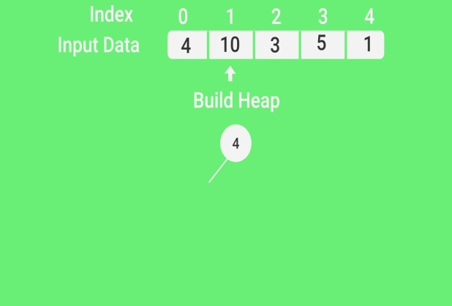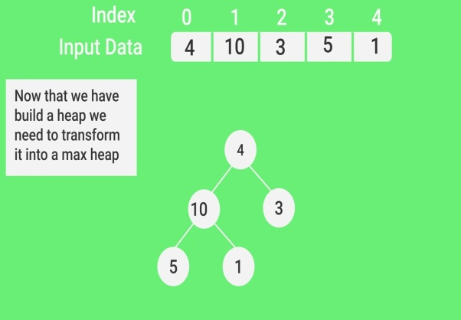

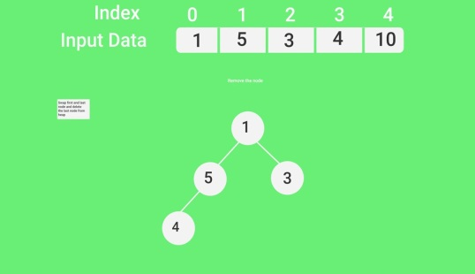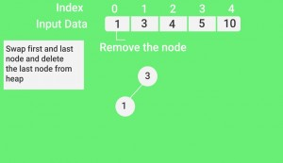

**Operations on Max Heap:**

1) getMax(): It returns the root element of Max Heap. Time Complexity of this operation is O(1).

**2)** extractMax(): Removes the maximum element from MaxHeap. Time Complexity of this Operation is O(Log n) as this operation needs to maintain the heap property (by calling heapify()) after removing root.

**3)**insert(): Inserting a new key takes O(Log n) time. We add a new key at the end of the tree. If new key is smaller than its parent, then we don’t need to do anything. Otherwise, we need to traverse up to fix the violated heap property.

**WORK BREAKDOWN STRUCTURE**