P6Project: Test a Perceptual Phenomenon

Sara Uenoyama

Questions: <https://docs.google.com/document/d/1-OkpZLjG_kX9J6LIQ5IltsqMzVWjh36QpnP2RYpVdPU/pub?embedded=True>

Dataset: <https://drive.google.com/file/d/0B9Yf01UaIbUgQXpYb2NhZ29yX1U/view>

1. Our Independent variable and dependent variable

In this case, our independent variable is the two conditions of words: congruent or incongruent. Our dependent variable is the time it takes for participants to name the ink colors of words on a list.

1. Appropriate hypotheses and statistical test of this task

Appropriate null hypothesis is that there is no difference in population mean time to name ink colors between congruent words list, µ*1* and incongruent words list, µ*2*. On the other hand, alternative hypothesis is that there is a statistical significant difference between the two. We can write down as follows in mathematical way.

- Null hypotheses: µ*1* = µ*2*

- Alternative hypotheses: µ*1* ≠ µ*2*

Appropriate test is two-sided t-test for following reasons.

- We expect that there is a difference in time to read congruent words list vs incongruent words list.

- We only have sample data, not knowing μand σ, which is used for z-test.

Assumptions made for the t-test are

- The scale of measurement applied to this data collection is continuous scale, “time”.

- The data is collected from randomly selected people from total population.

- As showed in my answer to question 4, the sample data is approximately normally distributed.

- The sample size, 24, is merely or not sufficient to draw bell-shaped distribution curve.

1. Descriptive statistics

Calculating from the dataset, sample mean and sample standard distribution from each group are

- x̄*A* = 14.05

- s*A* = 3.56

- ȳ*B* = 22.02

- s*B* = 4.8

*A* stands for sample data of congruent words and *B*stands for sample data of incongruent words.

1. Visualization of the distribution of the sample data

The sampling distribution of congruent words data is normal distribution as showed below.

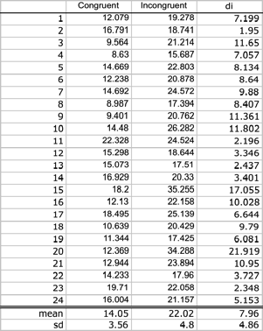

The sample data of incongruent words is normally distributed as well.

1. Two-tailed t-test

Calculate d*i* = y*i* – x*i* for each sample data.

Mean difference d̄ is

d̄ = ȳ*B* – x̄*A* = 7.96

Standard deviation of the difference is

s*d* = 4.86

Since the sample size is n = 24, degree of freedom is

Df = 24 – 1 = 23

Standard error of mean difference can be calculated from the number of samples and the sample standard deviations.

SE(d̄) = s*d* / √n = 0.99

Using the SEM value, we can calculate t-statics.

T-statistics = d̄ / SE(d̄) = 8.03

When α level is 0.05, t-critical value is 2.069.

t (23) = ±2.069, p = 0.025, two-tailed

Since t-statistics > t (23), we reject the null hypothesis. p <0.025.

In conclusion, in a Stroop effect experiment, the time it takes to name ink color of congruent word and one of incongruent word are different. As we expected, it takes more time to name ink color of words on incongruent words list.

Reference

<https://www.investopedia.com/ask/answers/073115/what-assumptions-are-made-when-conducting-ttest.asp>

<http://www.statstutor.ac.uk/resources/uploaded/paired-t-test.pdf>

<https://www.rapidtables.com/math/symbols/Statistical_Symbols.html>