DAY 2 LIST OF EXPERIMENTS

EXPERIMENT NO:01

Code:

**# Step 1: Define the data**

**age_groups <- c("5-6 years", "7-8 years", "9-10 years")**

**photograph_A <- c(18, 2, 20)**

**photograph_B <- c(22, 28, 10)**

**photograph_C <- c(20, 40, 40)**

**# Step 2: Create a matrix with the data**

**preferences_matrix <- matrix(c(photograph_A, photograph_B, photograph_C), nrow = 3, byrow = TRUE)**

**# Step 3: Calculate covariance between B and C**

**covariance_BC <- cov(photograph_B, photograph_C)**

**# Step 4: Calculate the sample covariance matrix for the preferences**

**covariance_matrix <- cov(preferences_matrix)**

**# Step 5: Calculate correlation between B and C**

**correlation_BC <- cor(photograph_B, photograph_C)**

**# Step 6: Calculate the sample correlation matrix for the preferences**

**correlation_matrix <- cor(preferences_matrix)**

**# Step 7: Print results**

**print("Covariance between B and C:")**

**print(covariance_BC)**

**print("Sample Covariance Matrix for the preferences:")**

**print(covariance_matrix)**

**print("Correlation between B and C:")**

**print(correlation_BC)**

**print("Sample Correlation Matrix for the preferences:")**

**print(correlation_matrix)**

OUTPUT:

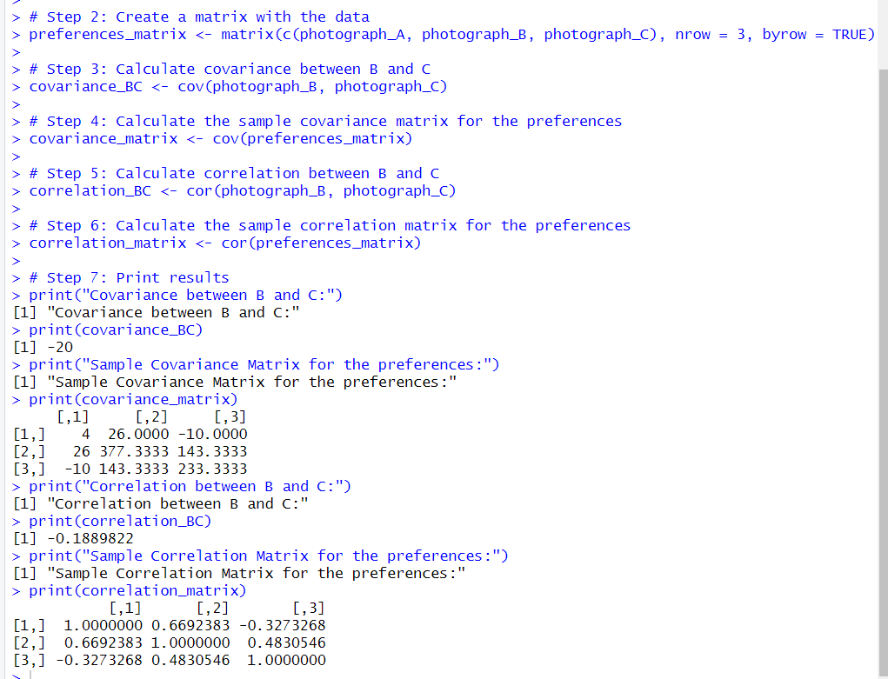

EXPERIMENT NO:02

Code:

**# Step 1: Define the data**

**age_groups <- c("5-6 years", "7-8 years", "9-10 years")**

**photograph_A <- c(18, 2, 20)**

**photograph_B <- c(22, 28, 10)**

**photograph_C <- c(20, 40, 40)**

**# Step 2: Create a matrix with the data**

**preferences_matrix <- matrix(c(photograph_A, photograph_B, photograph_C), nrow = 3, byrow = TRUE)**

**# Step 3: Calculate covariance between B and C**

**covariance_BC <- cov(photograph_B, photograph_C)**

**# Step 4: Calculate the sample covariance matrix for the preferences**

**covariance_matrix <- cov(preferences_matrix)**

**# Step 5: Calculate correlation between B and C**

**correlation_BC <- cor(photograph_B, photograph_C)**

**# Step 6: Calculate the sample correlation matrix for the preferences**

**correlation_matrix <- cor(preferences_matrix)**

**# Step 7: Print results**

**print("Covariance between B and C:")**

**print(covariance_BC)**

**print("Sample Covariance Matrix for the preferences:")**

**print(covariance_matrix)**

**print("Correlation between B and C:")**

**print(correlation_BC)**

**print("Sample Correlation Matrix for the preferences:")**

**print(correlation_matrix)**

OUTPUT:



EXPERIMENT NO:03

Code:

**data("AirPassengers")**

**hist(AirPassengers, breaks = seq(100, 700, by = 100), col = "blue", main=" Histogram for**

**Airpassengers", xlab = "Passenger count", ylab = "Frequency")**

**print(AirPassengers)**

OUTPUT:

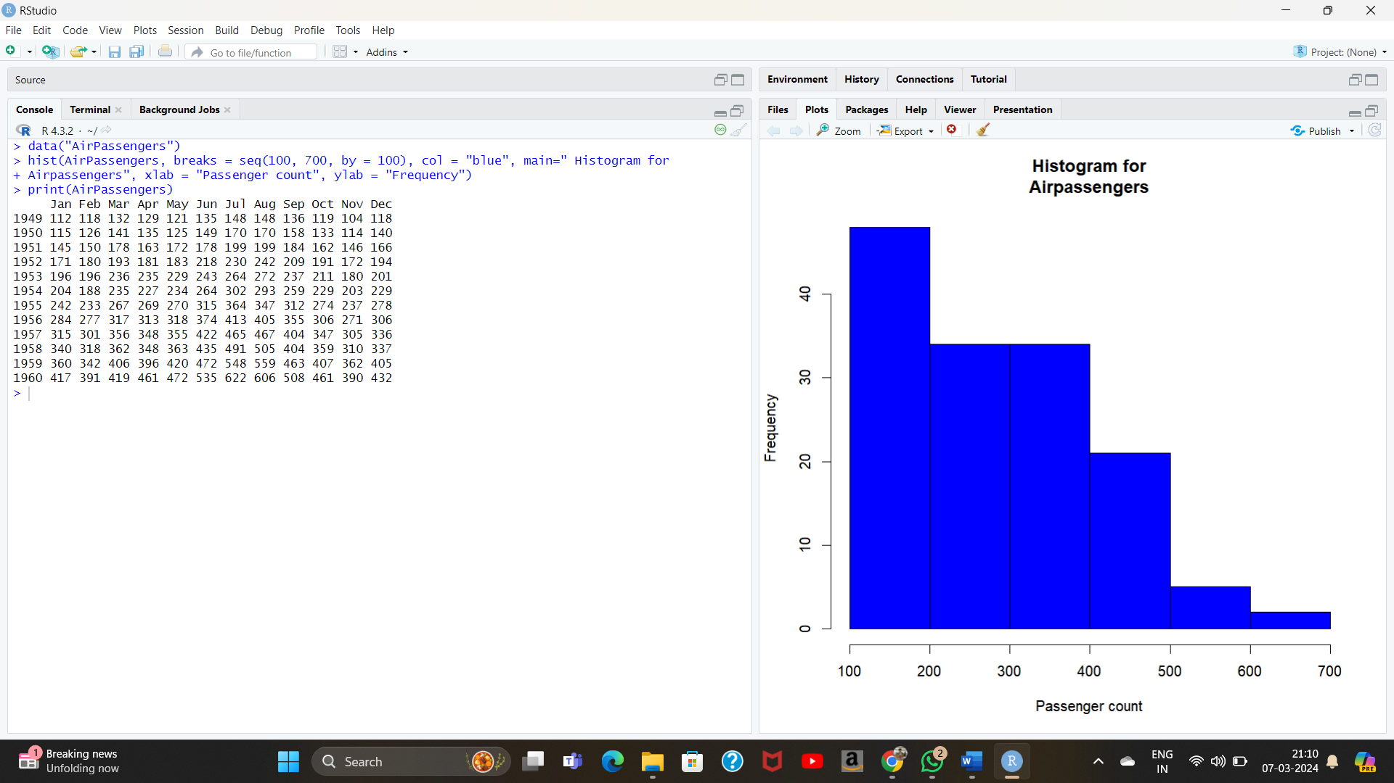

EXPERIMENT NO:04

Code:

**# Load the dataset**

**data(mtcars)**

**# Create an empty plot with the first set of data**

**plot(mtcars$mpg, type = "l", col = "blue", ylim = range(c(mtcars$mpg, mtcars$qsec)),**

**xlab = "Index", ylab = "Value")**

**# Add the second set of data as another line**

**lines(mtcars$qsec, col = "red")**

**# Add a legend**

**legend("topright", legend = c("mpg", "qsec"), col = c("blue", "red"), lty = 1)**

**# Add a title**

**title(main = "Line Chart of mpg and qsec")**

**print(mtcars)**

OUTPUT:

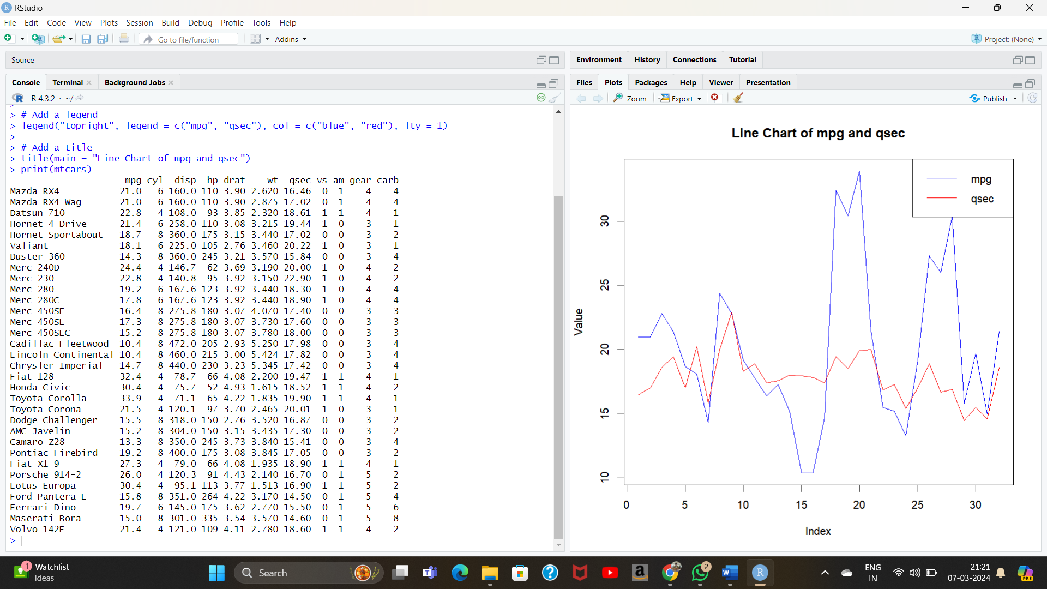

EXPERIMENT NO:05

Code:

**# Load the dataset**

**data(mtcars)**

**# Create a boxplot**

**boxplot(mpg ~ cyl, data = mtcars,**

**xlab = "Number of Cylinders",**

**ylab = "Miles per Gallon",**

**main = "Boxplot of Miles per Gallon by Number of Cylinders")**

**gprint(mtcars)**

OUTPUT:

