AIM:
To perform data inspection, filtering, grouping, aggregation, descriptive statistical analysis, and correlation analysis using Pandas and visualize the results using Matplotlib.
ALGORITHM:
- Import the dataset.
- Display the dataset.
- Check the dataset dimensions and data types.
- Generate a summary of the dataset.
- Filter the data based on the required condition and display the filtered records.
- Sort the data using the required column and display the sorted result.
- Perform statistical analysis by calculating the mean, median, mode, and standard deviation of numerical columns.
- Group the data using the required column and calculate the average values using aggregation.
- Perform correlation analysis between numerical columns.
- Display and interpret the results.

PROGRAM:
import pandas as pd
df = pd.read_csv("231401501.csv")
print(df.head())
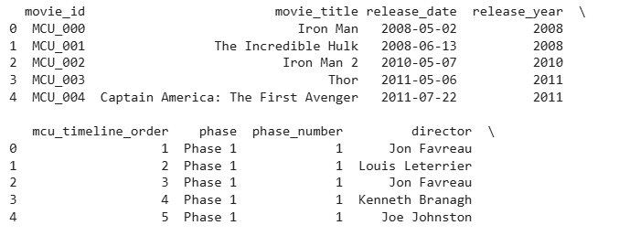
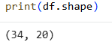

print(df.dtypes)

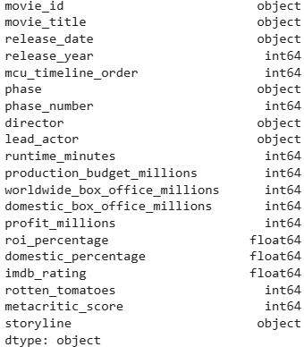
high_box_office = df[df["worldwide_box_office_millions"] > 1000]
print(high_box_office)
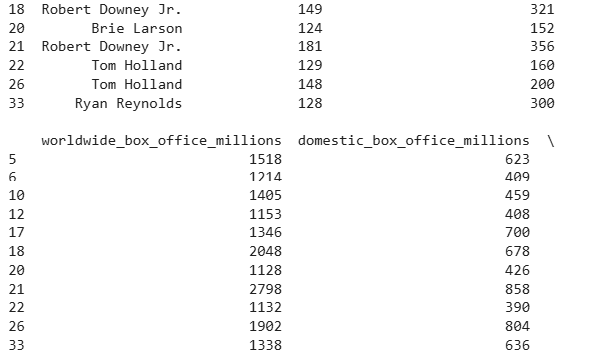
phase_3 = df[df["phase"] == "Phase 3"]
print(phase_3)
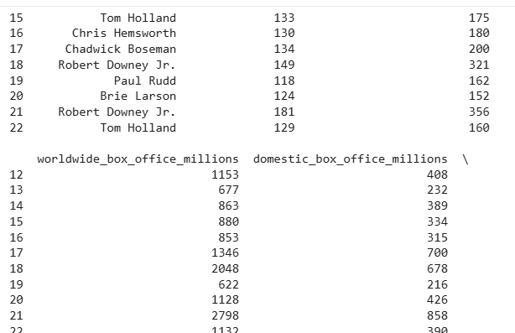
sorted_df = df.sort_values(
by="worldwide_box_office_millions",
ascending=False
)
print(sorted_df)
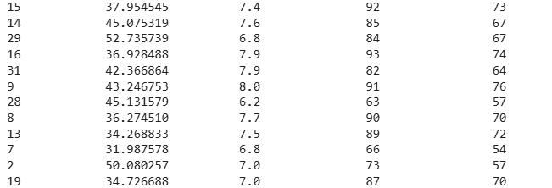
import pandas as pd
import matplotlib.pyplot as plt
sorted_df = df.sort_values(
by="worldwide_box_office_millions",
ascending=False
)
plt.figure(figsize=(12,5))
plt.bar(
range(len(sorted_df)),
sorted_df["worldwide_box_office_millions"]
)
plt.title("Worldwide Box Office Ranking")
plt.xlabel("Movies (Sorted)")
plt.ylabel("Worldwide Box Office (in millions)")
plt.show()

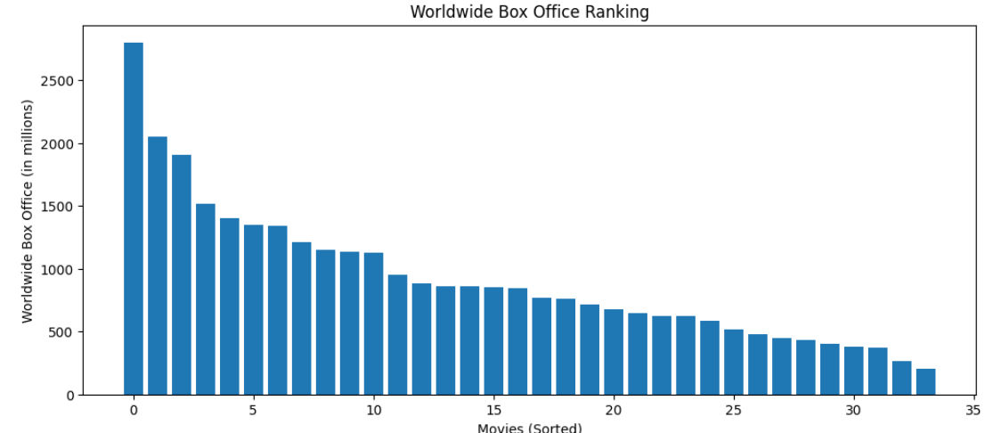
print("Mean =", df["worldwide_box_office_millions"].mean())
print("Median =", df["worldwide_box_office_millions"].median())
print("Mode =", df["worldwide_box_office_millions"].mode())
print("Standard Deviation =", df["worldwide_box_office_millions"].std())
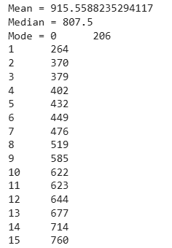

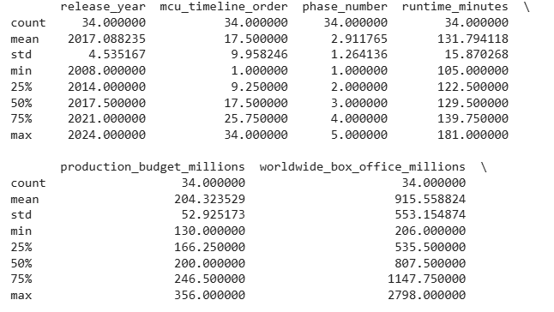

RESULT:
Thus, data inspection, filtering, sorting, descriptive statistical analysis, grouping, aggregation, and correlation analysis were successfully performed using Pandas. The analytical results were visualized and interpreted successfully.

