**TE CMPN A Name : Saravana sundar Nadar Roll no. : 70**

**PID : 192072 SEM : V**

**INTERNET PROGRAMMING - Experiment 3**

**Contact us form** using php with MySQL Database

**AIM:** Develop interactive web pages using PHP with database connectivity MYSQL

**THEORY:**

Details about all main **HTML & CSS** tags used in my webpage:

* **HEAD**
* **<html> :** The <html> tag represents the root of an HTML document.

The <html> tag is the container for all other HTML elements.

* **<meta> :** The <meta> tag defines metadata about an HTML document. Metadata is data (information)

about data. <meta> tags always go inside the <head> element, and are typically used to specify character set, page description, keywords, author of the document, and viewport settings.

* **<link> :** The <link> tag defines the relationship between the current document and an external resource.

The <link> tag is most often used to link to external style sheets.

The <link> element is an empty element, it contains attributes only.

* **<title> :** The <title> tag defines the title of the document. The title must be text-only, and it is shown in the browser's title bar or in the page's tab.
* **<head> :** The <head> element is a container for metadata (data about data) and is placed between the <html> tag and the <body> tag.

The following elements can go inside the <head> element:

<title> (required in every HTML document) <style> <base> <link> <meta> <script> <noscript>

* **<style> :** Used for adding a internal styling element.
* **BODY**
* **<header> :** The <header> element represents a container for introductory content or a set of navigational links.

A <header> element typically contains:

* one or more heading elements (<h1> - <h6>)
* logo or icon
* authorship information
* **<h1> - <h6> :** The <h1> to <h6> tags are used to define HTML headings.

<h1> defines the most important heading. <h6> defines the least important heading.

**Note:** Only use one <h1> per page - this should represent the main heading/subject for the whole page. Also, do not skip heading levels - start with <h1>, then use <h2>, and so on.

* **<div> :** The <div> tag defines a division or a section in an HTML document.

The <div> tag is used as a container for HTML elements - which is then styled with CSS or manipulated with JavaScript.

The <div> tag is easily styled by using the class or id attribute.

Any sort of content can be put inside the <div> tag!

* **<p> :** The <p> tag defines a paragraph.

**CODE :**

File Structure :

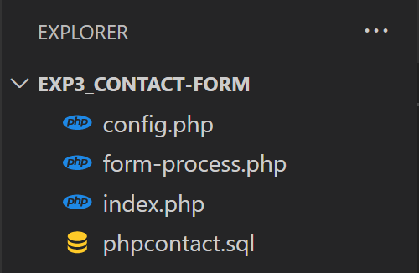

* **config.php**

<?php

     define("DB_HOST","localhost");

     define("DB_USER","root");

     define("DB_PASSWORD","");

     define("DB_NAME","phpcontact");

   $mysqli = new mysqli(DB_HOST,DB_USER, DB_PASSWORD,DB_NAME);

?>

* **form-process.php**

<?php

include("config.php");

extract($_POST);

$sql = "INSERT INTO `phpcontact`(`firstname`, `lastname`, `phone`, `email`, `message`) VALUES ('".$firstname."','".$lastname."',".$phone.",'".$email."','".$message."')";

$result = $mysqli->query($sql);

if(!$result){

    die("Couldn't enter data: ".$mysqli->error);

}

echo "Thank You For Contacting Us! ";

$mysqli->close();

?>

* **index.php**

<html>

<head>

    <title>Contact us form</title>

    <link rel="stylesheet" href="https://stackpath.bootstrapcdn.com/bootstrap/4.3.1/css/bootstrap.min.css">

    <style>

        * {

           background-color: #F3E0FF;

          }

        .content {

             background-color: #F3E0FF;

            }

    </style>

</head>

<body class="content">

    <div class="container">

        <h2>Contact Form</h2>

        <p> Send us a message!</p>

        <form action="form-process.php" method="POST">

            <div class="form-group">

                <label for="firstname">First Name</label>

                <input type="text" name="firstname" id="firstname" class="form-control" required>

            </div>

            <div class="form-group">

                <label for="lastname">Last Name</label>

                <input type="text" name="lastname" id="lastname" class="form-control" required>

            </div>

            <div class="form-group">

                <label for="phone">Phone</label>

                <input type="tel" name="phone" id="phone" class="form-control" required>

            </div>

            <div class="form-group">

                <label for="email">Email</label>

                <input type="email" name="email" id="email" class="form-control" required>

            </div>

            <div class="form-group">

                <label for="message">Message</label>

                <input type="text" name="message" id="message" class="form-control" required>

            </div>

            <div class="form-group">

                <br>

        <button class="btn btn-danger" type="reset">Reset</button>

        <button class="btn btn-success" type="submit">Submit</button>

    </div>

        </form>

    </div>

</body>

</html>

**OUTPUT:**

* **Filling the contact form.**

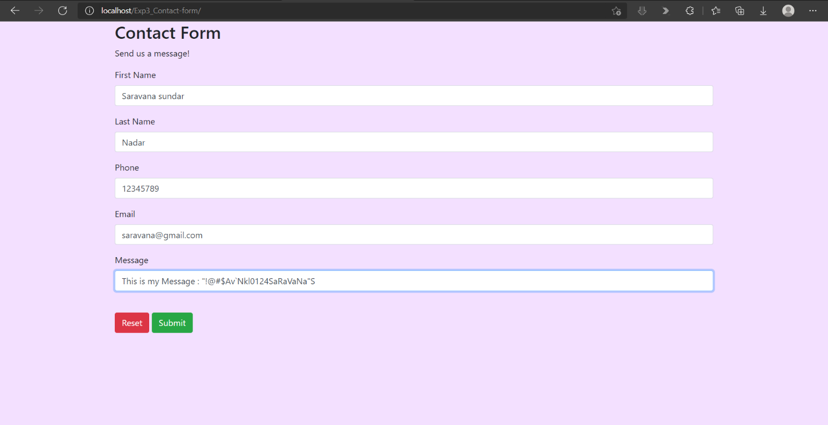

* **Confirmation Message of Successfully Submitted.**

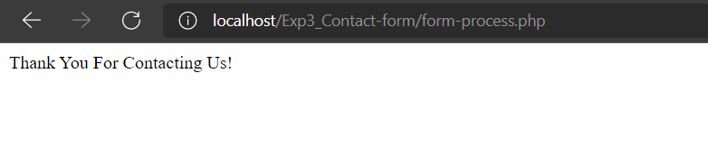

* **Record seen on Database.**



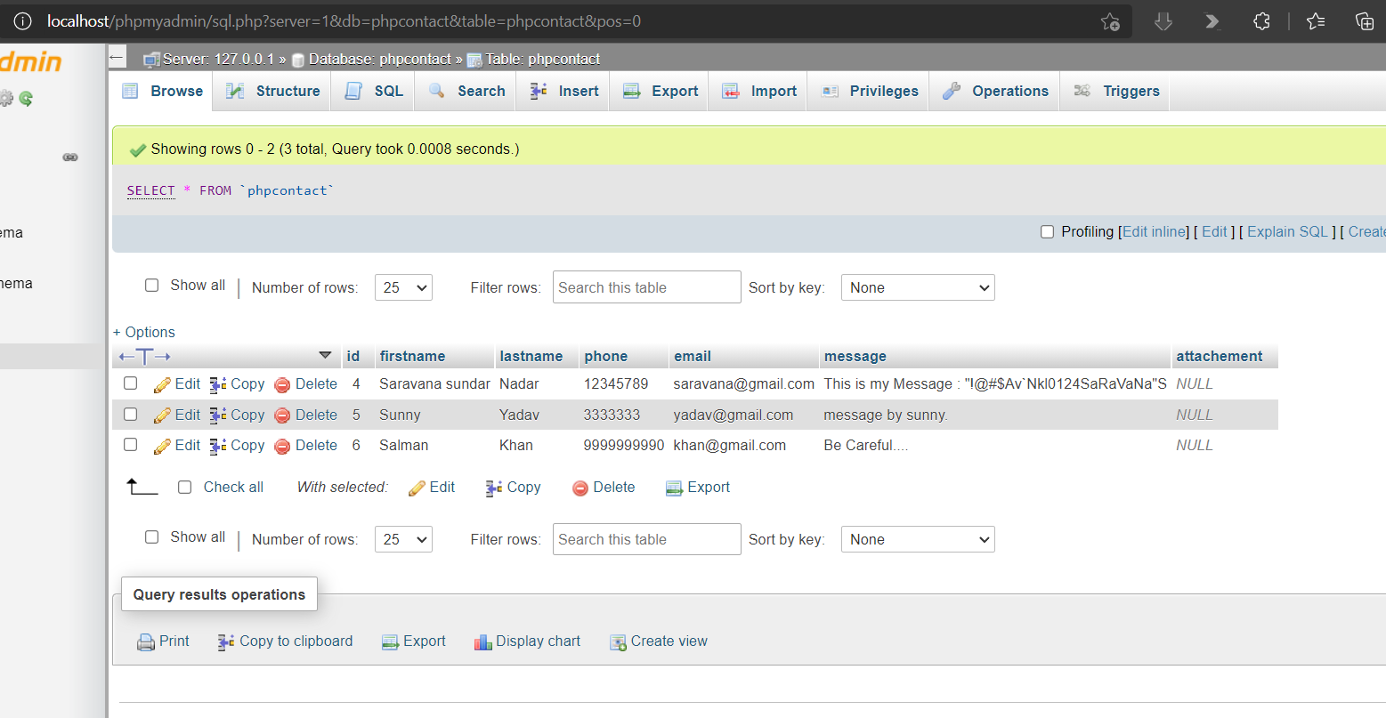

**CONCLUSION: :** Hence , by this experiment I have developed a simple **Contact Us form** in **PHP** and also configured the **MySQL Database conectivity** to store the messages with other details and meta data.