**TE CMPN A Name : Saravana sundar Nadar Roll no. : 70**

**PID : 192072 SEM : V**

**INTERNET PROGRAMMING - Experiment 4**

**Algorithm Visualizer Frontend Using React JS**

**AIM:** Create Responsive Animated Website using React js.

**IMPLEMENTATION:**

**File Stucture:**

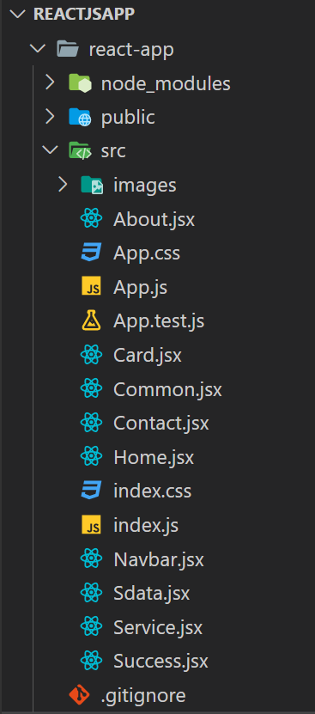

**CODE:**

* **App.js**

import React from "react";

import "../node_modules/bootstrap/dist/css/bootstrap.min.css";

import "../node_modules/bootstrap/dist/js/bootstrap.bundle.js";

import "./index.css";

import Navbar from "./Navbar";

import Home from "./Home";

import About from "./About";

import Service from "./Service";

import Contact from "./Contact";

import Success from "./Success";

import {Switch, Route, Redirect} from 'react-router-dom';

const App = () => {

  return(

    <>

      <Navbar />

      <Switch>

        <Route exact path="/" component={Home} />

        <Route exact path="/about" component={About} />

        <Route exact path="/service" component={Service} />

        <Route exact path="/contact" component={Contact} />

        <Route exact path="/success" component={Success} />

        <Redirect to="/"/>

      </Switch>

    </>

  )

};

export default App;

* **index.js**

import React from "react";

import ReactDOM from "react-dom";

import "./index.css";

import App from "./App";

import { BrowserRouter } from "react-router-dom";

ReactDOM.render(

  <>

    <BrowserRouter>

      <App />

    </BrowserRouter>

  </>,

  document.getElementById("root")

);

* **index.css**

@import

url('https://fonts.googleapis.com/css2?family=Muli:wght@200;300;400;500;600;700;800;90

&display=swap');

@import url('https://fonts.googleapis.com/css2?family=Poppins:wght@300;400;500;600;700;800;900&display=swap');

*,

*::before,

*::after {

    box-sizing: border-box;

}

body {

    font-family: 'Poppins';

}

.nav-link {

    font-size: 1.1em;

}

.nav-link {

    transition: 0.3s ease all !important;

}

.nav-link.menu_active {

    font-weight: bold;

    border-bottom: 1px solid coral;

    transition: 0.3s ease all !important;

}

a.btn-get-started {

    display: inline-block;

    text-decoration: none;

    color: #333;

    padding: 0.4em 0.9em;

    margin-top: 1em;

    border-radius: 30px;

    background: transparent;

    border: 1px solid #333;

    text-transform: uppercase;

    font: 400 1em/1.5em 'Poppins';

}

#header {

    width: 100%;

    height: 79vh;

}

#header h2 {

    display: #626262;

    font-size: 1.2em;

    margin-bottom: 1em;

    font-weight: normal;

}

#header h1 .brand-name {

    color: darkslateblue;

}

.navbar-brand>[alt=logo] {

    width: 60px;

    height: 60px;

}

* **Home.jsx**

import React from "react";

import Web from "./images/myImg.png";

import { NavLink } from "react-router-dom";

import Common from "./Common";

const Home = () => {

  return (

    <>

      <Common

        name="Visualize Algorithms with"

        img={Web}

        btnName="Algorithms"

        visited="./service"

      />

    </>

  );

};

export default Home;

* **Common.jsx**

import React from "react";

import Web from './images/myImg.png';

import {NavLink} from 'react-router-dom';

const Common = (props) => {

  return (

    <>

      <section id="header" className="mt-5">

        <div className="container-fluid nav_bg">

          <div className="row">

            <div className="col-md-10 mx-auto">

                <div className="row">

                    <div className="col-md-6 pt-5 pt-lg-0 order-2 order-lg-1

                     align-self-center">

                        <h1>

                            {props.name} <strong className="brand-name">Algorithm Visualizer</strong>

                        </h1>

                        <h2 className="my-3">

                        <del>MEMORISE</del> VISUALIZE Algorithms!

                        </h2>

                        <div className="mt-3">

                            <NavLink to={props.visited} className="btn-get-started">{props.btnName}</NavLink>

                        </div>

                    </div>

                    <div className="col-md-6 order-1 order-lg-2 header-img">

                        <img src={props.img} className="img-fluid" alt="home img"/>

                    </div>

                </div>

            </div>

          </div>

        </div>

      </section>

    </>

  );

};

export default Common;

* **Navbar.jsx**

import React from 'react';

import Logo from './images/logo.png';

import {NavLink} from 'react-router-dom';

const Navbar = ()=> {

    return (

    <>

    <div className="container-fluid nav_bg">

        <div className="row">

            <div className="col-md-10 mx-auto">

                <nav className="navbar navbar-expand-lg navbar-light ">

                    <div className="container-fluid">

                        <NavLink className="navbar-brand" to="/">

                            <img src={Logo} className="img-fluid" alt="logo"/>

                        </NavLink>

                         <NavLink className="navbar-brand" to="/">

                           <h2>Algorithm Visualizer</h2>

                        </NavLink>

                        <button className="navbar-toggler" type="button" data-bs-toggle="collapse" data-bs-target="#navbarSupportedContent" aria-controls="navbarSupportedContent" aria-expanded="false" aria-label="Toggle navigation">

                        <span className="navbar-toggler-icon"></span>

                        </button>

                        <div className="collapse navbar-collapse" id="navbarSupportedContent">

                        <ul className="navbar-nav mb-2 mb-lg-0" style={{marginLeft: "auto",}}>

                            <li className="nav-item">

                            <NavLink activeClassName="menu_active" className="nav-link" exact to="/">Home</NavLink>

                            </li>

                            <li className="nav-item">

                            <NavLink activeClassName="menu_active" className="nav-link" exact to="/service">Algorithms</NavLink>

                            </li>

                            <li className="nav-item">

                            <NavLink activeClassName="menu_active" className="nav-link" exact to="/about">Visualize</NavLink>

                            </li>

                            <li className="nav-item">

                            <NavLink activeClassName="menu_active" className="nav-link" exact to="/contact">Contact us</NavLink>

                            </li>

                        </ul>

                        </div>

                    </div>

                </nav>

            </div>

        </div>

    </div>

    </>

    )

}

export default Navbar;

* **About.jsx**

import React from "react";

import Web from './images/business.png';

import {NavLink} from 'react-router-dom';

import Common from "./Common"

const About = () => {

  return (

    <>

      <Common

        name="Visualizer Comming Soon"

        img={Web}

        btnName="Contact Us"

        visited="./contact"

      />

    </>

  );

};

export default About;

* **Services.jsx**

import React from "react";

import Card from "./Card";

import Sdata from "./Sdata";

const Service = () => {

  return (

    <>

      <div className="my-5">

        <h1 className="text-center">Algorithms</h1>

        <br></br>

        <div className="container-fluid nav_bg mb-5">

          <div className="row">

            <div className="col-md-10 mx-auto">

              <div className="row g-3">

                {

                  Sdata.map((val, index)=>{

                      return <Card key={index} imgsrc={val.imgsrc} title={val.title} />

                  })

                }

              </div>

            </div>

          </div>

        </div>

      </div>

    </>

  );

};

export default Service;

* **Sdata.jsx**

import Bubble from "./images/Bubble.gif";

import Insertion from "./images/Insertion.gif";

import Merge from "./images/Merge.gif";

import Binary from "./images/Binary.gif";

import BFS from "./images/bfs.gif";

import DFS from "./images/dfs.gif";

const Sdata = [

    {

        imgsrc : Bubble,

        title : "Bubble Sort"

    },

    {

        imgsrc : Insertion,

        title : "Insertion Sort"

    },

    {

        imgsrc : Merge,

        title : "Merge Sort"

    },

    {

        imgsrc : Binary,

        title : "Binary Search"

    },

    {

        imgsrc : BFS,

        title : "BFS (Breadth First Search)"

    },

    {

        imgsrc : DFS,

        title : "DFS (Depth First Search)"

    }

]

export default Sdata;

* **Contact.jsx**

import React, { useState  } from "react";

import { useHistory } from "react-router-dom";

const Contact = () => {

  let history = useHistory();

  // for name

  const [name, setName] = useState("");

  const nameEvent = (event) => {

    setName(event.target.value)

  };

  // for mobile

  const [mobile, setMobile] = useState("");

  const mobEvent = (event) => {

    setMobile(event.target.value)

  };

  // for mail

  const [mail, setMail] = useState("");

  const mailEvent = (event) => {

    setMail(event.target.value);

  };

  const submitForm = (e)=> {

    e.preventDefault();

    history.push(`/success`);

  }

  return (

    <>

      <div className="my-5">

        <h1 className="text-center">Contact Us</h1>

        <div className="container-fluid contact_div mb-5">

          <div className="row">

            <div className="col-md-7 mx-auto">

              <form action="" onSubmit={submitForm}>

                <div className="mb-3">

                  <label for="exampleInputEmail1" className="form-label">

                    Full Name

                  </label>

                  <input

                    type="text"

                    onChange={nameEvent}

                    className="form-control"

                    id="exampleInputEmail1"

                    placeholder="Enter your full name"

                    value={name}

                    required

                  />

                </div>

                <div className="mb-3">

                  <label for="exampleInputEmail1" className="form-label">

                    Phon No

                  </label>

                  <input

                    type="number"

                    onChange={mobEvent}

                    className="form-control"

                    id="exampleInputEmail1"

                    placeholder="Mobile Number"

                    value={mobile}

                    required

                  />

                </div>

                <div className="mb-3">

                  <label for="exampleInputEmail1" className="form-label">

                    Email

                  </label>

                  <input

                    type="email"

                    onChange={mailEvent}

                    className="form-control"

                    id="exampleInputEmail1"

                    placeholder="Email Address"

                    value={mail}

                    required

                  />

                </div>

                {/* <div className="mb-3">

                  <label for="exampleInputEmail1" className="form-label">Email</label>

                  <textarea type="email"rows="4" className="form-control" id="exampleInputEmail1" placeholder="Email Address" required ></textarea>

                </div> */}

                <button type="submit" className="btn btn-primary">

                  Submit

                </button>

              </form>

            </div>

          </div>

        </div>

      </div>

    </>

  );

};

export default Contact;

* **Card.jsx**

import React from "react";

import { NavLink } from "react-router-dom";

import web from "./images/gallery-1.jpg";

const Card = (props) => {

  return (

    <>

      <div className="col-md-4 col-10 mx-auto">

        <div className="card">

          <img src={props.imgsrc} className="card-img-top" title={props.title} alt={props.title} />

          <div className="card-body">

            <h5 className="card-title">{props.title}</h5>

            <p className="card-text">

              Algorithm's Description in a Simple and Understandable Manner...

            </p>

            <NavLink to="#" className="btn btn-primary">

              Visualize Now

            </NavLink>

          </div>

        </div>

      </div>

    </>

  );

};

export default Card;

* **Success.jsx**

import React from "react";

const Success = () => {

  return (

    <>

      <div className="my-5">

        <h1 className="text-center">Thank You For contacting Us :)</h1>

      </div>

    </>

  );

};

export default Success;

**OUTPUT:**

* **Creating React app**

**npx create-react-app <app-name>**

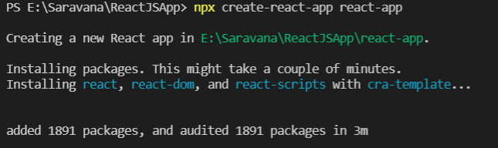

* **npm start**

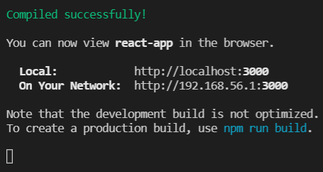

**WEBSITE:**

* **Home**

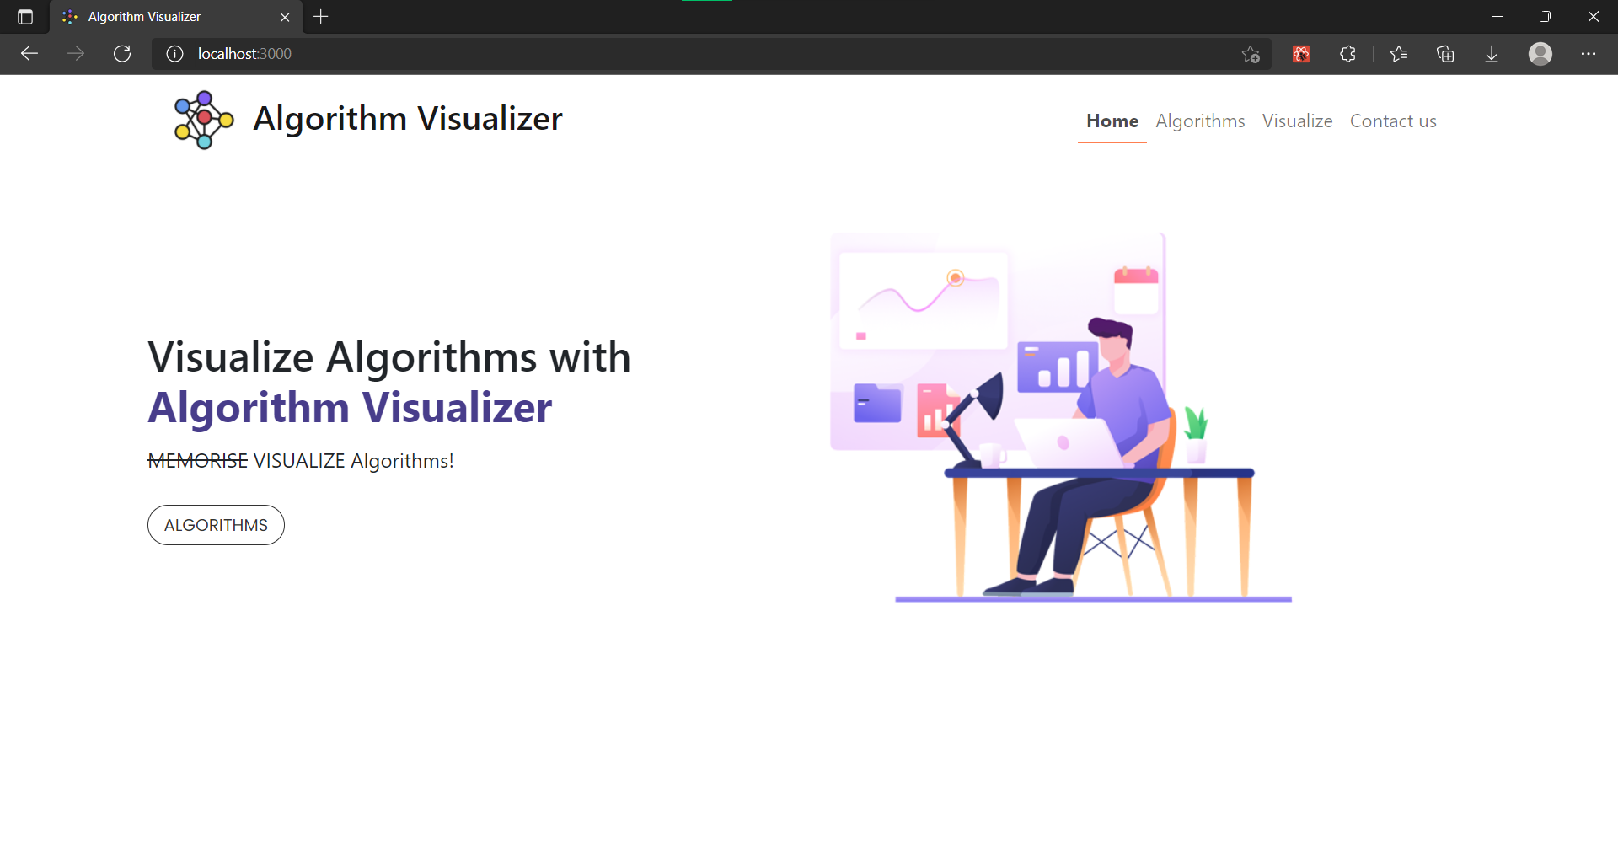

* **Algorithms**

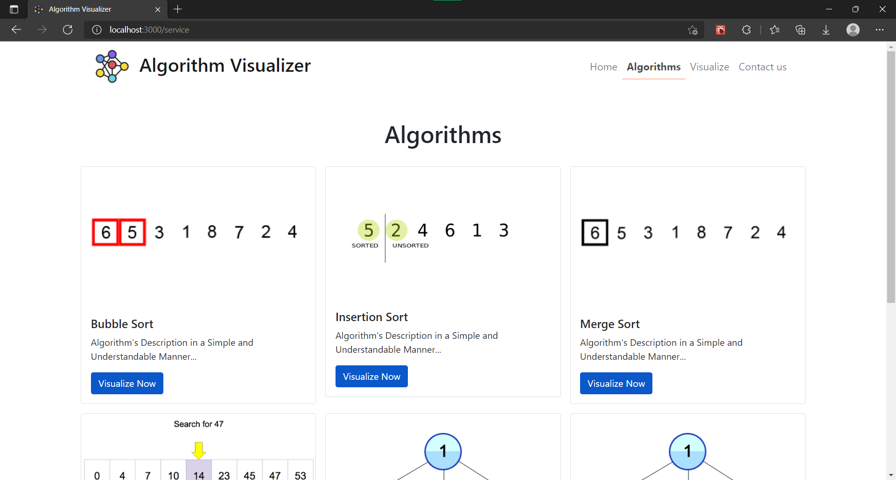

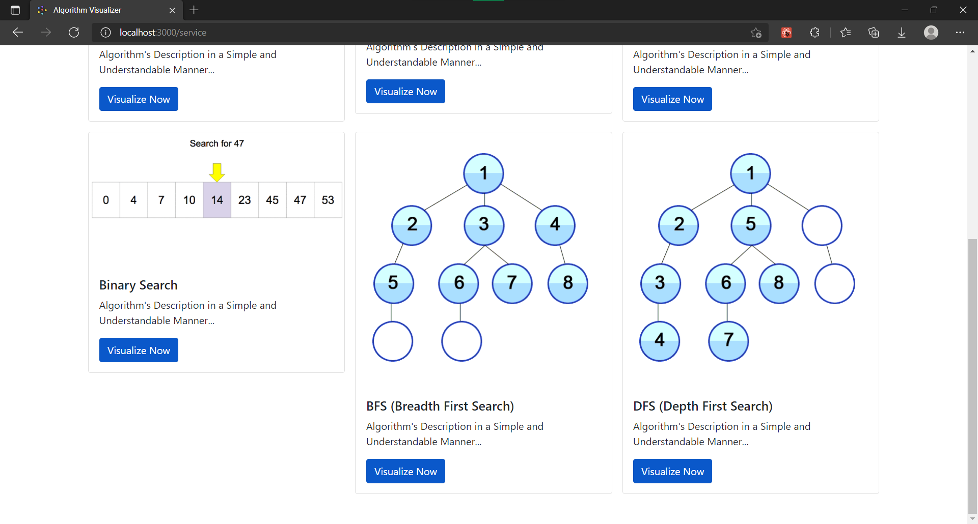

* **Visualize**

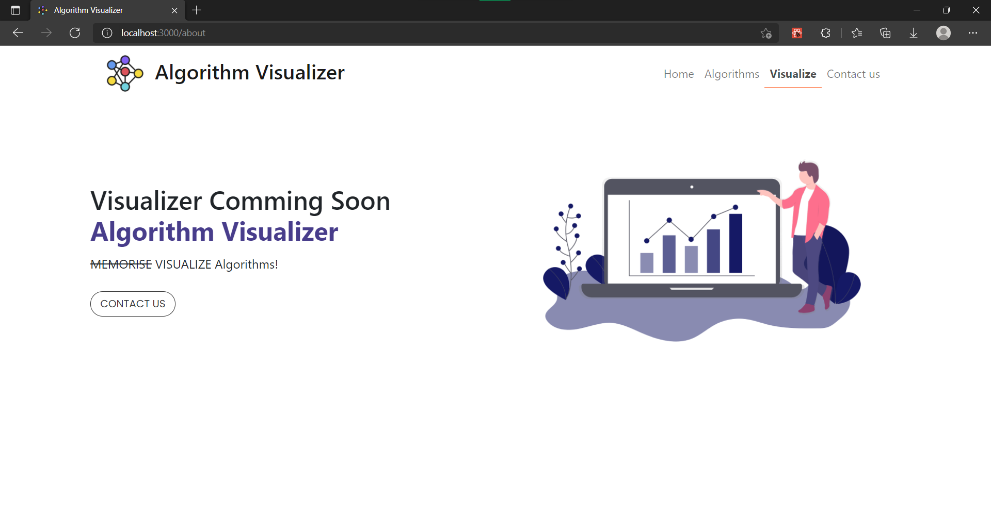

* **Contact us**

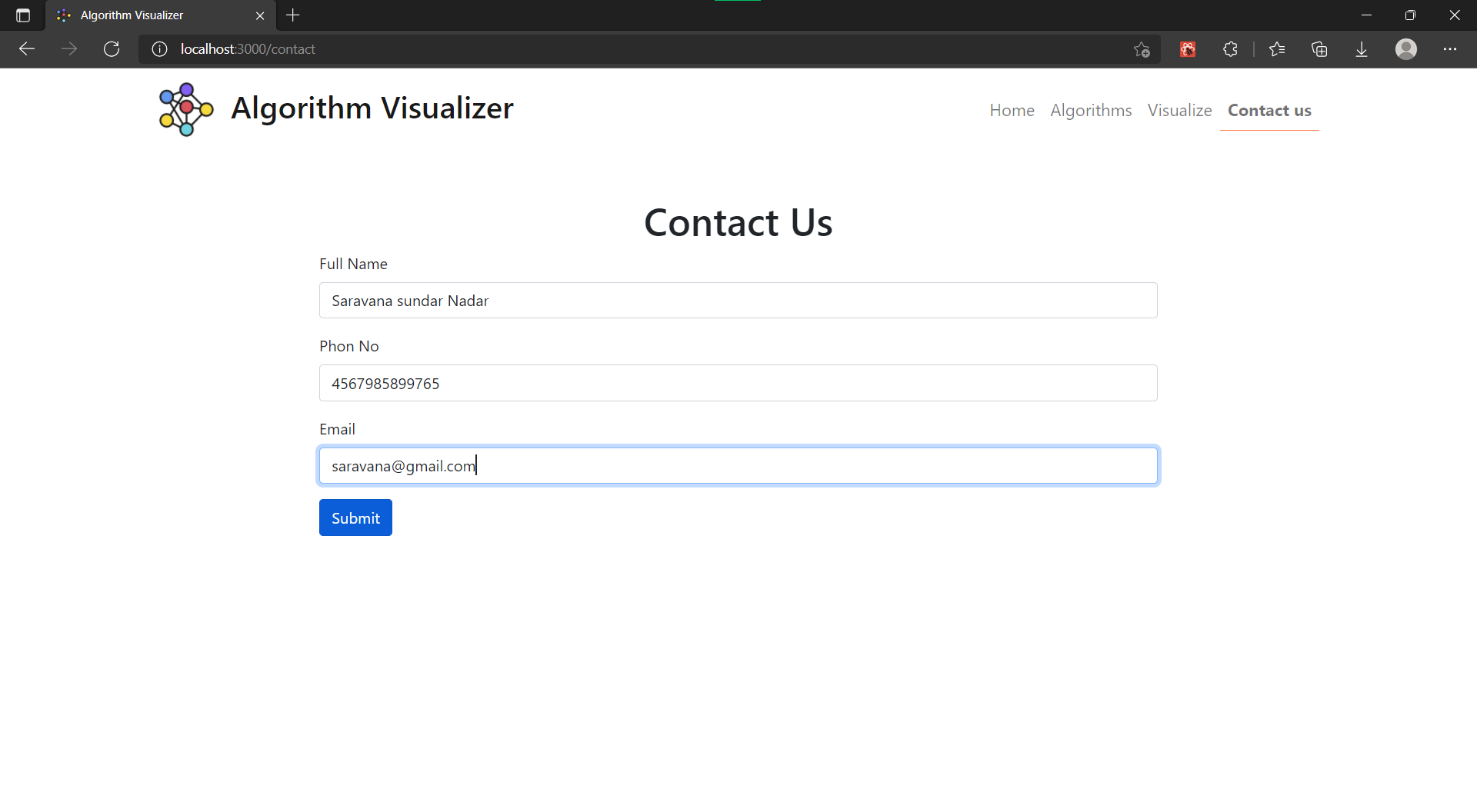

* **Successful Message**

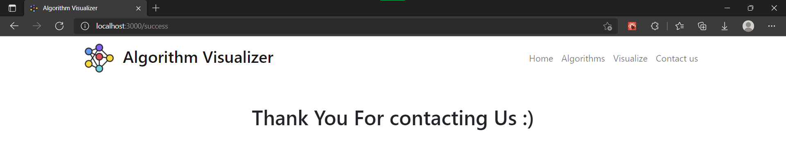

**CONCLUSION:**

In this experiment, we have learnt to create a react app with the help of the create-react-app tool in ReactJS , we have also implemented other concepts in this experiment such as JavaScript, JavaScriptXML(JSX), BootStrap, React DOM and many more which makes up a complete frontend Devalopment. The Website I made has a frontend for a Algorithm Visualization Website without the Visualizer it has a clean and fluid UI it is a responsive Website.