**TE CMPN A Name : Saravana sundar Nadar Roll no. : 70**

**PID : 192072 SEM : V**

**INTERNET PROGRAMMING - Experiment 2**

ROCK-PAPER-SCISSORS

**AIM:** Create Rock-Paper-Scissor game using JavaScript (Roll No: **51-71**)

**THEORY:**

Details about all main **HTML & CSS** tags used in my webpage:

* **HEAD**
* **<html> :** The <html> tag represents the root of an HTML document.

The <html> tag is the container for all other HTML elements.

* **<meta> :** The <meta> tag defines metadata about an HTML document. Metadata is data (information)

about data. <meta> tags always go inside the <head> element, and are typically used to specify character set, page description, keywords, author of the document, and viewport settings.

* **<link> :** The <link> tag defines the relationship between the current document and an external resource.

The <link> tag is most often used to link to external style sheets.

The <link> element is an empty element, it contains attributes only.

* **<title> :** The <title> tag defines the title of the document. The title must be text-only, and it is shown in the browser's title bar or in the page's tab.
* **<head> :** The <head> element is a container for metadata (data about data) and is placed between the <html> tag and the <body> tag.

The following elements can go inside the <head> element:

<title> (required in every HTML document) <style> <base> <link> <meta> <script> <noscript>

* **<style> :** Used for adding a internal styling element.
* **BODY**
* **<header> :** The <header> element represents a container for introductory content or a set of navigational links.

A <header> element typically contains:

* one or more heading elements (<h1> - <h6>)
* logo or icon
* authorship information
* **<h1> - <h6> :** The <h1> to <h6> tags are used to define HTML headings.

<h1> defines the most important heading. <h6> defines the least important heading.

**Note:** Only use one <h1> per page - this should represent the main heading/subject for the whole page. Also, do not skip heading levels - start with <h1>, then use <h2>, and so on.

* **<div> :** The <div> tag defines a division or a section in an HTML document.

The <div> tag is used as a container for HTML elements - which is then styled with CSS or manipulated with JavaScript.

The <div> tag is easily styled by using the class or id attribute.

Any sort of content can be put inside the <div> tag!

* **<nav> :** The <nav> tag defines a set of navigation links.

Notice that NOT all links of a document should be inside a <nav> element. The <nav> element is intended only for major block of navigation links.

* **<ul> , <li> :** The <ul> tag defines an unordered (bulleted) list.

The <li> tag defines a list item.

* **<p> :** The <p> tag defines a paragraph.

**CODE :**

File Structure :

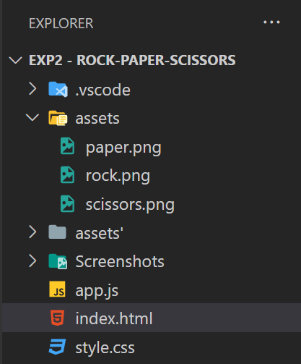

* **Index.html**

<!DOCTYPE html>

<html lang="en">

  <head>

    <meta charset="UTF-8" />

    <meta name="viewport" content="width=device-width, initial-scale=1.0" />

    <meta http-equiv="X-UA-Compatible" content="ie=edge" />

    <link rel="stylesheet" href="./style.css" />

    <title>Rock paper and scissors</title>

  </head>

  <body>

    <section class="game">

      <div class="score">

        <div class="player-score">

          <h2>Player</h2>

          <p>0</p>

        </div>

        <div class="computer-score">

          <h2>Computer</h2>

          <p>0</p>

        </div>

      </div>

      <div class="intro">

        <h1>Rock Paper Scissors</h1>

        <button>Let's Play</button>

      </div>

      <div class="match fadeOut">

        <h2 class="winner">Choose your option</h2>

        <div class="hands">

          <img class="player-hand" src="./assets/rock.png" alt="" />

          <img class="computer-hand" src="./assets/rock.png" alt="" />

        </div>

        <div class="options">

          <button class="rock">rock</button>

          <button class="paper">paper</button>

          <button class="scissors">scissors</button>

        </div>

      </div>

    </section>

    <script src="app.js"></script>

  </body>

</html>

* **style.css**

* {

  margin: 0;

  padding: 0;

  box-sizing: border-box;

}

section {

  height: 100vh;

  background-color: rgb(227, 248, 219);

  font-family: sans-serif;

}

.score {

  color: rgb(15, 59, 4);

  height: 20vh;

  display: flex;

  justify-content: space-around;

  align-items: center;

}

.score h2 {

  font-size: 30px;

}

.score p {

  text-align: center;

  padding: 10px;

  font-size: 25px;

}

.intro {

  color: rgb(15, 59, 4);

  height: 50vh;

  display: flex;

  flex-direction: column;

  align-items: center;

  justify-content: space-around;

  transition: opacity 0.5s ease;

}

.intro h1 {

  font-size: 50px;

}

.intro button,

.match button {

  width: 150px;

  height: 50px;

  background: none;

  border: none;

  color: rgb(224, 224, 224);

  font-size: 20px;

  background: rgb(45, 117, 96);

  border-radius: 3px;

  cursor: pointer;

}

.intro button:hover {

  background-color: #e0c9a6;

  color: rgb(15, 59, 4);

}

.match {

  position: absolute;

  top: 50%;

  left: 50%;

  transform: translate(-50%, -50%);

  transition: opacity 0.5s ease 0.5s;

}

.winner {

  color: rgb(15, 59, 4);

  text-align: center;

  font-size: 50px;

}

.hands,

.options {

  display: flex;

  justify-content: space-around;

  align-items: center;

}

.rock:hover {

  background-color: #5a4d41;

}

.paper:hover {

  background-color: #e0c9a6;

  color: rgb(15, 59, 4);

}

.scissors:hover {

  background-color: #c0c0c0;

  color: rgb(15, 59, 4);

}

.player-hand {

  transform: rotateY(180deg);

}

div.fadeOut {

  opacity: 0;

  pointer-events: none;

}

div.fadeIn {

  opacity: 1;

  pointer-events: all;

}

@keyframes shakePlayer {

  0% {

    transform: rotateY(180deg) translateY(0px);

  }

  15% {

    transform: rotateY(180deg) translateY(-50px);

  }

  25% {

    transform: rotateY(180deg) translateY(0px);

  }

  35% {

    transform: rotateY(180deg) translateY(-50px);

  }

  50% {

    transform: rotateY(180deg) translateY(0px);

  }

  65% {

    transform: rotateY(180deg) translateY(-50px);

  }

  75% {

    transform: rotateY(180deg) translateY(0px);

  }

  85% {

    transform: rotateY(180deg) translateY(-50px);

  }

  100% {

    transform: rotateY(180deg) translateY(0px);

  }

}

@keyframes shakeComputer {

  0% {

    transform: translateY(0px);

  }

  15% {

    transform: translateY(-50px);

  }

  25% {

    transform: translateY(0px);

  }

  35% {

    transform: translateY(-50px);

  }

  50% {

    transform: translateY(0px);

  }

  65% {

    transform: translateY(-50px);

  }

  75% {

    transform: translateY(0px);

  }

  85% {

    transform: translateY(-50px);

  }

  100% {

    transform: translateY(0px);

  }

}

* **app.js**

const game = () => {

  let pScore = 0;

  let cScore = 0;

  //Start the Game

  const startGame = () => {

    const playBtn = document.querySelector(".intro button");

    const introScreen = document.querySelector(".intro");

    const match = document.querySelector(".match");

    playBtn.addEventListener("click", () => {

      introScreen.classList.add("fadeOut");

      match.classList.add("fadeIn");

    });

  };

  //Play Match

  const playMatch = () => {

    const options = document.querySelectorAll(".options button");

    const playerHand = document.querySelector(".player-hand");

    const computerHand = document.querySelector(".computer-hand");

    const hands = document.querySelectorAll(".hands img");

    hands.forEach(hand => {

      hand.addEventListener("animationend", function() {

        this.style.animation = "";

      });

    });

    //Computer Options

    const computerOptions = ["rock", "paper", "scissors"];

    options.forEach(option => {

      option.addEventListener("click", function() {

        //Computer Choice

        const computerNumber = Math.floor(Math.random() * 3);

        const computerChoice = computerOptions[computerNumber];

        setTimeout(() => {

          //Here is where we call compare hands

          compareHands(this.textContent, computerChoice);

          //Update Images

          playerHand.src = `./assets/${this.textContent}.png`;

          computerHand.src = `./assets/${computerChoice}.png`;

        }, 2000);

        //Animation

        playerHand.style.animation = "shakePlayer 2s ease";

        computerHand.style.animation = "shakeComputer 2s ease";

      });

    });

  };

  const updateScore = () => {

    const playerScore = document.querySelector(".player-score p");

    const computerScore = document.querySelector(".computer-score p");

    playerScore.textContent = pScore;

    computerScore.textContent = cScore;

  };

  const compareHands = (playerChoice, computerChoice) => {

    //Update Text

    const winner = document.querySelector(".winner");

    //Checking for a tie

    if (playerChoice === computerChoice) {

      winner.textContent = "It is a tie";

      return;

    }

    //Check for Rock

    if (playerChoice === "rock") {

      if (computerChoice === "scissors") {

        winner.textContent = "Player Wins";

        pScore++;

        updateScore();

        return;

      } else {

        winner.textContent = "Computer Wins";

        cScore++;

        updateScore();

        return;

      }

    }

    //Check for Paper

    if (playerChoice === "paper") {

      if (computerChoice === "scissors") {

        winner.textContent = "Computer Wins";

        cScore++;

        updateScore();

        return;

      } else {

        winner.textContent = "Player Wins";

        pScore++;

        updateScore();

        return;

      }

    }

    //Check for Scissors

    if (playerChoice === "scissors") {

      if (computerChoice === "rock") {

        winner.textContent = "Computer Wins";

        cScore++;

        updateScore();

        return;

      } else {

        winner.textContent = "Player Wins";

        pScore++;

        updateScore();

        return;

      }

    }

  };

  //Is call all the inner function

  startGame();

  playMatch();

};

//start the game function

game();

**OUTPUT :**

* **Home**

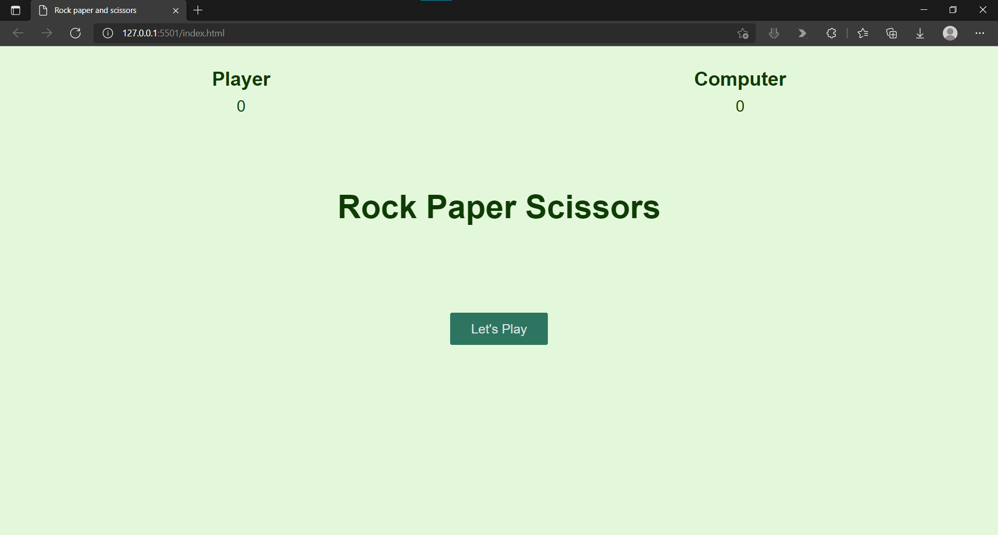

* **Game**

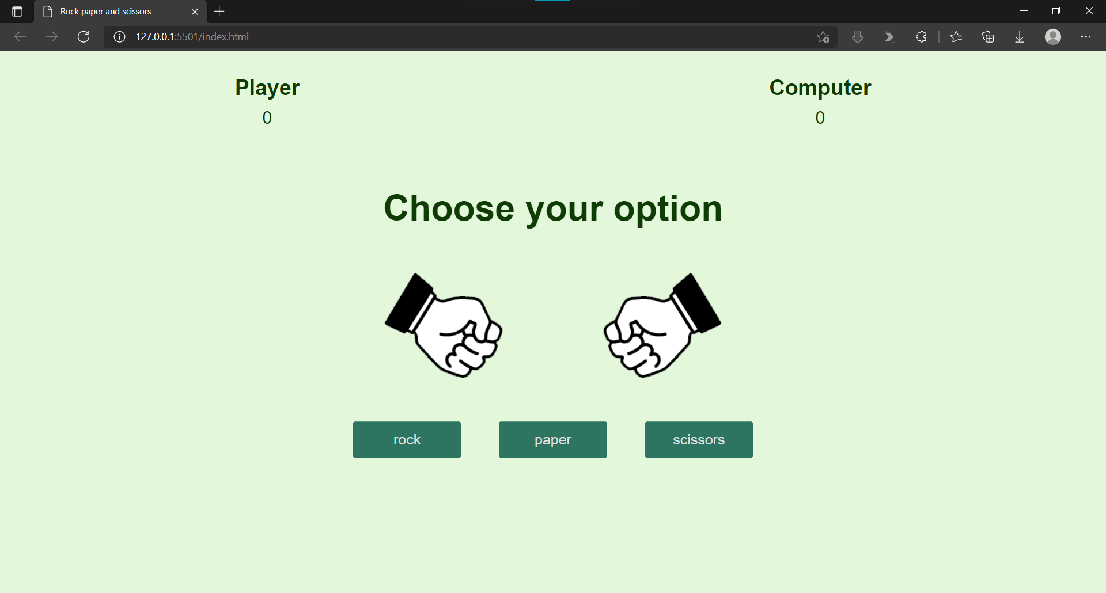

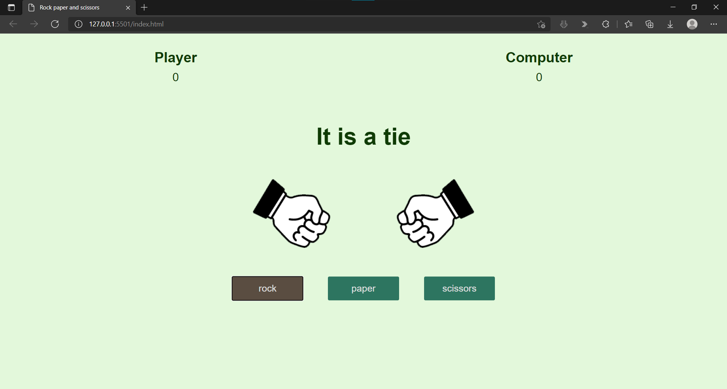

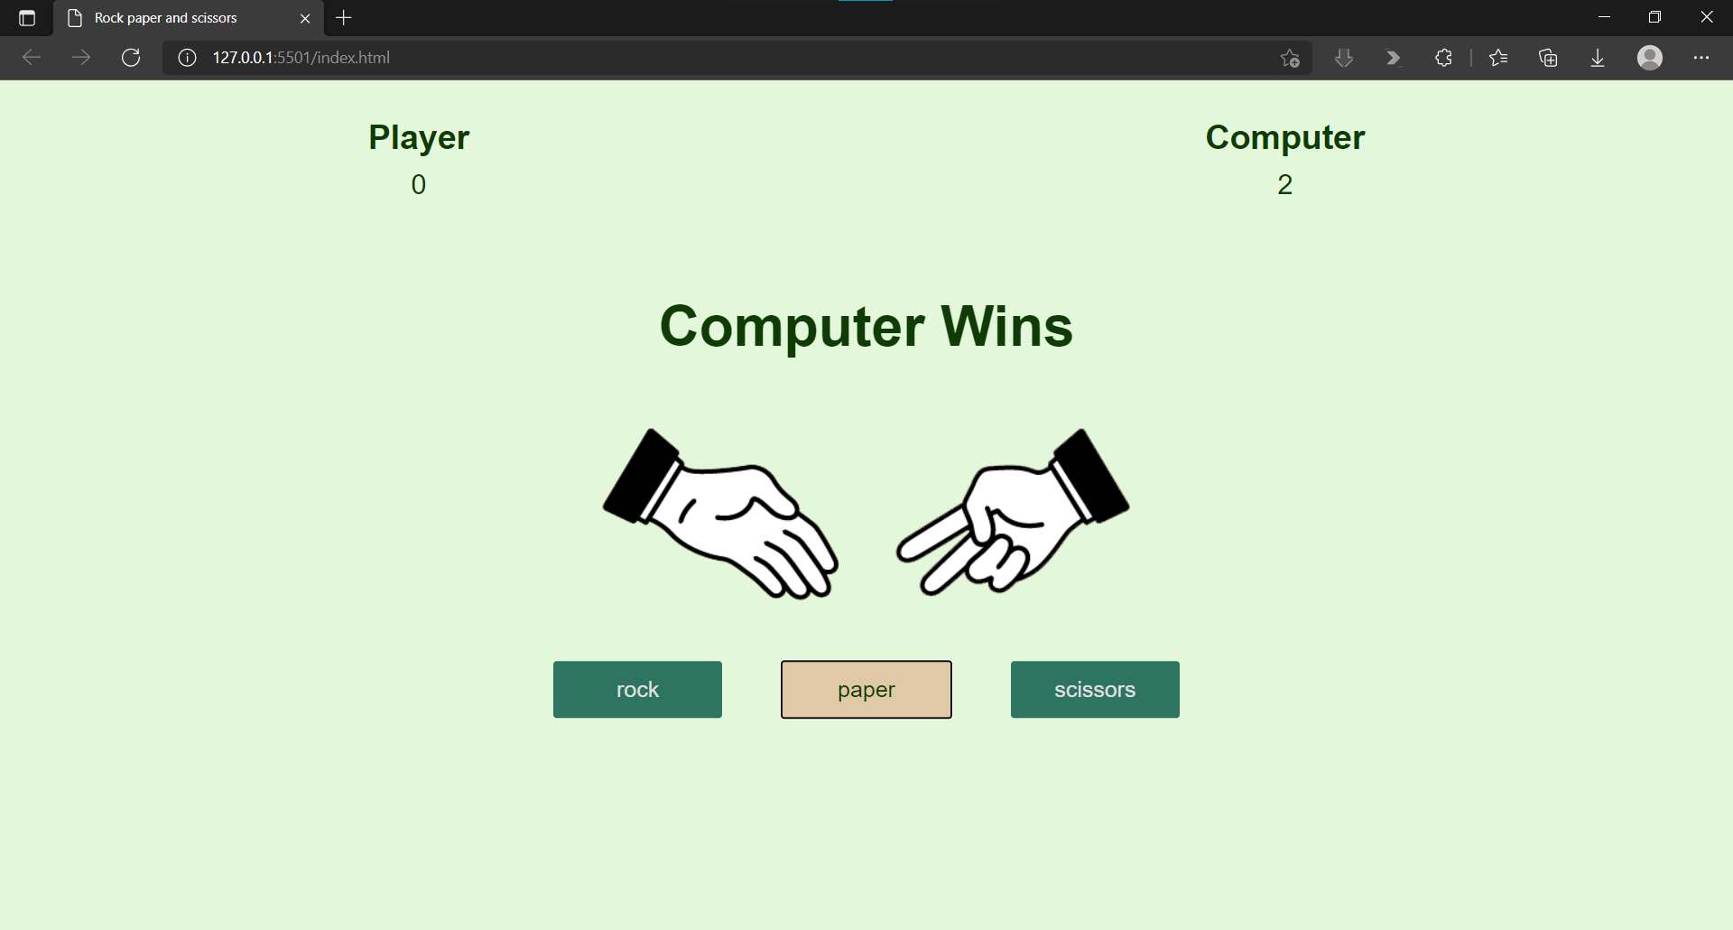

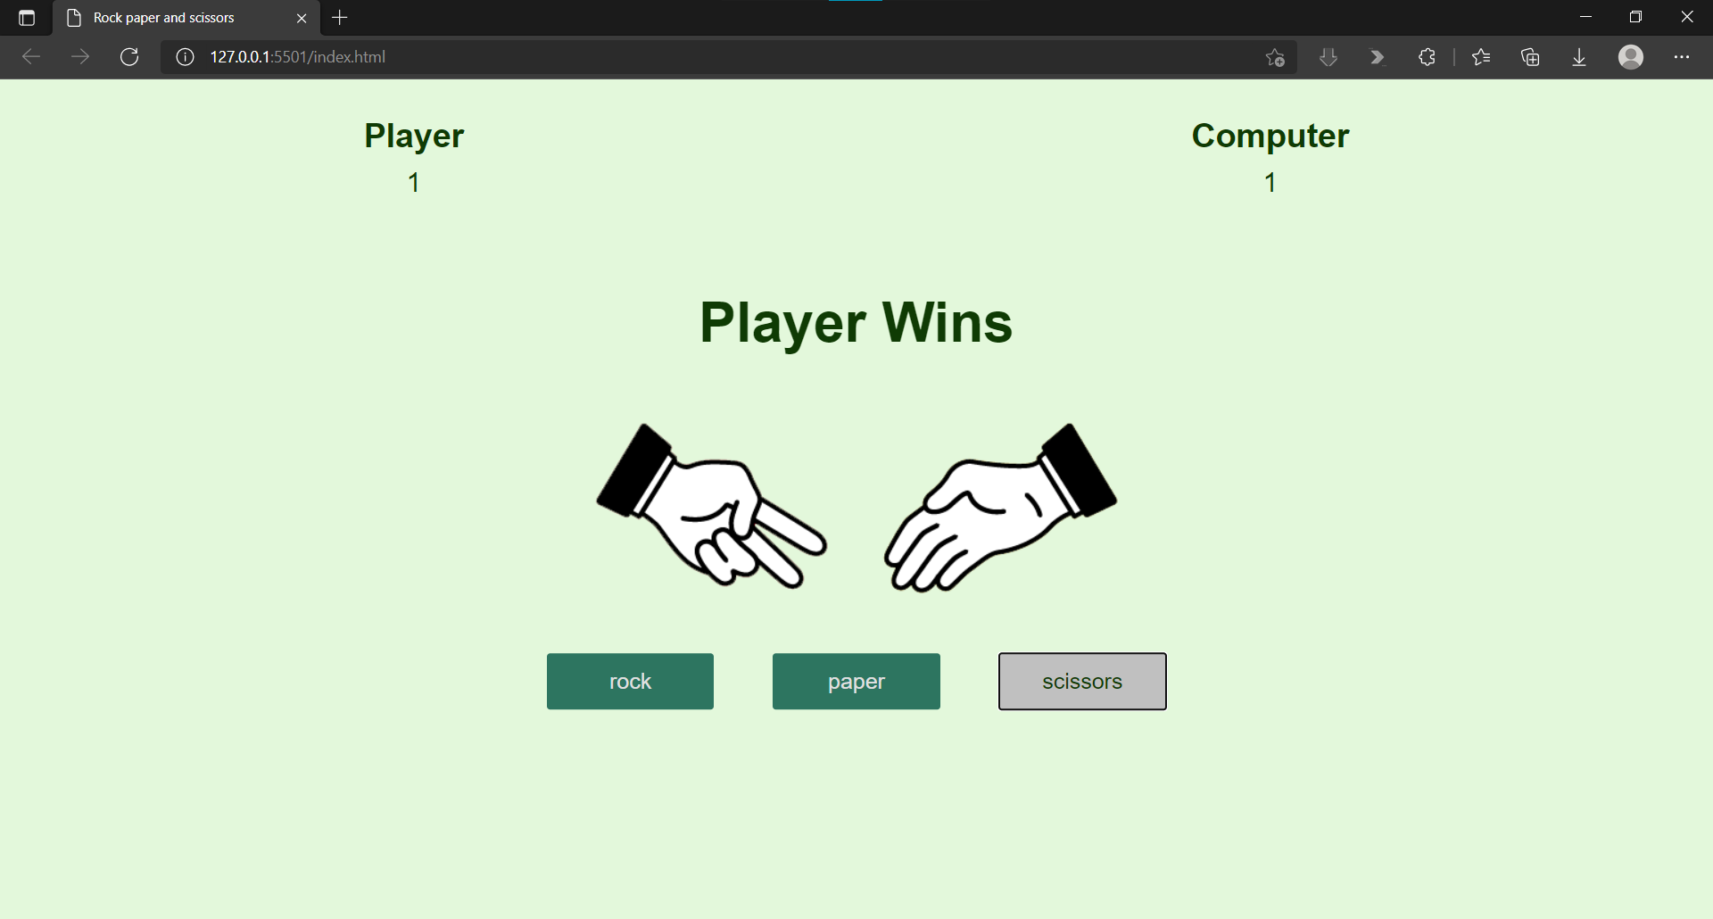

**CONCLUSION :** Hence , by this experiment we have implemented the basic HTML and CSS by creating this Webpage using various HTML & CSS tags. Also we have implemented the game logic of rock-paper-scissors in JavaScript which has helped in understanding some JavaScript concepts.