**SAFE MAMA**

This lock system is used to secure private things and objects in public places like apartments, temples, tourist places and so on.

BOARD AND PERIPHEARALS.

1. CU board (master locks/control unit).
2. Locks (child locks).
3. IR sensor.
4. RS485.
5. TTL to RS485 converter module.
6. Bluetooth module.
7. 12v DC Power supply.

NOTE: We call CU board as master lock and locks as child lock. For the master board, commands will be requested from tablet application and responses will be return back to the tablet application

DESCRIPTONS

MASTER LOCK

For network communication. Transfer TCP/IP commands (from tablet application via Bluetooth) to 485 format (to master lock). Support networking. Works well on IOS, Windows and Linux.

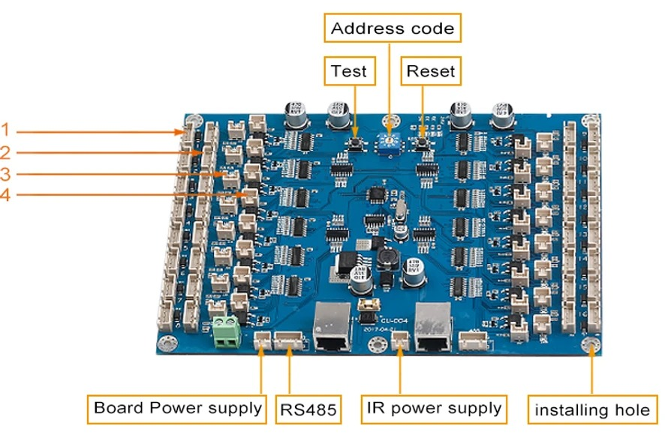

fig 1.1 (master lock)

1. Child locker port.

2. IR and LED light port.

3. IR feedback light(bi-color).

4. Lock feedback light.

Using address code rotation switch we can assign address from 0 to 9(10 addresses). Power supply for locks and IR given by the board. Ever locker port has a LED indication. A single master lock support 16 child locks and 16 IR sensors. Each child locker ports have its own addresses like 0x01, 0x02, 0x04, 0x08, 0x10, 0x20, 0x40, 0x80(which is 1byte) likewise 2nd byte has 8 locker addresses, totally 16 locks for a single master lock. For IR sensor port functionality is same as locker. Based on the address data from the protocol master lock will response.

CHILD LOCKS

Currently we use two types of locks,

* KR-S6070
* KR-S66N

KR-S6070 has no pushing mechanism. KR-S66N has a pushing mechanism when we release the lock.

These 2 locks have four pins +ve, -ve, signal and feedback.

IR sensor

There are 16 set of IR sensor every transmitter is looped together and every receiver has separate port like locker. Transmitter has +ve and –ve, but receiver have four pins +ve, -ve, signal and feedback.

RS485

Used for data communication between Bluetooth module and also communication between two master locks.

TTL to RS485 CONVERTER MODULE and BLUETOOTH MODULE

TTL to RS485 converter module used to transmit and receive protocol data between Bluetooth module and RS485. In Bluetooth we set 19200 BAUD rate.

WORKING

12v DC is given from SMPS, connecting child locks to board for power supply, to locks and detect lock’s condition (open/close). Then IR and LED light is connected. IR to check is the locker empty or not; LED light to lighting the locker when lock is open. IR feedback light(bi-color) used for indication using 2 pin RMC connector, Locker is empty, light turns green; locker is occupied, light turns red. In IR receiving side LED is used in between to light the cabin to be extended to every single locker, connecting lock feedback light, to show whether the lock is closed or not. When Lock is open, light turns on; when lock is close, light turns off.

Master lock Receive the command from Bluetooth application via rs485 and respond based on the command. Get feedback from the lock and send it to application.

Following commands are used in the protocol

* 0x30: Request locker’s door open or close Status
* 0x31: Request door open
* 0x32: Get lock status and infrared sensor status (locker/cabinet status) of all master boards on the RS485 bus
* 0x35: Response status of door open or close
* 0x36: Response status of all 10-door open or close

Protocol format

* + STX: 0x02 (Start Code)
  + DATA: 0x00(Address and commands)
  + ETX: 0x03 (End Code)
  + SUM: STX – Up to ETX Data, sum up all the byte.

Eg:- 0x02+0xFF+0x03 => (101+03) => 0x01+0x03 = 0x04.(while adding negate the first digit.)

There are three type of request protocol from the application.

* Request to open
* Request to get single board status
* Request to get all board status

In request to open lock. We have to mention starting of the protocol, address, command to open(0x31), ending of protocol, and sum.

In request to get response of single locker board(master lock). We have to mention starting of the protocol, address, command to get single board status (0x30), ending of protocol, and sum.

In request to get response of all locker board(master lock). We have to mention starting of the protocol, address, command to get single board status (0x32), ending of protocol, and sum.

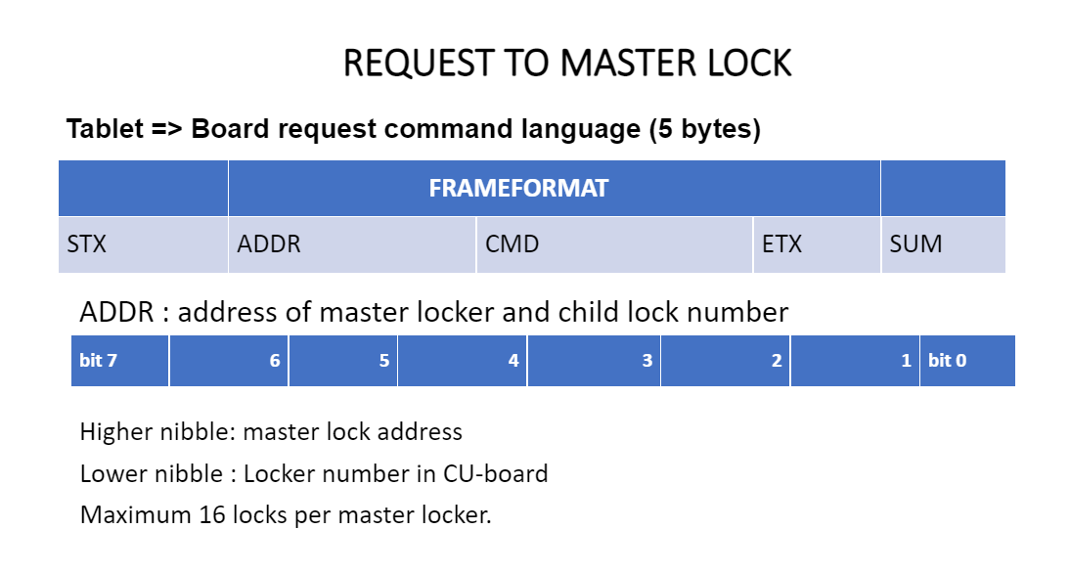

There are two type of response protocol from the board.

* Response of single board status
* Response of all board status

In response of single locker board(master lock). We will get starting of the protocol, address, command which indicate single board status (0x35), status of the board, ending of protocol, and sum.

In response of all locker board(master lock). We will get starting of the protocol, address, command which indicate single board status (0x36), status of the board, ending of protocol, and sum.

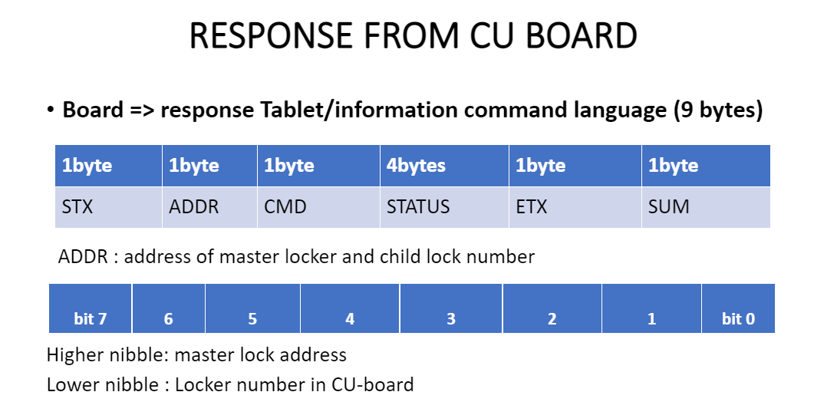

FLOW CHART

1. Request to open the door.  
     
   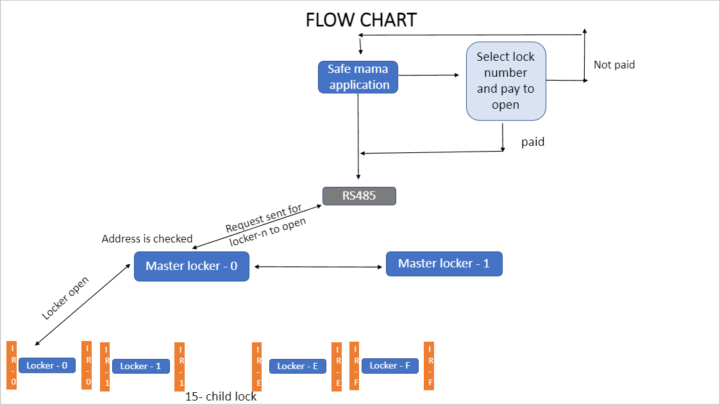

B) Request to get response of single lock.

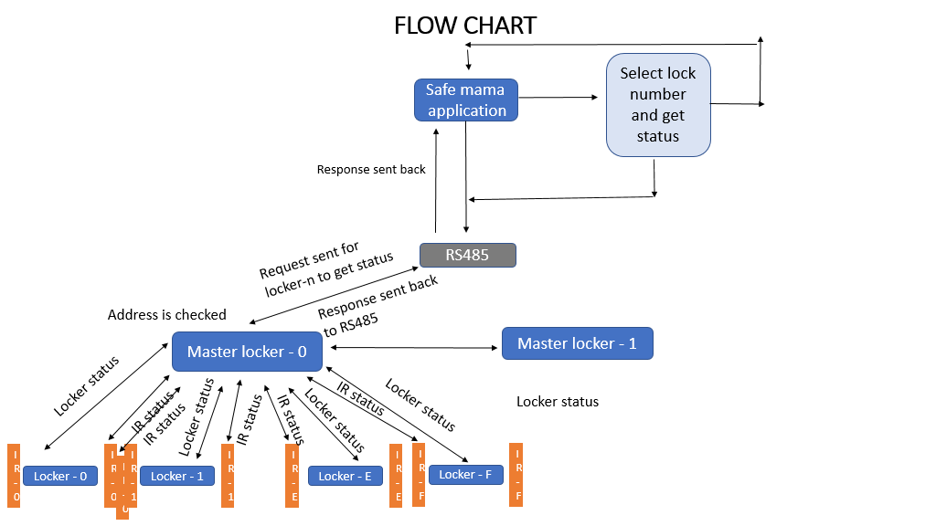

c) Request to get response of over all board.

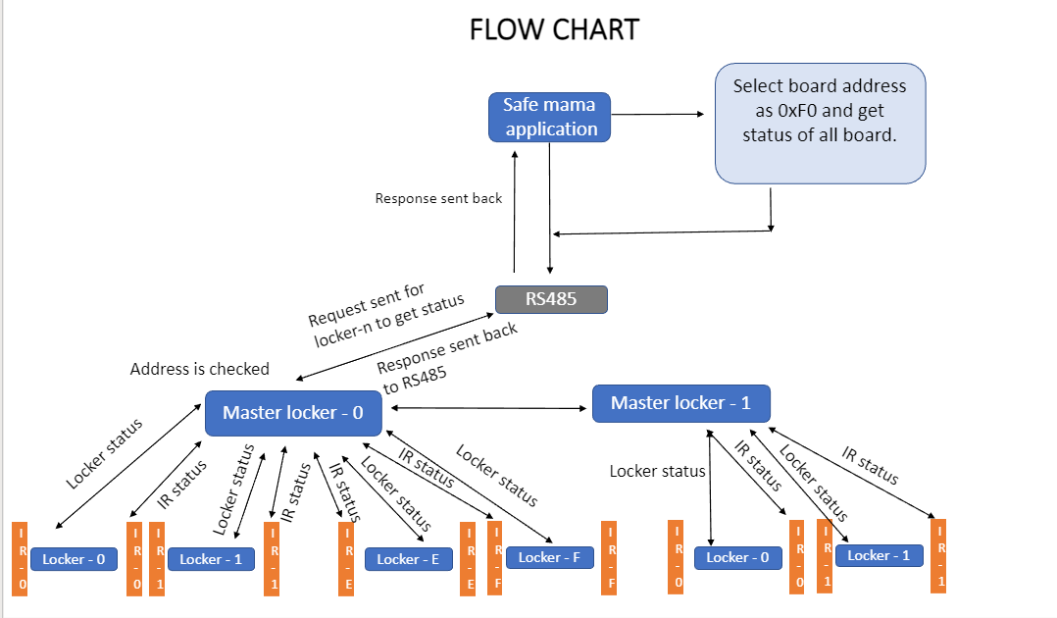

Reference

[SAFE MAMA.pptx](https://hfsgroupin-my.sharepoint.com/:p:/g/personal/karthikeyan_hfsgroup_in/EVYWh6NqlaJFg-dm9DcawLAB8n19EOQ0-N1C14vpQO3Dbg?e=Be0kBI)

[kerong locker.xlsx](https://hfsgroupin.sharepoint.com/:x:/s/NcCodeDevelopment/EePNcd3Zc5VOqohO1yEJeQsB4ulKumdoVOklg3SaEUVRsw?e=Lafm6t)