# 

# Transistor as a electrically controlled switch

In a BJT, Collector is physically the largest region, followed by the emitter. Base is the smallest region. In terms of doping, Emitter is the most heavily doped of the three, followed by the Collector and the Base is the least doped. The following picture captures this info.

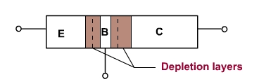

Let us look at how BJT acts as an electrically controlled switch in the CE configuration. We can use an abstract analogy for it: Imagine we are trying to turn right into Aakruti homes. But the gate is closed. We are waiting for the gate to be opened. There are lot of cars waiting behind us that need to continue going down the street - although the street is empty, they cannot go because we are blocking them. The moment the gate is opened and we make the turn, cars behind us can continue down the street. We can think of the Aakruti homes gate as the terminal connecting base to the battery - as soon as it is positively biased, it is like opening the gate. This will allow electrons to smoothly from the Collector to the Emitter.

In BJT, say in an npn one, the way this analogy works is that, as soon as BE is positively biased, electrons in the depletion layer get dislodged and go out of the base terminal thereby allowing electrons to flow from Emitter to the Collector [1]. The reason why not all electrons will simply exit out of the base terminal is that the base is very thin and the path out of the base is like a narrow gate - not many cars can turn into it - and since the wide road is now unblocked, most go from the Emitter to the Collector.

# Transistor as an amplifier

BJT acts as a current amplifier. Let us again go back to our analogy to understand this intuitively. Let us think of no. of cars/second as current - this is a very good equivalent as current is nothing but the amount of charge crossing a point per second. Imagine that, out of hundred cars, only 1 needs to turn into Aakruti homes. When the base current increases, it means that the turning cars are only waiting momentarily before they unblock others. Since most cars just want to go down the road, increasing base current even a little increases the CE current by a lot.

It is important to remember that transistor acts as a current amplifier. Turning it into a voltage amplifier take a few steps. We will learn this practically using trial and error SPICE simulations.

Take a look at the simple configuration below. BE is forward biased with no additional resistors. A resistor is added to the Collector just so that we can see the current going to it. It’s value is arbitrarily chosen.

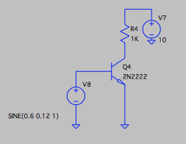

BE can be thought of as a diode. The diode VI curve typically looks like the figure below.

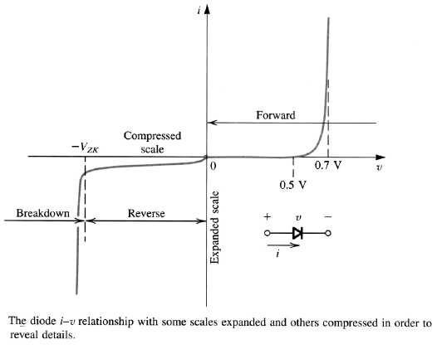

Although the VI curve is that of a specific diode, our BE diode will have similar characteristics - the absolute voltages in the figure may not match BE diode’s, but they can be used as a starting point for finding the BE diode’s VI characteristics. Note that, in the above figure, we are interested only in the linear part of the curve after v = 0.58V or so and not the part of the curve between 0.5V and approximately 0.58V where it has non-linear characteristics.

For our experimentation, let us first try a sine wave at a DC of 0.6V and a swing of 0.12V on either side. After simulating for a period of 1S, we check the I(b), which comes out as shown below.

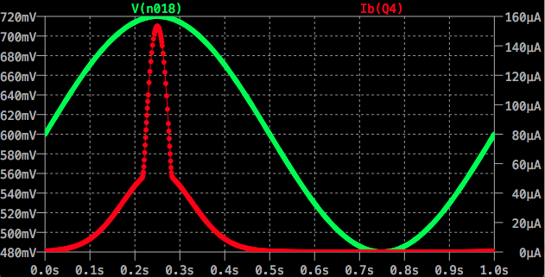

Since the Sine wave voltage curve between 0-90 degrees looks somewhat like a linear signal, the resulting I(b) will closely resemble the V-I characteristic curve for the given voltage range. As one can see, between 0s and 0.1s (i.e., 0.665V Vbe) or so, we seem to be in that “knee” of the V-I curve. We aren’t interested in this range.

While we have found out that we aren’t interested in the knee part of the V-I curve, we also aren’t interested in Vbe voltages that completely open the transistor. To know what is the upper limit of the voltage, we need to add the Collector current to the above diagram.

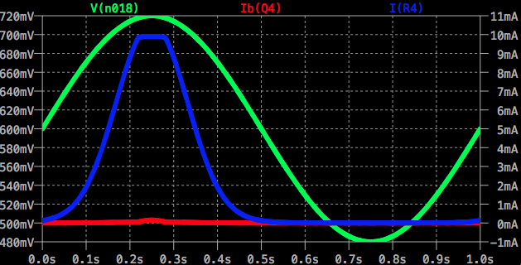

As one can see, beyond 0.716V, the transistor is fully open. So our usable Vbe range for this particular transistor is between 0.665V and 0.716V, or, for convenience, 0.715V. Let us try a Sine wave of 0.69V with a swing of 0.025V on either side. The results are as shown below.

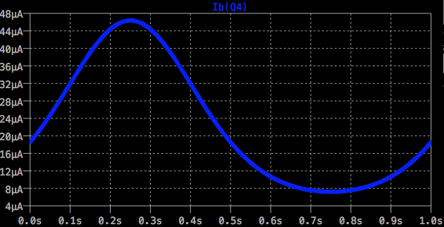

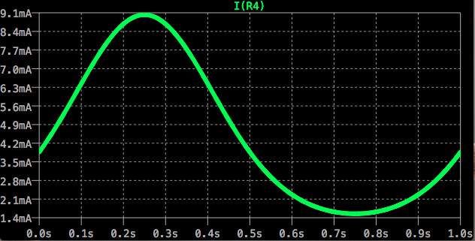

The current amplification is very clear. While the I(b) is spanning 39uA, the Collector current, I(R4) is spanning 7.5mA. That is roughly a 200x amplification.

At this point, it is important to remind ourselves that this is all just current amplification. We can look at the voltage amplification by comparing Vbe with Vce (V(n015))., shown below. 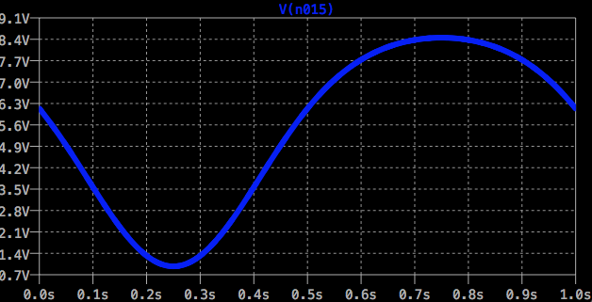

Vce swings 7.54V, compared to the 0.025V that Vbe swings. That is nearly a 300x amplification.

The difference between the current amplification factor and voltage amplification factor is because I(b) doesn’t linearly change with Vbe (investigate).

One cannot fail to notice how Vce is still not linear to Vbe. This is just the inherent non-linearity present in the transistor. In the next section, we can see how negative feedback can improve linearity and also a bunch of other things along with it.

# Negative Feedback in Amplifiers

Consider an abstract amplifier with an abstract negative feedback as shown below.

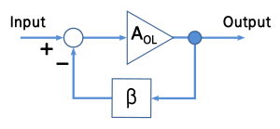

AOL is the open loop gain - something like the 300x gain we saw in our amplifier in the above section. 𝜷 is the feedback factor. What is shown here is that the output value is multiplied by 𝜷 and the result is subtracted from the input and given to the amplifier. The overall response of this circuit, if derived, would come to:

$A_{CL}=V_{out}/V_{in}=A_{OL}/(1+βA_{OL})$ → (1)

One can see in this equation that, if 𝜷AOL >> 1, then the formula simplifies to $A_{CL}= 1/β$! In other words, the closed loop gain is almost entirely determined by 𝜷. The implications of this on transistor based amplifier circuits are:

1. AOL is often not linear as we have seen in the previous section. This is because transistors are inherently non-linear. However 𝜷 can be made linear if we use resistors to make 𝜷.
   1. Not only the range used in an open loop amplifier circuit can be made linear, the usable range itself can be extended - essentially the range that wasn’t used in an open-loop configuration because it was too non-linear can also be pulled in to some extent.
2. AOL changes with temperature and other environmental factors. However resistor based 𝜷 varies very little w.r.to environmental factors. So the amplifier will be way more stable when there is negative feedback
3. When a transistor is smoked and we need to replace it, we need not worry about gain change due to process related differences
4. AOL isn’t constant across frequencies - in other words, it is actually AOL(ｚ). But a 𝜷 made of resistors has a much more flat response across frequencies.
   1. If required, one can even make a 𝜷(ｚ), i.e., an elaborate feedback circuit containing frequency selective elements like capacitors and inductors to make a desired frequency profile that is otherwise not possible with a transistor without negative feedback. In other words, using an amplifier with a frequency selective negative feedback, one can make active LPF, HPF, BPF (whereas simple RLC circuits are passive filters).
   2. Keep in mind that $A_{CL}= 1/β$ is only true when 𝜷AOL >> 1. At some high frequency, AOL will be so small that the condition above won’t be satisfied. So bandwidth will be limited in any case - it is just that it can be extended.

In the equation (1), it is important to note that ACL will always be less than AOL. Because, no matter how small 𝜷 is, the denominator will always be greater than the numerator.

It is also important to remember that, in an open loop configuration, the transfer function isn’t exactly just a constant AOL even if we are talking about the response at a single frequency - Otherwise, a constant AOL  would imply that the amplifier has a linear response which is the problem we are trying to solve in the first place. So the equation is just to give an idea on how negative feedback helps, but is too simplistic to use in mathematics in real world applications.

# CE Amplifier Negative Feedback Loops

Let us look at a few ways of introducing negative feedback in our simple CE amplifier. One of the simplest ways of introducing negative feedback is to simply add a resistor to the base. The following figure shows an open loop CE amplifier and the bottom one shows a closed loop CE amplifier.

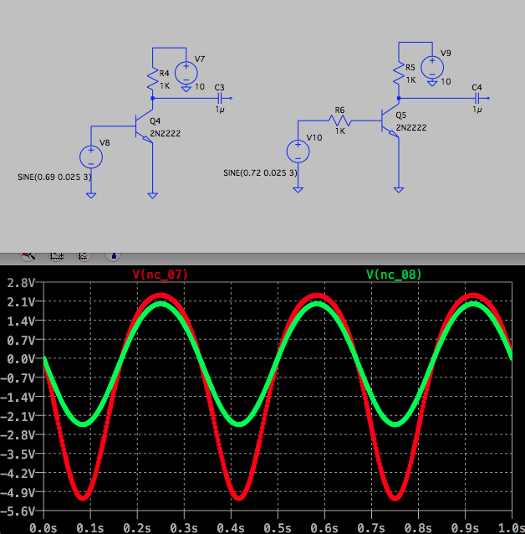

By adding a resistor at the base, when the voltage increases across BE, when the BE decreases consequently, the voltage will fall - thus making for a negative feedback. In the open loop amplifier, BE voltage will always be the same as the input signal voltage.

To compensate for the addition of a resistor at the base, the DC value of the closed loop amplifier’s input has to be increased. To find out what this DC value should be, we need to know the BE resistance value at the open loop DC value of 0.69V - This can be done by measuring I(b) at 0.69V, which happens to be 18uA, indicating a resistance of 38.33K. Since we want to keep the I(b) same in the closed loop as it is in the open loop configuration, we find out DC of closed loop Vin as = 18uA * (38.33K + 1K) = 0.72V (approx).

Note that, although we are changing the DC point, the swing remains the same in the closed loop config as it was in the open loop config.

The graph shown the open loop CE voltage (after the blocking capacitor) as the red signal and that of the closed loop as the green signal. One can clearly see how the latter looks much more like a sinusoid with almost equal swings in the positive and negative directions as compared to the red signal. This is because of the improvement in linearity. Of course, the amplification has decreased - but that is a small price to pay.

After some trial and error, we find out that

# From Hyperphysics

## Determining Load Line [2]

Transistor Characteristic Curves

(Approximate for 2N2222)

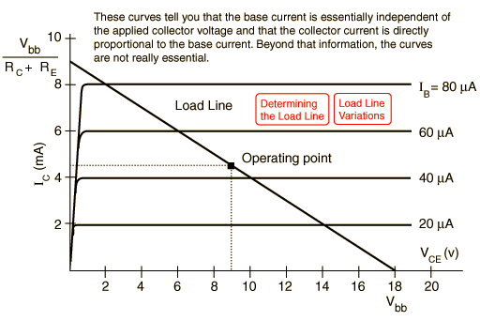

Transistor Load Line

(Approximate for 2N2222)

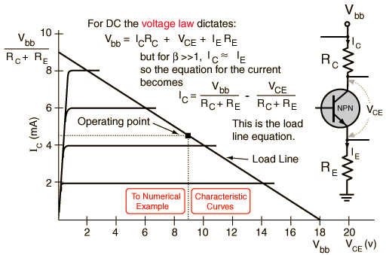

Transistor Load Line

(Approximate for 2N2222)

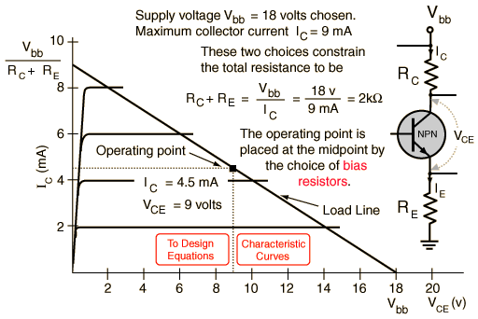

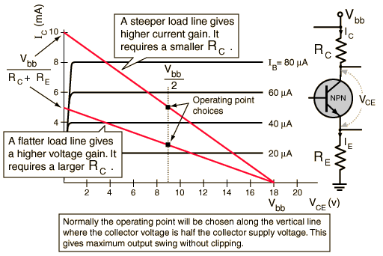

## Common Emitter Amplifier [3][4]

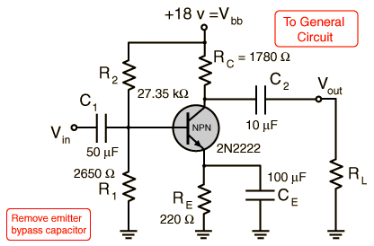

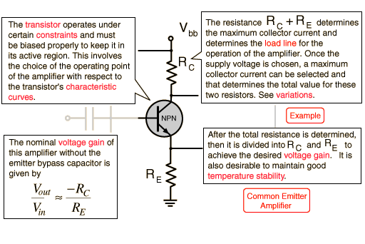

The collector voltage **VC** should be about half the supply voltage **Vbb**when there is no signal applied. This operating point allows a maximum swing of output voltage without clipping or distortion. One approach to design is to choose an operating collector current **IC** and then calculate the necessary collector resistor to drop from **Vbb** to that point. Choosing **RE**would then fix the load line and the gain.

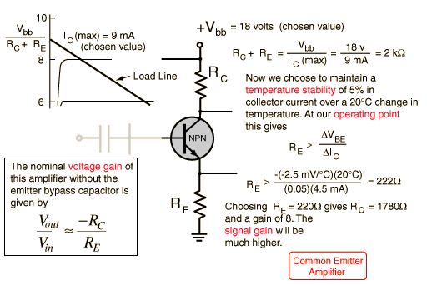

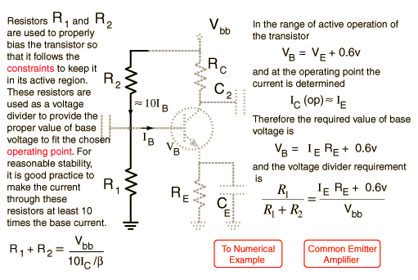

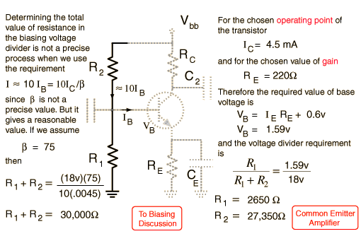

### An Example with Capacitor

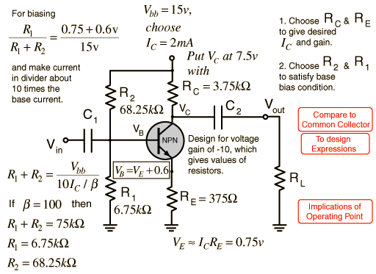

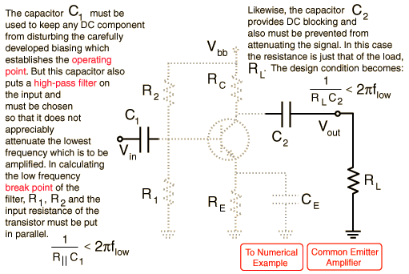

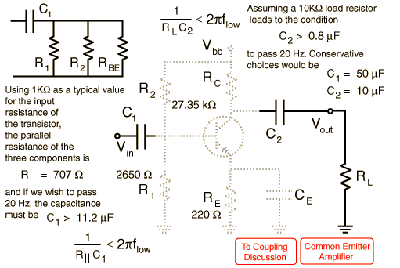

## Unbypassed Common Emitter Gain

**With Capacitor:**

|  |  |  |  |  |
| --- | --- | --- | --- | --- |
|  | **Looking at the DC behavior of the almlifier and following the convention that lower case letters represent changes in the respective quantities:**    **The gain is**    **but for AC signal variations for which CE is an effective bypass, the gain is**   |  |  | | --- | --- | |  |  | |  |

**Without Capacitor:**

|  |  |  |  |  |  |
| --- | --- | --- | --- | --- | --- |
|  | Looking at the DC behavior of the almlifier and following the convention that lower case letters represent changes in the respective quantities:    The gain is    which for small **rE** can be approximated by   |  |  |  | | --- | --- | --- | |  | |  | | --- | | [Add bypass](http://hyperphysics.phy-astr.gsu.edu/hbase/Electronic/npncegain.html#c2)  [capacitor](http://hyperphysics.phy-astr.gsu.edu/hbase/Electronic/npncegain.html#c2) | | |  |

**Numerical Example With Capacitor**

|  |  |  |  |  |
| --- | --- | --- | --- | --- |
|  | With the bypass capacitor in place, the voltage gain is dertemined by the collector resistor **RC** and the effective resistance of the transistor **rE**.     |  |  |  | | --- | --- | --- | | This effective resistance is    where **RBE** is the forward resistance of the base-emitter diode.   |  | | --- | | [Remove bypass](http://hyperphysics.phy-astr.gsu.edu/hbase/Electronic/npncegain.html#c1)  [capacitor](http://hyperphysics.phy-astr.gsu.edu/hbase/Electronic/npncegain.html#c1) | |  |  Temperature Stability in CE Amplifier Design [5] As the temperature of a transistor increases, the collector current will increase because   1. [Intrinsic semiconductor current](http://hyperphysics.phy-astr.gsu.edu/hbase/solids/intrin.html#c2) between the collector and base increases with temperature. Its flow through the biasing resistors drives the base more positive, increasing forward bias on the base-emitter diode. For a silicon diode Simpson quotes an increase of 2 nA for a 10°C temperature rise. 2. The base-emitter voltage required for a given collector current will decrease. This decrease is about -2.5 mV/°C.   An approximate relationship for the collector current change is:    An increase in temperature produces an increase in the minority carrier current, but a negative change in **VBE**, so both effects lead to an increase in collector current with temperature. Since the emitter resistance shows up in the denominator of both terms, this shows that a large value of **RE** is desirable for temperature stability.  The presence of **RE** provides negative feedback which stabilizes the circuit against changes in temperature, supply voltage, etc., but it also decreases the voltage gain. |

References:

[1] <https://www.youtube.com/watch?v=7ukDKVHnac4>

[2] <http://hyperphysics.phy-astr.gsu.edu/hbase/Electronic/loadline.html#c2>

[3] <http://hyperphysics.phy-astr.gsu.edu/hbase/Electronic/npnce3.html#c2>

[4] <http://hyperphysics.phy-astr.gsu.edu/hbase/Electronic/npncebias.html#c1>

[5] <http://hyperphysics.phy-astr.gsu.edu/hbase/Electronic/transtemp.html#c1>

[6] <http://www.colorado.edu/physics/phys3330/PDF/Experiment7.pdf>