Smart KP Muhurat Software

Support:
All queries and suggestions can be sent to: AstroOpenSource@gmail.com

Installation

Read and follow the instructions from InstallHelp.txt file

New features in Version: 1.5.11
- Now, GUI window can be resized or Maximized. All the controls resized accordingly.
- Speed Lagna Transit calculation added.
- Removed unused functions (clean up source code)
- In the Analysis screen Color is added to the column to indicate Yes No (RED, Light green and Thick green). Now it is easy to see quickly the best Muhurats.
- If no negative houses, the analysis column Y/N shows --.
- Event name added in Analysis window header.
- South Indian chart is modified:
- Bigger font to see clearly
- Cusps are in Blue color to see them clearly
- Lagna and Moon are shown in Different color to see RPs quickly
- In addition to Horary Lagna, the Time chart Lagna is also shown.
- This helps to see RPs of the time chart quickly.
- When an event is selected, the related help is displayed in Help Page. Select an event in Data page and click on Help Page to see the help.

New features in Version: 1.5.10.1
  - Place can be selected from Place Database
  - One place can be set to default place. Application start with this place
  - Add/Delete/Modify place of Database
  - Help file updated

Start the application

Double click on the program icon on the desktop. The main screen is displayed.

Note: Currently DSP is not supported and will be available in future versions.

How to Use
Data entry

Step |  | Instructions
1 |  | Enter Customer name  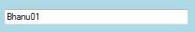
2 |  | Enter “From date” and “To date”. The application will analyze all possible Muhurats between these two dates.
3 |  | Enter “From Time” and “To time”. The application will analyze all possible Muhurats between these two timings for all dates between “From date” and “To date”.  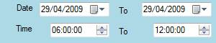  Example:  From date: 2009-04-15 To Date: 2009-04-18  From Time: 6:00 To Time: 11:00  Then all the Muhurats between 6:00 AM and 11:00 AM for the dates 15th, 16th, 17th and 18th April 2009.  Note:  - The time in 24 hours format and between 00:00:00 and 23:59:59.  - The “To date” must be greater than “From Date”.
4 |  | Select/Modify place:  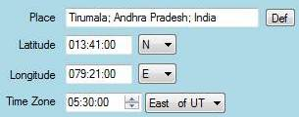  When the application starts, the default place is displayed.  Any time, if you want to select a default place, click on the button “Def”. The default place can be defined in “PlaceDB” Tab page (using “Set as Default place” button).  One can select another place from the place database.  ➔Select a place from Database:  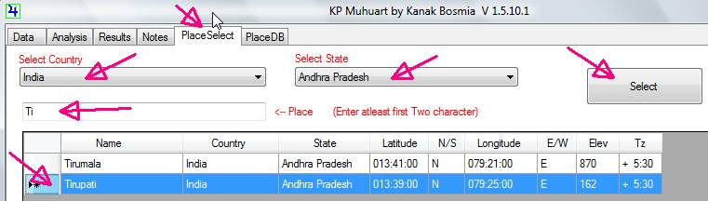  Click on “Place Select” Tab.  Select Country (Ex: India) from the drop down list.  Select State (Ex: Andhra Pradesh) from the drop down list.  Enter Place name (At least two characters, EX: Ti).  After entering two or more characters,  - The grid below is updated automatically as you enter more characters.  - Select one place from the list by clicking on the corresponding row.  - Click on the Button “Select”. Then the selected place is automatically updated in the Data entry page in the place.  ➔ The place you want is NOT in the Database of the information is not correct:  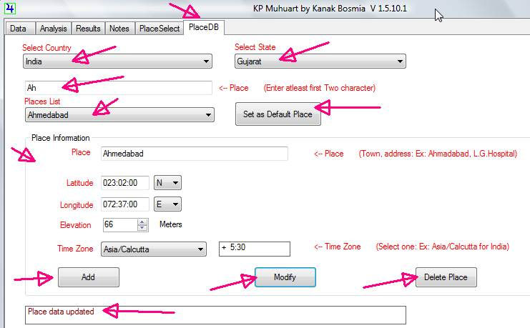  Click on “PlaceDB” Tab.  Select Country (Ex: India) from the drop down list.  Select State (Ex: Gujarat) from the drop down list.  Enter Place name (At least two characters, EX: Ah).  After entering two or more characters,  - The “Place List” drop down is updated automatically as you enter more characters.  - Select one place from the Places list.  - The information of the selected place (Place; Latitude; Longitude; Elevation; Time Zone) is displayed below.  - This information can be modified  Case A: Add a new place  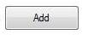  - Modify the above Place information and click on “Add” button.  - This adds new place using the information  - ERROR: If the place with same name is already exists, an error message is displayed in the “Status Window”.  - ERROR: The place name must be at least two characters.  Case B: Modify a place  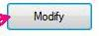  - Modify the above Place information and click on “Modify” button.  - This updates the place using the modified information.  - ERROR: The place name must be at least two characters.  Case C: Delete a place  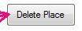  - Click on “Modify” button.  - This Deletes the place and cannot be undeleted.  Case D: Set as a Default place  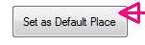  - Click on “Set as a Default Place” button.  - Currently selected place is set a default place. When the application started, the default place is used in the data entry page.
5 |  | Select Event from the drop down list  The events are arranged as per the Main house of the event.  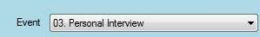  For example to find Muhurat to attend an interview,  Select 03.Personal Interview  NOTE: If the event you would like to use is not in the list, please send a mail with details to AstroOpenSource@gmail.com  The event will be added immediately in response.
6 |  | Click on “Show”. This will calculate and analyze all possible Muhurats. Wait until the Analysis window is displayed.  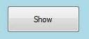  Note: This may take time, so please wait until the analysis window is displayed.
Analysis

1 | The analysis window has “Lagna Table” on the left.  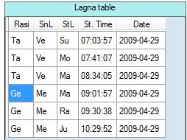  Each row represents one Lagna. Each Lagna has its Date, Lagna Start time, Raasi lord, Star lord and sub lord.  Click on Rasi lord on any Lagna.  Then all the Muhurats (Sub Level) belongs to selected Lagna are displayed on the right side of the window.  Example:  Select Lagna: Ge Me Ma 09 :01 :57 2009-04-29  The sub level analysis of the above selected Lagna is displayed on the right side of the window. Below is one Muhurat that is displayed:  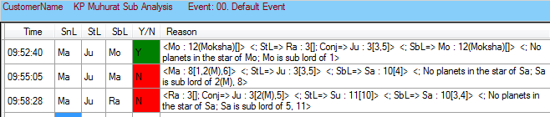  The time 09:52:40 is the start time of the Muhurat.  Ma is the Rasi lord; Ju is Star lord and Mo is the Sub lord.  The next column can have either N (Not a good Muhurat) or Y (can be slected for Muhurat). In this case Y is displayed and so this can be selected for Muhurat. For quick view, Y or N is indicated by Green or Red.  The analysis is displaed in the next column.  Example:  - <Mo : 12(Moksha)[]> : Mo is in 12. 12th house is Moksha sthana.  - <StL=> Ra : 3[]; Conj=> Ju : 3[3,5]> : The star lord Ra is in 3rd house. As Ra is a node, see alos Conjuunction. Ra conjunction with Ju and Ju is in 3rd and lord of 3 and 5.  - < SbL=> Mo : 12(Moksha)[]> : The sub lord Mo is in 12 which is Moksha Sthana.  - <No planets in the star of Mo; Mo is sub lord of 1>:  Please note that B indicates Baadhaka and M indicates Maaraka.  Note: Only Muhurats that have no B or M can be selected for a Possible Muhurat and so it is indicated with Y in the previous column.
2 | The automatic analysis is done each Muhurat is indicated as Y or N in the 5th column of sub analysis table.  If you feel that this is not correct, then Click on Y (or N) and modify to N (or Y).
3 | Click on each Lagna in the left side table. Verify the sub level analysis.
4 | Once analysis is completed, Select Results Page
Results

1 | All chosen Muhurats will be displayed on the left side of the window.  In the Analysis stage all Muhurats marked as Y or displayed here.  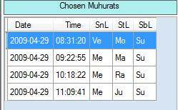  Click on a row to select One Muhurat for further chart analysis of the Lagna.  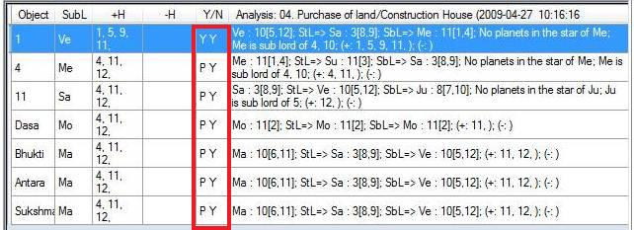  The lagna analysis, Cusp analysis and DBAS analysis are displayed on the right side of the window.  The Cusp analysis is based on the Event selected.  D(Dasa) B(Bhukti) A(Antara) S(Sookhma) of the Lagna are analysed.  Example:  This is 3rd cusp analysis. 3 cusp sub lord is Mo. The positive houses of the event is 3, 10, 6,11 and no negative houses.  The next column indicates:  The fist letter is about Positive houses and Second letter is about Negative hosues.  P Y ➔ 3rd cuspal sub lord partially signifies the Positive houses and signifies negative houses.  Y Y ➔ 3rd cuspal sub lord signifies all the Positive houses and signifies negative houses.  N Y ➔ 3rd cuspal sub lord do not signify any the Positive houses and signifies negative houses.  Y N ➔ 3rd cuspal sub lord signifies the Positive houses and do not signifies negative houses.  Summary:  P is Partially signifies  Y for Positive houses indicates it signifies positive houses  N for Positive houses indicates it does not signifies positive houses  Y for Negative houses indicates it signifies Negative houses  N for Negative houses indicates it does not signifies negative houses  The complete analysis of the 3rd cuspal sub lord is displayed in the last column.  This column also displayed with color:  RED: Not good  Light green: Can be selected  Thick Green: Very good
   | 3 | Mo | 3, 10, 6, 11, | - | P Y | Mo : 1[3]; StL=> Ra : 8[]; Conj=> Ju : 9[8,11]; SbL=> Ju : 9[8,11]; No planets in the star of Ju; Ju is sub lord of 4, 10; (+: 3, 10, 11, ); (-: )
2 | Click on Chart to display the chart.  The Lagna time can be adjusted using the time on the laft bottom side of the window.  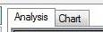  Also the chart can be displayed either in South style or North style.
3 | Click on “Print chart” to print the chart for offline analysis and for records.  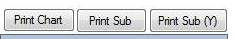
4 | Click on “Print Sub” to print the All entries in Analysis window. This is useful for records or for offline analysis.
5 | Click on “Print Sub (Y)” to print the All entries in Analysis window that are indicated as Y (Only Muhurats that are good for Muhurats). This is useful for records or for offline analysis.
Notes

1 | This is like a note pad. Here you can type in any information that could be useful for future reference.  Few facilities also, provided:  - Click right mouse inside the Notes window that pops up a menu. You select “Paste DTPE”. This pastes Dates, times, place and Event that were selected in the data entry stage.  - Use the popup menu to paste the Lagna table; Analysis table; Muhurat list; results table and the chart as bitmaps.
2 | After saving, this notes can be edited in Word compatible software to prepare a report or an article for publication.
Saving Data

1 | Select “Data” page where you have entered the data  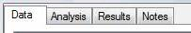
2 | Click on Save button. This popups the file browser. Select a directory and file name and click Save.  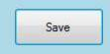  This saves the following data in the selected file (Ex: Bhanu01.dat):  - From and to dates  - From and to times  - Place name, Latitude, Longitude and Time zone  - Selected Event  And  - Notes in (Bhanu01.rtf)
Loading Data

1 | Click “ Load”Button.  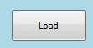
2 | This popups the file browser. Select a directory and file name and click Open.  This opens the following data from the selected file:  - From and to dates  - From and to times  - Place name, Latitude, Longitude and Time zone  - Selected Event  - Notes
3 | Continue the analysis and the notes if required
4 | Do not forget save the data

Note: The reports are in pdf format and can be found in the directory C:\KPMuhurat\Reports.
The header of the printed report has following information:

2009:02:15 23:58:13 (07:11:03 => 18:36:33 ) Place: Ahmedabad; Lat:023:00:00N Long:072:36:00E +05:30
Date Time Sun rise SunSet Place Latitude, Longutide and time zone

Note: Sub lord analysis:

Ra : 3[]; Conj=> Ma : 3[1,6]; Me : 3[8,11]; Ju : 3[2(M),5]; StL=> Mo : 1[9(B)]; SbL=> Ju : 3[2(M),5]; No planets in the star of Ra; Ra is sub lord of 9(Badhaka)

Ma: 3 [1,6]: Ma is in 3 and lord of 1 and 6

Ju : 3[2(M),5]: Ju is in 3 lord 2 (Maraka) and 5

Mo : 1[9(B)] : Mo is in 1, lord of 9 (Baadhaka)

Ra:3[]; Conj=> Ma:3[1,6]: Ra is in 3; Ma conj with Ma; Ma in 3, lord of 1,6.

