Visual Assist: Technical Documentation
Software for the B.Tech project report Navigating the Unseen: A Deep Learning Based Aid for the Blind, Government College of Engineering Kannur. This copy was made on 11 October 2026 from docs/TECHNICAL.md in the project repository.
This document explains how Visual Assist is built: its hardware, its software, the algorithms behind the guidance, every setting, the trained models, the demo page and the tests. It is written for someone who wants to understand, run, check or extend the project. For a short introduction and the list of voice commands, start with the README.

Contents
- Overview
- Architecture
- Hardware and wire protocols
- Software modules
- The main loop
- Voice commands
- Perception: what is where, and how far
- Guidance and route planning
- Feedback and adaptation
- Banknotes and faces
- Speech in and out, and languages
- Configuration reference
- Models and training
- Simulation
- The demo page
- Tests
- Installing and running
- What is verified, and known limits
- Relation to the project report
- Extending the project
- Repository layout

1. Overview
Visual Assist is a wearable aid for blind people. A camera recognises what is in the room, a LiDAR measures how far away it is, and a voice in an earphone tells the wearer what is there and guides them to what they ask for, around whatever stands in the way. The wearer speaks to it: "Where is the door?", "Guide me to the table", "What note is this?".
At a glance
Computer | Raspberry Pi 4
Sensors | Pi Camera, TF-Luna LiDAR, USB microphone
Actuators | Two servos (pan and tilt) driven by an ESP8266, an earphone
Language | Python 3 (about 4,000 lines in the visual_assist package)
Detection | Ultralytics YOLO: a pretrained YOLOv5-nano for everyday objects, a YOLOv5-nano trained here for doors, a YOLOv8-nano classifier trained here for banknotes
Tests | 176, none needing hardware
Origin | B.Tech project report "Navigating the Unseen: A Deep Learning Based Aid for the Blind", Government College of Engineering Kannur, April 2025

The report describes the system but does not include source code. This repository is a fresh implementation of that description.
Status. Everything here has been run on a PC: the tests, the guidance in simulated rooms, the models on held-out photos, and the demo page. Nothing has yet been run on the assembled device. Section 18 says exactly what has and has not been checked.

What it can do
Capability | How it is done
Name objects and say where they are | YOLO detection on each picture; left, centre or right from the position in the picture
Find doors | A second detection model, trained for this project
Measure distance | The LiDAR, checked against the object's size in the picture
Warn of obstacles | Spoken when something is closer than a distance that grows with walking speed
Find one object | The head looks at five angles, then turns to the object so the LiDAR can measure it
Guide to an object | A LiDAR sweep, a map of obstacles, the A* shortest-path search, and one spoken action at a time
Adapt to the wearer | Walking speed, pauses and familiarity change how early it warns and how much it says
Recognise people | OpenCV's YuNet finds faces and SFace compares them with registered ones
Read banknotes | An image classifier for Indian notes from ₹10 to ₹2000
Speak four languages | English, Malayalam, Hindi, Tamil

2. Architecture

2.1 Hardware
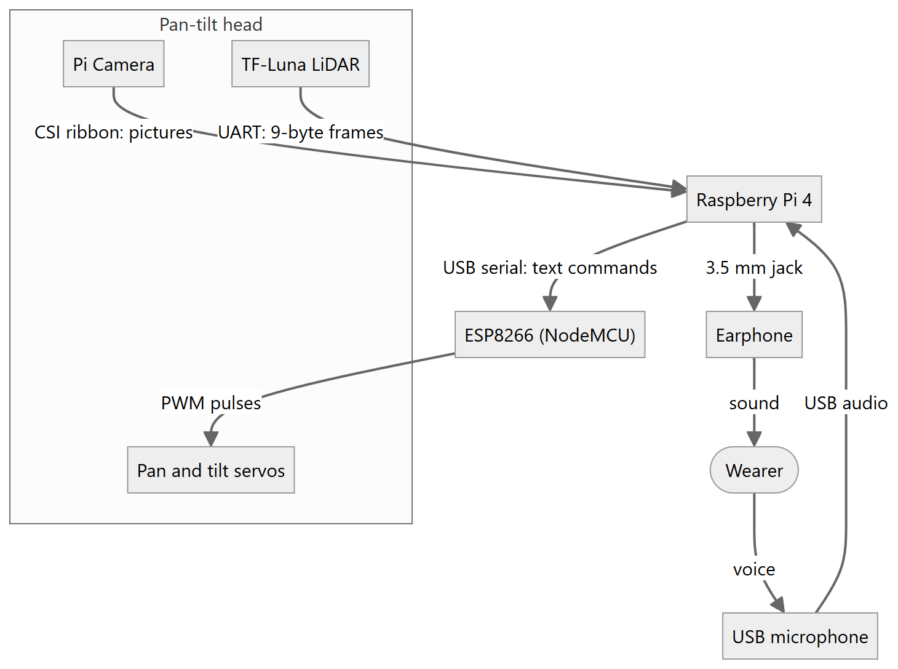
The Raspberry Pi is the only computer. The camera and the LiDAR sit together on a pan-tilt head, pointing the same way, so the LiDAR measures along the middle of the camera's picture, and the two servos turn them both. The ESP8266 exists only to turn the Pi's text commands into the pulses servos need.

2.2 Software
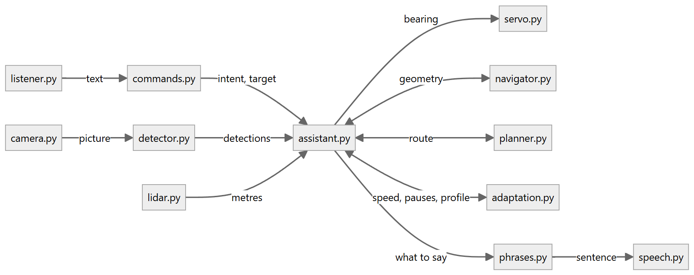
assistant.py is the hub. It owns the main loop, decides what to do next and calls everything else. The modules fall into four groups:
Group | Modules | Touches hardware
Devices | camera, lidar, servo, listener, speech | yes
Models | detector, currency, faces | no, but need their libraries
Reasoning | commands, navigator, planner, adaptation, phrases | no
Orchestration | assistant, config | no

2.3 Design rules
- Every device is optional. Each device module has an open_...() function. With the setting backend: auto it tries the real device and falls back to a stand-in that does nothing (NullLidar, NullPanTilt), to a webcam, or to the keyboard. The assistant then does what it still can: without a LiDAR, distances are camera estimates; without a turning head, there is no sweep and no route planning.
- The reasoning never imports hardware. navigator, planner, adaptation, commands and phrases are plain arithmetic and text, so they are tested directly.
- The assistant is handed its devices. Assistant(cfg, camera, detector, lidar, pantilt, speaker, ...) takes them as arguments. The same class therefore runs on the device, in the simulator (simulation.py) and inside a web page (live.py), with different objects passed in.
- Three threads. The main thread does all camera, LiDAR and servo work. A listener thread only puts recognised text on a queue. The speaker has a worker thread, so a slow detection never delays speech and an urgent warning can cut in.
The same Assistant class with its three sets of devices:
Role | On the device (build()) | In the simulator (make()) | In a web page (LiveAssistant)
Camera | PiCamera or OpenCVCamera | FakeCamera | LiveCamera: pictures taken by the page
Detector | Detector, MultiDetector (PyTorch) | FakeDetector | LiveDetector: results from the page's ONNX models
LiDAR | TFLuna | FakeLidar | NullLidar
Pan-tilt head | Esp8266PanTilt or GpioPanTilt | FakePanTilt | NullPanTilt
Speaker | Speaker | FakeSpeaker | LiveSpeaker: the browser's voice
Clock | time.monotonic | Clock, moved on by the test | time.monotonic

2.4 Threads and queues
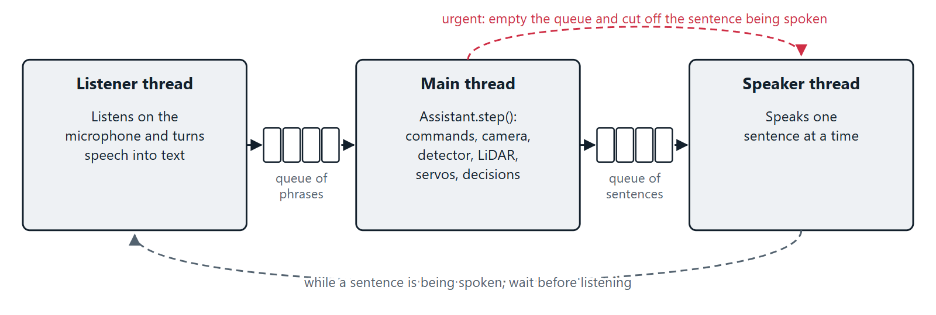
Only the main thread touches the camera, the LiDAR and the servos, so no device is ever used by two threads at once. The two queues are the only things the threads share.

2.5 Conventions
Quantity | Convention
Bearing | Degrees from where the wearer faces. 0 is straight ahead, positive is to the right
Distance | Metres
Planner map | The wearer at (0, 0) facing +y, with +x to the right
Servo angle | 0 to 180. 90 is straight ahead; a larger pan angle turns the head left
Picture box | (x1, y1, x2, y2) in pixels, origin top left

Terms used throughout: a detection is one object found in one picture; a sighting is a detection placed relative to the wearer (label, bearing, distance); a leg is one straight stretch of a planned route; the deadband is the angle (15° by default) within which something counts as straight ahead.

3. Hardware and wire protocols

3.1 Parts
Part | Job | Joined to the Pi by
Raspberry Pi 4 (Raspberry Pi OS, 64-bit) | Runs all the software
Raspberry Pi Camera Module | Pictures, 640 × 480 | CSI ribbon cable
TF-Luna LiDAR | Distance along the middle of the picture, 0.2 m to 8 m | UART, 115200 baud
ESP8266 (NodeMCU) | Turns text commands into servo pulses | USB serial, 115200 baud
Two SG90 servos on a pan-tilt bracket | Turn the camera and LiDAR | ESP8266 pins D5 and D6
USB microphone | Spoken commands | USB
Earphone | Spoken replies | 3.5 mm audio jack

3.2 Wiring
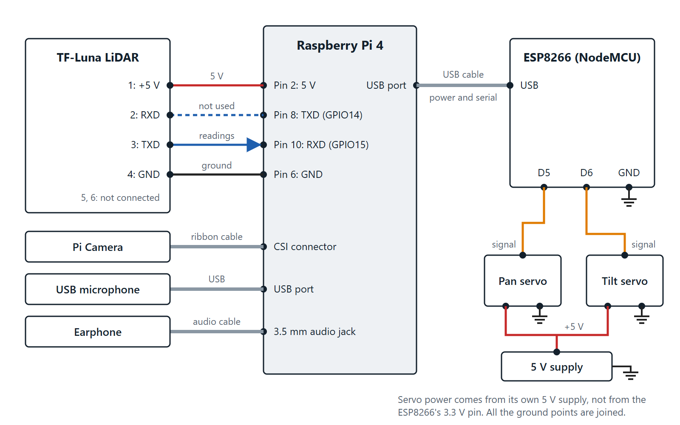
Every wire between the parts. The LiDAR's TXD goes to the Pi's RXD: that is the wire the readings travel on. The Pi's TXD is connected but the software never sends the LiDAR anything.
TF-Luna to Raspberry Pi
TF-Luna pin | Raspberry Pi
1, +5 V | Pin 2 (5 V)
2, RXD | Pin 8 (GPIO14, TXD)
3, TXD | Pin 10 (GPIO15, RXD)
4, GND | Pin 6 (GND)
5, 6 | Not connected

Servos to ESP8266 (the ESP8266 plugs into a USB port of the Pi)
Servo wire | Connect to
Pan signal (orange) | D5
Tilt signal (orange) | D6
Power (red) | A 5 V supply, not the ESP8266's 3.3 V pin
Ground (brown) | GND, shared with the ESP8266

Mount the LiDAR so that it points the same way as the camera. The software assumes the LiDAR measures along the centre of the picture.

3.3 TF-Luna frame format
Source: visual_assist/lidar.py.
The sensor sends 9-byte frames continuously at 115200 baud.
Byte | Meaning
1, 2 | Header, always 0x59 0x59
3, 4 | Distance in centimetres, low byte first
5, 6 | Signal strength, low byte first
7, 8 | Chip temperature (not used)
9 | Checksum: the low byte of the sum of bytes 1 to 8

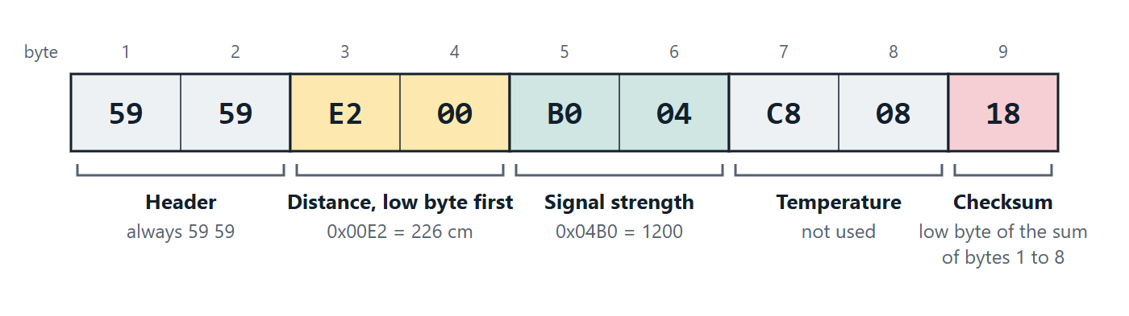
One frame, for a reading of 2.26 m.
In this example the distance is 0x00E2 = 226 cm and the signal strength is 0x04B0 = 1200. The first eight bytes add up to 0x318, whose low byte 0x18 matches the checksum.
How a reading is taken (TFLuna.read):
- Throw away what is buffered, so the reading belongs to where the head points now.
- Read 9 bytes and look for a complete frame with a correct checksum (find_frame, searching from the end so the newest wins). If the read started in the middle of a frame, read 9 more and look again.
- Decode it (parse_frame). The reading is discarded, giving None, if the signal strength is below 100 or equal to 65535, or if the distance is outside 0.2 m to 8.0 m.
encode_frame does the reverse and is used by the simulator and the tests.

3.4 ESP8266 command protocol
Sources: firmware/esp8266_pan_tilt/esp8266_pan_tilt.ino, visual_assist/servo.py.
One command per line over USB serial at 115200 baud. Each is answered with OK or ERR.
Command | Effect
PAN <0-180> | Turn the head left or right. 90 is straight ahead
TILT <0-180> | Tilt the head up or down. 90 is level
CENTER | Both servos to 90 (the Pi's driver does not use it; it sends PAN 90 and TILT 90)

The firmware maps the angle linearly onto a pulse of 500 to 2500 microseconds: pulse = 500 + angle × 2000 / 180. An angle outside 0 to 180 is held to that range.
On the Pi, look(bearing, tilt) computes
pan = clamp(pan_center - bearing) # + bearing if servo.pan_invert
tilt = clamp(tilt_center + tilt)
sends PAN then TILT, and waits servo.settle_s (0.4 s; 0.05 s between the steps of a sweep) for the head to stop. Example: to look 60° to the left, the bearing is −60, the Pi sends PAN 150, and the ESP8266 gives the pan servo pulses of 2167 µs.
Opening the serial port resets a NodeMCU, so the driver waits two seconds and discards the boot messages before the first command.
Without an ESP8266. With servo.backend: gpio the servos' signal wires go straight to the Pi (BCM pins 12 and 13 by default) and are driven by gpiozero with the same pulse range.

4. Software modules

4.1 The modules
All in visual_assist/.
Module | Responsibility | Main contents
assistant.py | Main loop, command handlers, guidance | Assistant, build()
config.py | Settings with their defaults; loads config.yaml | Config and one dataclass per section, load(), from_dict()
commands.py | Recognised text to a command | parse(), Command, SYNONYMS
camera.py | Pictures from the Pi Camera or a webcam | PiCamera, OpenCVCamera, open_camera()
detector.py | Object detection with one model or several | Detection, Detector, MultiDetector, center_detection()
lidar.py | TF-Luna frames | TFLuna, NullLidar, find_frame(), parse_frame(), encode_frame()
servo.py | The pan-tilt head | Esp8266PanTilt, GpioPanTilt, NullPanTilt
navigator.py | Bearings, distance from size, turn wording, the next instruction | Sighting, Instruction, visual_distance(), fuse_distance(), next_instruction()
planner.py | Obstacle map and A* route search | Obstacle, Leg, Route, obstacles_from_rays(), plan()
adaptation.py | Movement tracking, the user profile, the adaptive rules | UserProfile, MotionTracker, warn_distance(), verbosity()
phrases.py, locales/ | Every spoken sentence in four languages | Phrases
speech.py | Text to speech | Speaker, OfflineVoice, GoogleVoice
listener.py | Speech to text | VoskListener, GoogleListener, KeyboardListener
currency.py | Banknote recognition | CurrencyReader, decide(), denomination()
faces.py | Face recognition and registration | FaceBook, People, FaceModels, Face, similarity()
simulation.py | A simulated room, wearer and devices | World, make(), record(), trace()
live.py | The assistant fed by a web page's camera | LiveAssistant

Outside the package:
Path | What
main.py | Command line entry point
config.yaml | The settings in use
firmware/esp8266_pan_tilt/ | Arduino sketch for the ESP8266
training/ | Dataset preparation and training scripts
weights/ | Trained models
index.html, demo/ | The demo page
tests/ | The test suite

4.2 The data that passes between them
A picture goes through five kinds of record on its way to becoming a spoken instruction. Each is a small frozen dataclass.
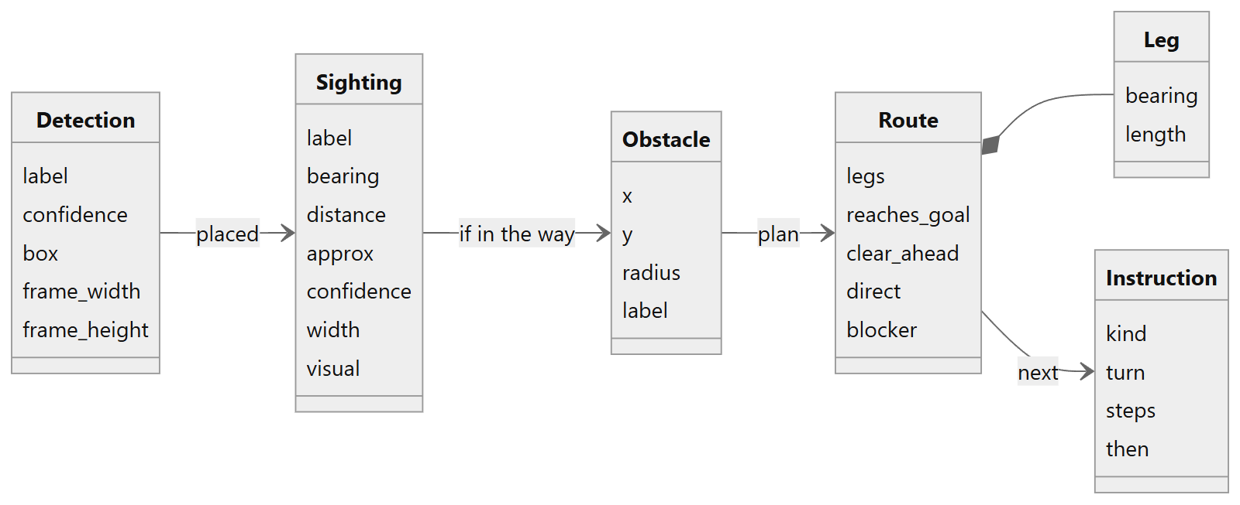
Record | Made by | Meaning
Detection | detector.py | One object in one picture: what, how sure, and its box in pixels
Sighting | Assistant._sightings() | That object relative to the wearer: bearing and distance. approx marks a camera estimate; visual keeps the camera's own estimate for later checks
Obstacle | planner.py | A disc on the floor map, from a LiDAR reading or from a sighting
Route, Leg | planner.plan() | The stretches to walk, and what was found about the straight line
Instruction | navigator.next_instruction() | The one action to speak next; phrases.py turns it into a sentence

5. The main loop
Assistant.run() says "Visual Assist is ready", starts the listener thread, and calls step() until told to stop.

5.1 One step
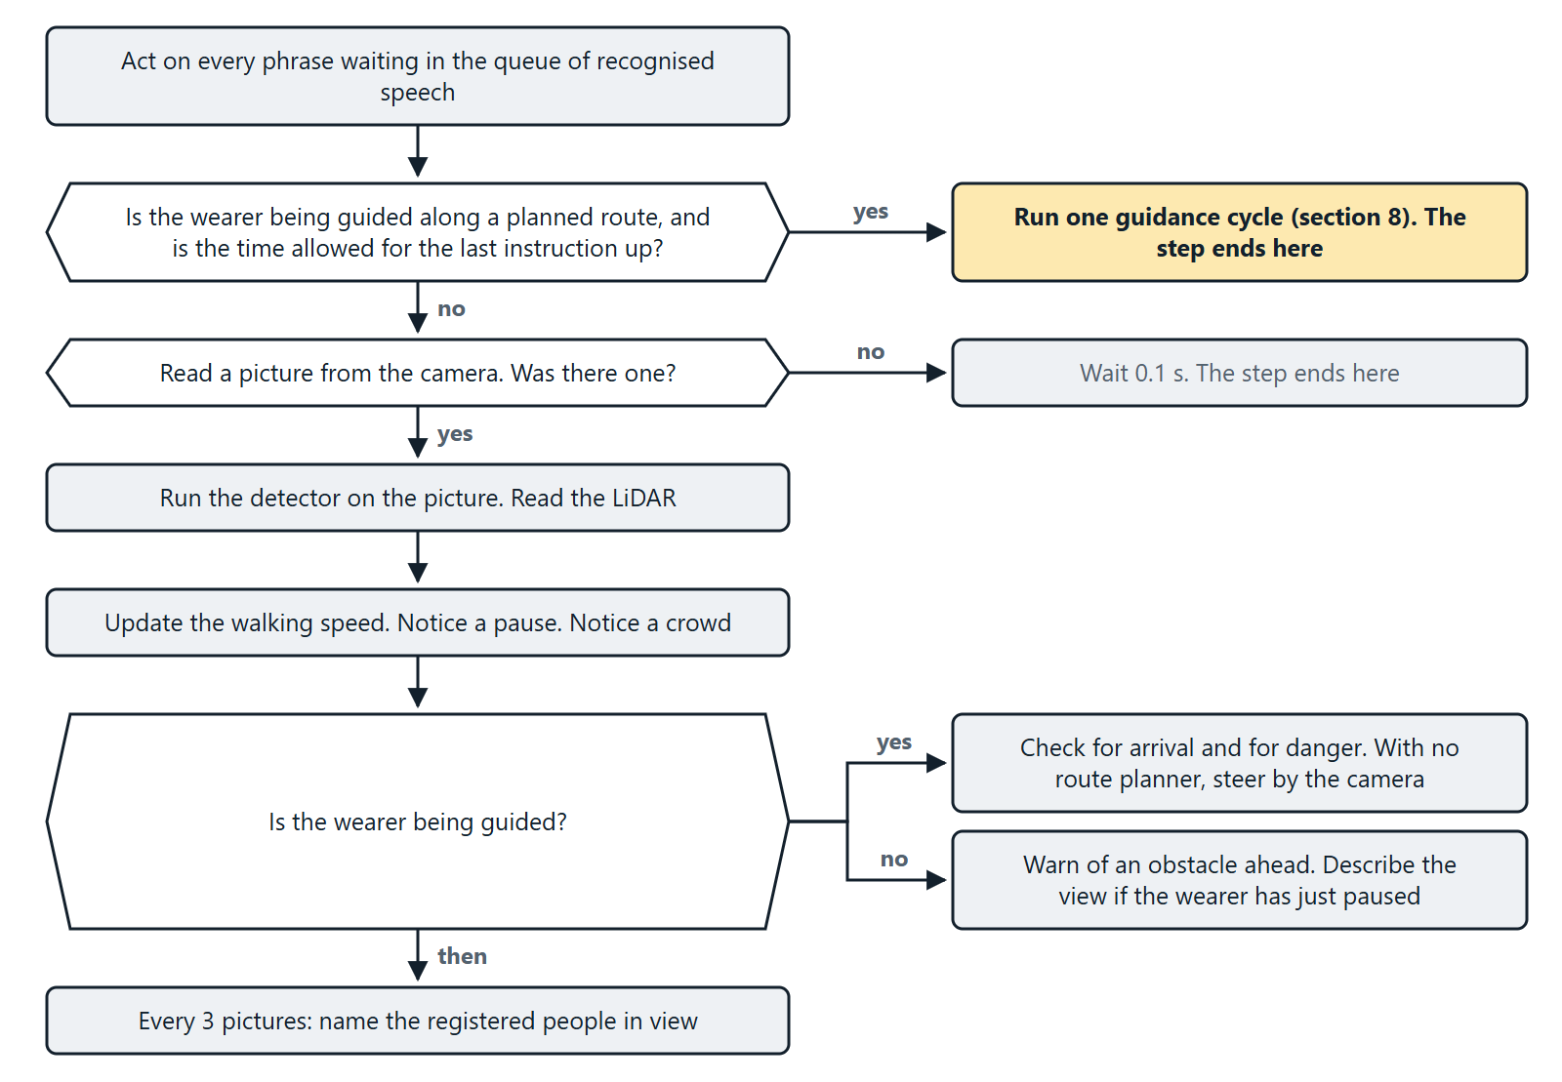
One pass of step(). A pointed box is a question; a box on the right is where that answer leads.
In words, one step() does this:
- Commands. Take every phrase waiting on the queue and act on it (section 6).
- Planned guidance. If the wearer is being guided along a planned route and the time allowed for the last instruction has passed, run one guidance cycle (section 8) and return.
- Look. Read one picture. Run the detector. Read the LiDAR.
- Movement. Update the walking speed and notice a pause (section 9).
- Crowd. Three or more people in view is announced once as crowded.
- React.
  - While guiding: check for arrival and for danger. Where no route can be planned, this step is the guidance itself, steering by the camera.
  - Otherwise: warn of an obstacle ahead, and describe the view to a hesitant wearer who has just stopped.
- Faces. Every third picture, name the registered people in view.
- Preview. With --show, draw the boxes and the LiDAR reading in a window.
The listener thread waits until the assistant has finished speaking, so it never transcribes the assistant's own voice, then listens and queues what it heard.
On exit, close() saves the user profile, centres the head, lets the speaker finish, and closes the devices.

5.2 A command from start to finish
What happens between the wearer asking "Where is the door?" and hearing the answer. Sections 6 and 7 explain each part.
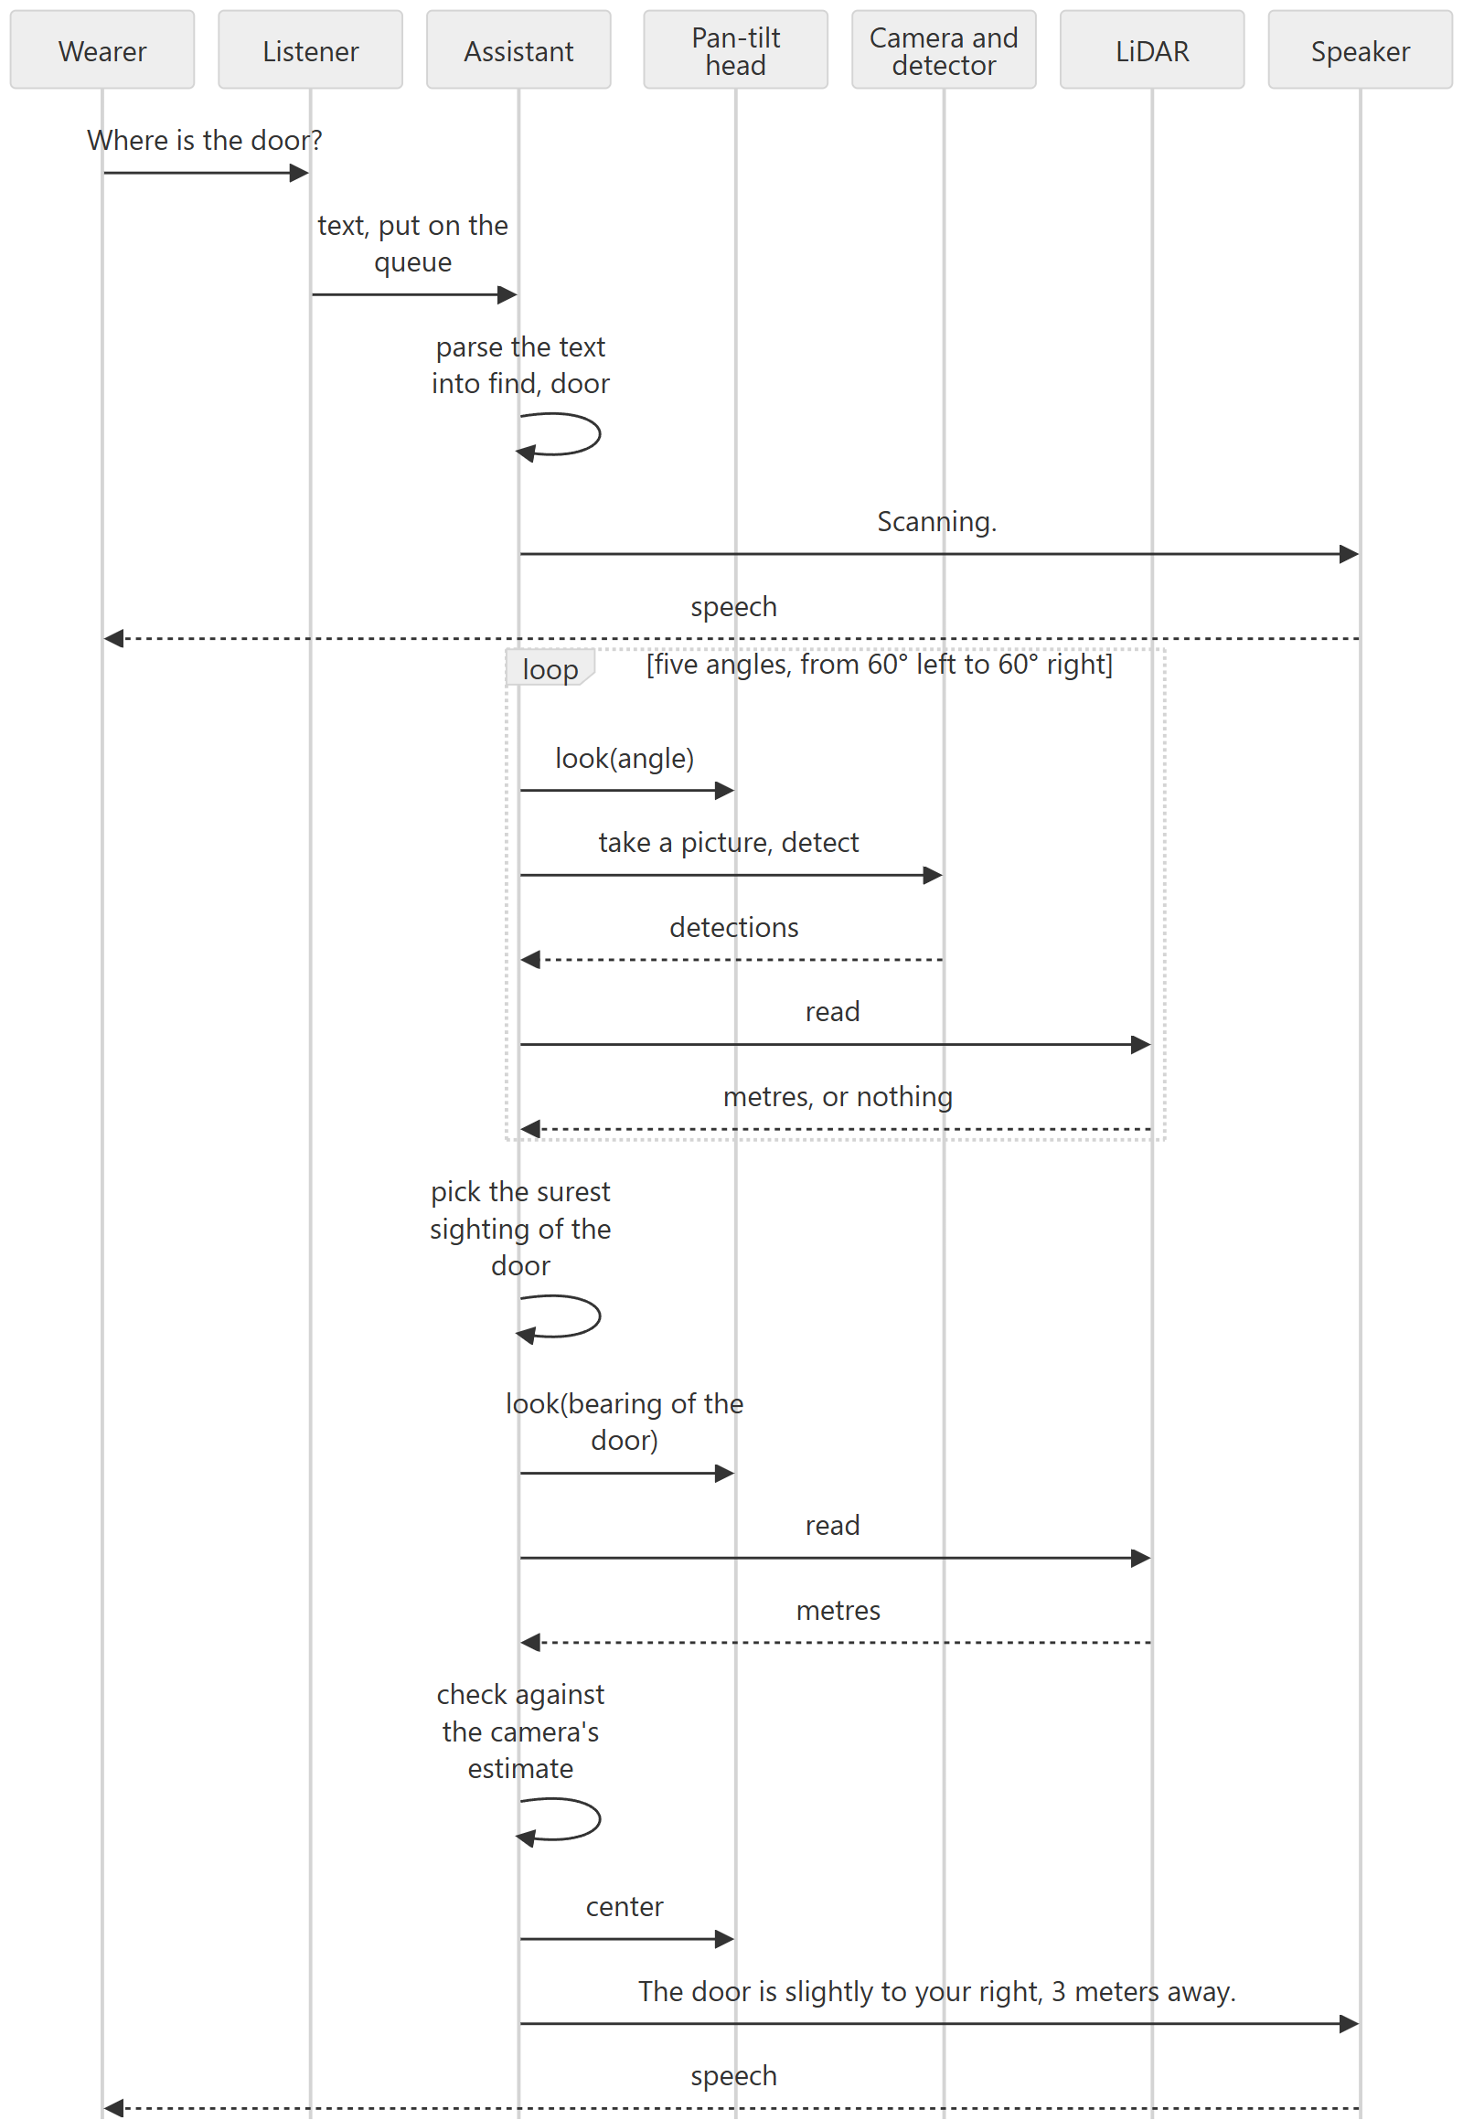
On the wire, each look() is two lines of text to the ESP8266 (PAN, TILT) and each LiDAR read is one 9-byte frame (section 3). The demo page's "Inside the device" section plays this same sequence with the real messages.

6. Voice commands
Source: visual_assist/commands.py. Commands are spoken in English whatever language the replies are in.
parse(text, labels) lowercases the text, strips punctuation, and tests it against these rules in order. The first match wins.
Order | Intent | Triggered by | Target
1 | exit | The whole phrase is one of: exit, quit, shut down, shutdown, power off, goodbye
2 | language | A language name with speak, talk, language, say, switch or change, or the name alone | en, ml, hi, ta
2 | verbosity | speak less, be brief; more detail, tell me more; normal detail | brief, detailed, normal
2 | rate | speak faster, too slow; speak slower, too fast | faster, slower
2 | warn | warn me earlier; warn me later, fewer warnings | earlier, later
3 | stop | stop, cancel
4 | repeat | repeat, say that again, pardon, come again
5 | register | register, remember, save this | The name after "as", "named" or "called", if given
6 | who | who
7 | money | money, note, rupee, rupees, currency, cash
8 | guide | guide me, take me, lead me, navigate, go to, bring me | The object named
9 | find | where, find, locate, is there, look for, search for | The object named
10 | find or distance | how far, distance | find if a known object is named, otherwise distance to whatever is ahead
11 | scan | scan, around, describe, surroundings, in front, what do you see
12 | help | help, what can you do

Naming an object. The target is the longest known label found in the phrase, singular or plural. Everyday words are mapped to the detector's labels first: desk to table, mug to cup, couch and settee to sofa, seat to chair, doorway to door, man, woman and someone to person. If no known label is found, the words after "the", "a", "my" or "to" are taken, so that "where is the kitchen" can be answered with "I have not been trained to recognise kitchen".
Speech that is not a command is ignored in silence, because a microphone overhears a great deal. If listener.wake_word is set (for example assistant), only phrases containing that word are obeyed, and one that contains it but is not understood gets a spoken "not understood".
Each intent is handled by the method Assistant._cmd_<intent>.

7. Perception: what is where, and how far

7.1 Detection
Source: visual_assist/detector.py.
Two models run on every picture and their results are pooled (MultiDetector):
Model | Finds | Confidence | Input size
weights/yolov5nu.pt | 80 everyday objects (COCO) | 0.35 | 640
weights/doors.pt | Doors only (its other classes are dropped) | 0.4 | 512

Some class names are replaced by the words people use: couch to sofa, dining table to table, tv to television, potted plant to plant, cell phone to phone.
Each result is a Detection: label, confidence, box, and the picture's size. From these it derives:
- position: left, center or right, by which third of the picture the middle of the box is in;
- spans_center: whether the middle column of the picture, where the LiDAR points, falls on the box;
- fills_frame: whether the box runs off all four sides, which means the camera is right in front of the object.
center_detection() picks the detection the LiDAR beam is most likely hitting: of those spanning the centre, the one whose middle is nearest it.

7.2 Bearing from a pixel
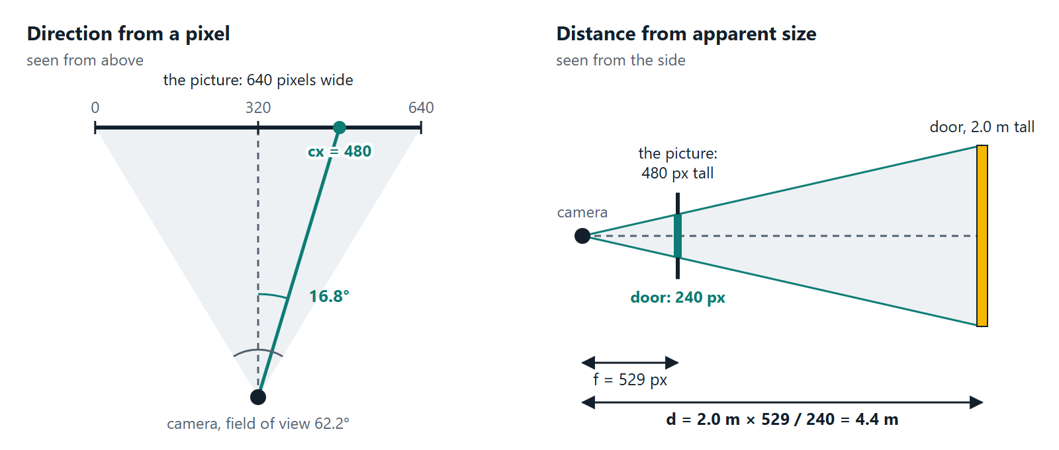
The geometry behind this section (left) and the next (right).
bearing = atan( (cx - W/2) / (W/2) × tan(HFOV / 2) )
cx is the column of the middle of the box, W the picture width, and HFOV the camera's horizontal field of view (62.2° for the Pi Camera Module V2). Added to the angle the head is turned to, this gives the object's bearing from the wearer.

7.3 Distance from apparent size
Source: visual_distance() in navigator.py.
An object of known real size looks smaller the further away it is:
focal_px = (H / 2) / tan(VFOV / 2)
distance = real_height × focal_px / height_px
Example: a door (2.0 m tall) that is 240 pixels tall in a 480-pixel picture with a vertical field of view of 48.8° is 2.0 × 529 / 240 = 4.4 m away.
Rules:
- Height is used when the whole height is in the picture. Close up, an object is taller than the picture, and its width is used instead.
- A box within 2 pixels of the picture's edge is taken to be cut off on that side. An object cut off both ways gives no estimate.
- Only objects whose size varies little are listed. Tables and sofas come in every size, so the camera alone cannot say how far they are.
Object | Height (m) | Width (m)
door | 2.0 | 0.9
person | 1.65 | 0.5
refrigerator | 1.7 | 0.7
chair | 0.9 | 0.5
bottle | 0.25 | 0.08
cup | 0.1 | 0.08

7.4 Combining the LiDAR and the camera
Source: fuse_distance().
The LiDAR is exact, but it measures whatever its beam hits. Aimed at a door, it may be stopped by a chair in front of the door.
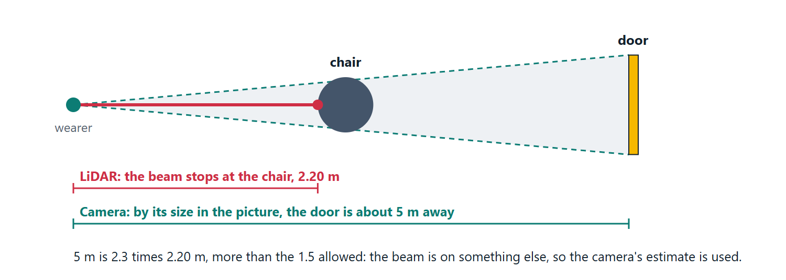
The case the check exists for, with the figures from the demo's "chair in the way" room.
So each reading is compared with the camera's estimate:
LiDAR reading | Camera estimate | Distance used | Spoken as
none | none | unknown | no distance
none | available | the camera's | "about 4.5 meters"
available | none | the LiDAR's | "2.4 meters"
both, within a factor of 1.5 of each other |  | the LiDAR's | "2.4 meters"
both, further apart than that |  | the camera's | "about 5 meters"

A camera estimate is rounded to the nearest half metre and always spoken with "about".

7.5 Looking around
A scan (_scan) turns the head to five angles (−60°, −30°, 0°, 30°, 60°) and at each takes a picture, runs detection and reads the LiDAR. The LiDAR reading is credited only to the detection on the camera's axis.
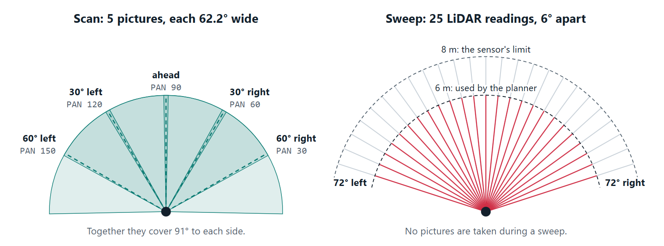
A scan (left) finds what is in the room and where. A sweep (right, used by route planning in section 8.2) finds where the obstacles are.
When the same kind of object is reported in more than one view, _pick chooses: the most confident report decides where the object is; among the views within 15° of that, the one with a measured distance wins, then the one where the object was nearest the middle of the picture.
To measure an object whose distance is not yet exact (_range), the head turns to its bearing (at most 90° either way), the LiDAR is read, and the reading is combined with the camera's estimate as in 7.4.

8. Guidance and route planning
Sources: assistant.py (_plan_route, _obstacles, _instruct), planner.py, navigator.py (next_instruction).
"Guide me to the door" first finds and measures the door as in section 7. If the door is already within reach, the assistant says so. Otherwise guidance begins, and repeats the cycle below after every instruction until the wearer arrives. Because the whole cycle runs again each time, a turn that was too wide or a step that was too short is corrected as it happens.
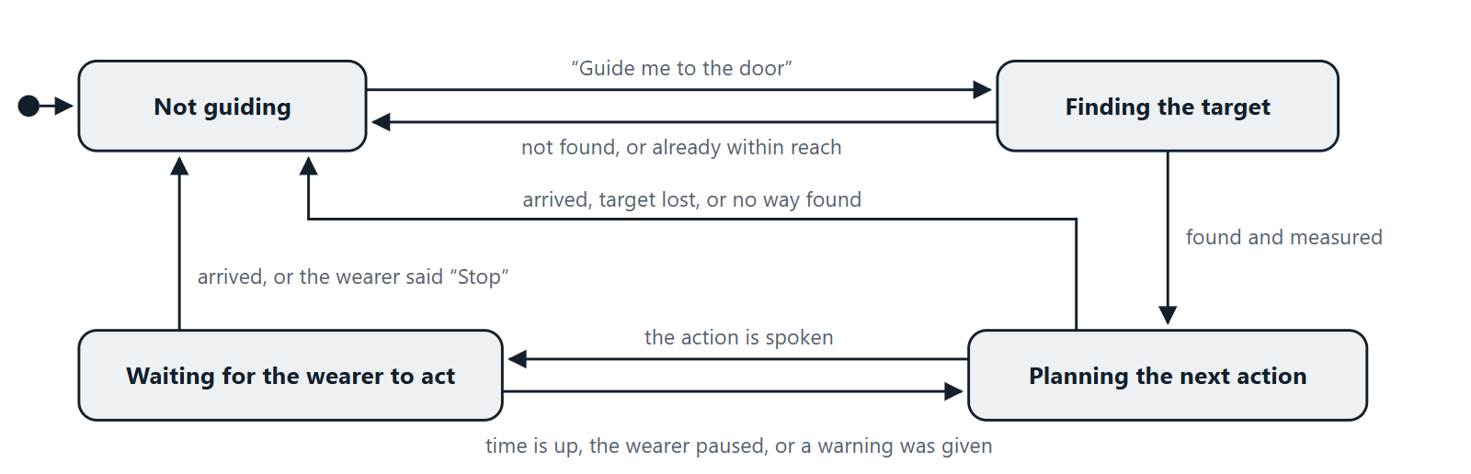
The states of guidance. "Planning" is one pass through the cycle in 8.1; "waiting" is the main loop of section 5 carrying on while the wearer turns or walks.

8.1 One guidance cycle
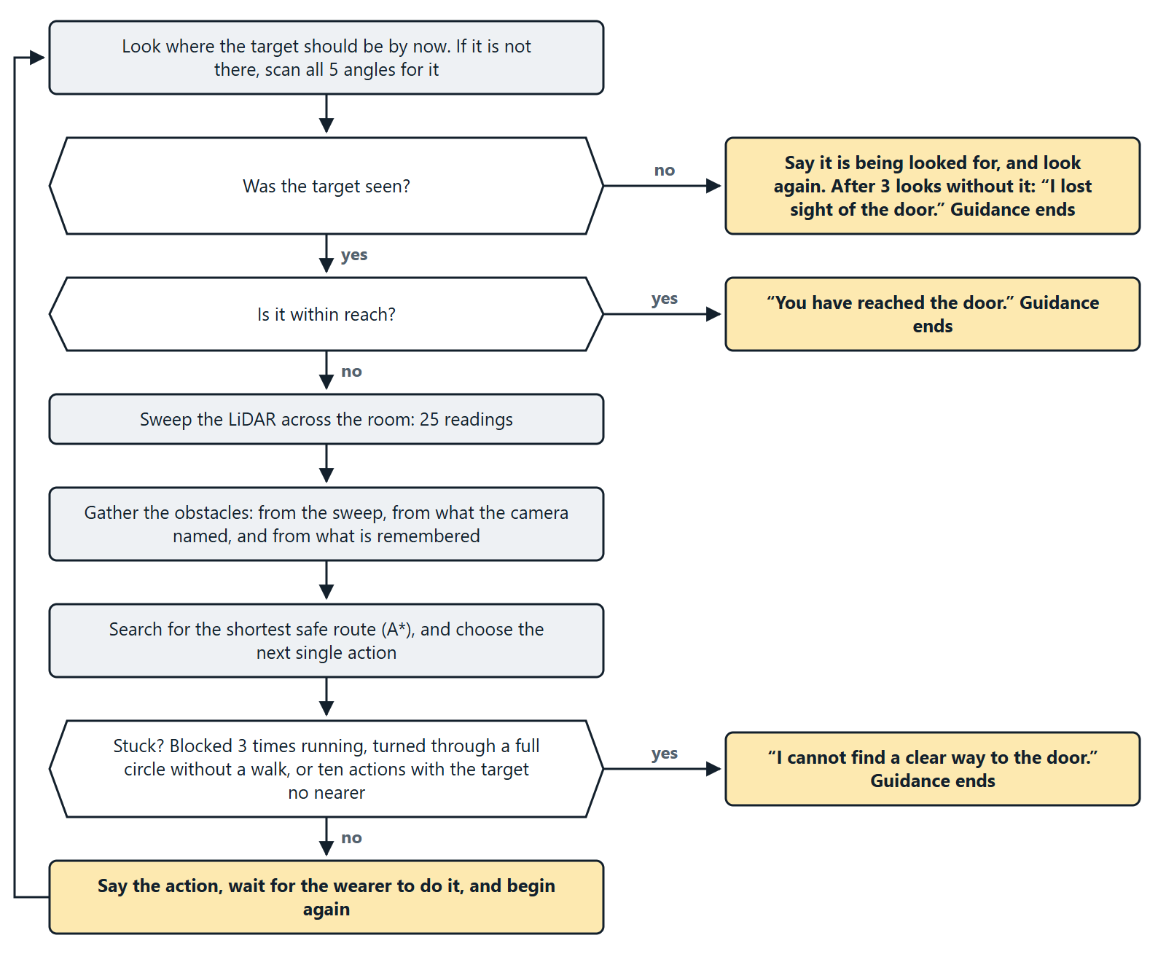
One guidance cycle. The sections below take its steps in turn; 8.6 says more about being stuck.

8.2 Obstacles
Three sources are put together (_obstacles):
- The sweep. The head turns from −72° to +72° in 6° steps and the LiDAR is read at each: 25 readings. Each hit within 6 m becomes a disc (obstacles_from_rays). Two hits on one wall are distance × step apart, so each disc is given half of that as its radius (0.25 m at most); otherwise a wall would look like a row of posts to walk between. Neighbouring hits that are no further apart than a slanted wall would put them are joined with extra discs every 0.2 m. A bigger jump is the edge of an object with open floor beside it, and is left open.
- The camera. Every object named in the latest look, other than the target, becomes a disc sized from how wide it looked (radius 0.1 m to 0.75 m), centred one radius beyond its near face. These carry a name, which is how the wearer can be told "Chair in the way".
- Memory. A sweep sees only what is in front. When the wearer turns on the spot, what was found before is still there, at another angle. Obstacles are remembered by their direction relative to the target, which does not move, and put back wherever the target is seen next. The memory is dropped as soon as the wearer walks.
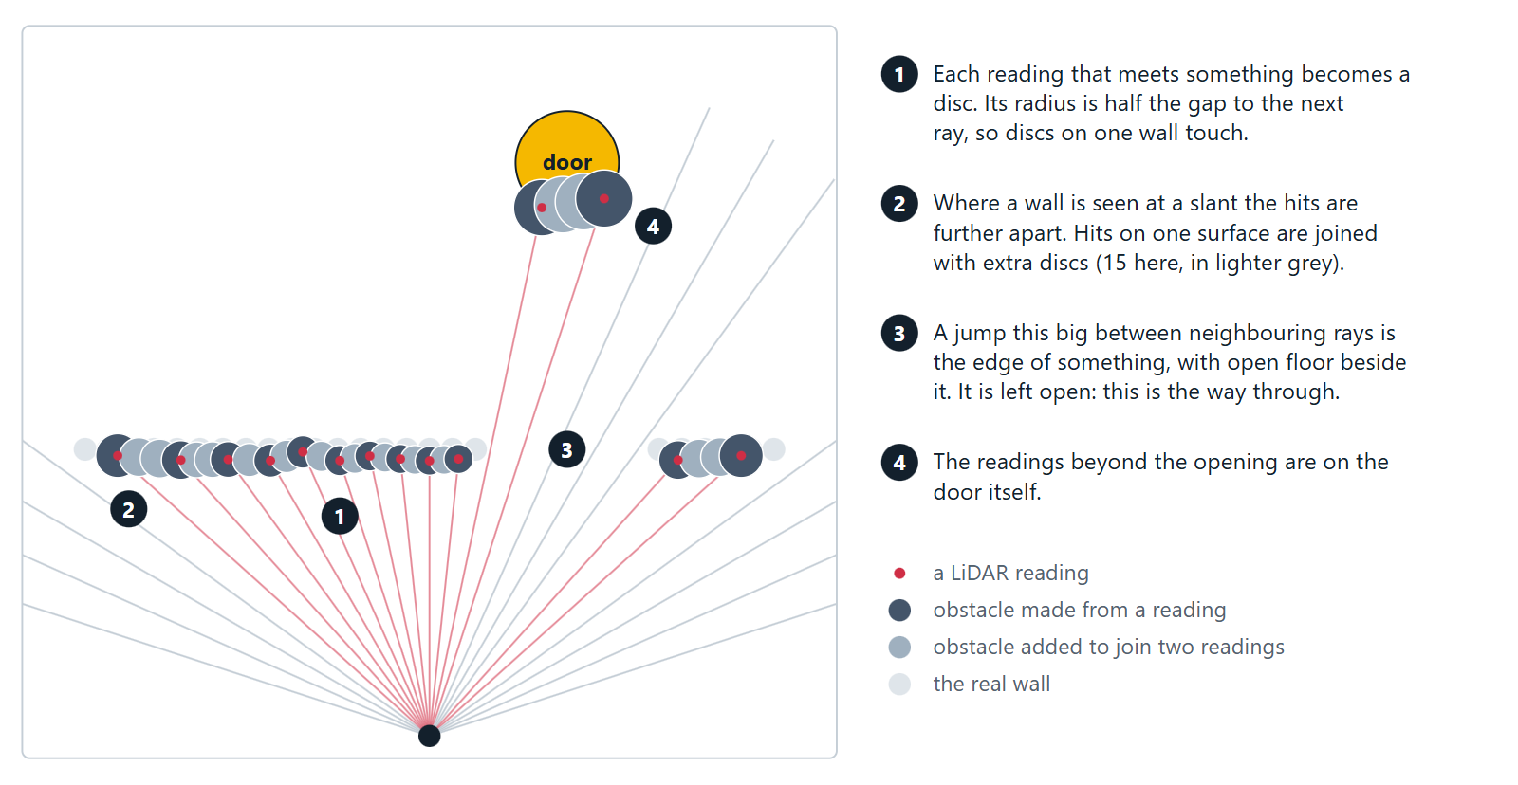
A sweep turned into obstacles, in the demo's "wall with an opening" room. Computed by obstacles_from_rays().

8.3 The map and the search
plan() builds a grid of 10 cm cells covering the floor from the wearer to 1.5 m beyond the target, and 1.5 m behind the wearer.
- Blocked cells. Every cell within radius + 0.35 m of an obstacle's centre is blocked. The 0.35 m is the clearance: half the width a walking person needs.
- Soft margin. The next 0.3 m is free but costs more to cross, up to three times as much right at the blocked edge. The route therefore keeps a little further away where that costs little.
- The target itself. Obstacles within reach of the target are the target's own surface. They do not block the route, or the destination would be walled off.
- The wearer's own position is always free.
- Unmeasured space is treated as free. This is safe because the wearer is only ever told to walk in a direction the sweep has just covered.
The search is A* over the grid, moving to any of the eight neighbouring cells, never cutting diagonally between two blocked cells. The cost of a move is its length times one plus the soft-margin penalty. The estimate of what remains is the straight-line distance to the stopping point, which is arrive_m (0.6 m) short of the target.
- If nothing is in the way, the route is the straight line and no search is run.
- If the target cannot be reached, the route goes to the closest reachable point, provided that is at least 0.3 m nearer than standing still.
- The search stops after 40,000 cells.
The staircase the grid produces is then straightened: each corner is dropped if the stretch before it and the stretch after it can be joined by a line that crosses no blocked cell. What remains is the list of legs.
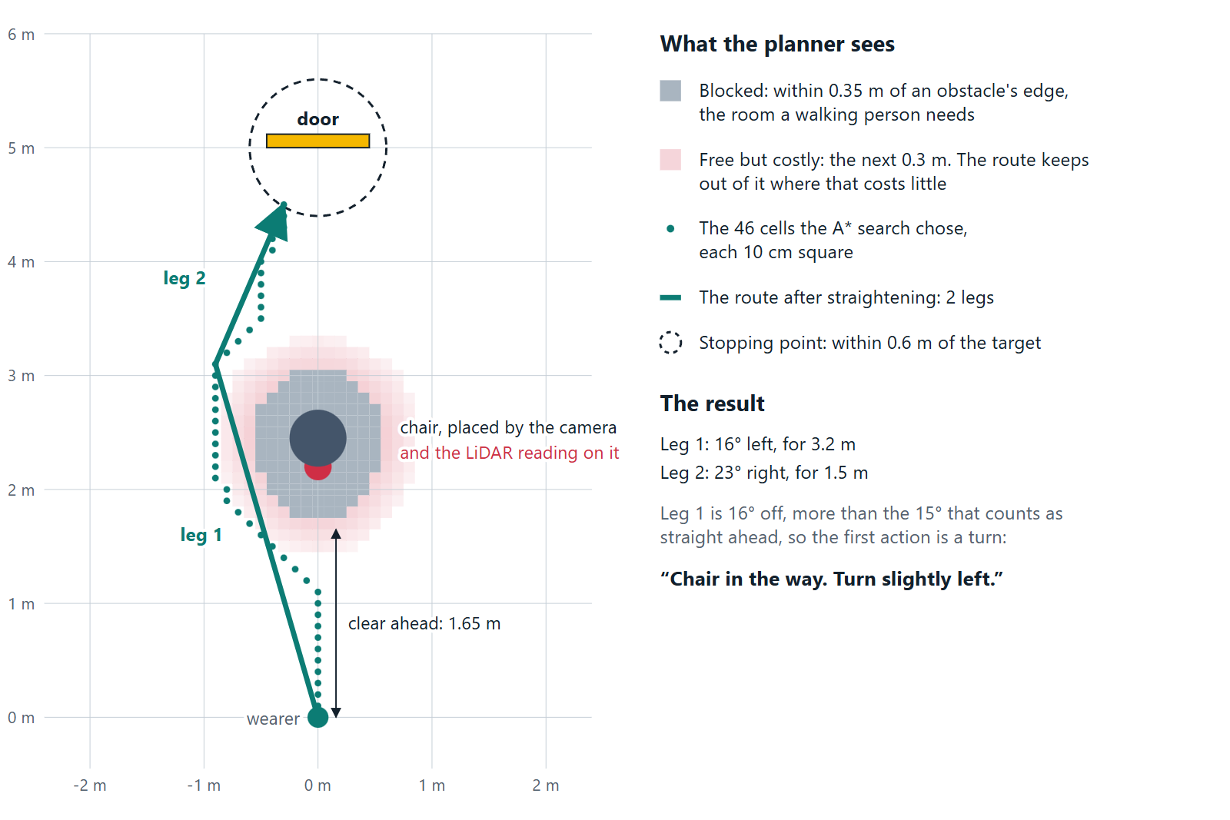
The map and the route for the demo's "chair in the way" room, drawn from the planner's own grid. The dotted line is what the search found; the solid line is the same route after straightening.
The result is a Route:
Field | Meaning
legs | The stretches to walk, each a bearing and a length. Empty means no way forward
reaches_goal | Whether the route ends at the target
clear_ahead | Metres that are free straight ahead of the wearer
direct | Whether the straight line to the target is free
blocker | The name of what blocks that line, if the camera named it

clear_ahead does count the target's own surface, with a clearance of 0.15 m: the route may end beside the target, but nobody is to be walked into it.

8.4 Choosing the next action
next_instruction() turns the route into exactly one action:
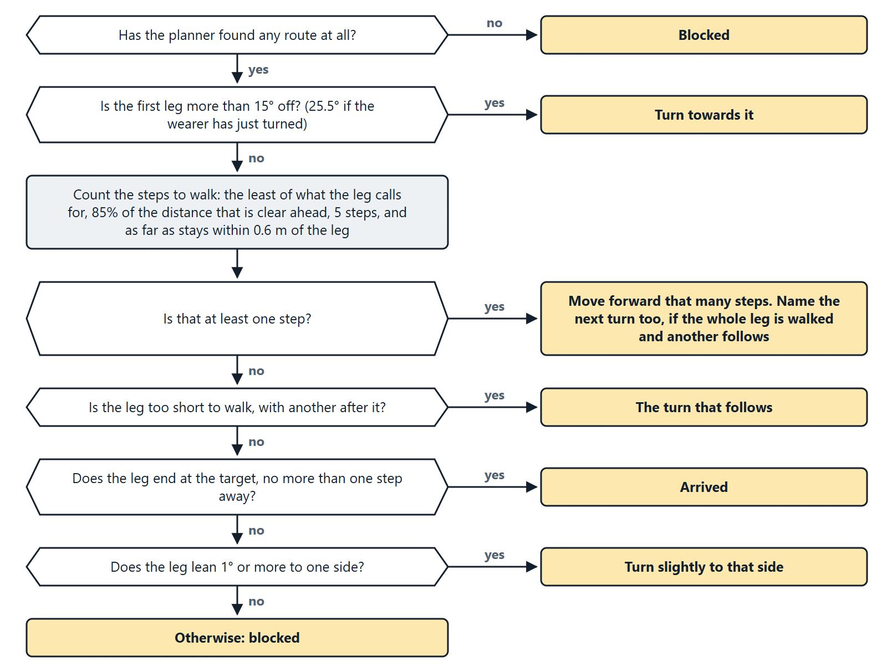
Choosing the action. A pointed box is a question; a box on the right is the action that answer leads to.
The same rules in words:
- Turn first. If the first leg is more than 15° off, the action is a turn, and nothing else.
- Then walk. The number of steps is the smallest of:
  - what the leg calls for (its length divided by the 0.6 m step);
  - what there is room for: 85% of clear_ahead;
  - five steps;
  - as far as can be walked before drifting 0.6 m sideways from the leg, since the wearer walks the way they face, not exactly along the leg.
- Mention the next turn ("Move forward 4 steps, then turn right") only if the whole leg is being walked and another follows.
If no whole step can be taken, one of these applies instead:
- Skip a leg too short to walk and go straight to the turn that follows it.
- Arrived, if this leg ends at the target and is no longer than one step.
- Edge away. If there is no room for a step although the wearer faces almost the right way, they are brushing past something: turn slightly to the side the route leans.
- Blocked if none of these applies.
An Instruction has a kind (turn, move, arrived, blocked), a turn name, a number of steps, and optionally a turn to make after walking.

8.5 Turns
A spoken turn comes in three sizes. People told to turn "slightly" turn about 30°, and told to "turn" about 90°, so the sizes are chosen around those.
Angle to turn | Spoken | The wearer is expected to turn
up to 15° | nothing: it is straight ahead | 0°
up to 60° | "Turn slightly left / right" | 30°
up to 135° | "Turn left / right" | 90°
more | "Turn around" | 180°

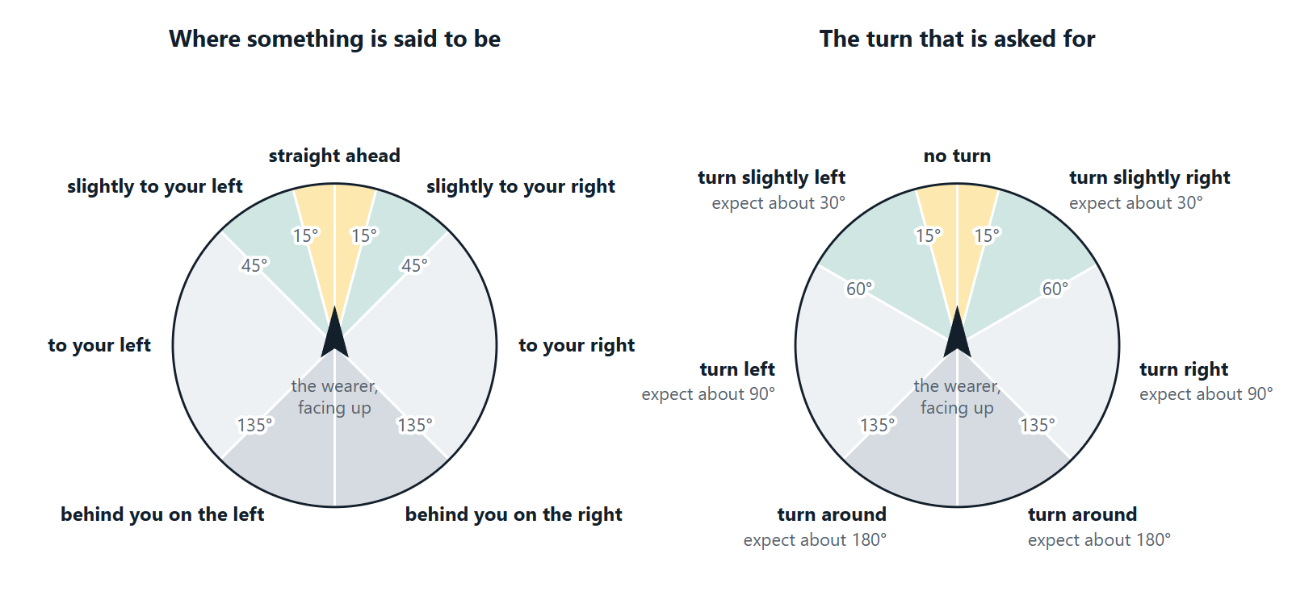
The words for where something is (left) change at different angles from the turn that is asked for (right). Something 50° to the right is "to your right", but the turn towards it is still "slightly right", because a slight turn of about 30° leaves less to correct than a full turn of 90°.
Nobody turns exactly 30°. Right after a turn, the "straight ahead" band is therefore widened by a factor of 1.7 (to 25.5°), so that the small error left over is walked off rather than corrected with turn after turn.

8.6 Keeping the wearer steady
Imprecise turns and steps are expected, and several rules stop them from causing trouble:
- No walk longer than what was just measured as clear, less a 15% margin, and never more than five steps.
- No ping-pong between two routes. Two ways round an obstacle are often nearly the same length, and which is shorter can change with every sweep. If the wearer has just been turned one way and the new plan would turn them back, the route is planned again with a preference for walking straight ahead (keep_straight), accepting up to 0.5 m more length.
- The target behind the wearer. A detour can turn the wearer's back on the target, further round than the head can look. For up to two cycles the assistant carries on from where the target must be.
- Giving up, aloud. Guidance ends with "I cannot find a clear way to the door. Guidance stopped." when the way has been blocked three times running, when the wearer has been turned through a full circle without a walk, or when ten instructions have brought the target no nearer (by at least 0.3 m). It ends with "I lost sight of the door. Guidance stopped." after three looks without it.

8.7 Timing
After an instruction the assistant waits before planning again (_time_for):
Instruction | Wait
A turn | 3 s
Blocked, or "forward slowly" | 4 s
A walk | 2 s, plus the steps at the wearer's own pace, plus 1.5 s if a turn follows; at most 12 s

The pace is the step length divided by the wearer's usual walking speed, which is learned (section 9). Meanwhile the main loop keeps watching. A pause by the wearer brings the next cycle forward at once, and an obstacle warning brings it forward to within a second.

8.8 Arrival
The aim is to stop arrive_m (0.6 m, arm's reach) from the target. Steps are whole, so the wearer has arrived once less than half a step short of that: at 0.9 m with the default settings. Between cycles, arrival is also noticed directly when the target is on the camera's axis and that close, or when no distance is known and the target has grown to fill the picture.
On arrival the trip is counted in the profile, so that a destination walked to three times gets brief guidance from then on.

8.9 Without a LiDAR or a turning head
No route can be planned. Guidance then steers straight at the target by camera, every picture (_direct_instruction): turn until it is ahead, then walk towards it. This is what happens on a laptop and in the demo page's camera section.

8.10 A worked example
One whole trip, recorded from the simulator: a chair stands 2.2 m in front of the wearer, directly between them and a door 5 m away. The simulated wearer does exactly what is said.
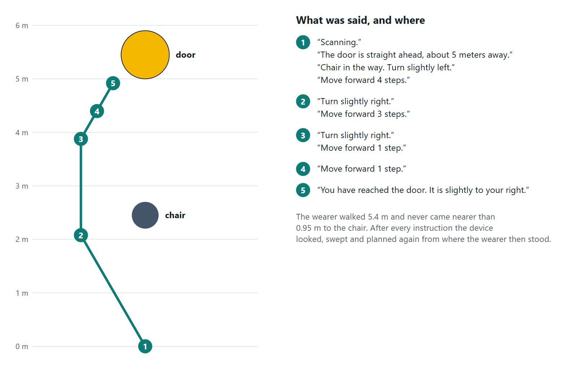
The path walked, and what was said at each numbered place. This is the trip the demo page plays in its first section.
Three things in it are typical:
- The first route leaned 16° left, but the wearer was told "slightly left" and turned 30°. The next plan started from where they then stood and faced, and simply carried on from there.
- Walks are short: 4 steps, then 3, then 1 and 1. Each is limited by what the sweep had just measured as clear.
- The trip ends beside the door, not in front of it, because the route came round the chair. The last sentence says which way the door is.

9. Feedback and adaptation
Source: visual_assist/adaptation.py.
The device has no motion sensor. The wearer's movement is read from what it has (MotionTracker):
What | Read from | Details
Walking speed | How fast the LiDAR distance ahead shrinks | Smoothed by half each reading. A change faster than 2.5 m/s is taken to be the beam jumping to another object and is ignored
Turning | How far the picture slides sideways between two pictures | Phase correlation on 160 × 120 grey copies; more than 8° counts as turning. No speed is measured while turning
Standing still | Neither of the above changing | Speed under 0.15 m/s, or under 3% of the picture changing
A pause | Standing still for 6 s after having moved | Counted once per stop

9.1 Rules
The assistant notices | and responds by
Walking speed | Warning further ahead: 1.0 m + speed × 1.5 s, between 0.5 m and 3.0 m. At 1 m/s that is 2.5 m
An obstacle less than 1.5 s of walking away | "Stop, chair ahead, 1.1 meters", cutting in on anything being said. Repeated at most every 1.5 s
Walking fast, or a crowd | Shorter gaps between warnings: 4 s divided by 1 + speed, halved in a crowd
Standing before the same obstacle | Not repeating the warning for 15 s unless the distance changes by 0.3 m
A pause during guidance | Repeating the instruction
Two pauses within two minutes | Detailed speech, and a description of what is ahead at each pause (at most every 30 s)
Three or more people in view | Saying once a minute at most that it is crowded, keeping warnings short, and not announcing strangers
A target guided to three times | Brief guidance: "3 steps."
A person met three times | Announcing them by name only, and before less familiar people
A person not met for a day or more | Adding how many days it has been
The wearer's usual walking pace | Timing the wait after "move forward" to match; learned 5% at a time

How much is said (verbosity) is decided in this order: the wearer's stated preference, then hesitation (detailed), then familiarity with the target (brief), otherwise normal.

9.2 Deciding whether to warn
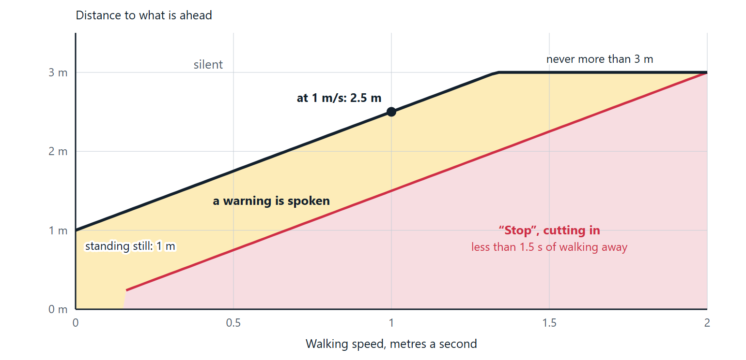
How far ahead a warning is given, against walking speed, with the default settings. Computed by warn_distance() and is_urgent().
Being inside the warning distance is not enough for a warning to be spoken. _warn_obstacle() runs on every picture and decides:
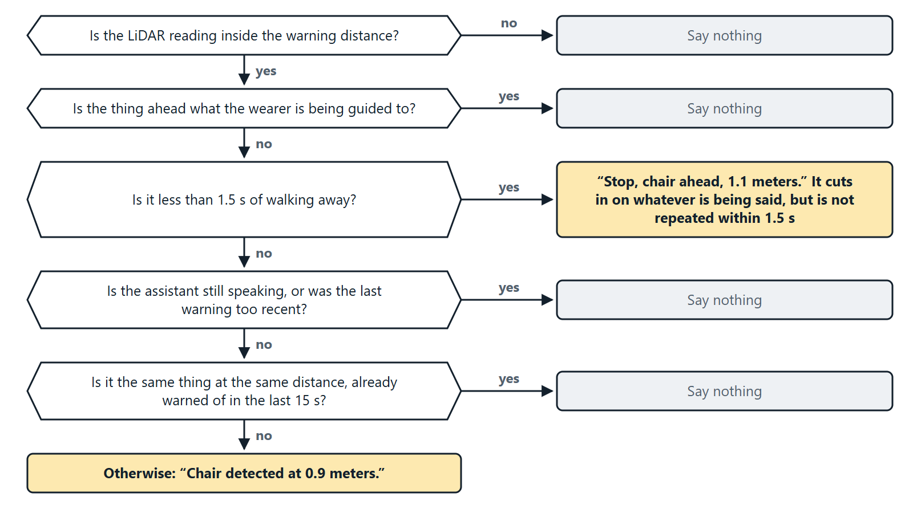
The thing ahead is named from the detection on the camera's axis; if there is none it is called an obstacle.

9.3 The profile
UserProfile is saved as JSON at data/profile.json whenever it changes.
Field | Meaning | Changed by
language | Spoken language | "Speak in Malayalam"
verbosity | brief or detailed; empty means decide automatically | "Speak less", "More detail", "Normal detail"
speech_rate | Words per minute, 100 to 260 | "Speak faster / slower", 25 at a time
warn_offset_m | Added to the warning distance, −0.5 to 1.5 | "Warn me earlier / later", 0.25 m at a time
walk_speed | Usual walking speed, m/s | Learned while walking
targets | Times guided to each kind of object | Each arrival
people | For each person: meetings and when last seen | Each announcement

A profile file that cannot be read is ignored with a warning.

10. Banknotes and faces

10.1 Banknotes
Source: visual_assist/currency.py.
The model is an image classifier with 11 classes: 10_new, 10_old, 20, 50_new, 50_old, 100_new, 100_old, 200, 500, 2000 and none. Old and new series look different, so they are separate classes; only the value is spoken.
"What note is this?" takes three pictures and averages the model's scores, so one blurred picture cannot decide the answer. decide() then adds the scores of the series of the same value (55% 100_new plus 35% 100_old is a confident 100) and takes the highest.
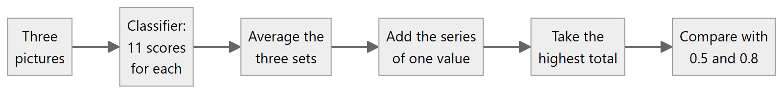
Confidence | Answer
0.8 or more | "This is a 500 rupee note."
0.5 to 0.8 | "This looks like a 500 rupee note, but I am not sure. Please show it again."
below 0.5, or the none class | "I do not see a currency note. Hold it closer to the camera."

The threshold for a plain statement is set high on purpose: a confident mistake about money is the costly kind.

10.2 Faces
Source: visual_assist/faces.py.
Two models from OpenCV's model zoo do the work. Both run on the OpenCV that is already installed, so nothing has to be compiled on the device.
Model | File in weights/ | Job
YuNet | face_detection_yunet_2023mar.onnx (0.2 MB) | Finds the faces in a picture, with five landmarks on each: the eyes, the nose, the corners of the mouth
SFace | face_recognition_sface_2021dec.onnx (39 MB) | Turns one face, straightened by its landmarks to 112 × 112 pixels, into 128 numbers: its feature

Pictures of the same person give features that point nearly the same way. How nearly is their similarity: the cosine of the angle between them, 1 for identical and about 0 for unrelated faces.
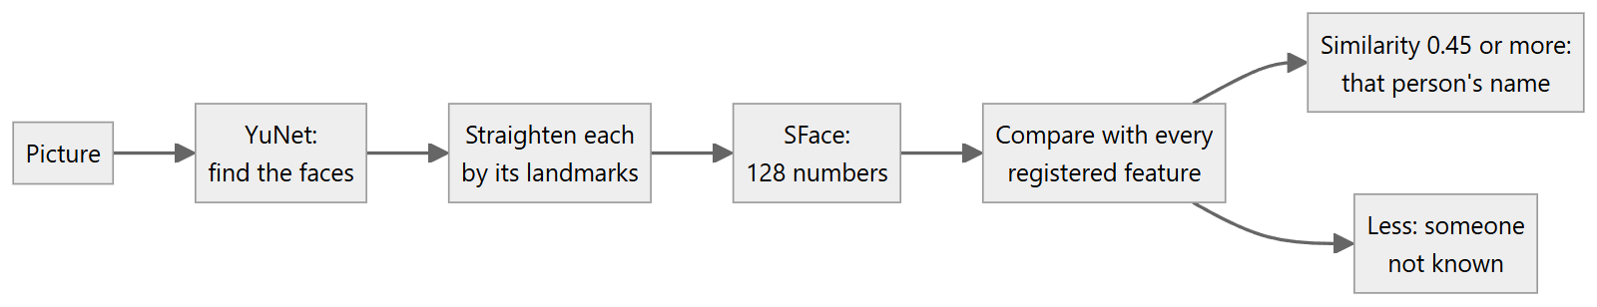
Recognising. A face is given the name of the registered person whose feature it is most like, provided the similarity is at least faces.similarity (0.45). Otherwise it is "a person I do not know". At most the five largest faces in a picture are looked at, and faces narrower than faces.min_face_px (40 pixels, about two metres away) are left out: too few pixels to tell one person from another.
- Every third picture is checked. Each person is announced at most once every 20 seconds, the most often met first.
- An unknown face gets "There is a person I do not know. Say register face to remember them.", at most once every 20 seconds and not in a crowd.
Registering. "Register face" or "Remember this person as Ashna" stores the feature of the largest face in view. The face must be at least twice min_face_px wide (within about a metre), so that the stored likeness is a good one; up to five pictures are tried. If no name was given the assistant asks for one and waits up to 15 seconds. python main.py register NAME does the same from the command line. Registering someone again adds another view of them, which helps them be recognised from more angles; the eight most recent views are kept.
What is stored. Only the features, in data/faces/faces.json, with the name of the model that made them. Photos are never kept and nothing leaves the device. A file made by a different model is ignored with a warning, since its numbers cannot be compared with these.
Choosing the threshold. On 352 faces from 292 unrelated photos, 0.05% of the pairs of faces from different photos scored 0.45 or more (0.34% at OpenCV's suggested 0.363). In a handful of photos of the same person the similarity was 0.75 to 0.98. The stricter 0.45 was chosen because, for a blind wearer, a wrong name is worse than "a person I do not know". Lower it if known people often go unrecognised; raise it if strangers are named.
If the model files are missing and cannot be downloaded, or OpenCV is older than 4.8, face recognition is switched off with a warning and everything else carries on.

11. Speech in and out, and languages

11.1 Speech out
Source: visual_assist/speech.py.
Voice | What | Needs
offline | espeak-ng on the Pi, the built-in Windows voices on a PC | nothing
gtts | Google Text-to-Speech, natural voices in all four languages | internet; mpg123 on the Pi
console | Print only | nothing

With speech.backend: auto, English uses the offline voice and the other languages use Google's. Whatever is chosen, the offline voice stands behind it: if a voice fails (usually no internet) the next one speaks the sentence and the failed one is left alone for 60 seconds. A dropped connection never means silence.
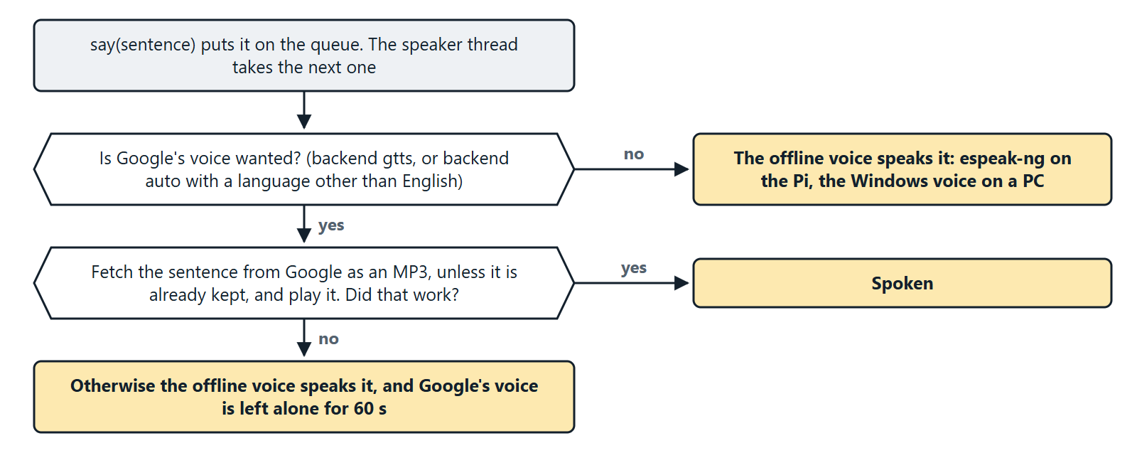
Speaker.say(text) puts the sentence on a queue served by a worker thread. With urgent=True the queue is emptied and the sentence being spoken is cut off. Each Google sentence is fetched once and kept as an MP3 in the system's temporary folder, since phrases such as "Scanning" repeat. Every sentence is also printed as [TTS]: ....

11.2 Speech in
Source: visual_assist/listener.py.
Backend | What | Needs
vosk | Offline recognition, 16 kHz mono | A Vosk model in models/
google | Google Speech Recognition, language en-IN | internet
keyboard | Typed commands | nothing

With listener.backend: auto, Vosk is tried, then Google, then the keyboard. Each backend has one method, listen(), which returns the text heard within listener.timeout_s (6 s) or nothing.

11.3 Languages
Source: visual_assist/phrases.py and visual_assist/locales/.
Every sentence the assistant can say is stored per language in locales/<code>.json, so sentences can be corrected or translated without touching code. A file has three parts:
Part | Content
name | The language's name
phrases | 87 sentences and fragments, with {placeholders}
labels | Object names in that language, with the grammar they need

A phrase is normally one string. Two kinds have variants:
- By count: {"one": "move forward 1 step", "other": "move forward {n} steps"}.
- By the grammatical form of the object named: {"default": ..., "f": ...}. Hindi verbs agree with the gender of the object, and Tamil uses a different verb for people than for things. A label declares its form, and the form used before a postposition, as {"text": ..., "form": ..., "obl": ...}.
A phrase or label missing from a language falls back to English.
The Malayalam, Hindi and Tamil sentences were written by a non-native speaker and should be read through by a native speaker before real use.

12. Configuration reference
All settings live in config.yaml. Every key is optional; the defaults are in config.py. An unknown key is an error, so a typing mistake is caught at start-up. Paths are relative to the folder holding the config file. auto means: use the real device if it is there, otherwise carry on without it.

camera
Key | Default | Meaning
backend | auto | auto, picamera2 or opencv
index | 0 | Webcam number when the Pi Camera is not used
width, height | 640, 480 | Picture size
hfov_deg, vfov_deg | 62.2, 48.8 | Field of view (Pi Camera Module V2). Wrong values give wrong bearings and distances

detector
Key | Default | Meaning
weights | weights/yolov5nu.pt | The main model
confidence | 0.35 | Detections below this are dropped
imgsz | 640 | Model input size
aliases | couch to sofa, and others | Model class name to spoken name
extra | the door model | More models. Each entry has weights and optionally classes (keep only these), confidence, imgsz, aliases

lidar
Key | Default | Meaning
backend | auto | auto, tfluna or none
port | /dev/serial0 | Serial port
baudrate | 115200

servo
Key | Default | Meaning
backend | auto | auto, esp8266, gpio or none
port | /dev/ttyUSB0 | The ESP8266's serial port
baudrate | 115200
pan_pin, tilt_pin | 12, 13 | BCM pins, gpio backend only
pan_center, tilt_center | 90, 90 | Servo angle for straight ahead and level
pan_invert | false | Set true if "right" turns the head left
scan_angles | −60, −30, 0, 30, 60 | Where the head looks during a scan
settle_s | 0.4 | Wait after a move before using the camera

speech
Key | Default | Meaning
backend | auto | auto, offline, gtts or console
language | en | en, ml, hi or ta
rate | 160 | Words per minute (offline voice)

listener
Key | Default | Meaning
backend | auto | auto, vosk, google, keyboard or none
vosk_model | models/vosk-model-small-en-us-0.15 | Folder of the Vosk model
language | en-IN | For the Google backend
wake_word | empty | If set, only phrases containing it are obeyed
timeout_s | 6 | How long one listen() waits

faces
Key | Default | Meaning
enabled | true
dir | data/faces | Where the registered faces are kept
detector | weights/face_detection_yunet_2023mar.onnx | The model that finds faces; downloaded on first use
recogniser | weights/face_recognition_sface_2021dec.onnx | The model that tells faces apart; downloaded on first use
similarity | 0.45 | Least likeness (0 to 1) for a face to be given a name. Higher is stricter
min_face_px | 40 | Faces narrower than this are ignored; twice this is needed to register
every_n_frames | 3 | Check every n-th picture
announce_cooldown_s | 20 | Least time between announcing the same person

navigation
Key | Default | Meaning
step_length_m | 0.6 | The wearer's step; guidance counts in these
obstacle_warn_m | 1.0 | Warning distance when standing still
arrive_m | 0.6 | Stop this far from the target
warn_cooldown_s | 4 | Least time between obstacle warnings
center_deadband_deg | 15 | Within this angle the target is "straight ahead". Must be at least half of a slight turn (about 30°), or guidance swings from side to side
lost_frames | 3 | Looks without the target before guidance stops

planner
Key | Default | Meaning
enabled | true | Needs a LiDAR and a turning head
sweep_half_angle_deg | 72 | How far the sweep goes to each side
sweep_step_deg | 6 | Angle between readings
sweep_settle_s | 0.05 | Wait at each step of the sweep
clearance_m | 0.35 | Room kept between the wearer and obstacles
resolution_m | 0.1 | Map cell size
max_range_m | 6.0 | LiDAR hits beyond this are ignored

adaptation
Key | Default | Meaning
enabled | true
profile | data/profile.json | Where the user profile is kept
reaction_s | 1.5 | Warn this many seconds of walking ahead
max_warn_m | 3.0 | Longest warning distance
walk_speed_mps | 0.8 | Starting guess of the walking speed
pause_s | 6 | Standing still this long is a pause
pause_window_s | 120 | Pauses within this time are counted together
hesitant_pauses | 2 | Pauses in the window before speech turns detailed
describe_cooldown_s | 30 | Least time between descriptions on pausing
crowded_people | 3 | People in view that make a place crowded
familiar_after | 3 | Trips to a target before guidance turns brief

currency
Key | Default | Meaning
weights | weights/currency.pt | The banknote model; empty switches the feature off
confidence | 0.8 | Below this the answer is given as a guess
minimum | 0.5 | Below this it is treated as no note

Constants in the code
These are not settings, but they shape the behaviour described above.
Constant | Value | Where | Meaning
AGREEMENT | 1.5 | navigator | LiDAR and camera must agree within this factor
SLIGHT_TURN_DEG | 60 | navigator | Largest turn spoken as "slightly"
AFTER_TURN_SLACK | 1.7 | navigator | Widening of "straight ahead" right after a turn
STEP_MARGIN | 0.85 | navigator | Share of the clear distance that may be walked
MAX_STEPS | 5 | navigator | Longest walk in one instruction
MAX_DRIFT_M | 0.6 | navigator | Most a walk may stray sideways from its leg
SOFT_MARGIN_M, SOFT_PENALTY | 0.3, 2.0 | planner | Extra room taken when it costs little
TARGET_CLEARANCE_M | 0.15 | planner | How near the target's surface a walk may end
STRAIGHT_BONUS_M | 0.5 | planner | Extra length accepted to keep going straight
MAX_EXPANSIONS | 40,000 | planner | Limit on the search
MAX_STALLED | 10 | assistant | Instructions without progress before giving up
SAME_OBJECT_DEG | 15 | assistant | Sightings this close in direction are one object

13. Models and training
File | Kind | Classes | Base | Trained on
weights/yolov5nu.pt | Detector | 80 (COCO) |  | By Ultralytics; downloaded on first run
weights/doors.pt | Detector | door (and handle, cabinet door, refrigerator door, which are dropped) | yolov5nu.pt | DoorDetect and Open Images
weights/currency.pt | Classifier | 10 kinds of note and "none" | yolov8n-cls.pt | Mendeley Indian banknote dataset, plus Open Images and door photos for "none"
weights/face_detection_yunet_2023mar.onnx | Face detector | faces, with five landmarks |  | By OpenCV's model zoo; downloaded on first use
weights/face_recognition_sface_2021dec.onnx | Face recogniser | a 128-number feature |  | By OpenCV's model zoo; downloaded on first use

From the public datasets to the models the device and the demo page use:
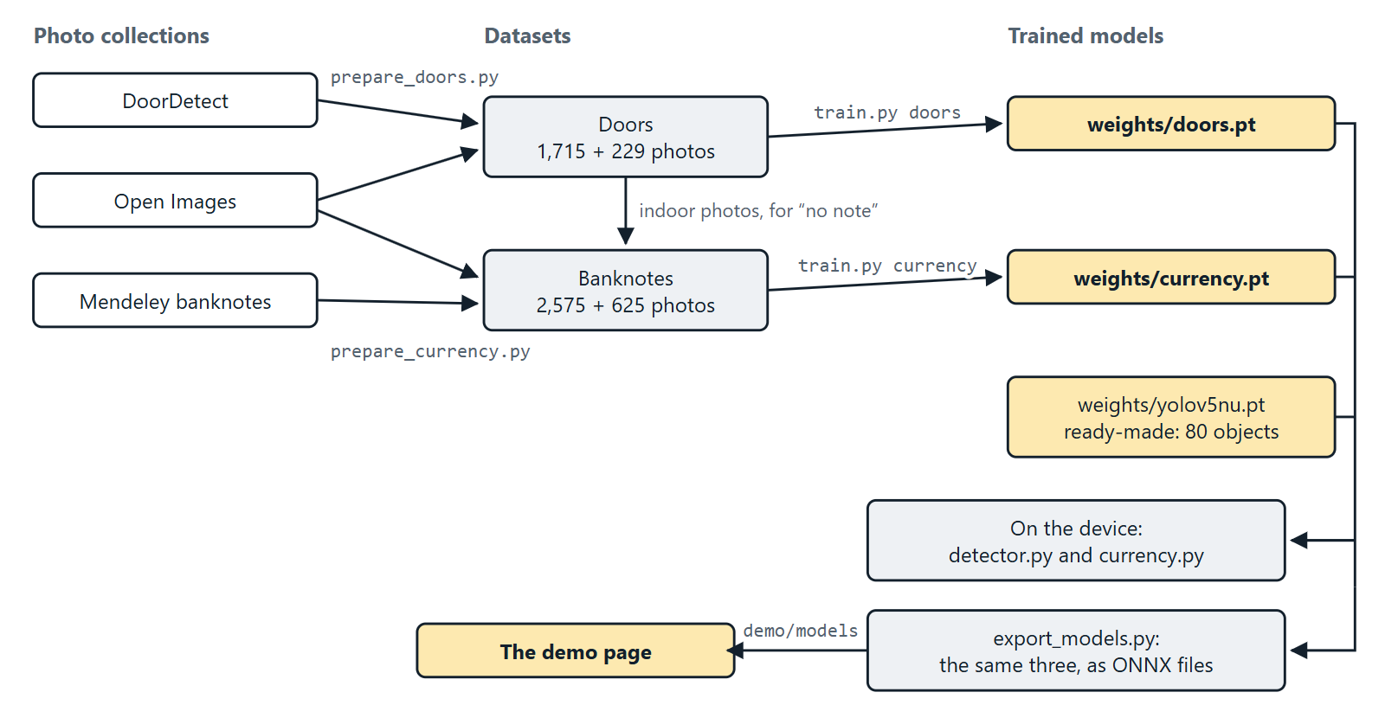

13.1 Training
Scripts: training/.
pip install ultralytics pillow
python training/prepare_doors.py # downloads about 700 MB, builds the dataset
python training/train.py doors # about 1.5 hours on a laptop CPU
python training/prepare_currency.py # downloads about 750 MB
python training/train.py currency # about ten minutes
Preset | Image size | Epochs | Batch | Frozen layers | Notes
doors | 512 | 30 | 16 | 10 (the backbone) | Sized for a CPU
currency | 256 | 6 | 32 | 0 | Also trains on upside-down notes
custom | 640 | 100 | 16 | 0 | Your own dataset, see training/dataset.yaml

Any option given after the preset name overrides it. With a GPU, train the whole door network for longer:
python training/train.py doors --imgsz 640 --epochs 100 --freeze 0
Training stops early after 10 epochs without improvement, copies the best weights to weights/<name>.pt, and prints the scores on the validation photos.
Datasets
Dataset | Use | Size
Doors | DoorDetect (indoor photos) merged with every Open Images validation and test photo that has a "Door" box; shrunk to 640 px; 12% held out | 1,715 training photos with 1,451 labelled doors; 229 held out
Banknotes | One folder per class; shrunk to 512 px; 20% held out. The "none" class is Open Images photos with large faces and hands, other everyday photos, and indoor photos from the door set | 2,575 training photos; 625 held out (400 notes, 225 "none")

The "none" class matters as much as the notes. A camera held by a person mostly sees that person. An earlier version of the model, with a thinner "none" class, called a face a ₹10 note.

13.2 Measured accuracy
All figures are on photos the models never saw during training.
Door model (strict score: AP50 0.45). Judged the way the assistant uses it, at the confidence set in config.yaml:
 | Indoor photos (136) | All photos (229)
When it reports a door, it is right | 69% (38 of 55) | 71% (102 of 143)
Doors found | 64% (39 of 61) | 54% (98 of 181)
Large doors found (at least 8% of the picture) | 85% (17 of 20) | 67% (53 of 79)
Photos with a false door | 15 of 136 | 32 of 229

This is enough for a prototype but not reliable: small, distant or half-hidden doors are often missed, and about one photo in nine shows a false door. The assistant allows for it by scanning from five angles and trusting the most confident sighting. The model was trained on a laptop CPU with most of the network frozen; full training on a GPU should do better.
Banknote model
Held-out photos | Result
400 banknotes | 390 named correctly and stated plainly
 | 9 named correctly, offered as a guess
 | 1 named wrongly, offered as a guess
 | 0 named wrongly and stated plainly; 0 missed
225 photos with no banknote | 225 correctly reported as no note

The banknote photos come from the same collection as the training photos (same notes, same camera), so expect lower accuracy on a live camera. It has not been tried with real notes.

13.3 Models for the browser
demo/export_models.py converts the three trained models to ONNX (opset 17) into demo/models/, copies the two face models there (they are ONNX files already), and writes models.json with each model's input size, thresholds and class names, all taken from config.yaml. The demo page therefore detects with the same settings as the device. Run it again after retraining a model or changing those settings; a test fails while they disagree. A model that has not changed since it was last converted is left alone.

13.4 Data sources
- DoorDetect. M. Arduengo, C. Torras, L. Sentis, "Robust and adaptive door operation with a mobile robot", Intelligent Service Robotics, 2021. https://github.com/MiguelARD/DoorDetect-Dataset
- Open Images V7. Google; images CC BY 2.0, annotations CC BY 4.0. https://storage.googleapis.com/openimages/web/index.html
- Dataset of Indian (Rupees) and Thai (Baht) Banknotes with Annotations. V. Meshram, K. Patil, P. Chumchu, Mendeley Data, 2021, CC BY 4.0. https://data.mendeley.com/datasets/2kfz5yc7pt/1

14. Simulation
Source: visual_assist/simulation.py.
The simulator lets the whole assistant run with no hardware. It is what the tests, python main.py simulate and the demo page use.
The world. The floor is a plane seen from above. Everything solid is a disc: labelled things ({"door": (x, y, radius)}) and anonymous blocks. A wall is a row of small discs. The World also holds the wearer's position and heading, where the head points, the path walked, and the closest the wearer has come to anything.
The stand-in devices
Stand-in | Behaviour
FakeCamera | Returns a placeholder picture
FakeDetector | Reports every labelled thing inside the field of view, with the box a real object of that size would have. It ignores what is hidden behind something else
FakeLidar | The distance to the first disc along the beam, up to 8 m
FakePanTilt | Sets where the head points; FixedPanTilt is a head that cannot turn
FakeSpeaker | Collects what is said
Clock | Time that moves only when told to, so tests are instant and repeatable

The simulated wearer. World.obey(instruction) does what was said. Given a random source, it does so imprecisely: turns are off by up to a third and steps by up to 15%.
Entry points
Function | Use
make(things, blocks, ...) | An assistant in a simulated room: (assistant, world, speaker, clock)
follow_guidance(assistant, world, clock) | Keep obeying until guidance ends
cluttered_room(rng) | A door 3 m to 6 m away with up to five obstacles before it
record(things, blocks, language) | One guided trip as plain data, for the demo page to replay
trace(scene) | One command followed cable by cable, for the demo page's device section
demonstrate(room, language, seed) | What python main.py simulate runs

Wire-level simulation. trace() does not use FakeLidar and FakePanTilt. It uses the real drivers, TFLuna and Esp8266PanTilt, connected to a simulated serial line each: SimulatedUart answers every read with the frame a TF-Luna would send, and SimulatedEsp8266 does what the firmware does with each line of text. The text and bytes recorded are therefore what the Raspberry Pi really sends and expects.
python main.py simulate # a chair between the wearer and the door
python main.py simulate --room opening # a wall with one opening
python main.py simulate --seed 5 # a random cluttered room
python main.py --language ml simulate # the same, spoken in Malayalam

15. The demo page
Sources: index.html, demo/. Live at https://saravanakumart362-create.github.io/Visual-assist/.
The page is static: plain files served by GitHub Pages, with no server of its own. It has three demonstrations.

15.1 The three demonstrations
Section | What the visitor does | What runs
Ask for the door | Drags a door and obstacles round a simulated room, picks a language, presses "Guide me to the door" | The project's own Python guidance code, in the browser
Try it on your own camera | Starts their camera and asks "What is around me?", "Where is the door?", "What note is this?", "Who is this?" by button, typing or voice; registers a face by name | The project's three models, and its assistant, in the browser
Inside the device | Steps through a command and sees what each part sends to the next | Two recorded commands, and a live one that follows whatever was last asked of the camera

15.2 How Python and the models run in a browser
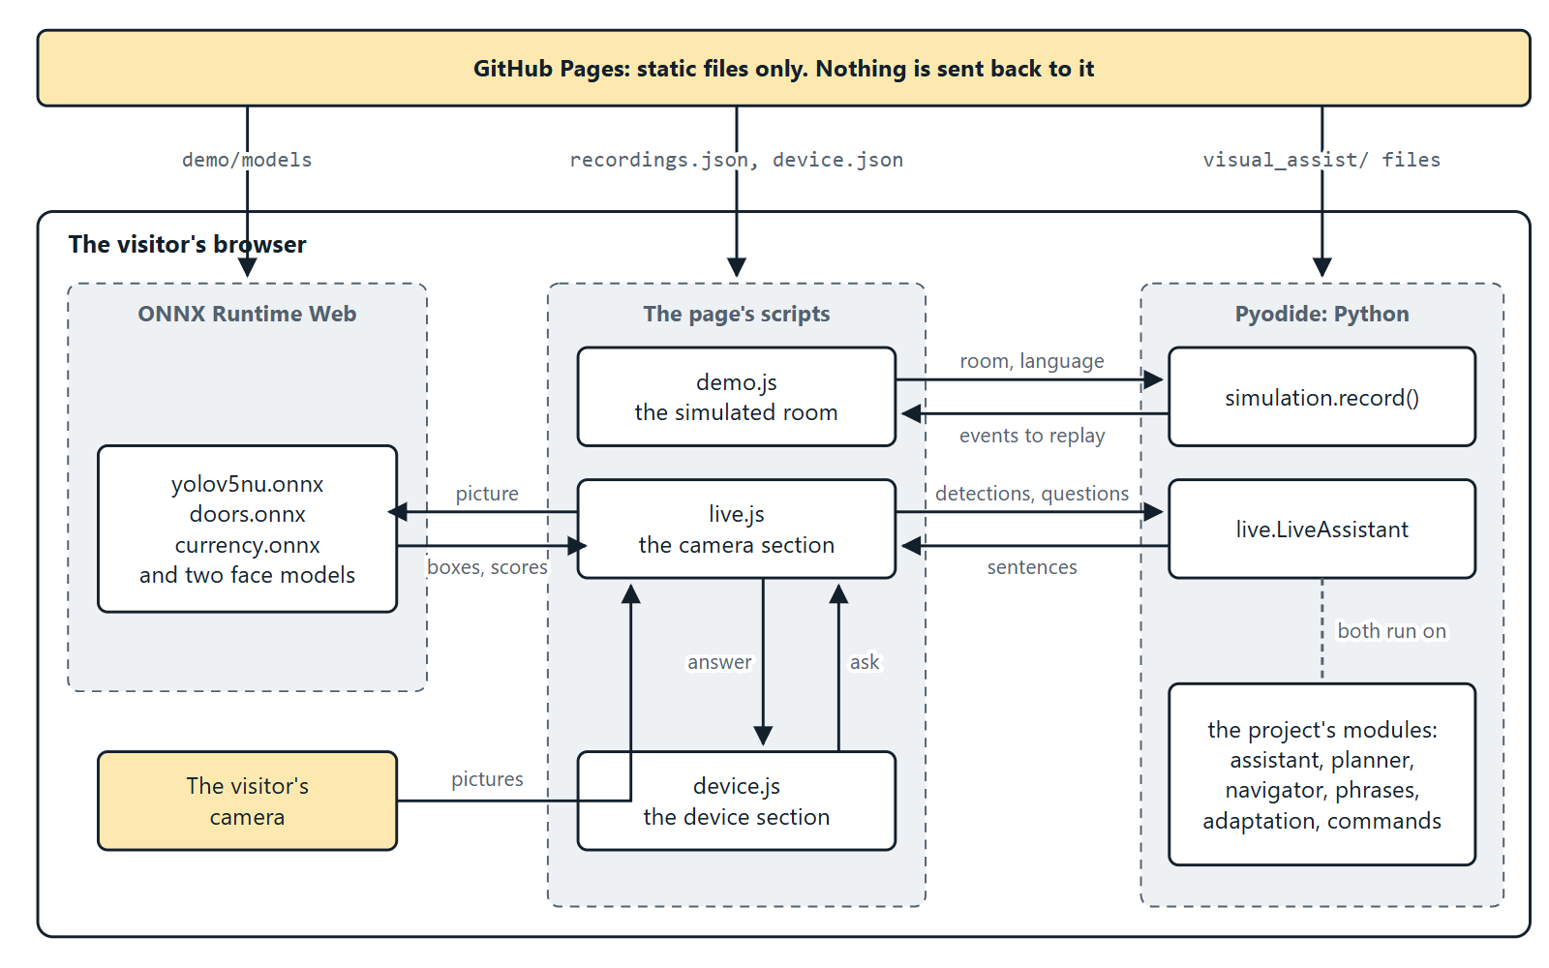
What runs where. Nothing is sent back to the server: once the files are loaded, everything happens in the visitor's browser.
- Python. Pyodide (version 0.26.4) is a Python interpreter compiled for browsers. demo/demo.js fetches a fixed list of the project's own files from visual_assist/ and runs them unchanged. A test checks that this list is enough.
- Models. ONNX Runtime Web (version 1.19.2) runs the models in a worker, so the page stays responsive. The first start downloads about 40 MB; the two face models (39 MB) are fetched only when someone first asks about a face.
- Speech. The browser's own speech synthesis speaks the answers, and in Chrome and Edge its speech recognition takes spoken questions.
- Privacy. The camera picture never leaves the visitor's device.

15.3 Files
File | Role
index.html | The page, including the diagram of the device as inline SVG
demo/demo.css | Styling, light and dark
demo/demo.js | The simulated room; loads Pyodide and the project's Python
demo/live.js | The camera section: detection, the banknote model, the assistant
demo/device.js | The device section: lights parts, moves a dot along cables, lists what was sent
demo/recordings.json | The two preset rooms and one recorded trip through each
demo/device.json | The two recorded commands of the device section
demo/models/ | The ONNX models and models.json
demo/make_recordings.py | Writes the two JSON files and stamps the page's links
demo/export_models.py | Converts the models (section 13.3)
.nojekyll | Must stay: without it GitHub Pages hides visual_assist/__init__.py

15.4 The simulated room
The preset rooms play at once from recordings.json, even where Pyodide cannot load. Any other room, or any other language, is planned on the spot: the page calls simulation.record() in the browser's Python and replays the events it returns.
Event | Content
say | Who spoke (user or assistant) and the text
look | The head turns to this angle
photo | The camera takes a picture
ray | One LiDAR reading: bearing and distance
route | The planned route as points
turn | The wearer turns to this heading
walk | The wearer walks to this point

15.5 The camera section
Each cycle the page draws the camera picture into each model's input size, runs the two detection models, and hands the results to visual_assist.live.LiveAssistant as JSON. That class presents them to the ordinary Assistant as the camera and detector it expects, with no LiDAR and no turning head. What is then decided and said is the same code that runs on the device.
LiveAssistant method | Purpose
see(picture) | One analysed picture; runs one step of the assistant
hear(text) | A question, answered on the next picture. Returns what it was taken to be
intent(text), command(text) | What the command parser makes of a question
view() | The current picture as the assistant sees it: each object's place, bearing and estimated distance
note(scores) | The banknote model's scores
use_faces(on) | Says whether the page has its face models loaded
people() | The faces in the current picture: each one's box, name if known, and likeness
set_language(code), greet(), camera_off() | As named
guiding | The object being guided to, if any

Because there is no LiDAR, distances are camera estimates ("about 2 meters"), and there is no route planning.
Faces on the page. The page runs the same two face models as the device (section 10.2). OpenCV is not there to do the steps between them, so live.js does: it puts the picture in the top left of a black 640 × 640 square for the detector, reads the detector's three grids of answers into boxes and landmarks, keeps the surest of any that overlap, and draws each face turned, scaled and shifted so that its landmarks land where the recogniser expects them. A prototype of exactly these steps gave the same boxes and landmarks as OpenCV, and features matching OpenCV's to four decimal places.
The boxes and features go to Python with each picture, and from there on the code is the device's own: the same FaceBook and People match them against the registered faces with the same threshold. Three things differ:
- Registered faces are kept in the page's memory only, and are forgotten when the page is closed or reloaded.
- The device waits up to 15 seconds for a name after "Register face". A page cannot wait without freezing, so LiveAssistant asks the question and takes the name from the next phrase.
- The face models load on the first question about a face, not at the start.

15.6 The device section
A diagram shows every part and the cable joining it to the Raspberry Pi. For each step of a command, device.js lights the parts at work, moves a dot along the cables in use, and lists what was sent.
Each step in device.json has a kind:
Kind | Shows
hear, understand, speak | The words heard, the command they became, a sentence spoken
turn | The lines of text sent to the ESP8266, its replies, the pulse given to each servo
see | What the detector named in one picture
measure | The LiDAR's 9 bytes and what they mean
look | Turn, see and measure together, for the later views
aim | The head turned to an object, the LiDAR reading, the camera's estimate, and which was used
centre | The head returning to straight ahead
sweep | The 25 readings of a sweep
plan | The obstacles given to the planner, and the route found

The third choice, Your camera, live, is not a recording. When a question is answered in the camera section, live.js reports the steps it really went through, with the picture taken, what was found in it and the sentence built. The parts a phone or laptop lacks (LiDAR, ESP8266, servos) are shown faded. The two sections talk only through three events on the document:
Event | Sent by | Meaning
visualassist:camera | live.js | The camera started or stopped
visualassist:answer | live.js | A question was answered; carries its steps
visualassist:ask | device.js | Ask this question

15.7 Keeping the page current
python demo/make_recordings.py
Run this after changing the guidance code, the style sheet or a script. It rewrites both JSON files and renews the ?v= code on each link to a style sheet or script in index.html. The code is made from the file's contents, so a browser that kept an old copy sees a new address and fetches the new file. The tests fail while anything here is out of date.

15.8 Publishing and previewing
GitHub Pages. In the repository open Settings, then Pages; choose Deploy from a branch, branch main, folder / (root).
On your own PC
python -m http.server 8000 # then open http://localhost:8000/
Opening index.html by double-clicking does not work, because browsers do not let a page read other files straight from the disk.

16. Tests
python -m pytest
176 tests, about seven seconds, no hardware needed.
File | Tests | Covers
tests/test_core.py | 25 | Settings, command parsing, LiDAR frames, the LiDAR and servo drivers on a fake serial line, bearings and turns, distance from size, combining LiDAR and camera, banknote decisions
tests/test_planner.py | 17 | Routes on open floor, round an obstacle, through a gap in a wall, when walled in; joining LiDAR hits into walls; the rules for choosing an instruction
tests/test_phrases.py | 12 | Sentences in English; every language complete, with the same placeholders; grammatical forms
tests/test_adaptation.py | 19 | Speed from the LiDAR, pauses, warning distance, urgency, verbosity, the saved profile, crowds, familiar faces
tests/test_assistant.py | 22 | The whole assistant in simulated rooms: find, scan, distance, guidance with and without a planner, giving up, faces, banknotes, language, wake word
tests/test_random_rooms.py | 2 (4 runs) | 240 random cluttered rooms
tests/test_faces.py | 11 | Face matching and its threshold, the saved file, registering only a face that is close, several tries, doing without when the models are missing; and that the real models load
tests/test_live.py | 14 | The assistant fed by a web page: answers, upright phone pictures, banknotes, guidance by camera, faces found by the page, a name taken from the next phrase
tests/test_demo.py | 11 | Recordings match the current code; the page's Python file list is complete; page links are stamped; browser models match config.yaml; nothing the page needs is ignored by git

The random rooms. 240 rooms are walked, half of them by a simulated wearer whose turns are off by up to a third and whose steps by up to 15%. Two promises are checked:
- Safety is absolute. In no room, however roughly the instructions are followed, does the wearer come within 10 cm of an obstacle or 5 cm of the door, and guidance always ends.
- Success is statistical. At least 95% of the rooms are solved by a wearer who follows exactly, and at least 90% by one who follows imprecisely. A room that is not solved must end with the assistant saying so.

17. Installing and running

17.1 On a PC, with or without a webcam
git clone https://github.com/saravanakumart362-create/Visual-assist.git
cd Visual-assist
pip install opencv-python ultralytics pyyaml pyserial gTTS pytest

python main.py simulate # no hardware at all
python main.py check # which devices and libraries were found
python main.py --keyboard --show # live on a webcam, typed commands
python -m pytest # the tests

17.2 On the Raspberry Pi
# 1. Enable the camera and the serial port (Interface Options ->
# Serial Port: login shell NO, hardware port YES), then reboot.
sudo raspi-config

# 2. System packages
sudo apt update
sudo apt install -y python3-picamera2 python3-opencv espeak-ng mpg123 \
portaudio19-dev

# 3. Python packages (the venv must see the apt-installed picamera2)
python3 -m venv --system-site-packages venv
source venv/bin/activate
pip install -r requirements.txt

# 4. Offline speech recognition model
mkdir -p models && cd models
wget https://alphacephei.com/vosk/models/vosk-model-small-en-us-0.15.zip
unzip vosk-model-small-en-us-0.15.zip && cd ..
Copy the whole project folder to the Pi, including weights/doors.pt and weights/currency.pt. The two face models (39 MB) are downloaded to weights/ the first time the assistant starts with an internet connection; copy them from the PC as well if the Pi will have none. Flash the sketch in firmware/esp8266_pan_tilt/ to the ESP8266 with the Arduino IDE (board: NodeMCU 1.0), then plug it into the Pi.

17.3 Command line
Command | Effect
python main.py | Start the assistant
python main.py check | Try to open each part and report what was found. Run this first
python main.py register NAME | Register the face in front of the camera
python main.py simulate [--room chair|opening] [--seed N] | Guide a simulated wearer

Option | Effect
--config PATH | Use another settings file
--keyboard | Type commands instead of speaking them
--show | Show the camera view with boxes
--language en|ml|hi|ta | Language to speak

Options go before the command: python main.py --language ml simulate.

17.4 First start on the hardware
Expect to adjust config.yaml when the hardware is first connected:
Symptom | Setting
check reports no LiDAR or no pan-tilt | lidar.port, servo.port
"Turn right" guidance turns the head left | servo.pan_invert: true
The head does not face forward at rest | servo.pan_center, servo.tilt_center
Directions or camera distances are off | camera.hfov_deg, camera.vfov_deg
Other people's talk triggers commands | listener.wake_word

17.5 Files written while running
File | Content
data/profile.json | The user profile (section 9.3)
data/faces/faces.json | The registered faces (section 10.2)
The system's temporary folder, visual_assist_tts/ | Cached speech from Google

data/ is not committed to git: it is personal.

18. What is verified, and known limits
Verified on a PC
- The test suite.
- Guidance in simulation: 997 of 1,000 random rooms reached; the other three ended with a spoken stop; nothing was ever touched.
- The door and banknote models on held-out photos (section 13.2).
- Speech synthesis in all four languages.
- A short live trial on a webcam with typed questions.
- Face registration and recognition, with saved photos standing in for the camera: a person registered from one photo was named in other photos of them, alone and beside someone else, and other people were not.
- The demo page in a headless browser, its camera section with saved photos standing in for the camera. That includes faces: a person registered there from one photo was named in other photos, and other people were not.
Not verified
- Anything on the Raspberry Pi itself: the Pi Camera, the TF-Luna, the servos and ESP8266, the microphone.
- The LiDAR and servo drivers against real hardware. They have been run only against the simulated LiDAR and ESP8266.
- Face recognition on a live camera, and how often it names people rightly in everyday light and at everyday angles.
- The demo page's camera section on a real camera or a phone, and its spoken questions and spoken answers.
- The Malayalam, Hindi and Tamil sentences, by a native speaker.
Known limits
- Route planning has been exercised only against simulated rooms. Real LiDAR readings are noisier, and a single beam at one height does not see obstacles above or below it. The white cane stays essential.
- The camera's distance estimate assumes ordinary sizes. Tables and sofas vary too much, so without the LiDAR their distance is not given.
- Walking speed is measured only while walking towards something within the LiDAR's 8 m.
- Voice commands are English only; the replies are multilingual.
- Banknote recognition expects the note held close to the camera, filling most of the picture, as in the training photos.
- The simulated detector does not model one object hiding another.

19. Relation to the project report
The report describes the system but does not include its source code, so this is a new implementation of that description. Where the report is silent or inconsistent, these choices were made:
Topic | In the report | Here
LiDAR model | The text names both "TF-Luna" and "TF-LC02"; the code screenshot reads TF-Luna UART frames | TF-Luna over UART
LiDAR wiring | The circuit diagram labels the lines SDA/SCL (I²C); the code screenshot uses serial | UART wiring
Servo control | The text says the ESP8266 drives the servos; the circuit diagram wires them to the Pi | Both are supported (servo.backend)
Detection models | One custom model for doors, chairs and desks | The pretrained model for everyday objects and a separately trained one for doors, which keeps the pretrained model's accuracy
Face recognition |  | OpenCV's YuNet and SFace models. The widely used face_recognition library must be compiled on each machine and would not install on the development PC

The report also describes door detection, adaptation to the wearer, banknote recognition, speech in several languages and shortest-path routing around obstacles. All five are implemented here (sections 7 to 11).

20. Extending the project
Recognise another kind of object. Label photos in YOLO format (see training/dataset.yaml), then:
python training/train.py custom --data my.yaml --name indoor
Add weights/indoor.pt to detector.extra in config.yaml. If the object's size varies little, add it to TYPICAL_SIZE_M in navigator.py so the camera can estimate its distance. Add its name to the labels of each locale file, and run python demo/export_models.py for the demo page.
Add a language. Copy locales/en.json to locales/<code>.json and translate the right-hand sides, keeping the {placeholders}. Add the language's English name to LANGUAGES in phrases.py. The tests check that the new file is complete.
Add a voice command. Add a rule to parse() in commands.py, a method _cmd_<intent> to Assistant, any new sentence to every locale file, and a case to the parsing test in tests/test_core.py.
Support another device. Write a class with the same methods as the one it replaces and return it from the module's open_...() function:
Device | Methods
Camera | read() giving a BGR picture or nothing, close()
LiDAR | read() giving metres or nothing, close(), and available
Pan-tilt | look(bearing, tilt, settle), center(), close(), and can_move
Listener | listen() giving text or nothing
Speaker | say(text, wait, urgent), wait(), configure(language, rate), close(), and busy, last, language, rate

After any change to the guidance code, run python demo/make_recordings.py and then python -m pytest. The drawings in this document are computed from the code as well: python docs/make_figures.py draws them again.

21. Repository layout
main.py command line entry point
config.yaml all settings
requirements.txt Python packages
README.md introduction and voice commands
docs/TECHNICAL.md this document
docs/make_figures.py, img/ the drawings in this document, and what draws them
index.html, demo/ the demo page
visual_assist/
assistant.py main loop, voice commands, guidance
planner.py obstacle map and A* route search
navigator.py bearings, distance checks, next instruction
adaptation.py motion tracking, user profile, adaptive rules
phrases.py, locales/ every spoken sentence, in four languages
commands.py speech text to intent
config.py settings and their defaults
camera.py Pi Camera or webcam
detector.py YOLO detection, one model or several
currency.py banknote recognition
faces.py face recognition and registration
lidar.py TF-Luna frames
servo.py pan-tilt head (ESP8266 or GPIO)
speech.py text to speech
listener.py speech to text
simulation.py simulated room and devices
live.py the assistant fed by a web page's camera
firmware/esp8266_pan_tilt/ Arduino sketch for the servo controller
training/ dataset preparation and training scripts
weights/ the trained models
tests/ python -m pytest
data/ written while running; not in git

