### Task 1: Database Discovery
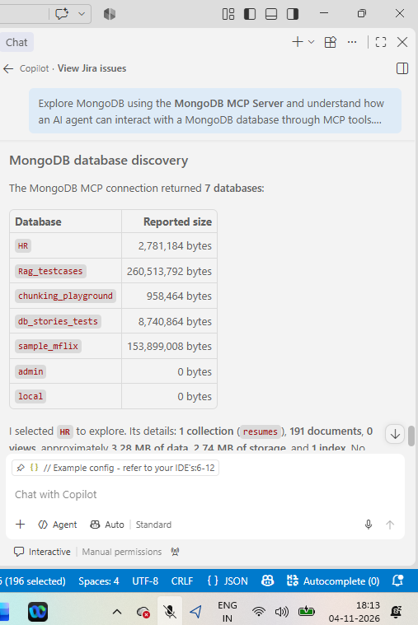
### Task 2: Collection Discovery
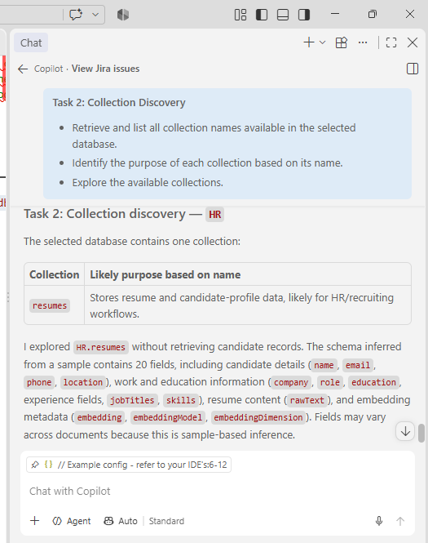
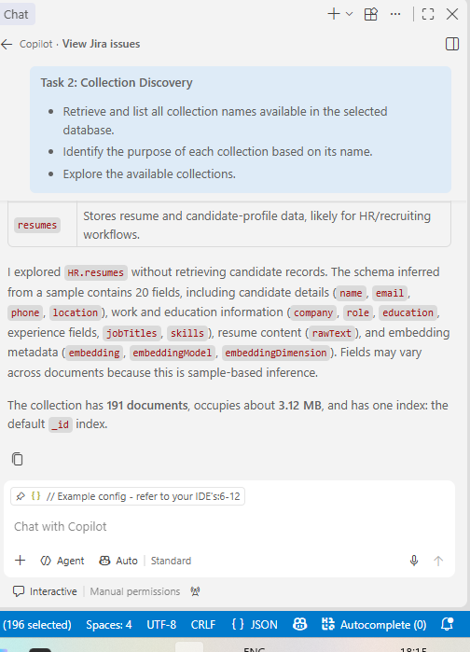
### Task 3: Sample Data Retrieval
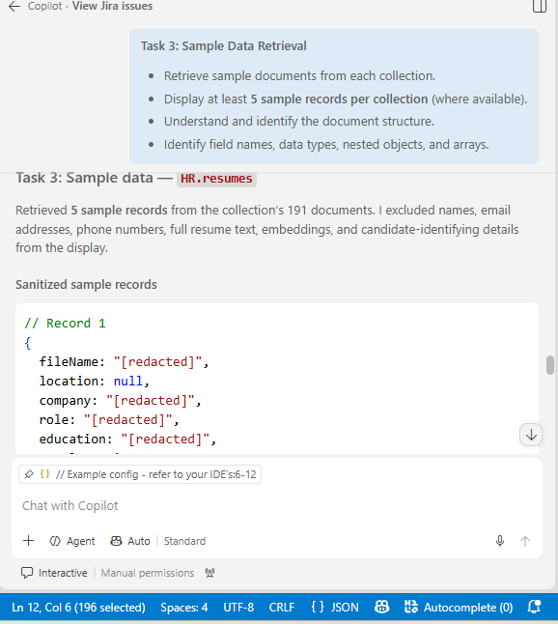

// Record 1
{
fileName: "[redacted]",
location: null,
company: "[redacted]",
role: "[redacted]",
education: "[redacted]",
totalExperience: 13,
relevantExperience: null,
skills: ["[string]", "..."],
jobTitles: ["[string]", "..."],
experienceSummary: "[redacted]",
embeddingModel: "mistral-embed",
embeddingDimension: 1024,
createdAt: ISODate("[redacted]"),
updatedAt: ISODate("[redacted]")
}

// Record 2
{
fileName: "[redacted]",
location: "[redacted]",
company: "[redacted]",
role: "[redacted]",
education: "[redacted]",
totalExperience: 7,
relevantExperience: 7,
skills: ["[string]", "..."],
jobTitles: ["[string]", "..."],
experienceSummary: "[redacted]",
embeddingModel: "mistral-embed",
embeddingDimension: 1024,
createdAt: ISODate("[redacted]"),
updatedAt: ISODate("[redacted]")
}

// Record 3
{
fileName: "[redacted]",
location: "[redacted]",
company: "[redacted]",
role: "[redacted]",
education: "[redacted]",
totalExperience: 7,
relevantExperience: 7,
skills: ["[string]", "..."],
jobTitles: ["[string]", "..."],
experienceSummary: "[redacted]",
embeddingModel: "mistral-embed",
embeddingDimension: 1024,
createdAt: ISODate("[redacted]"),
updatedAt: ISODate("[redacted]")
}

// Record 4
{
fileName: "[redacted]",
location: "[redacted]",
company: "[redacted]",
role: "[redacted]",
education: "[redacted]",
totalExperience: null,
relevantExperience: null,
skills: ["[string]", "..."],
jobTitles: ["[string]", "..."],
experienceSummary: "[redacted]",
embeddingModel: "mistral-embed",
embeddingDimension: 1024,
createdAt: ISODate("[redacted]"),
updatedAt: ISODate("[redacted]")
}

// Record 5
{
fileName: "[redacted]",
location: "[redacted]",
company: "[redacted]",
role: "[redacted]",
education: "[redacted]",
totalExperience: null,
relevantExperience: null,
skills: ["[string]", "..."],
jobTitles: ["[string]", "..."],
experienceSummary: "[redacted]",
embeddingModel: "mistral-embed",
embeddingDimension: 1024,
createdAt: ISODate("[redacted]"),
updatedAt: ISODate("[redacted]")
}

