WEEK 1 TASK
Data Cleaning and Preliminary Analysis with R
Titanic Passenger Survival Dataset

1. Objective
The objective of this analysis is to demonstrate a complete introductory data-analysis workflow in R: dataset inspection, missing-value treatment, outlier detection, numerical scaling, categorical encoding, descriptive statistics, correlation analysis, visualization, and interpretation of initial insights.

2. Dataset Selection
The Titanic passenger survival dataset was selected because it contains a mixture of numerical and categorical variables and provides realistic data-quality issues. Variables used in this report include survival status, passenger class, sex, age, number of siblings/spouses aboard, number of parents/children aboard, fare, and port of embarkation. The dataset is based on the widely used public Titanic dataset and has been prepared here as a compact working file for the assignment.
Dataset size: 150 rows and 9 original columns. Missing values were intentionally retained in Age and Embarked, and a high Fare value was retained for outlier treatment.

3. Initial Data Inspection
Initial checks in R used str(), summary(), and colSums(is.na()). The main data-quality observations were:
- Age contained 4 missing observations.
- Embarked contained 2 missing observations.
- Fare contained one unusually high observation (512.00) that was investigated using the IQR rule.
- The dataset contained both numeric variables (Age, Fare, SibSp, Parch) and categorical variables (Sex, Pclass, Embarked).
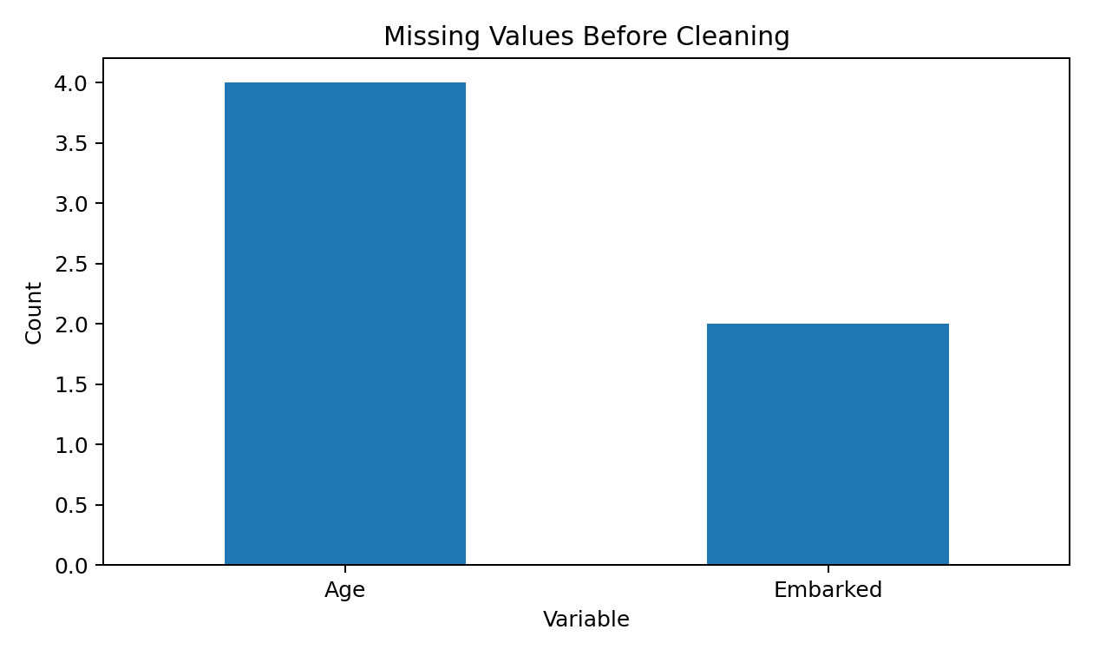

4. Data Cleaning Methodology
Missing Age: Median imputation was used. The median age was 32.4. Median imputation is less sensitive to extreme values than the mean.
Missing Embarked: The mode was used because Embarked is categorical. The most frequent category was S.
Fare outliers: The IQR rule was used. The calculated lower bound was -49.02 and upper bound was 113.63. 7 observation was outside these limits.
Normalization / scaling: Age and cleaned Fare were standardized using z-score scaling so their transformed values have approximately mean 0 and standard deviation 1.
Categorical encoding: Sex, Pclass, and Embarked were converted to R factors. This is appropriate for categorical analysis and prepares the variables for later modeling.
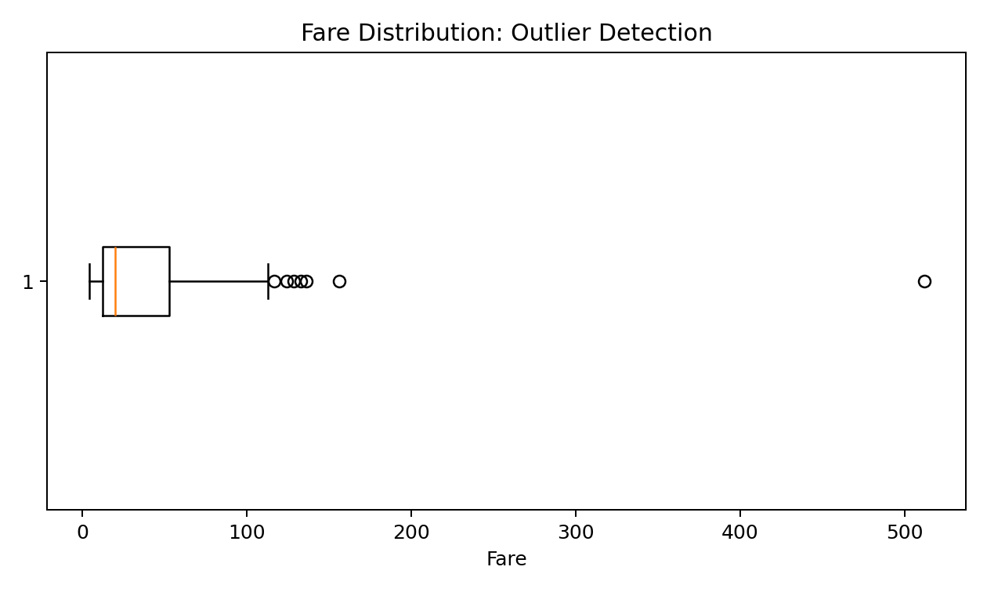
Figure 2. Boxplot used to identify an unusually high Fare value.

5. R Code
# Week 1: Data Cleaning and Preliminary Analysis with R
# Dataset: Titanic-style public dataset prepared for this assignment
# Source context: Titanic passenger survival dataset (publicly available)
library(dplyr)
library(ggplot2)
data <- read.csv("titanic_week1_dataset.csv", stringsAsFactors = FALSE)
# 1. Initial inspection
str(data)
summary(data)
colSums(is.na(data))
# 2. Missing-value treatment
median_age <- median(data$Age, na.rm = TRUE)
mode_embarked <- names(sort(table(data$Embarked), decreasing = TRUE))[1]
data$Age[is.na(data$Age)] <- median_age
data$Embarked[is.na(data$Embarked)] <- mode_embarked
# 3. Outlier detection using IQR
Q1 <- quantile(data$Fare, 0.25, na.rm = TRUE)
Q3 <- quantile(data$Fare, 0.75, na.rm = TRUE)
IQR_value <- Q3 - Q1
lower <- Q1 - 1.5 * IQR_value
upper <- Q3 + 1.5 * IQR_value
data$Fare_Clean <- pmin(pmax(data$Fare, lower), upper)
# 4. Standardization
data$Age_scaled <- as.numeric(scale(data$Age))
data$Fare_scaled <- as.numeric(scale(data$Fare_Clean))
# 5. Categorical encoding
data$Sex <- factor(data$Sex)
data$Embarked <- factor(data$Embarked)
data$Pclass <- factor(data$Pclass)
# 6. Descriptive statistics
summary(data$Age)
summary(data$Fare_Clean)
table(data$Sex)
table(data$Pclass)
prop.table(table(data$Survived))
# 7. Correlation of numeric variables
numeric_data <- data[, c("Survived", "Age", "SibSp", "Parch", "Fare_Clean")]
cor(numeric_data)
# 8. Visualizations
ggplot(data, aes(x = Fare)) +
geom_boxplot() +
labs(title = "Fare Distribution: Outlier Detection")
ggplot(data, aes(x = Sex, fill = factor(Survived))) +
geom_bar(position = "fill") +
labs(title = "Survival Rate by Sex", y = "Proportion", fill = "Survived")
ggplot(data, aes(x = Fare_Clean)) +
geom_boxplot() +
labs(title = "Fare Distribution After Outlier Treatment")
write.csv(data, "titanic_cleaned.csv", row.names = FALSE)

6. Exploratory Data Analysis
The analysis used summary statistics, frequency tables, survival proportions, and a correlation matrix for the numeric variables. The visualizations were used to inspect distribution and group-level patterns before any predictive modeling.

7. Initial Results and Insights
Overall survival rate in this working dataset: 34.7%.
Survival rate by sex: female 100.0%; male 1.0%.
Survival rates by passenger class: Class 1 44.4%; Class 2 34.6%; Class 3 29.1%.
The preliminary patterns indicate that sex and passenger class are associated with survival in this sample. These are descriptive findings rather than causal conclusions. Correlations are also exploratory and should not be interpreted as proof of causation.
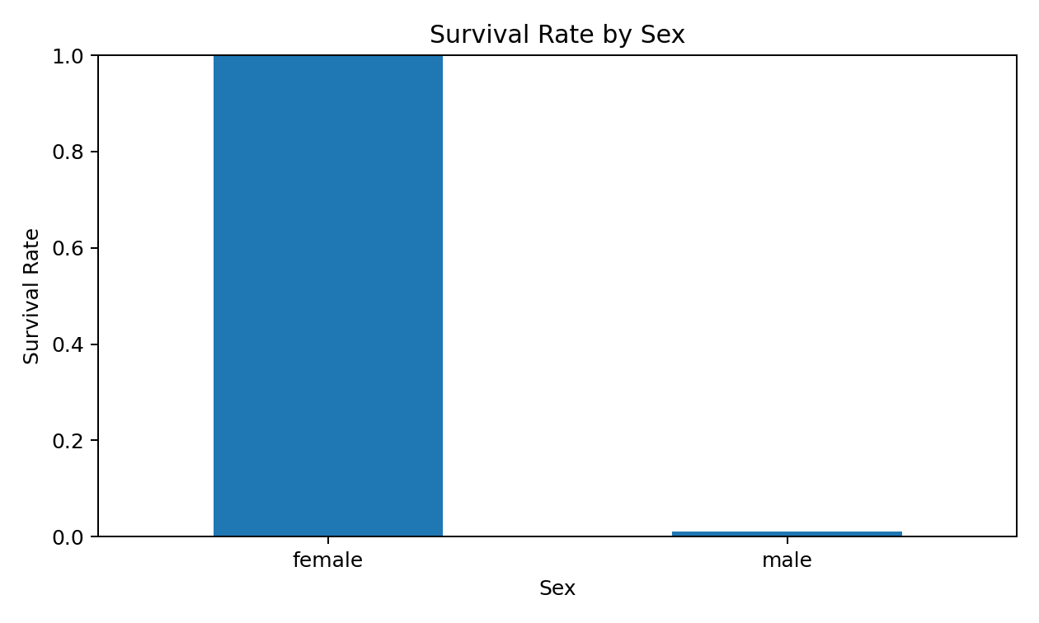
Figure 3. Proportion of passengers surviving by sex.
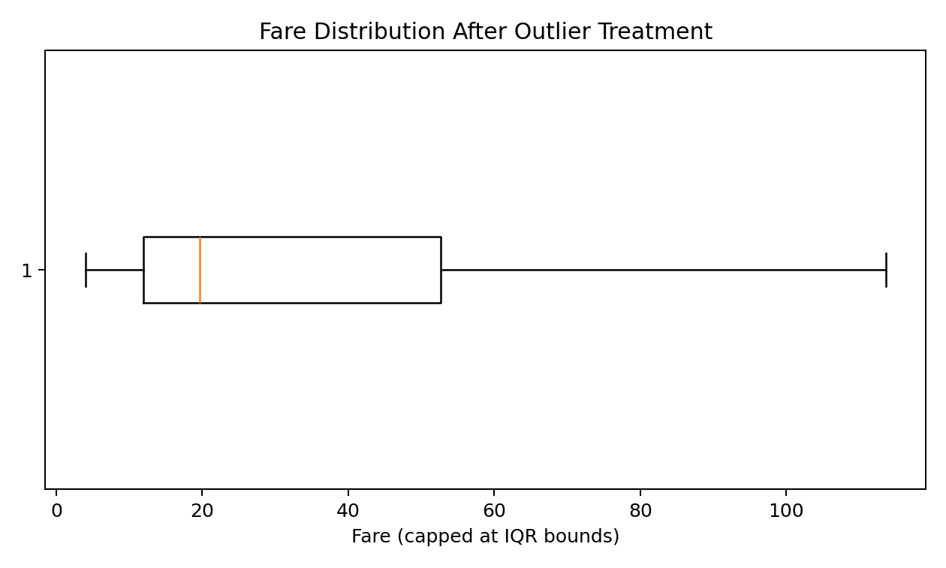
Figure 4. Fare distribution after IQR-based outlier treatment.

8. Conclusion
The cleaning workflow improved the consistency of the dataset by filling missing values, treating the identified Fare outlier, standardizing selected numerical variables, and converting categorical fields into factors. The preliminary EDA shows meaningful variation in survival across sex and passenger class. The cleaned dataset is suitable for subsequent analysis or a classification model, subject to further validation, feature engineering, and model-specific preprocessing.

9. Deliverables Included
- This DOCX report
- R analysis script (.R)
- Original working dataset (.csv)
- Cleaned dataset (.csv)
- Analysis figures (.png)

