WEEK 2 TASK
Data Visualization and Insight Communication using R
Titanic Passenger Survival Dataset

1. Dataset Overview
This project continues the Titanic passenger dataset used in Week 1. The dataset contains survival status, passenger class, sex, age, family-related variables, fare, and embarkation port. The cleaned data from Week 1 is used so the visualizations focus on communicating patterns rather than repeating data-cleaning steps.

2. Visualization Design
Five visualization types were selected to communicate different aspects of the data. Bar charts compare survival rates across groups, a histogram shows the distribution of age, a scatter plot explores the relationship between age and fare, and a line chart communicates how survival rate changes across age groups.

1. Survival Rate by Sex
A bar chart was selected because the goal is to compare two categorical groups. The chart shows a substantially higher observed survival rate for females than males in this working dataset.
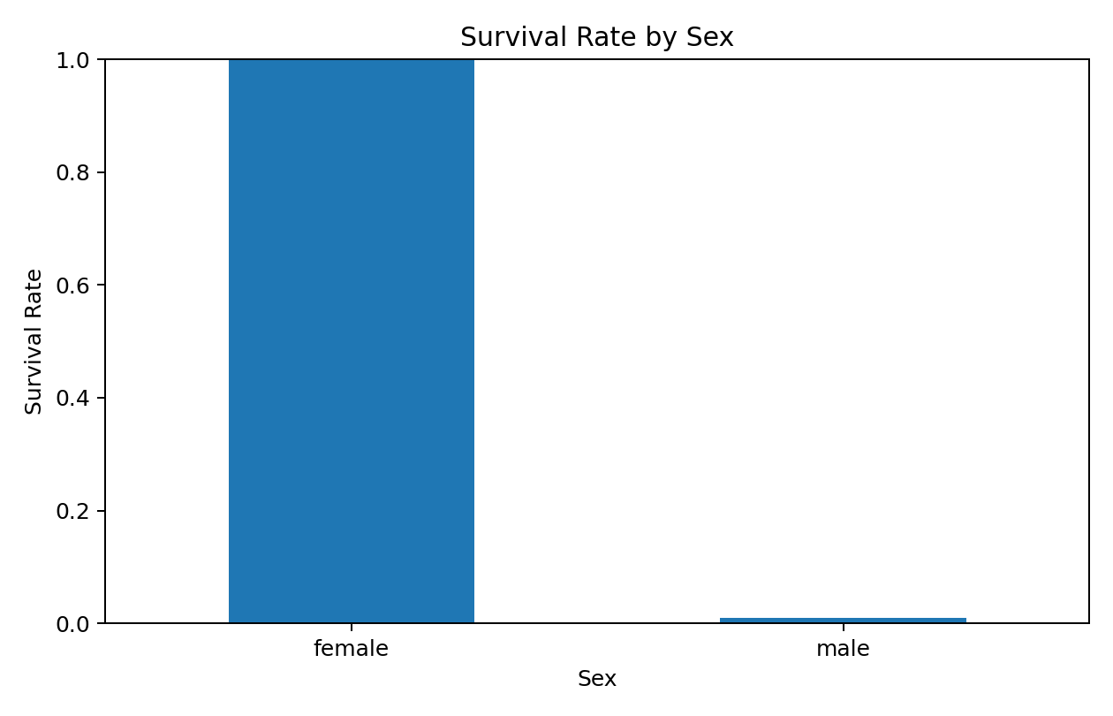

2. Survival Rate by Passenger Class
A bar chart makes differences across the three passenger classes easy to compare. The visualization shows that survival rates vary by class, with higher observed survival in the upper class in this sample.
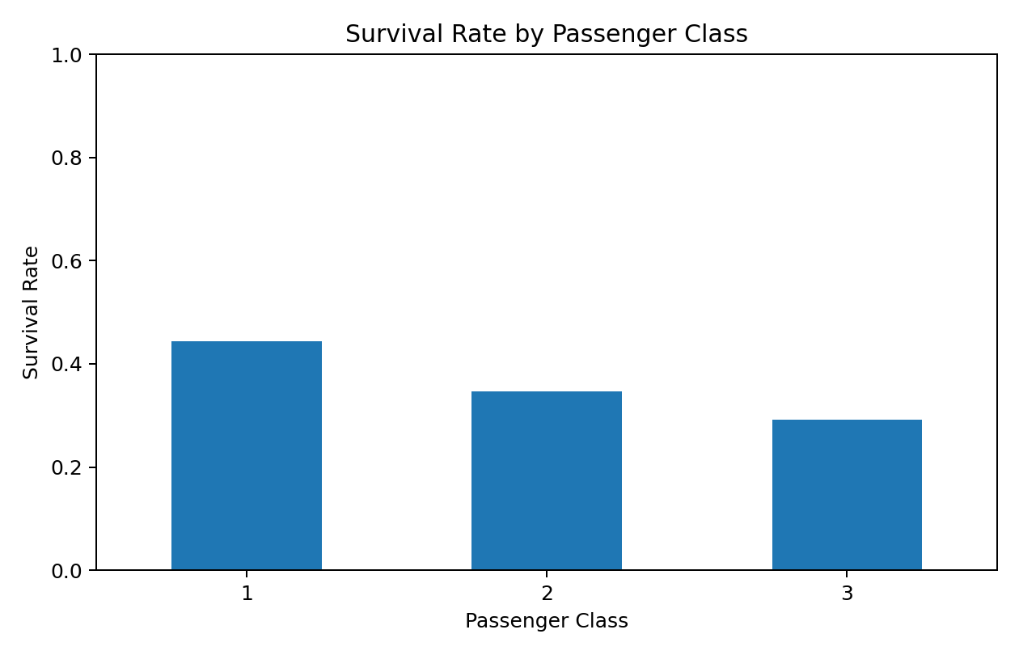

3. Age Distribution
A histogram shows how passengers are distributed across age ranges. It provides a quick view of the concentration and spread of passenger ages.
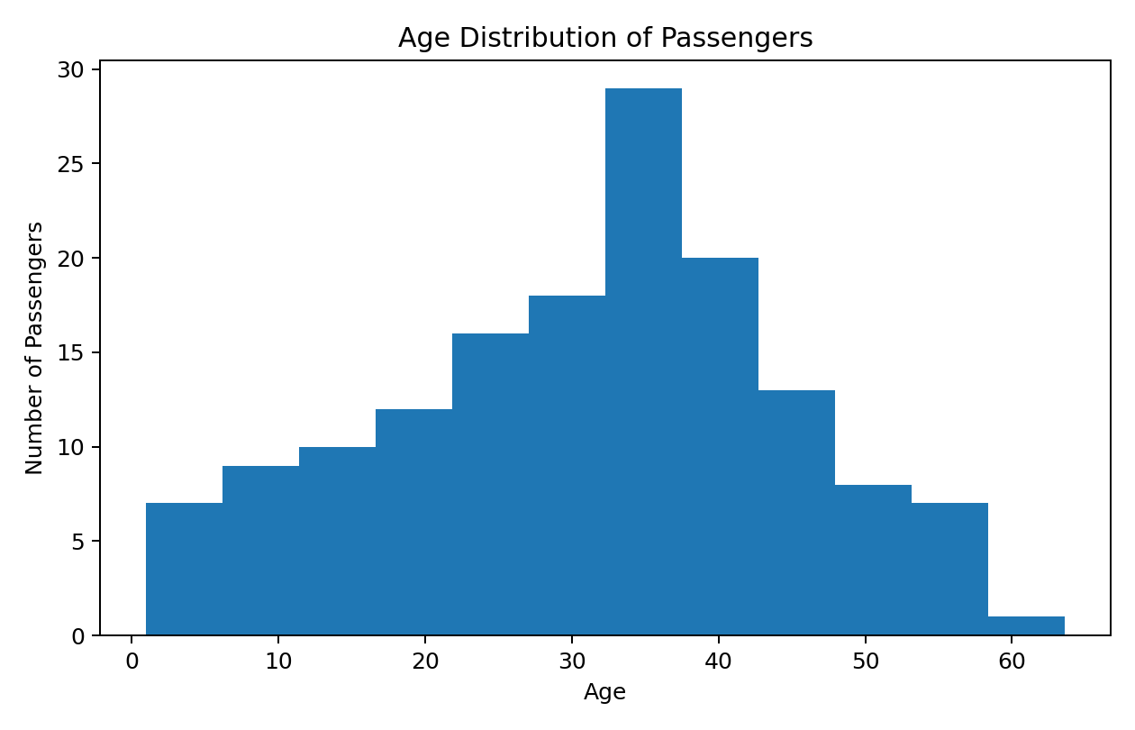

4. Age vs Cleaned Fare
A scatter plot was selected to examine whether age and fare move together. The points show considerable variation, suggesting that age alone does not explain fare differences.
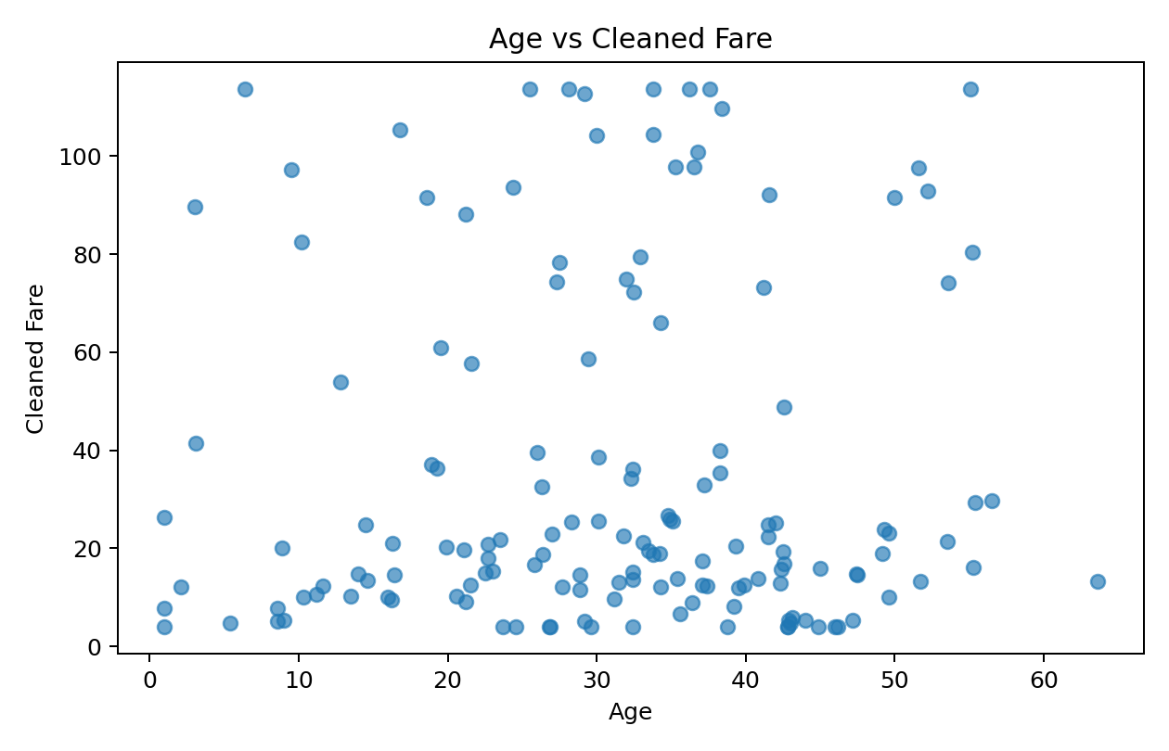

5. Survival Rate by Age Group
A line chart highlights changes in survival rate across ordered age groups. It provides a simple view of how survival patterns vary across different age ranges.
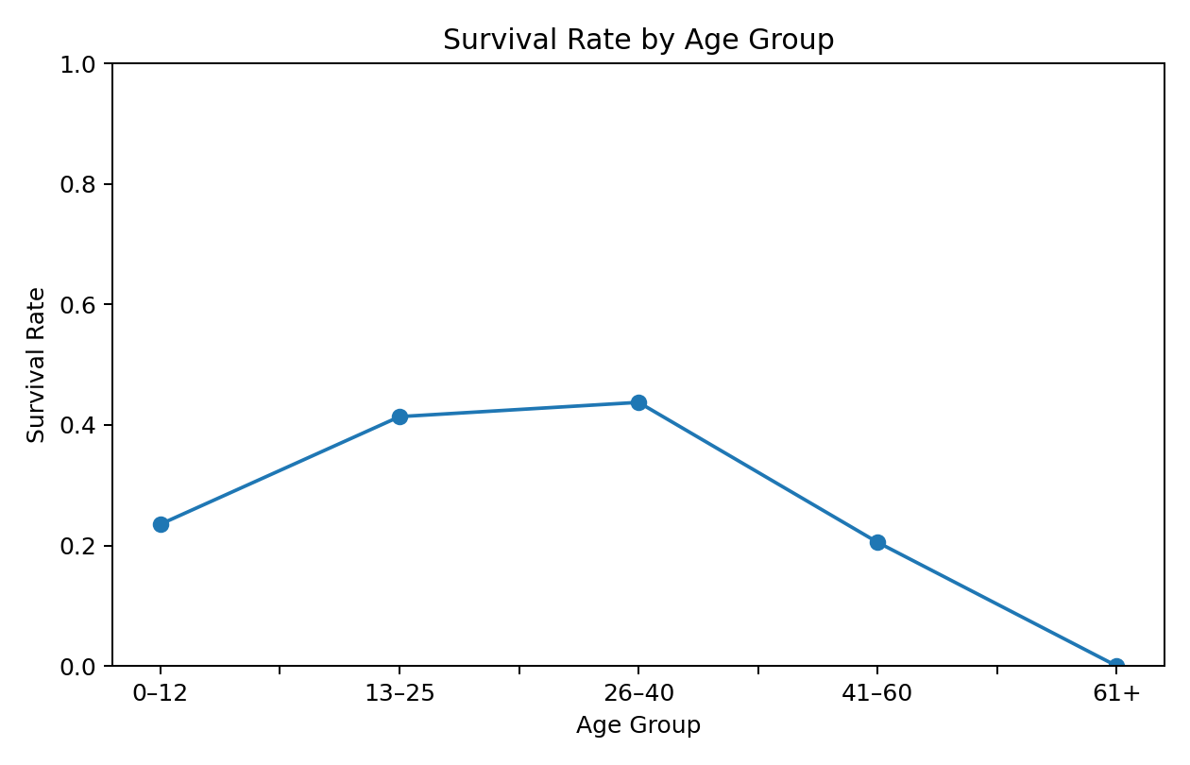

3. Key Insights
The overall observed survival rate in the working dataset is 34.7%. The sex comparison shows a clear difference: the female survival rate is 100.0%, compared with 1.0% for males.
Survival also varies by passenger class: Class 1 = 44.4%, Class 2 = 34.6%, and Class 3 = 29.1%.
The age histogram shows most observations concentrated in young-to-middle adult ranges. The age-versus-fare scatter plot does not show a simple linear relationship. These are descriptive patterns and should not be interpreted as causal effects.

4. R Code
# Week 2: Data Visualization and Insight Communication using R
# Dataset: Titanic passenger survival dataset
# Required packages: ggplot2, dplyr
library(ggplot2)
library(dplyr)
data <- read.csv("titanic_week2_dataset.csv", stringsAsFactors = FALSE)
# Convert categorical variables
data$Sex <- factor(data$Sex)
data$Pclass <- factor(data$Pclass)
data$Embarked <- factor(data$Embarked)
# 1. Bar chart: survival rate by sex
sex_summary <- data %>%
group_by(Sex) %>%
summarise(Survival_Rate = mean(Survived))
ggplot(sex_summary, aes(x = Sex, y = Survival_Rate)) +
geom_col() +
labs(title = "Survival Rate by Sex",
x = "Sex", y = "Survival Rate") +
ylim(0, 1)
# 2. Bar chart: survival rate by passenger class
class_summary <- data %>%
group_by(Pclass) %>%
summarise(Survival_Rate = mean(Survived))
ggplot(class_summary, aes(x = Pclass, y = Survival_Rate)) +
geom_col() +
labs(title = "Survival Rate by Passenger Class",
x = "Passenger Class", y = "Survival Rate") +
ylim(0, 1)
# 3. Histogram: age distribution
ggplot(data, aes(x = Age)) +
geom_histogram(bins = 12, na.rm = TRUE) +
labs(title = "Age Distribution of Passengers",
x = "Age", y = "Number of Passengers")
# 4. Scatter plot: age vs fare
ggplot(data, aes(x = Age, y = Fare_Clean)) +
geom_point(alpha = 0.65, na.rm = TRUE) +
labs(title = "Age vs Cleaned Fare",
x = "Age", y = "Cleaned Fare")
# 5. Line chart: survival rate by age group
data$AgeBand <- cut(data$Age,
breaks = c(0, 12, 25, 40, 60, 100),
labels = c("0-12", "13-25", "26-40", "41-60", "61+"))
age_summary <- data %>%
group_by(AgeBand) %>%
summarise(Survival_Rate = mean(Survived, na.rm = TRUE))
ggplot(age_summary, aes(x = AgeBand, y = Survival_Rate, group = 1)) +
geom_line() +
geom_point() +
labs(title = "Survival Rate by Age Group",
x = "Age Group", y = "Survival Rate") +
ylim(0, 1)
# Optional: save the cleaned visualization dataset
write.csv(data, "titanic_week2_visualization_data.csv", row.names = FALSE)

5. Conclusion
The visualizations communicate group differences, distributions, and relationships in the Titanic dataset using R and ggplot2. Selecting a chart according to the analytical question makes the findings easier for both technical and non-technical audiences to understand.

