1. Find all the information about each products

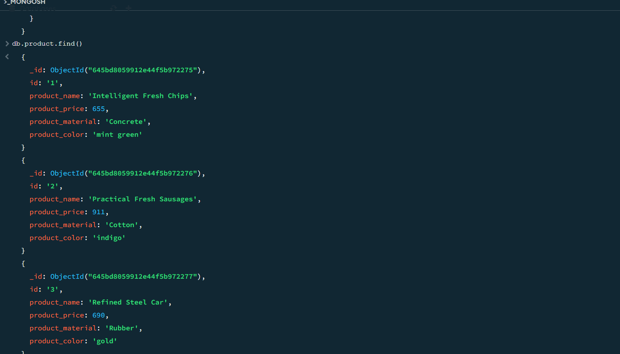

1. Find the product price which are between 400 to 800

Answer: db.product.find({product_price: {$gte : 400,$lte : 800}})

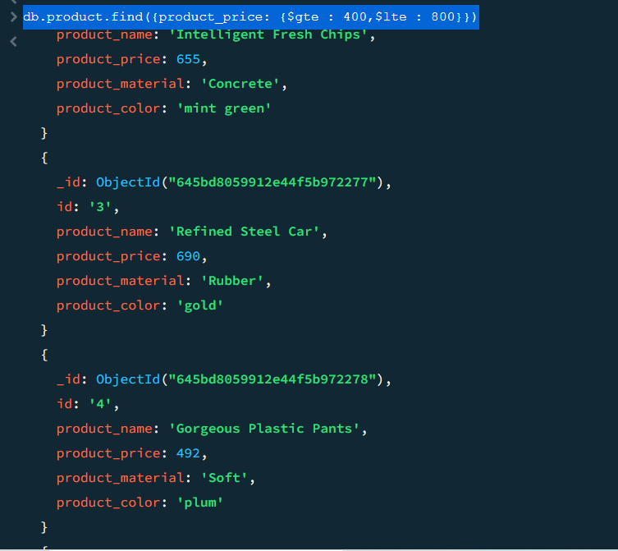

3 . Find the product price which are not between 400 to 600

Answer: db.product.find({product_price: {$not :{$lte : 400,$gte : 800}}})

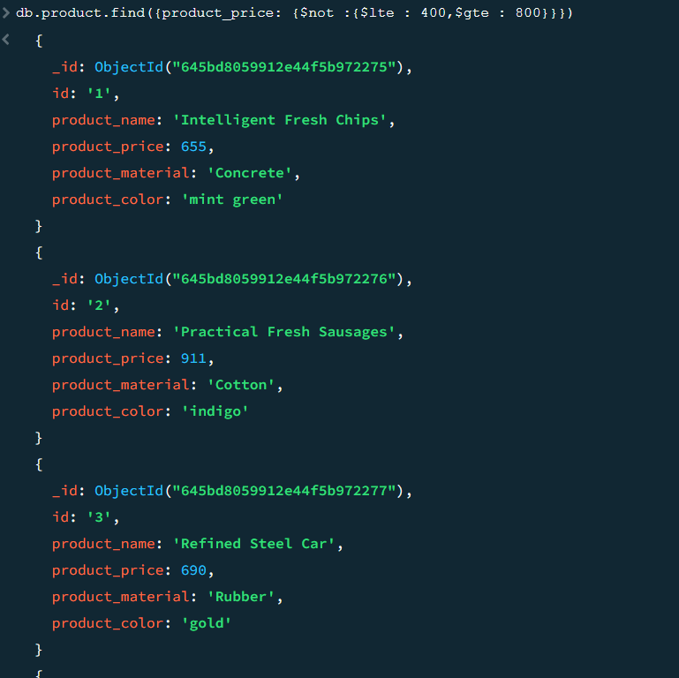

4. List the four product which are grater than 500 in price

answer: db.product.find({product_price : {$gt:500}})

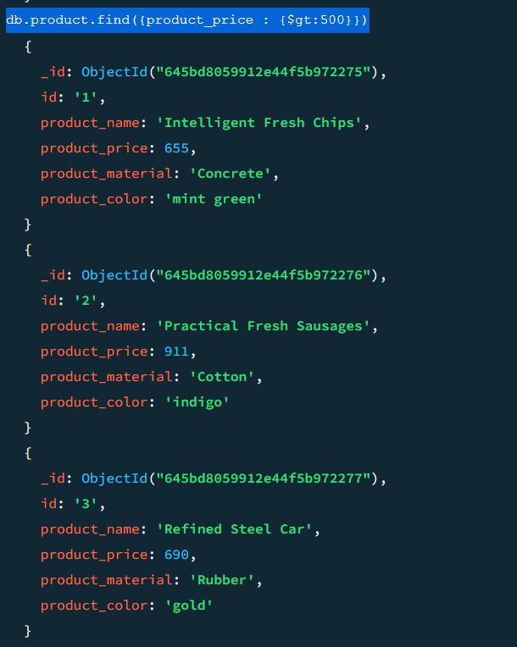

5. Find the product name and product material of each products

Answer: db.products.find({},{_id: 0, product_name: 1, product_material: 1}).toArray();

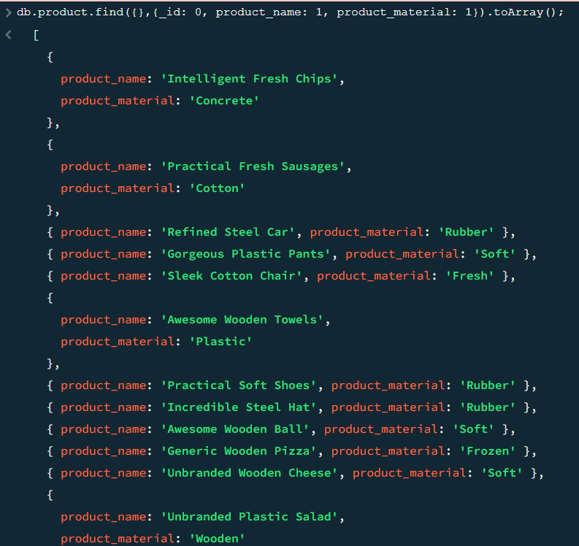

6. Find the product with a row id of 10

answer : db.product.find({id:"10"})

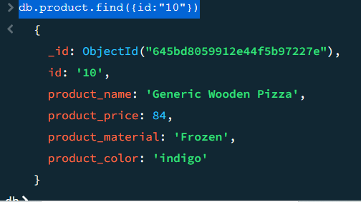

7. Find only the product name and product material

Answer: db.products.find({},{product_name: 1, product_material: 1}).toArray();

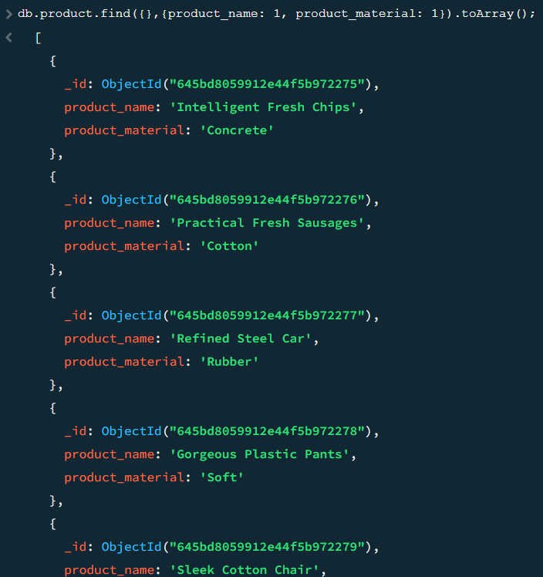

8. Find all products which contain the value of soft in product material

Answer: db.product.find({product_material: 'Soft'})

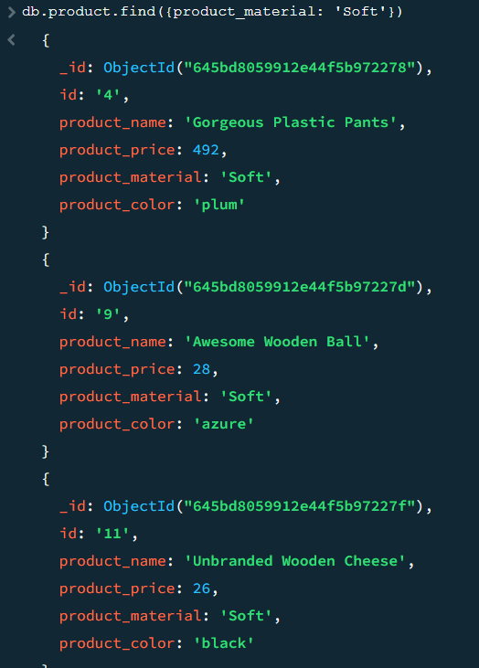

9. Find products which contain product color indigo and product price 492.00

Answer: db.product.find({$or: [{product_color: "indigo"},{product_price: 492}]});

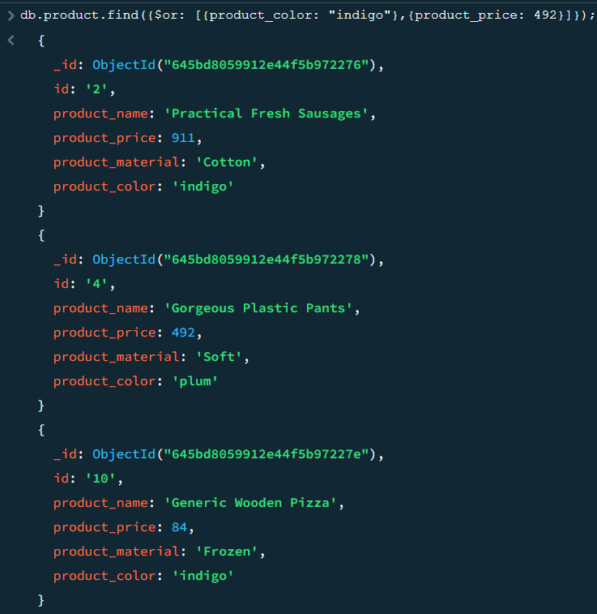

10. Delete the products which product price value are same

Answer: db.product.aggregate([

{$group: {_id: "$product_price", count: {$sum: 1}}},

{$match: {_id: {$ne: null}, count: {$gt: 1}}}

]);

db.product.deleteMany({$or: [{product_price: 36},{product_price: 47}]});

