db.zenclass.insertMany([

{

"user" : "Saravanan",

"codekata" : 175,

"attendance" : "Present",

"topics" : "JS",

"topic_date" : new Date("<2022-11-20>"),

"task_date" : new Date("<2022-11-25>"),

"tasks" : "timeoud-message",

"company_drives" : "TCS",

"company_drives_date" : new Date("<2022-12-05>"),

"placement": "Appeared",

"mentors" : "Sanjay"

},

{

"user" : "vinod",

"codekata" : 200,

"attendance" : "Present",

"topics" : "MongoDB",

"topic_date" : new Date("<2022-11-15>"),

"task_date" : new Date("<2022-11-20>"),

"tasks" : "mongo DB commands",

"company_drives" : "Infosys",

"company_drives_date" : new Date("<2022-07-25>"),

"placement": "Appeared",

"mentors" : "Mohan"

},

{

"user" : "sidharth",

"codekata" : 180,

"attendance" : "Present",

"topics" : "Node_js",

"topic_date" : new Date("<2022-09-16>"),

"task_date" : new Date("<2022-09-21>"),

"tasks" : "RWD,bootstrap",

"company_drives" : "ZOHO",

"company_drives_date" : new Date("<2022-08-28>"),

"placement": "Appeared",

"mentors" : "Raghav"

},

{

"user" : "Chandran",

"codekata" : 190,

"attendance" : "Present",

"topics" : "HTML",

"topic_date" : new Date("<2022-05-11>"),

"task_date" : new Date("<2022-05-17>"),

"tasks" : "responsive_web_design,webkata",

"company_drives" : "WIPRO",

"company_drives_date" : new Date("<2022-04-22>"),

"placement": "Appeared",

"mentors" : "Magesh"

},

{

"user" : "Santhosh",

"codekata" : 250,

"attendance" : "Present",

"topics" : "CSS",

"topic_date" : new Date("<2020-10-12>"),

"task_date" : new Date("<2020-10-14>"),

"tasks" : "responsive_web_design",

"company_drives" : "MndTree",

"company_drives_date" : new Date("<2022-06-15>"),

"placement": "Appeared",

"mentors" : "Prakash"

},

{

"user" : "Narayaan",

"codekata" : 200,

"attendance" : "Absent",

"topics" : "JS EXERCISES",

"topic_date" : new Date("<2022-09-10>"),

"task_date" : new Date("<2022-09-16>"),

"tasks" : "ASYNC-AWAIT",

"company_drives" : "Oracle",

"company_drives_date" : new Date("<2022-07-31>"),

"placement": "Not_appeared",

"mentors" : "Rupan"

},

{

"user" : "Durga",

"codekata" : 180,

"attendance" : "Present",

"topics" : "React",

"topic_date" : new Date("<2022-04-15>"),

"task_date" : new Date("<2022-14-21>"),

"tasks" : "movie_app-react",

"company_drives" : "Sapient",

"company_drives_date" : new Date("<2020-03-04>"),

"placement": "Appeared",

"mentors" : "Raghav"

},

{

"user" : "Dharma",

"codekata" : 225,

"attendance" : "Present",

"topics" : "nodejs",

"topic_date" : new Date("<2022-02-17>"),

"task_date" : new Date("<2022-02-22>"),

"tasks" : "DB-Connect & queries",

"company_drives" : "Microsoft",

"company_drives_date" : new Date("<2022-04-22>"),

"placement": "Appeared",

"mentors" : "Nagarajan"

},

]);

Query 1: Find all the topics and tasks which are thought in the month of October

Answer: : db.zenclass.find({$or: [{topic_date: {$gte : new Date("<2020-10-01>"),$lte: new Date("<2020-10-31>")}},{task_date: {$gte : new Date("<2020-10-01>"), $lte: new Date("<2020-10-31>")}}]},{topics: 1, tasks: 1}).toArray();

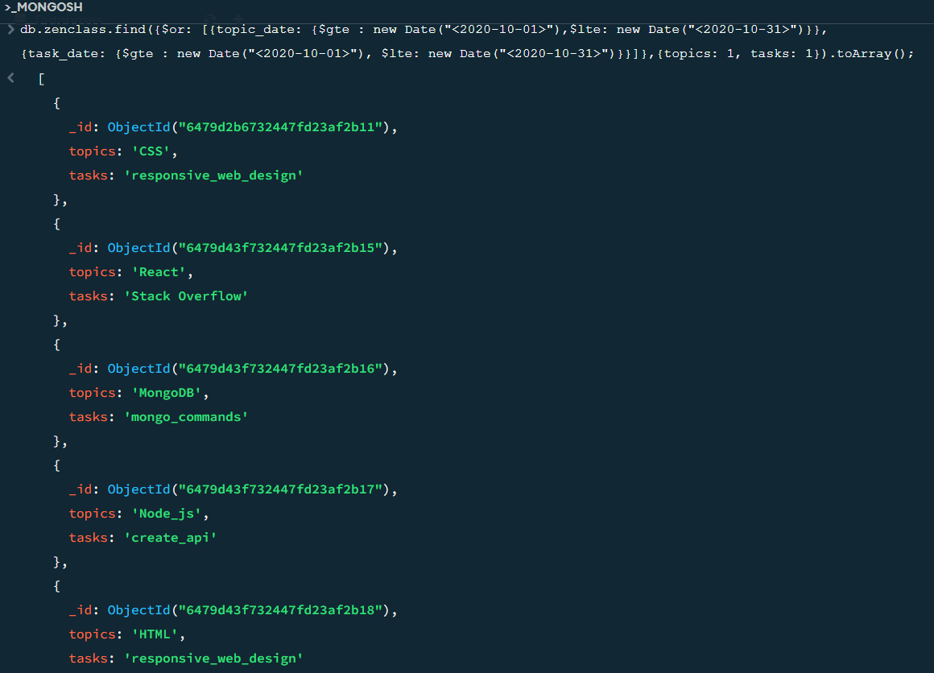

Query 2. Find all the company drives which appeared between 15 oct-2020 and 31-oct-2020

Answer: db.zenclass.find({company_drives_date: {$gte : new Date("<2020-10-15>"), $lte: new Date("<2020-10-31>")}},{company_drives: 1}).toArray();

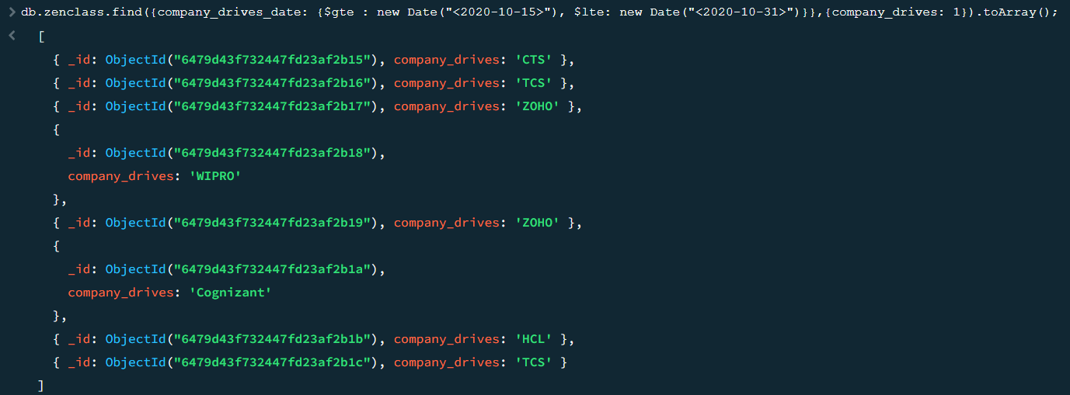

Query 3: Find all the company drives and students who are appeared for the placement.

Answer: db.zenclass.find({placement: "Appeared"},{ _id: 0,user: 1, company_drives: 1}).toArray();

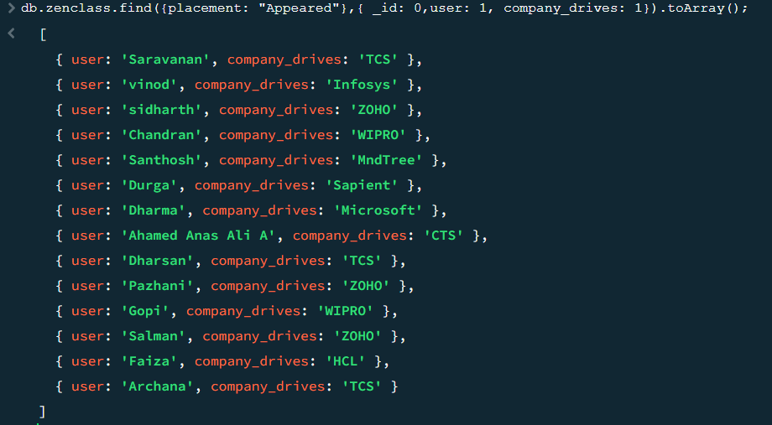

Query 4: Find the number of problems solved by the user in codekata

Answer: db.zenclass.find({},{_id: 0,user: 1, codekata: 1}).toArray();

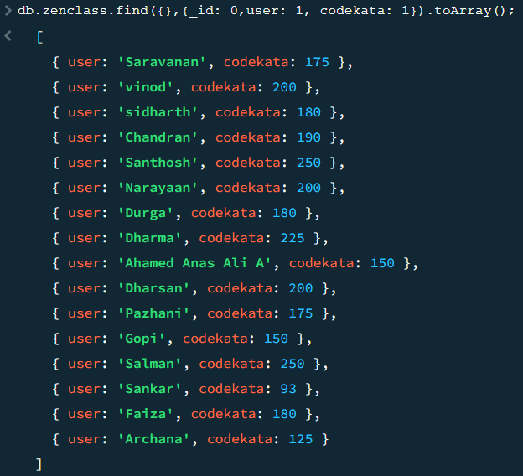

Query 5. Find all the mentors with who has the mentee's count more than 15

Answer: db.zenclass.aggregate([ {$group: {_id: "$mentors", count: {$sum: 1}}}, {$match: {_id: {$ne: null}, count: {$gt: 15}}}]); db.zenclass.find({mentors: "Raghav"},{user: 1, mentors: 1});

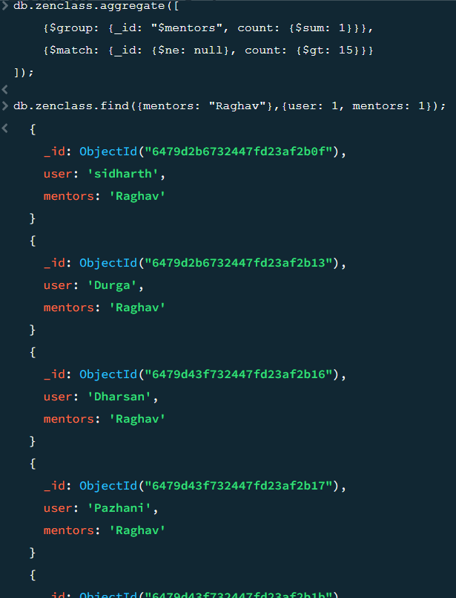

Query 6: Find the number of users who are absent and task is not submitted between 15 oct-2020 and 31-oct-2020

Answer: db.zenclass.find({$or: [{attendance: "Absent"}, {task_date: {$not: {$gte: new Date("<2020-10-15>"), $lte: new Date("<2020-10-31>")}}}]});

