
Dr. Rajesh Child Health Clinic Dr. Rajesh M
MD - Pediatrics
Dr. M. Rajesh's Children's Hospital Vijaya Nagar Velachery 600042 Chennai
Name: Subhathikshitha S
Age/Sex: 1y 2m 1d / F
ID: RM19854
Weight: 8.2 kg
Date: 04-05-2026

Diagnosis: URTI Upper Respiratory Tract Infection, Gastritis

Rx | Name | Frequency | Duration | Notes
1 | Drop Capsivon P Nasal | 2 drops - Thrice a day | 3 Days
2 | Syrup V Cold  ( COUGH / COLD ) | 2.5 ml - 0 - 2.5 ml | 3 Days | After Food
3 | Sachet Esgerd Junior  Indigestion / acidity | 0 - 1 - 0 | 5 Days | Before Food, Mix with 10 ml water
4 | Sachet Flora 33  PROBIOTIC | 0 - 0 - 1 | 5 Days | Before Food, Mix with 10 ml water

Instructions:
Diet :
Plenty of warm water , Barley kanji / water
Apple , Pomegranate , Papaya , Boiled vegetables
Idli , rice kanji , rasam rice , Idiappam , Oats , Dosai without oil , Dhal water rice , Poha Received with thanks ₹500 for Consultation (₹500)
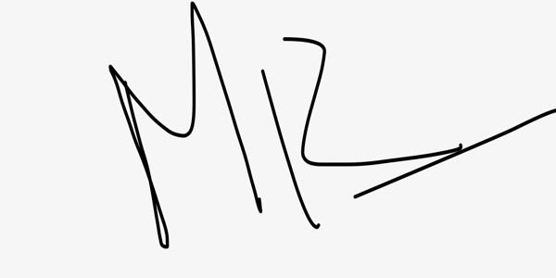
Dr. Rajesh M
MD - Pediatrics
69689
Find your prescription online on docon.co.in

