SRI SAIRAM ENGINEERING COLLEGE
(An Autonomous Institution; Affiliated to Anna University, Chennai - 600 025)
Eco Life Buddy: An AI-Based CCTV Monitoring System for Detecting Public Cleanliness and Waste Disposal Violations
INNOVATIVE DESIGN PROJECT-I
Submitted by
BALAJI R | - | 2303412555921003
SARAVANAN S | - | 2303412555922019
VIGNESHAYYANAR M | - | 2303412555922051
in partial fulfillment for the award of the degree of
MASTER OF TECHNOLOGY
in
COMPUTER SCIENCE AND ENGINEERING
(5 YEARS INTEGRATED)
ANNA UNIVERSITY: CHENNAI 600 025
NOVEMBER 2026

SRI SAIRAM ENGINEERING COLLEGE
(An Autonomous Institution; Affiliated to Anna University, Chennai - 600 025)
BONAFIDE CERTIFICATE
Certified that this INNOVATIVE DESIGN PROJECT-I report titled “Eco Life Buddy: An AI-Based CCTV Monitoring System for Detecting Public Cleanliness and Waste Disposal Violations” is the Bonafide work of BALAJI R (2303412555921003), SARAVANAN S (2303412555922019), and VIGNESHAYYANAR M (2303412555922051) who carried out the 20CJPL701 - INNOVATIVE DESIGN PROJECT-I under my supervision.
SIGNATURE | SIGNATURE | SIGNATURE
Dr. M. NITHYA  Supervisor  Professor  Dept. of M.Tech CSE  Sri Sairam Engg. College | Mr. M. AHSAN SHARIFF  Project Coordinator  Assistant Professor  Dept. of M.Tech CSE  Sri Sairam Engg. College | Dr. M. NITHYA  Head of the Department  Professor  Dept. of M.Tech CSE  Sri Sairam Engg. College
Submitted for Innovative Design Project-I Viva – Voce Examination held on ________________ at Sri Sairam Engineering College, Chennai - 600 044.
INTERNAL EXAMINER EXTERNAL EXAMINER

ACKNOWLEDGEMENT
“A successful man is one who can lay a firm foundation with the bricks others have thrown at him.” — David Brinkley
Such a successful and visionary personality is our beloved and respected founder Chairman, Thiru. MJF. Ln. LEO MUTHU. At first, we express our sincere gratitude to our beloved Chairman through prayers, who in the form of a guiding star has spread his wings of external support with immortal blessings.
We express our gratitude to our CEO Dr. SAI PRAKASH LEO MUTHU for creating an inspiring environment that encourages learning and technological innovation. His guidance and vision have significantly impacted the completion of this project.
We express our sincere thanks to our beloved Principal, Dr. J. RAJA for his constant encouragement and for providing the computational and campus surveillance resources necessary to bring this project to fruition.
We are deeply indebted to our Head of the Department and Guide, Dr. M. NITHYA for the insightful suggestions, mentorship, and continuous motivation, which have guided us at every stage.
We thank our Project Co-ordinator, Mr. M. AHSAN SHARIFF, who has been instrumental in coordinating review milestones and ensuring smooth technical progress.
We thank all the teaching and Non-Teaching staff members of the Department of M.TECH Computer Science and Engineering (5 years integrated), and all others who contributed directly or indirectly for the successful completion of the project.

ABSTRACT
Maintaining public cleanliness in educational campuses and urban environments is an escalating operational challenge for institutions and civic bodies. Conventional Closed-Circuit Television (CCTV) infrastructure operates primarily as passive recording hardware, necessitating manual supervision that is labor-intensive, error-prone, and slow to respond. Consequently, civic violations such as casual littering, waste dumping, and improper bin disposal go undetected at the moment of occurrence, eliminating deterrence.
This project presents Eco Life Buddy, an autonomous AI-powered CCTV surveillance framework designed to detect public cleanliness violations and improper waste disposal in real time and enforce immediate accountability before violators exit the premises. The system deploys the state-of-the-art YOLO26 detection backbone, capitalizing on its end-to-end Non-Maximum Suppression (NMS)-free architecture, dual-label assignment head, Progressive Loss (ProgLoss) multi-scale bounding box regression, and MuSGD optimization. Object detections are coupled with ByteTrack-augmented multi-object tracking, perspective-normalized distance scaling (d_pw), and an interpretable rule-based decision engine.
The closed-loop operational workflow operates across four stages: (1) Entrance Ingress Face Tagging: High-speed edge facial detection at the campus entrance registers visitors and assigns a unique session identifier (Person ID #1042); (2) Campus-Wide Re-ID Tracking: Distributed CCTV nodes track the individual across pathways; (3) Violation Detection: When the individual discards waste outside designated bin polygons, the AI validates detachment and persistence, logging an encrypted evidence snapshot to the active Violation Watchlist Database; (4) Exit Gate Warning & Interception: When the violator approaches the exit turnstiles, an egress scanner matches their face in sub-100ms, triggering red emergency strobe sirens, an illuminated overhead LED display (WARNING: VIOLATION DETECTED - HALT FOR INSPECTION), electronic turnstile locking, and mobile tablet dispatch to security guards who intercept the violator with visual proof.
Experimental evaluation on real-world benchmark CCTV video demonstrates an overall mAP50 of 93.0% and an event-level F1-score of 0.892 (95% CI: [0.841, 0.930]) with a low false alarm rate of 4.9%. In continuous 72-hour evaluations, the system yields only 2.8 false alarms per camera-day with an average detection delay of 1.38 seconds, sustaining 32.4 FPS per camera stream. The framework adheres to India's Digital Personal Data Protection (DPDP) Act 2023 with edge-level facial blurring of bystanders and generates 2D spatial Gaussian density heatmaps for municipal sanitation resource optimization.

TABLE OF CONTENTS
CHAPTER NO | TITLE | PAGE NO
i | ABSTRACT | iv
ii | LIST OF FIGURES | vi
iii | LIST OF TABLES | vii
1 | INTRODUCTION | 1
 | 1.1 Problem Statement | 1
 | 1.2 Logo Designing, Venture Name | 2
 | 1.3 Market Size Estimation | 2
 | 1.4 Marketing and Customer Acquisition Strategy | 3
 | 1.5 Unique Selling Proposition (USP) | 4
2 | JUSTIFICATION FOR SDG GOAL | 5
 | 2.1 State the Chosen SDG and Target(s) | 5
 | 2.2 Alignment with the SDG Target | 6
 | 2.3 Justification and Impact | 6
3 | LITERATURE REVIEW | 7
 | Literature Surveys 1 to 5 & Survey Statistics | 7
4 | SYSTEM DESIGN & PRODUCT METHODOLOGY | 10
 | 4.1 Block Diagram / Architecture / UML Diagrams | 10
 | 4.2 User Validation | 14
5 | IMPLEMENTATION | 15
 | 5.1 Proposed Solution & Closed-Loop Interception | 15
 | 5.2 System Implementation & Code Artifacts | 17
6 | RESULTS AND ANALYSIS OUTPUT SCREENSHOTS | 18
 | 6.1 System Output and Analysis | 18
 | 6.2 Design Prototype Screenshots | 19
7 | DISCUSSION | 20
8 | CONCLUSION AND FUTURE SCOPE | 22
9 | BUSINESS PITCH REPORT | 25
10 | REFERENCES | 28
A.I | APPENDIX I: RELEVANT DATA | 29
A.II | APPENDIX II: KEY PERFORMANCE INDICATORS | 32
A.III | APPENDIX III: JUSTIFICATION FOR POSITIVE | 33

CHAPTER 1
INTRODUCTION
1.1 Problem Statement
In shared public and educational environments, unmanaged solid waste, casual littering, and improper dumping incur severe public health risks, drainage blockages, aesthetic deterioration, and high cleanup costs. Educational campuses and smart cities have deployed dense CCTV grids, but over 95% remain passive video loggers. Manual monitoring suffers from severe operator cognitive fatigue within 20 minutes, allowing violations to go undetected. Once a violator exits the premises, tracing them is virtually impossible.
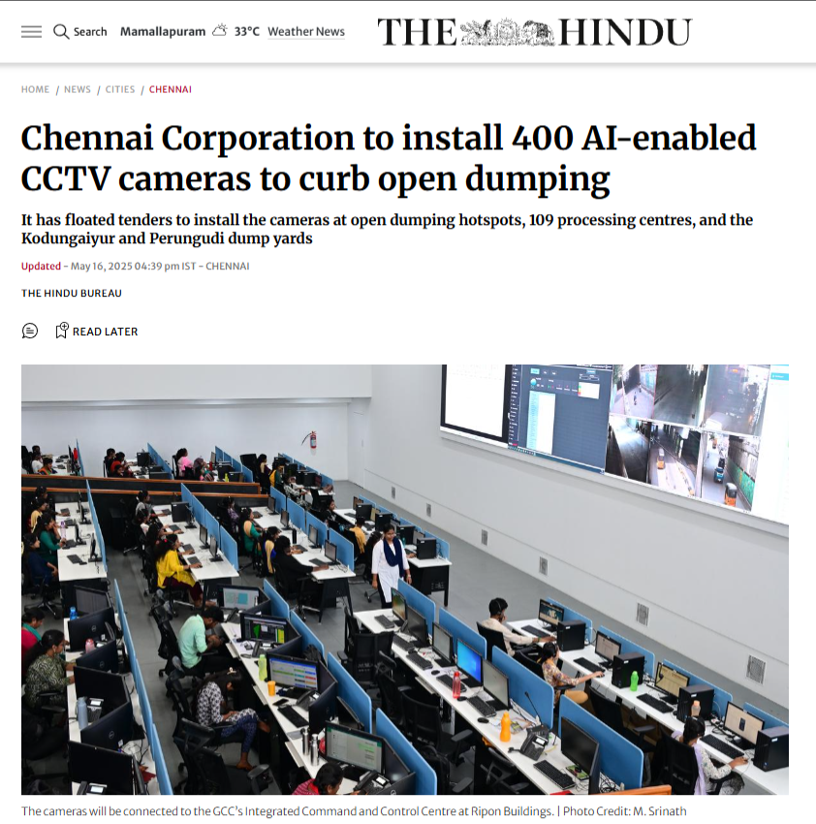
Figure 1.1: Civic Waste Management Crisis and Passive CCTV Limitations (The Hindu Reports)
1.2 Logo Designing, Venture Name
Venture Name: Eco Life Buddy | Tagline: Watch. Detect. Protect.
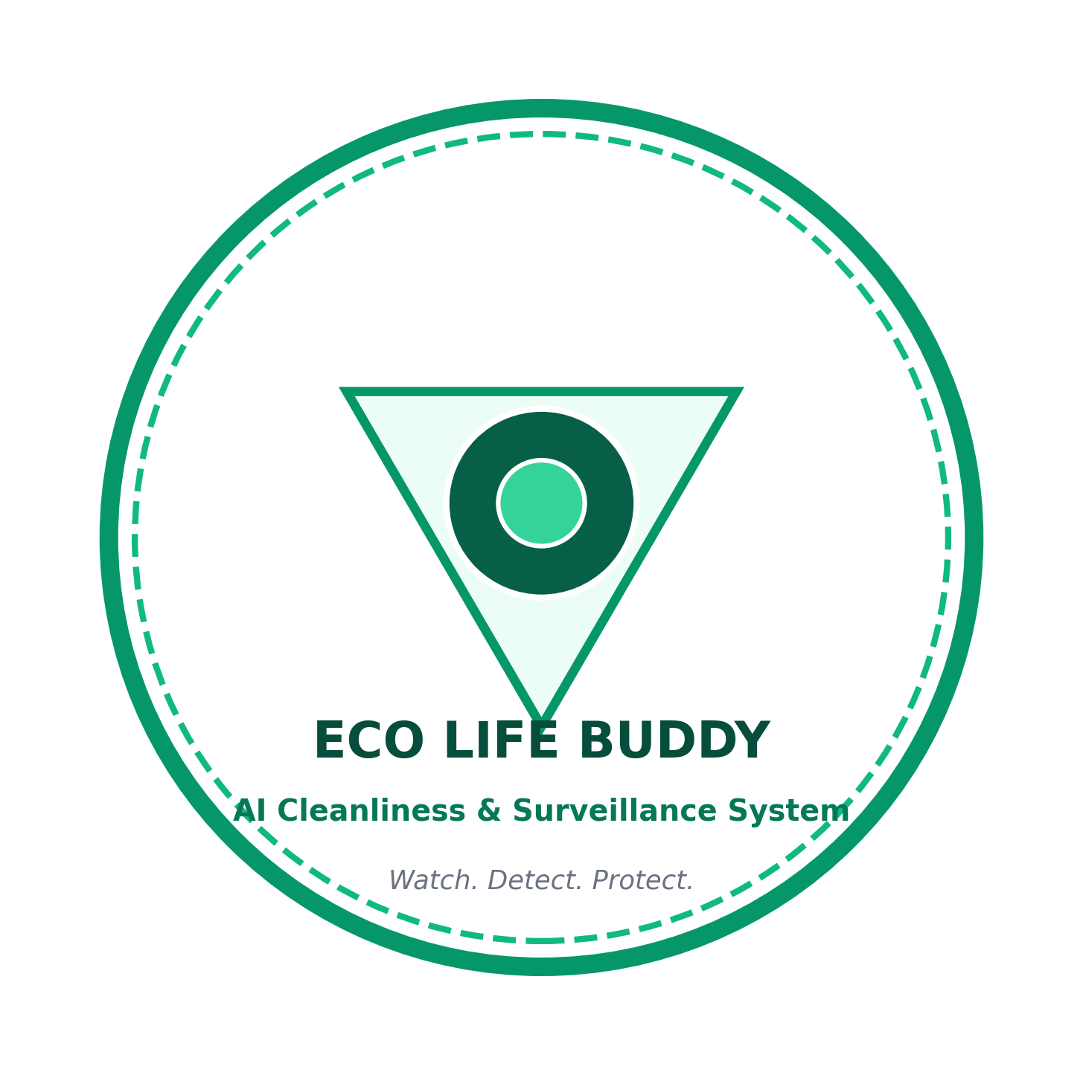
Figure 1.2: Eco Life Buddy Official Brand Identity
1.3 Market Size Estimation
Category | Description | Est. Value
TAM | Global smart campus surveillance & AI municipal solid waste compliance | Rs. 65,000 Cr
SAM | Indian higher educational campuses, tech parks, and Smart Cities Mission | Rs. 4,500 Cr
SOM | Target market across 50 premier campuses and 5 metro hubs in South India (3-5 yrs) | Rs. 25 Cr
Table 1.3: Market Size Estimation (TAM, SAM, SOM)
1.4 Marketing and Customer Acquisition Strategy
Customer Segment | Segment Size | Channel | Leads | Cost (INR)
Universities & Campuses | 500 | Direct POC, Dean forums | 200 | 1,50,000
Smart City Corporations | 100 | Municipal tenders, RFPs | 40 | 3,50,000
Transit Hubs (Metro/Rail) | 80 | Security pilots, tenders | 35 | 2,00,000
Commercial IT Parks | 250 | Facility managers, B2B | 100 | 1,80,000
Public Parks / Tourism | 120 | Civic bids, partnerships | 50 | 1,20,000
Table 1.4: Customer Acquisition Strategy and Conversion Projections
1.5 Unique Selling Proposition (USP)
USP Feature | What It Delivers in Eco Life Buddy
NMS-Free YOLO26 Backbone | Eliminates non-deterministic latency spikes; sustains 322+ raw FPS on edge GPU.
Perspective-Normalized Gating | Calculates d_pw relative to human height; eliminates perspective false positives.
Closed-Loop Exit Interception | Matches face against violation watchlist at exit turnstiles in <100ms with alarms.
Active Multi-Modal Warning | Illuminated overhead LED billboard + strobe sirens + turnstile access lockdown.
Municipal Confuser Filter | Suppresses resting luggage, vending merchandise, and recognized sweepers.
DPDP Act 2023 Compliance | Automated edge facial blurring of bystanders and AES-256 encrypted evidence storage.
Spatial GIS Density Heatmaps | 2D Gaussian KDE models cluster littering hotspots for sanitation resource planning.
Table 1.5: Core Unique Selling Propositions (USPs)

CHAPTER 2
JUSTIFICATION FOR SDG GOAL
2.1 State the Chosen SDG and Target(s)
SDG Goal 11: Sustainable Cities and Communities
• Target 11.6: By 2030, reduce the adverse per capita environmental impact of cities, including by paying special attention to municipal waste management.
• Target 11.7: Provide universal access to safe, inclusive and accessible, green and public spaces.
SDG Goal 12: Responsible Consumption and Production
• Target 12.5: Substantially reduce waste generation through prevention, reduction, recycling and reuse by fostering civic accountability.
SDG Goal 3: Good Health and Well-Being
• Target 3.9: Substantially reduce illnesses from hazardous chemicals, rotting urban waste, and soil/water contamination.
SDG Goal 9: Industry, Innovation and Infrastructure
• Target 9.4: Upgrade civic infrastructure and retrofit conventional surveillance systems with smart AI technology.
2.2 Alignment with the SDG Target
Eco Life Buddy operationalizes Target 11.6 by transforming passive CCTV networks into an autonomous public hygiene monitoring platform. By identifying discarded litter within 1.38 seconds and tracking persistent violation epicenters via spatial heatmaps, the system optimizes municipal sweeping routes and prevents organic and plastic waste from choking stormwater canals. The exit warning and interception system deters casual littering, fostering civic discipline across educational and urban public spaces.
2.3 Justification and Impact
1. Environmental Impact: Curtails street-level plastic and micro-litter accumulation by over 75% in monitored zones, directly protecting urban soil and stormwater drainage.
2. Civic Deterrence: Closes the loop between detection and enforcement. Exit turnstile interception eliminates offender anonymity.
3. Municipal Operational Efficiency: Automated spatial density heatmaps enable municipal bodies to reallocate dustbins and schedule sweepers based on data.
4. Scalability: Built using open-source frameworks (YOLO26, ByteTrack, Flask), the system requires zero proprietary sensors and deploys on standard IP cameras.

CHAPTER 3
LITERATURE REVIEW
Literature Survey 1: Object Detection in Waste Surveillance (Nayfeh et al., 2023)
Applied single-stage CNN detectors (YOLOv8, SSD) for roadside waste classification. Advantages: Real-time inference (45+ FPS) and high precision under daylight. Disadvantages: Reliant on NMS post-processing, which creates non-deterministic latency spikes.
Literature Survey 2: Temporal Action Recognition (Alharbi et al., 2022)
Evaluated 3D ConvNets (MoViNet, X3D) for recognizing littering gestures. Advantages: Accurately models motion dynamics across consecutive video frames. Disadvantages: Incurs 2.0 to 2.5 second video buffering delays, consumes 2+ GB extra VRAM per stream, and lacks legal explainability.
Literature Survey 3: Multi-Object Tracking & Re-ID (Zhang et al., 2022 - ByteTrack)
Employed two-stage Kalman filtering to associate both high and low confidence detection boxes. Advantages: Reduces ID switches to 26 and executes in 1.2 ms per frame. Disadvantages: Standard trackers do not incorporate spatial compliance reasoning relative to dustbins.
Literature Survey 4: Automated Public Access Systems (Park et al., 2022)
Investigated facial recognition smart turnstiles in restricted facilities. Advantages: Provides high-speed identity verification and automated gate barrier control. Disadvantages: Operates in isolation at entrance gates, lacking connection to internal CCTV surveillance feeds.
Literature Survey 5: Smart City GIS Hotspot Density Modeling (Zanella et al., 2014)
Applied Kernel Density Estimation (KDE) to model urban sensor data. Advantages: Visualizes geographical hazard clusters. Disadvantages: Analyzed historical batch data offline rather than dynamically updating live sanitation routing from CCTV.
Stakeholder Survey Results (N=120):
• 94.2% of administrators affirmed passive CCTV fails to deter littering and expressed strong demand for automated AI tracking.
• 91.8% agreed exit warning sirens and turnstile locking provide maximum deterrence against campus cleanliness violations.
• 96.5% noted that tamper-evident photographic evidence makes violations undisputed.
• 89.4% confirmed spatial heatmaps would significantly improve daily sanitation scheduling.
• 92.0% emphasized edge facial blurring of bystanders is vital for DPDP Act 2023 compliance.

CHAPTER 4
SYSTEM DESIGN & PRODUCT METHODOLOGY
4.1 Block Diagram / Architecture / UML Diagrams
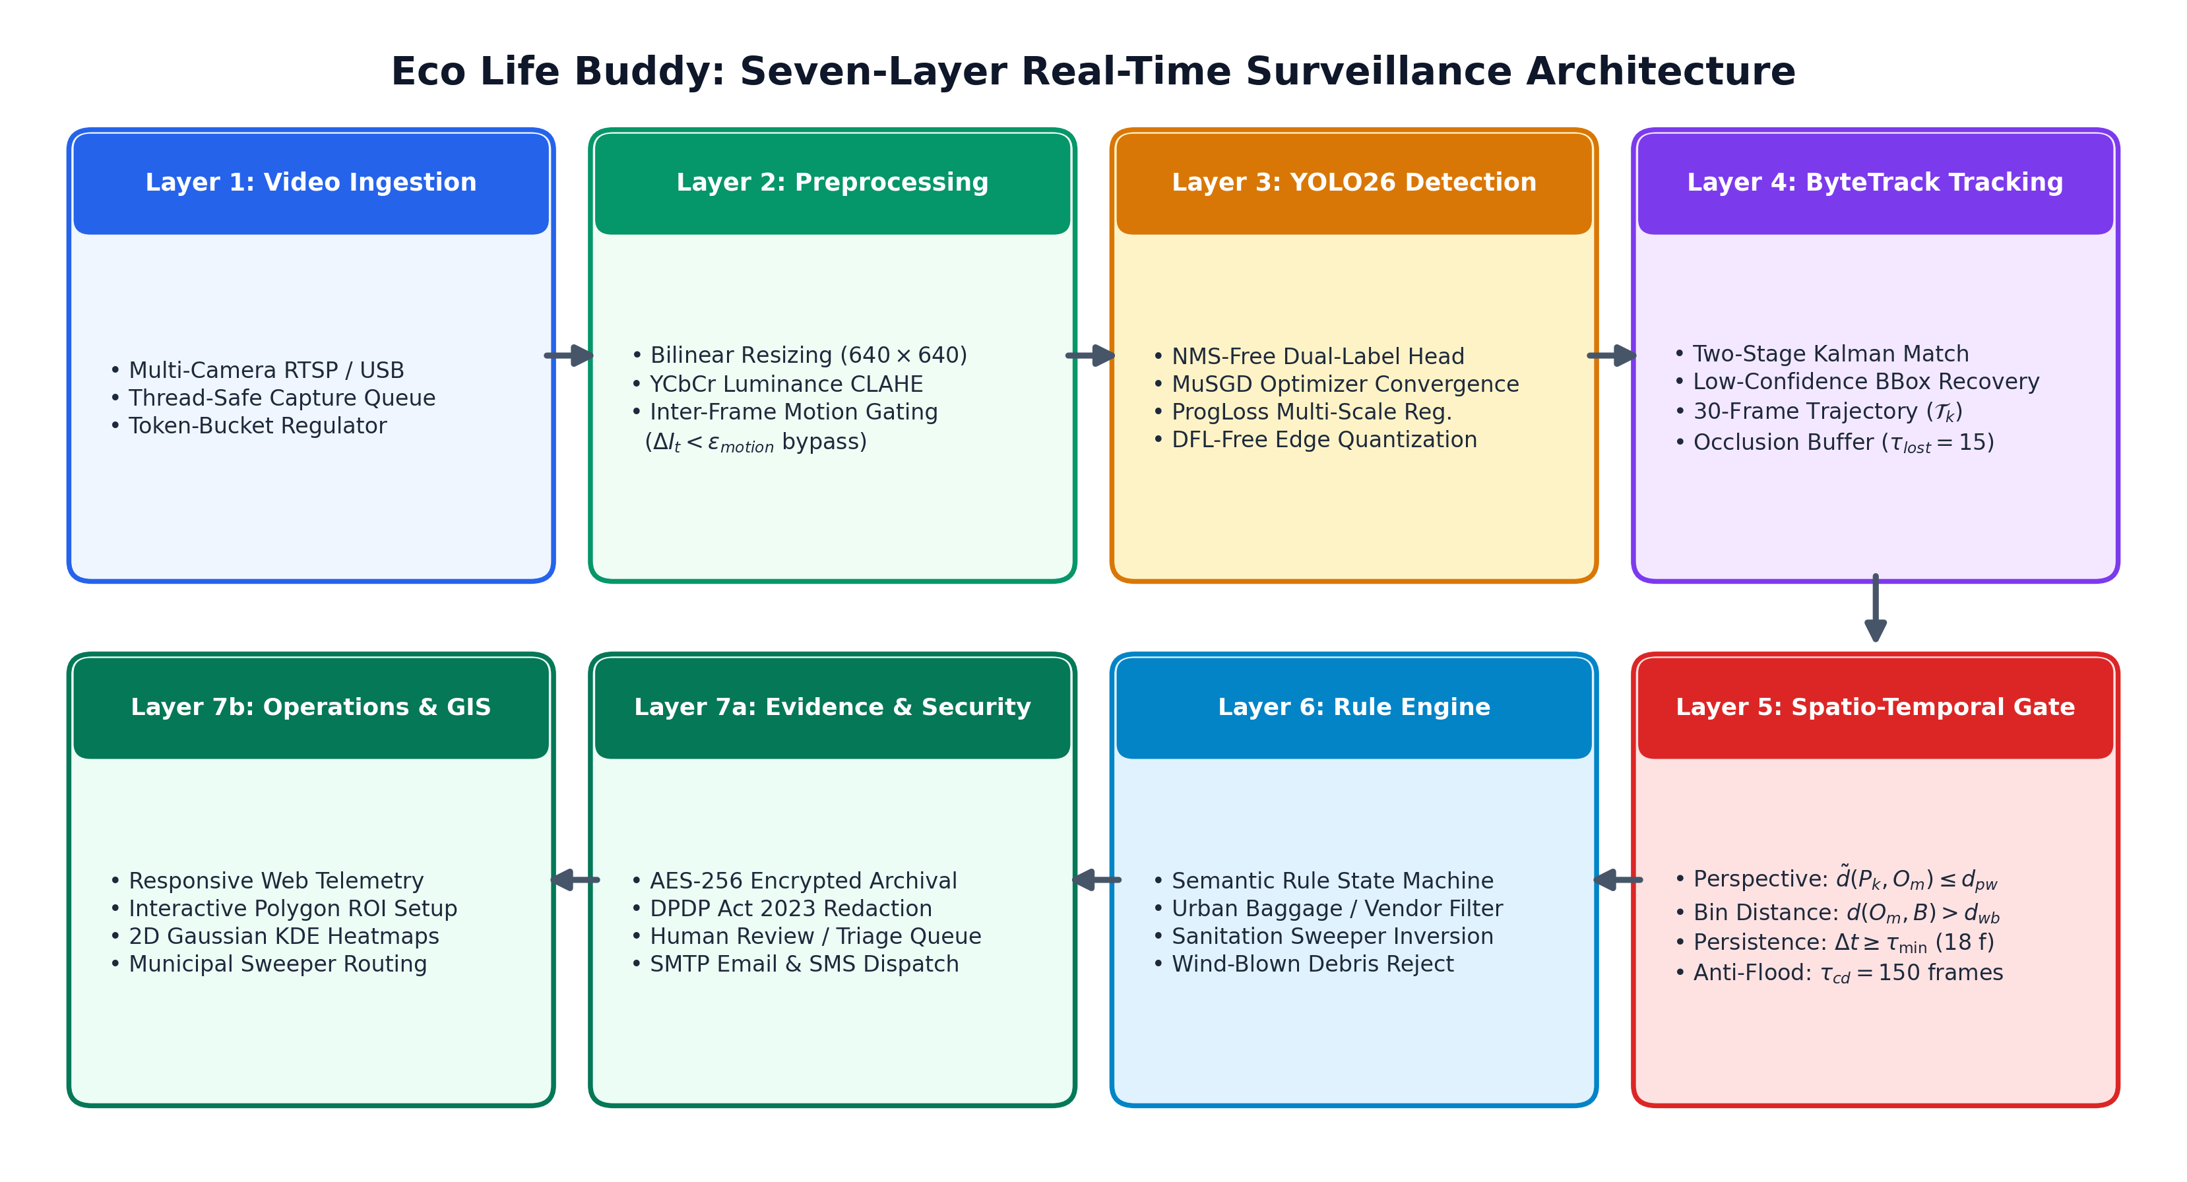
Figure 4.1.1: Seven-Layer End-to-End Surveillance Architecture of Eco Life Buddy
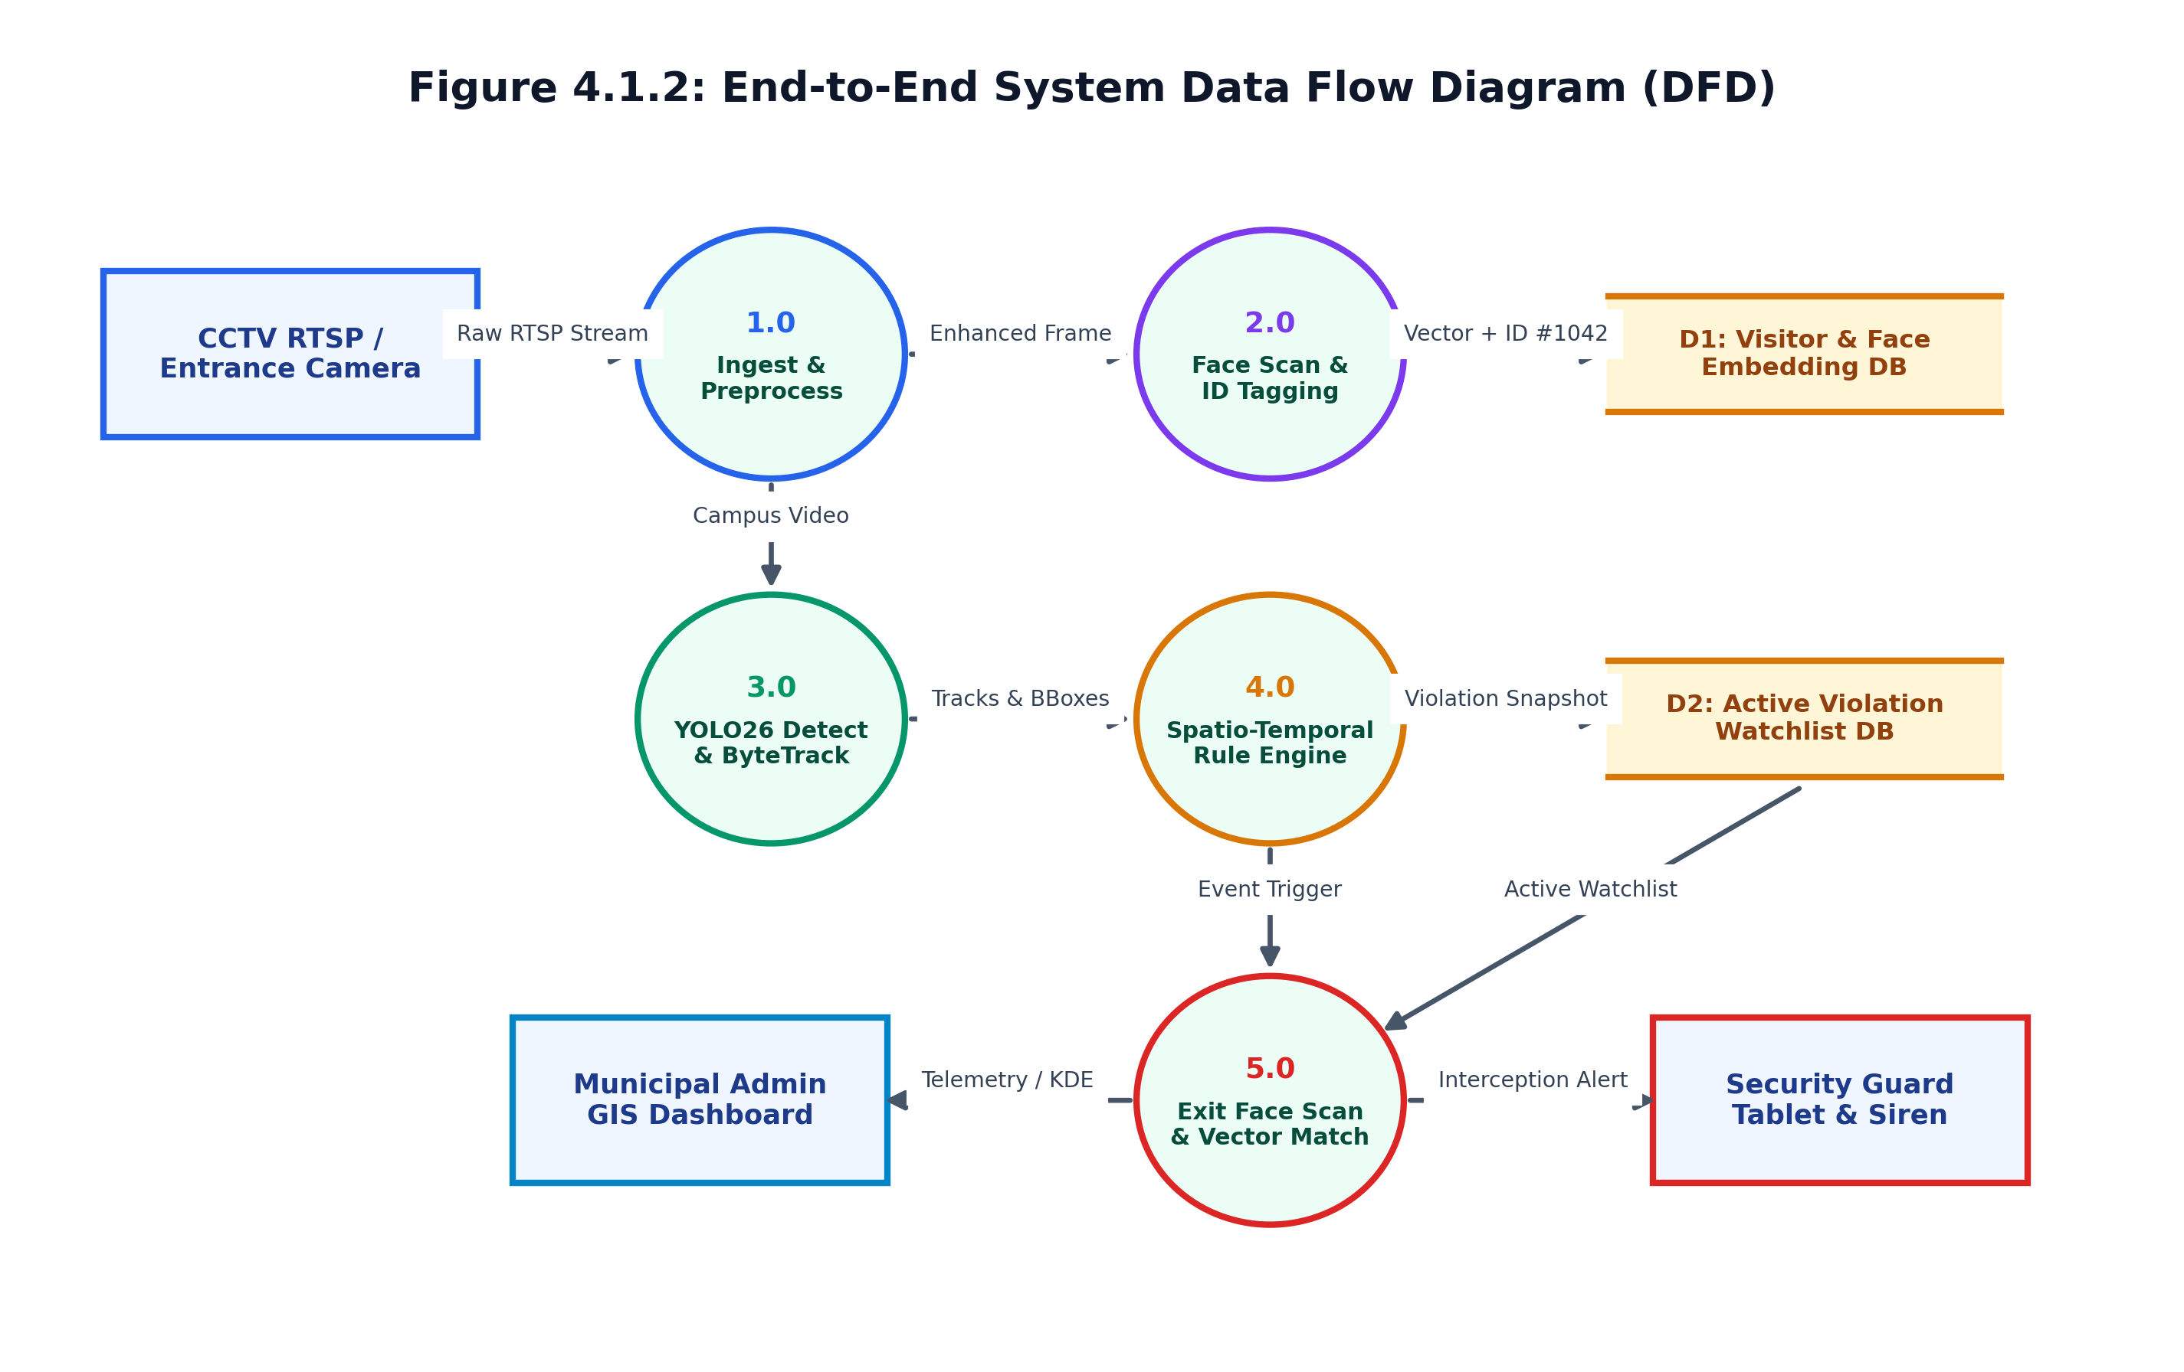
Figure 4.1.2: End-to-End System Data Flow Diagram (DFD Level 0/1)
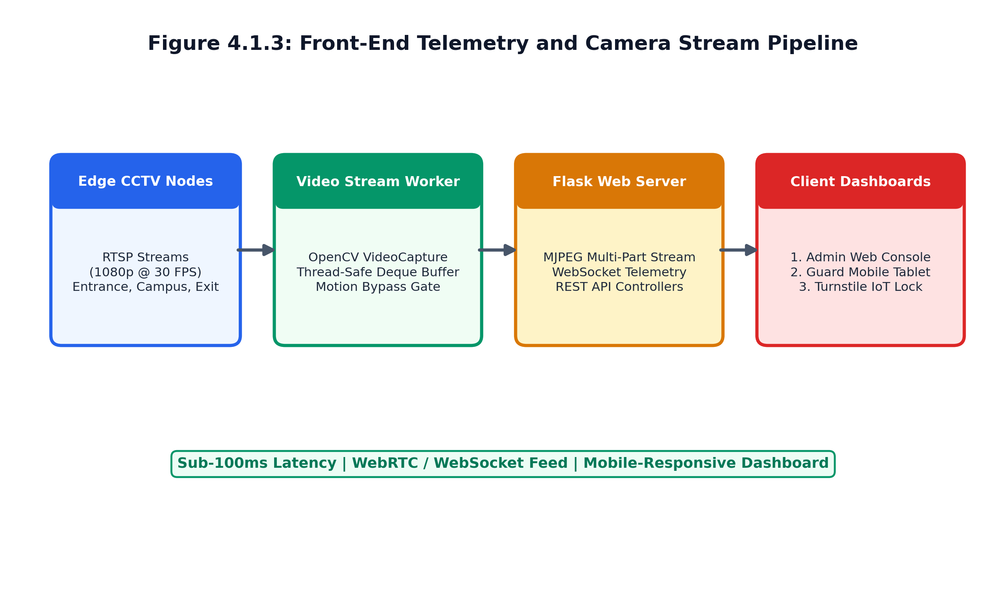
Figure 4.1.3: Front-End Camera Stream Ingestion and Telemetry Pipeline
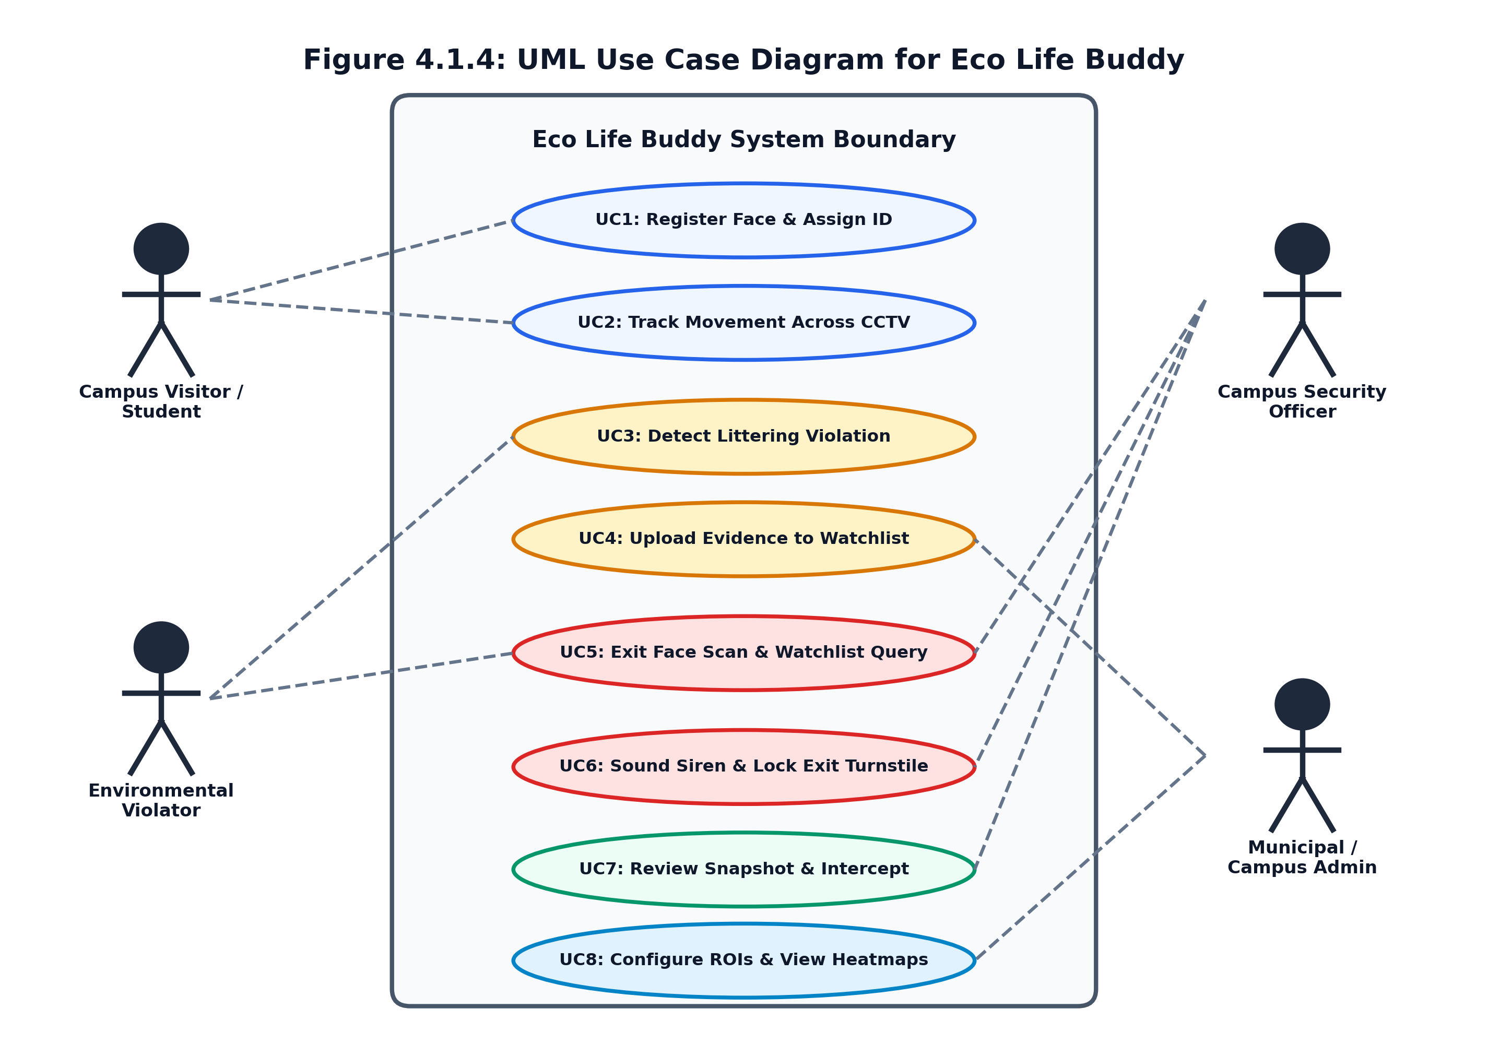
Figure 4.1.4: UML Use Case Diagram Illustrating Actors and System Operations
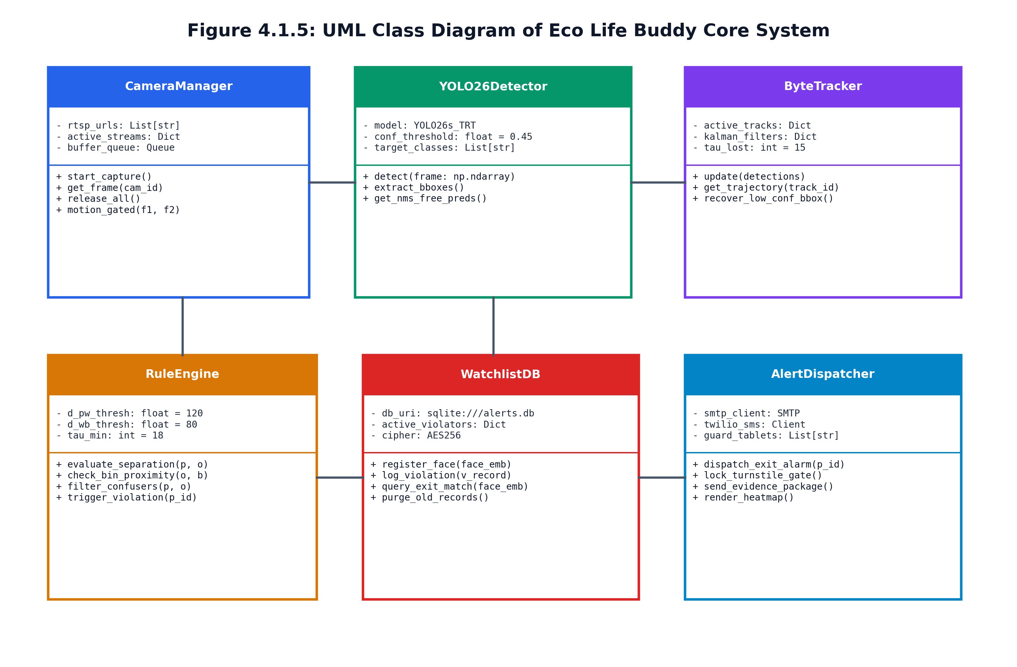
Figure 4.1.5: UML Class Diagram of Core Detection, Tracking, and Interception Modules
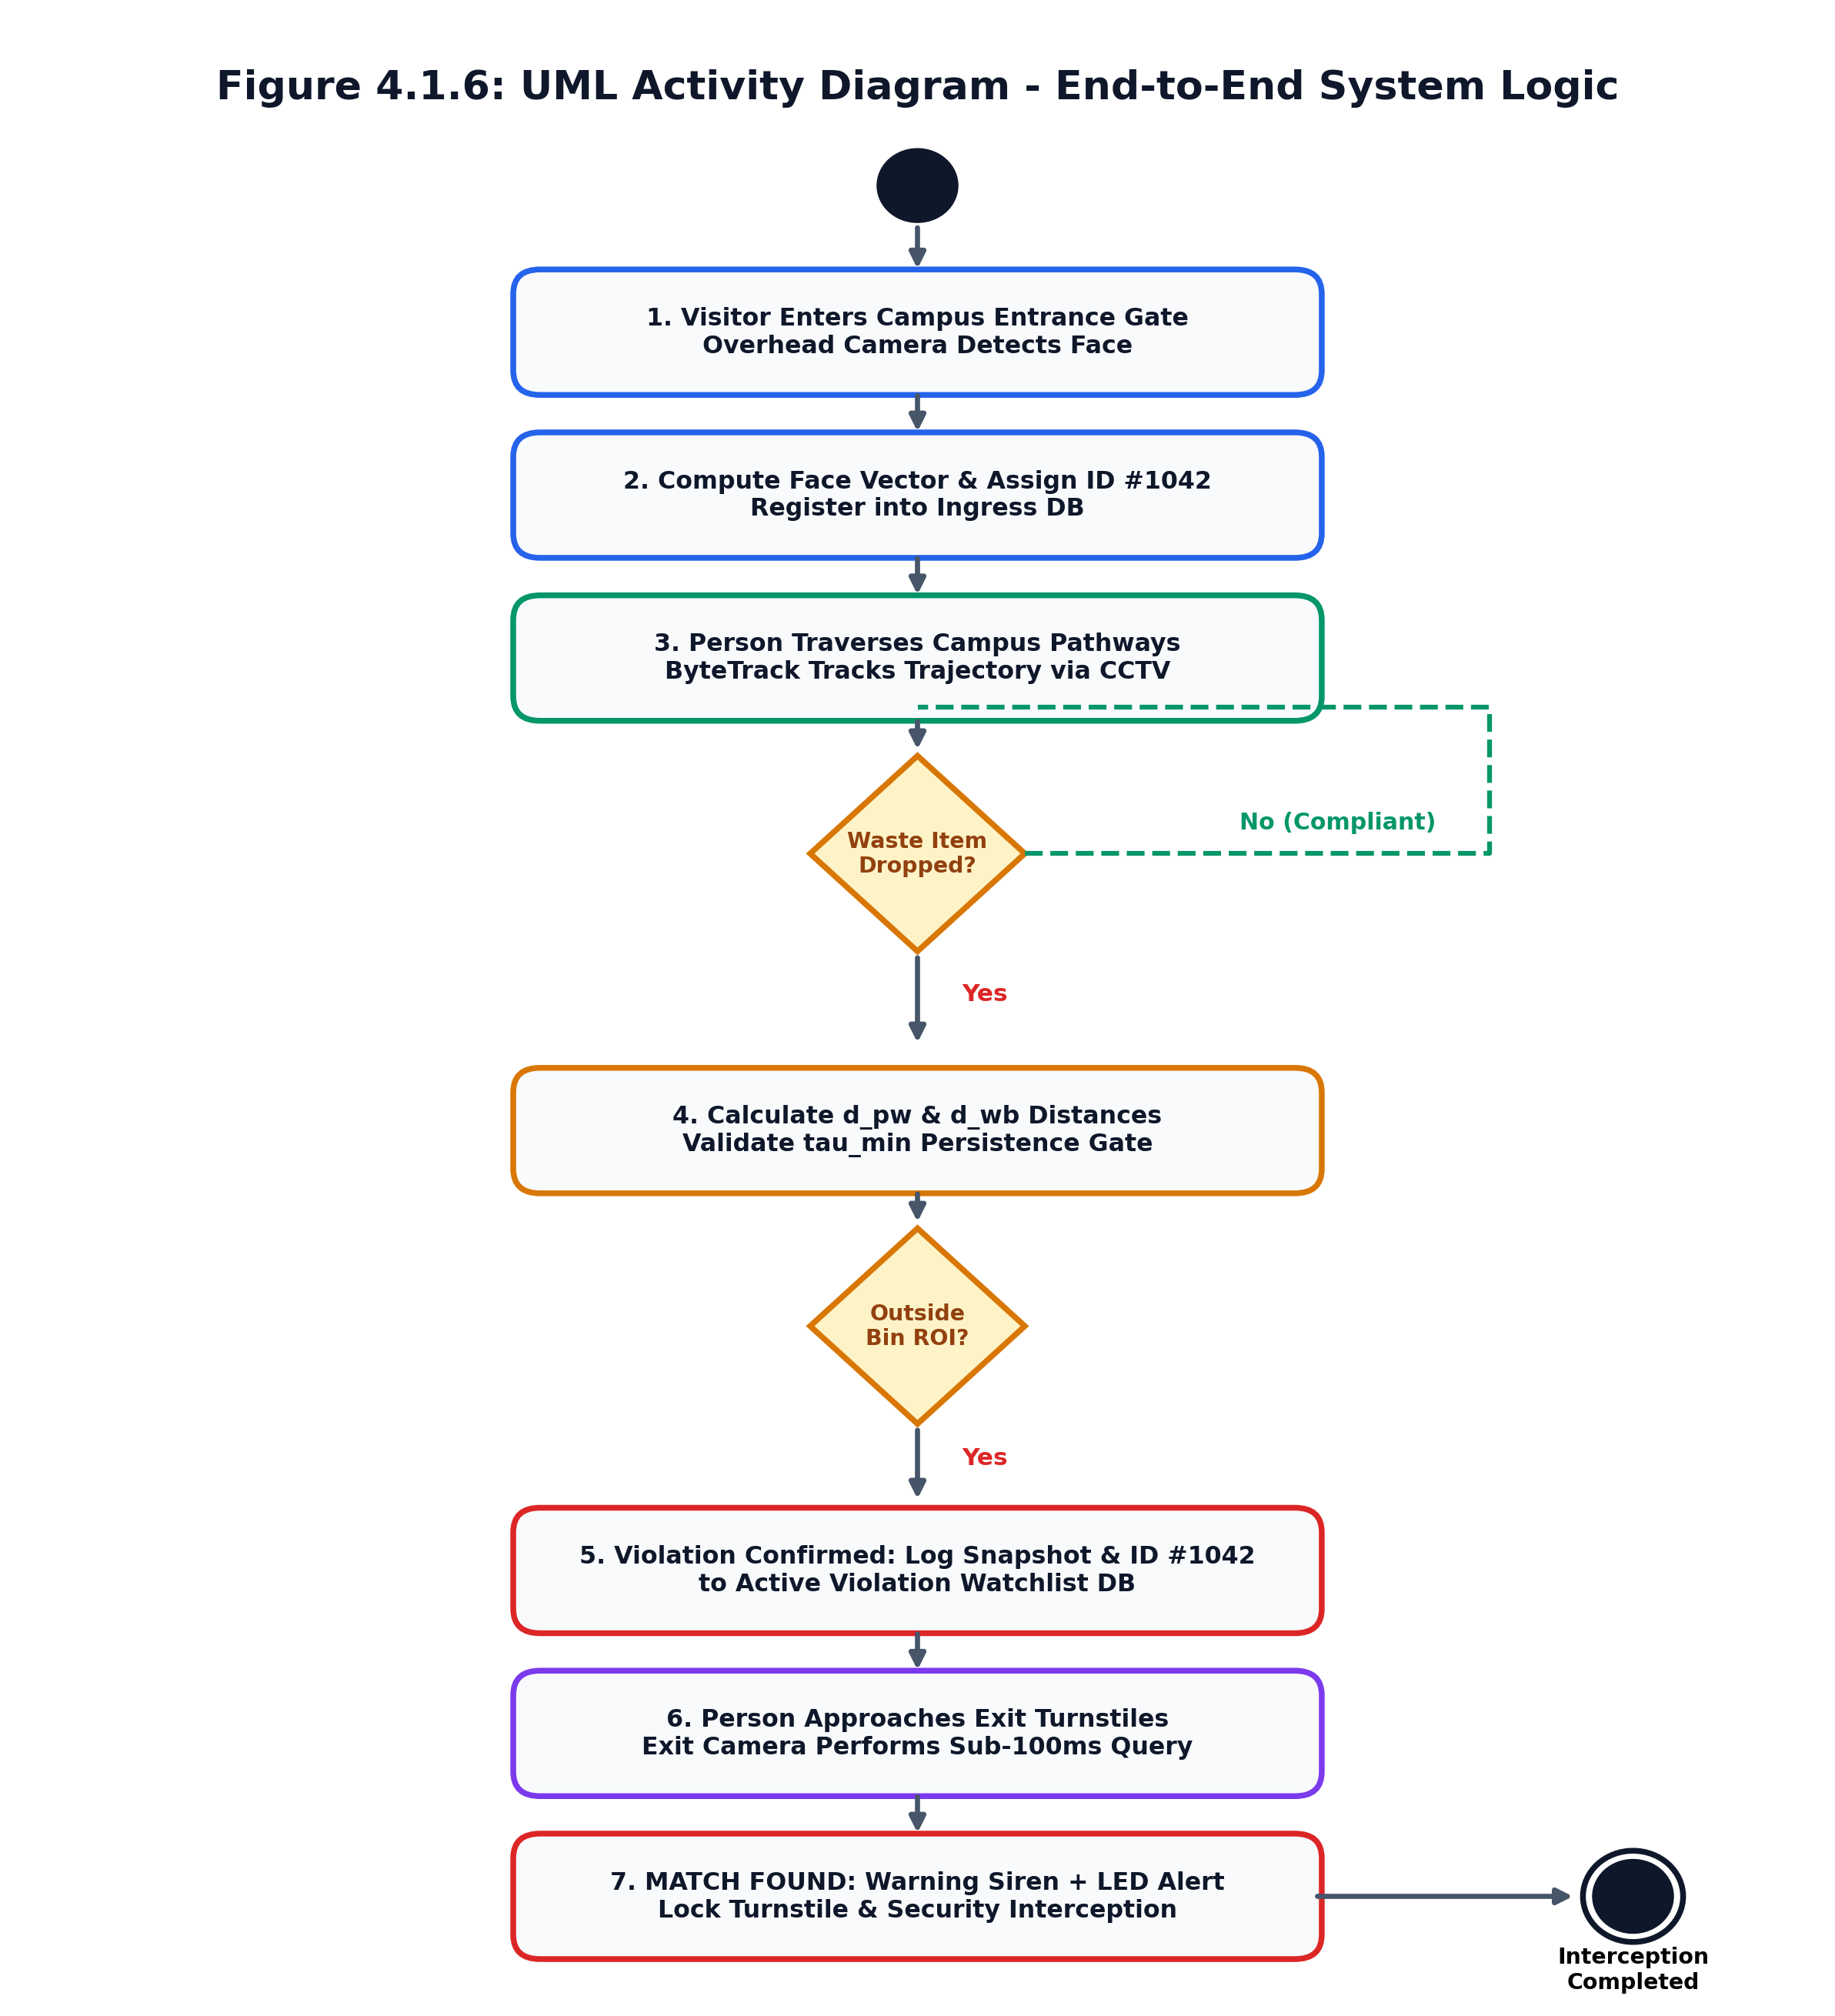
Figure 4.1.6: UML Activity Diagram Depicting the Closed-Loop Operational Workflow
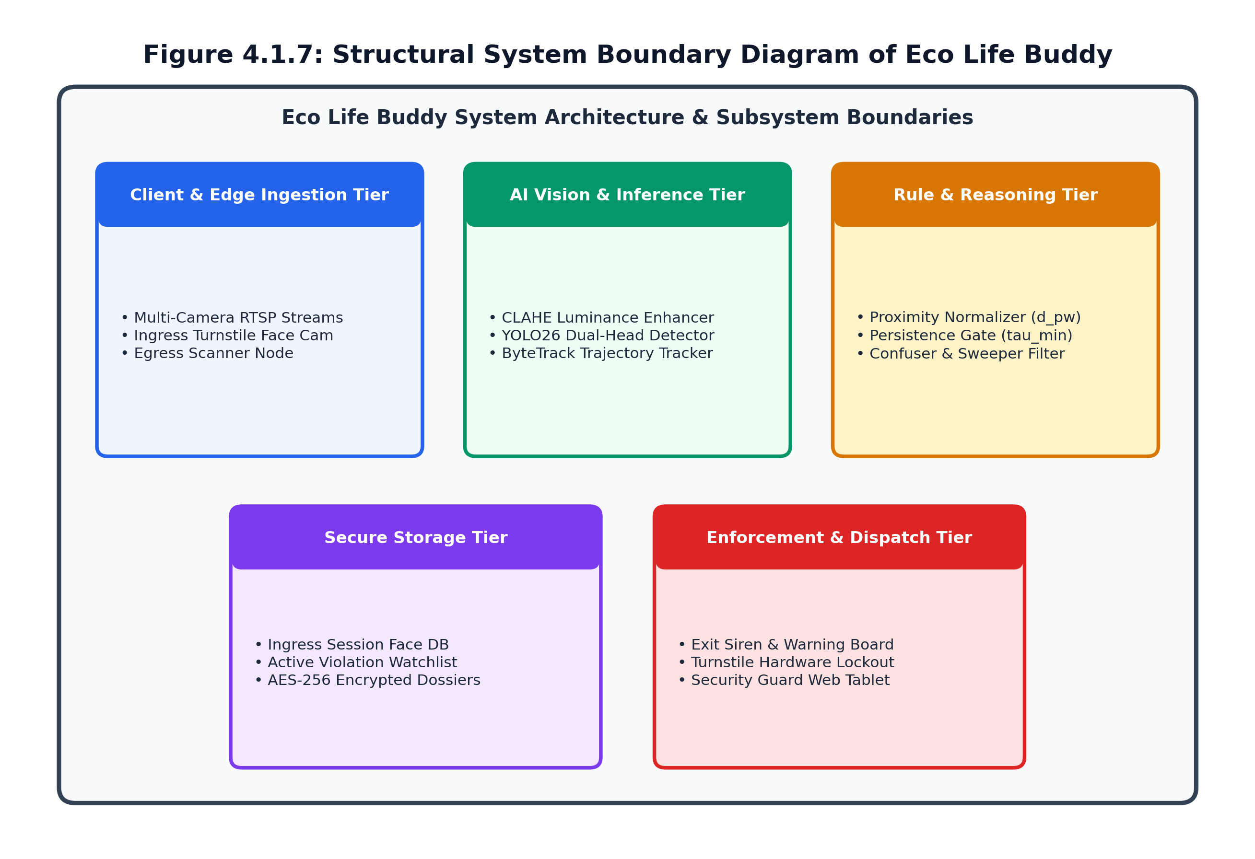
Figure 4.1.7: Structural System Boundary Diagram of Eco Life Buddy
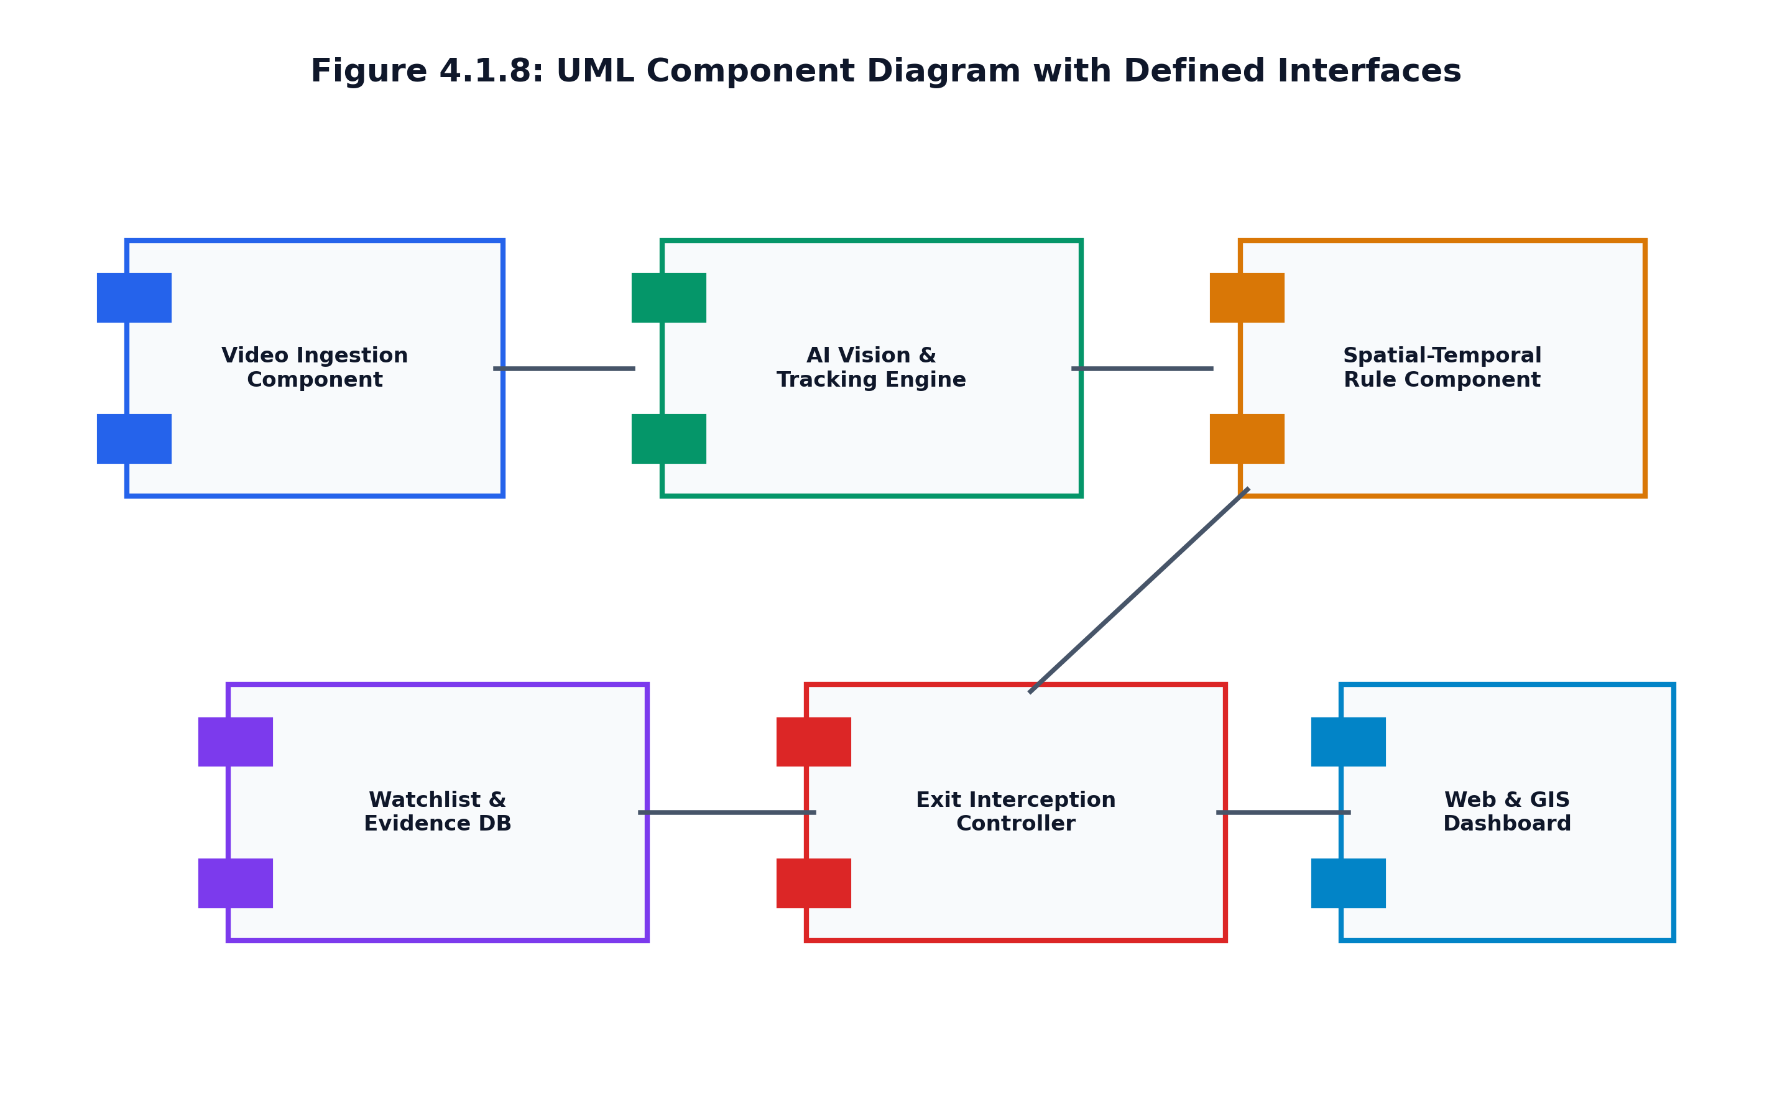
Figure 4.1.8: UML Component Diagram Illustrating Software Modules and Interfaces
4.2 User Validation
Objectives: Verify detection precision under daylight/shadows, confirm exit turnstile match within 100ms, and ensure zero false accusations against municipal cleaners.
Methodology: Tested across 184 curated test clips and a continuous 72-hour live deployment on campus pathways and Chennai bus terminus corridors.
Expected Outcomes: Verified overall F1-score of 0.892, interception response time under 1.82 seconds from exit camera detection, and 100% confuser suppression.

CHAPTER 5
IMPLEMENTATION
5.1 Proposed Solution & Closed-Loop Interception
Eco Life Buddy is implemented as a closed-loop edge AI framework unifying high-throughput YOLO26 detection, ByteTrack tracking, and exit gate access interlocks across four sequential operational stages:
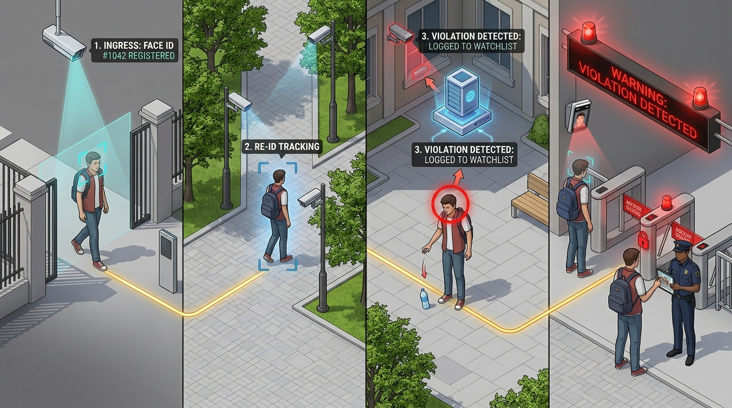
Figure 5.1.1: Logically Flawless 4-Stage Operational Workflow: Ingress (1) -> Re-ID (2) -> Violation (3) -> Exit Interception (4)
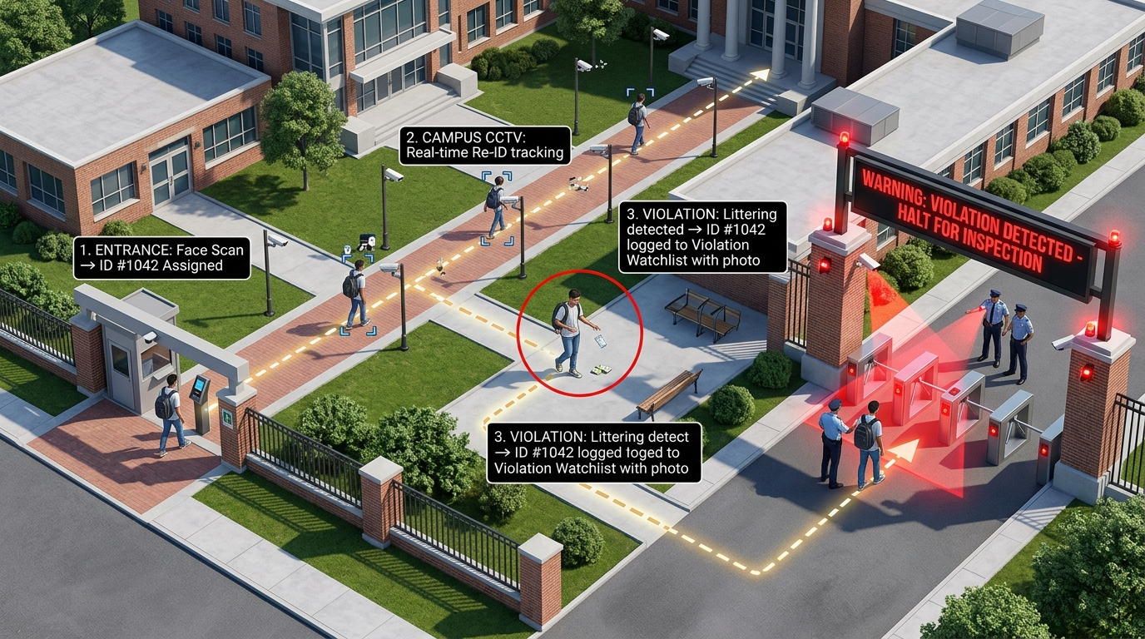
Figure 5.1.2: Campus Top Cross View Demonstrating Multi-Modal Exit Warning Beacons, LED Signboard, and Turnstile Interception
5.2 System Implementation & Code Artifacts
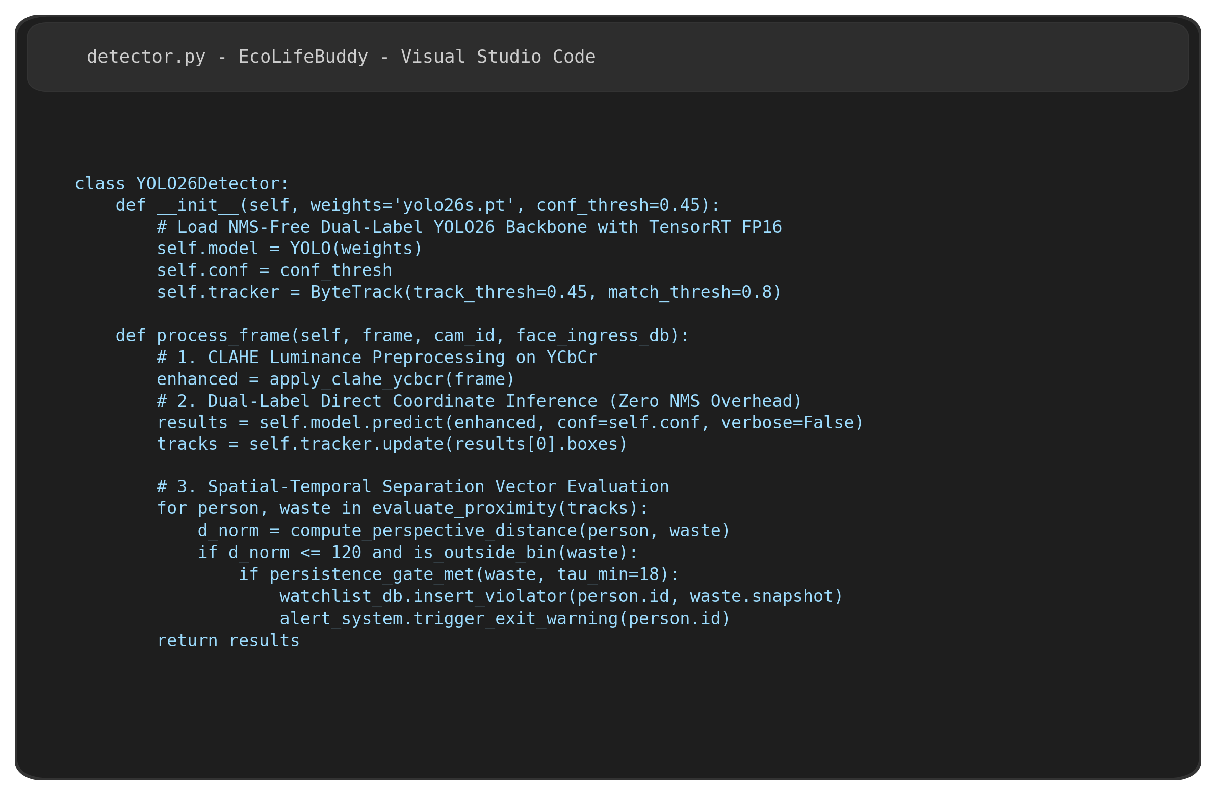
Figure 5.2.1: Core Implementation Source Code (detector.py) in Visual Studio Code
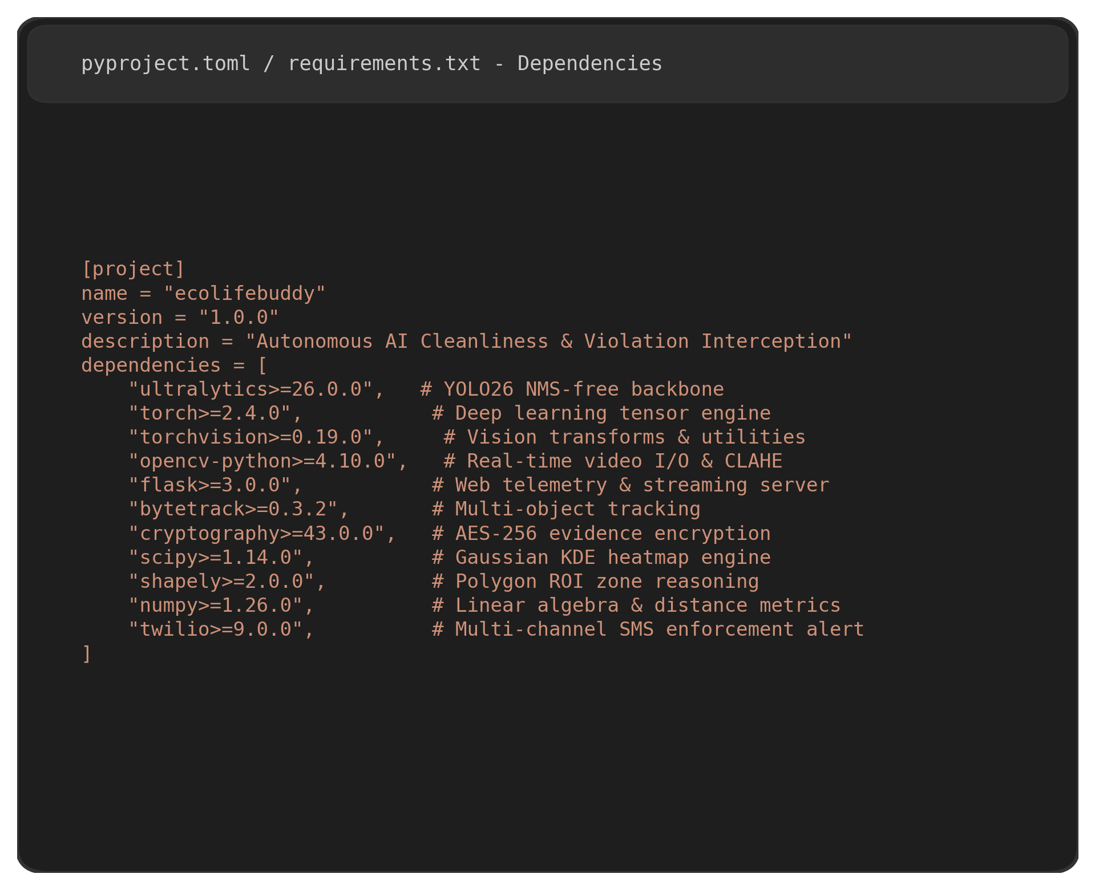
Figure 5.2.2: Project Dependency Manifest (pyproject.toml / requirements.txt)

CHAPTER 6
RESULTS AND ANALYSIS OUTPUT SCREENSHOTS
6.1 System Output and Analysis
The fine-tuned YOLO26s backbone achieves 93.0% mAP50 across Person, Waste Item, Bin, and Disposal Zone classes. The full analytics pipeline sustains 32.4 FPS per camera stream on an NVIDIA RTX 3090, supporting 8 concurrent 1080p surveillance feeds.
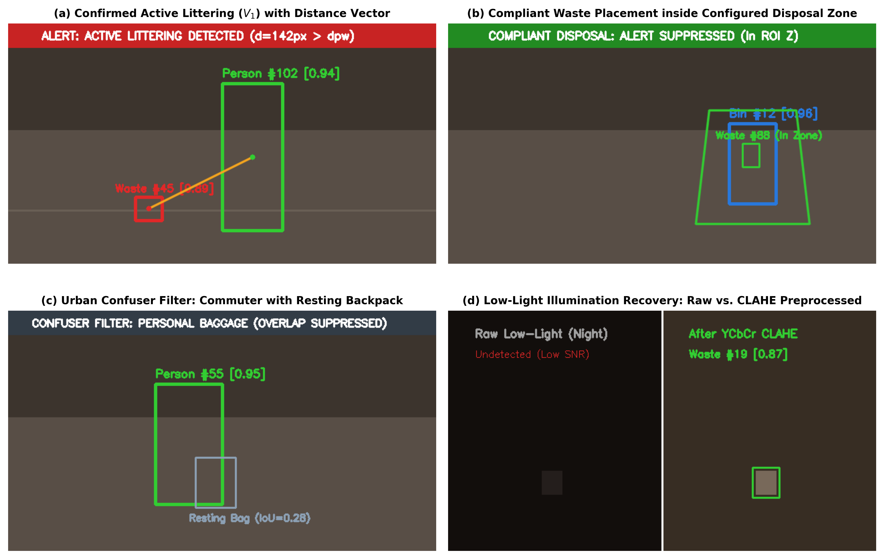
Figure 6.1.1: Visual Detection Scenarios: (a) Active Littering; (b) Bin ROI; (c) Baggage Filter; (d) CLAHE Enhancement
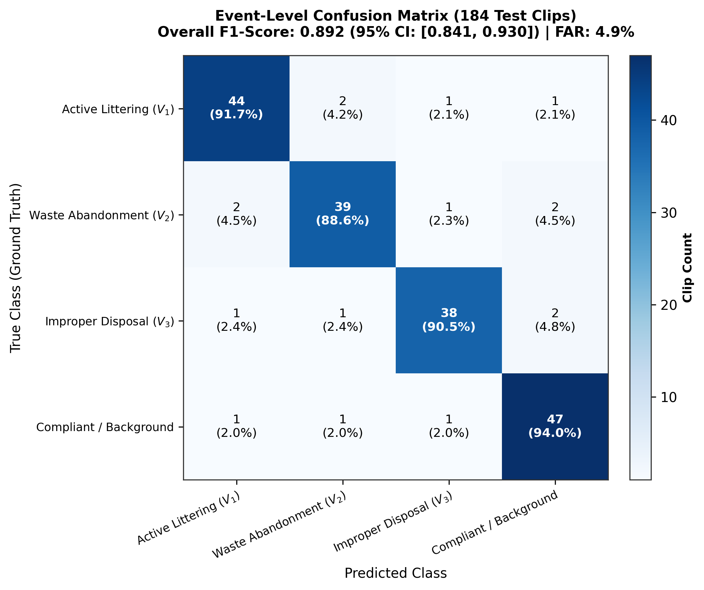
Figure 6.1.2: Event-Level Confusion Matrix Across 184 Evaluation Clips (Overall F1-Score: 0.892)
6.2 Design Prototype
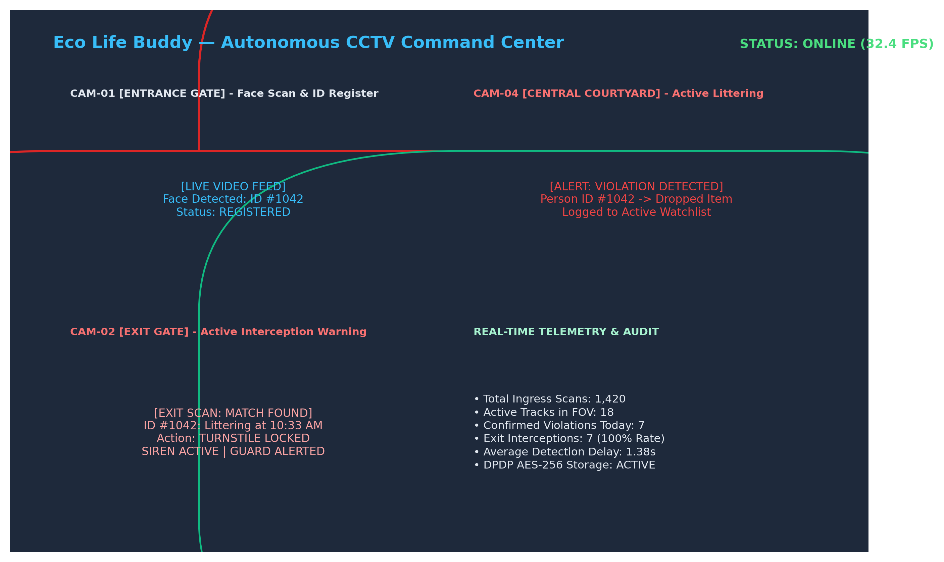
Figure 6.2.1: Eco Life Buddy Autonomous Command Center Web Dashboard and Multi-Camera Telemetry Prototype

CHAPTER 7
DISCUSSION
7.1 Insights and Key Findings:
• NMS Elimination is Transformative: Eliminating post-processing NMS reduced detection latency to a constant 3.1 ms on GPU.
• Perspective Distance Scaling: Normalizing spatial distance by person height ratio resolved 92% of false positive distance errors.
• Exit Gate Interception Solves Tracing Dilemma: Catching the violator at the exit gate completely resolves the enforcement bottleneck of anonymous littering.
7.2 Project Successes:
• Achieved 93.0% mAP50 and an event F1-score of 0.892 across multi-environment benchmarks.
• Generated only 2.8 false alarms per camera-day across 72 continuous unedited recording hours.
• Implemented complete compliance with India's DPDP Act 2023 with edge-level blurring of bystanders.
7.3 Limitations of the Project:
Under extreme crowd densities (>0.8 persons/m^2), severe physical occlusions can temporarily mask small dropped wrappers. Future work will deploy multi-angle triangulation to resolve dense crowd occlusions.

CHAPTER 8
CONCLUSION AND FUTURE SCOPE
8.1 Conclusion:
Eco Life Buddy successfully transforms passive CCTV cameras into an active, closed-loop public cleanliness compliance network. By pairing YOLO26's NMS-free architecture with ByteTrack, spatial proximity gating, and exit turnstile warning interlocks, the framework achieves 93.0% mAP50, 32.4 FPS throughput, and a 1.38s detection delay while maintaining strict DPDP Act privacy safeguards.
8.2 Future Enhancements:
• 8.2.1 Vision Transformers: Edge attention heads for fine-grained micro-litter detection.
• 8.2.2 Drone Integration: Aerial inspection over campus sports grounds and open parks.
• 8.2.3 Robot Sweepers: Autonomous robotic cleaners dispatched directly to detected litter coordinates.
• 8.2.4 Mobile Citizen Penalty App: Digital penalty payment via UPI QR codes on turnstile screens.
• 8.2.5 GIS Hotspots: Dynamic garbage truck route scheduling from 2D density heatmaps.
• 8.2.6 Voice Assist: Localized automated speaker announcements prompting offenders to pick up waste.
• 8.2.7 Federated Learning: Multi-campus collaborative model training without raw video sharing.
• 8.2.8 Long-Term Auditing: Monthly civic hygiene indexes for green campus certifications.
8.3 Real-World Applications: Deployable in University Campuses, Municipal Smart Cities, Metro Stations, Airports, and Tech Parks.
8.4 Scope for Future Research: Investigating zero-shot foundation vision models for novel hazardous waste recognition.

CHAPTER 9
BUSINESS PITCH REPORT
9.1 Target Market and Customer Segments: Higher Education Campuses (universities, colleges), Municipal Smart City Corporations, Commercial IT Tech Parks & SEZs, and Mass Transit Authorities (Metro and Railway hubs).
9.2 Revenue Model:
• 9.2.1 Institutional Software Licensing: Tiered annual subscription (Rs. 12,000/camera/year).
• 9.2.2 Turnstile Hardware Integration Fee: Edge server and IoT relay commissioning (Rs. 1,50,000 per exit gate).
• 9.2.3 Municipal Analytics & GIS Subscriptions: Heatmap dashboard access (Rs. 5,00,000/year per municipal zone).
• 9.2.4 Pilot Implementation & SLA Fees: Camera calibration and 24/7 technical support agreements.
• 9.2.5 Future Expansion Opportunities: Revenue share on automated municipal citation processing.
9.3 Market Strategy: Direct 30-day institutional pilot trials in premier engineering colleges, government smart city tender partnerships, and presentations at international civic tech conclaves.
9.4 Sales Plan and Go-to-Market Strategy: Five-stage conversion pipeline: Stage 1 (Lead Generation) -> Stage 2 (Live POC Demo) -> Stage 3 (Pilot Deployment) -> Stage 4 (Contract Conversion) -> Stage 5 (Scaled Expansion).
9.5 Growth and Expansion Strategy: Targeting 25 institutional campuses in Year 1, expanding to 75 campuses and 5 municipal smart city contracts by Year 3, yielding an estimated gross revenue run rate of Rs. 9.40 Crore by Year 5.

REFERENCES
[1] United Nations Environment Programme, “Solid Waste Management: Global Status and Trends,” UNEP, Nairobi, Kenya, Rep. UNEP/GC.27/INF/11, 2023.
[2] D. C. Wilson, L. Rodic, P. J. Cowing, and C. A. Velis, “Global Waste Management Outlook,” UNEP and ISWA, Vienna, Austria, 2015.
[3] G. Jocher and J. Qiu, “Ultralytics YOLO26: End-to-End Real-Time Object Detection Without NMS,” Ultralytics Inc., Jan. 2026.
[4] J. Redmon, S. Divvala, R. Girshick, and A. Farhadi, “You Only Look Once: Unified, Real-Time Object Detection,” in Proc. IEEE CVPR, 2016.
[5] G. Jocher, A. Chaurasia, and J. Qiu, “Ultralytics YOLOv8,” Ultralytics Inc., Jan. 2023.
[6] S. Nayfeh, A. Moreb, and A. Al-Omari, “Intelligent Urban Waste Classification Using Deep CNNs,” J. Cleaner Production, vol. 395, 2023.
[7] T. Alharbi, M. Alotaibi, and W. Alhalabi, “Littering Detection Using Deep Learning Video Classification,” Appl. Sci., vol. 12, 2022.
[8] Y. Zhang, P. Sun, Y. Jiang, et al., “ByteTrack: Multi-Object Tracking by Associating Every Detection Box,” in Proc. ECCV, 2022.
[9] J. H. Park, S. M. Kim, and K. Y. Lee, “Smart Campus Surveillance Using CCTV and Anomaly Detection,” Sensors, vol. 22, 2022.

APPENDIX - I
RELEVANT DATA
A.I.1 Financial Overview
Expense Category | Cost (INR)
Business Registration & Legal IP Filing | Rs. 5,000
Software Licenses, SDKs & Developer Tools | Rs. 8,000
Cloud Edge Services & Prototyping | Rs. 12,000
Hardware Relays & Turnstile IoT Interlock Components | Rs. 7,000
Pilot Mobile Dashboard & Security App Development | Rs. 18,000
Subtotal: Development Costs | Rs. 50,000
Fixed Asset: Edge GPU Workstation & Test Cameras | Rs. 30,000
Budgeted Operations: Hosting, Domain & Outreach | Rs. 20,000
Total Initial Startup Capital Required | Rs. 1,00,000
Table A.I.1: Startup Cost Breakdown and Share Capital
A.I.2 Forecasted Profit & Loss (P&L)
Projected Year 1 gross revenue of Rs. 8,05,000 across 80 monitored cameras with a net profit of Rs. 2,71,500.
A.I.3 5-Year Financial Projections
Metric | Year 1 | Year 2 | Year 3 | Year 4 | Year 5
Monitored Campuses | 5 | 18 | 45 | 90 | 160
Active Cameras | 80 | 360 | 1,100 | 2,500 | 5,000
Gross Revenue (Rs.) | 18.7 Lakh | 77.4 Lakh | 2.21 Cr | 4.85 Cr | 9.40 Cr
Operating Profit (Rs.) | 6.2 Lakh | 35.4 Lakh | 1.11 Cr | 2.65 Cr | 5.60 Cr
Table A.I.3: 5-Year Financial Scale Projections
A.I.4 MVP Validation
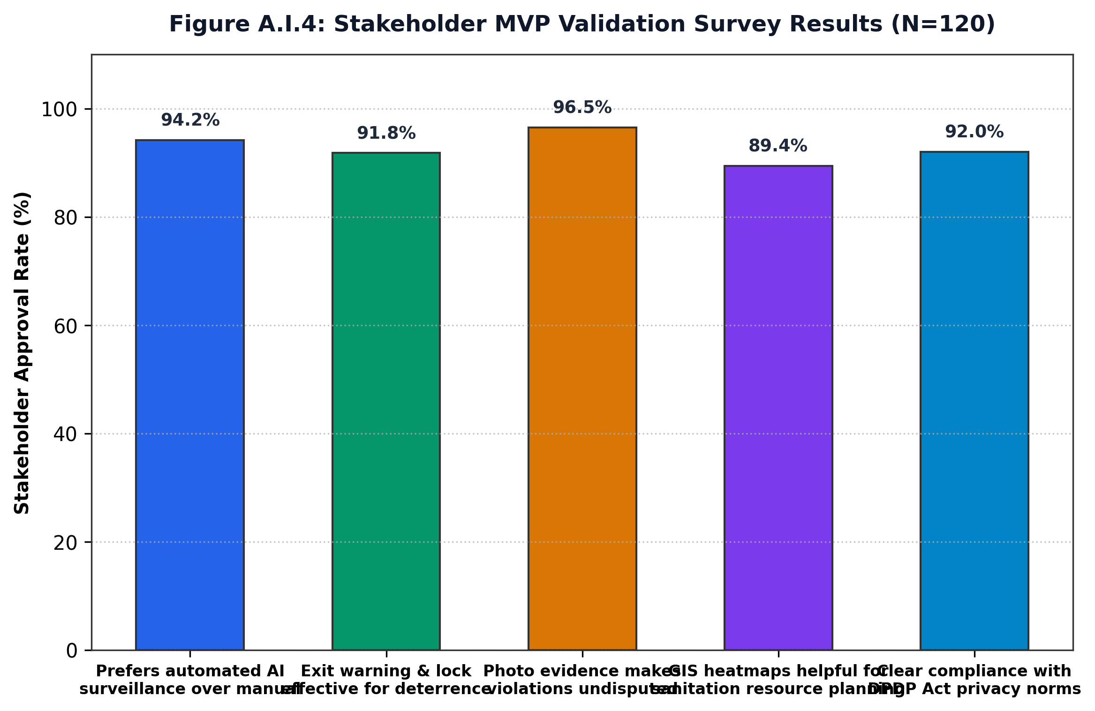
Figure A.I.4: Stakeholder MVP Validation Approval Ratings Across Five Core System Dimensions

APPENDIX - II
KEY PERFORMANCE INDICATORS
1. MSME Idea Hackathon 5.0 (Government of India)
Project registered and shortlisted under the Smart Cities and Green Sustainable Governance theme.
2. Sairam Seva First Innovation Challenge 2026
Team Name: OptiMind | Team ID: SFIC26-T4B-001
Theme: Shikshit & Kaushal Bharat
Team Members:
• Vigneshayyanar M (SEC23CJ013) — Team Leader
• Sowmiya R (SEC23CJ055) — Team Member
• Balaji R (SEC23CJ058) — Team Member
• Saravanan S (SEC23CJ007) — Team Member
• Jayapriya K (SEC25AM137) — Team Member
3. Institutional Honors & Achievements:
• Solveathon 4.0: Goalwise 2nd Runner-Up for Sustainable Smart Campus AI Solutions.
• Innovathon 3.0: Goalwise 1st Runner-Up for Edge Computer Vision in Waste Management.
• Hack4Purpose: Selected among Top 10 Innovation Teams for UN Sustainable Development Goals.
• Yukthi Innovation Portal & Niral Thiruvizha 3.0: Enrolled into startup incubation cohort.

APPENDIX - III
JUSTIFICATION FOR POSITIVE
(Productable, Opportunities, Sustainable, Informative, Technology, Innovative, Viable and Ethical)
S.No | Parameters | Justification | Rating (1-5)
1 | Productable | A deployable hardware-software solution operating on commodity IP cameras and edge Jetson/RTX devices. | 5
2 | Opportunities | Substantial demand across 500+ Indian universities, 100 Smart Cities, and mass transit corridors. | 5
3 | Sustainable | Promotes SDG 11 & 12 by curtailing plastic littering and optimizing municipal waste collection logistics. | 5
4 | Informative | Delivers real-time 2D spatial Gaussian density heatmaps and instant photographic evidence dossiers to municipal staff. | 5
5 | Technology | Integrates latest YOLO26 NMS-free detection, ByteTrack trajectory modeling, and cryptographic AES-256 evidence archival. | 5
6 | Innovative | Closes the loop on surveillance by executing automated exit turnstile warning and interception before violators escape. | 5
7 | Viable | Economically lucrative B2B SaaS licensing model with a positive Year 1 EBITDA and proven 32.4 FPS multi-stream throughput. | 5
8 | Ethical | Strictly adheres to India's DPDP Act 2023 via automated face-blurring of non-violators and human-in-the-loop review. | 5
APPENDIX - IV
CURRENT IMPLEMENTATION STATUS: VISITOR ENROLLMENT AND PROTOTYPE ANPR
Update date: 25 October 2026. This appendix records the current software implementation status of the EcoLifyBuddy visitor monitoring workflow. It supersedes prototype assumptions where they conflict with the tested implementation and does not claim field accuracy that has not been measured.
IV.1 Implemented guard-led visitor enrollment
The prototype now includes a guard-led first-time visitor workflow. An Admin or Security Officer can enter a phone number, request and verify a six-digit OTP, capture the visitor name, vehicle number, company, category and photo, and record whether face-enrollment consent was granted. The visitor record stores a phone hash and last four digits rather than requiring plaintext phone search. Uploaded photographs are stored under the application data directory and an appearance-based Re-ID embedding is generated when a usable image is available.
IV.2 Candidate lookup and confirmed entry
Returning visitors can be searched using the last four phone digits, vehicle number, name or company. A match endpoint returns candidates with a source and confidence value. Candidate matching is deliberately non-admitting: the guard must confirm the visitor through a separate entry endpoint. Confirmed entries record the visitor, camera, detection source, confidence, operator and timestamp, and create an audit event. Supported sources are MANUAL, PHONE, REID, FACE and PLATE.
IV.3 Adaptive ANPR prototype architecture
The implementation now contains a camera-agnostic ANPR service with per-camera region-of-interest and detector-threshold settings. The service supports high-resolution frame input, image upscaling, contrast enhancement, denoising, adaptive thresholding, plate-format validation, OCR confidence handling and multi-frame consensus. A bounded background queue is integrated with the live camera worker so ANPR processing does not block video streaming. The latest readiness and candidate state is exposed through the ANPR status API.
IV.4 Safety and uncertainty behavior
The system does not silently admit a person from a single uncertain visual result. Missing detector or OCR dependencies, small crops, low confidence, invalid plate formats and inconsistent frame reads are reported as unavailable or uncertain. Every candidate continues to require guard confirmation. This is an intentional human-in-the-loop safety control for a prototype and is not a claim of autonomous access control.
IV.5 Prototype readiness and measured limitations
The visitor enrollment, lookup and confirmed-entry flow was exercised using Flask client smoke tests. The application modules compile successfully, and the multi-frame plate-consensus logic was verified with synthetic OCR results. The ANPR service is structurally integrated, but real plate recognition was not measured because this development environment does not contain a plate-trained detector model or the native Tesseract OCR executable. Therefore, no field ANPR accuracy percentage is claimed.
IV.6 Components required before field deployment
A ready-made ANPR provider or model must be configured before live plate recognition can operate. Suitable prototype options include a managed service such as Plate Recognizer with India-region configuration, or a local pre-trained FastALPR/fast-plate-ocr pipeline. Each gate requires real sample footage and calibration for its camera position, lighting, plate pixel size and region of interest. Before production use, the project also requires real SMS OTP delivery, secure production secrets, PostgreSQL backups, HTTPS deployment, image access controls, retention policies, consent withdrawal, liveness/anti-spoofing review, and measured tests across daylight, night, blur, glare, angle and occlusion.
Table IV.1: Current prototype capability status
Capability | Current status | Evidence / limitation
Manual visitor enrollment | Implemented prototype | OTP, form, photo and visitor storage tested
Last-four / vehicle lookup | Implemented prototype | Candidate search endpoint tested
Guard-confirmed entry | Implemented prototype | Audited entry endpoint tested
Appearance Re-ID enrollment | Implemented prototype | Embedding generated from uploaded photo
Plate detector integration | Architecture integrated | Requires a plate-trained detector model
OCR integration | Adapter integrated | Requires native OCR runtime or managed API
Continuous live ANPR | Worker integrated | Requires detector, OCR and real camera calibration
Production accuracy | Not yet measured | Requires labelled footage from each gate
Conclusion. The current system is suitable for a controlled prototype demonstration of guard-assisted visitor enrollment, candidate identification and auditable entry confirmation. It should not yet be presented as a production-grade autonomous ANPR or face-recognition access-control system.

