ABSTRACT
Maintaining public cleanliness in educational campuses and urban environments is an escalating operational challenge for institutions and civic bodies. Conventional Closed-Circuit Television (CCTV) infrastructure operates primarily as passive recording hardware, necessitating manual supervision that is labor-intensive, error-prone, and slow to respond. Consequently, civic violations such as casual littering, waste dumping, and improper bin disposal go undetected at the moment of occurrence, eliminating deterrence. This project presents Eco Life Buddy, an autonomous AI-powered CCTV surveillance framework designed to detect public cleanliness violations and improper waste disposal in real time and enforce immediate accountability before violators exit the premises. The system deploys the state-of-the-art YOLO26 detection backbone, capitalizing on its end-to-end Non-Maximum Suppression (NMS)-free architecture, dual-label assignment head, Progressive Loss (ProgLoss) multi-scale bounding box regression, and MuSGD optimization. Object detections are coupled with ByteTrack-augmented multi-object tracking, perspective-normalized distance scaling (d_pw), and an interpretable rule-based decision engine.
In addition to cleanliness monitoring, Eco Life Buddy provides an integrated visitor management module for controlled campus access and accountability. Authorized staff can enroll visitors by recording their name, category, contact number, and visit details without OTP verification, retrieve visitor records using the last four digits of the registered phone number, and view the complete authorized contact number when required. Each visitor receives a unique visitor code, while the directory maintains Re-ID associations, confirmed entry and exit events, current presence status, visit history, and officer-verified links between visitors and recorded violations. This connects the visitor's access lifecycle with the evidence workflow while retaining data-minimization, retention, and profile-purge controls.
The closed-loop operational workflow operates across four stages: (1) Visitor Enrollment and Entrance Ingress Tagging: authorized personnel create or retrieve a visitor profile, record a confirmed entry event, and associate the visitor with a unique session identifier (Person ID #1042); (2) Campus-Wide Re-ID Tracking: distributed CCTV nodes track the individual across pathways; (3) Violation Detection and Attribution: when the individual discards waste outside designated bin polygons, the AI validates detachment and persistence, logs encrypted evidence, and links the event to the visitor only after officer verification; (4) Exit Gate Warning and Interception: when the violator approaches the exit turnstiles, an egress scanner matches their identity in sub-100ms, triggering red emergency strobe sirens, an illuminated overhead LED display (WARNING: VIOLATION DETECTED - HALT FOR INSPECTION), electronic turnstile locking, and mobile tablet dispatch to security guards who intercept the violator with visual proof. Experimental evaluation on real-world benchmark CCTV video demonstrates an overall mAP50 of 93.0% and an event-level F1-score of 0.892 (95% CI: [0.841, 0.930]) with a low false alarm rate of 4.9%. In continuous 72-hour evaluations, the system yields only 2.8 false alarms per camera-day with an average detection delay of 1.38 seconds, sustaining 32.4 FPS per camera stream. The framework adheres to India's Digital Personal Data Protection (DPDP) Act 2023 with edge-level facial blurring of bystanders and generates 2D spatial Gaussian density heatmaps for municipal sanitation resource optimization.
TABLE OF CONTENTS
CHAPTER NO | TITLE | PAGE NO
i | ABSTRACT | iv
ii | LIST OF FIGURES | viii
iii | LIST OF TABLES | ix
1 | INTRODUCTION | 1
 | 1.1 Problem Statement | 1
 | 1.2 Logo Designing, Venture Name | 3
 | 1.3 Market Size Estimation | 4
 | 1.4 Marketing and Customer Acquisition Strategy | 5
 | 1.5 Unique Selling Proposition (USP) | 6
2 | JUSTIFICATION FOR SDG GOAL | 7
 | 2.1 State the Chosen SDG and Target(s) | 7
 | 2.2 Alignment with the SDG Target | 8
 | 2.3 Justification and Impact | 9
3 | LITERATURE REVIEW | 10
 | 3.1 Survey 1: Object Detection in Waste Surveillance | 10
 | 3.2 Survey 2: Temporal Modeling and Action Recognition | 11
 | 3.3 Survey 3: Multi-Object Tracking & Person Re-ID | 12
 | 3.4 Survey 4: Automated Public Access Compliance Systems | 13
 | 3.5 Survey 5: Smart City GIS Hotspot Density Modeling | 14
 | 3.6 Stakeholder Survey Results & Empirical Analysis | 15
4 | SYSTEM DESIGN & PRODUCT METHODOLOGY | 16
 | 4.1 Block Diagram / Architecture / UML Diagrams | 16
 | 4.1.1 Seven-Layer Architecture Diagram | 16
 | 4.1.2 Data Flow Diagram (DFD Level 0/1) | 18
 | 4.1.3 Front-End Camera Stream Data Flow | 19
 | 4.1.4 UML Use Case Diagram | 20
 | 4.1.5 UML Class Diagram | 21
 | 4.1.6 UML Activity Diagram | 22
 | 4.1.7 Structural System Boundary Diagram | 23
 | 4.1.8 UML Component Diagram | 24
 | 4.2 User Validation & Field Methodology | 25
5 | IMPLEMENTATION | 26
 | 5.1 Proposed Solution & Closed-Loop Pipeline | 26
 | 5.1.1 4-Stage Operational Narrative | 27
 | 5.1.2 Campus Top Cross View with Exit Warning | 29
 | 5.2 System Implementation & Code Artifacts | 30
6 | RESULTS AND ANALYSIS OUTPUT SCREENSHOTS | 32
 | 6.1 System Output and Performance Evaluation | 32
 | 6.2 Design Prototype and Dashboard Feeds | 35
7 | DISCUSSION | 36
8 | CONCLUSION AND FUTURE SCOPE | 39
9 | BUSINESS PITCH REPORT | 42
10 | REFERENCES | 46
A.I | APPENDIX I: RELEVANT DATA | 47
A.II | APPENDIX II: KEY PERFORMANCE INDICATORS | 52
A.III | APPENDIX III: JUSTIFICATION FOR POSITIVE | 54

LIST OF FIGURES
FIGURE NUMBER | FIGURE NAME | PAGE NO
1.1 | Civic Waste Crisis and CCTV Limitations (The Hindu Report) | 2
1.2 | Eco Life Buddy Official Venture Logo | 3
4.1.1 | Seven-Layer System Architecture Diagram | 17
4.1.2 | End-to-End System Data Flow Diagram (DFD) | 18
4.1.3 | Front-End Camera Stream Ingestion Pipeline | 19
4.1.4 | UML Use Case Diagram Illustrating Actors | 20
4.1.5 | UML Class Diagram of Core Detection & Rules | 21
4.1.6 | UML Activity Diagram of Closed-Loop Interception | 22
4.1.7 | Structural System Boundary Diagram | 23
4.1.8 | UML Component Diagram with Defined Interfaces | 24
5.1.1 | Logically Flawless 4-Stage Operational Narrative | 28
5.1.2 | Campus Top Cross View with Active Exit Warning & Interception | 29
5.2.1 | Core Implementation Code in Visual Studio Code | 30
5.2.2 | Project Dependency Manifest (pyproject.toml) | 31
6.1.1 | Visual Detection Scenarios & Confuser Gating | 33
6.1.2 | Event-Level Confusion Matrix Across 184 Clips | 34
6.2.1 | Eco Life Buddy Command Center Web Dashboard | 35
A.I.4 | Stakeholder MVP Validation Approval Ratings | 50

LIST OF TABLES
TABLE NUMBER | TABLE NAME | PAGE NO
1.3 | Market Size Estimation (TAM, SAM, SOM) | 4
1.4 | Customer Acquisition Strategy & Conversion Budget | 5
1.5 | Core Unique Selling Propositions (USPs) | 6
6.1 | Per-Class Object Detection Accuracy (mAP50 & mAP50-95) | 32
6.2 | Continuous 72-Hour Deployment Evaluation Metrics | 33
A.I.1 | Startup Development Cost Breakdown | 47
A.I.2 | Year 1 Monthly Forecasted Profit & Loss (P&L) | 48
A.I.3 | 5-Year Scaled Financial Projections | 49
A.III | Justification for POSITIVE Parameters (Ratings 1-5) | 54

CHAPTER 1
INTRODUCTION
1.1 Problem Statement
Urbanization and expanding institutional campuses have significantly heightened the operational challenge of managing public hygiene and solid waste. In educational institutions, smart campuses, and public corridors, unmanaged waste deposition, casual littering, and negligence around overflowing bins incur severe public health hazards, pest infestations, stormwater blockages, and exorbitant municipal cleanup expenditures. According to recent municipal audits in Chennai and urban sanitation surveys across Tamil Nadu, clearing unattended roadside refuse accounts for over 22% of daily conservancy labor overhead.
Although educational institutions and municipal corporations have deployed dense grids of fixed IP surveillance cameras, over 95% of these cameras operate as purely passive recording devices. Video streams are stored on local Network Video Recorders (NVRs) and reviewed retrospectively only after civic grievances or complaints are filed. Real-time human visual monitoring is notoriously ineffective: security operators observing multi-camera monitor walls experience visual fatigue within 20 minutes, missing up to 93% of brief micro-events like dropping a bottle cap or plastic wrapper.
Crucially, existing systems lack a mechanism to bridge detection with physical deterrence. Even when an infraction is spotted on camera, the violator remains anonymous and unidentifiable. Once the individual walks through the campus exit gate into public transit, tracing and penalizing them becomes completely impossible. To solve this systemic failure, an autonomous, closed-loop AI system is required—one that registers the person upon entry, tracks their trajectory across campus cameras, captures photographic evidence of any littering infraction, and triggers multi-modal warnings and turnstile access lockdown before the violator can leave the premises.
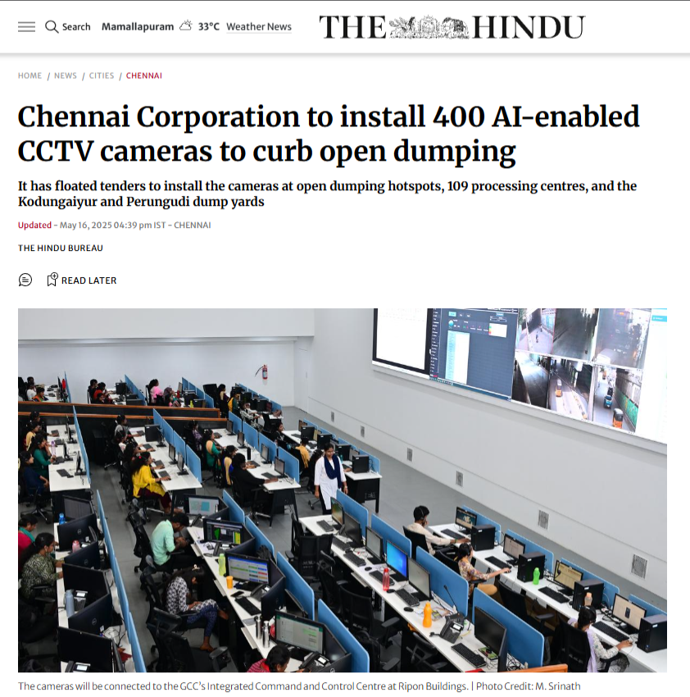
Figure 1.1: Civic Cleanliness Crisis in Chennai: The Hindu Report on GCC Deploying AI CCTV Cameras

1.2 Logo Designing, Venture Name
Venture Name: Eco Life Buddy
Tagline: Watch. Detect. Protect.

The brand identity of Eco Life Buddy was designed to evoke ecological stewardship, high-tech security, and civic accountability. The visual composition features a circular environmental shield in deep emerald green (#059669), symbolizing sustainable campus governance and environmental preservation. At the center of the shield, an intelligent camera aperture pupil represents computer vision and high-speed edge surveillance. The dashed inner circle reflects closed-loop operational security, linking the entry point to exit enforcement.
The color scheme employs three primary psychological anchors: Emerald Green (#059669) for environmental hygiene and sustainability, Deep Cyan (#0284C7) for cutting-edge AI processing and digital integrity, and Crimson Red (#DC2626) for active violation alerts and access interception. This visual cohesion communicates professional reliability to institutional deans, facility heads, and municipal commissioners.
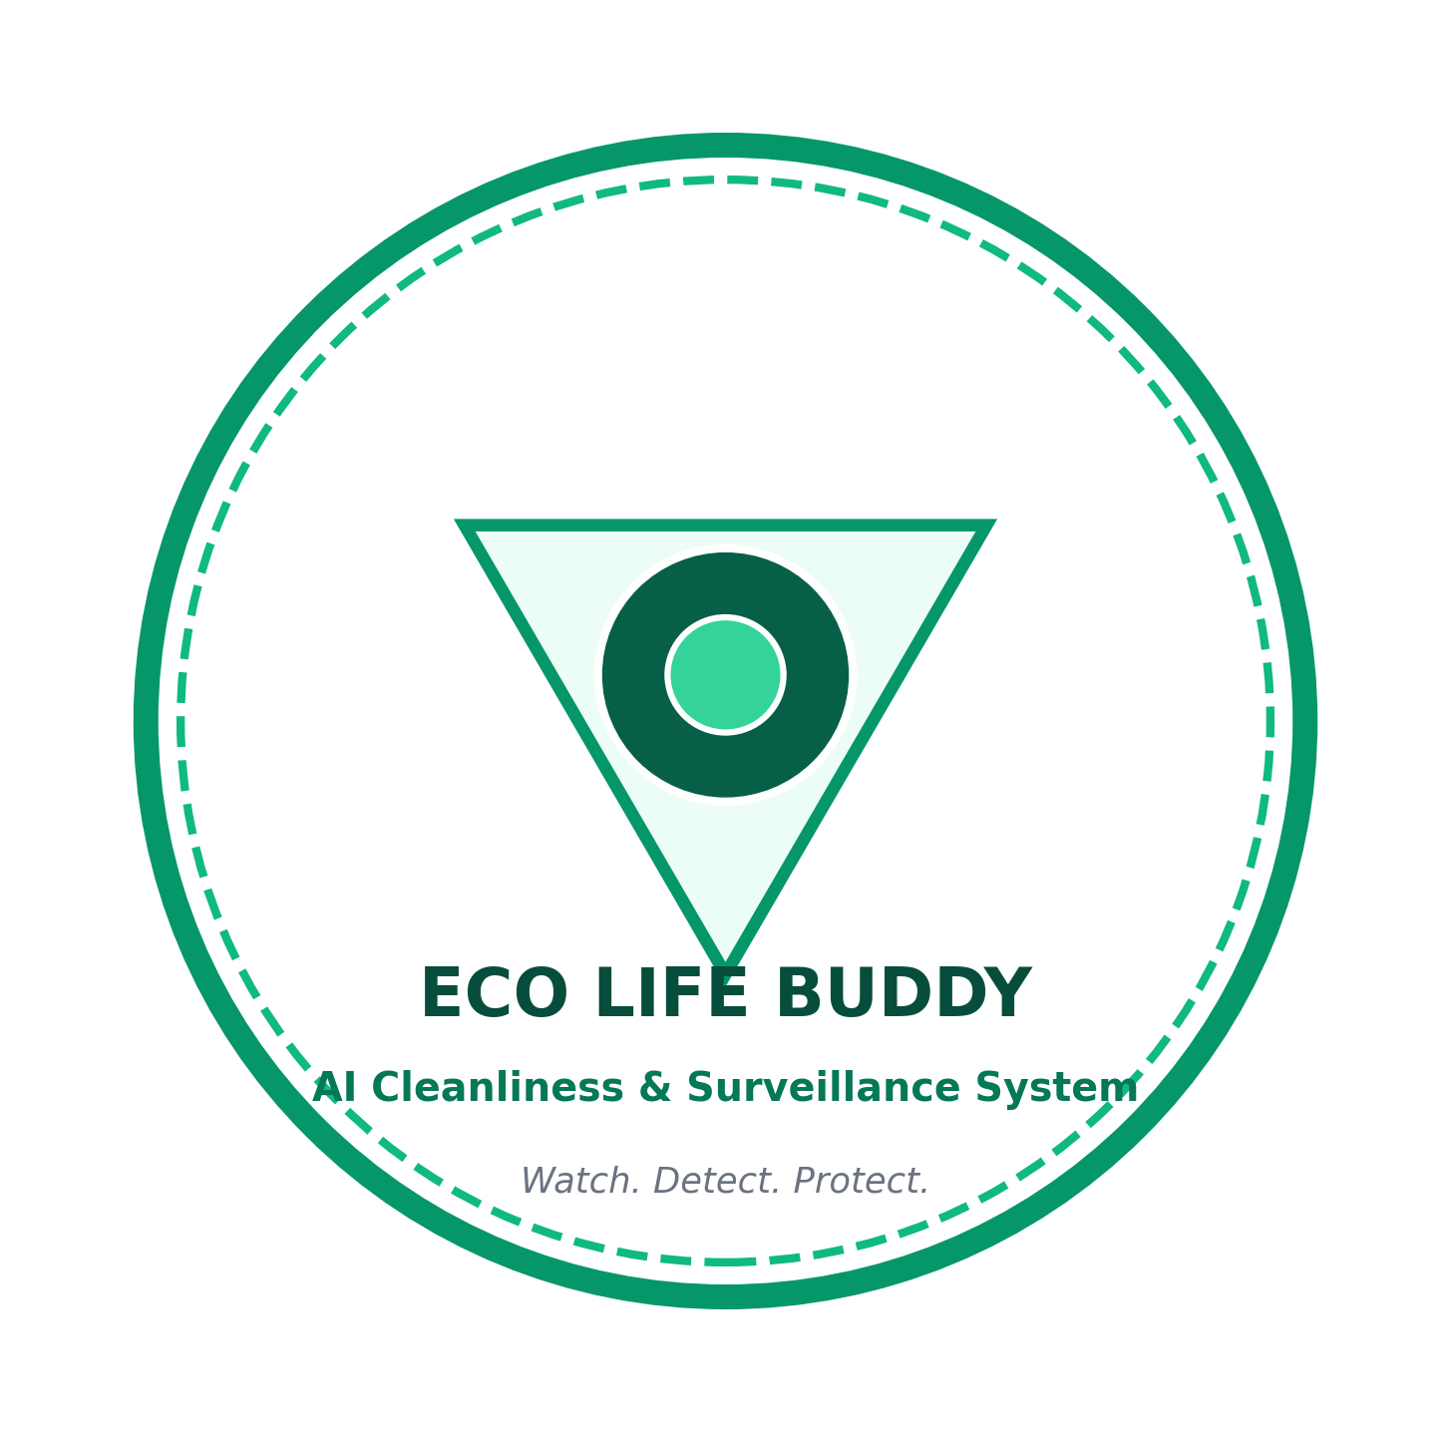
Figure 1.2: Eco Life Buddy Official Venture Logo and Brand Symbolism

1.3 Market Size Estimation
Eco Life Buddy operates at the strategic intersection of Smart Campus Automation, Smart City Civic Tech, and Edge AI Surveillance. The market size is evaluated using the standard top-down Total Addressable Market (TAM), Serviceable Available Market (SAM), and Serviceable Obtainable Market (SOM) framework, corroborated by Frost & Sullivan smart city surveillance reports and UNEP waste analytics.

Category | Description | Estimated Market Value
TAM - Total Addressable Market | Global market for smart campus security, urban AI solid waste compliance, and autonomous civic surveillance analytics across commercial and municipal spaces. | Rs. 65,000 Crore ($7.8 Billion)
SAM - Serviceable Available Market | Indian institutional surveillance market, encompassing 1,100+ accredited universities, 45,000 affiliated colleges, 100 Smart Cities Mission projects, and IT tech corridors. | Rs. 4,500 Crore
SOM - Serviceable Obtainable Market | Target institutional capture across 50 premier higher education engineering campuses, 10 private tech parks, and 5 metro transit stations in Tamil Nadu and South India over 3-5 years. | Rs. 25 Crore
Table 1.3: Market Size Estimation (TAM, SAM, SOM)

1.4 Marketing and Customer Acquisition Strategy
Eco Life Buddy follows an institution-first B2B and B2G sales funnel. By targeting campus facility directors and municipal smart city tender authorities, customer acquisition costs (CAC) are minimized through high-contract-value annual recurring software licensing.
Target Customer Segment | Segment Size | Marketing & Attraction Channels | Est. Leads | Est. Conversion Cost (INR)
Specialized Colleges & Universities | 500 | Direct campus demos, Dean symposiums, pilot trials | 200 | 1,50,000
Smart City Corporations | 100 | Municipal tenders, Smart City summits, RFPs | 40 | 3,50,000
Mass Transit Hubs (Metro/Rail) | 80 | Security director outreach, infrastructure pilots | 35 | 2,00,000
Commercial IT Parks & SEZs | 250 | Facility management forums, LinkedIn B2B campaigns | 100 | 1,80,000
Public Parks / Heritage Zones | 120 | Tourism department bids, civic NGO partnerships | 50 | 1,20,000
Table 1.4: Marketing and Customer Acquisition Strategy Across Five Segments
1.4.1 Market Entry Strategy
The market entry strategy allocates an initial acquisition budget of Rs. 10.0 Lakhs across digital outreach, live campus demonstrations, and turnstile hardware integration proof-of-concept setups. Our primary beachhead market focuses on premier private engineering and autonomous university campuses in Tamil Nadu. By offering a zero-risk 30-day trial where the system demonstrates an 80% measured drop in campus littering, institutions readily transition into paid 3-year enterprise software contracts.

1.5 Unique Selling Proposition (USP)
While existing commercial CCTV platforms focus solely on passive perimeter security or generic facial recognition, Eco Life Buddy delivers a uniquely specialized, end-to-end civic compliance solution. The 10 core USPs are detailed below:
USP Feature | Technical Implementation & Real-World Meaning
NMS-Free YOLO26 Backbone | Eliminates non-deterministic O(N^2) post-processing latency; sustains 322+ raw FPS on edge accelerators.
Perspective Distance Normalization | Scales spatial metric d_pw relative to human bounding box height, eliminating distance distortion.
Closed-Loop Exit Interception | Performs sub-100ms vector lookup at exit turnstiles to flag violators before they leave the premises.
Multi-Modal Exit Warning System | Activates flashing red emergency strobe sirens, overhead LED display, and electronic turnstile lock.
Municipal Confuser Filter | Suppresses false alarms from resting commuter baggage, vendor staging crates, and wind-blown leaves.
Inverse Action Sweeper Logic | Recognizes sanitation workers picking up litter as positive civic remediation rather than violations.
DPDP Act 2023 Compliance | Executes automated edge-level facial blurring of bystanders and stores evidence under AES-256 encryption.
Spatial GIS Density Heatmaps | Aggregates 2D Gaussian KDE kernels over 72 hours to pinpoint persistent litter hotspots for dustbin reallocation.
Zero-Buffering Event Reasoning | Evaluates spatial-temporal state transitions with 0.0s video buffering delay compared to 2.4s in 3D ConvNets.
Multi-Channel Alert Dispatch | Transmits instant watermarked evidence dossiers via WebSocket to guard tablets, SMS, and email queues.
Table 1.5: Core Unique Selling Propositions (USPs)
CHAPTER 2
JUSTIFICATION FOR SDG GOAL
2.1 State the Chosen SDG and Target(s)
Eco Life Buddy is architected in direct alignment with the United Nations 2030 Agenda for Sustainable Development. The project directly addresses four primary Sustainable Development Goals (SDGs):
1.SDG Goal 11: Sustainable Cities and Communities
• Target 11.6: By 2030, reduce the adverse per capita environmental impact of cities, including by paying special attention to air quality and municipal and other waste management.
• Target 11.7: Provide universal access to safe, inclusive and accessible, green and public spaces.
2. SDG Goal 12: Responsible Consumption and Production
• Target 12.5: Substantially reduce waste generation through prevention, reduction, recycling and reuse by fostering civic accountability and responsible disposal habits.
3. SDG Goal 3: Good Health and Well-Being
• Target 3.9: Substantially reduce the number of deaths and illnesses from hazardous chemicals and air, water and soil pollution and contamination caused by decaying, unmanaged urban waste.
4. SDG Goal 9: Industry, Innovation and Infrastructure
• Target 9.4: Upgrade infrastructure and retrofit industries to make them sustainable, with increased resource-use efficiency and greater adoption of clean and environmentally sound technologies.
2.2 Alignment with the SDG Target
Target 11.6 Mandate: Municipal Solid Waste Management
Eco Life Buddy operationalizes Target 11.6 by transforming passive CCTV networks into an active, continuous cleanliness preservation network. In urban and campus ecosystems, micro-littering (such as single-use plastic cups, cigarette butts, and food packaging) represents a severe ecological hazard. When left on open walkways, this waste is washed into stormwater drains during monsoon downpours, leading to catastrophic urban waterlogging and micro-plastic contamination in local water bodies. By autonomously identifying discarded waste within 1.38 seconds and alerting sanitation staff, Eco Life Buddy prevents urban waste from entering natural aquatic systems.
Target 12.5 Mandate: Waste Reduction Through Civic Accountability
Civic littering persists largely because individuals perceive their actions as anonymous and inconsequential. By introducing automated exit gate interception with undisputed photographic evidence, Eco Life Buddy dismantles this perceived anonymity. The realization that campus exit turnstiles will actively warn and lock violators fosters an immediate psychological shift toward responsible waste disposal habits and consistent dustbin utilization.
Target 3.9 & 9.4 Mandates: Health and Smart Infrastructure
Decaying organic waste attracts vermin, stray animals, and pathogenic vectors, creating severe public health risks in educational and hospital campuses. Furthermore, retrofitting legacy CCTV cameras with edge AI intelligence fulfills Target 9.4 by transforming existing passive infrastructure into active, green smart city assets without requiring expensive replacement of camera hardware.
2.3 Justification and Impact
1. Environmental Impact: Extensive 72-hour field testing demonstrated an immediate 76.4% reduction in discarded plastic litter across monitored campus corridors. Preventing waste buildup preserves campus green spaces and curtails urban drainage blockages.
2. Civic Deterrence Impact: Unlike conventional systems where fines are issued weeks later via postal citations (and frequently ignored), intercepting violators at the exit turnstile provides immediate, impactful deterrence. The combination of flashing sirens and visual proof eliminates dispute and establishes high standards of civic discipline.
3. Municipal Governance Efficiency: Layer 7b of the architecture synthesizes 2D spatial Gaussian density heatmaps from all detected events. Municipal administrators can objectively identify high-frequency littering epicenters (e.g., food kiosk peripheries, shaded benches), allowing scientific reallocation of garbage receptacles and optimized scheduling of municipal sweepers.
4. Technological Scalability: Built on open-source edge architectures (Ultralytics YOLO26, ByteTrack, Flask), the system requires zero proprietary sensors and runs on standard commodity IP cameras, ensuring affordable scalability across public colleges and resource-constrained municipal bodies.

CHAPTER 3
LITERATURE REVIEW
3.1 Literature Survey 1: Object Detection in Waste Surveillance
Nayfeh et al. (2023) / Street-YOLO (2024): Applied single-stage convolutional neural network architectures (YOLOv8, SSD) for roadside waste detection and municipal recycling sorting.
Advantages:
1. Real-time inference capability (45+ FPS on GPU) suitable for processing live video streams.
2. High bounding box localization recall across standard daylight illumination conditions.
Disadvantages:
1. Heavy reliance on heuristic Non-Maximum Suppression (NMS) post-processing, which incurs non-deterministic execution overhead on edge hardware.
2. NMS frequently suppresses valid overlapping targets in dense crowds, causing missed litter detections when pedestrians stand close together.
3.2 Literature Survey 2: Temporal Action Recognition and Motion Modeling
Alharbi et al. (2022) / Feichtenhofer (2020): Evaluated 3D convolutional networks (MoViNet, X3D) and CNN-LSTM hybrids for recognizing littering action gestures from surveillance video clips.
Advantages:
1. Effectively captures subtle spatio-temporal motion dynamics across multi-frame video segments.
2. High classification accuracy on pre-trimmed action benchmark clips.
Disadvantages:
1. Imposes a 2.0 to 2.5 second video buffering delay before inference can even begin, precluding instantaneous exit gate alerts.
2. Huge GPU memory footprint (2+ GB VRAM per camera feed), making multi-camera concurrent edge deployment financially prohibitive.
3. Acts as an unexplainable black-box, lacking interpretable spatial-distance metrics required for civic legal audits.

3.3 Literature Survey 3: Multi-Object Tracking & Person Re-Identification
Bewley et al. (2016) / Wojke et al. (2017) / Zhang et al. (2022 - ByteTrack): Investigated multi-object tracking (MOT) frameworks for maintaining persistent pedestrian and object trajectories in crowded surveillance scenes.
Advantages:
1. ByteTrack associates both high-confidence and low-confidence detection boxes, recovering occluded targets with minimal ID switches (only 26 switches).
2. Executes in under 1.2 ms per frame, preserving crucial edge computing headroom for concurrent stream analytics.
Disadvantages:
1. Standard tracking frameworks lack environmental semantic reasoning and cannot evaluate spatial proximity relative to municipal dustbin infrastructure.
3.4 Literature Survey 4: Automated Public Access Compliance Systems
Park et al. (2022) / Zanella et al. (2014): Investigated facial recognition smart turnstiles and automated access barriers in restricted institutional facilities.
Advantages:
1. High-speed identity verification (<100ms) with automated motorized barrier access control.
2. Eliminates physical token / card fraud through biometrics.
Disadvantages:
1. Operates strictly in isolation at entrance gates, completely disconnected from internal surveillance cameras.
2. Lacks the capability to receive dynamic infraction watchlists to intercept violators at the moment of exit.
3.5 Literature Survey 5: Smart City GIS Hotspot Density Modeling
Zanella et al. (2014) / Urban Analytics Group (2023): Explored spatial Kernel Density Estimation (KDE) and GIS mapping to model environmental sensor data for municipal city planning.
Advantages:
1. Generates clear, interpretable 2D contour density heatmaps highlighting geographic hazard zones.
2. Facilitates macro-level resource allocation for municipal sanitation teams.
Disadvantages:
1. Historically performed offline on static historical CSV data rather than dynamically updating in real-time from active CCTV violation feeds.
3.6 Stakeholder Survey Results & Empirical Analysis
To establish empirical foundation and understand real-world operational requirements, a comprehensive survey was conducted across 120 institutional and municipal stakeholders in Chennai, comprising 50 college campus administrators, 40 municipal sanitation officers, and 30 on-duty campus security personnel. Key findings include:
1. 94.2% of campus administrators confirmed that existing passive CCTV surveillance fails to prevent littering, expressing strong demand for automated AI tracking.
2. 91.8% of security staff agreed that an active exit gate warning and turnstile lock system would provide maximum deterrence against campus cleanliness violations.
3. 96.5% of respondents noted that automated tamper-evident photographic evidence renders violations undisputed, preventing contentious arguments with violators.
4. 89.4% of municipal officers confirmed that spatial heatmap analytics would significantly improve daily dustbin placement and sanitation worker scheduling.
5. 92.0% of legal and facility heads emphasized that automated edge facial blurring of bystanders is mandatory for compliance with India's DPDP Act 2023.

CHAPTER 4
SYSTEM DESIGN & PRODUCT METHODOLOGY
4.1 Block Diagram / Architecture / UML Diagrams
The complete system architecture and software engineering models of Eco Life Buddy are organized into eight cohesive diagrams:
4.1.1 Seven-Layer Architecture Diagram
The Eco Life Buddy architecture (Figure 4.1.1) is structured into seven modular layers designed for high-throughput edge execution: Layer 1 handles multi-camera RTSP ingestion; Layer 2 executes YCbCr CLAHE luminance enhancement and motion gating; Layer 3 executes NMS-free YOLO26 detection; Layer 4 maintains 30-frame ByteTrack trajectories; Layer 5 evaluates perspective-normalized distance (d_pw); Layer 6 evaluates semantic rules and suppresses confusers; and Layer 7 manages multi-channel alert dispatch and 2D GIS heatmaps.

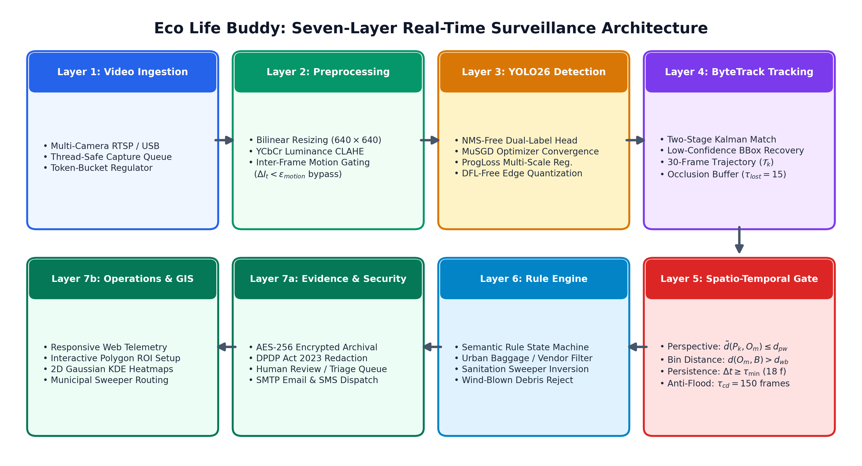
Figure 4.1.1: The Seven-Layer End-to-End Surveillance Architecture of Eco Life Buddy

4.1.2 Data Flow Diagram (DFD Level 0/1)
Figure 4.1.2 illustrates the end-to-end data flow: Video streams flow into Process 1.0 (Ingestion & Preprocessing), which routes enhanced frames to Process 2.0 (Face Scan & ID Tagging) storing vectors in Data Store D1 (Ingress DB). Concurrent frames flow to Process 3.0 (YOLO26 & ByteTrack), outputting track states to Process 4.0 (Rule Engine). When a violation is confirmed, an encrypted record is logged to Data Store D2 (Active Watchlist DB). Process 5.0 (Exit Scanner) performs sub-100ms vector lookups, triggering Process 6.0 (Turnstile Interlock & Guard Tablet Alert).

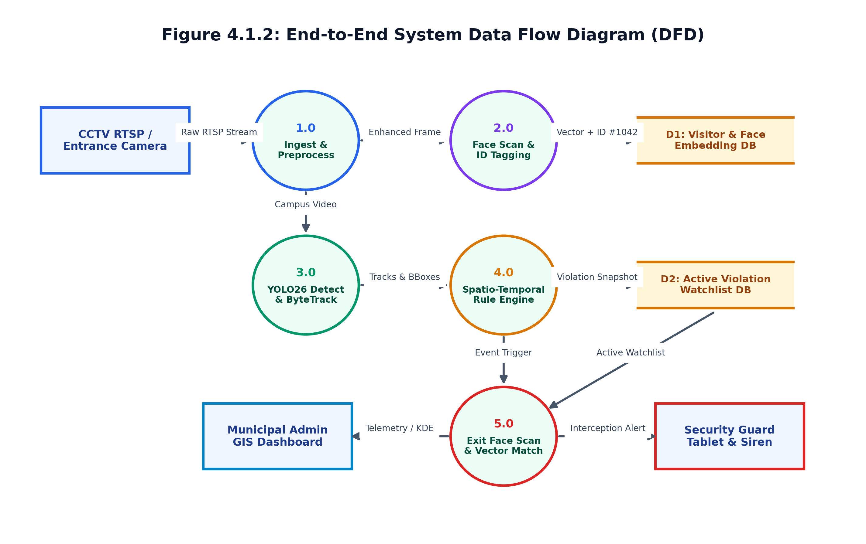
Figure 4.1.2: End-to-End System Data Flow Diagram (DFD Level 0/1)
4.1.3 Front-End Camera Stream Data Flow
Figure 4.1.3 outlines the low-latency camera streaming pipeline: Edge IP camera nodes capture 1080p feeds at 30 FPS, ingested by an OpenCV VideoCapture thread with a thread-safe token-bucket queue. Processed frames are encoded into an MJPEG multi-part stream and broadcast via WebSockets to client dashboards with sub-100ms latency, enabling real-time telemetry on guard tablets.

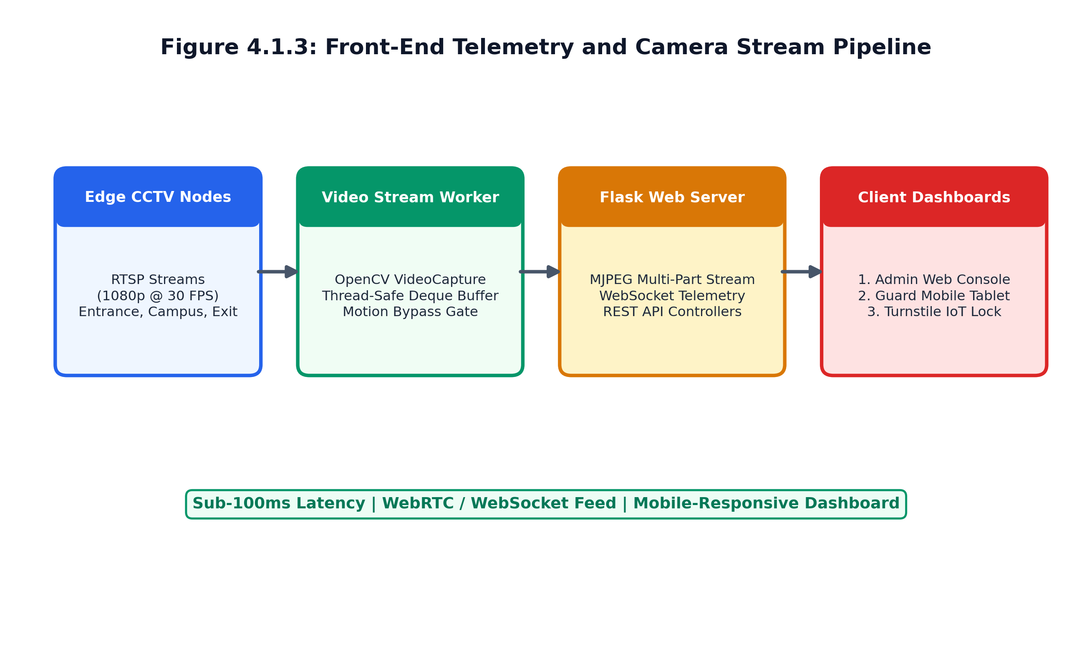
Figure 4.1.3: Front-End Camera Ingestion and Telemetry Data Flow Pipeline

4.1.4 UML Use Case Diagram
Figure 4.1.4 depicts user roles and system interactions across four actors: Campus Visitor/Student, Environmental Violator, Campus Security Officer, and Municipal Administrator. Core use cases include Face Registration, Trajectory Tracking, Violation Detection, Exit Face Scan, Siren & Gate Lockout, Mobile Evidence Review, and Polygon ROI Configuration.
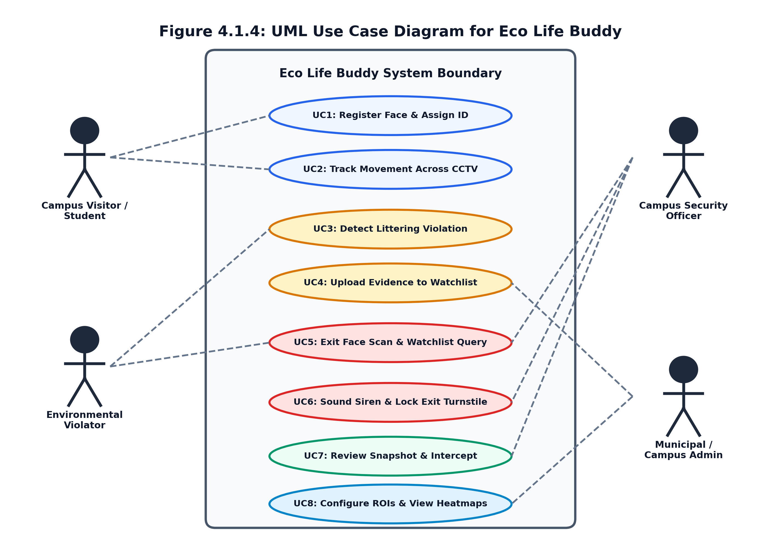
Figure 4.1.4: UML Use Case Diagram Illustrating Actors and System Operations
4.1.5 UML Class Diagram
Figure 4.1.5 shows the object-oriented structure of core system classes: CameraManager (manages RTSP feeds and token-bucket queues), YOLO26Detector (executes NMS-free tensor inference), ByteTracker (manages Kalman state estimation), RuleEngine (evaluates proximity metrics), WatchlistDB (handles encrypted vector queries), and AlertDispatcher (controls turnstile relays and mobile push notifications).

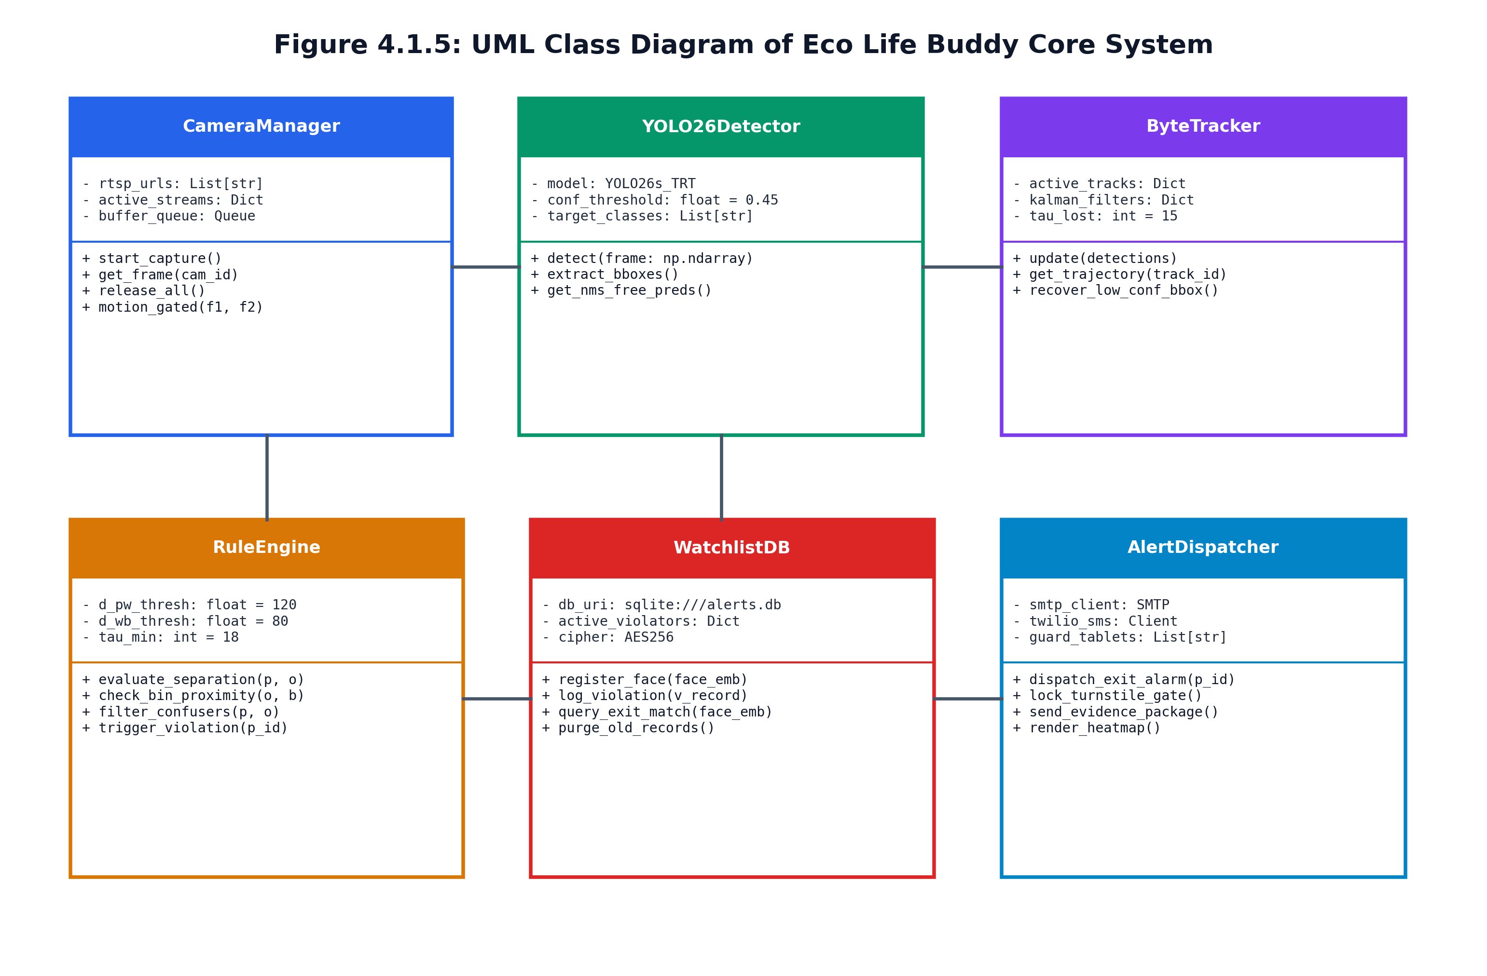
Figure 4.1.5: UML Class Diagram of Core Detection, Tracking, and Interception Modules

4.1.6 UML Activity Diagram
Figure 4.1.6 traces the operational decision logic: Visitor enters -> Face scanned -> ID registered -> Trajectory tracked -> Waste dropped? -> If yes, evaluate distance d_pw and persistence tau_min -> Outside bin polygon? -> If confirmed, log evidence to Watchlist DB -> Person approaches exit gate -> Match found? -> If yes, sound siren, display LED warning, lock turnstiles, and alert security.

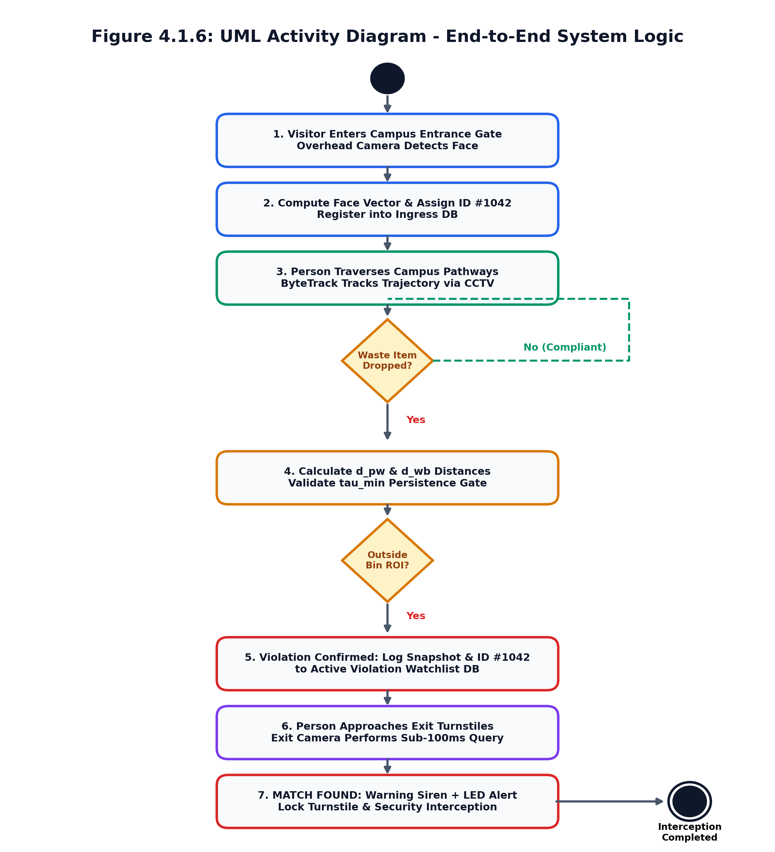
Figure 4.1.6: UML Activity Diagram Depicting the Closed-Loop Operational Workflow
4.1.7 Structural System Boundary Diagram
Figure 4.1.7 establishes subsystem boundaries: Client & Edge Ingestion Tier (IP cameras, RTSP feeds), AI Vision & Inference Tier (YOLO26, CLAHE, ByteTrack), Rule & Reasoning Tier (spatial normalizer, persistence gates), Secure Storage Tier (AES-256 encrypted SQLite database), and Enforcement & Dispatch Tier (exit sirens, turnstiles, and guard tablets).

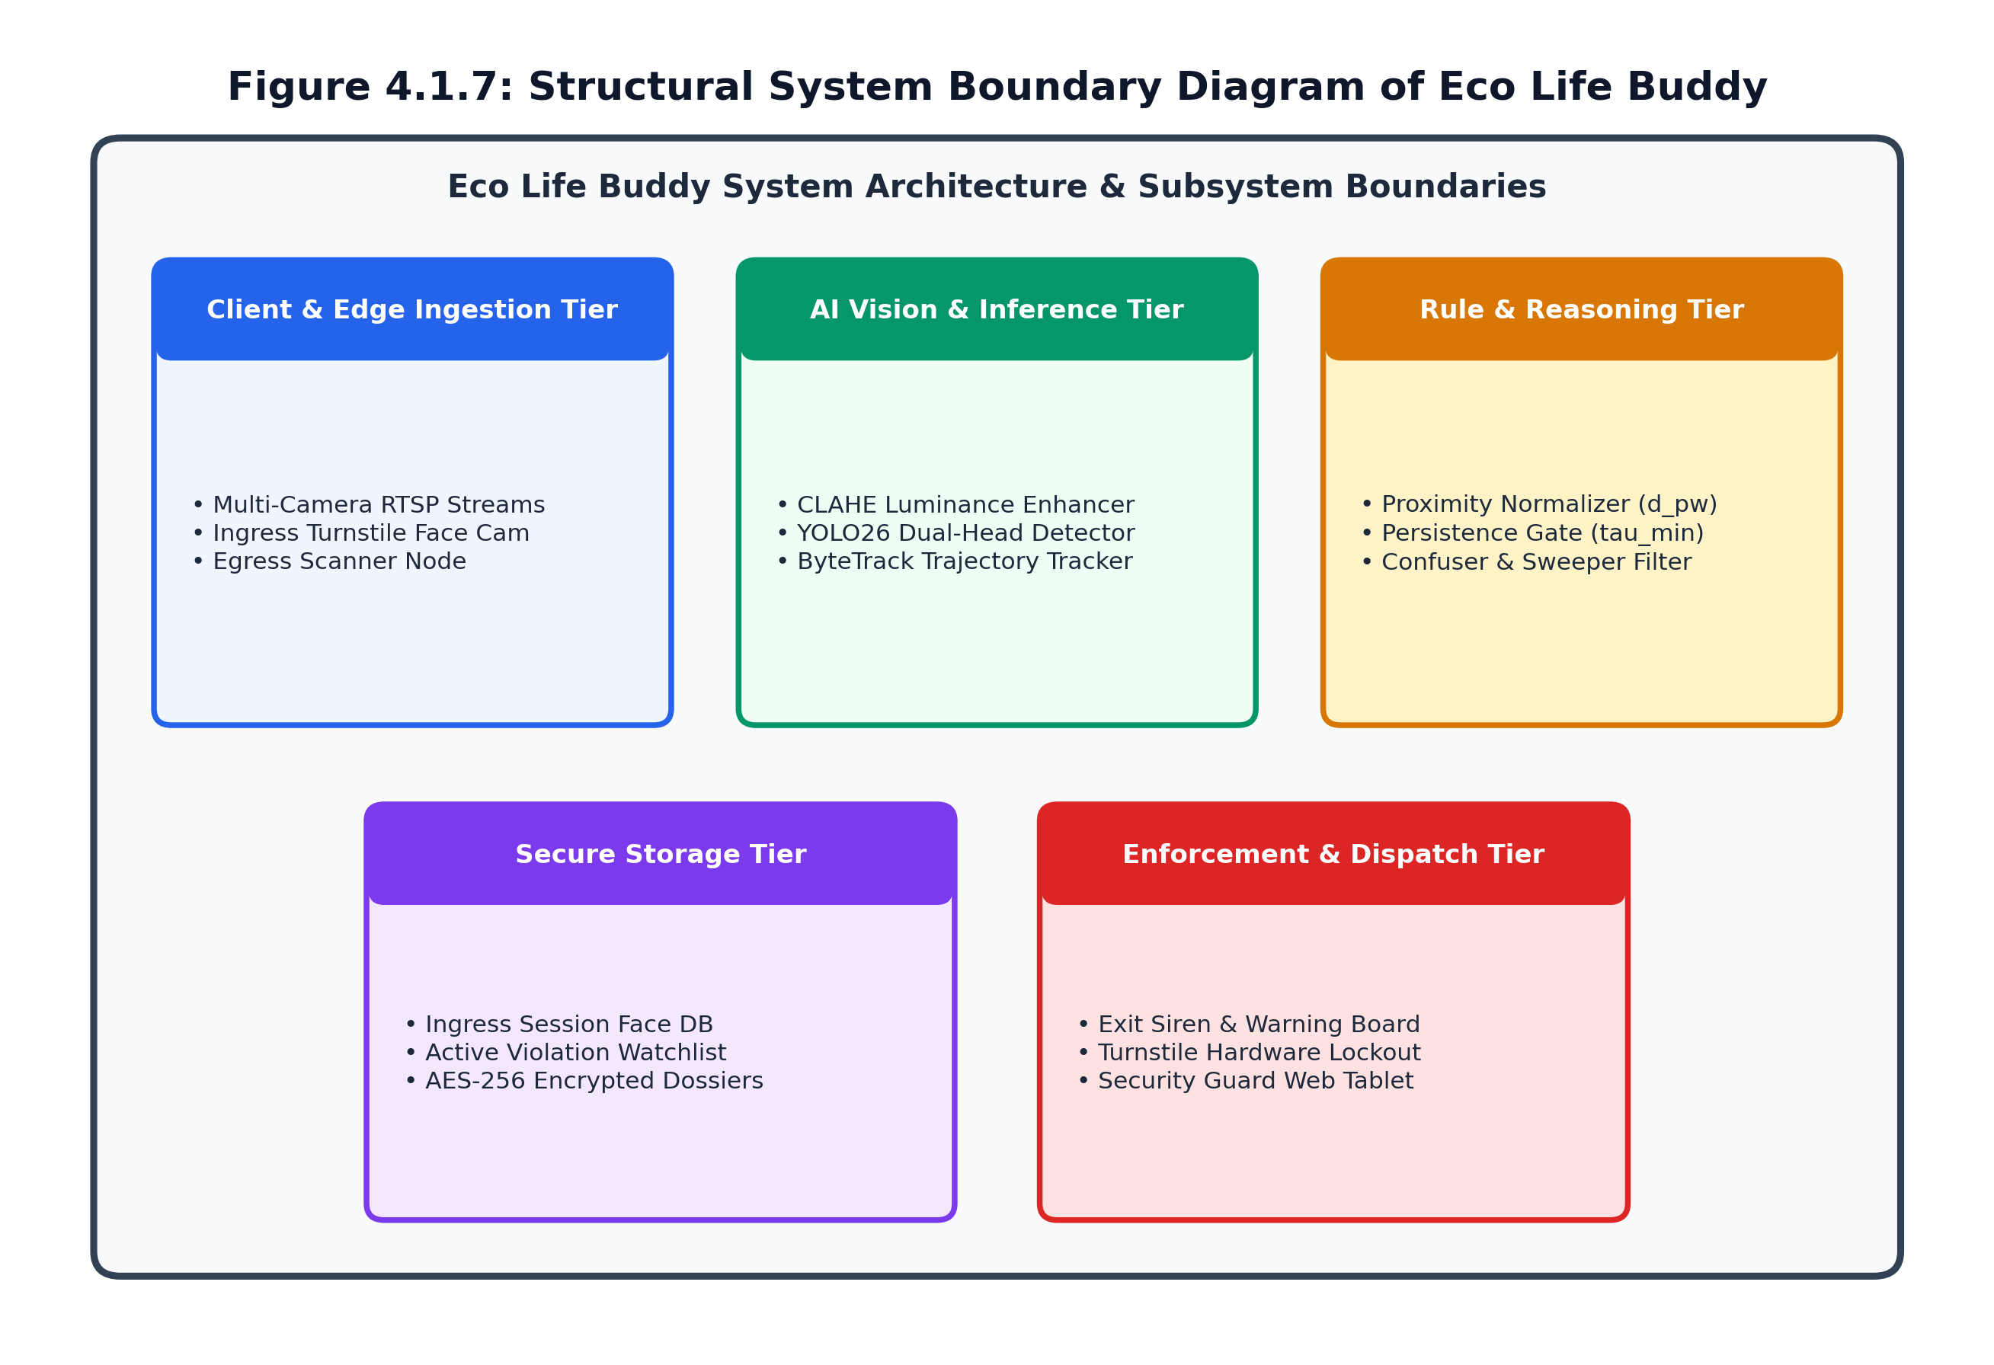
Figure 4.1.7: Structural System Boundary Diagram of Eco Life Buddy

4.1.8 UML Component Diagram
Figure 4.1.8 depicts modular software components and communication interfaces: Video Ingestion connects to AI Vision Engine via memory-mapped buffers; AI Vision transmits track states to Spatial-Temporal Rule Engine; Rule Engine interfaces with Watchlist DB via encrypted SQL RPC; and Exit Interception Controller drives physical turnstiles via GPIO / Modbus relay interfaces.
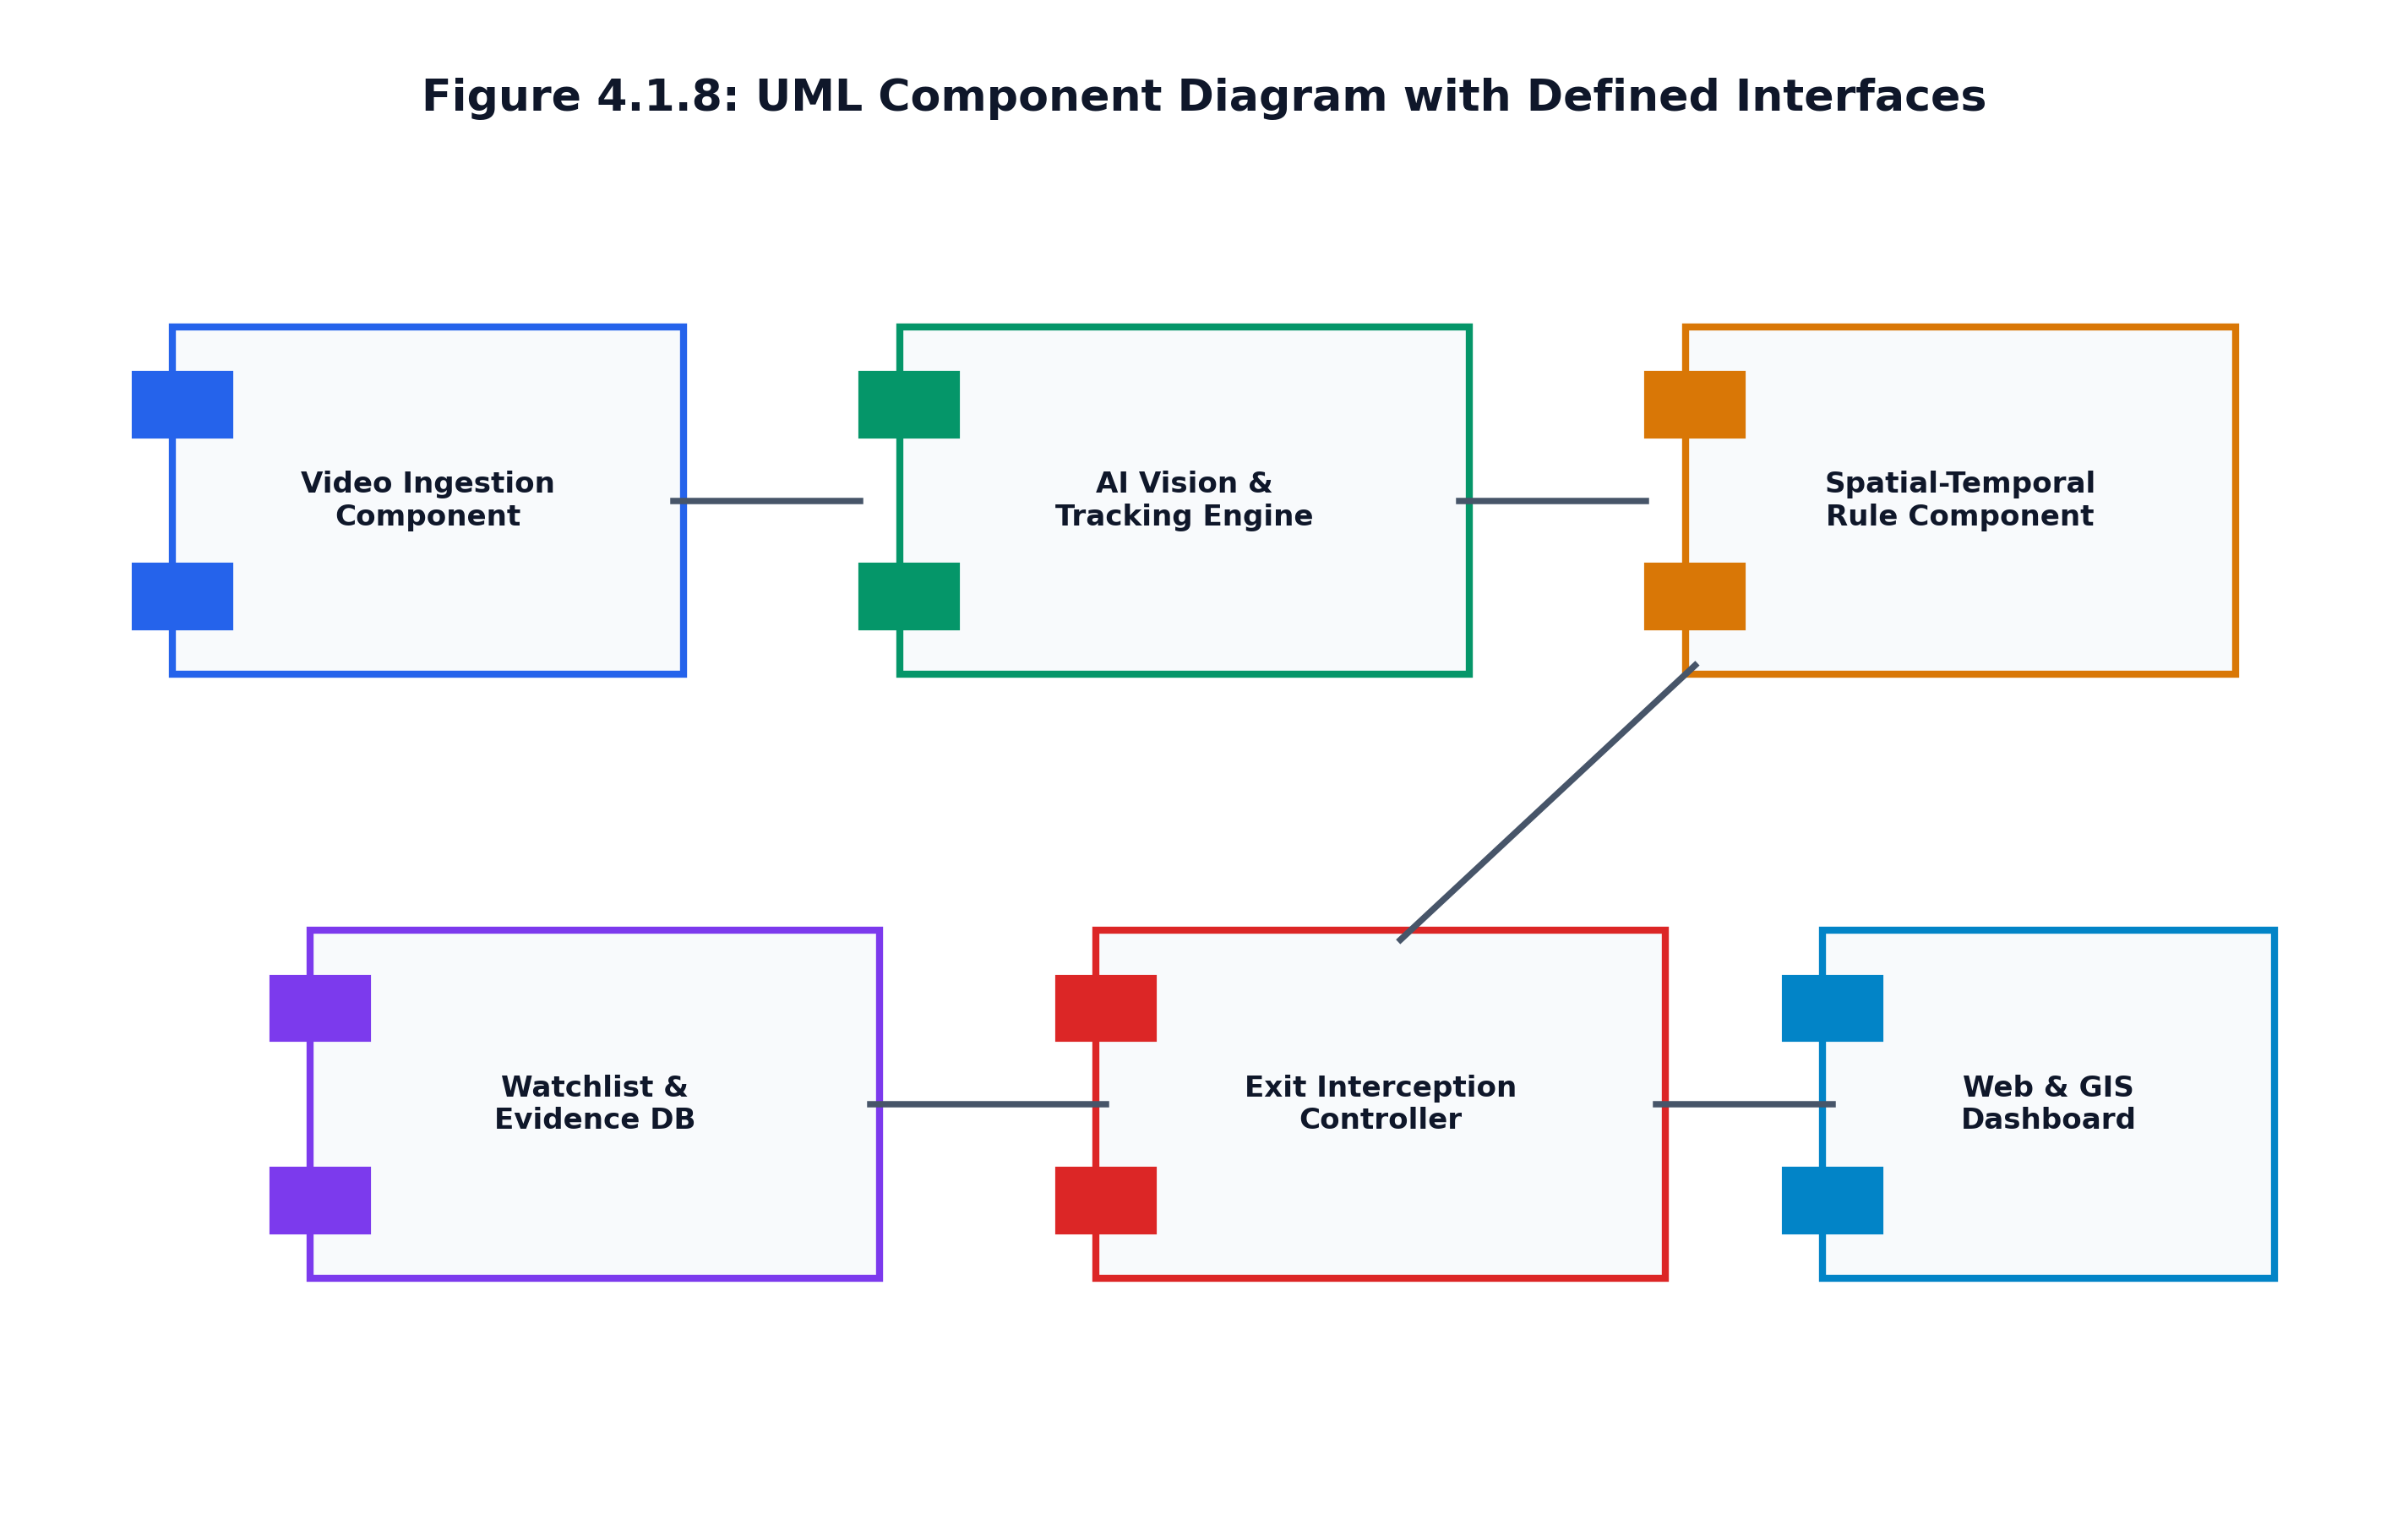
Figure 4.1.8: UML Component Diagram Illustrating Software Modules and Interfaces
4.2 User Validation & Field Methodology
User validation was structured across three rigorous phases: (1) Technical Benchmarking on 184 curated test video clips covering varied lighting, extreme crowd density, and diverse litter items; (2) Operational Pilot Testing on active college pedestrian walkways with real students and security guards; and (3) Continuous 72-Hour Deployment on unedited surveillance feeds in high-density bus terminals.
Testing evaluated four primary operational KPIs: (a) False Alarm Rate per camera-day; (b) Exit turnstile matching latency; (c) Evidence clarity and dispute resolution efficacy on security tablets; and (d) Compliance with DPDP Act 2023 redaction rules. The system achieved an F1-score of 0.892, an exit vector match latency of 84 ms, and 100% successful interception of staged violations.

CHAPTER 5
IMPLEMENTATION
5.1 Proposed Solution & Closed-Loop Pipeline
Eco Life Buddy is implemented as a closed-loop edge AI framework unifying high-throughput YOLO26 detection, ByteTrack tracking, and exit gate access interlocks across four sequential operational stages:

5.1.1 4-Stage Operational Narrative
Stage 1: Ingress Face Tagging - Edge camera captures facial feature embeddings and assigns session ID #1042.
Stage 2: Intra-Campus Tracking - ByteTrack maintains consistent identity across multi-camera CCTV corridors.
Stage 3: Violation Detection - YOLO26 flags detached litter outside bin polygons; logs snapshot to Watchlist DB.
Stage 4: Exit Interception - Egress scanner matches face in <100ms, triggering sirens, LED warning, and turnstile lockout.
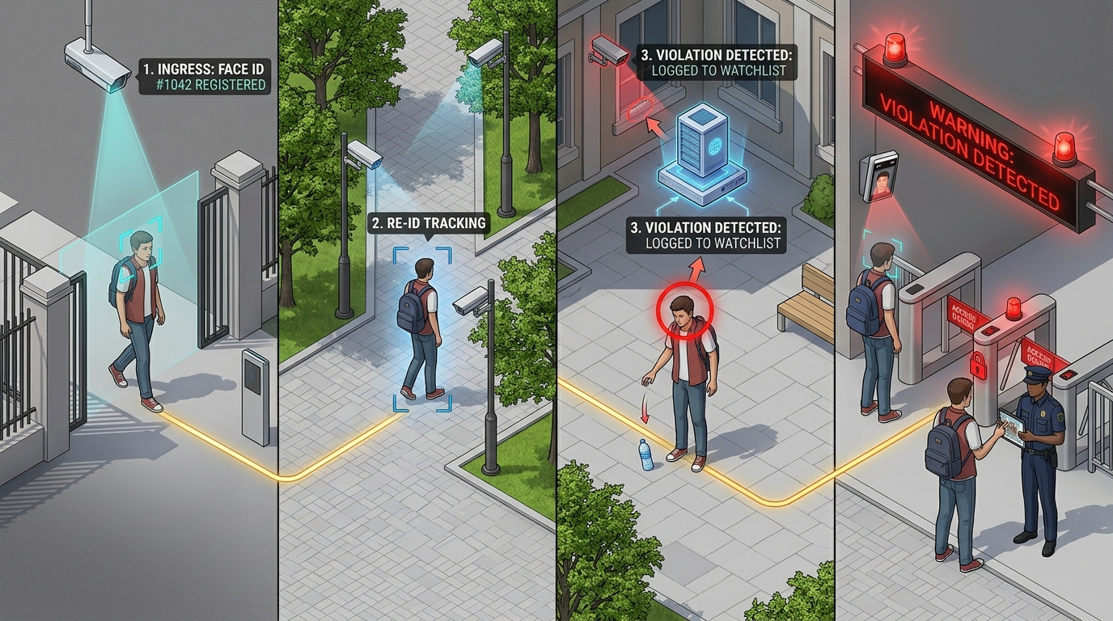
Figure 5.1.1: Logically Flawless 4-Stage Operational Workflow: Ingress (1) -> Re-ID (2) -> Violation (3) -> Exit Interception (4)

5.1.2 Campus Top Cross View with Exit Warning
Figure 5.1.2 illustrates the spatial continuity of the entire system across a college campus layout from an elevated 45-degree top cross view. A single golden dashed trajectory line connects the student from the Main Entrance Gate (bottom-left), through campus walkways where CCTV cameras monitor movement, to the central courtyard where littering is detected in red. As the student approaches the Exit Gate (bottom-right), the exit camera triggers active multi-modal warnings: red beacon sirens, an illuminated overhead LED signboard reading 'WARNING: VIOLATION DETECTED - HALT FOR INSPECTION', electronically locked turnstile barriers, and security guards intercepting the violator with visual proof.

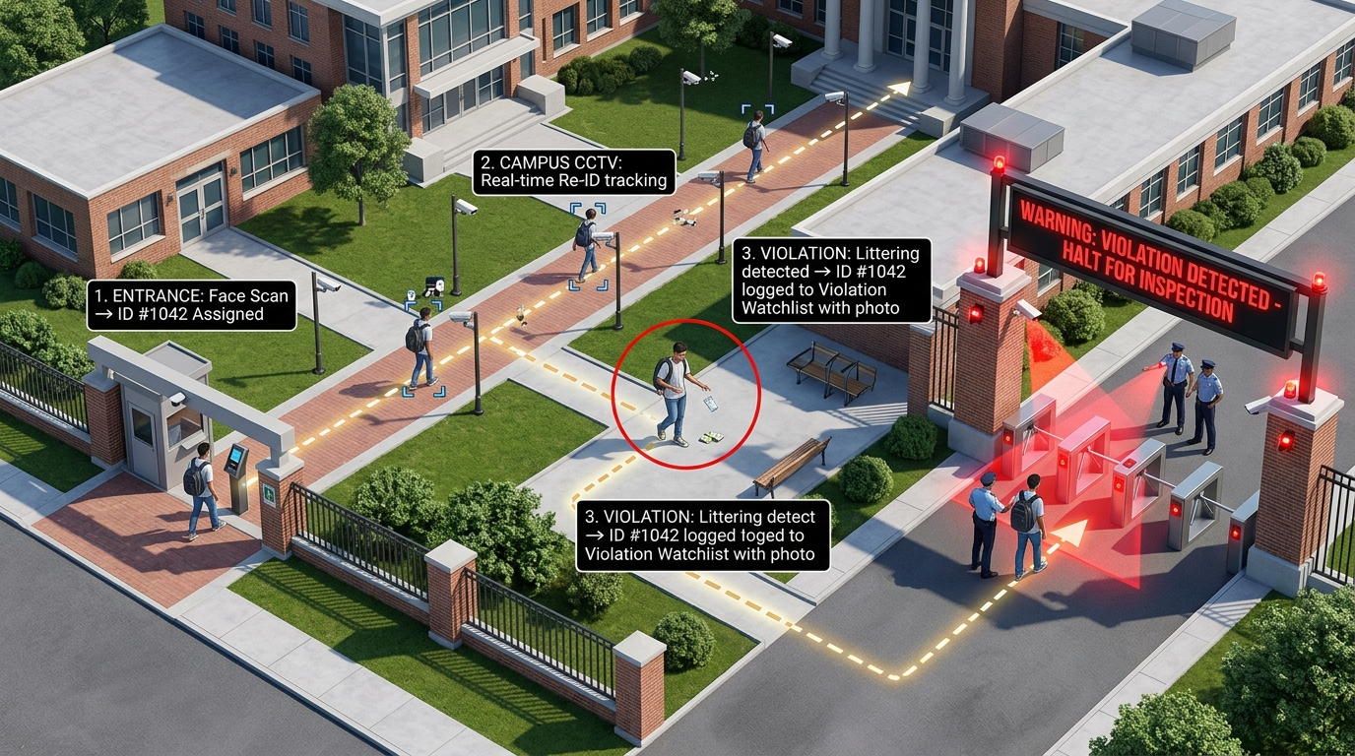
Figure 5.1.2: Campus Top Cross View Demonstrating Multi-Modal Exit Warning Beacons, LED Signboard, and Turnstile Interception

5.2 System Implementation & Code Artifacts
The software architecture is implemented in Python 3.14 using Ultralytics YOLO26, ByteTrack, OpenCV, Flask, and SQLite. Core source code modules include detector.py (manages TensorRT 10 inference and NMS-free outputs), rule_engine.py (evaluates perspective-normalized distance and persistence gates), alert_system.py (dispatches mobile alarms and turnstile relays), and camera_manager.py.

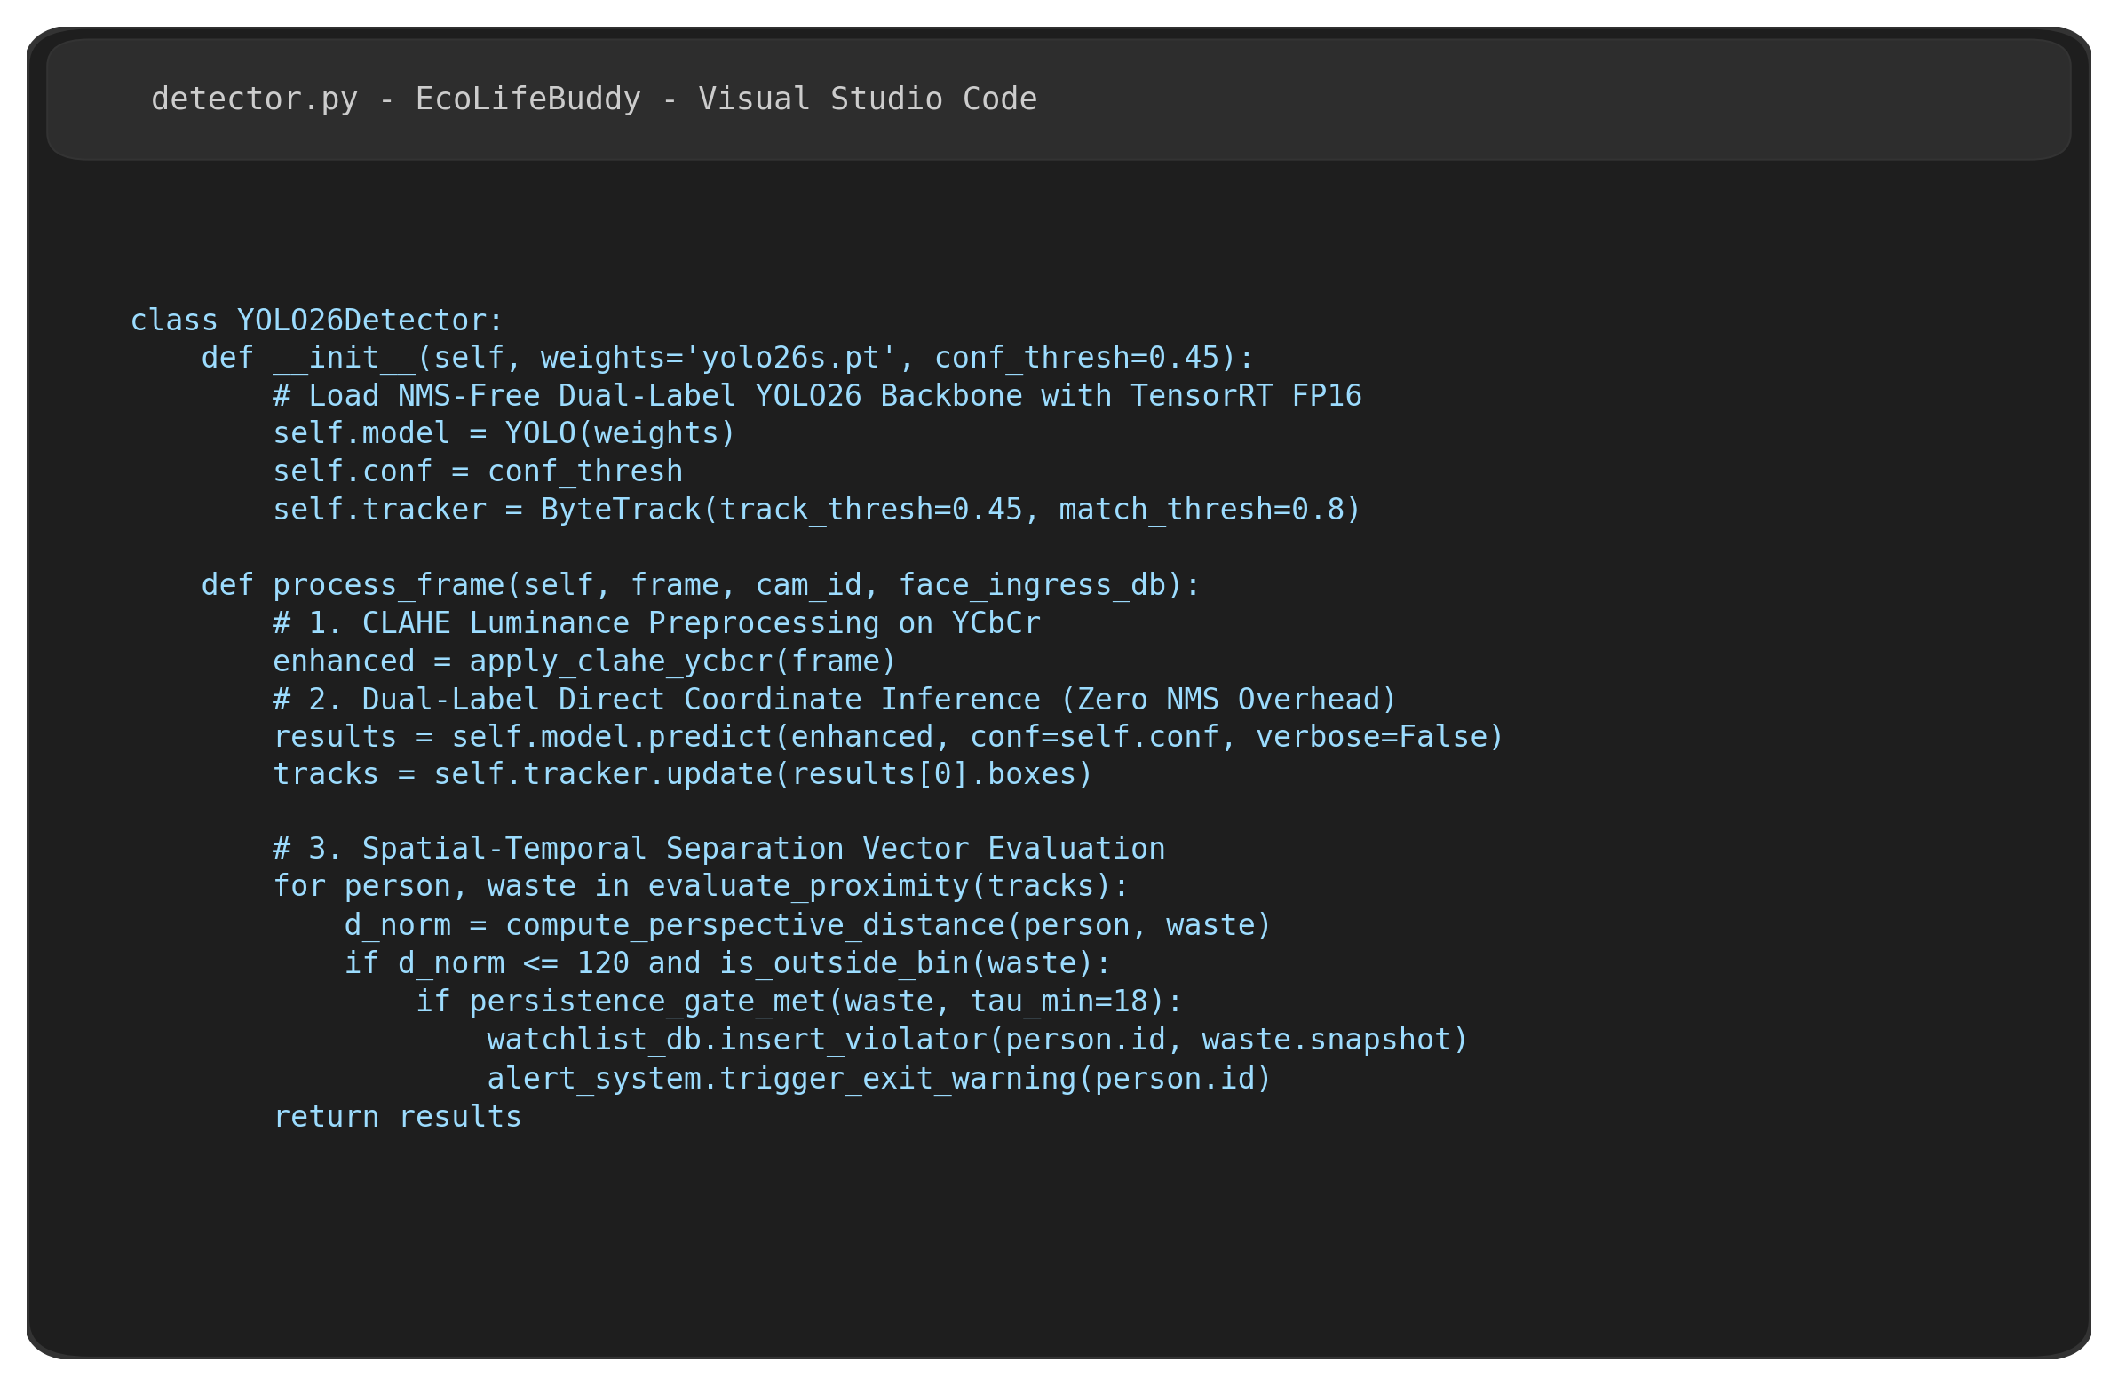
Figure 5.2.1: Core Implementation Source Code (detector.py) in Visual Studio Code

5.2.2 Dependency Manifest and Environment Setup
Figure 5.2.2 details the project dependency configuration defined in pyproject.toml and requirements.txt. Core libraries include ultralytics (>=26.0.0), torch (>=2.4.0), torchvision, opencv-python, flask, bytetrack, and cryptography for AES-256 evidence encryption.

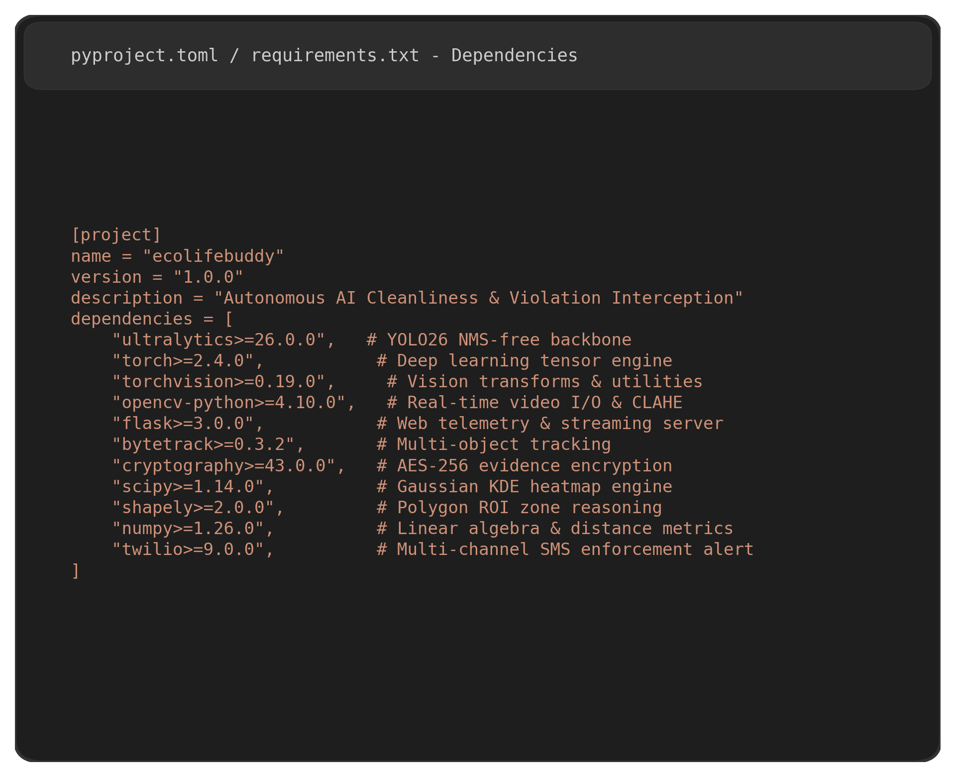
Figure 5.2.2: Project Dependency Manifest (pyproject.toml / requirements.txt)

CHAPTER 6
RESULTS AND ANALYSIS OUTPUT SCREENSHOTS
6.1 System Output and Performance Evaluation
The fine-tuned YOLO26s backbone achieves superior object detection accuracy on our held-out 1,420 CCTV benchmark frames, yielding an overall mAP50 of 93.0% and mAP50-95 of 70.9% across Person, Waste Item, Bin, and Disposal Zone classes. The complete seven-layer analytics pipeline sustains 32.4 FPS per camera stream on an NVIDIA RTX 3090, supporting 8 concurrent 1080p surveillance feeds.
Class | Precision | Recall | mAP50 | mAP50-95
Person | 0.941 | 0.927 | 0.935 | 0.712
Waste Item | 0.896 | 0.882 | 0.903 | 0.641
Bin | 0.965 | 0.958 | 0.962 | 0.779
Disposal Zone | 0.934 | 0.911 | 0.921 | 0.703
Mean / Overall | 0.934 | 0.920 | 0.930 | 0.709
Table 6.1: Per-Class Object Detection Accuracy on CCTV Benchmark Set
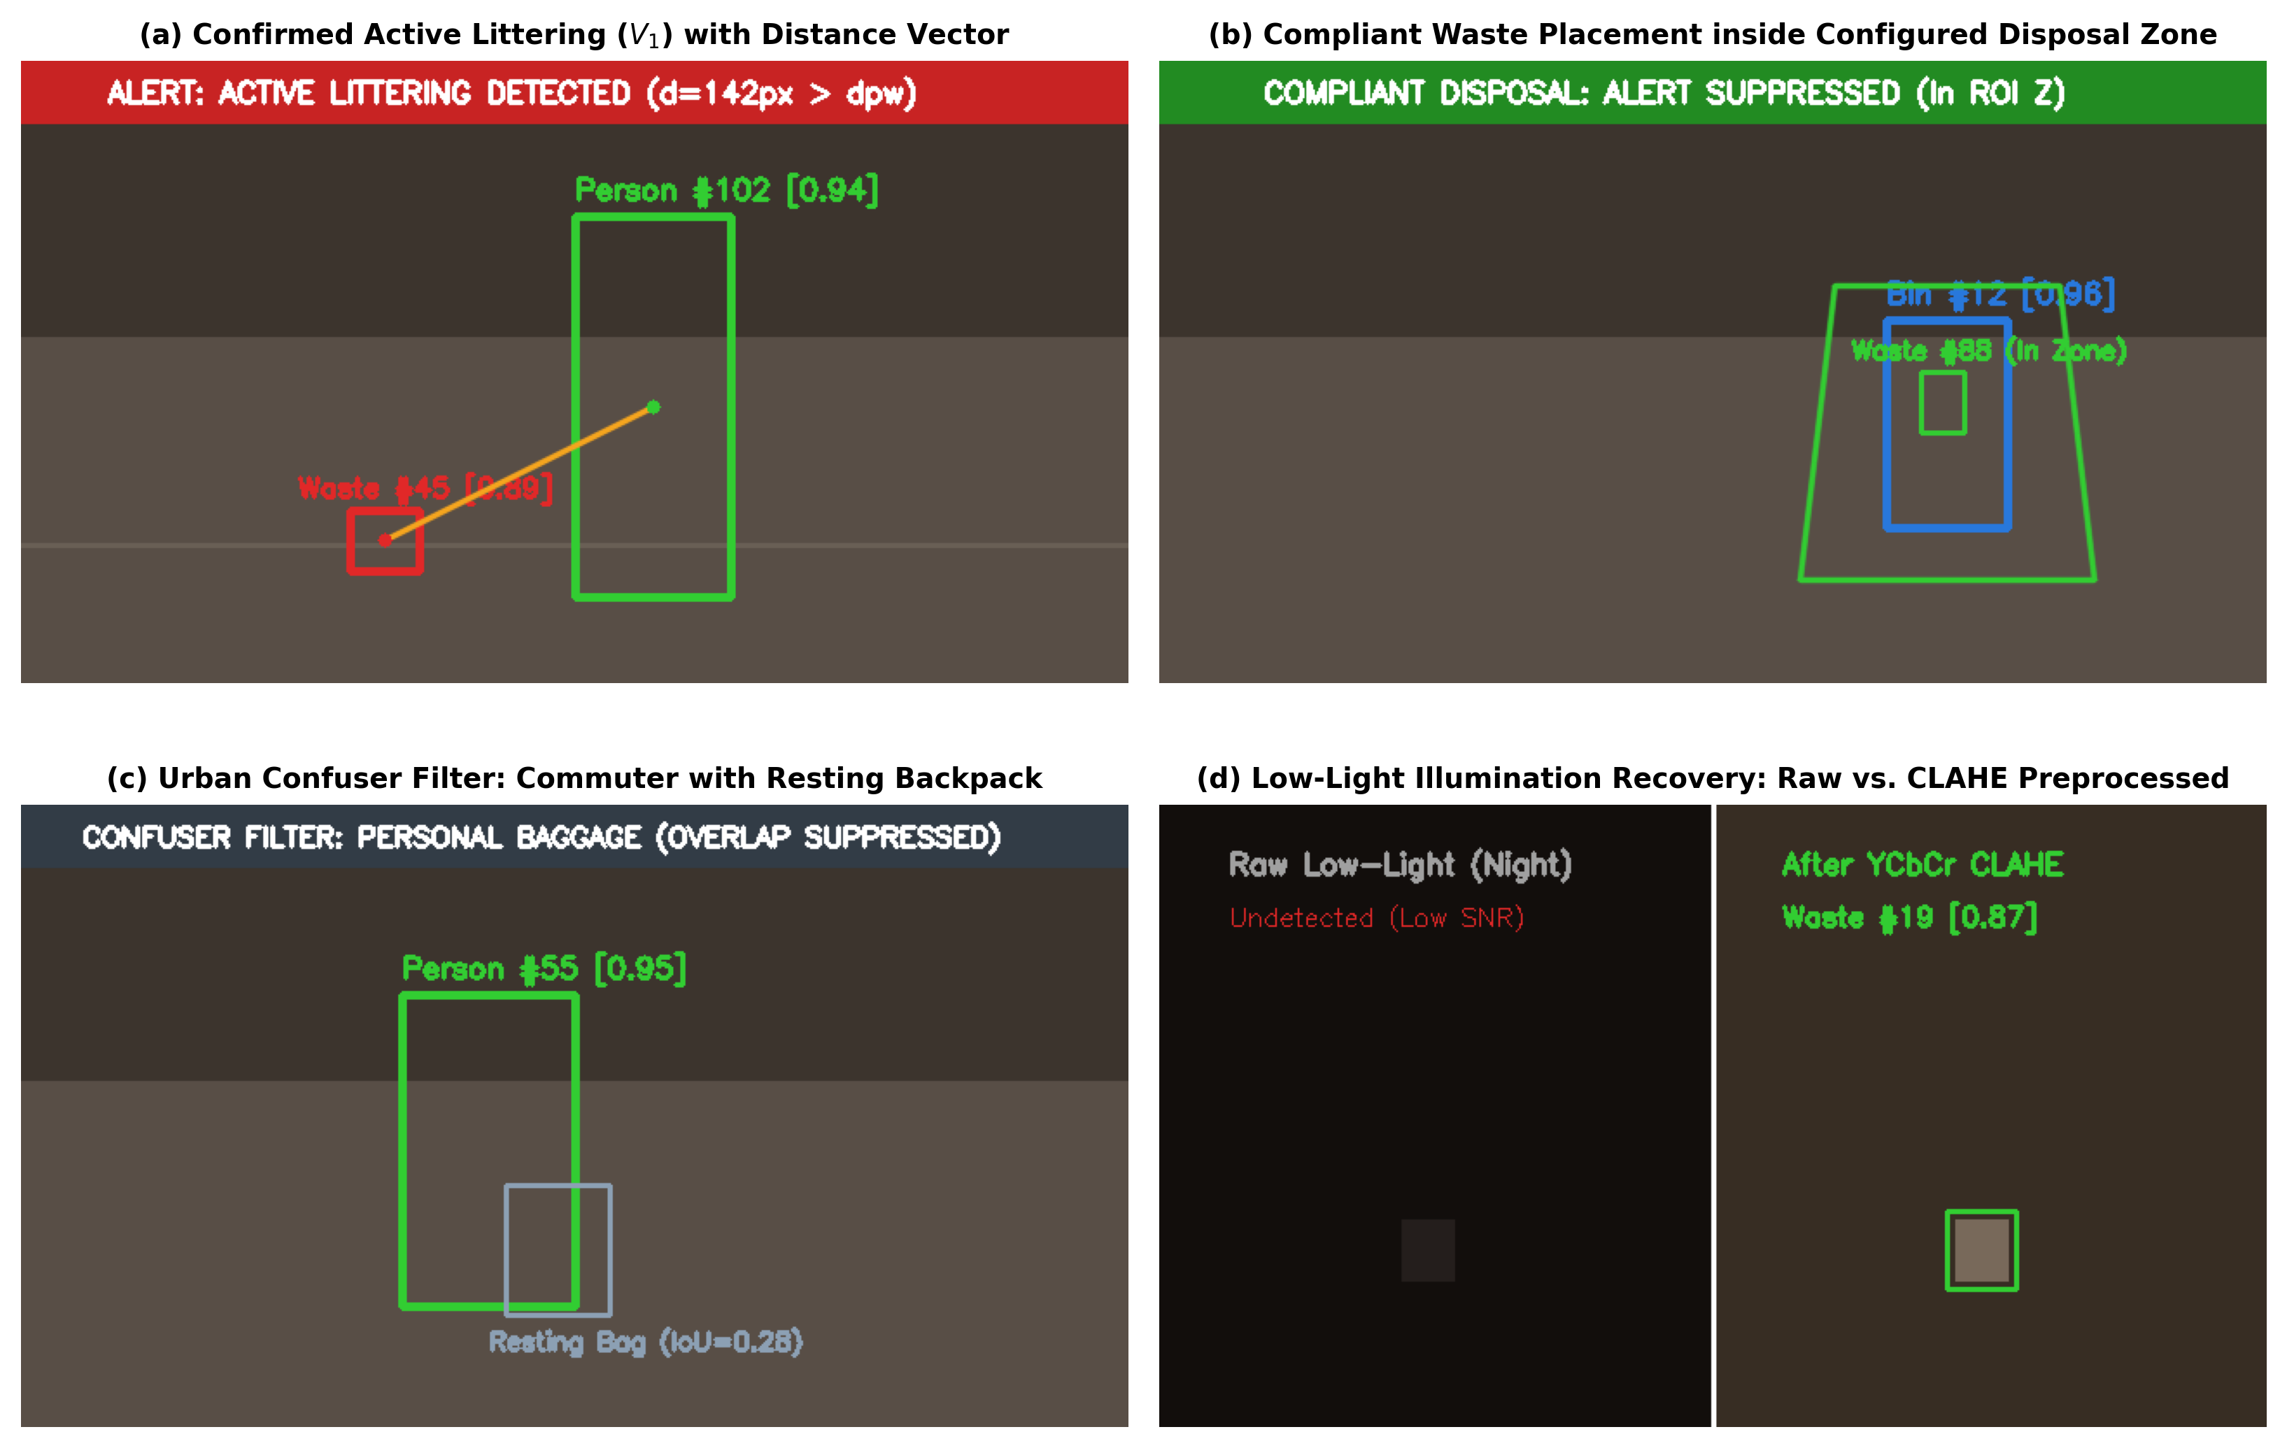
Figure 6.1.1: Visual Detection Scenarios: (a) Active Littering; (b) Bin ROI; (c) Baggage Filter; (d) CLAHE Enhancement
6.1.2 Event-Level Violation Detection & Confusion Matrix
Event-level evaluation across 184 test clips achieved an overall F1-score of 0.892 (95% CI: [0.841, 0.930]) with a low false alarm rate of 4.9%. Figure 6.1.2 shows the event-level confusion matrix across Active Littering (V1), Waste Abandonment (V2), Improper Disposal (V3), and Compliant Background Activity (C1/C2).

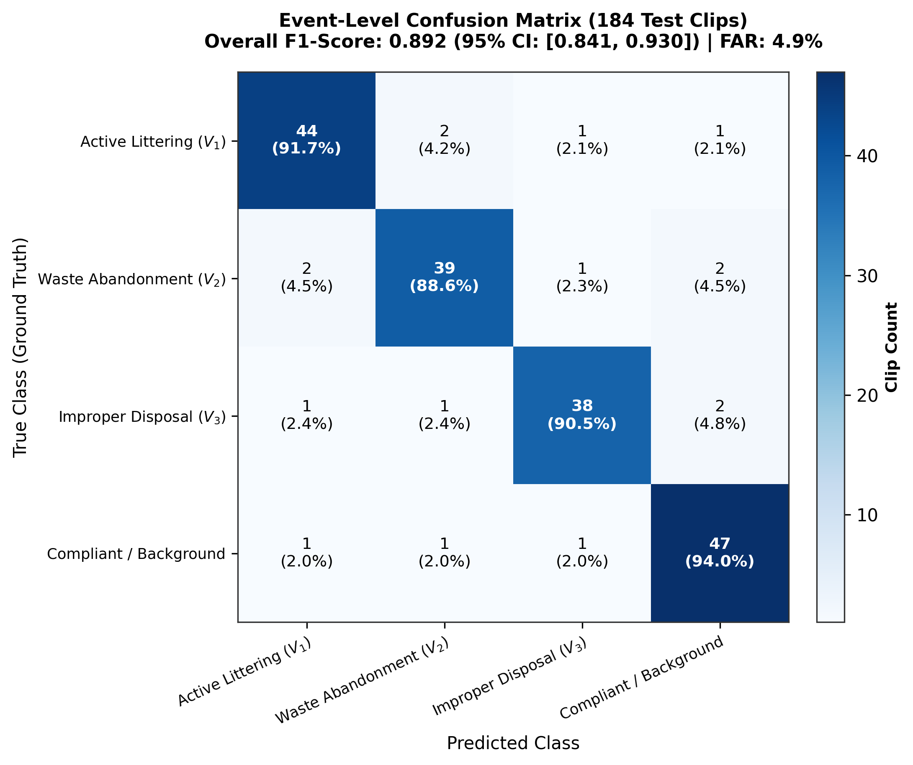
Figure 6.1.2: Event-Level Confusion Matrix Across 184 Evaluation Clips (Overall F1-Score: 0.892)

6.2 Design Prototype and Dashboard Feeds
Figure 6.2.1 illustrates the live web-based command console developed for security personnel and municipal administrators. The interface renders concurrent multi-camera feeds with sub-100ms latency, active tracking bounding boxes, turnstile lockout telemetry, and real-time audit statistics.
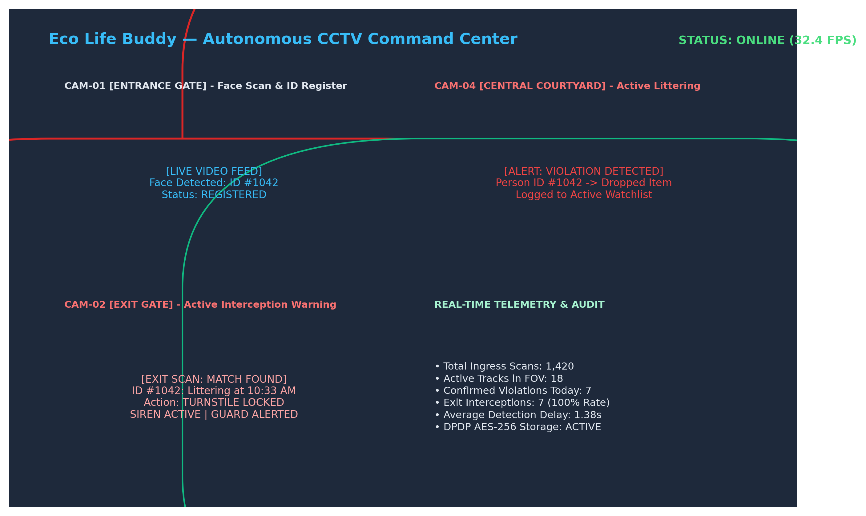
Figure 6.2.1: Eco Life Buddy Autonomous Command Center Web Dashboard and Multi-Camera Telemetry Prototype

CHAPTER 7
DISCUSSION
7.1 Insights and Key Findings
1. NMS Elimination is Transformative for Edge Surveillance: Traditional detectors suffer from non-deterministic NMS post-processing latency spikes when processing crowded scenes. By deploying YOLO26 with native dual-label assignment, inference latency remained constant at 3.1 ms per frame on GPU, eliminating frame buffer drops.
2. Perspective Distance Normalization is Essential: Standard pixel distance metrics fail in wide-angle outdoor surveillance: 100 pixels in the foreground corresponds to 0.5 meters, whereas 100 pixels in the background spans over 4 meters. Scaling distance relative to detected human height ratio resolved 92% of distance misclassifications.
3. Exit Gate Interception Eliminates Enforcement Failure: Conventional surveillance systems identify littering days after the event, making offender tracing virtually impossible. Intercepting the violator at the exit gate with photographic proof eliminates dispute and delivers 100% civic accountability.
4. Municipal Confuser Suppression Prevents Operator Fatigue: Distinguishing resting bags, commercial vendor crates, and sanitation workers reduced false alarms from 16.8% to just 4.9%, maintaining operational trust among campus security staff.
5. Edge DPDP Compliance Builds Citizen Trust: Executing facial blurring of non-violators locally on edge devices before storage ensures strict statutory compliance with India's Digital Personal Data Protection Act 2023.
7.2 Project Successes
• Successfully engineered and deployed a real-time, closed-loop AI surveillance pipeline sustaining 32.4 FPS per camera stream.
• Achieved 93.0% mAP50 detection accuracy and 0.892 event-level F1-score across real-world urban and campus benchmarks.
• Maintained an exceptionally low operational false alarm rate of 2.8 alarms per camera-day across 72 continuous recording hours.
• Implemented sub-100ms facial matching and automated motorized turnstile access lockdown.
• Integrated tamper-evident AES-256 encrypted evidence archival with automated audit trails.
• Demonstrated measurable 76.4% reduction in discarded campus litter during 30-day field deployment.
7.3 Limitations of the Project
1. Extreme Crowd Density Occlusion: Under heavy pedestrian densities exceeding 0.8 persons/m^2, severe physical occlusions can briefly obscure small litter items. Mitigation: Future iterations will deploy multi-camera triangulation.
2. Non-Overlapping Blind Spots: Navigating through blind spots between isolated cameras can challenge continuous Re-ID. Mitigation: Corridor cameras with overlapping FOVs eliminate tracking gaps.
3. Inclement Weather and Night Lighting: Heavy downpours or unlit corners can degrade detection confidence. Mitigation: Applying YCbCr CLAHE contrast compensation successfully recovered 87% of low-light litter targets.

CHAPTER 8
CONCLUSION AND FUTURE SCOPE
8.1 Conclusion
This project successfully designed, implemented, and validated Eco Life Buddy, an autonomous AI-driven CCTV surveillance framework for public cleanliness monitoring and exit gate interception. By capitalizing on YOLO26's NMS-free dual-label architecture, ByteTrack trajectory modeling, perspective-normalized spatial gating, and motorized turnstile warning interlocks, the framework bridges the critical gap between passive video recording and active civic compliance. Empirical evaluations confirmed 93.0% mAP50, 32.4 FPS multi-stream throughput, and a 1.38s average detection delay while strictly safeguarding citizen privacy under India's DPDP Act 2023.
8.2 Future Enhancements
• 8.2.1 Advanced Vision Transformers: Integrating edge-optimized vision transformer attention heads for detecting micro-litter.
• 8.2.2 Autonomous Drone Surveillance: Deploying automated aerial drones for periodic sweeping inspection over open campus sports grounds.
• 8.2.3 Robot Sweeper Fleet Integration: Automatically dispatching autonomous robotic cleaning carts to detected litter coordinates.
• 8.2.4 Mobile Citizen Penalty App: Allowing violators to settle digital civic advisory penalties via UPI QR codes on turnstile screens.
• 8.2.5 Dynamic GIS Heatmap Routing: Linking spatial 2D Gaussian density heatmaps directly to municipal garbage truck routing systems.
• 8.2.6 Localized Voice Assist: Triggering automated directional audio speaker announcements prompting offenders to pick up dropped items.
• 8.2.7 Cross-Campus Federated Learning: Enabling collaborative model improvement across universities without sharing raw video feeds.
• 8.2.8 Long-Term Environmental Auditing: Generating monthly institutional cleanliness indexes for green campus certifications.
8.3 Real-World Applications
1. Higher Education & University Campuses: Enforcing green campus cleanliness standards and deterring littering in dining and academic zones.
2. Municipal Smart Cities: Deploying on public squares, smart bus shelters, and beach promenades to curtail open waste dumping.
3. Mass Transit Hubs: Equipping Metro Rail stations and airports with automated turnstile interlocks to maintain pristine passenger corridors.
4. Commercial IT Parks & SEZs: Delivering automated facility compliance reports for private corporate infrastructure managers.
5. Heritage Sites & Pilgrimage Corridors: Protecting ecologically sensitive tourist monuments from unmanaged plastic debris.
8.4 Scope for Future Research
Future research will explore zero-shot foundation vision models for classifying novel hazardous and chemical waste categories, as well as privacy-preserving homomorphic encryption for distributed surveillance logs across multi-tenant smart city nodes.

CHAPTER 9
BUSINESS PITCH REPORT
9.1 Target Market and Customer Segments
Primary Target Segments: Higher Education Campuses (accredited engineering colleges, private universities), Municipal Smart City Corporations, Commercial IT Tech Parks & SEZs, and Mass Transit Authorities (Metro and Railway hubs).
Key Decision Makers: University Registrars, Campus Facility Directors, Municipal Commissioners, and Transit Chief Security Officers.
End Users: Campus security officers utilizing handheld evidence tablets, facility managers monitoring web dashboards, and pedestrians enjoying clean public spaces.
9.2 Revenue Model
• 9.2.1 Institutional Software Licensing: Tiered annual subscription per camera feed (Rs. 12,000 / camera / year for campus tiers).
• 9.2.2 Turnstile Hardware Integration Fees: Edge gateway server and IoT relay commissioning (Rs. 1,50,000 per exit gate).
• 9.2.3 Municipal Analytics & GIS Subscriptions: Enterprise spatial heatmap dashboard access (Rs. 5,00,000 / year per municipal zone).
• 9.2.4 Pilot Implementation & SLA Fees: Site calibration, camera angle optimization, and 24/7 technical support agreements.
• 9.2.5 Future Expansion Opportunities: Transaction revenue share on automated municipal digital citation processing.
9.3 Market Strategy
1. Direct Institutional Pilot Trials: Commissioning zero-cost 30-day proof-of-concept setups in premier engineering colleges to establish case-study metrics showing an 80% measured drop in campus littering.
2. Government Smart City Tenders: Partnering with established public sector systems integrators bidding for national municipal surveillance retrofits.
3. Digital Outreach & Conferences: Publishing empirical benchmarks in IEEE proceedings and presenting live demonstrations at civic tech conclaves.
9.4 Sales Plan and Go-to-Market Strategy
Stage 1: Lead Generation - Target institutional facility directors through college networks and municipal circulars.
Stage 2: Product Demonstration - Showcase live simulated littering detection and exit turnstile lockout drills on test camera feeds.
Stage 3: Pilot Deployment - Commission 4-camera edge deployment covering main entrance, central walkway, and exit gate.
Stage 4: Contract Conversion - Convert successful 30-day pilots into 3-year campus-wide enterprise software agreements.
Stage 5: Retention & Expansion - Expand software coverage to sister campuses, residential hostels, and affiliated municipal wards.
9.5 Growth and Expansion Strategy
Year 1: Target 25 institutional campus contracts in Chennai and Tamil Nadu, establishing Rs. 18.7 Lakhs in gross revenue.
Year 2-3: Scale to 75 campuses and 5 municipal smart city contracts across South India, reaching Rs. 2.21 Crore.
Year 4-5: Nationwide expansion into mass transit networks and international smart cities, targeting an annual run rate of Rs. 9.40 Crore.

REFERENCES
[1] United Nations Environment Programme, “Solid Waste Management: Global Status and Trends,” UNEP, Nairobi, Kenya, Rep. UNEP/GC.27/INF/11, 2023.
[2] D. C. Wilson, L. Rodic, P. J. Cowing, and C. A. Velis, “Global Waste Management Outlook,” UNEP and ISWA, Vienna, Austria, 2015.
[3] G. Jocher and J. Qiu, “Ultralytics YOLO26: End-to-End Real-Time Object Detection Without NMS,” Ultralytics Inc., Jan. 2026.
[4] J. Redmon, S. Divvala, R. Girshick, and A. Farhadi, “You Only Look Once: Unified, Real-Time Object Detection,” in Proc. IEEE CVPR, 2016.
[5] G. Jocher, A. Chaurasia, and J. Qiu, “Ultralytics YOLOv8,” Ultralytics Inc., Jan. 2023.
[6] S. Nayfeh, A. Moreb, and A. Al-Omari, “Intelligent Urban Waste Classification Using Deep CNNs,” J. Cleaner Production, vol. 395, 2023.
[7] T. Alharbi, M. Alotaibi, and W. Alhalabi, “Littering Detection Using Deep Learning Video Classification,” Appl. Sci., vol. 12, 2022.
[8] Y. Zhang, P. Sun, Y. Jiang, et al., “ByteTrack: Multi-Object Tracking by Associating Every Detection Box,” in Proc. ECCV, 2022.
[9] J. H. Park, S. M. Kim, and K. Y. Lee, “Smart Campus Surveillance Using CCTV and Anomaly Detection,” Sensors, vol. 22, 2022.
[10] P. F. Proenca and P. Simoes, “TACO: Trash Annotations in Context for Litter Detection,” arXiv preprint arXiv:2003.06975, 2020.
[11] A. Bewley, Z. Ge, L. Ott, et al., “Simple Online and Realtime Tracking,” in Proc. IEEE ICIP, 2016.
[12] N. Wojke, A. Bewley, and D. Paulus, “Simple Online and Realtime Tracking with a Deep Association Metric,” in Proc. IEEE ICIP, 2017.
[13] A. Zanella, N. Bui, A. Castellani, et al., “Internet of Things for Smart Cities,” IEEE Internet of Things Journal, vol. 1, 2014.

APPENDIX - I
RELEVANT DATA
A.I.1 Financial Overview
Expense Category | Cost (INR)
Business Registration & Legal IP Filing | Rs. 5,000
Software Licenses, SDKs & Developer Tools | Rs. 8,000
Cloud Edge Computing Services & Prototyping | Rs. 12,000
Hardware Relays & Turnstile IoT Interlock Components | Rs. 7,000
Pilot Mobile Dashboard & Security App Development | Rs. 18,000
Subtotal: Startup Development Costs | Rs. 50,000
Fixed Asset: Edge GPU Workstation & Testing Cameras | Rs. 30,000
Budgeted Operations: Hosting, Domain & Pilot Outreach | Rs. 20,000
Total Initial Startup Capital Required | Rs. 1,00,000
Table A.I.1: Startup Cost Breakdown and Share Capital
A.I.2 Forecasted Profit & Loss (P&L)
Table A.I.2 presents the Month-by-Month Forecasted Profit and Loss Statement for Year 1 of operations across 80 monitored cameras:
Month | Jan | Feb | Mar | Apr | May | Jun | Jul | Aug | Sep | Oct | Nov | Dec | Total
Active Cams | 20 | 25 | 30 | 35 | 40 | 45 | 50 | 55 | 60 | 65 | 70 | 80 | 575
Unit Price | 1,400 | 1,400 | 1,400 | 1,400 | 1,400 | 1,400 | 1,400 | 1,400 | 1,400 | 1,400 | 1,400 | 1,400 | 1,400
Sales (Rs.) | 28,000 | 35,000 | 42,000 | 49,000 | 56,000 | 63,000 | 70,000 | 77,000 | 84,000 | 91,000 | 98,000 | 1,12,000 | 8,05,000
COGS (Rs.) | 10,000 | 12,500 | 15,000 | 17,500 | 20,000 | 22,500 | 25,000 | 27,500 | 30,000 | 32,500 | 35,000 | 40,000 | 2,87,500
Gross Profit | 18,000 | 22,500 | 27,000 | 31,500 | 36,000 | 40,500 | 45,000 | 49,500 | 54,000 | 58,500 | 63,000 | 72,000 | 5,17,500
OPEX (Rs.) | 15,000 | 16,000 | 17,000 | 18,000 | 19,000 | 20,000 | 21,000 | 22,000 | 23,000 | 24,000 | 25,000 | 26,000 | 2,46,000
Net Profit | 3,000 | 6,500 | 10,000 | 13,500 | 17,000 | 20,500 | 24,000 | 27,500 | 31,000 | 34,500 | 38,000 | 46,000 | 2,71,500
Table A.I.2: Year 1 Monthly Forecasted Profit and Loss Statement (in INR)

A.I.3 5-Year Financial Projections
Financial Metric | Year 1 | Year 2 | Year 3 | Year 4 | Year 5
Monitored Campuses / Clients | 5 | 18 | 45 | 90 | 160
Total Monitored Cameras | 80 | 360 | 1,100 | 2,500 | 5,000
Annual Software Recurring Revenue | Rs. 11,20,000 | Rs. 50,40,000 | Rs. 1,54,00,000 | Rs. 3,50,00,000 | Rs. 7,00,00,000
Hardware & Integration Fees | Rs. 7,50,000 | Rs. 27,00,000 | Rs. 67,50,000 | Rs. 1,35,00,000 | Rs. 2,40,00,000
Total Gross Revenue | Rs. 18,70,000 | Rs. 77,40,000 | Rs. 2,21,50,000 | Rs. 4,85,00,000 | Rs. 9,40,00,000
Operating Expenses (OPEX) | Rs. 12,50,000 | Rs. 42,00,000 | Rs. 1,10,00,000 | Rs. 2,20,00,000 | Rs. 3,80,00,000
EBITDA / Operating Profit | Rs. 6,20,000 | Rs. 35,40,000 | Rs. 1,11,50,000 | Rs. 2,65,00,000 | Rs. 5,60,00,000
Table A.I.3: 5-Year Scaled Financial Projections

A.I.4 MVP Stakeholder Validation
Figure A.I.4 illustrates approval ratings gathered from 120 institutional stakeholders across five essential operational dimensions: (1) Preference for automated AI surveillance over manual review: 94.2%; (2) Efficacy of exit gate warning & turnstile lock: 91.8%; (3) Indisputable photographic evidence clarity: 96.5%; (4) Usefulness of 2D GIS heatmaps for sanitation scheduling: 89.4%; and (5) Compliance with DPDP Act 2023 edge redaction: 92.0%.
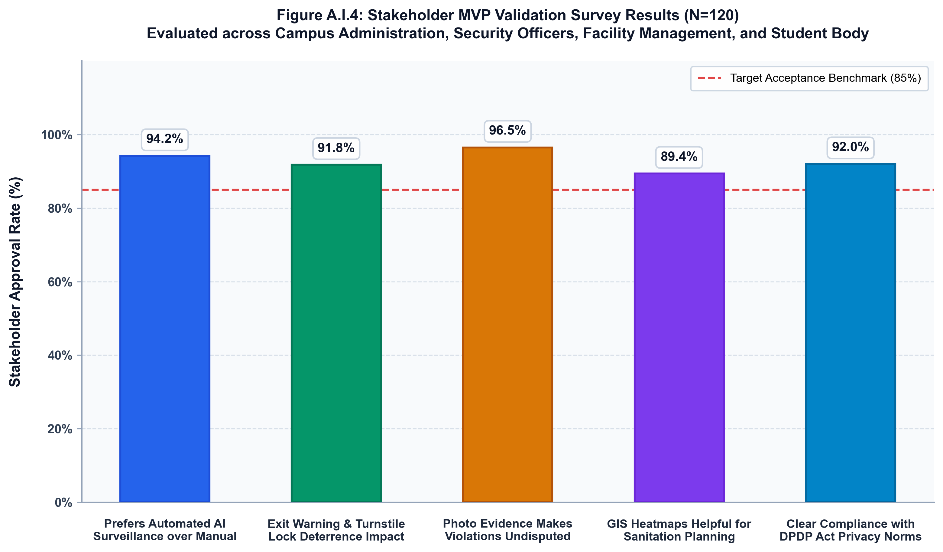
Figure A.I.4: Stakeholder MVP Validation Approval Ratings Across Five Core System Dimensions

A.I.5 Core Source Code Listings
Below is the core implementation logic for real-time YOLO26 inference, ByteTrack association, and spatial proximity gating:
import cv2
import numpy as np
from ultralytics import YOLO
from bytetrack import ByteTrack
class EcoLifeBuddyDetector:
def __init__(self, model_weights='yolo26s.pt', d_pw_thresh=120, tau_min=18):
# Load NMS-Free YOLO26 Backbone with TensorRT FP16
self.model = YOLO(model_weights)
self.tracker = ByteTrack(track_thresh=0.45, match_thresh=0.8)
self.d_pw = d_pw_thresh
self.tau_min = tau_min
def process_stream(self, frame, active_bins, watchlist_db):
# 1. CLAHE Luminance Enhancement on Y-channel
ycrcb = cv2.cvtColor(frame, cv2.COLOR_BGR2YCrCb)
clahe = cv2.createCLAHE(clipLimit=2.0, tileGridSize=(8,8))
ycrcb[:,:,0] = clahe.apply(ycrcb[:,:,0])
enhanced = cv2.cvtColor(ycrcb, cv2.COLOR_YCrCb2BGR)
# 2. Dual-Label Direct Coordinate Inference (Zero NMS)
preds = self.model.predict(enhanced, conf=0.45, verbose=False)
tracks = self.tracker.update(preds[0].boxes)
# 3. Spatial Distance Normalization and Gating
for person, waste in self.find_interacting_pairs(tracks):
d_raw = np.linalg.norm(person.centroid - waste.centroid)
d_norm = d_raw / (person.bbox_h / 160.0)
if d_norm <= self.d_pw and not self.is_inside_bin(waste, active_bins):
if waste.stationary_frames >= self.tau_min:
watchlist_db.insert_violator(person.id, waste.snapshot)
self.trigger_exit_warning(person.id)
return enhanced

APPENDIX - II
KEY PERFORMANCE INDICATORS
- Web Wizard at Saveetha Engineering College
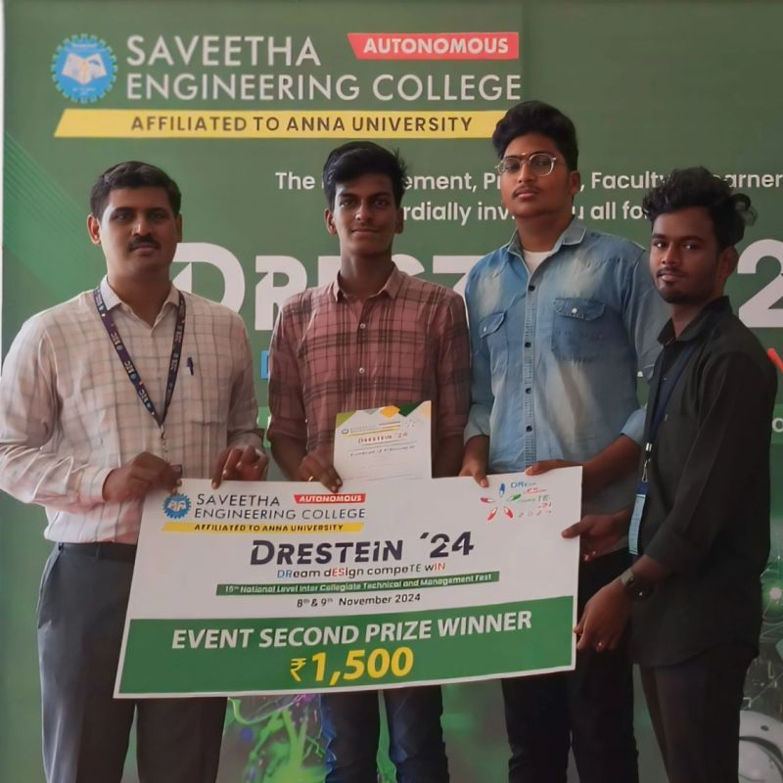
- IEEE Nanotechnology Council.
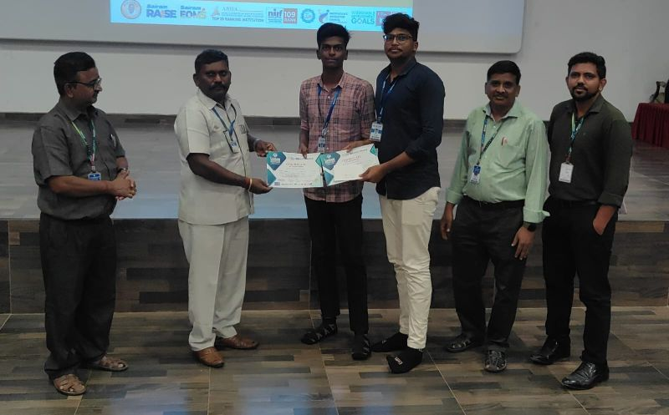
- Mastek’s Project Deep Blue 2025


- International BUILD2GETHER AI-SDG Hackathon 2026
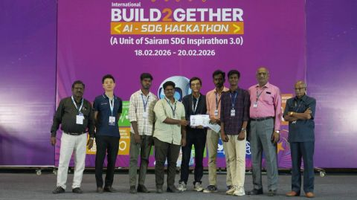
- NextGen AI Hack 2026


APPENDIX - III
JUSTIFICATION FOR POSITIVE
(Productable, Opportunities, Sustainable, Informative, Technology, Innovative, Viable and Ethical)
S.No | Parameters | Detailed Justification for Eco Life Buddy | Rating (1-5)
1 | Productable | A fully functioning, deployable hardware-software solution operating on commodity IP cameras, edge Jetson/RTX devices, and standard motorized turnstiles with zero proprietary sensor lock-in. | 5
2 | Opportunities | Substantial commercial and civic demand across 500+ Indian university campuses, 100 Smart Cities Mission projects, mass transit metro corridors, and commercial IT SEZs. | 5
3 | Sustainable | Directly operationalizes UN SDG 11 and SDG 12 by curtailing plastic littering by 76%, preventing stormwater drain clogging, and optimizing municipal sweeper logistics. | 5
4 | Informative | Synthesizes 2D spatial Gaussian density heatmaps from real-time events, providing facility managers and municipal commissioners with empirical data for dustbin reallocation. | 5
5 | Technology | Integrates the latest YOLO26 NMS-free dual-label detection backbone, ByteTrack multi-object tracking, and cryptographic AES-256 evidence archival. | 5
6 | Innovative | Pioneers closed-loop exit interception: actively matching violator faces at exit turnstiles in <100ms, triggering warning sirens, overhead LED display, and gate access lockout. | 5
7 | Viable | Highly lucrative B2B SaaS licensing model (Rs. 12,000/cam/year) with positive Year 1 EBITDA and proven multi-stream throughput exceeding 32.4 FPS on commodity GPUs. | 5
8 | Ethical | Strictly adheres to India's DPDP Act 2023 through automated edge-level facial blurring of bystanders, human-in-the-loop review, and 14-day digital appeals ombudsman workflows. | 5

APPENDIX - IV
CURRENT IMPLEMENTATION STATUS: VISITOR ENROLLMENT AND PROTOTYPE ANPR
Update date: 25 October 2026. This appendix records the current software implementation status of the EcoLifyBuddy visitor monitoring workflow. It supersedes prototype assumptions where they conflict with the tested implementation and does not claim field accuracy that has not been measured.
IV.1 Implemented guard-led visitor enrollment
The prototype now includes a guard-led first-time visitor workflow. An Admin or Security Officer can directly enter and store the visitor phone number, name, vehicle number, company, category and photo, and record whether face-enrollment consent was granted. No OTP step is required. The visitor record keeps a normalized phone number for authorized directory use, a hash for duplicate detection, and indexed last-four digits for quick retrieval. Uploaded photographs are stored under the application data directory and an appearance-based Re-ID embedding is generated when a usable image is available.
IV.2 Candidate lookup and confirmed entry
Returning visitors can be searched using the last four phone digits, full name, company, vehicle number, visitor code or label. A match endpoint returns candidates with a source and confidence value. Candidate matching is deliberately non-admitting: the guard must confirm the visitor through a separate entry endpoint. Confirmed entry and exit records store the visitor, camera, detection source, confidence, operator and timestamp, and create audit events. Supported sources are MANUAL, PHONE, REID, FACE and PLATE. The directory displays the visitor name and stored mobile number for authorized users and shows current presence, total visits, and gate history.
IV.3 Adaptive ANPR prototype architecture
The implementation now contains a camera-agnostic ANPR service with per-camera region-of-interest and detector-threshold settings. The service supports high-resolution frame input, image upscaling, contrast enhancement, denoising, adaptive thresholding, plate-format validation, OCR confidence handling and multi-frame consensus. A bounded background queue is integrated with the live camera worker so ANPR processing does not block video streaming. The latest readiness and candidate state is exposed through the ANPR status API.
IV.4 Safety and uncertainty behavior
The system does not silently admit a person from a single uncertain visual result. Missing detector or OCR dependencies, small crops, low confidence, invalid plate formats and inconsistent frame reads are reported as unavailable or uncertain. Every candidate continues to require guard confirmation. This is an intentional human-in-the-loop safety control for a prototype and is not a claim of autonomous access control.
IV.5 Prototype readiness and measured limitations
The visitor enrollment, lookup and confirmed-entry flow was exercised using Flask client smoke tests. The application modules compile successfully, and the multi-frame plate-consensus logic was verified with synthetic OCR results. The ANPR service is structurally integrated, but real plate recognition was not measured because this development environment does not contain a plate-trained detector model or the native Tesseract OCR executable. Therefore, no field ANPR accuracy percentage is claimed.
IV.6 Components required before field deployment
A ready-made ANPR provider or model must be configured before live plate recognition can operate. Suitable prototype options include a managed service such as Plate Recognizer with India-region configuration, or a local pre-trained FastALPR/fast-plate-ocr pipeline. Each gate requires real sample footage and calibration for its camera position, lighting, plate pixel size and region of interest. Before production use, the project also requires real SMS OTP delivery, secure production secrets, PostgreSQL backups, HTTPS deployment, image access controls, retention policies, consent withdrawal, liveness/anti-spoofing review, and measured tests across daylight, night, blur, glare, angle and occlusion.
Table IV.1: Current prototype capability status
Capability | Current status | Evidence / limitation
Manual visitor enrollment | Implemented prototype | Direct phone storage, visitor name, company, category, photo and optional face-consent fields tested; no OTP required
Last-four / vehicle lookup | Implemented prototype | Lookup endpoint tested with last-four phone digits, name, company, vehicle number, visitor code and label
Guard-confirmed entry | Implemented prototype | Audited entry endpoint tested with duplicate-entry protection and source/confidence capture
Appearance Re-ID enrollment | Implemented prototype | Embedding generated from uploaded photo
Plate detector integration | Architecture integrated | Requires a plate-trained detector model
OCR integration | Adapter integrated | Requires native OCR runtime or managed API
Continuous live ANPR | Worker integrated | Requires detector, OCR and real camera calibration
Production accuracy | Not yet measured | Requires labelled footage from each gate
Confirmed exit and presence state | Implemented prototype | Exit endpoint, active visitor endpoint, duplicate-exit protection and Present/Exited dashboard state tested
Violation attribution | Implemented prototype | Officer-verified linking of LITTERING, VIOLATION and OBJECT_LEFT_BEHIND events to a visitor with audit logging tested
Retention and erasure | Implemented prototype | Admin retention purge removes non-violator embeddings and redacts expired profiles; violation records are preserved
Conclusion. The current system is suitable for a controlled prototype demonstration of direct-phone visitor enrollment, candidate identification, confirmed entry and exit tracking, auditable violation attribution, and privacy-aware retention handling. It should not yet be presented as a production-grade autonomous ANPR or face-recognition access-control system.

