

**COLLEGE CODE: 8107**

**COURSE: DATA ANALYTICS WITH COGNOS**

**PHASE IV: EXPLORATORY THE DATA**

**TITLE: PRODUCT SALES ANALYSIS**

**TEAM MEMBERS:**

* ARUL PALANIAPPA S 8107243009

arulpalaniappa.s@care.ac.in

* AZARUDEEN B 810721243011 azarudeen.b@care.ac.in

* BALAJI C

810721243012

balaji.c@care.ac.in

* SARAVANAN V 810721243045 saravanan.v@care.ac.in

* VIMAL M

810721243057

vimal.m@care.ac.in

About Dataset :

Greetings , fellow analyst ! REC corp LTD. is small-scaled business venture established in India. They have been selling FOUR PRODUCTS for OVER TEN YEARS. The products are P1, P2, P3 and P4. They have collected data from their retail centers and organized it into a small csv file , which has been given to you.

**The excel file contains about 8 numerical parameters :**

* Q1- Total unit sales of product 1
* Q2- Total unit sales of product 2
* Q3- Total unit sales of product 3
* Q4- Total unit sales of product 4
* S1- Total revenue from product 1
* S2- Total revenue from product 2
* S3- Total revenue from product 3
* S4- Total revenue from product 4

Import Libraries:

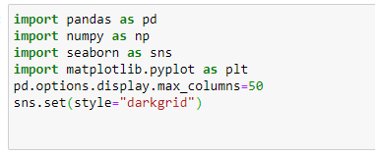

Import Data:

