EXP.NO: 2 Write JavaScript Programme to validate the following fields of the HTML
Registration Page.

AIM:
To write JavaScript code to validate user input in a registration form. The validation will
ensure that the data entered by the user meets specific criteria for each field. This will help in maintaining data integrity and prevent invalid submissions.

ALGORITHM:
1. Input:
• The user fills in the following fields: First Name, Password, E-mail, Mobile
Number, Last Name, and Address.
2. Validation Steps:
1. Validate First Name:
o Check if the first name contains only alphabets.
o Ensure the length of the First Name is at least 6 characters.
o If any of these conditions fail, display an error message indicating the required
input.
2. Validate Password:
o Check if the password is at least 6 characters long.
o If it is less than 6 characters, display an error message.
3. Validate E-mail:
o Use a regular expression to check if the email follows the standard pattern:
name@domain.com.
o Ensure that the email contains no invalid characters and matches the required
pattern.
o If it doesn&#39;t match, display an error message indicating an invalid email
format.

4. Validate Mobile Number:
o Check if the mobile number contains exactly 10 digits.
o Ensure there are no alphabets or special characters.
o If the number is invalid, display an error message indicating the correct
format.
5. Validate Last Name:
o Ensure the Last Name field is not empty.
o If it is empty, display an error message.
6. Validate Address:
o Ensure the Address field is not empty.
o If it is empty, display an error message.

CODE:
Index.html:
<!DOCTYPE html>
<html>
<head>
<title>Event Booking</title>
<link rel="stylesheet" href="style.css">
</head>

<body>

<nav>
<a href="index.html">Home</a>
<a href="location.html">Location</a>
<a href="booking.html">Booking</a>
<a href="about.html">About Us</a>
</nav>

<section class="hero">
<h1>Book Events Instantly 🎉</h1>
<p>Check locations, verify seating, and reserve tickets in seconds!</p>
</section>

<div class="container">
<div class="cards">

<div class="card">
<h2>📍 Live Locations</h2>
<p>View event venues with embedded maps.</p>
</div>

<div class="card">
<h2>💺 Smart Seating</h2>
<p>Check seat availability before booking.</p>
</div>

<div class="card">
<h2>⚡ Fast Registration</h2>
<p>Register and confirm tickets instantly.</p>
</div>

</div>
</div>

</body>
</html>

location.html:
<!DOCTYPE html>
<html>
<head>
<title>Locations</title>
<link rel="stylesheet" href="style.css">
</head>

<body>

<nav>
<a href="index.html">Home</a>
<a href="location.html">Location</a>
<a href="booking.html">Booking</a>
<a href="about.html">About Us</a>
</nav>
<section class="page-heading">
<h1>📍 Event Locations</h1>
<p>Find our event venues across Chennai</p>
</section>

<div class="map-container">

<iframe src="https://maps.google.com/maps?q=chennai&t=&z=13&ie=UTF8&iwloc=&output=embed"></iframe>

<iframe src="https://maps.google.com/maps?q=marina%20beach&t=&z=13&ie=UTF8&iwloc=&output=embed"></iframe>

<iframe src="https://maps.google.com/maps?q=velachery&t=&z=13&ie=UTF8&iwloc=&output=embed"></iframe>

</div>

</body>
</html>

Booking.html:
<!DOCTYPE html>
<html>
<head>
<title>Booking</title>
<link rel="stylesheet" href="style.css">
</head>

<body>

<nav>
<a href="index.html">Home</a>
<a href="location.html">Location</a>
<a href="booking.html">Booking</a>
<a href="about.html">About Us</a>
</nav>

<div class="booking-box">

<div class="box">
<h2>Seating</h2>

<details>
<summary><button>Check Availability</button></summary>

<div class="seats">

<label class="seat-label">
<input type="checkbox">
<img src="seat.jpeg" class="seat-icon">
</label>
<label class="seat-label">
<input type="checkbox">
<img src="seat.jpeg" class="seat-icon">
</label>
<label class="seat-label">
<input type="checkbox">
<img src="seat.jpeg" class="seat-icon">
</label>
<label class="seat-label">
<input type="checkbox">
<img src="seat.jpeg" class="seat-icon">
</label>
<label class="seat-label">
<input type="checkbox">
<img src="seat.jpeg" class="seat-icon">
</label>
<label class="seat-label">
<input type="checkbox">
<img src="seat.jpeg" class="seat-icon">
</label>
<label class="seat-label">
<input type="checkbox">
<img src="seat.jpeg" class="seat-icon">
</label>
<label class="seat-label">
<input type="checkbox">
<img src="seat.jpeg" class="seat-icon">
</label>
<label class="seat-label">
<input type="checkbox">
<img src="seat.jpeg" class="seat-icon">
</label>
<label class="seat-label">
<input type="checkbox">
<img src="seat.jpeg" class="seat-icon">
</label>
<label class="seat-label">
<input type="checkbox">
<img src="seat.jpeg" class="seat-icon">
</label>
<label class="seat-label">
<input type="checkbox">
<img src="seat.jpeg" class="seat-icon">
</label>
<label class="seat-label">
<input type="checkbox">
<img src="seat.jpeg" class="seat-icon">
</label>
<label class="seat-label">
<input type="checkbox">
<img src="seat.jpeg" class="seat-icon">
</label>

</div>

</details>

</div>

<div class="box">
<h2>Book Now</h2>
<p>After selecting seats proceed to register.</p>

<a href="register.html">
<button>Register</button>
</a>

</div>

</div>

</body>
</html>

Register.html:
<!DOCTYPE html>
<html>
<head>
<title>Register</title>
<link rel="stylesheet" href="style.css">
</head>

<body>

<nav>
<a href="index.html">Home</a>
<a href="location.html">Location</a>
<a href="booking.html">Booking</a>
<a href="about.html">About Us</a>
</nav>

<div class="booking-box">

<div class="box">
<h2>Event Registration</h2>

<form>
<input type="text" placeholder="Your Name">
<input type="email" placeholder="Email">
<input type="tel" placeholder="Phone Number">

<button>Submit</button>
</form>

</div>

</div>

</body>
</html>

About.html:
<!DOCTYPE html>
<html>
<head>
<title>About Us</title>
<link rel="stylesheet" href="style.css">
</head>

<body>

<nav>
<a href="index.html">Home</a>
<a href="location.html">Location</a>
<a href="booking.html">Booking</a>
<a href="about.html">About Us</a>
</nav>

<div class="about">

<h1>About Our Event</h1>

<p>
We provide a seamless event booking experience with real-time seating,
interactive maps, and instant registration.
</p>

<h3>📞 Contact</h3>
<p>+91 98765 43210</p>

<h3>📧 Email</h3>
<p>support@eventbook.com</p>

</div>

</body>
</html>

Style.css:
*{
margin:0;
padding:0;
box-sizing:border-box;
}

html,body{
height:100%;
font-family: 'Segoe UI', sans-serif;
}

/* 🔥 Cinematic Background */
body{
min-height:100vh;

background:
linear-gradient(rgba(0,0,0,0.6), rgba(0,0,0,0.6)),
url("img1.jpg");

background-size:cover;
background-position:center;
background-attachment:fixed;
}

/* NAVBAR */

nav{
background:#0b1c39;
padding:18px;
text-align:center;
}

nav a{
color:white;
text-decoration:none;
margin:0 25px;
font-size:18px;
font-weight:600;
transition:.3s;
}

nav a:hover{
color:#00ffd5;
}

/* HERO */

.hero{
height:85vh;
display:flex;
justify-content:center;
align-items:center;
text-align:center;
color:white;
flex-direction:column;
}

.hero h1{
font-size:55px;
}

.hero p{
font-size:22px;
margin-top:10px;
}

/* CARDS */

.container{
width:90%;
margin:auto;
}

.cards{
display:flex;
justify-content:center;
gap:40px;
flex-wrap:wrap;
margin-top:60px;
}

.card{
width:280px;
padding:30px;
border-radius:18px;
text-align:center;

background:rgba(255,255,255,0.12);
backdrop-filter:blur(10px);

color:white;
transition:.4s;
}

.card:hover{
transform:translateY(-10px);
}

button{
padding:12px 25px;
border:none;
border-radius:8px;
background:#00ffd5;
font-weight:bold;
cursor:pointer;
margin-top:15px;
}

/* MAP */

.map-container{
display:flex;
gap:30px;
flex-wrap:wrap;
justify-content:center;
margin-top:50px;
}

iframe{
width:350px;
height:260px;
border-radius:12px;
border:none;
}

/* BOOKING */

.booking-box{
display:flex;
flex-direction:column;
align-items:center;
margin-top:80px;
gap:40px;
}

.box{
width:320px;
padding:30px;
border-radius:15px;
text-align:center;

background:rgba(255,255,255,0.15);
backdrop-filter:blur(12px);
color:white;
}

/* SEATS */

details{
margin-top:20px;
}

.seats{
margin-top:20px;
}

.seat{
width:35px;
height:35px;
background:#00ff88;
display:inline-block;
margin:6px;
border-radius:6px;
}

/* REGISTER */

form{
display:flex;
flex-direction:column;
gap:15px;
}

input{
padding:10px;
border-radius:6px;
border:none;
}

/* ABOUT */

.about{
width:70%;
margin:auto;
margin-top:80px;
color:white;
text-align:center;
line-height:1.8;
}
.seat-label input{
display:none;
}
.seat-icon{
width:45px;
margin:6px;
cursor:pointer;
transition:0.3s;
}
.seat-label input:checked + .seat-icon{
filter: brightness(0) saturate(100%)
invert(64%) sepia(77%)
saturate(420%) hue-rotate(90deg);

transform:scale(1.2);
}

OUTPUT:

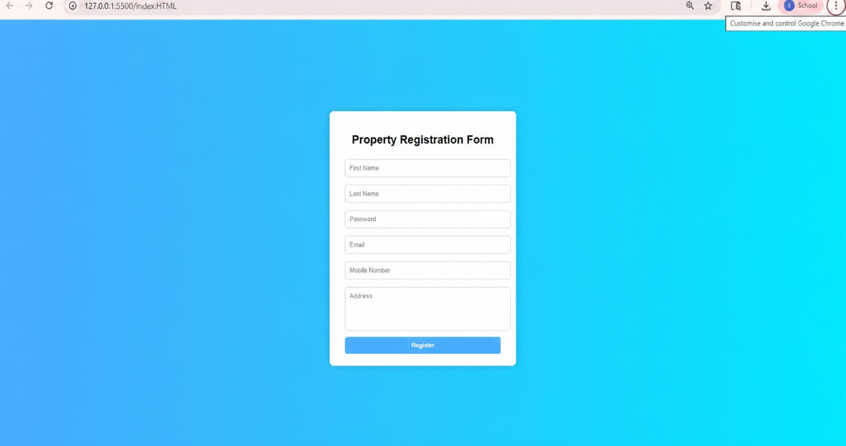

RESULT:
HTML page with Form is created and is validated using Javascript.

