Sql basics
Index
1.Crud
2.Precision and scale
3.Data types
4.Primary key
5.Foreign key
6.Top
6.Distinct
8.Alter table
9.Order by
10.Where
11.Like
12.In
13.Count
14.Aggregate function
15.Subqueries
16.Group by
17.Having
18.Joins
-----------------------first half ------------------------------
19.Null
20.Storing values into tables
21.Self join (not understand clearly)
22.Variable
23.If
24.Case when
25.@@identity
26.Trim ,left, right and time and date ,ceiling, floor etc
27.Coalesece
28.Stored procedure
29.Functions
30.Views
31.Cursor
32.Trigger
33.Indexing

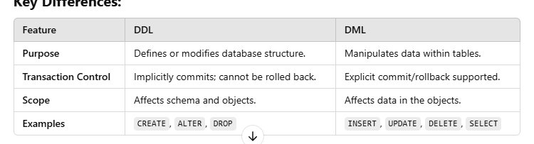

Data types
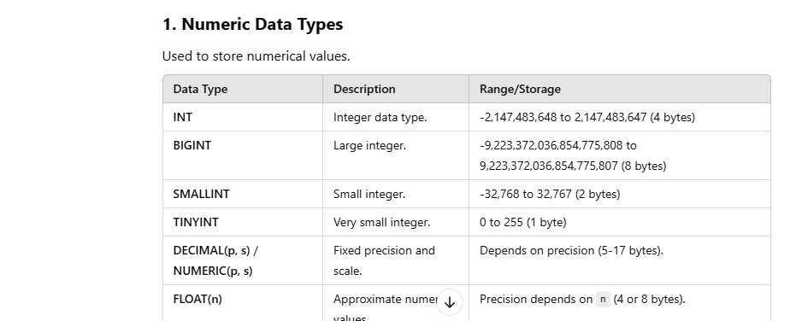

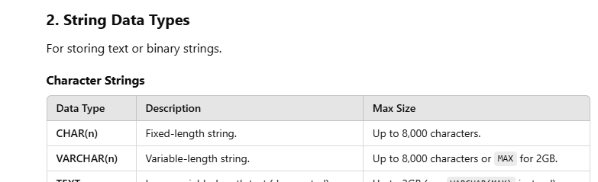

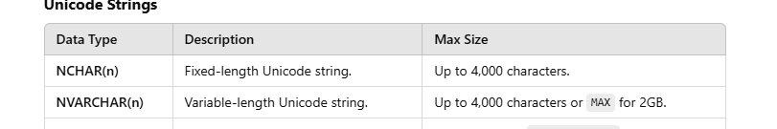

Enum sila data types eruku venum na pathuka

Crud –
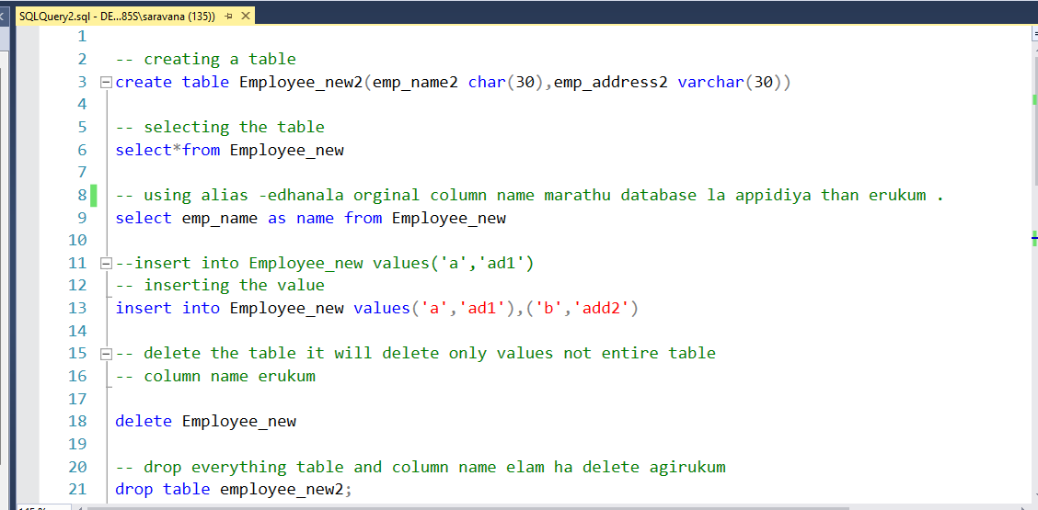

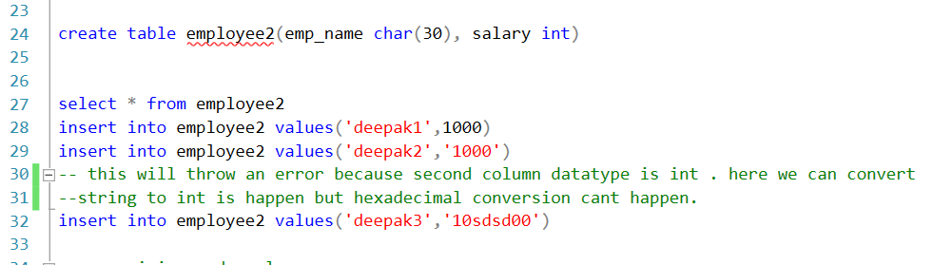

- 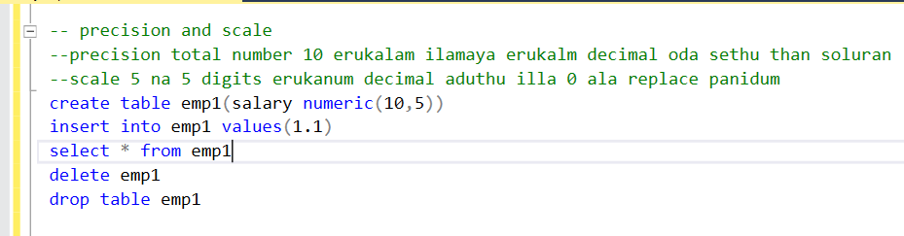
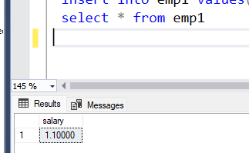
enga 10 precision
5 scale

- 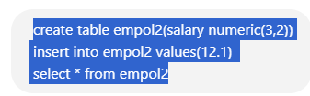

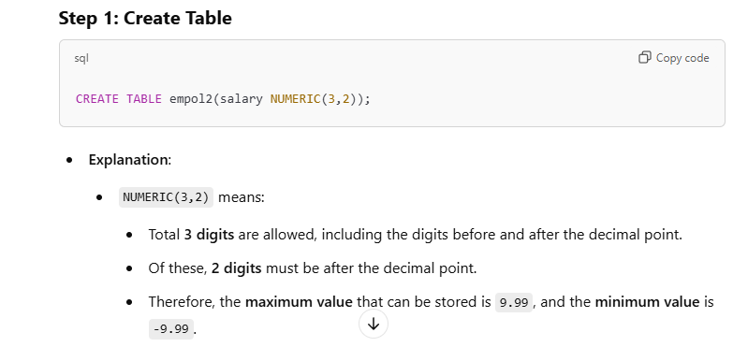

- 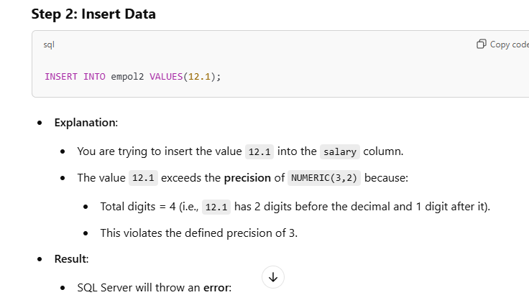
- 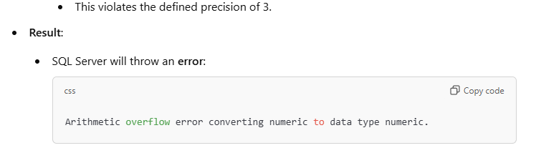
This will work
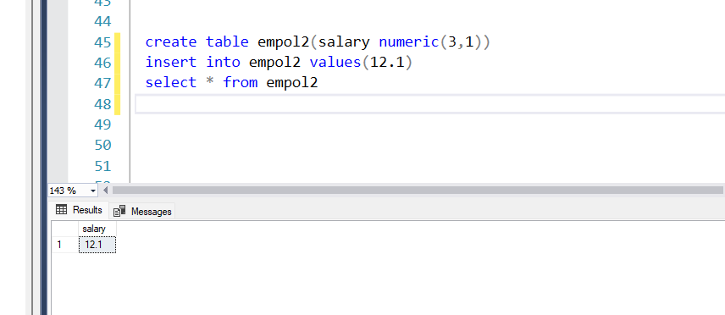

- 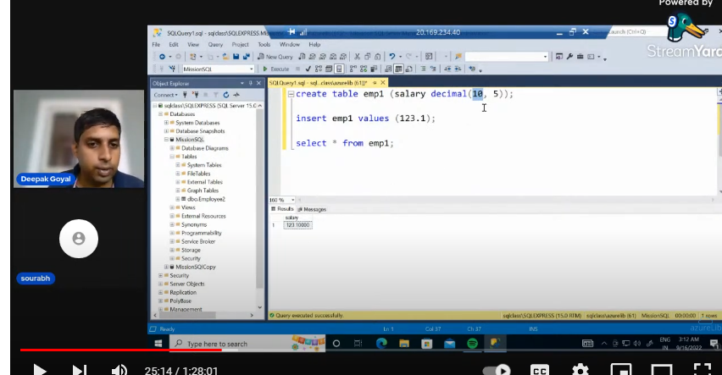
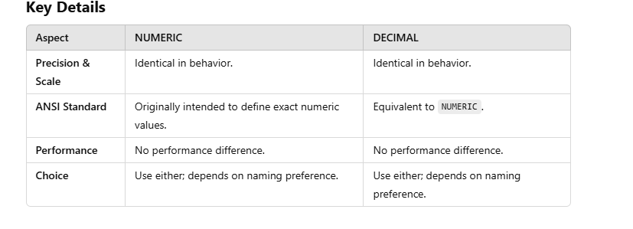
- Update table name set columnname(what column you want to change ) where row name (condition )
- 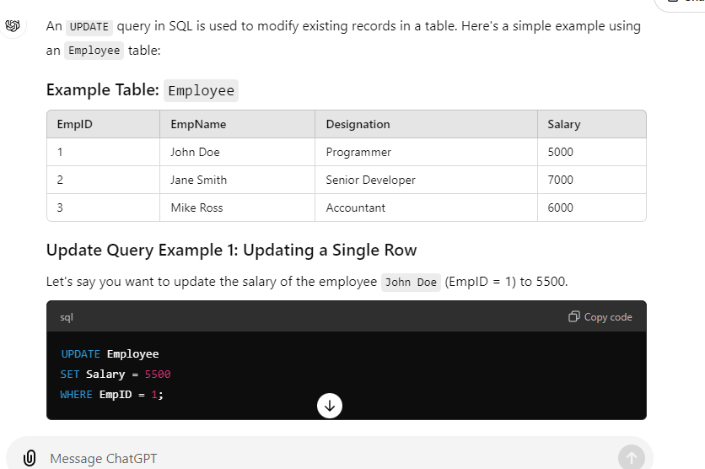
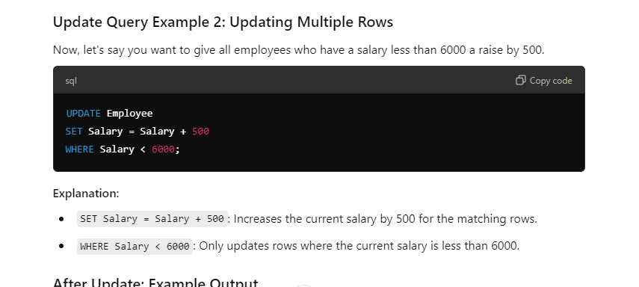
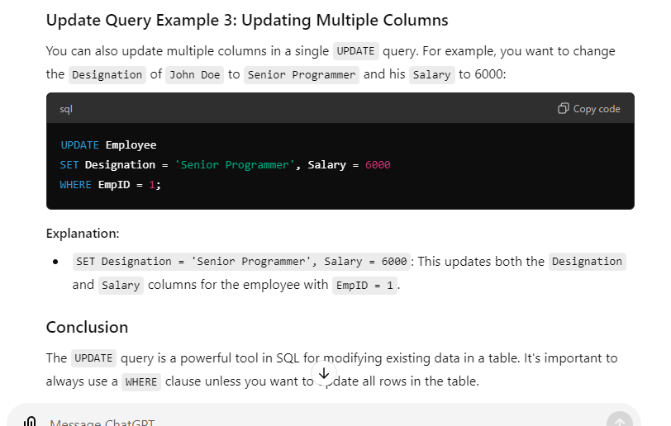

Execution order
• FROM Clause: Not applicable (only one table involved).
• WHERE Clause: Rows where department_id = 10 are filtered.
• SET Clause: For each qualifying row, salary is increased by 10%.
• Commit or Rollback: If part of a transaction, the changes remain pending until committed
Char and varchar-
char- stores data in ascii format and fixed in size
For eg char(10) but you saved abc event it will take 10 space in memory
varchar – based on the data it will allocate the memory
eg varchar(10) you stored abc it will store only 3 space in memory for tracking purpose it will store extra 2 bytes.

nChar and nvarchar- specifically stores other languages and special characters.
see row 1 and 2
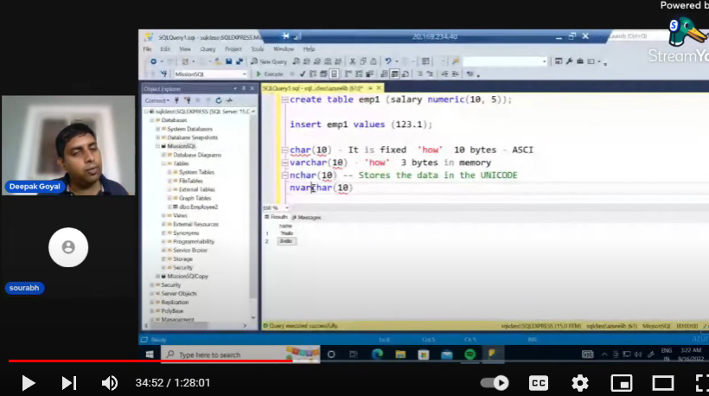
primary key
comment line la ena solirupan na second row data and third row data vum same nu.
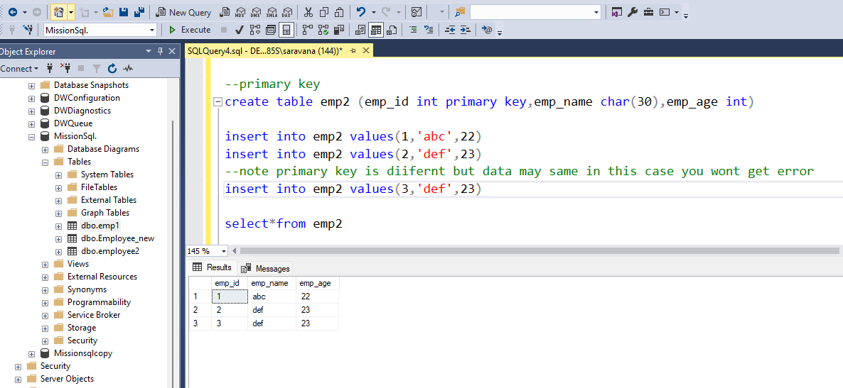

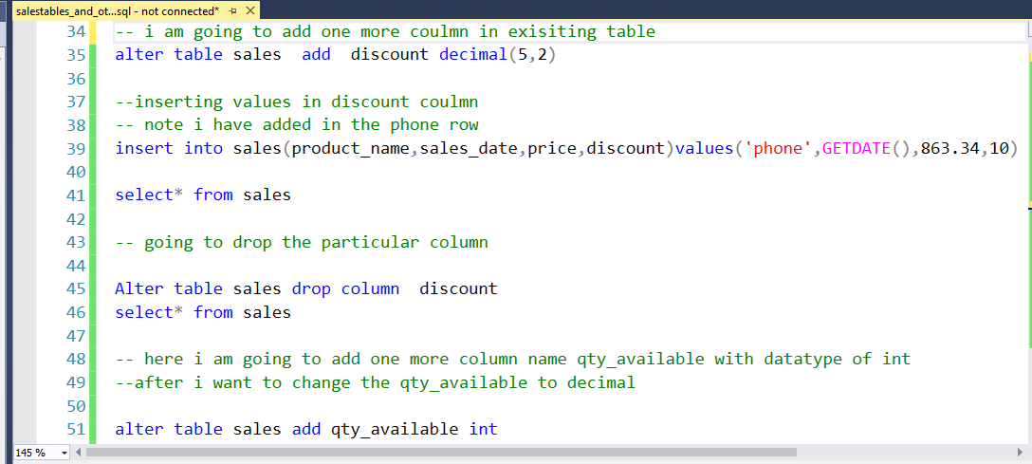

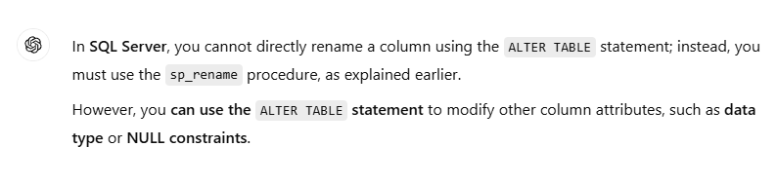

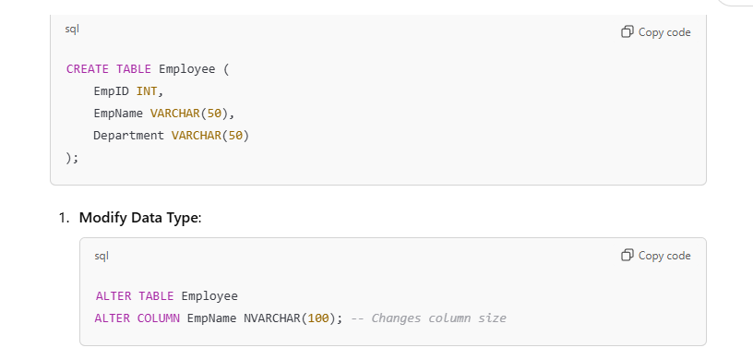

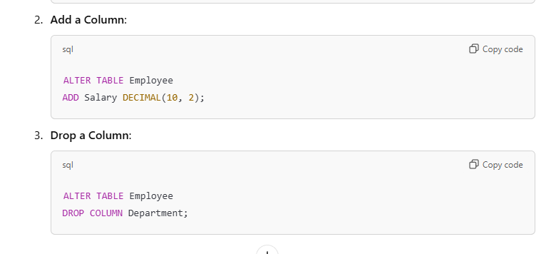


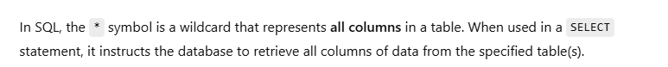

For crud refer this
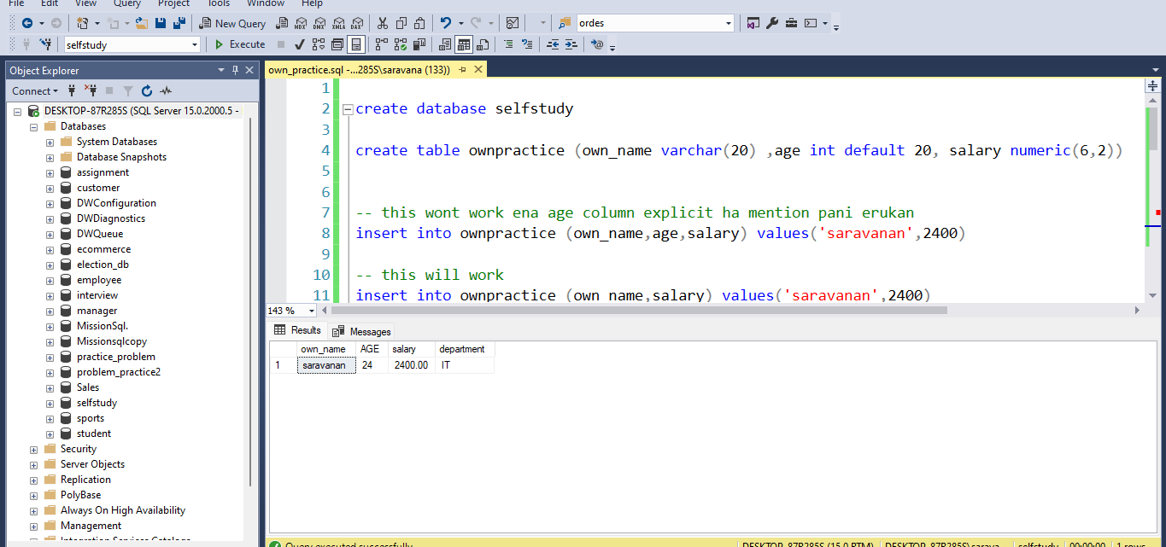

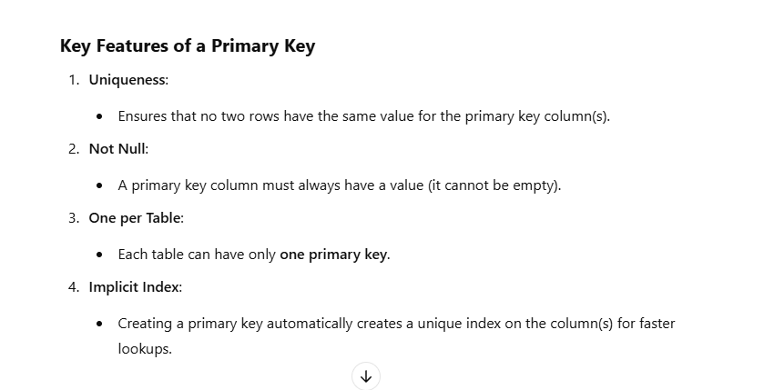

primary key error
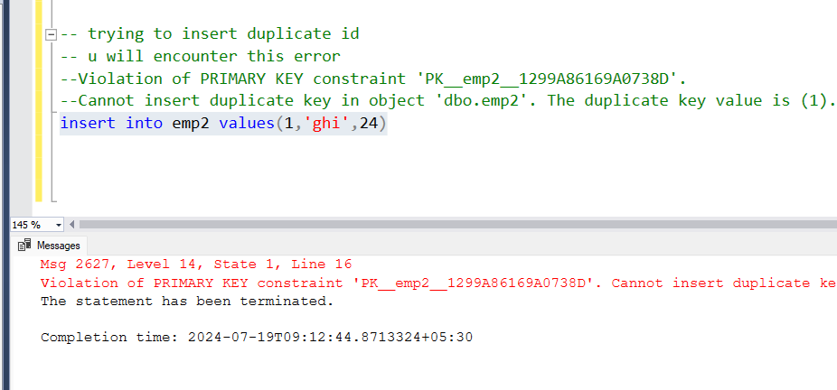

creating foreign key

foreign key error
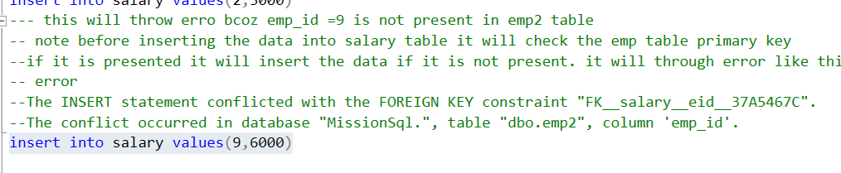
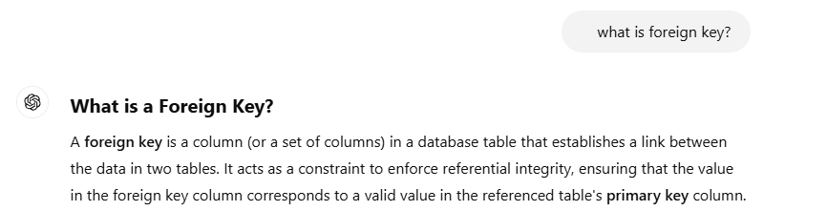

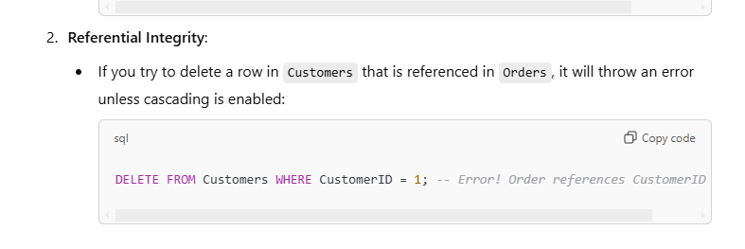

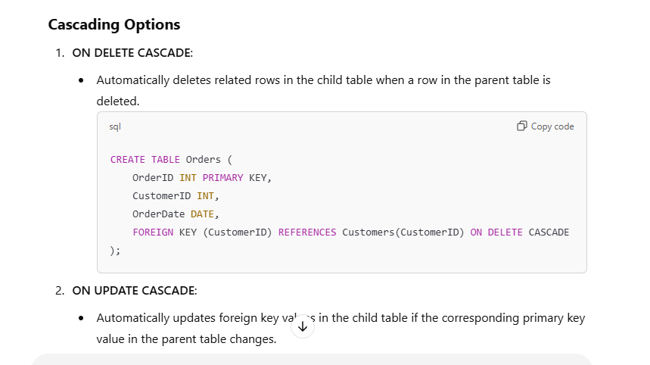

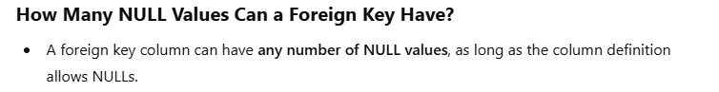

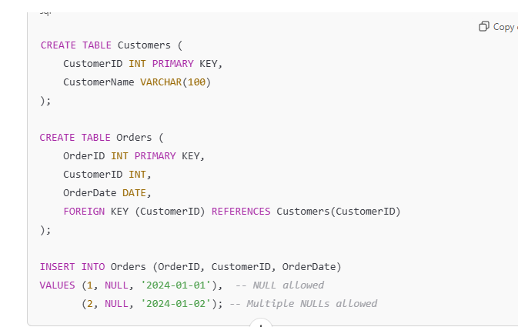

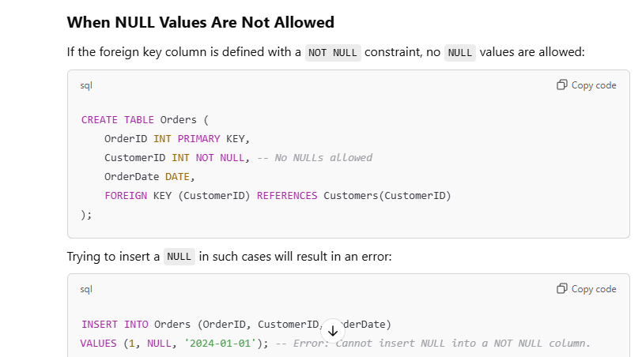

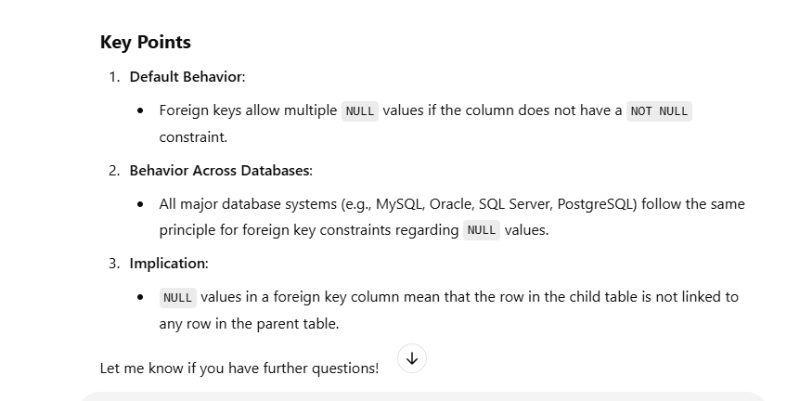
----------------------------------------------------------------------------------------

election db design
default values lam set panitu select pani pakuren . default values ha lam show agala.-
balance erukura column kulam data kuduthathan default values show agum.
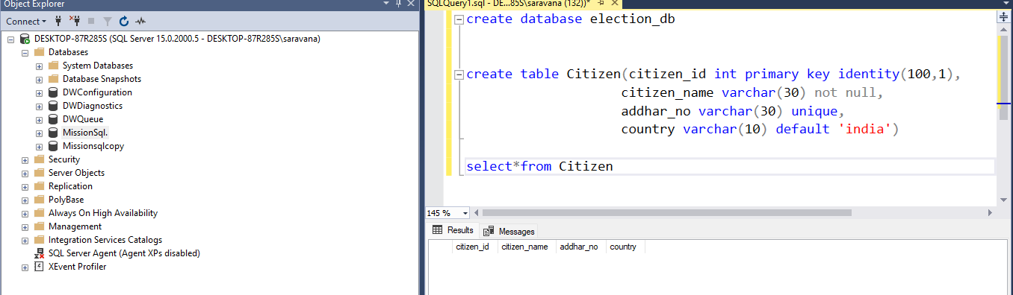
Mention the column name . here I have given the default value for first colum and last column
databse got confuse which one I have to pick nu.

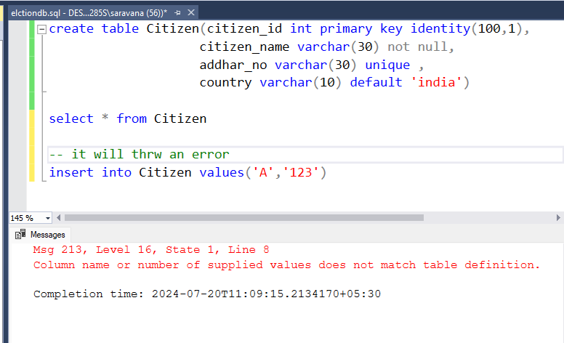

After inserting crt column
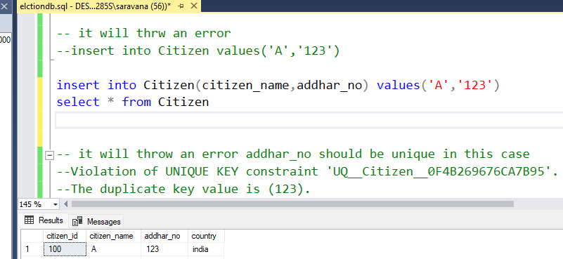-

Try to add same value.it throws an error.
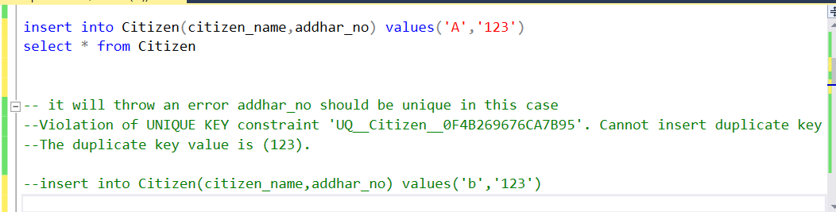

Primary key value ha note panu
data Thapa erunthalum primary key update aguthu.
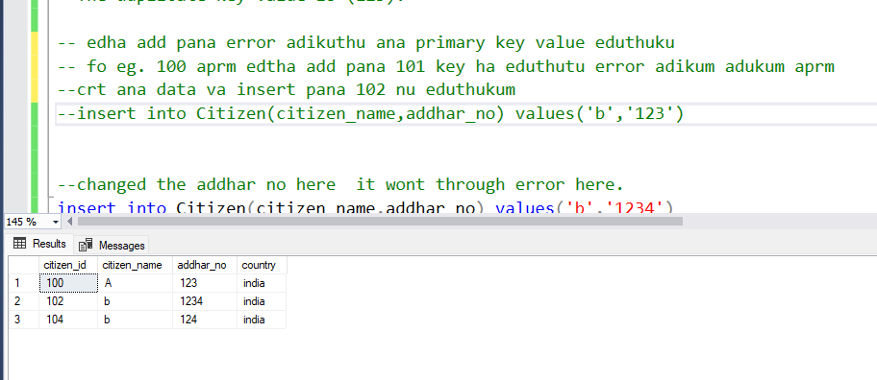

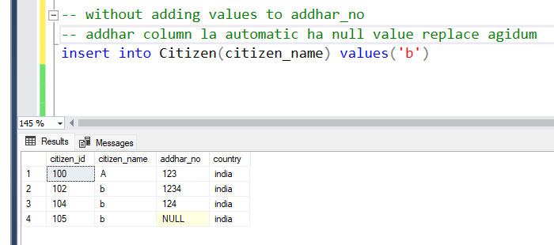

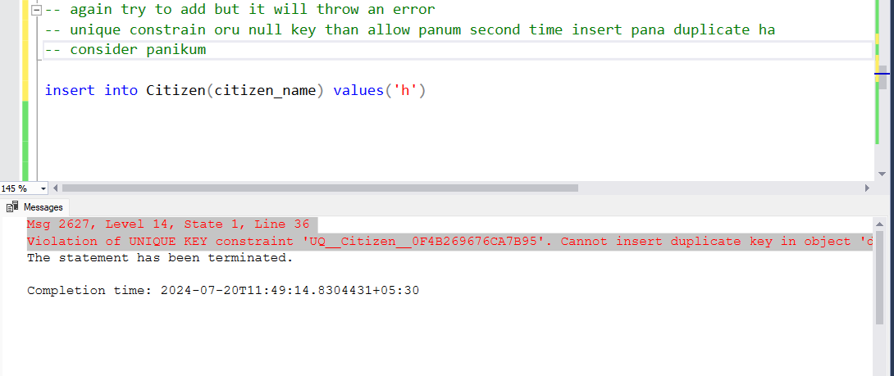

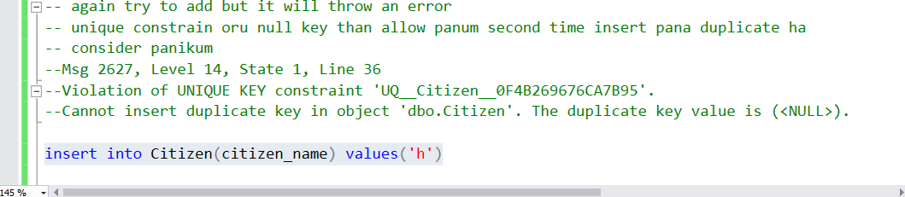
null – no value
0 means value
blank also a value
store pancard value as varchar bcoz that is alphanumeric.

Schema – it is nothing but logically separate . salary related details lam accounts schema la podanum , building related details lam infrastructure schema la podanum.
Eppidi than separate agirukum.
oru doubt varalam oru oru table ha oru oru database la podalam but system related issue varum ha.
so athan oru databas elaya neraya schema create pani adhula poturuvanaga.
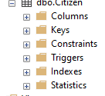

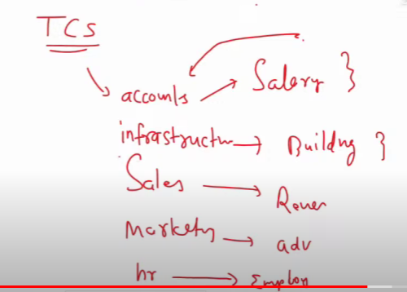
Primary key and foreign key kaga than etha create panuren.

Voter id

Default ha dbo nu oru schema create agum ana na enga voterschema nu manuall ha create panirukan.
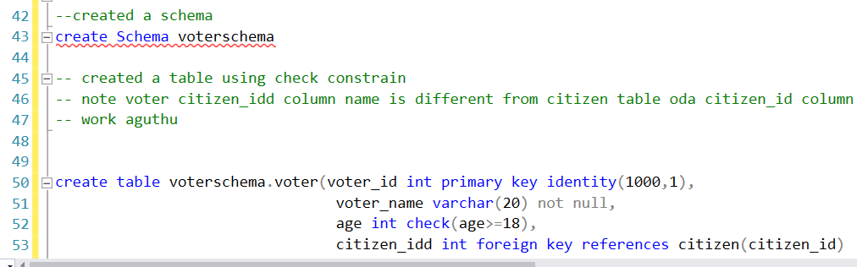

Voter id la value increase aguthu
Show agurathula mothala erukurathu voter id table and then citizen table.
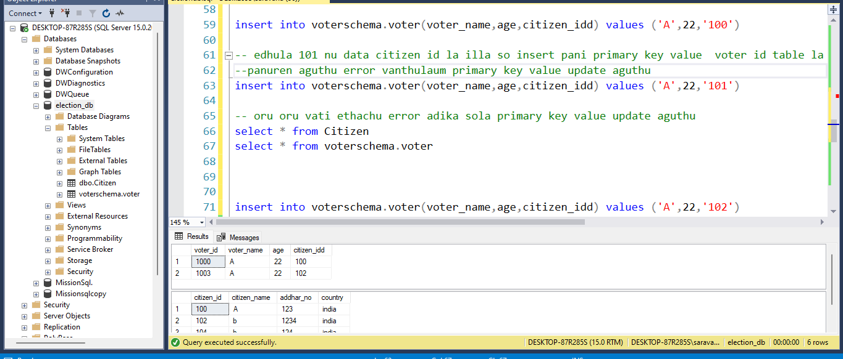

`
creating sales table
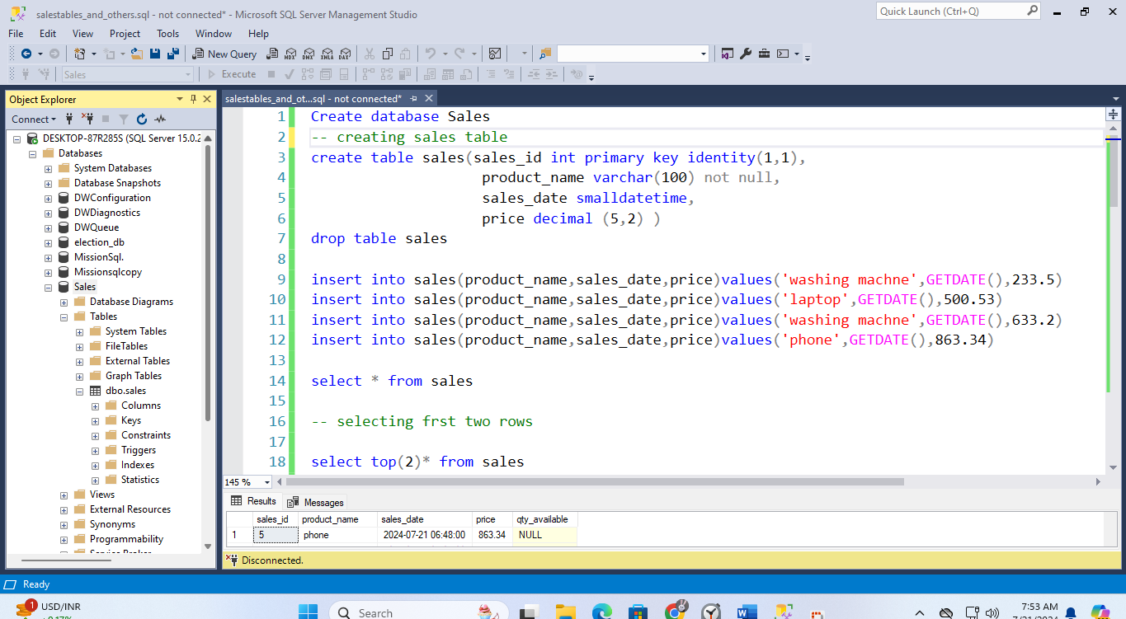

Top and distinct
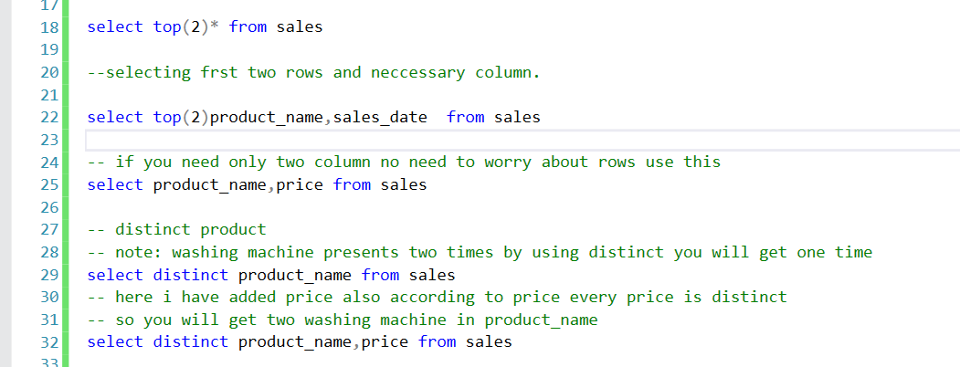

Order by
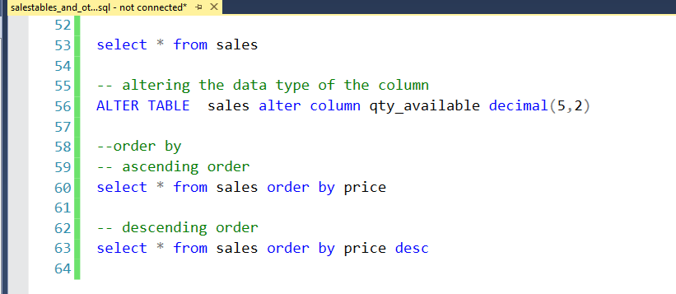

Order by using two column name asc order
descending order la explain panirupan eppidi work aguthunu
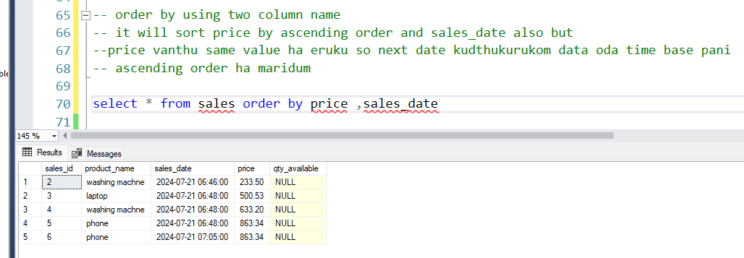
Order by descending order
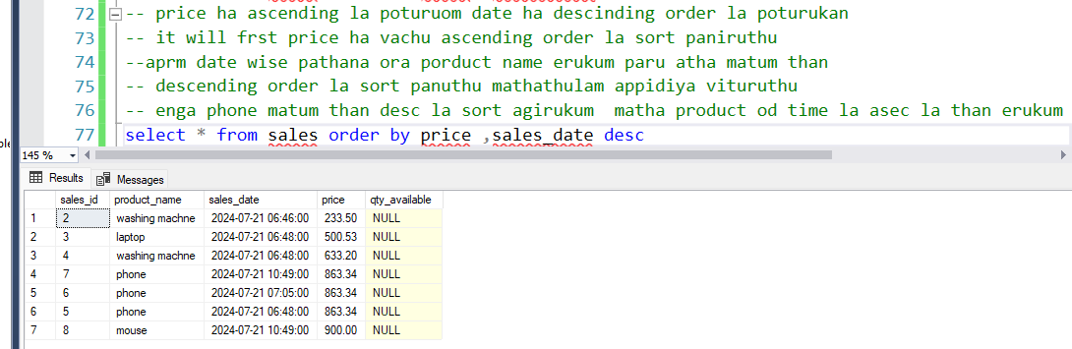
Column name base
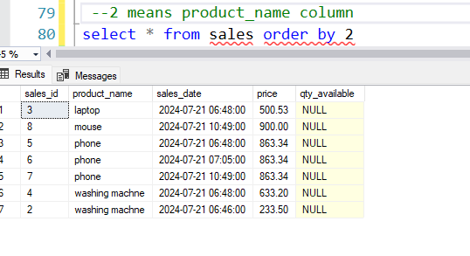
Where
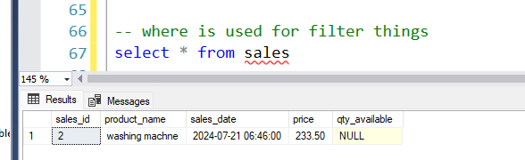

Greater than and lesser than
Edhula price >500.53 pota last value ha exclude panidum.
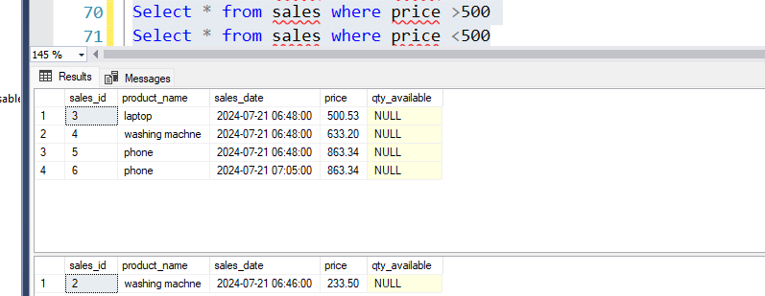

between
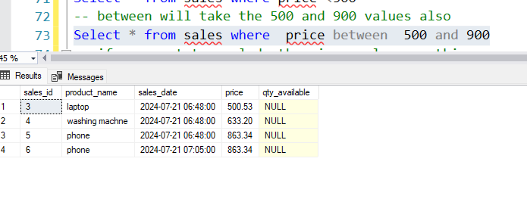
Excluding that values
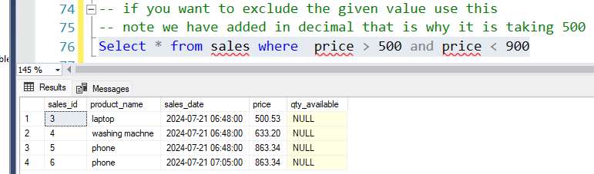

Like
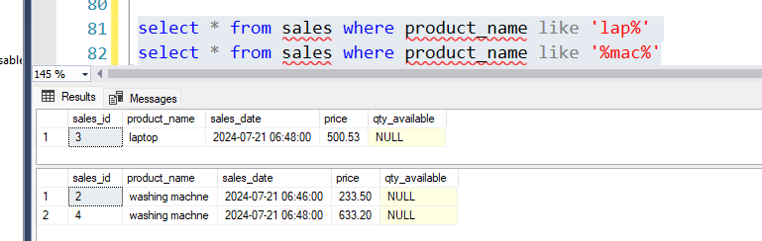
Not like
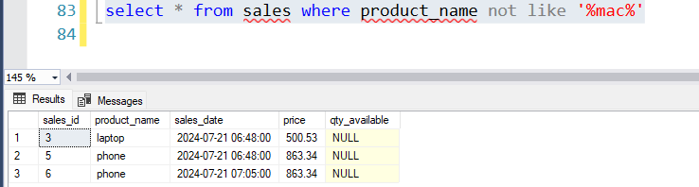

In and not in
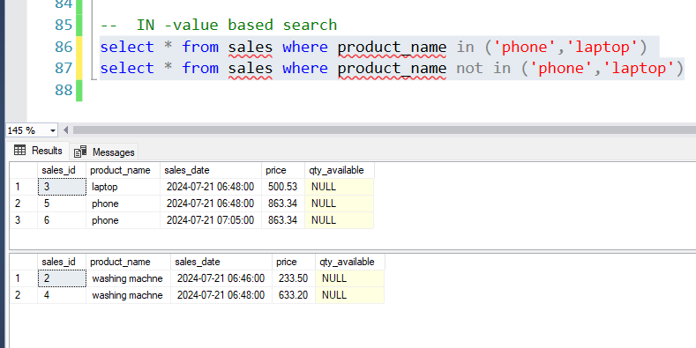

We cant use IN with Like:

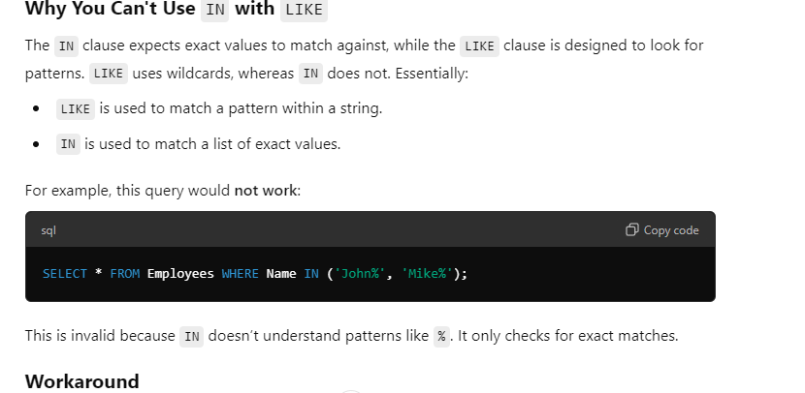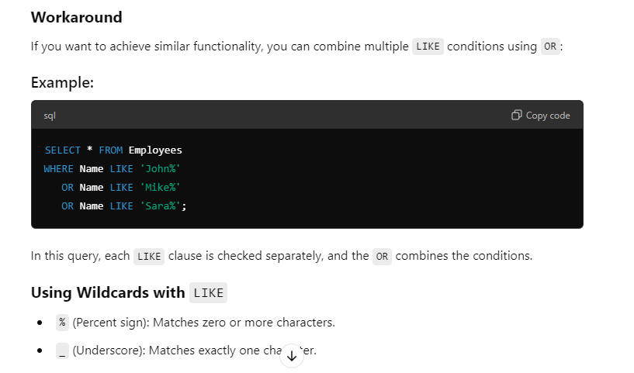
Underscore means single character

https://www.youtube.com/watch?v=xeJdGxpwnvA
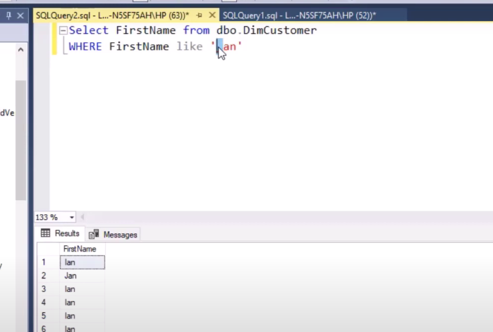

%- one or more character
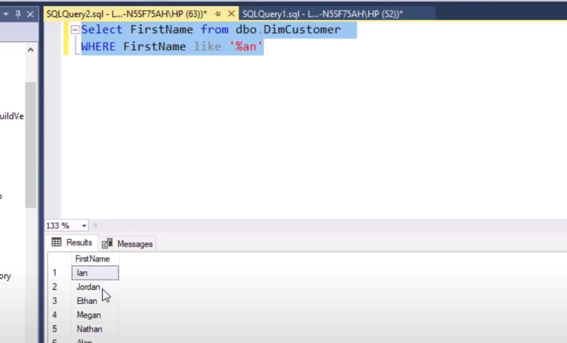

Frst charcter vanthu AorCorD ga erukanaum adhuku aprm ena vena erukalam na etha use panika
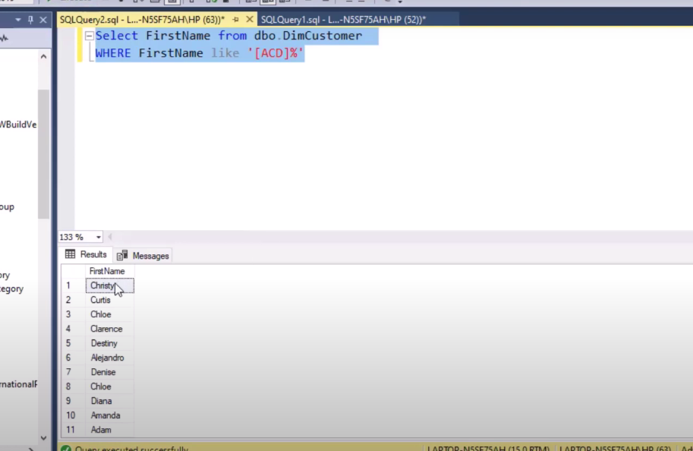

Same than but oru range ha venum na [A-P]%-> starting with a to p etc then % edhukuna flowed by any character nurathuku.
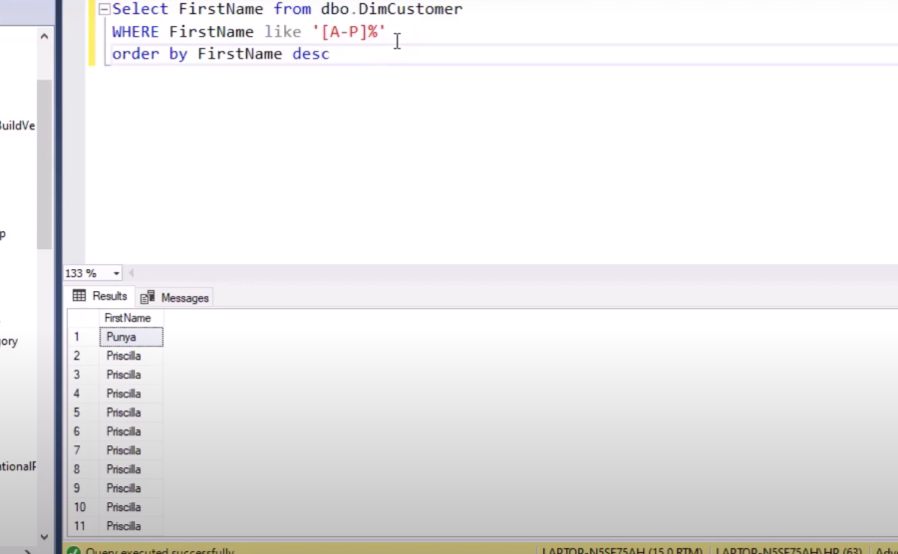

etha reverse panaum na not like potuka
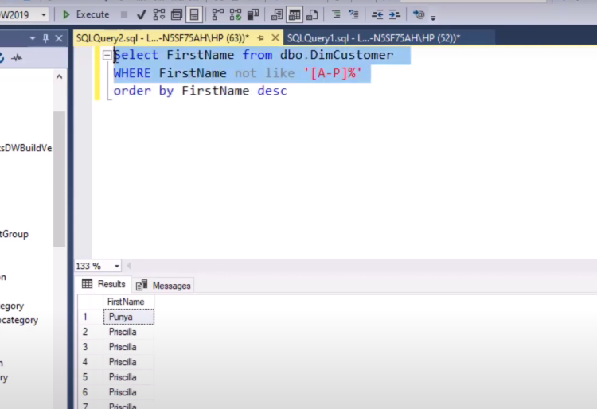

Eppidi kuda not use panikalam -> D aprm erukurathu than varum
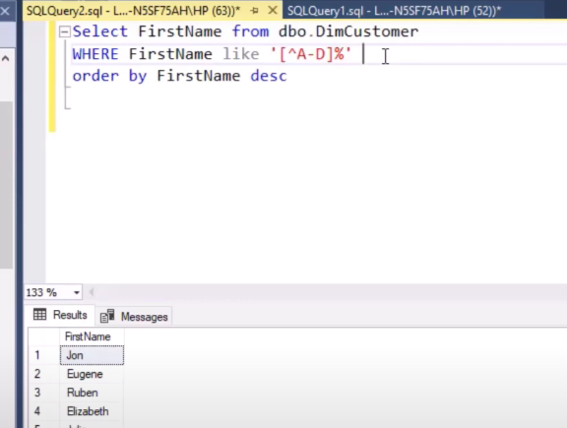

Third value hypen erukanum adhuku etha use panuranga
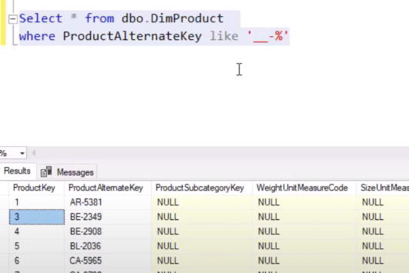
Eppa 20% erukura data va matum edukanumna eppidi % pota wildcard ha consider paniKum
so atha escape character ha matahanum

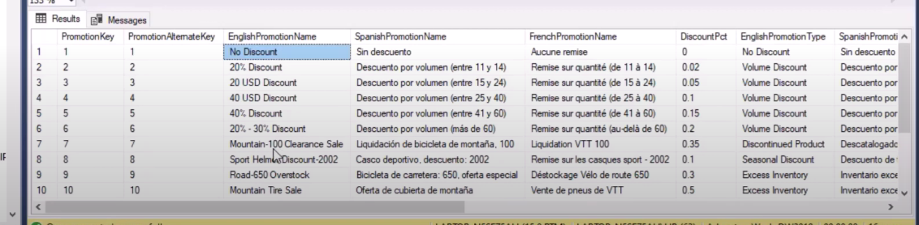

So eppidi use pananum note backslash than use pananum illa ! kuda use panalam
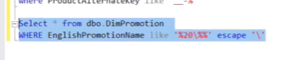
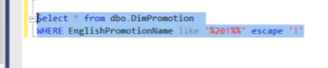
Etha kuda use panikalam
Escape character ha vida etha crt ha eruku nu nenaikuren.
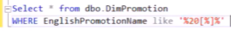

-----------------------------------------------------------------------------------------------------
Count- subqueries and others.sql
Things to know 3 things in count
count will count the no of rows
count will count the duplicate values in the row
count will not count the null values in the row if you specify any column
if you didn’t specify any column name count will consider the null value row also

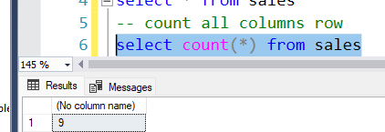
edhu duplicate product um sethu count panum
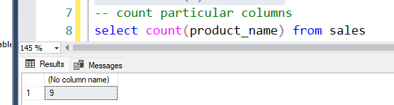
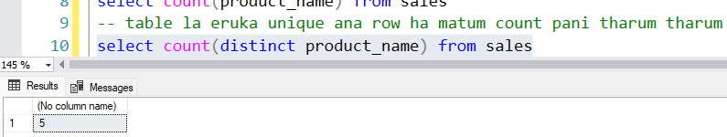
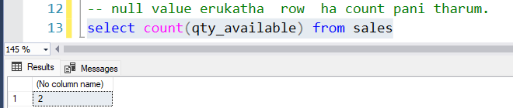
where clause using null and not null
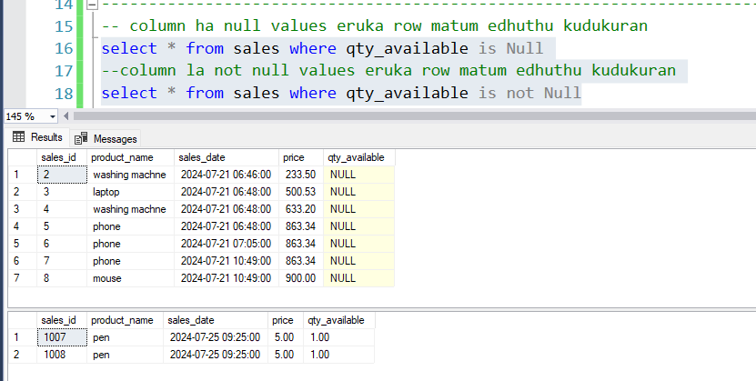
min ,max
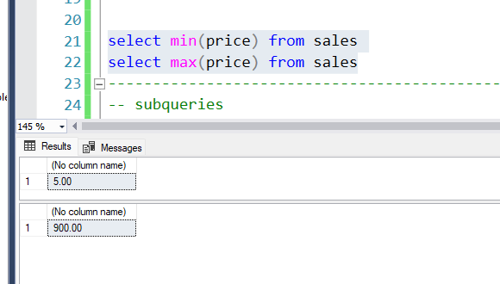

Subqueries
Note :Price column matum than eduthu vanthu tharum
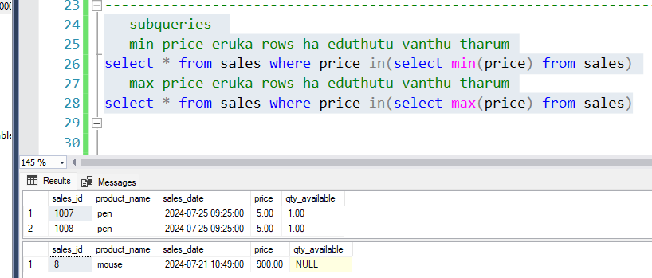
avg,std
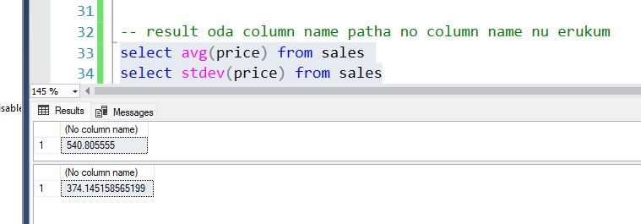
Expression
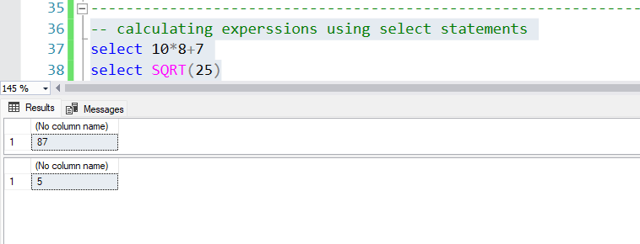
groupby
aggregation -Aggregation in the context of databases and data analysis refers to the process of combining multiple pieces of data to produce a summary result.
group by database la poi padichika silathu add panirukan
file name groupby and others
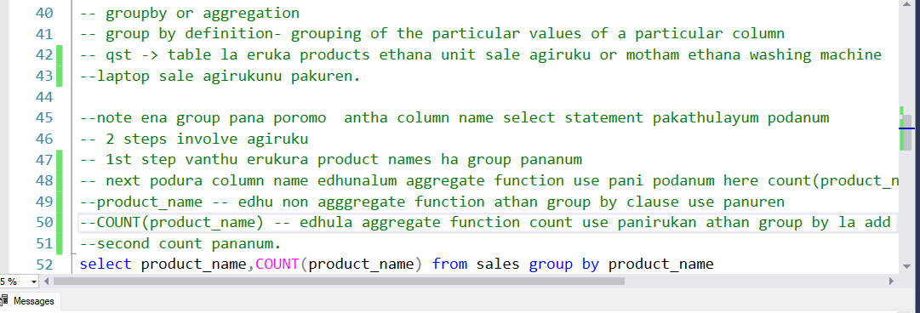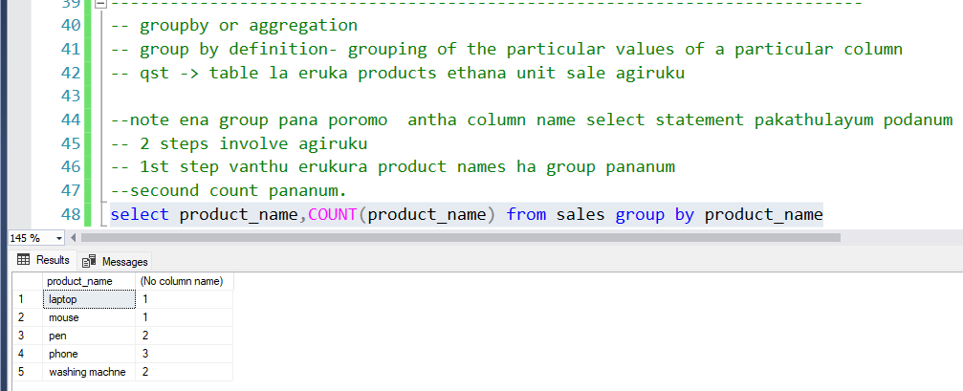

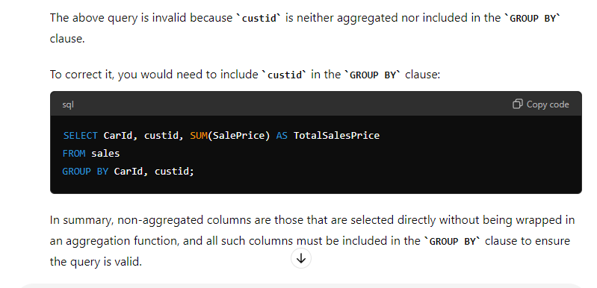
sum the price
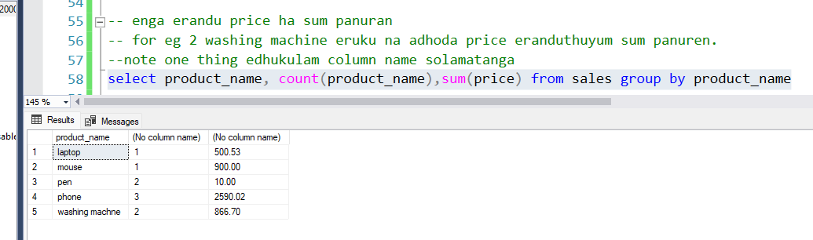
alias
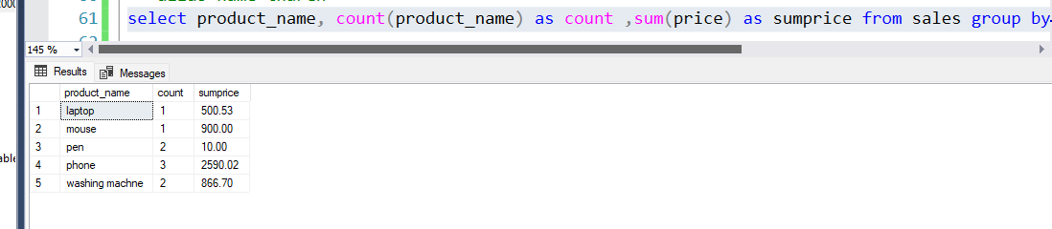
having clause
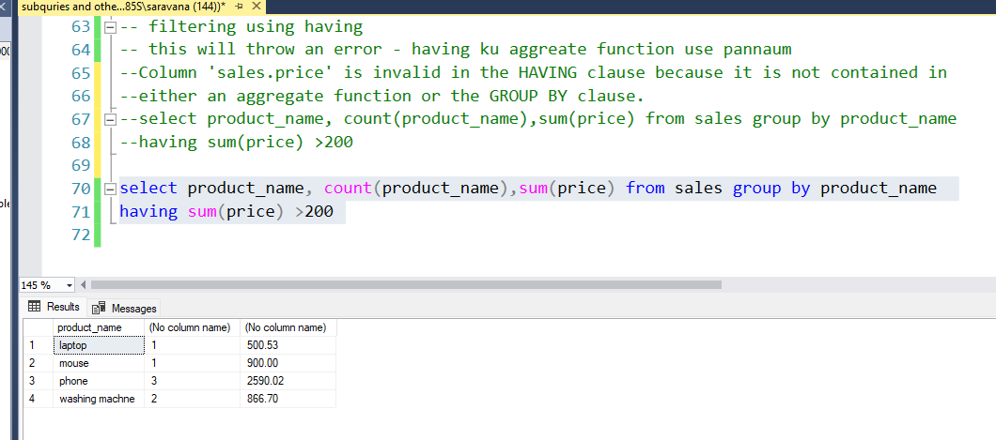

Reason for creating two tables.
entha sales table ena mean panuthu na - customer adhoda info va entha table la store panuthu(ena product vangirukaru , evlo quantity , etc ).
eppa new ha oru product ha company launch panuthu na atha entha table la poda mudiyathu
and eppa oru product name romba perusa eruku na atha entha sales table la store panna performance issue varum . adhuku badhila adhoda primary id ha store panurathu than best.
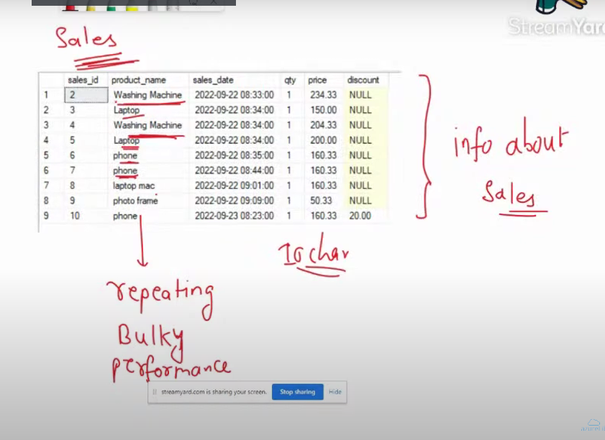

So athan sales thaniya product thaniya create panirupan.
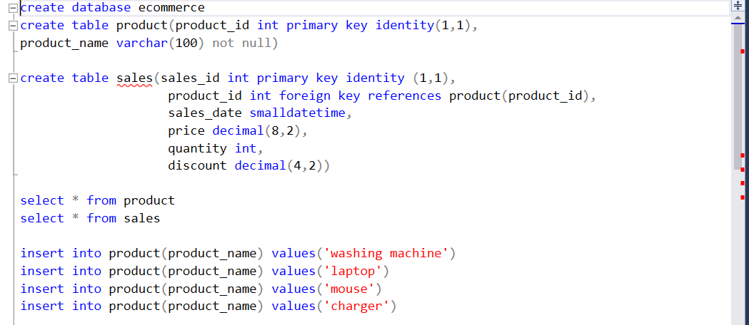

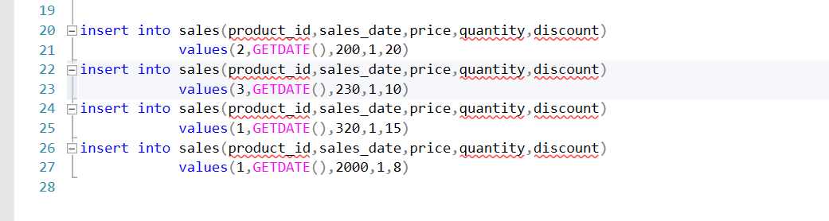
Assignment
employee table
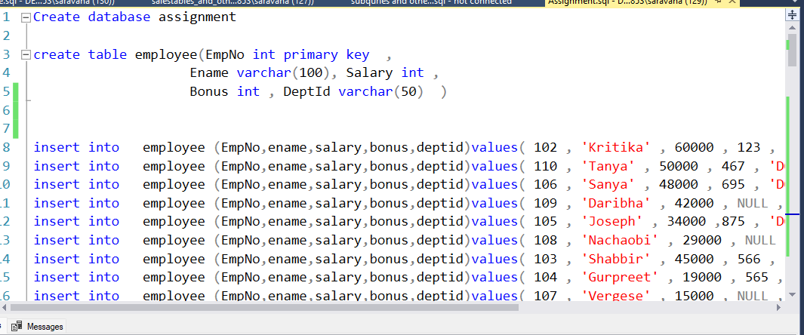

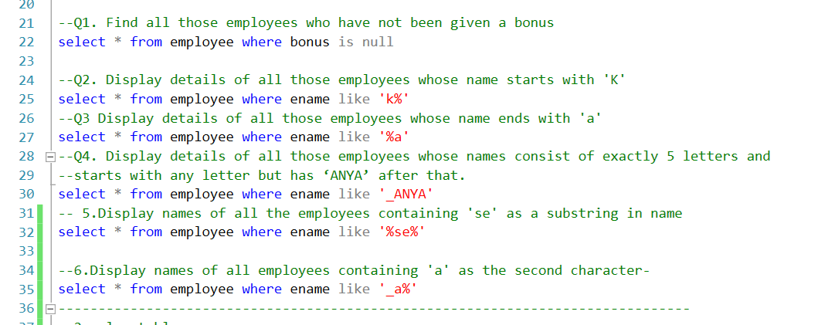

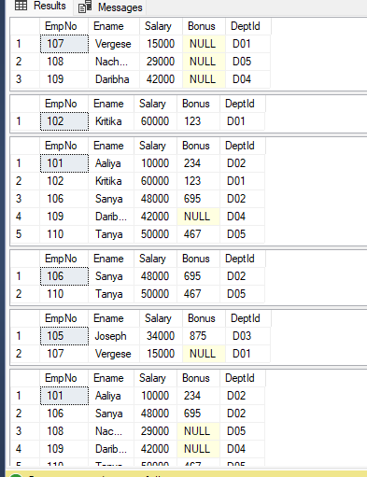

sales table
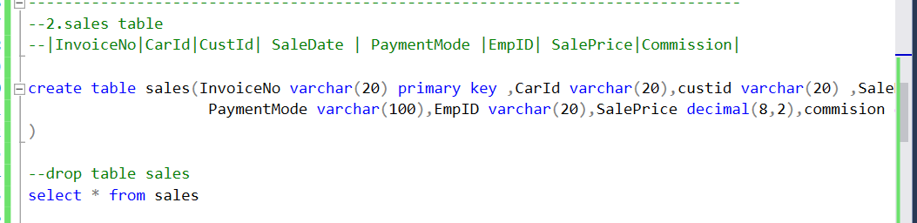

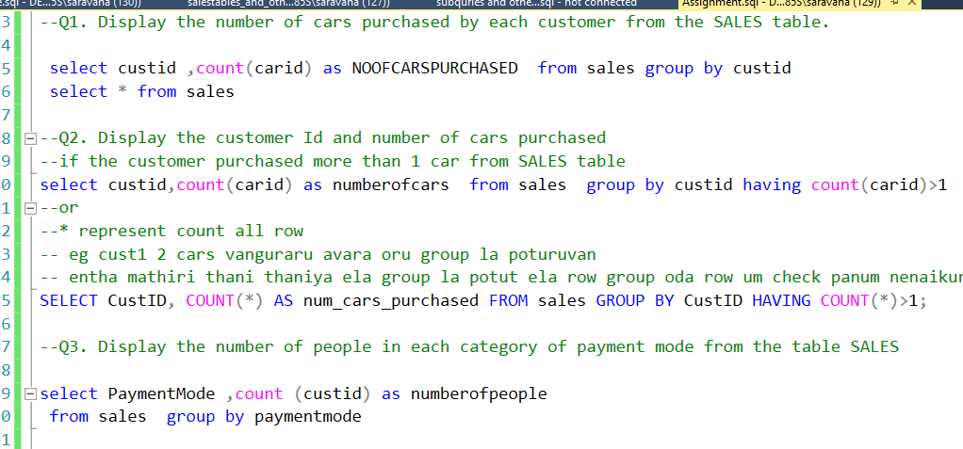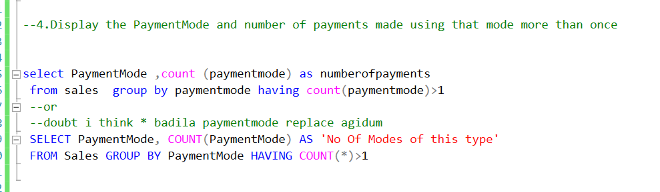

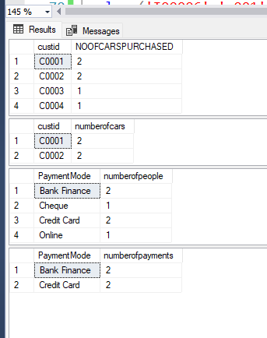
Part 1 completed
5 departments eruku max use pana orae oru value than varum.
group use pana oru oru deparment kum oru oru max value varum.
Joins -
joins basics - https://www.youtube.com/watch?v=6B8SxF6E99A
joins on vs where - https://www.youtube.com/watch?v=f9lbm7HA7pw
TTR : condition ethachu pota where la podanum on la podakudathu
inner joins
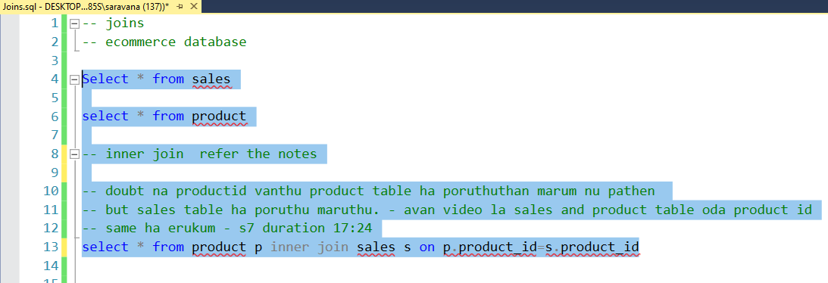

https://www.youtube.com/watch?v=AYg1f7RYJxQ&t=160s

Eppidi inner joins eruku
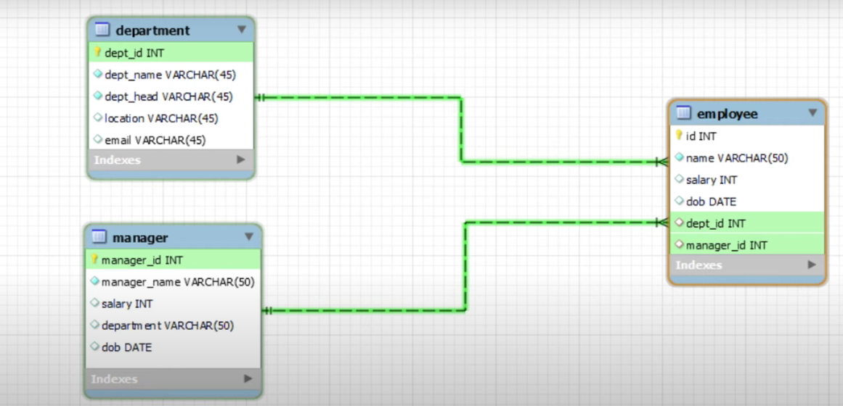

Eppidiyum inner join eruku
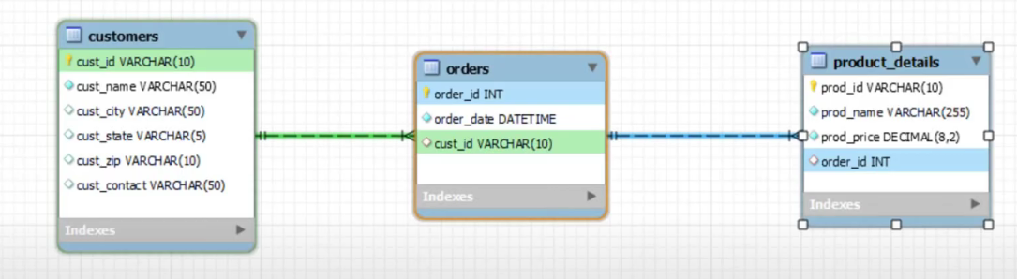

Output
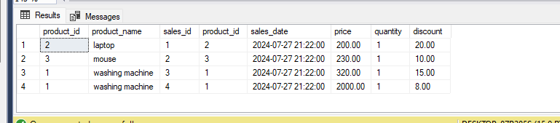
left,right,full
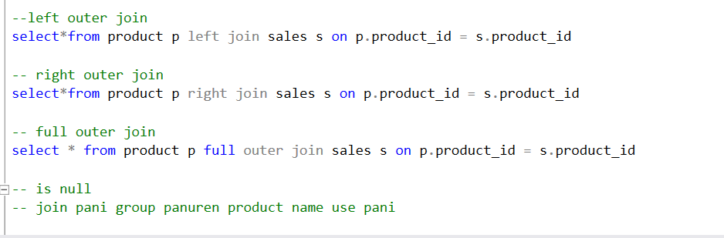
Output
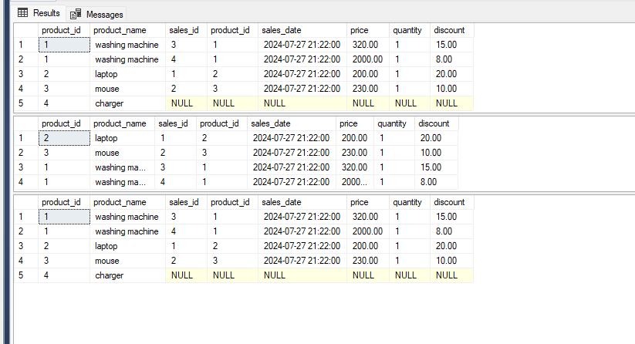

isnull
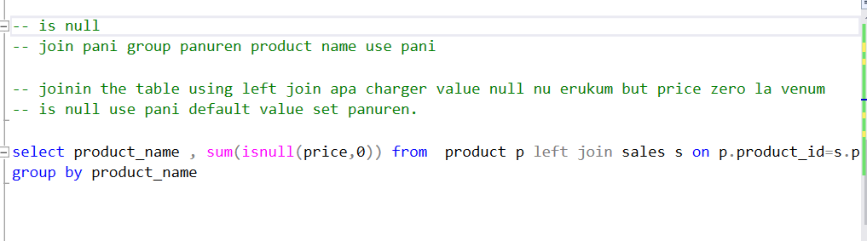
output
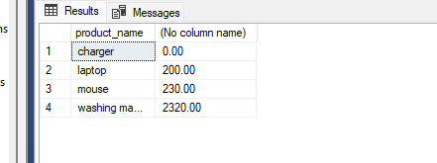

Storing values into new tables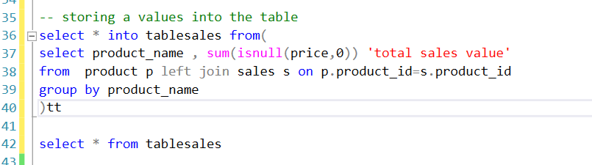
Output
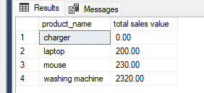

Self join
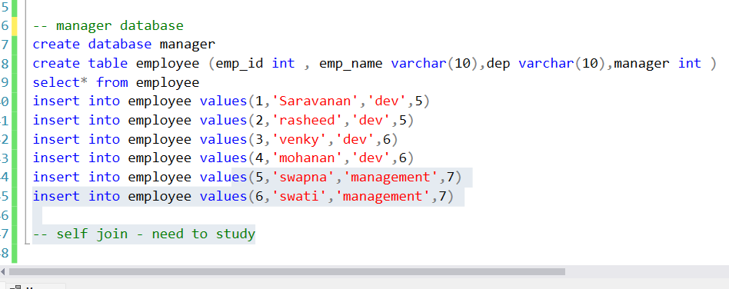

declaring a variable
int ha varchar ha mathuran concatenate panurathuku.
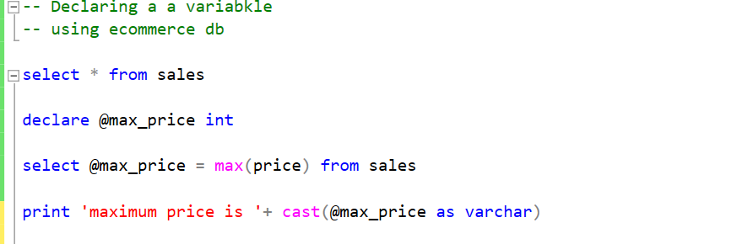
if
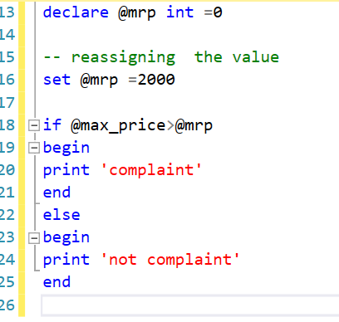

output
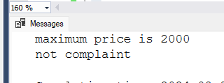

end case
score column badhila case use panuren


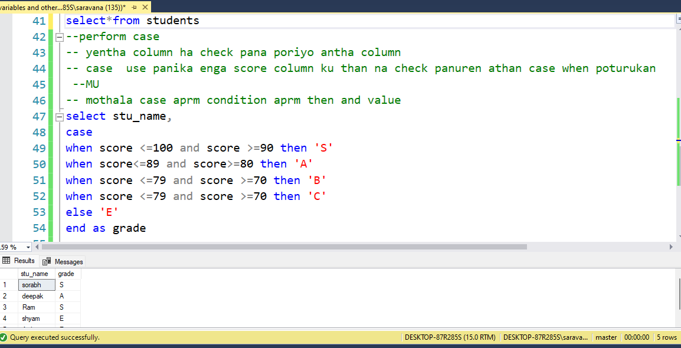-
Why score values ha character ha katurom na data base la int oda storage space than kami so mothala int la store panitu aprm varchar la display pannurom.

Oru databse ha eppidi than thani thani ya design pannanum
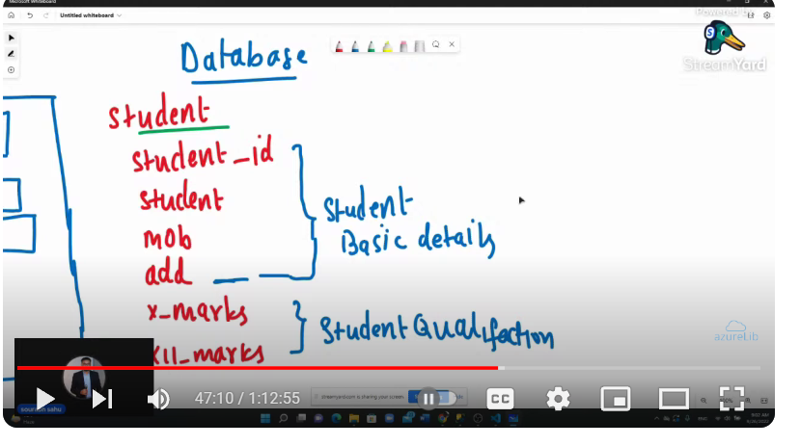

@@identity
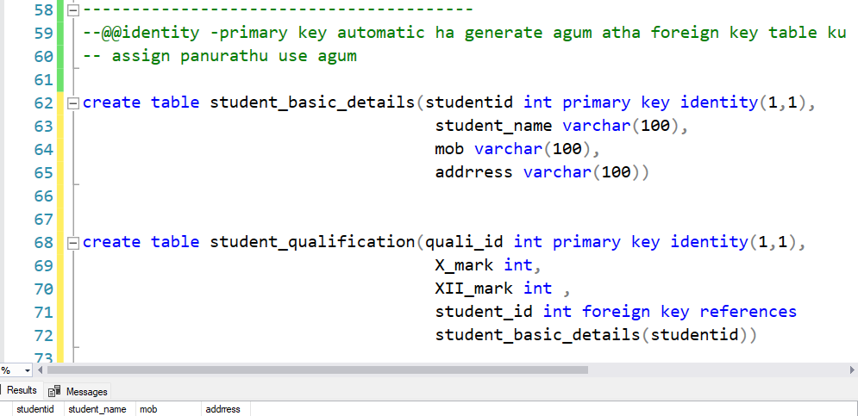

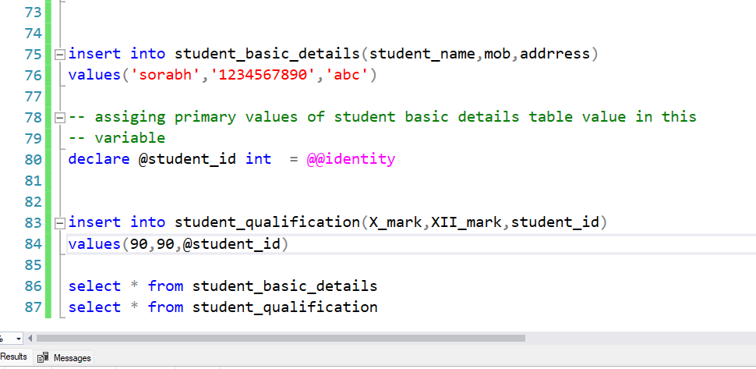

File vanthu advanced simple concepts.sql
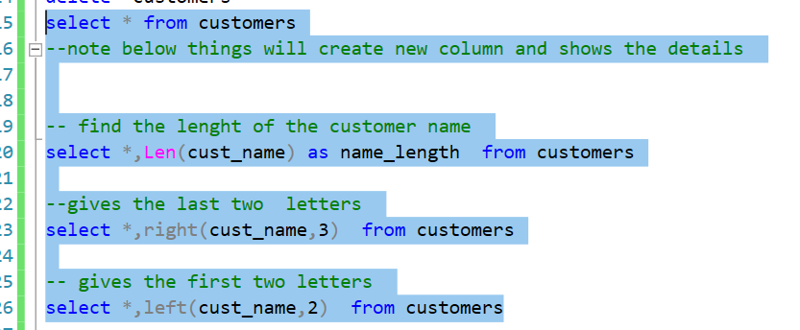
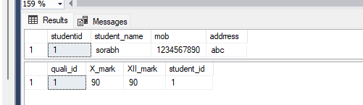
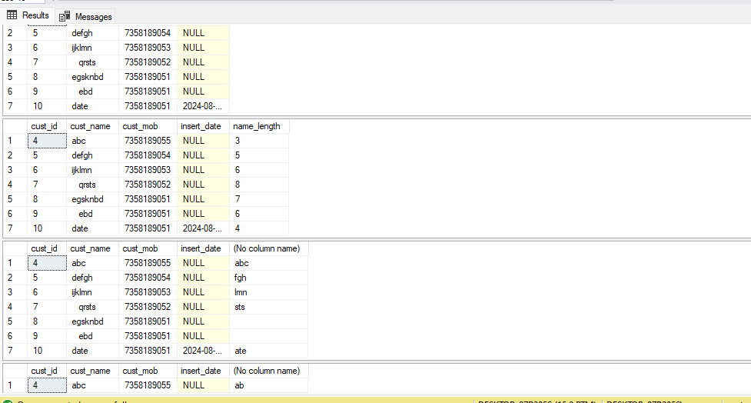
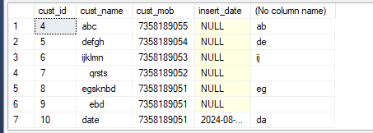

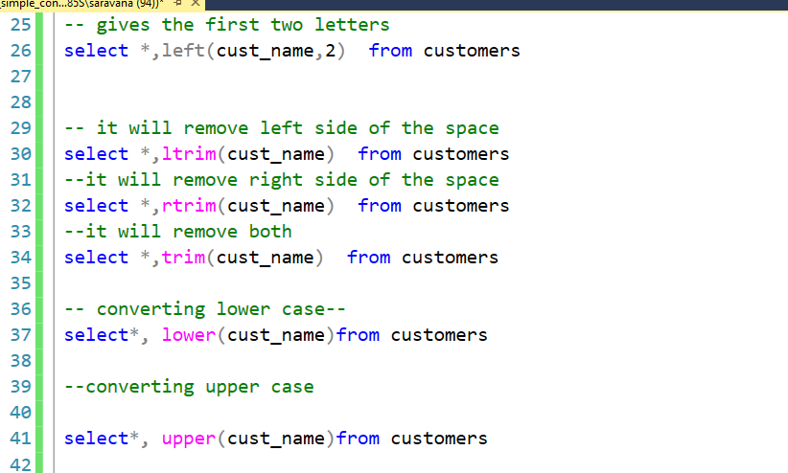

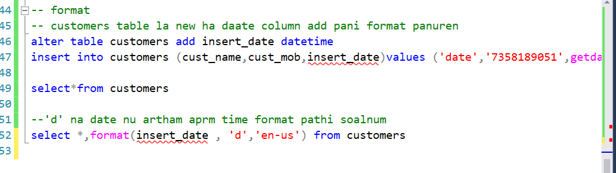
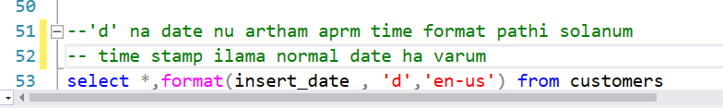
Output=

Note:Enga sports db select agiruku nee customer db select paniko
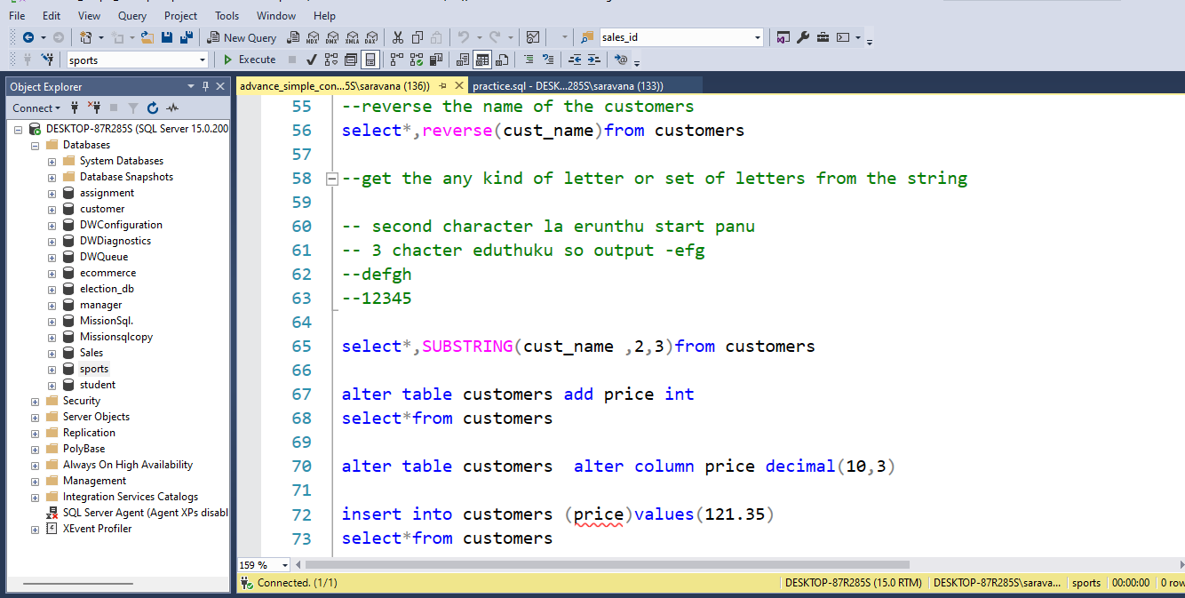
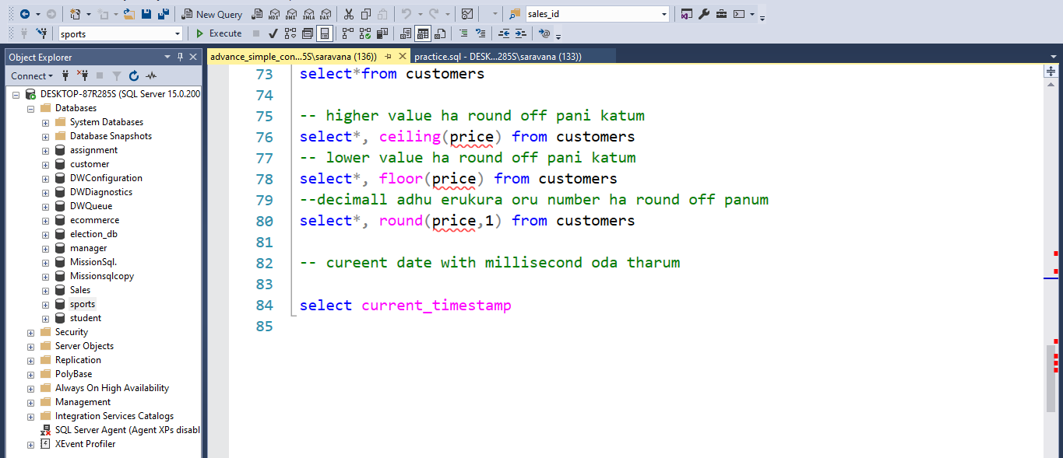

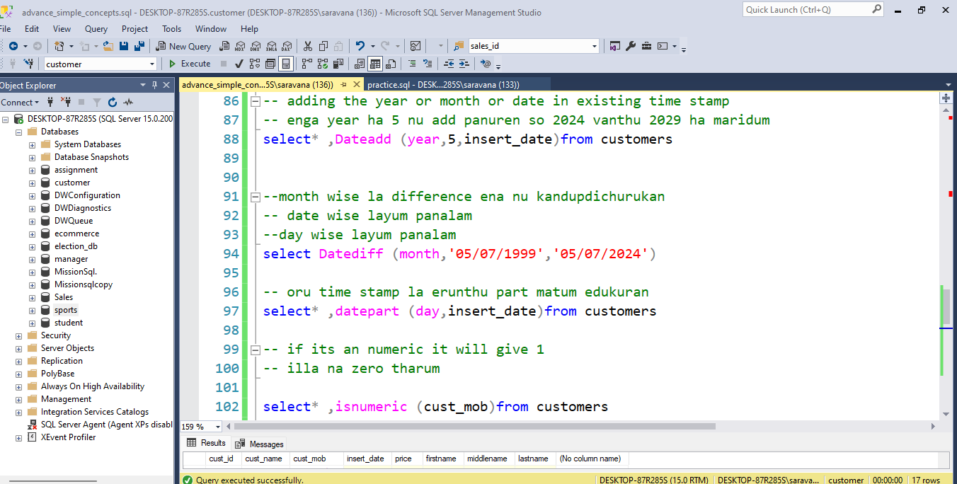

Coalesce
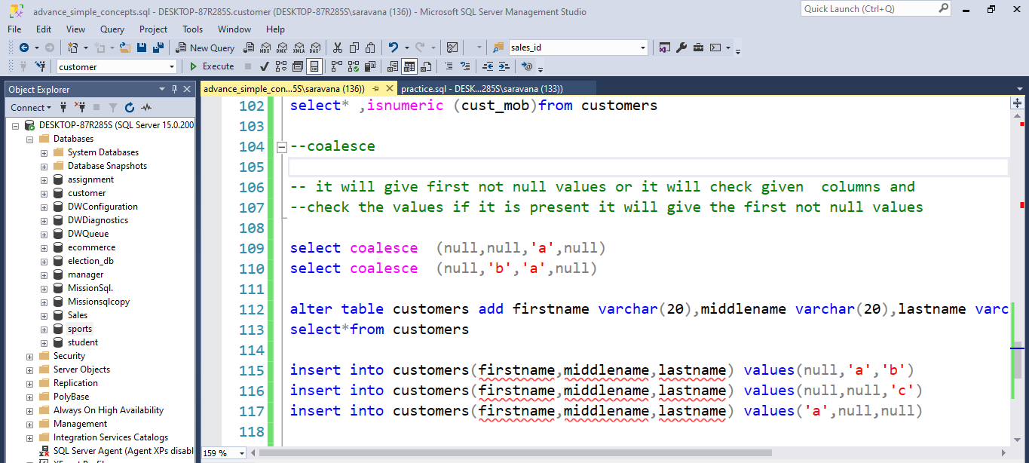

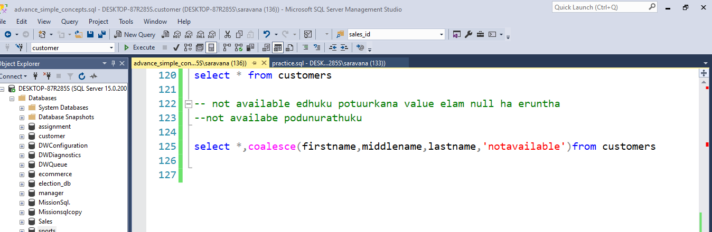

stored procedure
sp store agura edamum enga eruku
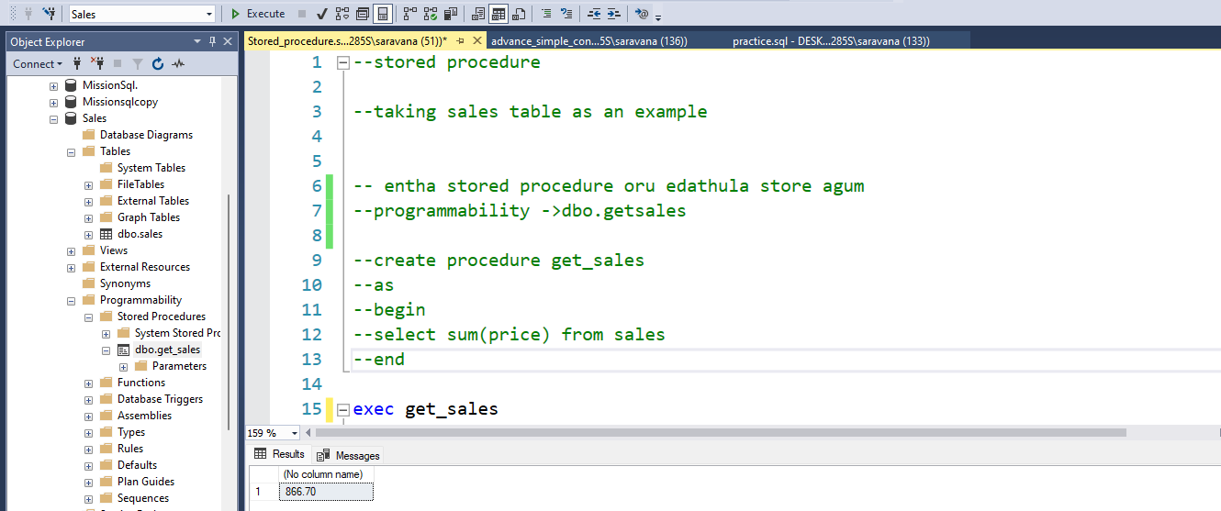

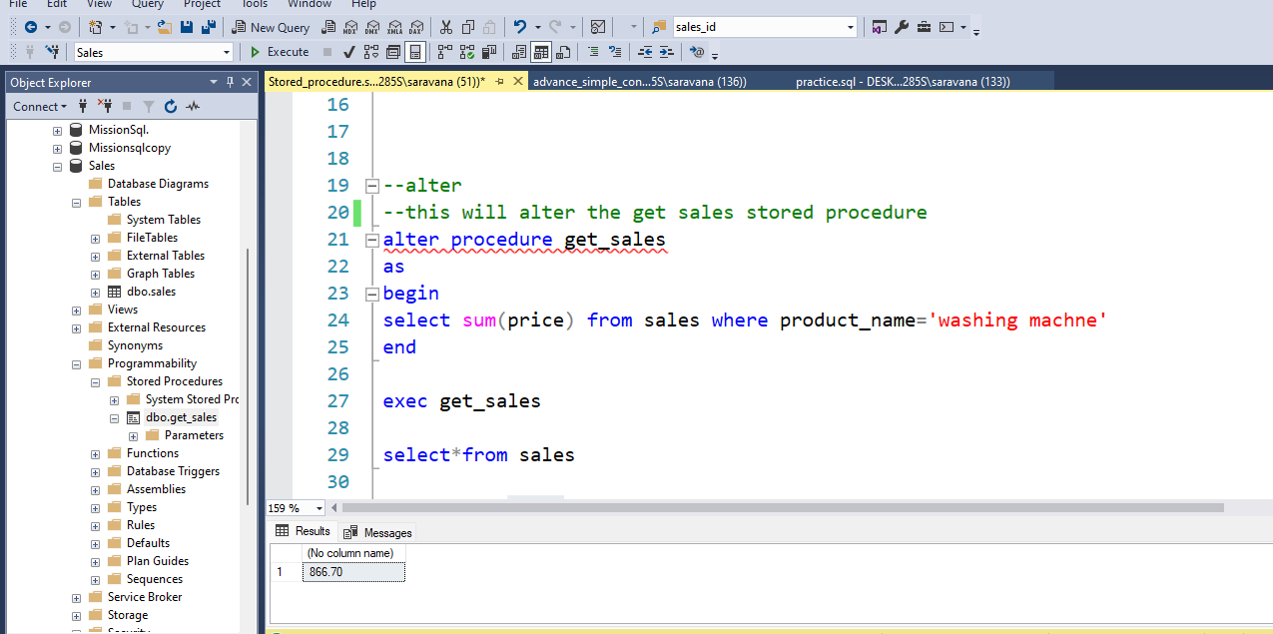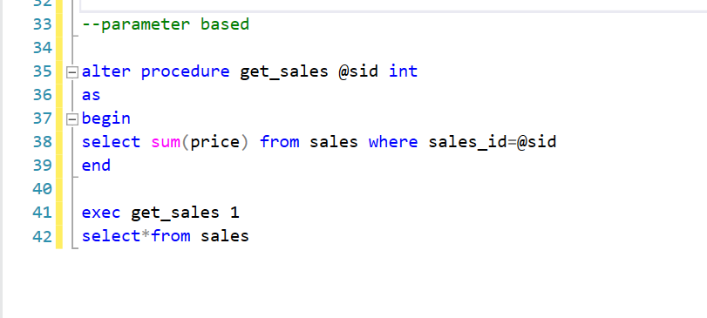

Passing two parameter
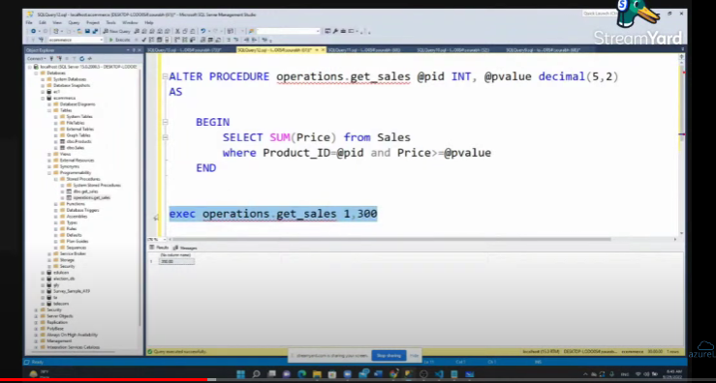

Default value
price vanthu pass panala na zero nu eduthuku nu soluvan
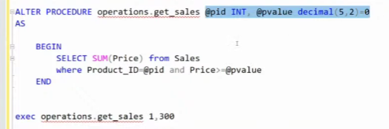

functions
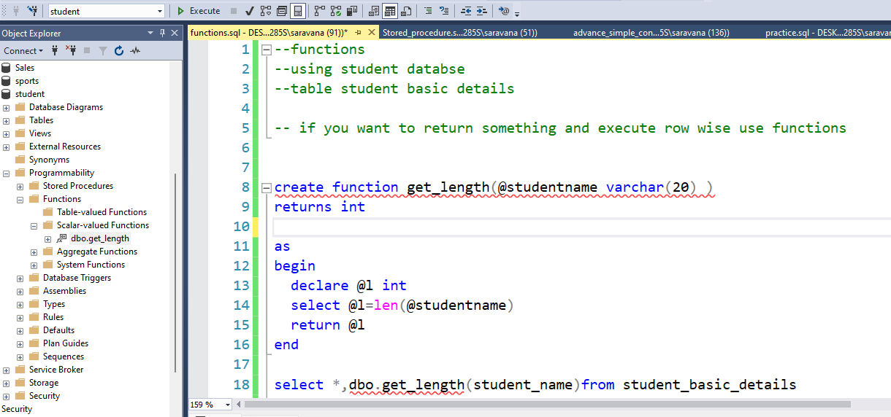

Output

two functions um ora time use panikalam
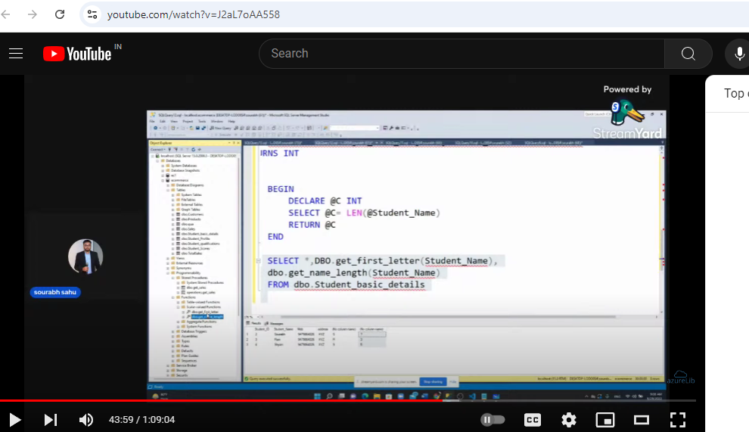

views – virtual ha oru table create agum adhula yentha functions vena entha table ku use panikalam
product_sale nu oru virtual table ha create panuren
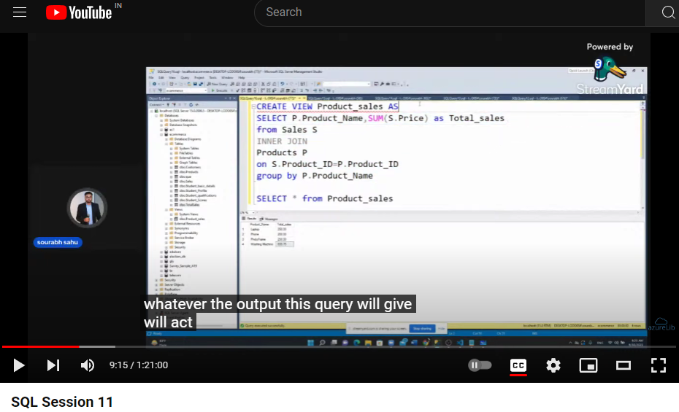

applying functions on the table and dropping the table

cursor-skipped

Trigger
Slogs nu oru table create panuren edhu yedhuku create panurana vera oru table la value insert pana enga logs trigger aganum adhuku panuren.
for eg student_score oru table eruku adhula data va insert pana entha slogs la logs add aga etha panuren.
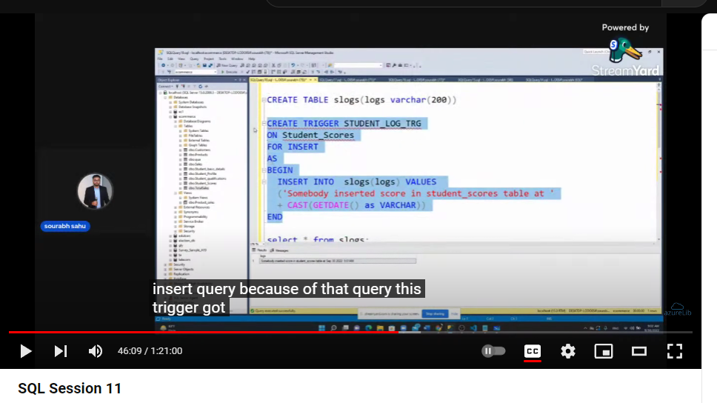
Mothala slogs ethachu eruka nu check panuren
aprm data va insert panuren
aprm insert pana data student table la pakuren
aprm slogs la log ha check panuren log generate agi eruka nu.
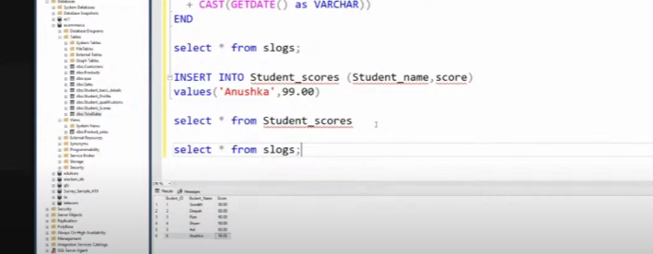

indexing – data va sorting order la vachutu aprm atha indexing pananum appidi pana easy ha data va retrive panalam edhuku peru clsutured index . most of the primary keys lam clustered index than
note: oru table ku oru clustered index than erukum neraya non clustered index erukum .
but non clustered index ha book eppidi entha page la entha info erukunu solathu antha mathiri data store pani search panalam.
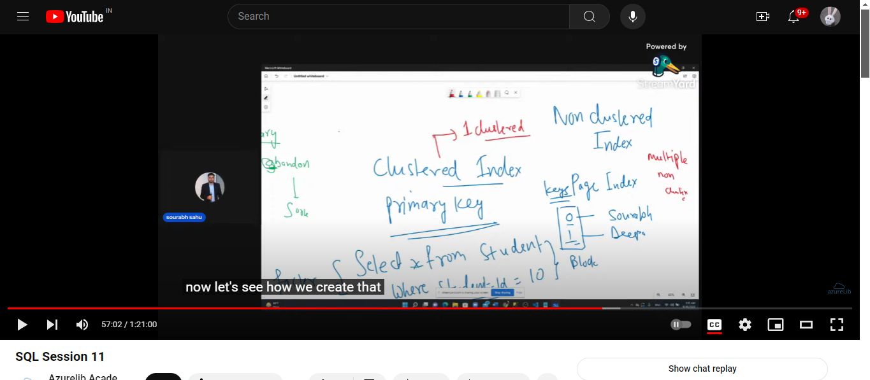
primary key laya cluster index create panuren athana error adikuthu
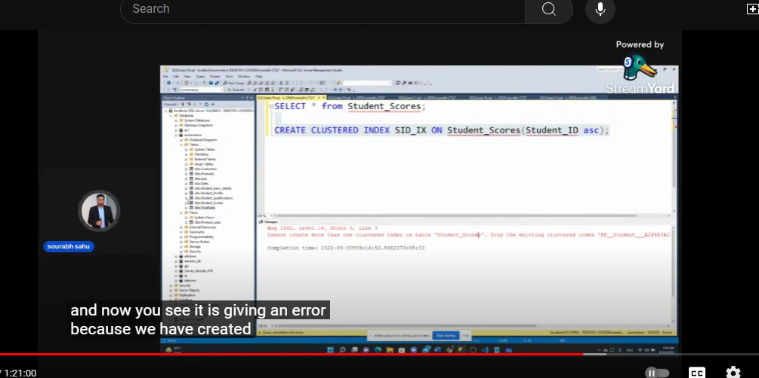

error adikurathunala antha primary key constrains ha antha column ku
remove panitu cluster index create panuren and
non clustered index um create panuren vera column ku
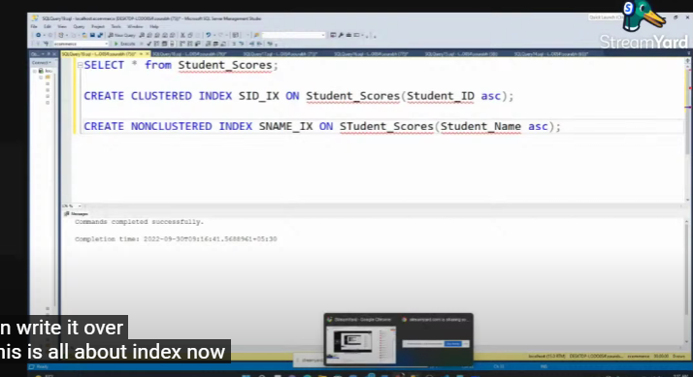
interview question

Things to know
count(product name) eppidi kudthu entha column la null values ha eruntha atha count panathu.
but overall ha count pana count value eduthukum
but edhuva count(*) kudutha nula values eduthukum.

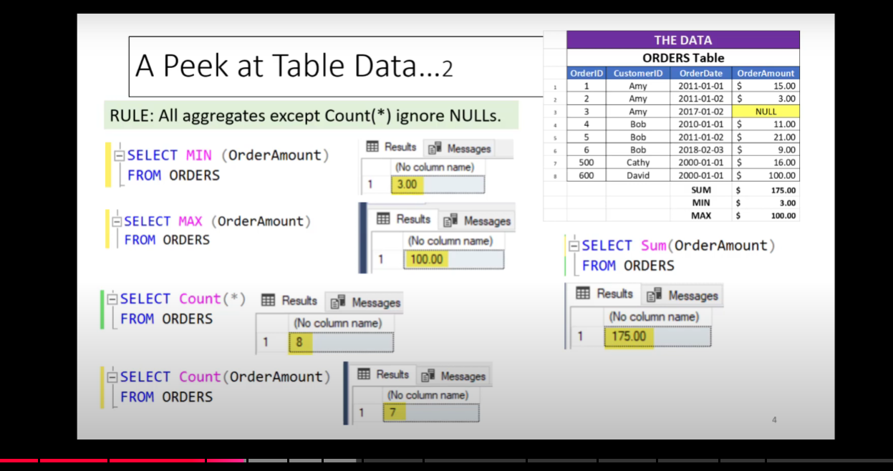
You can take like other than count(*) every thing ignores null.
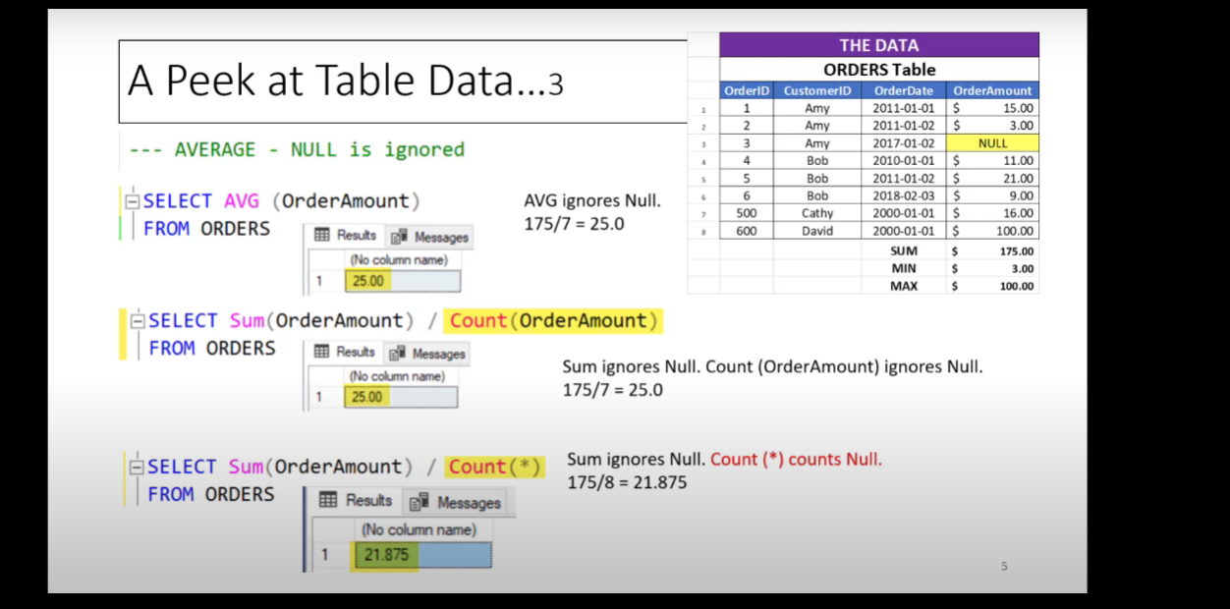
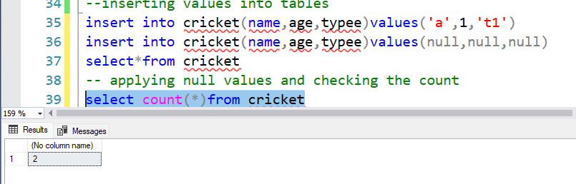Note : but it will count duplicate values so for this we are using distinct

Windows function
https://www.youtube.com/watch?v=Ww71knvhQ-s&t=379s
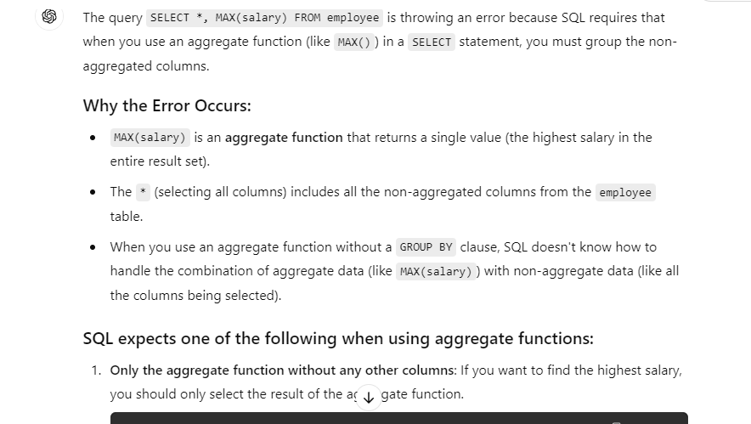

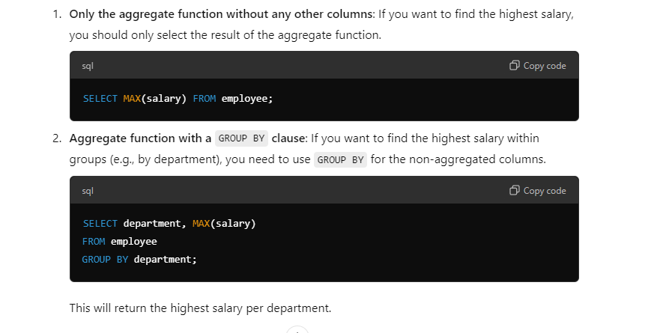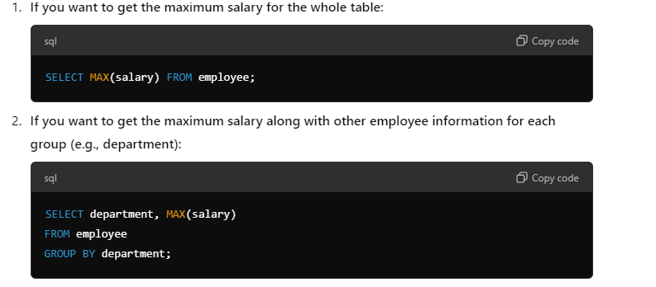

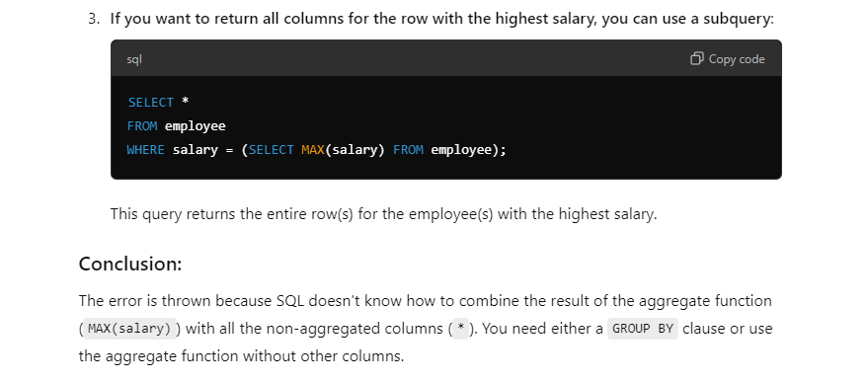
We can use windows function also
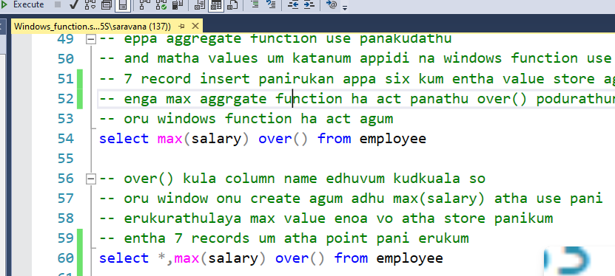
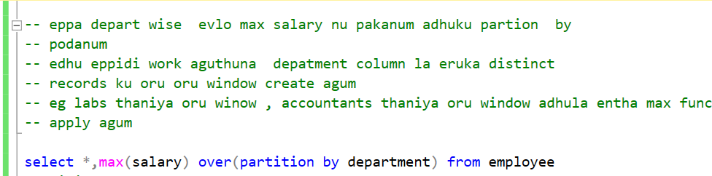
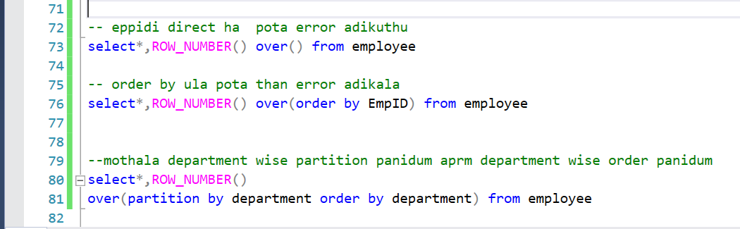
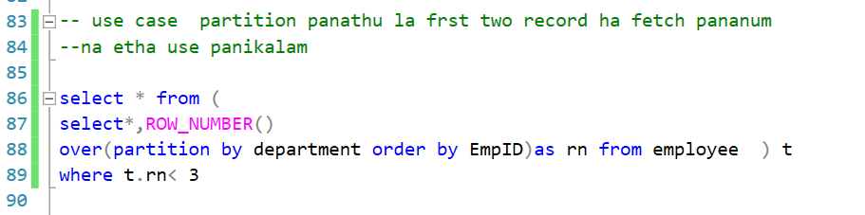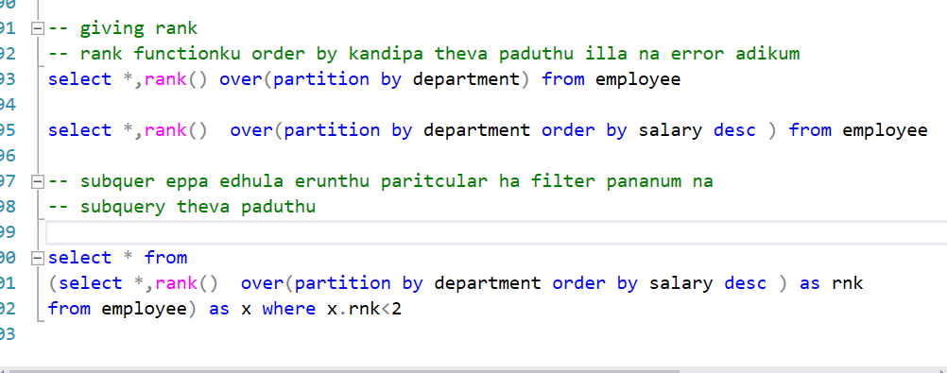

Periya difference lam ill dense rank uku
Rank duplicate values eruntha next value skip panidum like rnk column paru 3rd rank erukathu and
4th rank erukum edhuva dense_rnk column paru 3rd rank erukum evlothan difference .
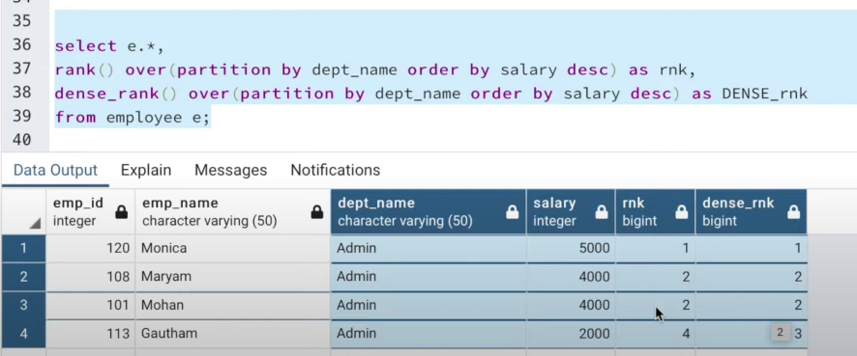

LEAD and LAG
Concepts
Eppa salary column nu onu eruku adula 2nd column oda salary ha 1st column use pani compare
pannuvom athan lag edoda wise versa than lead

Lag

Department wise partition . emp id wise order panirukan
last column pathan frst salary ku munadi edhvum illa so null
last column oda second row pathana salary oda 1st value vachruku eduthan elathukum use agum
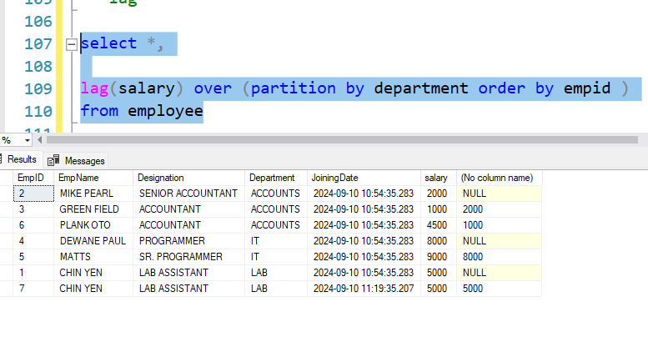
lead appidiya wise versa
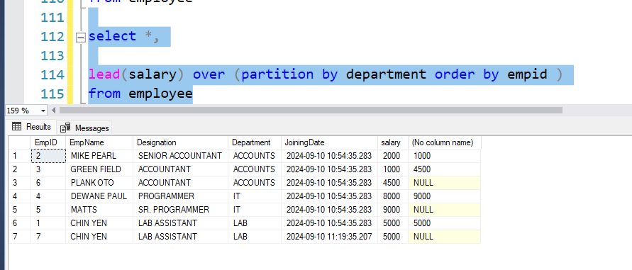
Use case : 1st row salaray record ha eduthu second row salary record kuda compare panuren

Row no 2la eruka salary ha frt kuda chek panuren
1000 vanthu 2000 oda perusa chinathanu chinathu so pervious employee earing more nu poten.
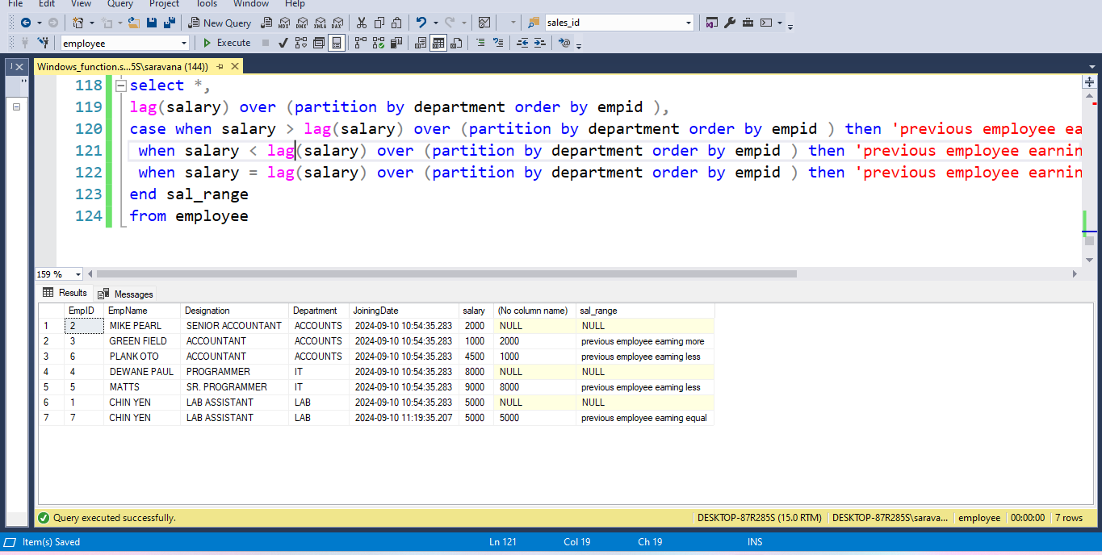

With clause or CTE or subquery factoring
https://www.youtube.com/watch?v=QNfnuK-1YYY
when to use CTE
orae subquery ha multiple time use panura edathul etha use panalam
performance based query ku etha use panalam.
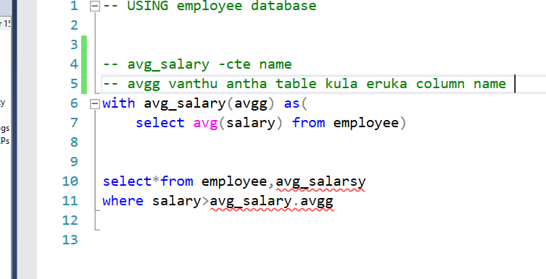

interview question
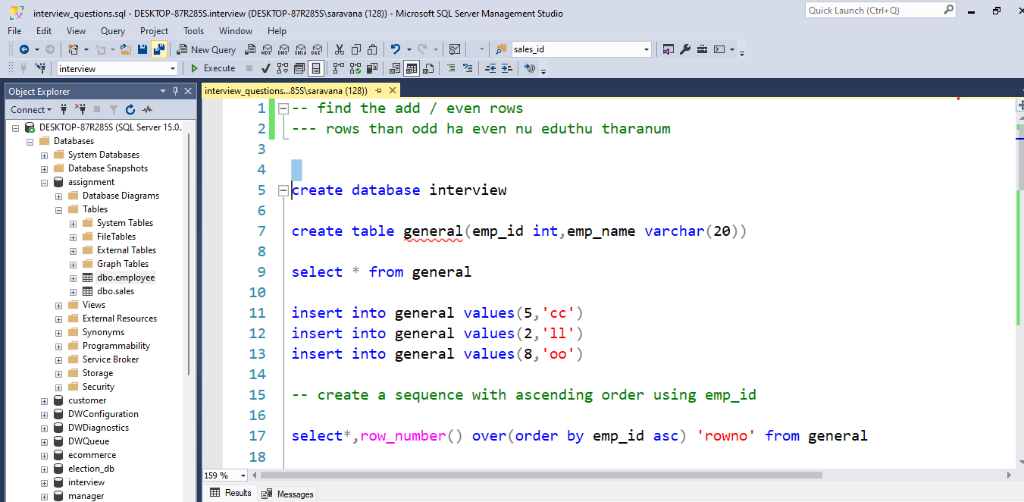
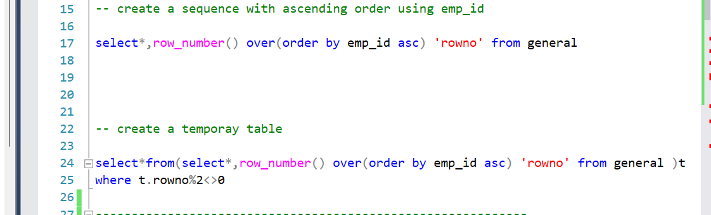
---------------------------------------------------------------------
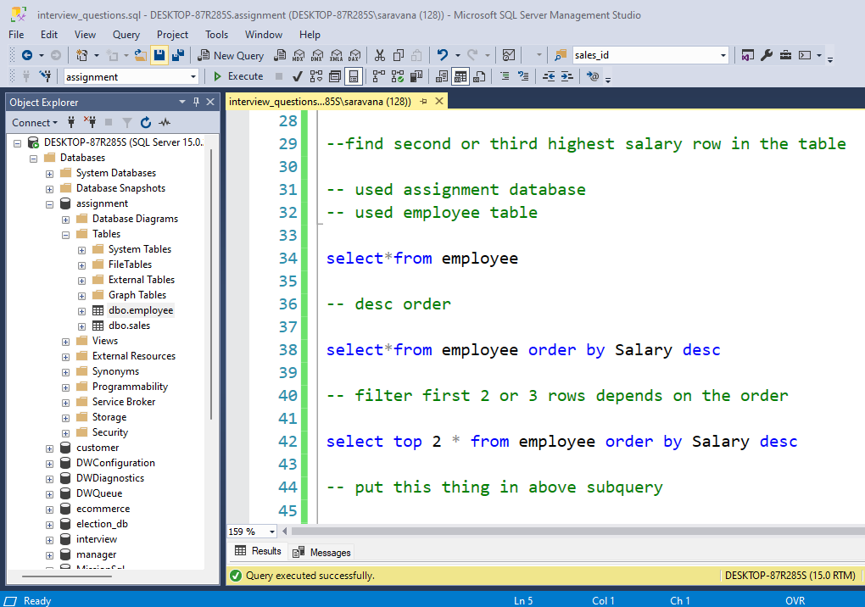
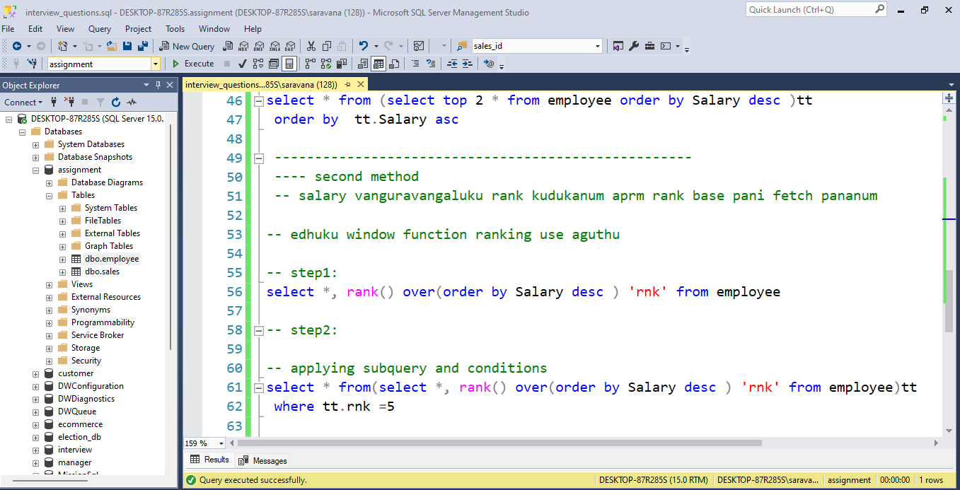
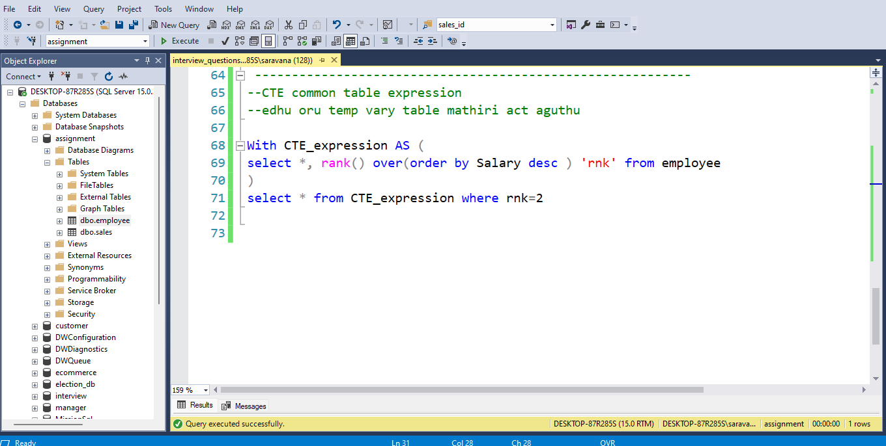

Problems
Reference from here -https://www.w3resource.com/sql-exercises/
database used – practice_problem
Retreive topic

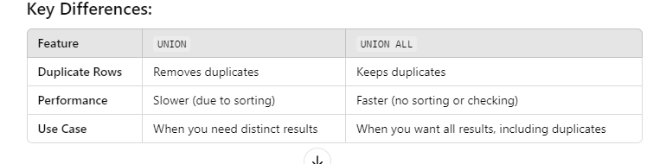
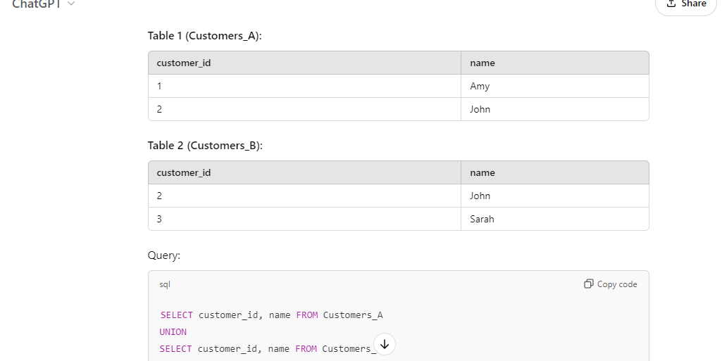

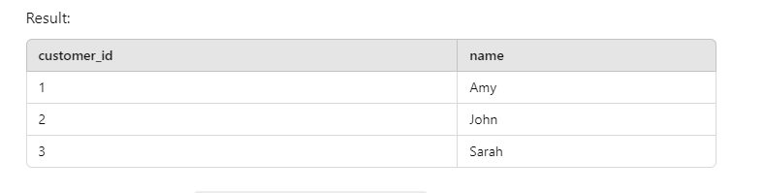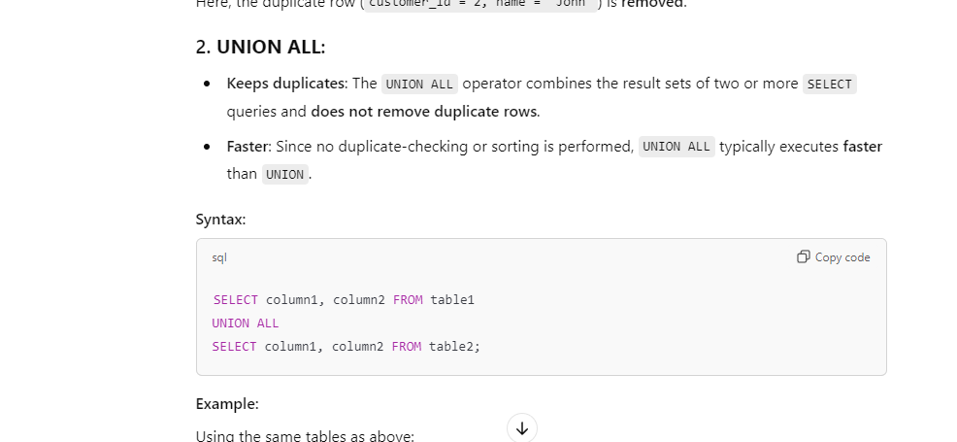
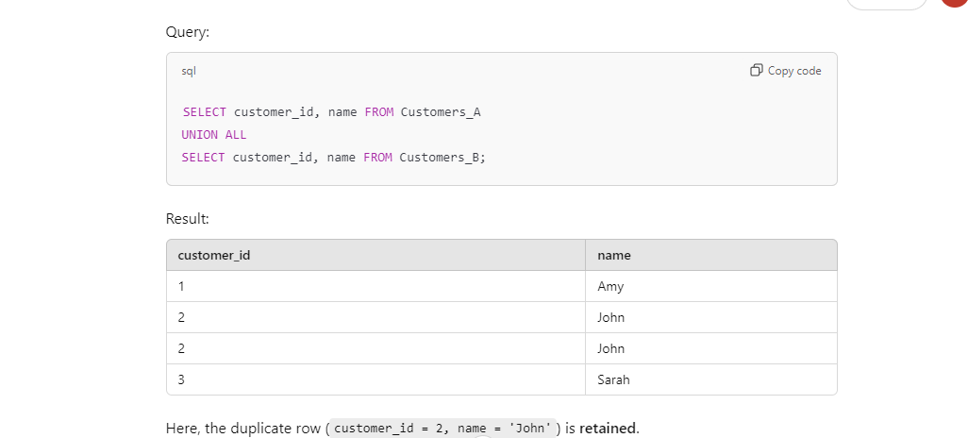

Need to watch -https://www.youtube.com/watch?v=HmZgq-NdgUg

