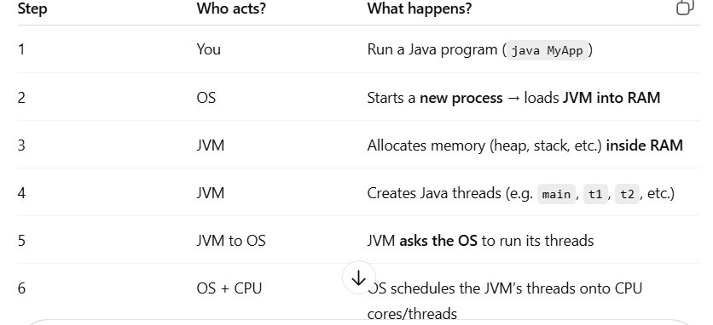
jvm creates threads and gave to os . so take the threads and give it cpu .
Cpu is executing the threads
🔁 A process holds the code and resources
🧠 Execution is the actual running of that code by the CPU
A thread is a lightweight unit of execution within a process.
process kula neraya lines of code eruku adula oru set of line of code ha thread la wrap pani erupan. Line of code than execution of code nu solalam
- Every app (like Chrome, VS Code, Java app) runs as a process.
A process can have one or more threads to do tasks in parallel.
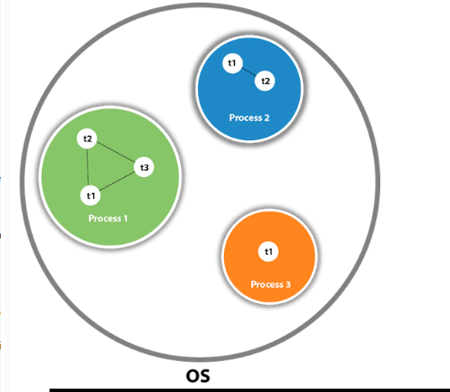

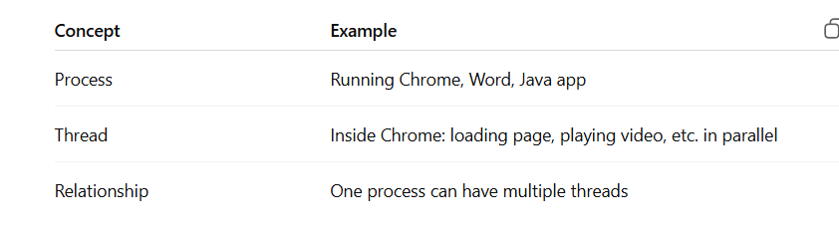
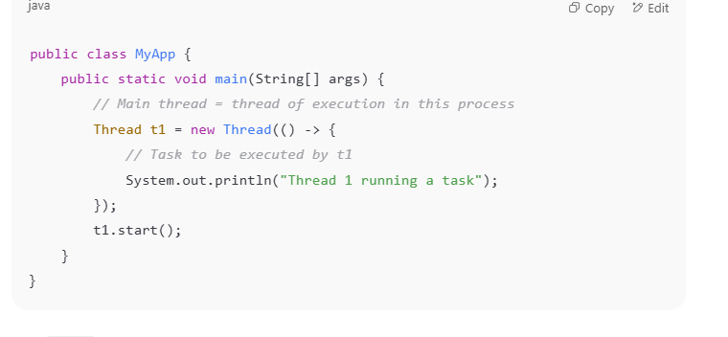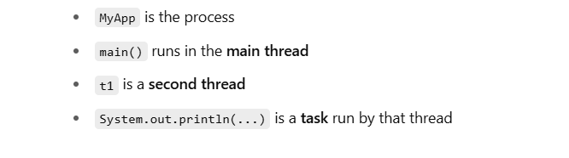
threads,heap,satck all will be present in ram ?
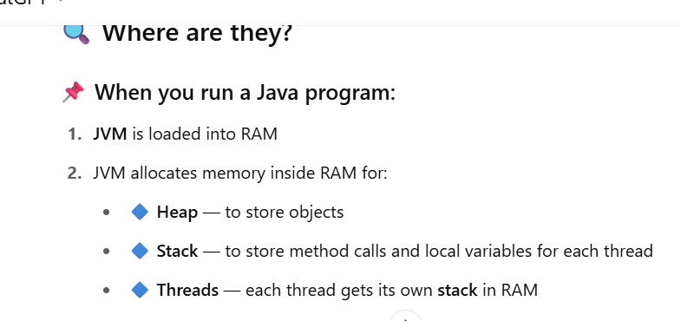
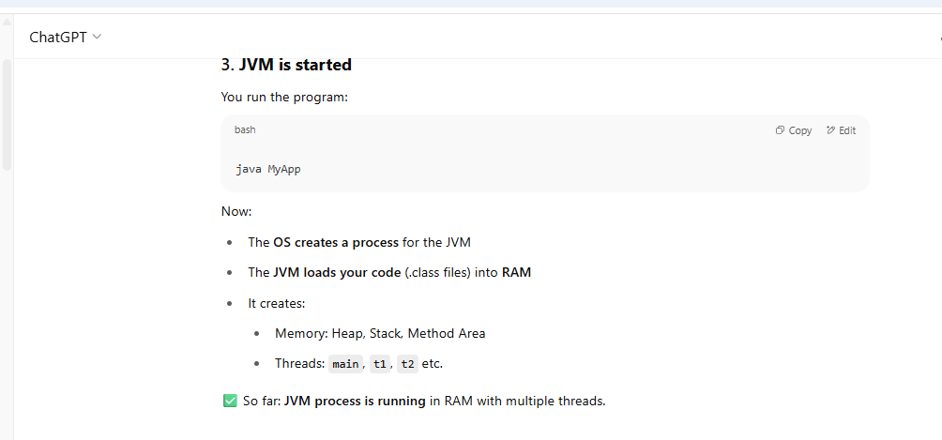
jvm process means ?
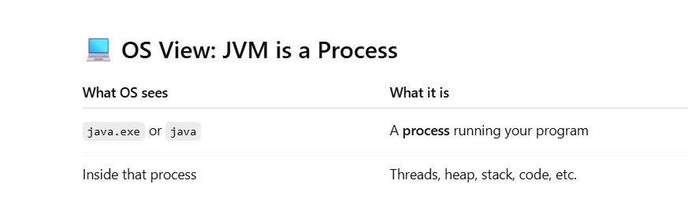

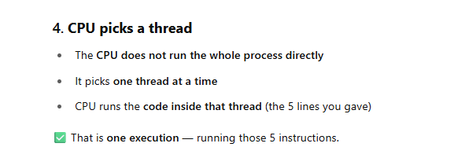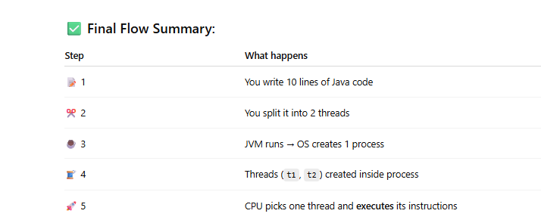

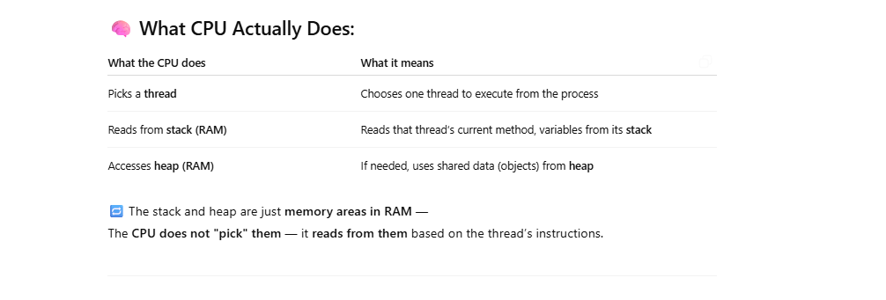

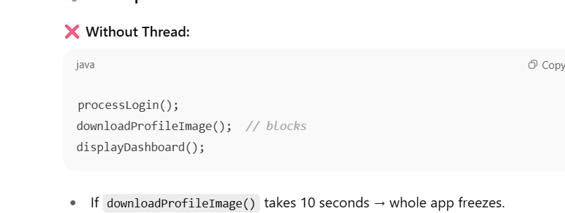

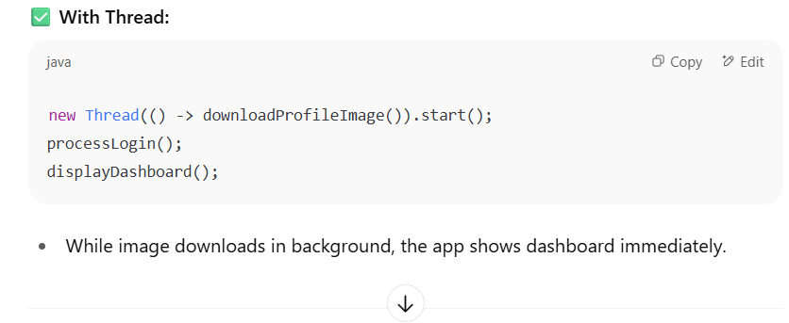
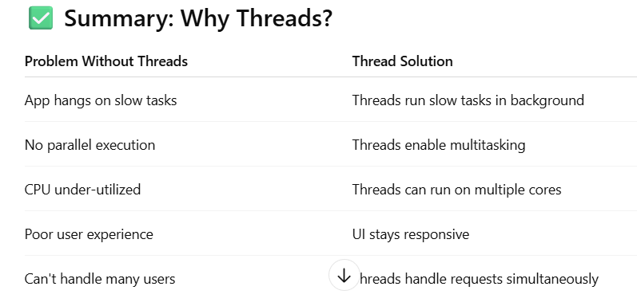

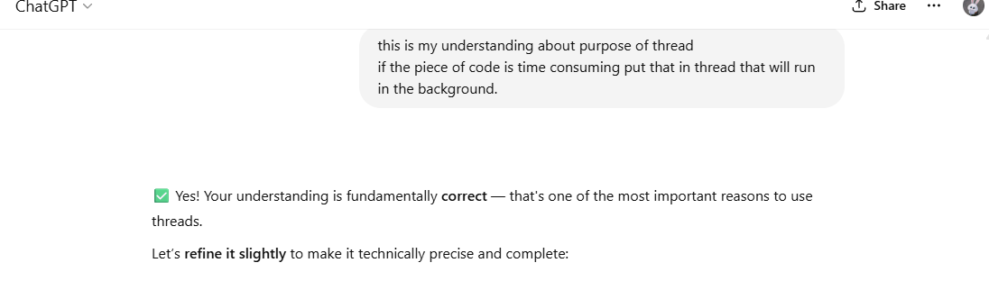
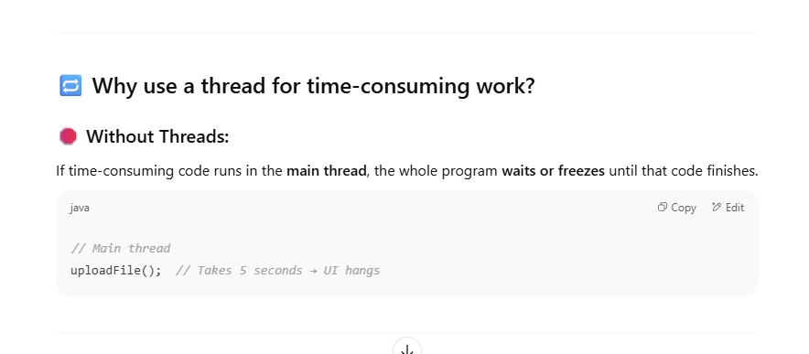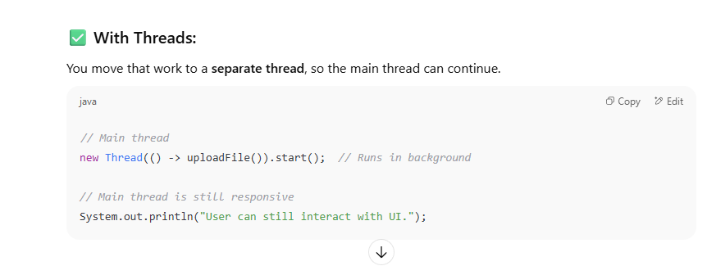
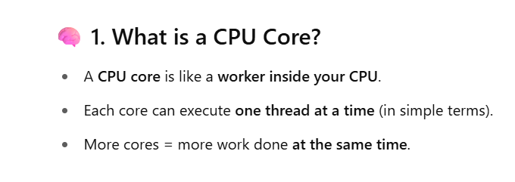
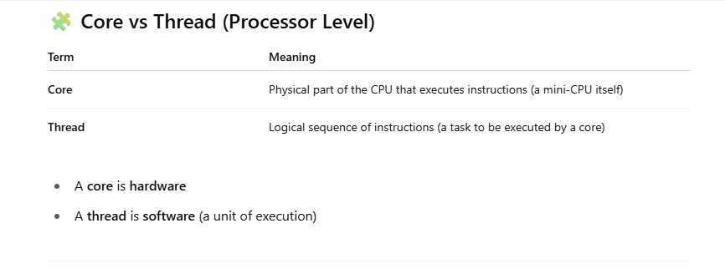

eg here Microsoft word is process . inside word we are typing that is one thread during typing automatic correction will pop up that is done by another thread those thread running on core
switiching between task is less expensive because shares same address space.
above example one process has multiple threading
Multiprocessing – switiching between ms word to gmail – for os it is expensive operation because it share different address space.

Creating thread using Thread class
Go and check here
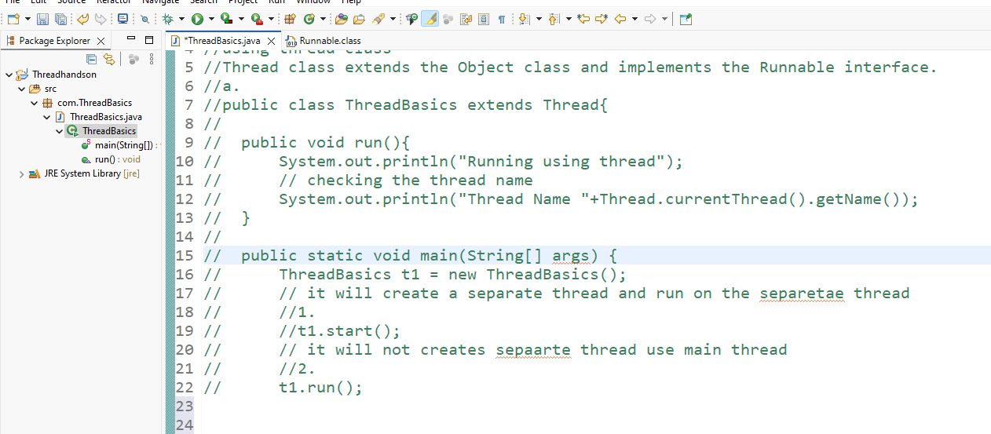
Here I created two thread it contains logic
You’ve created two threads with two separate instances of MyTask.
Class itself acts as thread and it contains logic
if the object change we have to create new object like this no loose couple is there
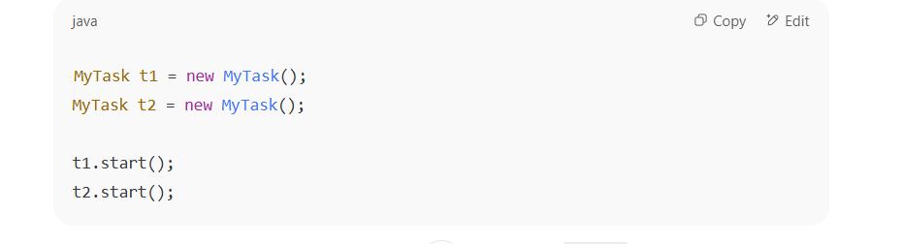
Using Runnable interface
Go and chek here
I followed separation of concern – class contains logic . class is wrapped inside the interface
so interface know what to do .
but it doesn’t know How to do when to do . threads know this thigs so we are giving this task to
Threads.
One task given to multiple threads
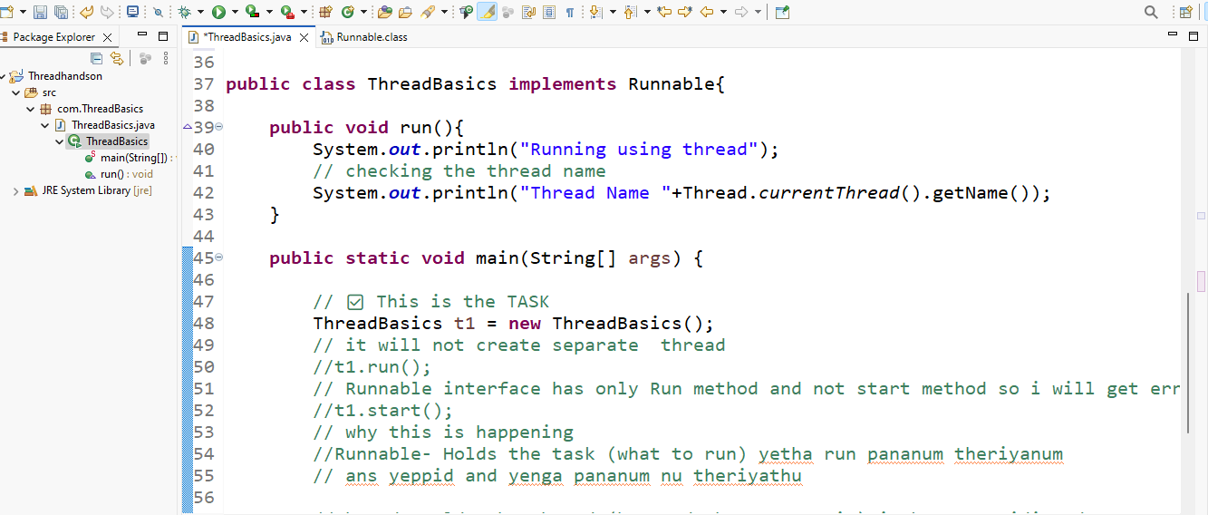
Seems any number of object will come it will we can use it in thread.
tomorrow instead of MyTask we can give any object so threads can take.
here we can see the clarity clearly I gave task to threads . threads takes that task and running, but above not
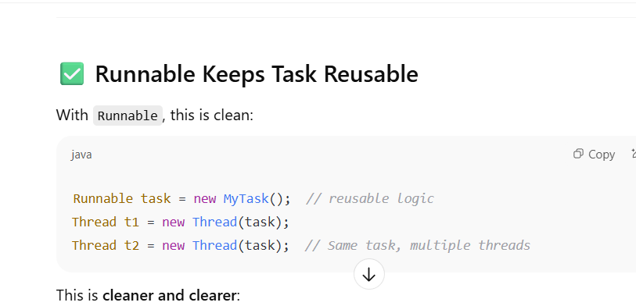

here I have learned about abstraction concepts
Runnable is an interface . we don’t which object will come and fix . we one only the method present in the interface.
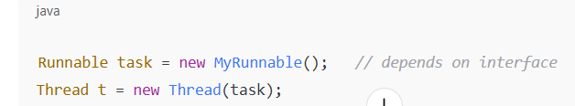
Sleep
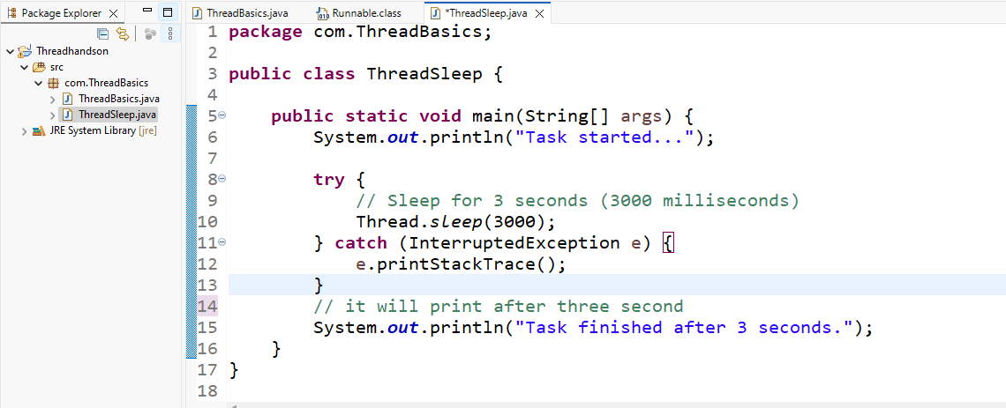

sleep using two threads.
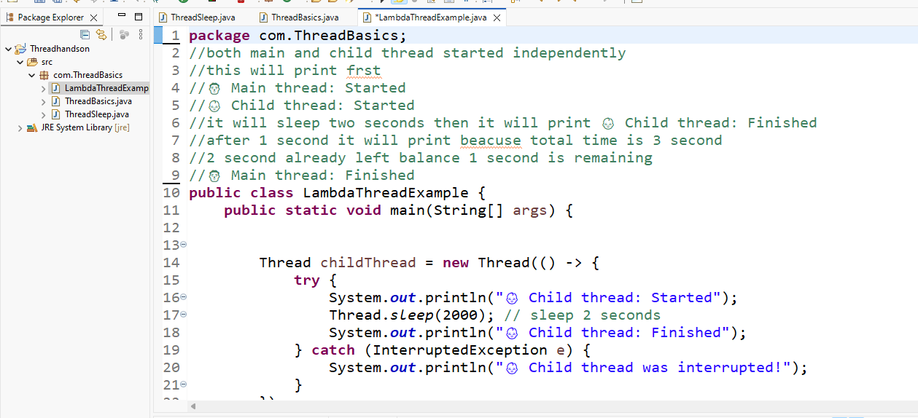
Wait concepts

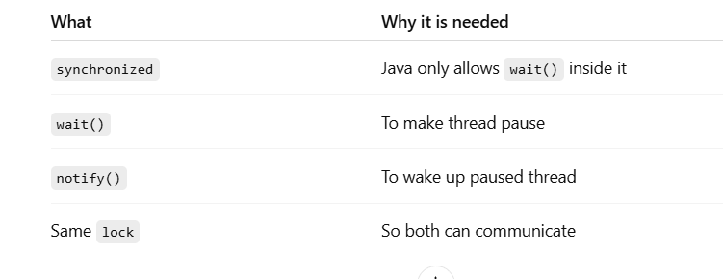
without synchronized block if I use this . it will throw error like this
lock.wait(); // ❌ IllegalMonitorStateException if not inside synchronized(lock)
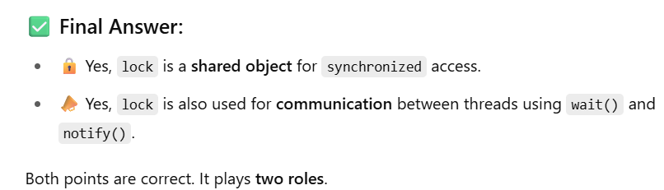
lock – only for communication.
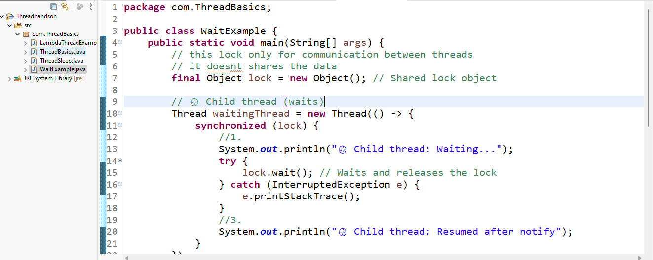
lock both two use cases
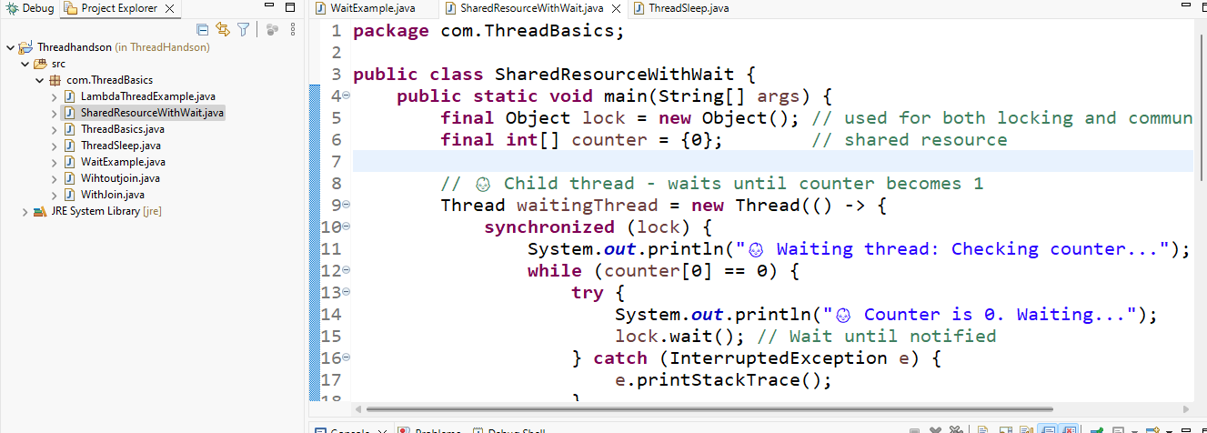
lock.sleep is not possible. Sleep is a static method . lock is an object
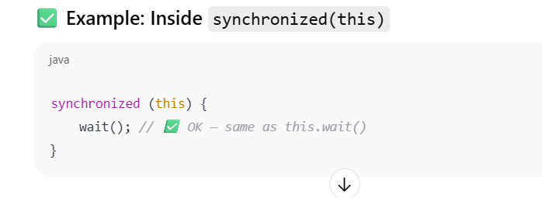
conclusion of wait
if you want to use wait you should use synchronized block and lock,notify . it involves two thread one for wiat. Another thread is for notify.
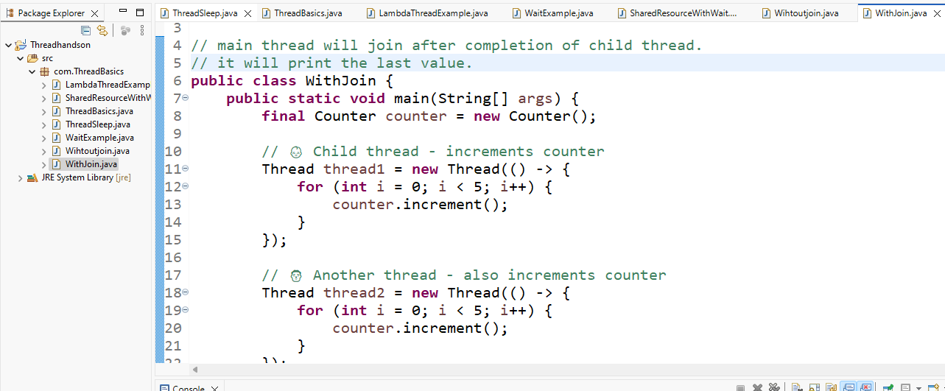
synchronized methods vs blocks

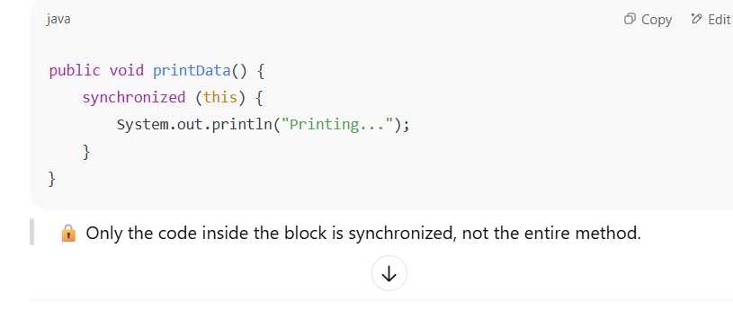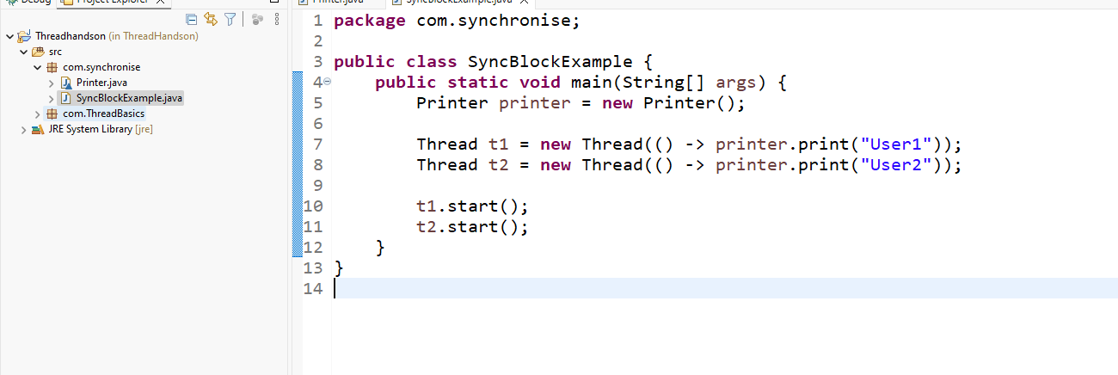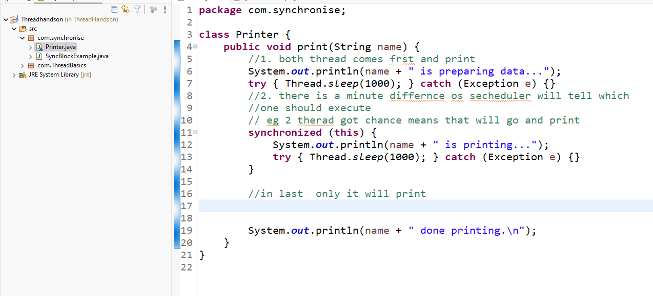

Go to eclipse and see the handson
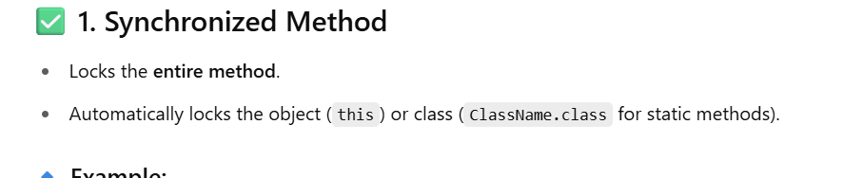
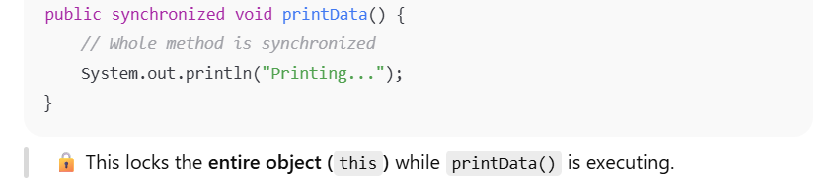
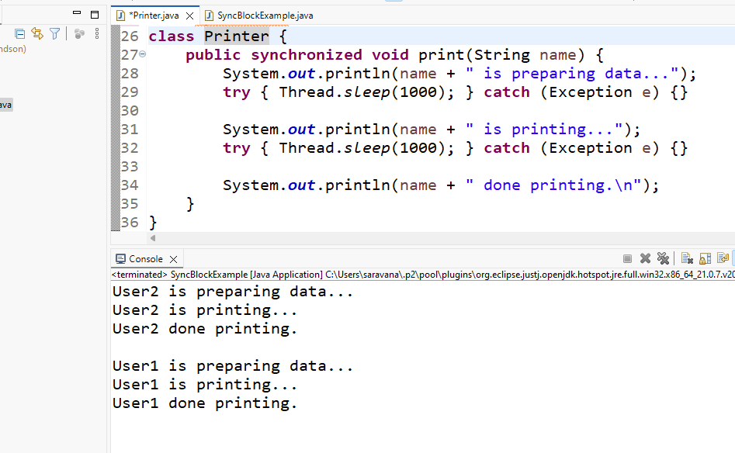
Just get to know what it is
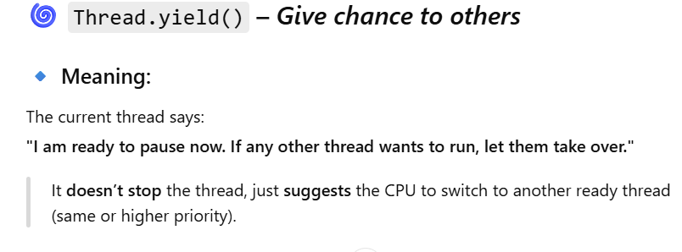
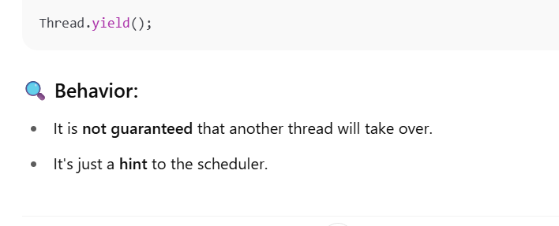
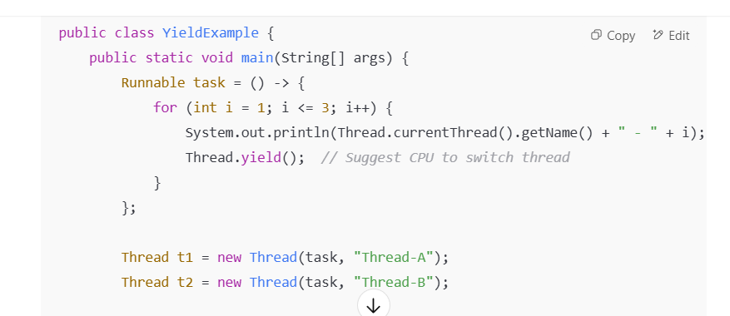

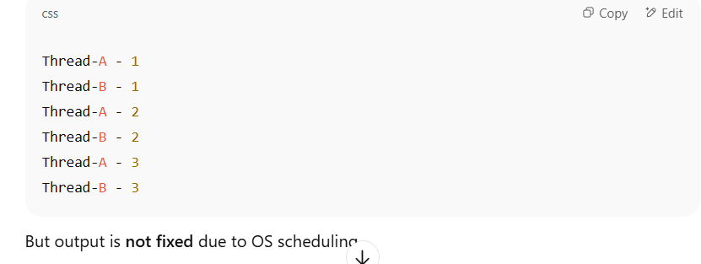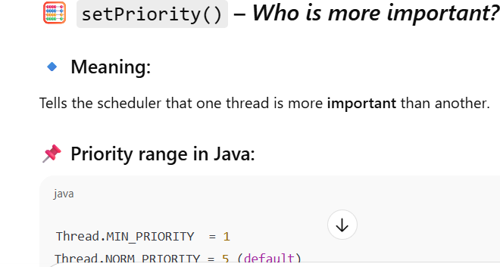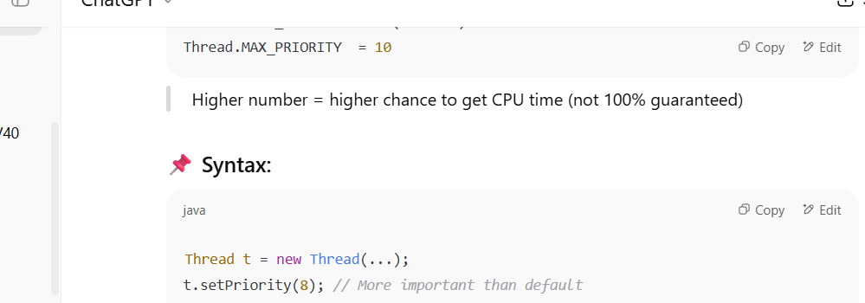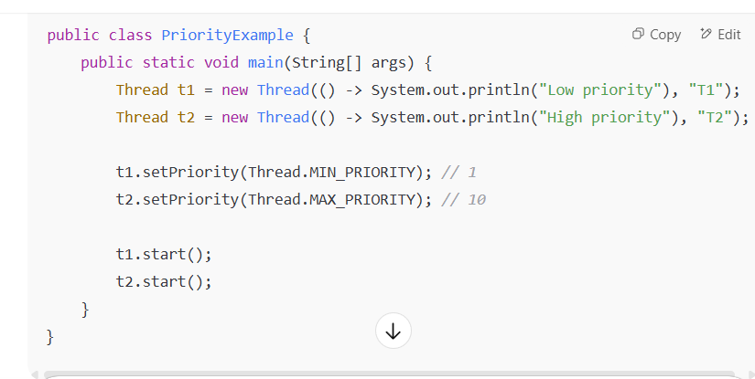
Output is still not guaranteed, but T2 (high priority) is more likely to execute first.
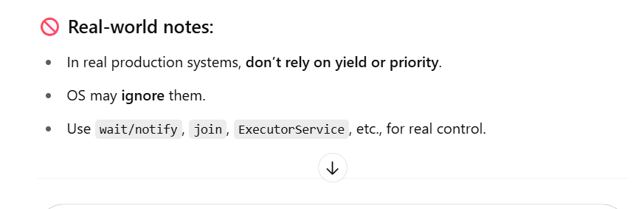
Race condition.
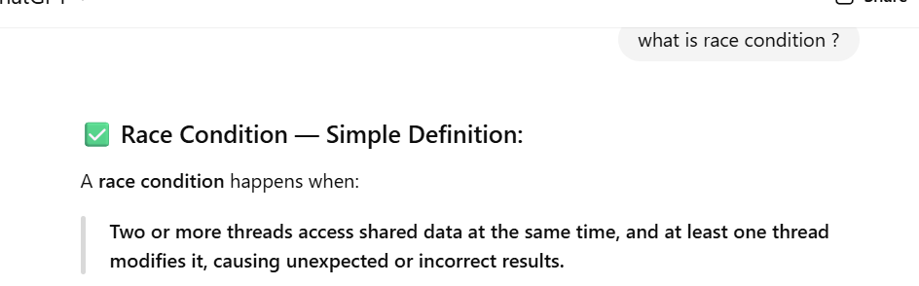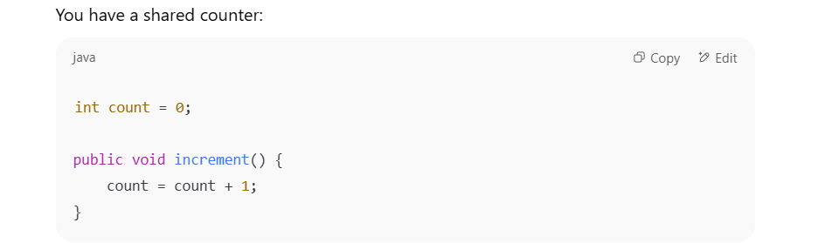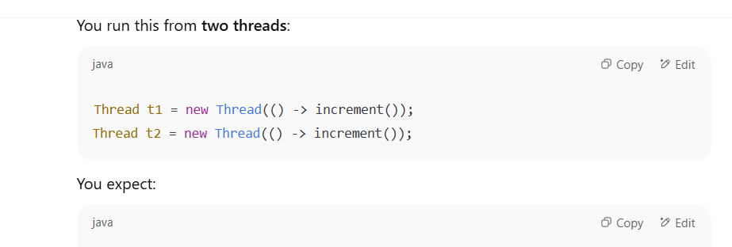
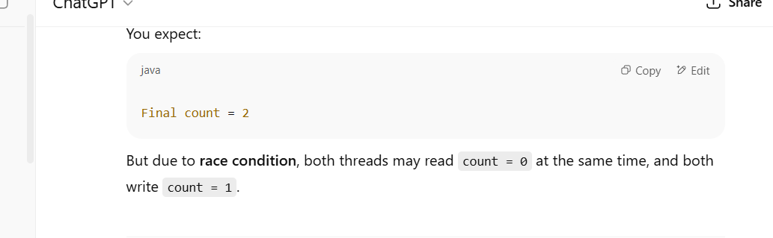
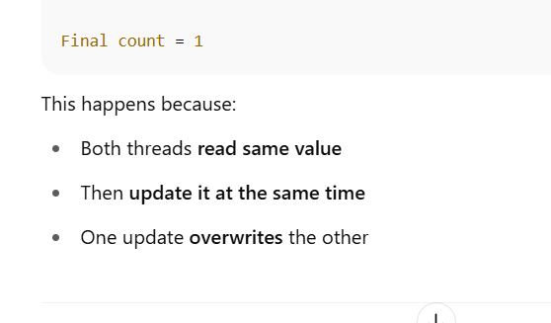
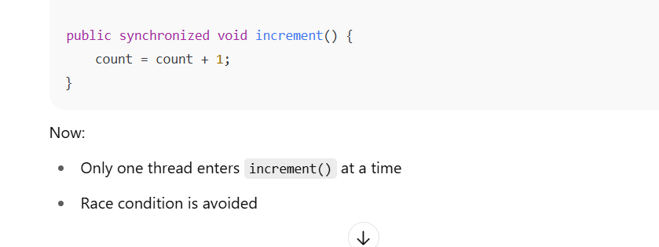

refer here
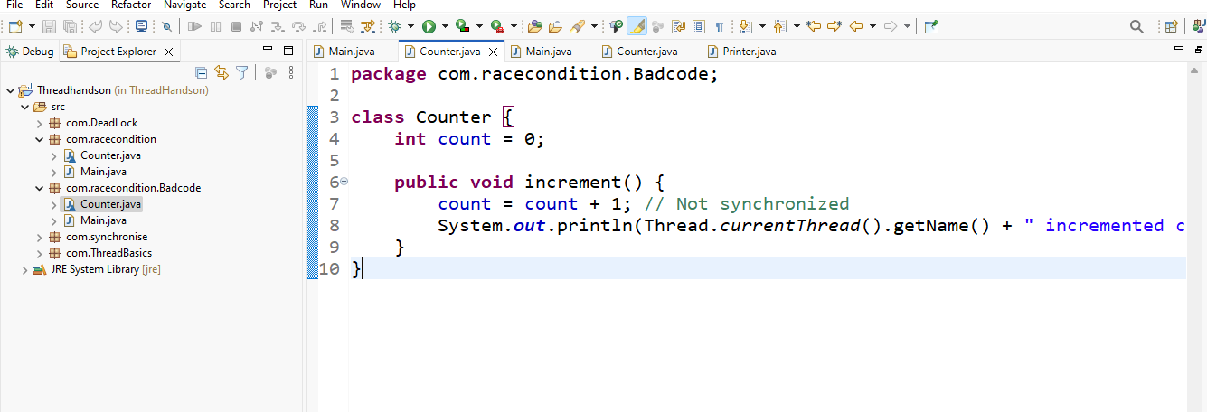
synchronize is used to avoid race condition.but if you don’t use synchronize properly it may end up in dead look
Go and refer here
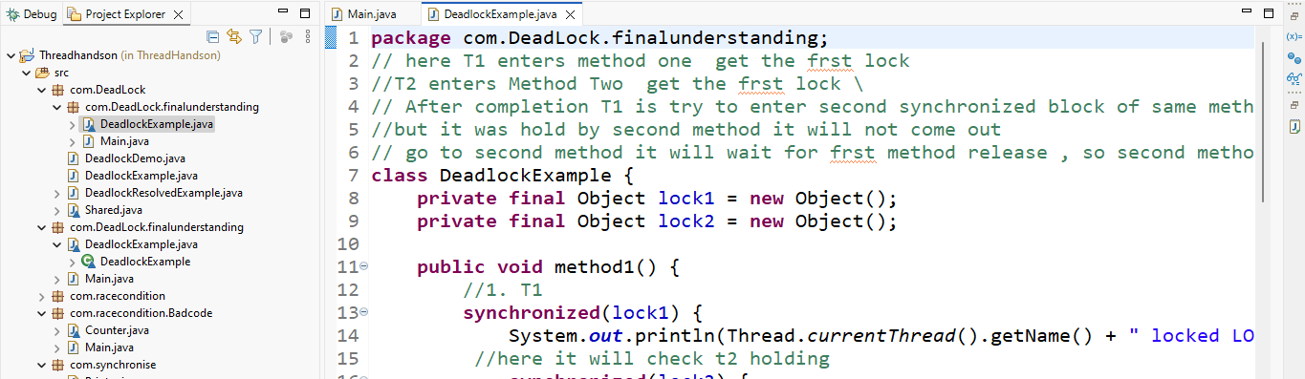
Concept | Meaning
Concurrency | Multiple tasks progress together, maybe switching back & forth
Parallelism | Multiple tasks run truly at the same time, on different CPU cores

• Thread Life Cycle = Big picture (entire flow)
• Thread States = Real-time status within that life cycle
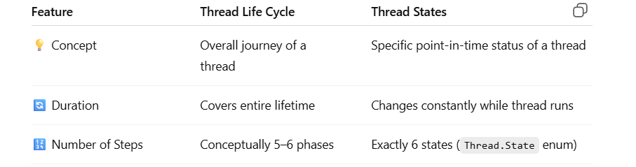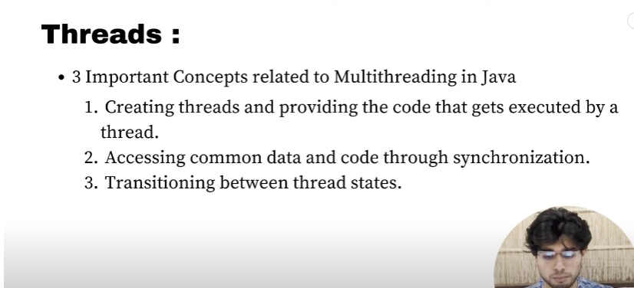

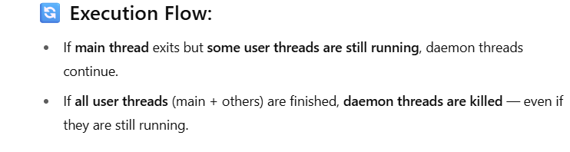

Best method to create is implementing interface
why extending thread class is not better option . if you extend thread class you extend only one class . but if you implements interface you can extend additionally one more class this is the only advantage
start vs run
start is used to create new thread. Once the new thread has been created it iternally calls run method.
Start is an Asynchronous method .
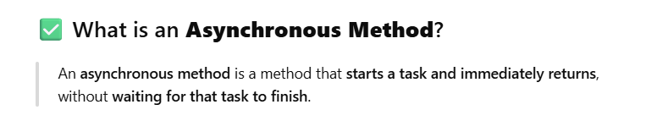
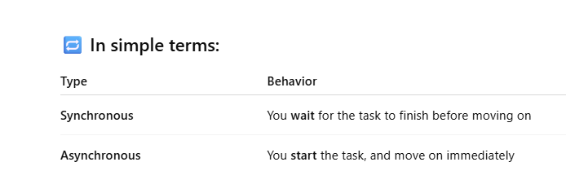
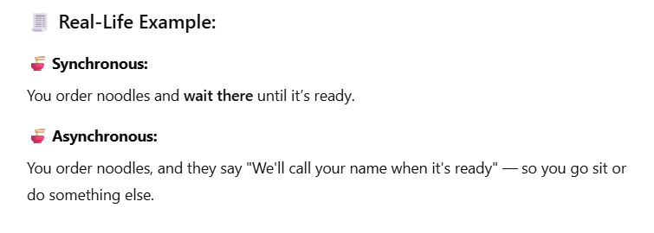



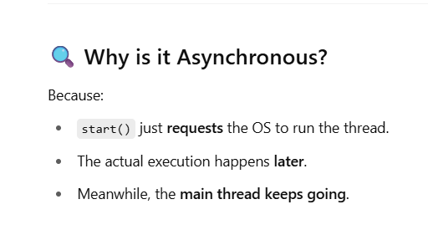

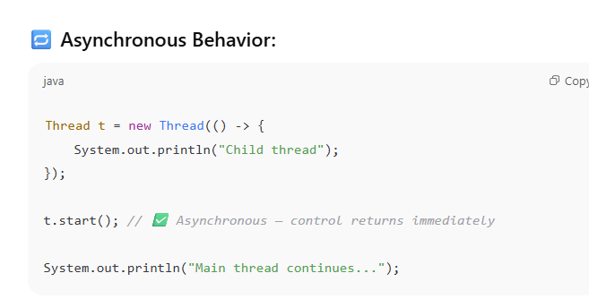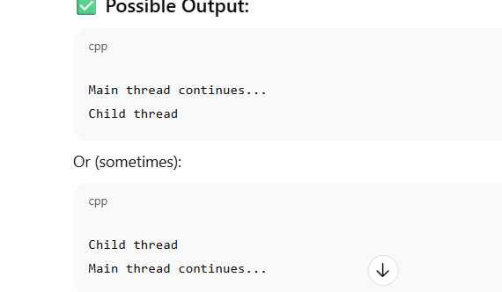

Left 19:00
If the main thread completed jvm will check any other user thread is running . if its running it will executed that also and then finish
24:00 upto 33:00
he tell how the two ways of thread working together
Race condition happening in synchronization
- consider we have multiple thread are in same space try to access on object at a time will lead to error
in below example thread 1 accessed remaining seat simultaniouesly thread 2 access the remaining seats . and update there end as bookings 2 but available seats is one only.

if we avoid this make one thread at a time to access the shared resource
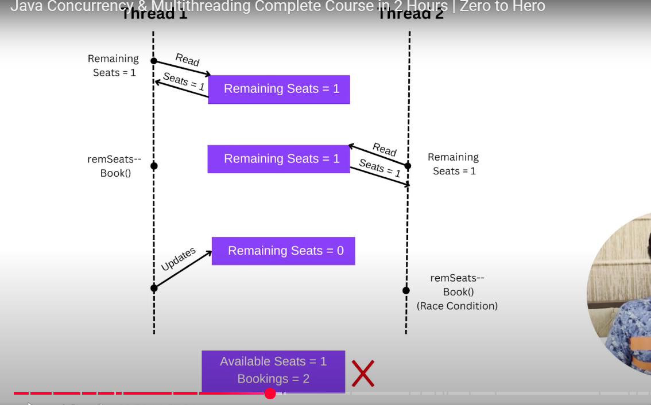

Difference between bocked and waiting state
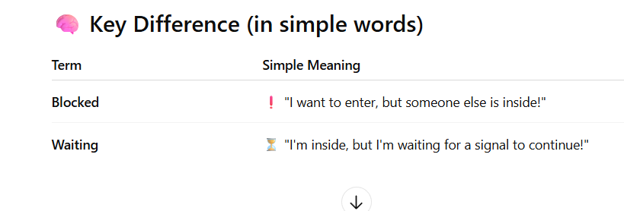
Blocking example
• Thread T1 wants to enter a synchronized method.
• But Thread T2 is already inside that method.
• So T1 is Blocked (waiting for lock).

Waiting example
• Thread T1 is inside the method.
• It calls wait() to pause itself and wait for a signal.
• Another thread must call notify() to wake it up.
Difference between wait and sleep
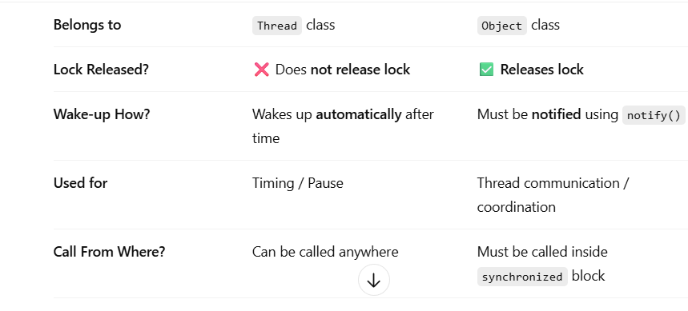
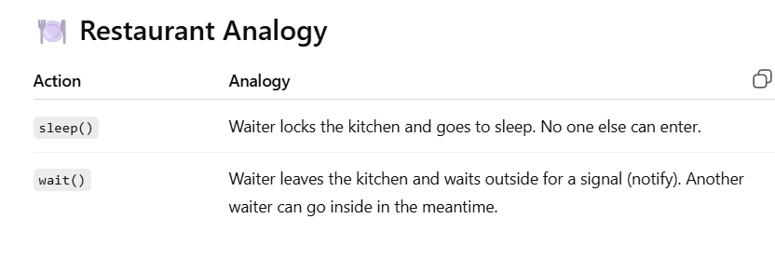
we can use static synchronized method also
THREAD STATES
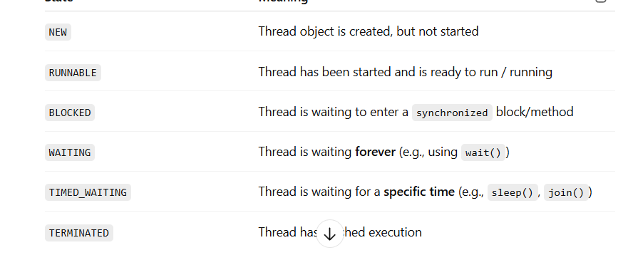

SEE EXAMPLES HERE
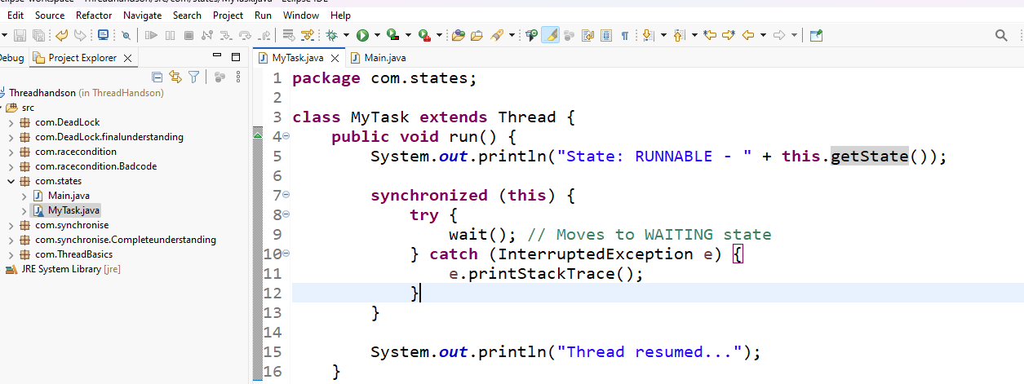

ExecutorService- it will create a thread for us. It will start the thread and will execute the threads.

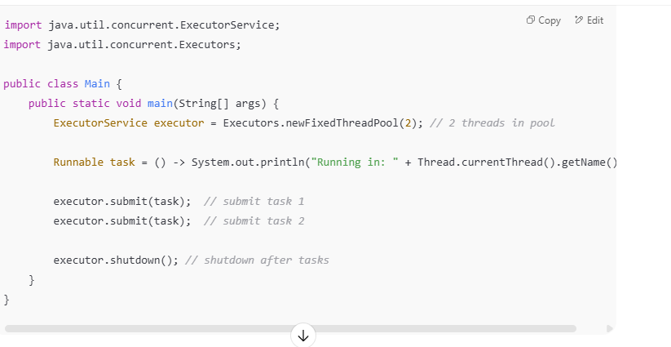
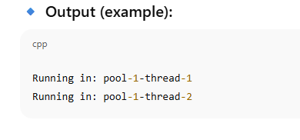

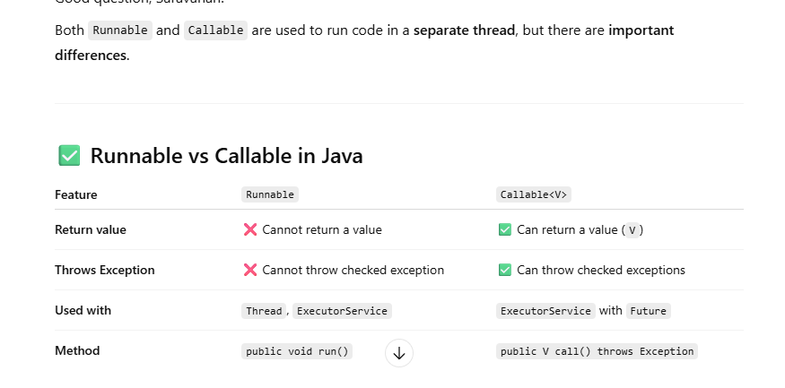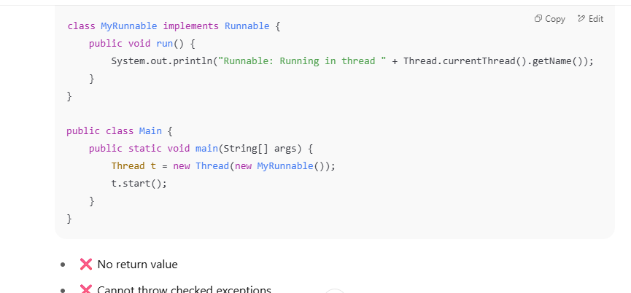

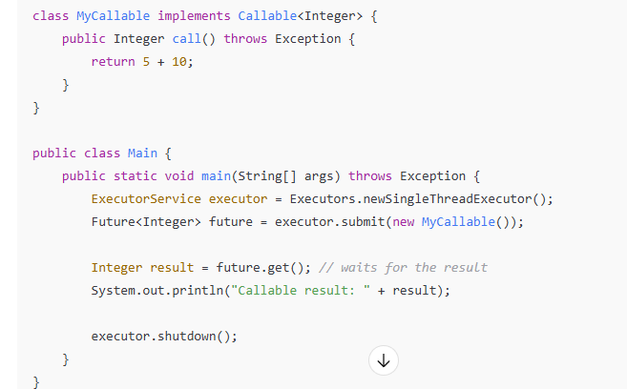

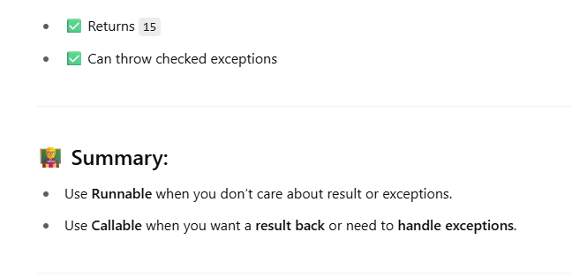

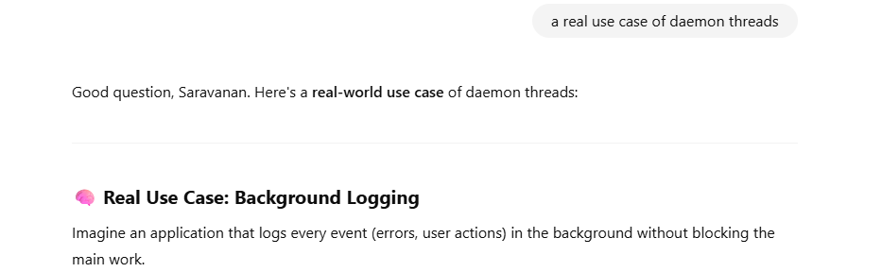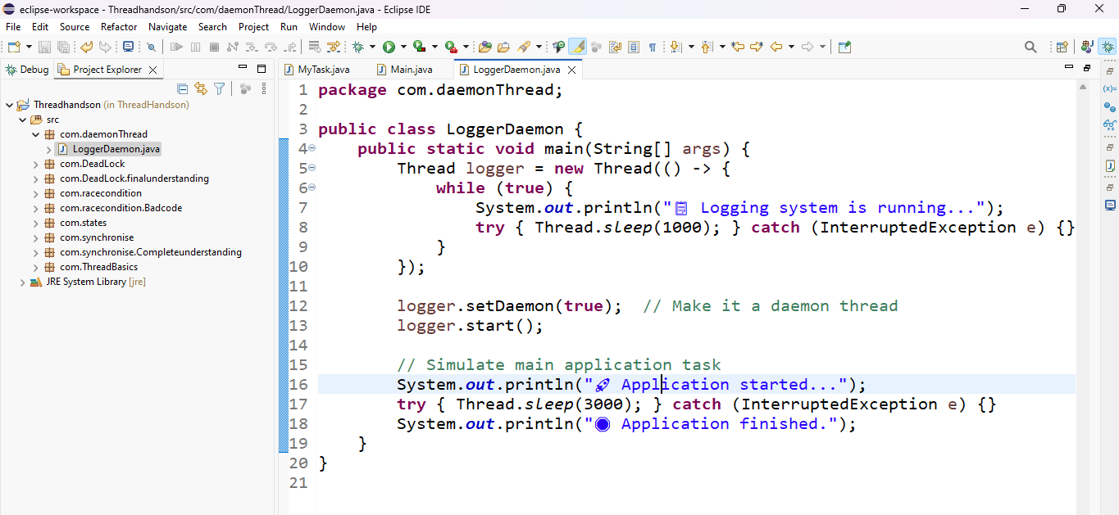

Thread Interruption:
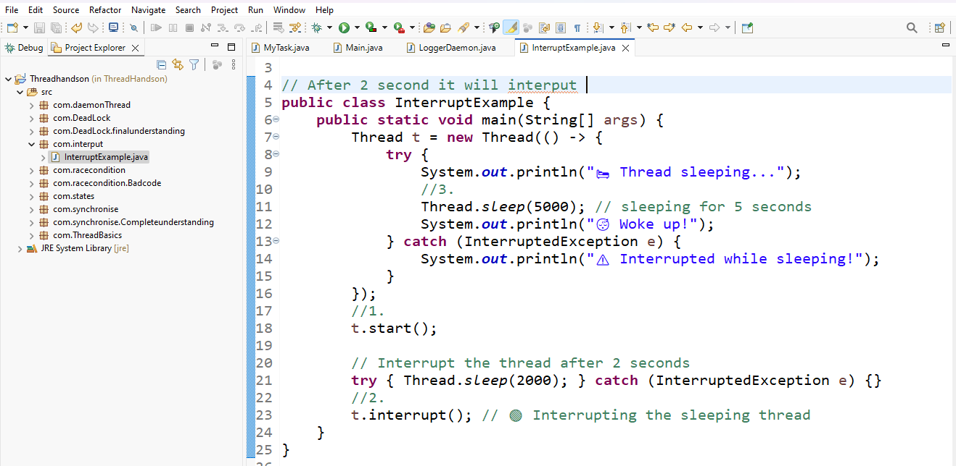

ReentrantLock
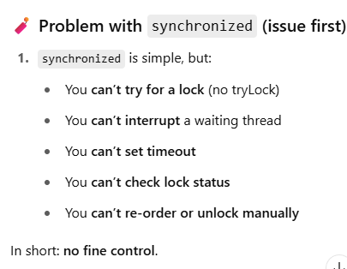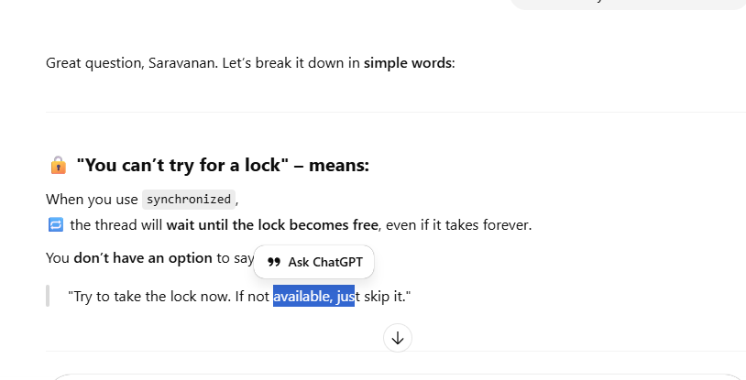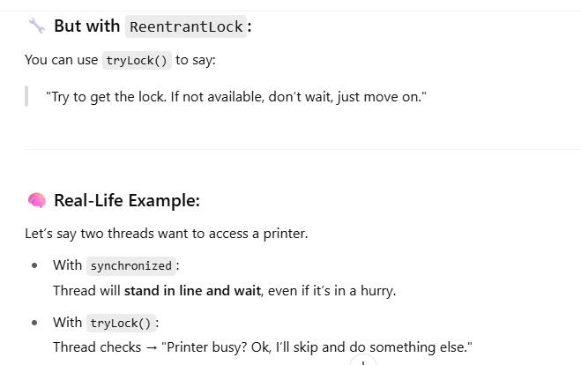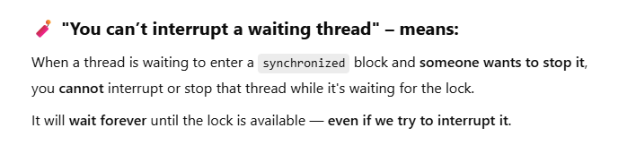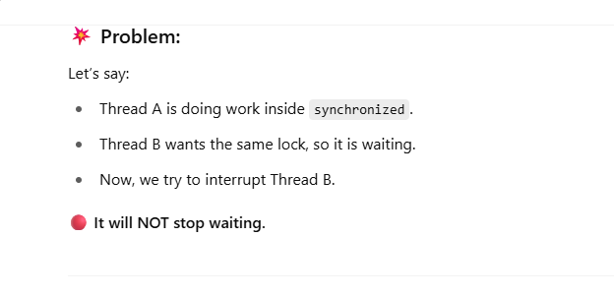
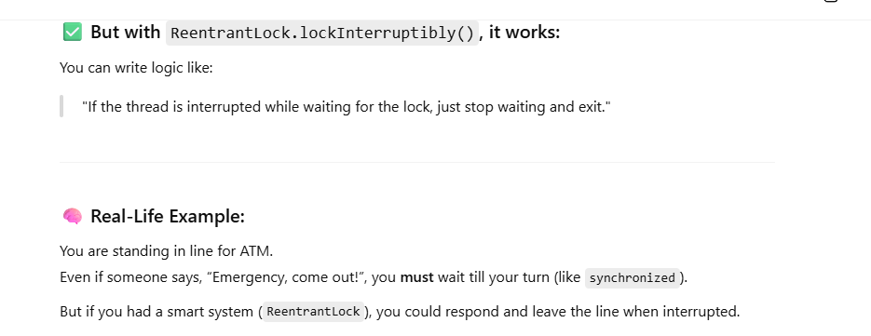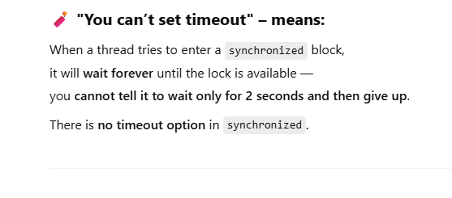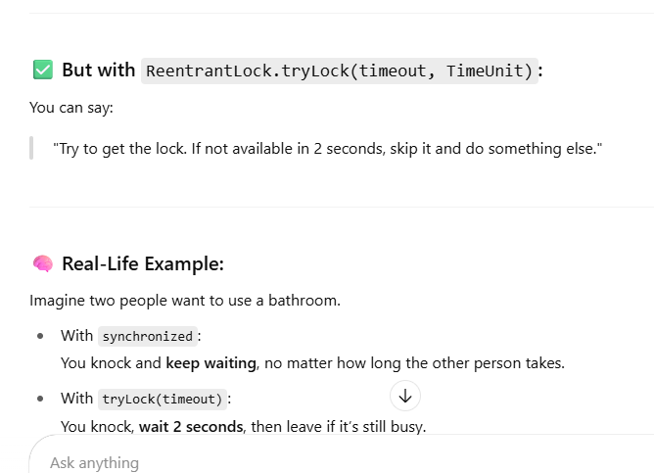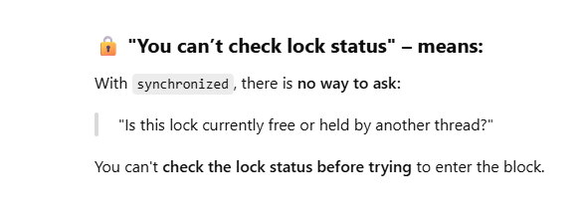

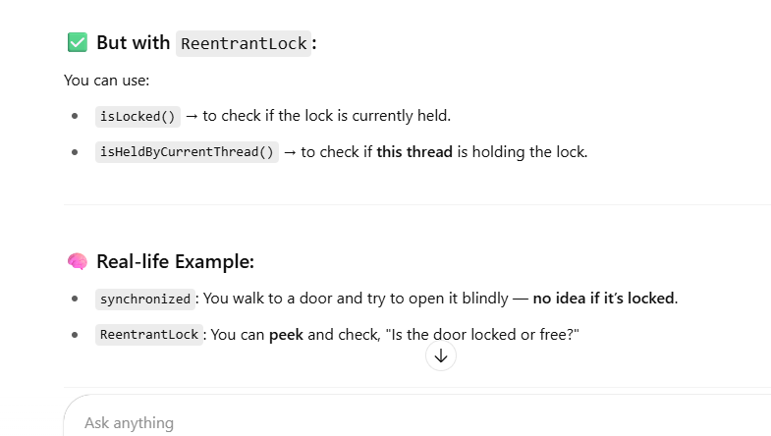
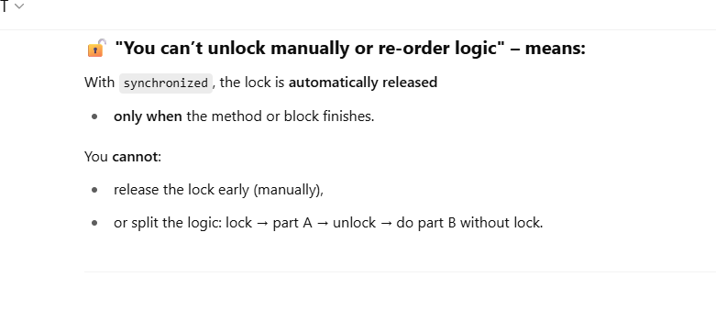
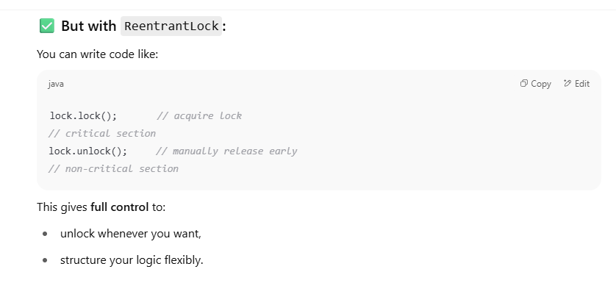
conclusion -to overcome the synchronized issue we use Rentarant lock
