DYNAMIC FLIGHT FARE FORECASTING USING MACROECONOMIC REGRESSORS
A PROJECT REPORT
Submitted in partial fulfilment of the requirements for the award of the degree of
BACHELOR OF TECHNOLOGY
in
COMPUTER SCIENCE AND ENGINEERING
Submitted by
[STUDENT NAME] ([REGISTER NUMBER])
Under the guidance of
[GUIDE NAME], [Designation]
[DEPARTMENT OF COMPUTER SCIENCE AND ENGINEERING]
[COLLEGE NAME]
[City] - [Year]

BONAFIDE CERTIFICATE
This is to certify that this project report titled "Dynamic Flight Fare Forecasting Using Macroeconomic Regressors" is the bonafide work of [STUDENT NAME] ([REGISTER NUMBER]), who carried out the project work under my supervision.
[Guide signature] [Head of Department signature]

DECLARATION
I hereby declare that the project report titled "Dynamic Flight Fare Forecasting Using Macroeconomic Regressors" submitted for the degree of Bachelor of Technology is my original work and has not been submitted for any other degree or diploma.
Place: [City]
Date: [Date] [Student signature]

ACKNOWLEDGEMENT
I thank [Guide name] for guidance throughout this project, the Head of the Department and the faculty of the [Department], and my family and friends for their support. I also thank the Federal Reserve Bank of St. Louis for the free FRED database.

TABLE OF CONTENTS
1. INTRODUCTION 9
1.1 Overview 9
1.2 Time Series Forecasting 9
1.3 ARIMA and ARIMAX 9
1.4 Problem Statement 9
1.5 Objectives 9
1.6 Scope of the Project 10
1.7 Organisation of the Report 10
2. LITERATURE SURVEY 11
2.1 Do jet fuel price movements help forecast airline fares and the demand for air travel? 11
2.2 Another look at measures of forecast accuracy 11
2.3 Comparing predictive accuracy 11
2.4 Spurious regressions in econometrics 11
2.5 statsmodels: Econometric and statistical modeling with Python 11
2.6 Forecasting: Principles and Practice (dynamic regression) 12
3. SYSTEM ANALYSIS 13
3.1 Existing System 13
3.2 Proposed System 13
3.3 Feasibility Study 14
4. SYSTEM REQUIREMENTS 15
4.1 Hardware Requirements 15
4.2 Software Requirements 15
4.3 Functional Requirements 15
5. SYSTEM DESIGN 16
5.1 Design Architecture 16
5.2 Data Flow Diagram 16
5.3 Usecase Diagram 17
5.4 Class Diagram 17
5.5 Activity Diagram 18
5.6 Sequence Diagram 19
5.7 ER Diagram 19
6. DATA AND PRE-PROCESSING 20
6.1 Data Sources 20
6.2 Pre-processing 20
6.3 Exploratory Analysis 21
6.4 Train-Test Split 21
7. METHODOLOGY 22
7.1 Model 1: Multiple Linear Regression 22
7.2 Naive Forecast 22
7.3 ARIMA(1,1,1) 22
7.4 Model 2: ARIMAX(1,1,1) 22
7.5 Robustness Checks 22
7.6 Evaluation Metrics 23
8. IMPLEMENTATION 24
8.1 Software Description 24
8.2 List of Modules 24
8.3 Deploy 24
9. RESULTS AND DISCUSSION 26
9.1 Model 1: Linear Regression 26
9.2 Test-Period Accuracy 26
9.3 Model 2: ARIMAX Coefficients 27
9.4 Order Search 27
9.5 Forecast Horizons 28
9.6 Discussion and Limitations 28
10. CONCLUSION AND FUTURE WORK 29
10.1 Conclusion 29
10.2 Future Work 29
11. REFERENCES 30

ABSTRACT
Airline fares change with the wider economy, yet many fare forecasts rely only on past fare values. This project forecasts the US CPI Airline Fares index using macroeconomic regressors from FRED: jet fuel prices, overall CPI, unemployment, consumer sentiment and a COVID-19 indicator. The combined monthly dataset covers Apr 1990 to Aug 2026 (437 months). All regressors are lagged to avoid data leakage, and the last 36 months are held out for testing.
Model 1, a multiple linear regression on the indicators alone, linked higher fares to inflation (0.5643) and jet fuel (0.1344) and lower fares to the COVID-19 period (-0.3000), but forecast poorly (MAPE 11.729%). Model 2, an ARIMAX(1,1,1) model that combines fare history with the regressors, achieved a one-month-ahead MAPE of 1.771% and R² of 0.923 on the test months, against 2.152% for a naive forecast and 1.849% for ARIMA without regressors. CPI and the COVID-19 period were the significant drivers. Robustness checks with AIC order search, walk-forward retraining and horizons of up to 12 months confirmed a consistent but modest gain from the indicators. A Streamlit application presents the forecast, the accuracy and the drivers.
Keywords: Airfare forecasting, Time series, ARIMA, ARIMAX, Macroeconomic indicators, Jet fuel, CPI, FRED, Streamlit

1. INTRODUCTION

1.1 Overview
Airfares are among the most visible prices in the economy. They react to the cost of jet fuel, to general inflation, to how many people have jobs and how confident consumers feel, and to shocks such as the COVID-19 pandemic, when air travel collapsed. Forecasting fares helps travellers plan, helps airlines and agencies set budgets, and shows how strongly economic conditions are passed on to ticket prices.

1.2 Time Series Forecasting
A time series is a sequence of values recorded in time order, here one value of the fare index per month. Neighbouring months are similar, so the order of observations matters. Forecasting predicts future values, and a forecast must always be judged on periods that come after the data used to build it.

1.3 ARIMA and ARIMAX
ARIMA models predict a series from its own past values (AR), from past forecast errors (MA) and after differencing (I) to remove trends. ARIMAX adds external explanatory variables (the X), so that forecasts can respond to changes in the economy [6].

1.4 Problem Statement
Airfares rise and fall with fuel costs, inflation and travel demand, and they collapsed during the COVID-19 pandemic. Forecasts built only on past fares cannot explain these movements, while models built only on economic indicators ignore that this month's fare is closely tied to last month's. The problem is to forecast the US airline fare index accurately, explain how the economy moves it, and measure honestly how much the economic indicators add.

1.5 Objectives
1. Collect the US CPI Airline Fares index and four macroeconomic series from FRED.
2. Build one monthly dataset with lags that prevent data leakage and a COVID-19 indicator.
3. Explore the relationships: correlations and the best jet fuel lag.
4. Fit a baseline linear regression on the indicators alone (Model 1) and read its coefficients.
5. Fit ARIMAX(1,1,1) (Model 2), which combines fare history with the indicators, and compare it with naive and ARIMA benchmarks on the last 36 months.
6. Test robustness: AIC order search, walk-forward retraining and forecast horizons of 1, 3, 6 and 12 months.
7. Deliver a Streamlit app that shows the forecast, the accuracy and the drivers.

1.6 Scope of the Project
The project forecasts the US airline fare index (not individual ticket prices) at monthly frequency, using public US data. Indian fares and route-level prices are outside the scope and listed as future work.

1.7 Organisation of the Report
Chapter 2 reviews the literature, Chapter 3 the existing and proposed systems, Chapter 4 the requirements and Chapter 5 the design. Chapter 6 describes the data, Chapter 7 the method, Chapter 8 the implementation and Chapter 9 the results. Chapter 10 gives the conclusion and future work, followed by the references.

2. LITERATURE SURVEY

2.1 Do jet fuel price movements help forecast airline fares and the demand for air travel?
Authors: Atems, Bachmeier and Williams, 2019 [1]
Studies whether jet fuel prices help predict US airline fares and air travel demand, using in-sample and out-of-sample forecasting exercises.
Relevance to this project: Base paper: motivates jet fuel as a regressor and out-of-sample evaluation of what it adds.

2.2 Another look at measures of forecast accuracy
Authors: Hyndman and Koehler, 2006 [2]
Reviews forecast accuracy measures such as MAPE and RMSE, explains when they break down, and recommends scaled errors for comparing series.
Relevance to this project: Guides the choice of MAPE, RMSE and R², and the comparison with a naive forecast.

2.3 Comparing predictive accuracy
Authors: Diebold and Mariano, 1995 [3]
Proposes a test of whether two forecasts differ significantly in accuracy.
Relevance to this project: Named as future work to test whether ARIMAX's gain over ARIMA is significant.

2.4 Spurious regressions in econometrics
Authors: Granger and Newbold, 1974 [4]
Shows that regressing one trending (non-stationary) series on another often gives high R² and 'significant' coefficients that are meaningless.
Relevance to this project: Explains why correlations are measured on year-over-year changes and why ARIMAX models differences (d = 1).

2.5 statsmodels: Econometric and statistical modeling with Python
Authors: Seabold and Perktold, 2010 [5]
Describes the statsmodels library, which provides SARIMAX and other time-series models in Python.
Relevance to this project: Provides the SARIMAX implementation used for ARIMA and ARIMAX.

2.6 Forecasting: Principles and Practice (dynamic regression)
Authors: Hyndman and Athanasopoulos, 2021 [6]
Textbook treatment of ARIMA and dynamic regression: regression on external predictors with ARIMA errors, forecasting with predictors and evaluation on test periods.
Relevance to this project: The methodological basis of the ARIMAX model and the time-based evaluation.

3. SYSTEM ANALYSIS

3.1 Existing System
Fare forecasts are commonly made from the history of the fares alone (trend and seasonal patterns), or from simple regressions on economic variables. Atems et al. [1] show that jet fuel prices carry some predictive information for US airfares, but a plain regression on trending series risks spurious results [4], and a history-only model cannot say why fares change.

Disadvantages of the Existing System
- No economic explanation: history-only forecasts cannot attribute a rise to fuel or inflation.
- Slow to react to shocks: the COVID-19 collapse broke past patterns.
- Regression alone ignores time: it treats months as independent and cannot correct itself when fares drift.
- Spurious relationships: series that both trend upward look related even when they are not [4].

3.2 Proposed System
The proposed system forecasts the fare index with ARIMAX, a regression with ARIMA errors [6] that keeps fare history and adds the macroeconomic regressors. All regressors are lagged so only information available at forecast time is used, the last 36 months are held out, and the model is compared with a naive forecast and with ARIMA without regressors to isolate what the indicators add.

Advantages of the Proposed System
- Accurate: MAPE 1.771% on the test months, R² 0.923, against 11.729% for the linear regression baseline.
- Explainable: coefficients show how CPI and the COVID-19 period move fares, with p-values.
- Honest evaluation: time-based split, lagged regressors and fair benchmarks.
- Robust: checked with AIC tuning, walk-forward retraining and four forecast horizons.
- Reproducible: public FRED data that can be refreshed every month.

3.3 Feasibility Study

Technical Feasibility
A few hundred monthly observations; all models fit in seconds with statsmodels on a normal laptop.

Economic Feasibility
FRED data and all software are free.

Operational Feasibility
The app needs only a browser; data can be refreshed by downloading the latest FRED CSVs.

4. SYSTEM REQUIREMENTS

4.1 Hardware Requirements
Table 4.1: Hardware requirements
Component | Minimum
Processor | Intel Core i3 or equivalent
RAM | 4 GB
Hard disk | 1 GB free space

4.2 Software Requirements
Table 4.2: Software requirements
Component | Specification
Operating system | Windows 10/11
Language | Python 3.x (Anaconda)
Environment | Jupyter Notebook
Libraries | pandas, NumPy, matplotlib, scikit-learn, statsmodels, Streamlit

4.3 Functional Requirements
- Load and align the five FRED series.
- Fit ARIMAX and the benchmarks and forecast the test months.
- Report MAPE, RMSE and R².
- Show the forecast, the accuracy and the drivers in a web app.

5. SYSTEM DESIGN

5.1 Design Architecture
Figure 5.1 shows the flow from the FRED downloads to the evaluated forecasts and the app.
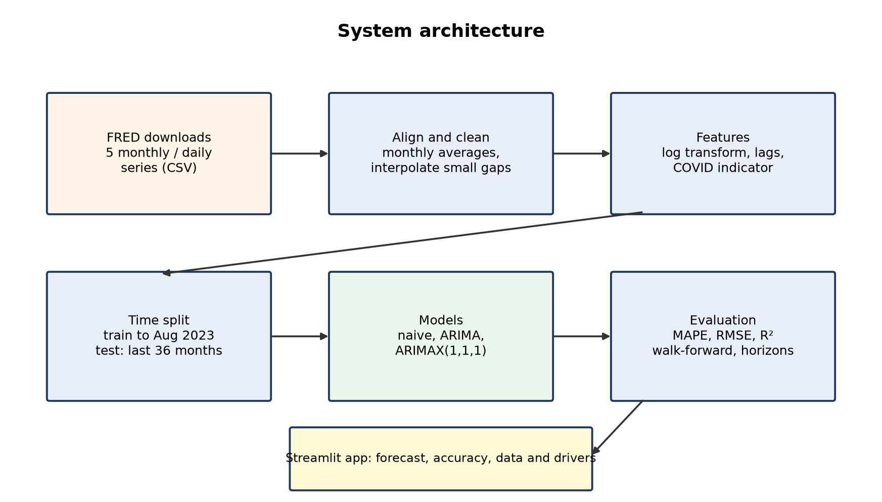
Figure 5.1: System architecture

5.2 Data Flow Diagram
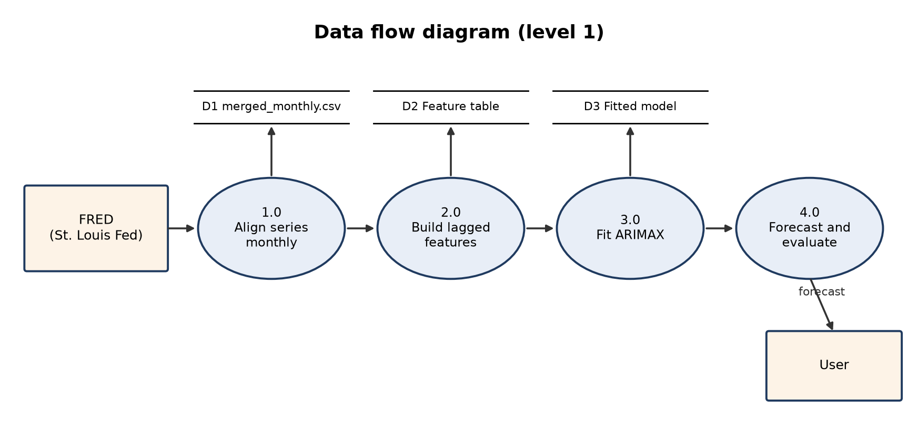
Figure 5.2: Data flow diagram (level 1)

5.3 Usecase Diagram
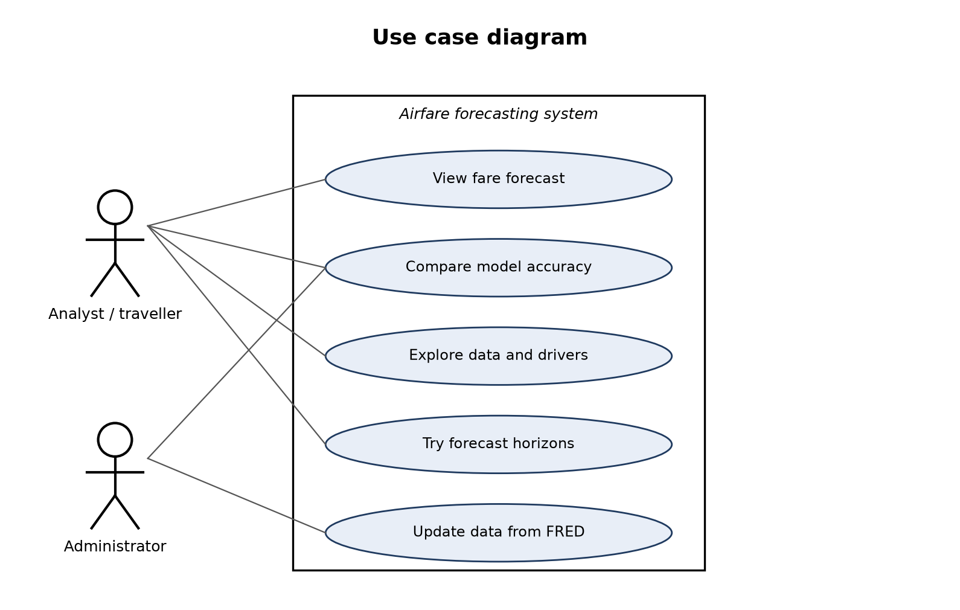
Figure 5.3: Use case diagram

5.4 Class Diagram
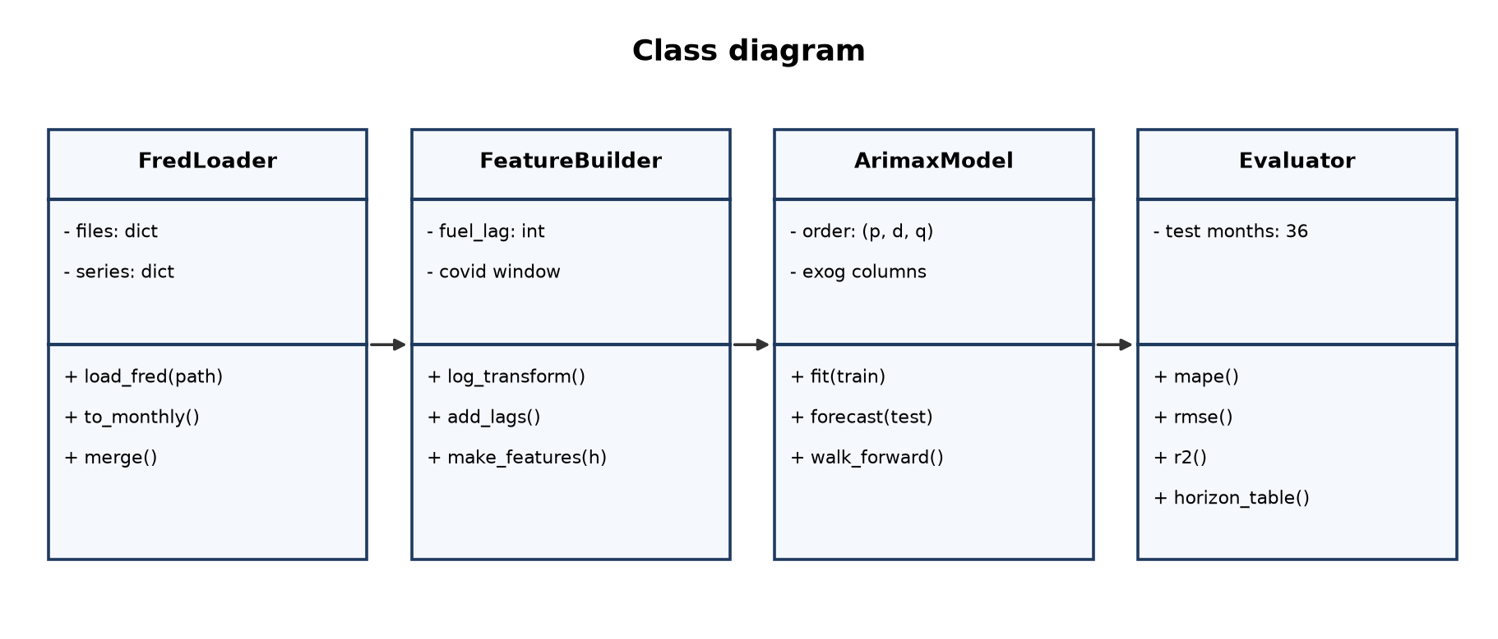
Figure 5.4: Class diagram

5.5 Activity Diagram
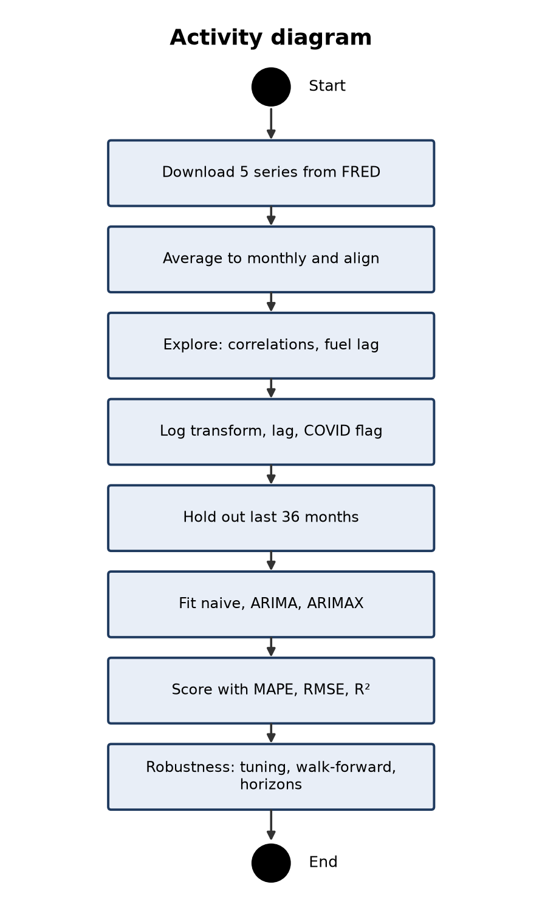
Figure 5.5: Activity diagram

5.6 Sequence Diagram
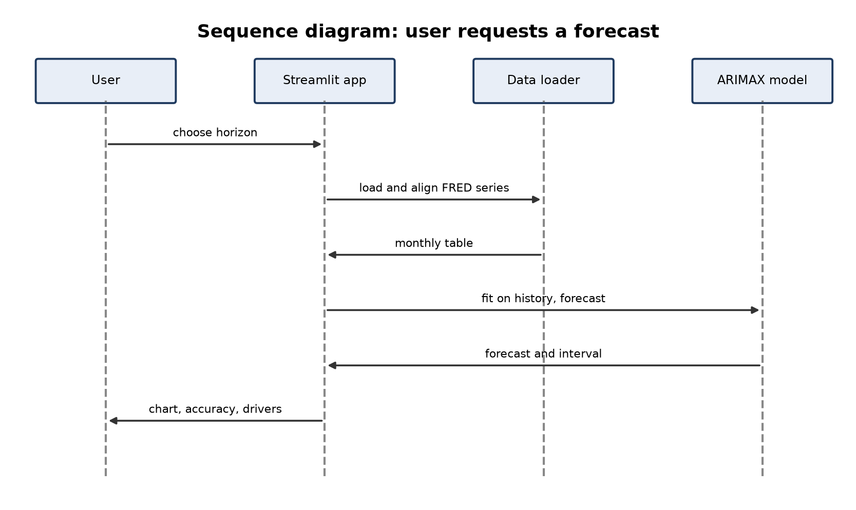
Figure 5.6: Sequence diagram

5.7 ER Diagram
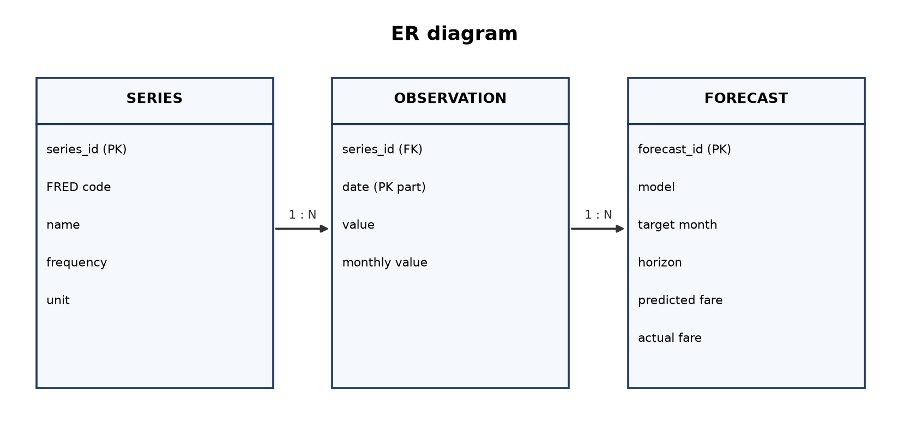
Figure 5.7: ER diagram

6. DATA AND PRE-PROCESSING

6.1 Data Sources
Table 6.1: Data series
Series | FRED ID | Role | What it measures | Frequency
Airline fares | CUSR0000SETG01 | Target | US CPI Airline Fares index (seasonally adjusted) | Monthly
jet_fuel | DJFUELUSGULF | Regressor | Jet fuel price, US Gulf Coast ($/gallon) | Daily → monthly mean
cpi | CPIAUCSL | Regressor | Overall Consumer Price Index | Monthly
unemp | UNRATE | Regressor | Unemployment rate (%) | Monthly
sentiment | UMCSENT | Regressor | University of Michigan consumer sentiment | Monthly

Table 6.2: Date range of each download
Series | From | To
airfare | Jan 1989 | Aug 2026
jet_fuel | Apr 1990 | Sep 2026
cpi | Jan 1947 | Aug 2026
unemp | Jan 1948 | Sep 2026
sentiment | Nov 1952 | Aug 2026

6.2 Pre-processing
- Daily jet fuel prices are averaged to monthly values.
- Months where any series is missing at the start are dropped; gaps of up to 3 months are interpolated.
- The merged table has 437 months (Apr 1990 to Aug 2026) and is saved as merged_monthly.csv.
- Fares, fuel and CPI are log-transformed so coefficients read as percentage effects.
Table 6.3: Model features
Column | Definition | Why
y | log(airfare) | Target (log, so changes are percentages)
fuel | log(jet fuel), lagged 2 months | Lag chosen by lag-correlation analysis
cpi | log(CPI), lagged 1 month | Not yet published in the forecast month
unemp | unemployment, lagged 1 month | Same reason
sentiment | sentiment, lagged 1 month | Same reason
covid | 1 from Mar 2020 to Jun 2021, else 0 | Pandemic indicator

6.3 Exploratory Analysis
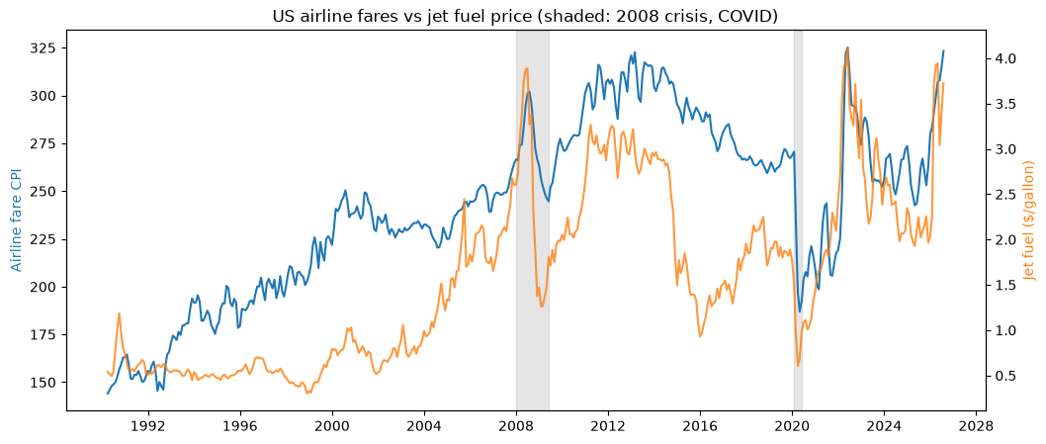
Figure 6.1: Airline fare index and jet fuel price
Table 6.4: Correlation of year-over-year changes
 | airfare | jet_fuel | cpi | unemp | sentiment
airfare | 1.00 | 0.53 | 0.62 | -0.48 | -0.16
jet_fuel | 0.53 | 1.00 | 0.66 | -0.38 | -0.17
cpi | 0.62 | 0.66 | 1.00 | -0.35 | -0.33
unemp | -0.48 | -0.38 | -0.35 | 1.00 | -0.26
sentiment | -0.16 | -0.17 | -0.33 | -0.26 | 1.00

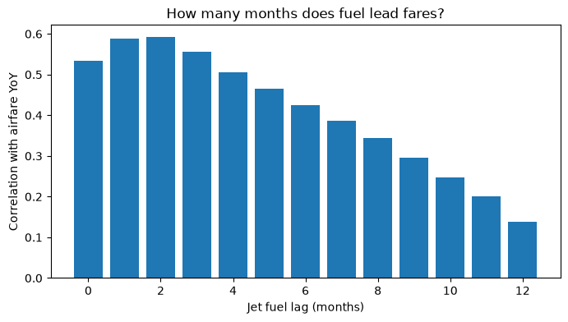
Figure 6.2: Lag correlation; best jet fuel lag 2 months

6.4 Train-Test Split
Training months: Jun 1990 to Aug 2023 (399). Test months: Sep 2023 to Aug 2026 (36). The data is never shuffled.

7. METHODOLOGY

7.1 Model 1: Multiple Linear Regression
Ordinary least squares picks the coefficients that minimise the squared differences between predicted and actual log fares over the training months. Because fares, fuel and CPI are in logs, their coefficients are percentage effects (elasticities).
log(Fare_t) = β0 + β1 log(Fuel_(t-2)) + β2 log(CPI_(t-1)) + β3 Unemp_(t-1) + β4 Sent_(t-1) + β5 COVID_t + ε_t

7.2 Naive Forecast
Next month's fare equals this month's. Every useful model must beat it.

7.3 ARIMA(1,1,1)
Models the monthly change in log fares from the previous change and the previous forecast error, without regressors.

7.4 Model 2: ARIMAX(1,1,1)
Adds the lagged regressors to ARIMA, i.e. a regression with ARIMA errors [6]. The model is fitted once on the training months and then applied to the test months one month at a time, revealing each actual value before forecasting the next.
Δy_t = φ1 Δy_(t-1) + θ1 ε_(t-1) + β1 fuel_(t-2) + β2 cpi_(t-1) + β3 unemp_(t-1) + β4 sent_(t-1) + β5 covid_t + ε_t

7.5 Robustness Checks
- AIC order search: all orders (p, 1, q) with p, q from 0 to 3.
- Walk-forward: retrain every month on all data before it, then forecast the next month.
- Ensemble: average of walk-forward ARIMAX, walk-forward ARIMA and naive.
- Horizons: 1, 3, 6 and 12 months, with every regressor lagged at least the horizon.

7.6 Evaluation Metrics
Table 7.1: Evaluation metrics
Metric | Formula | Meaning
MAPE | mean(|actual - forecast| / actual) × 100 | Typical miss in percent; main metric
RMSE | sqrt(mean((actual - forecast)²)) | Typical miss in index points, punishing large misses
R² | 1 - SS_res / SS_tot | Share of variation explained (1 = perfect)

8. IMPLEMENTATION

8.1 Software Description

Python
Language used for all code.

Jupyter Notebook
Interactive environment for the two notebooks.

pandas and NumPy
Reading the FRED CSVs, resampling, merging and transforming.

statsmodels
SARIMAX implementation for ARIMA and ARIMAX [5].

scikit-learn
MAPE, RMSE and R² metrics.

matplotlib
Charts.

Streamlit
The web application.

8.2 List of Modules
1. Data loading and alignment
2. Exploratory analysis
3. Feature construction
4. Model fitting and forecasting
5. Evaluation and robustness
6. Web application

8.3 Deploy
The app reads the FRED files from ML06-second-review/data and opens at http://localhost:8501.
cd ML06-FLIGHT-FARE-FORECASTING\ML06-final-review\app
streamlit run flight_app.py

Table 8.1: Application tabs
Tab | Function
Forecast | Forecast of the fare index with the chosen horizon
Model accuracy | Test-period accuracy of the models
Data and drivers | The series and how they relate to fares

9. RESULTS AND DISCUSSION

9.1 Model 1: Linear Regression
Table 9.1: Model 1 coefficients
Term | Coefficient | p-value
const | 1.9025 | 0.0
fuel | 0.1344 | 0.0
cpi | 0.5643 | 0.0
unemp | 0.0250 | 0.0
sentiment | 0.0049 | 0.0
covid | -0.3000 | 0.0

Model 1 is a multiple linear regression (ordinary least squares) of log fares on the same lagged indicators, without fare history. It links higher fares to inflation (CPI 0.5643) and jet fuel (0.1344) and lower fares to the COVID-19 period (-0.3000). Because fares, fuel and CPI are in logs, a 10% higher price level goes with about 5.6% higher fares. But it treats every month as independent and cannot correct itself when fares drift, so its forecasts are poor: MAPE 11.729%, RMSE 33.686, R² -1.771 (worse than predicting the average). The unemployment coefficient has the wrong sign, a symptom of overlap with CPI (multicollinearity).

9.2 Test-Period Accuracy
Table 9.2: All models, one month ahead
Model | MAPE % | RMSE | R²
ARIMAX (with macro) | 1.771 | 5.623 | 0.923
ARIMAX tuned (1, 1, 2) | 1.782 | 5.712 | 0.920
ARIMAX walk-forward (with macro) | 1.805 | 5.749 | 0.919
ARIMA walk-forward (no macro) | 1.848 | 5.837 | 0.917
ARIMA (no macro) | 1.849 | 5.777 | 0.919
Ensemble (avg of 3) | 1.888 | 5.955 | 0.913
Naive (last month) | 2.152 | 6.958 | 0.882
Linear regression (macro only) | 11.729 | 33.686 | -1.771

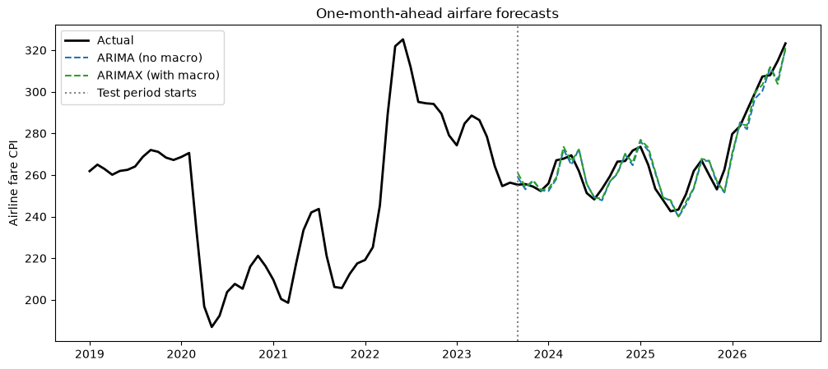
Figure 9.1: Actual fares and forecasts

9.3 Model 2: ARIMAX Coefficients
Table 9.3: ARIMAX(1,1,1) coefficients
Term | Coefficient | p-value
fuel | 0.0126 | 0.3272
cpi | 1.6723 | 0.0000
unemp | 0.0007 | 0.7500
sentiment | 0.0002 | 0.2787
covid | -0.0457 | 0.0000
ar.L1 | -0.1269 | 0.0702
ma.L1 | 0.6714 | 0.0000
sigma2 | 0.0005 | 0.0000

9.4 Order Search
Table 9.4: Best orders by AIC
Order (p, 1, q) | AIC
(1, 1, 2) | -1873.920980
(2, 1, 2) | -1873.168264
(1, 1, 3) | -1871.674879
(3, 1, 2) | -1870.700538
(2, 1, 3) | -1870.329145

9.5 Forecast Horizons
Table 9.5: MAPE by horizon
Horizon (months) | Naive MAPE % | ARIMA MAPE % | ARIMAX MAPE % | Macro gain %
1 | 2.15 | 1.85 | 1.77 | 4.23
3 | 4.97 | 4.71 | 4.72 | -0.28
6 | 6.96 | 6.96 | 6.78 | 2.64
12 | 7.97 | 7.88 | 7.65 | 2.94

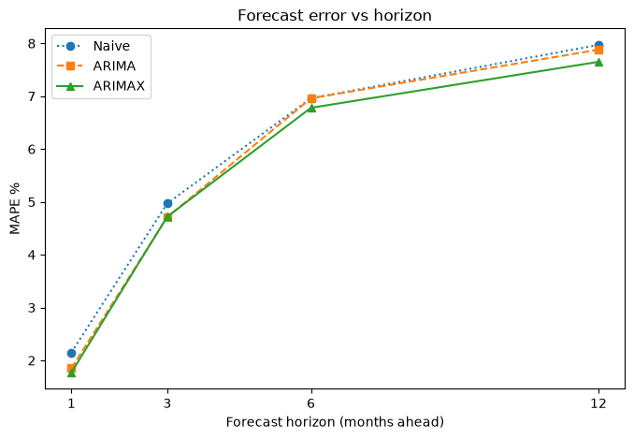
Figure 9.2: MAPE by forecast horizon

9.6 Discussion and Limitations
- ARIMAX is the best model (1.771% MAPE), 85% lower than the linear regression (11.729%); fare history provides most of the accuracy, the indicators a modest gain (4.2% over ARIMA).
- Model 1's regression on trending levels is exposed to spurious regression [4] and multicollinearity (unemployment's coefficient has the wrong sign).
- CPI includes airline fares, so part of the CPI effect overlaps with the target.
- Fuel's effect builds slowly and overlaps with CPI, so it is not significant in the short run.
- Future regressor values are unknown when forecasting far ahead, which is why they are lagged by the horizon.
- FRED revises recent data, so downloads on different days can differ slightly.

10. CONCLUSION AND FUTURE WORK

10.1 Conclusion
Airline fares are best forecast by combining their own recent history with macroeconomic conditions. The linear regression baseline showed the expected directions (inflation and fuel raise fares, COVID-19 lowered them) but forecast poorly (11.729% MAPE). ARIMAX(1,1,1) reached 1.771% MAPE on the last 36 months, beating the naive forecast and ARIMA without regressors, and CPI and the COVID-19 period were its significant drivers.

10.2 Future Work
- Test whether ARIMAX's gain over ARIMA is significant with the Diebold-Mariano test [3].
- Add airline-specific data: passenger traffic, seat capacity, route prices.
- Apply the method to Indian fares with aviation turbine fuel prices and the USD/INR rate.
- Use CPI excluding airfares to remove the overlap with the target.

11. REFERENCES
[1] B. Atems, L. Bachmeier, C. Williams, "Do jet fuel price movements help forecast airline fares and the demand for air travel?," Applied Economics Letters, vol. 26, no. 11, pp. 877-882, 2019. Available: https://doi.org/10.1080/13504851.2018.1510466
[2] R. J. Hyndman, A. B. Koehler, "Another look at measures of forecast accuracy," International Journal of Forecasting, vol. 22, no. 4, pp. 679-688, 2006. Available: https://doi.org/10.1016/j.ijforecast.2006.03.001
[3] F. X. Diebold, R. S. Mariano, "Comparing predictive accuracy," Journal of Business & Economic Statistics, vol. 13, no. 3, pp. 253-263, 1995. Available: https://doi.org/10.1080/07350015.1995.10524599
[4] C. W. J. Granger, P. Newbold, "Spurious regressions in econometrics," Journal of Econometrics, vol. 2, no. 2, pp. 111-120, 1974. Available: https://doi.org/10.1016/0304-4076(74)90034-7
[5] S. Seabold, J. Perktold, "statsmodels: Econometric and statistical modeling with Python," Proceedings of the 9th Python in Science Conference (SciPy 2010), pp. 92-96, 2010. Available: https://doi.org/10.25080/Majora-92bf1922-011
[6] R. J. Hyndman, G. Athanasopoulos, "Forecasting: Principles and Practice, 3rd edition (chapter 10, Dynamic regression models)," OTexts, Melbourne, 2021. Available: https://otexts.com/fpp3/

