Dynamic Flight Fare Forecasting Using Macroeconomic Regressors
Second Review: Implementation, Results and Model Selection
[Student name] · [Register number] · Guide: [Guide's name] · [Department, College]

1. Progress since the first review
- Five FRED series downloaded, aligned to monthly values and merged (merged_monthly.csv).
- Data explored: correlations of year-over-year changes and the best jet fuel lag (M1_data_exploration.ipynb, M2_arimax.ipynb).
- Model 1 (linear regression) and Model 2 (ARIMAX) fitted with naive and ARIMA benchmarks, all scored on the last 36 months (M2_arimax.ipynb).
- Robustness checks: AIC order search, walk-forward retraining, ensemble and forecast horizons.
- Streamlit app (flight_app.py) built for the final review.

2. Data preparation
Table 1: Preparation steps
Step | What was done | Result
Load | Five FRED CSVs read; daily jet fuel averaged to months | One monthly table
Align | Keep months where all series exist; interpolate gaps of up to 3 months | 437 months, Apr 1990 to Aug 2026
Features | log fares, fuel and CPI; fuel lagged 2 months, others 1; COVID indicator | 435 usable rows
Split | Last 36 months held out | train 399 / test 36 months

3. Exploratory analysis
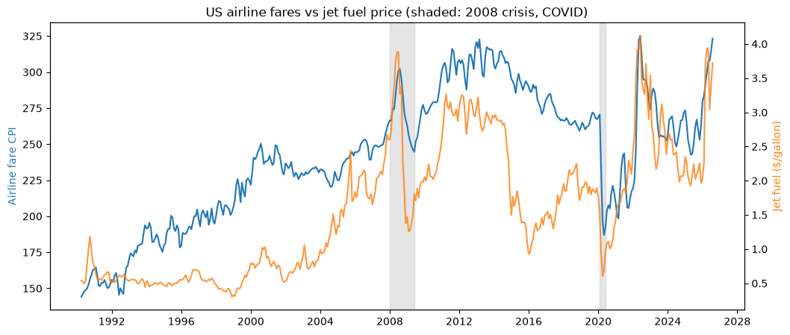
Figure 1: Airline fare index and jet fuel price
Table 2: Correlation of year-over-year changes (M2 notebook)
 | airfare | jet_fuel | cpi | unemp | sentiment
airfare | 1.00 | 0.53 | 0.62 | -0.48 | -0.16
jet_fuel | 0.53 | 1.00 | 0.66 | -0.38 | -0.17
cpi | 0.62 | 0.66 | 1.00 | -0.35 | -0.33
unemp | -0.48 | -0.38 | -0.35 | 1.00 | -0.26
sentiment | -0.16 | -0.17 | -0.33 | -0.26 | 1.00

Correlations are measured on year-over-year changes rather than levels, because series that all trend upward would otherwise look strongly related [4]. Fare changes move with jet fuel and CPI and against unemployment.
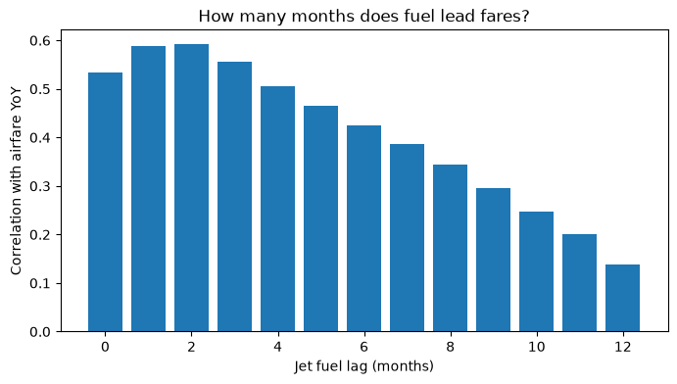
Figure 2: Correlation of fare changes with lagged jet fuel changes
The strongest correlation is at a jet fuel lag of 2 months, so fuel enters the model lagged by 2 months. (The M1 notebook, run on only 437 months of fuel data, found a lag of 2.)

4. Models and results

Model 1: linear regression
Table 3: Model 1 coefficients (log fares on lagged indicators)
Term | Coefficient | p-value
const | 1.9025 | 0.0
fuel | 0.1344 | 0.0
cpi | 0.5643 | 0.0
unemp | 0.0250 | 0.0
sentiment | 0.0049 | 0.0
covid | -0.3000 | 0.0

Model 1 is a multiple linear regression (ordinary least squares) of log fares on the same lagged indicators, without fare history. It links higher fares to inflation (CPI 0.5643) and jet fuel (0.1344) and lower fares to the COVID-19 period (-0.3000). Because fares, fuel and CPI are in logs, a 10% higher price level goes with about 5.6% higher fares. But it treats every month as independent and cannot correct itself when fares drift, so its forecasts are poor: MAPE 11.729%, RMSE 33.686, R² -1.771 (worse than predicting the average). The unemployment coefficient has the wrong sign, a symptom of overlap with CPI (multicollinearity).

All models on the test months
Table 4: All models on the test months Sep 2023 to Aug 2026 (one month ahead)
Model | MAPE % | RMSE | R²
ARIMAX (with macro) | 1.771 | 5.623 | 0.923
ARIMAX tuned (1, 1, 2) | 1.782 | 5.712 | 0.920
ARIMAX walk-forward (with macro) | 1.805 | 5.749 | 0.919
ARIMA walk-forward (no macro) | 1.848 | 5.837 | 0.917
ARIMA (no macro) | 1.849 | 5.777 | 0.919
Ensemble (avg of 3) | 1.888 | 5.955 | 0.913
Naive (last month) | 2.152 | 6.958 | 0.882
Linear regression (macro only) | 11.729 | 33.686 | -1.771

ARIMAX with the macroeconomic regressors (Model 2) is the most accurate model: MAPE 1.771%, about 85% lower than the linear regression, 18% lower than the naive forecast and 4.2% lower than ARIMA without regressors. Fare history does most of the work; the indicators add a consistent but modest gain.
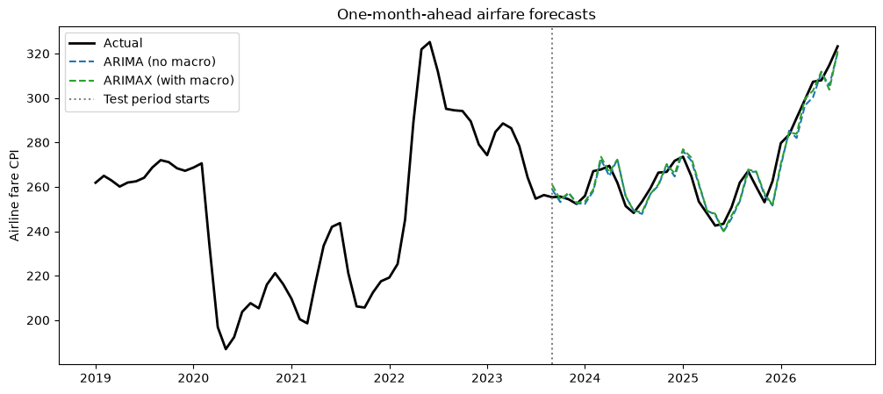
Figure 3: Actual fares and one-month-ahead forecasts

Model 2: ARIMAX coefficients
Table 5: ARIMAX(1,1,1) coefficients
Term | Coefficient | p-value
fuel | 0.0126 | 0.3272
cpi | 1.6723 | 0.0000
unemp | 0.0007 | 0.7500
sentiment | 0.0002 | 0.2787
covid | -0.0457 | 0.0000
ar.L1 | -0.1269 | 0.0702
ma.L1 | 0.6714 | 0.0000
sigma2 | 0.0005 | 0.0000

CPI and the COVID-19 indicator are significant (p < 0.05): a 1% rise in CPI goes with about a 1.7% short-run rise in fares, and fares were about 4.5% lower in the pandemic period. The CPI effect is larger than in Model 1 because ARIMAX works with monthly changes (short-run effects) while Model 1 relates levels over the whole period. Fuel, unemployment and sentiment are not significant once CPI and fare history are included. These are associations, not proof of cause.

Order search by AIC
Table 6: Best orders by AIC
Order (p, 1, q) | AIC
(1, 1, 2) | -1873.920980
(2, 1, 2) | -1873.168264
(1, 1, 3) | -1871.674879
(3, 1, 2) | -1870.700538
(2, 1, 3) | -1870.329145

AIC preferred (1, 1, 2), but it scored slightly worse on the test months (see the results table), so (1, 1, 1) is kept.

Forecast horizons
Table 7: MAPE by forecast horizon (regressors lagged at least the horizon)
Horizon (months) | Naive MAPE % | ARIMA MAPE % | ARIMAX MAPE % | Macro gain %
1 | 2.15 | 1.85 | 1.77 | 4.23
3 | 4.97 | 4.71 | 4.72 | -0.28
6 | 6.96 | 6.96 | 6.78 | 2.64
12 | 7.97 | 7.88 | 7.65 | 2.94

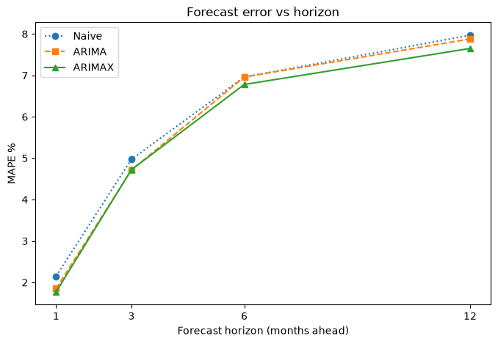
Figure 4: MAPE by forecast horizon
Errors grow with the horizon, as expected. ARIMAX is best at 1, 6 and 12 months; at 3 months ARIMA is marginally better.

5. Model selection
Selected model: ARIMAX (with macro) (Model 2, ARIMAX(1,1,1)). It has the lowest MAPE (1.771%) and highest R² (0.923) on the 36 test months, and it stays ahead of ARIMA under walk-forward retraining. Model 1 (MAPE 11.729%) remains useful for explaining the long-run direction of each indicator.

6. Safeguards against leakage
- Time-based split; the test months come after all training months.
- Regressors lagged (fuel 2 months, others 1 month), and by at least the horizon for longer forecasts.
- Correlations measured on year-over-year changes to avoid spurious regression [4].
- The overall CPI contains airline fares; this overlap is noted as a limitation (airfares are a very small share of CPI).

7. Next steps for the final review
- Finish the Streamlit app.
- Write the final report and slides.
- Prepare the demo and viva answers.

References
[1] B. Atems, L. Bachmeier, C. Williams, "Do jet fuel price movements help forecast airline fares and the demand for air travel?," Applied Economics Letters, vol. 26, no. 11, pp. 877-882, 2019. Available: https://doi.org/10.1080/13504851.2018.1510466
[2] R. J. Hyndman, A. B. Koehler, "Another look at measures of forecast accuracy," International Journal of Forecasting, vol. 22, no. 4, pp. 679-688, 2006. Available: https://doi.org/10.1016/j.ijforecast.2006.03.001
[3] F. X. Diebold, R. S. Mariano, "Comparing predictive accuracy," Journal of Business & Economic Statistics, vol. 13, no. 3, pp. 253-263, 1995. Available: https://doi.org/10.1080/07350015.1995.10524599
[4] C. W. J. Granger, P. Newbold, "Spurious regressions in econometrics," Journal of Econometrics, vol. 2, no. 2, pp. 111-120, 1974. Available: https://doi.org/10.1016/0304-4076(74)90034-7
[5] S. Seabold, J. Perktold, "statsmodels: Econometric and statistical modeling with Python," Proceedings of the 9th Python in Science Conference (SciPy 2010), pp. 92-96, 2010. Available: https://doi.org/10.25080/Majora-92bf1922-011
[6] R. J. Hyndman, G. Athanasopoulos, "Forecasting: Principles and Practice, 3rd edition (chapter 10, Dynamic regression models)," OTexts, Melbourne, 2021. Available: https://otexts.com/fpp3/

