INTERPRETABLE PREDICTION OF 30-DAY HOSPITAL READMISSION IN DIABETIC PATIENTS
A PROJECT REPORT
Submitted in partial fulfilment of the requirements for the award of the degree of
BACHELOR OF TECHNOLOGY
in
COMPUTER SCIENCE AND ENGINEERING
Submitted by
[STUDENT NAME] ([REGISTER NUMBER])
Under the guidance of
[GUIDE NAME], [Designation]
[DEPARTMENT OF COMPUTER SCIENCE AND ENGINEERING]
[COLLEGE NAME]
[City] - [Year]

BONAFIDE CERTIFICATE
This is to certify that this project report titled "Interpretable Prediction of 30-Day Hospital Readmission in Diabetic Patients" is the bonafide work of [STUDENT NAME] ([REGISTER NUMBER]), who carried out the project work under my supervision.
[Guide signature] [Head of Department signature]

DECLARATION
I hereby declare that the project report titled "Interpretable Prediction of 30-Day Hospital Readmission in Diabetic Patients" submitted for the degree of Bachelor of Technology is my original work and has not been submitted for any other degree or diploma.
Place: [City]
Date: [Date] [Student signature]

ACKNOWLEDGEMENT
I thank [Guide name] for guidance throughout this project, the Head of the Department and the faculty of the [Department], and my family and friends for their support. I also thank the creators of the Diabetes 130-US Hospitals dataset for making it public.

TABLE OF CONTENTS
1. INTRODUCTION 9
1.1 Overview 9
1.2 Data Science 9
1.3 Machine Learning 9
1.4 Interpretable Machine Learning 9
1.5 Problem Statement 10
1.6 Objectives 10
1.7 Scope of the Project 10
1.8 Organisation of the Report 10
2. LITERATURE SURVEY 11
2.1 Impact of HbA1c Measurement on Hospital Readmission Rates 11
2.2 Derivation and validation of the LACE index 11
2.3 Risk Prediction Models for Hospital Readmission: A Systematic Review 11
2.4 Supersparse Linear Integer Models for Optimized Medical Scoring Systems 12
2.5 Stop Explaining Black Box Machine Learning Models for High Stakes Decisions 12
2.6 Regression Shrinkage and Selection via the Lasso 12
2.7 Summary of the Survey 12
3. SYSTEM ANALYSIS 13
3.1 Existing System 13
3.2 Proposed System 13
3.3 Feasibility Study 14
4. SYSTEM REQUIREMENTS 15
4.1 Hardware Requirements 15
4.2 Software Requirements 15
4.3 Functional Requirements 15
4.4 Non-Functional Requirements 15
5. SYSTEM DESIGN 16
5.1 Design Architecture 16
5.2 Data Flow Diagram 16
5.3 Usecase Diagram 17
5.4 Class Diagram 17
5.5 Activity Diagram 17
5.6 Sequence Diagram 18
5.7 ER Diagram 19
6. DATASET AND PRE-PROCESSING 20
6.1 Dataset Description 20
6.2 Attributes 20
6.3 Missing Values 21
6.4 Pre-processing 21
6.5 Train, Validation and Test Split 22
7. METHODOLOGY AND ALGORITHMS 23
7.1 Model 1: LACE-style Points Score 23
7.2 Model 2: Learned Points Score 23
7.3 Model 2: IF-THEN Rules 24
7.4 Black-box Reference 24
7.5 Evaluation Metrics 24
8. IMPLEMENTATION 25
8.1 Software Description 25
8.2 List of Modules 25
8.3 Module Description 25
8.4 Deploy 26
9. RESULTS AND DISCUSSION 27
9.1 Model 1 27
9.2 Model 2 27
9.3 Comparison 30
9.4 Discussion and Limitations 30
10. CONCLUSION AND FUTURE WORK 31
10.1 Conclusion 31
10.2 Future Work 31
11. REFERENCES 32

ABSTRACT
Hospital readmission within 30 days of discharge is costly for hospitals and harmful for patients, and many such readmissions can be prevented if high-risk patients are identified before they go home. This project builds and compares interpretable models that predict 30-day readmission for diabetic inpatients, using the UCI "Diabetes 130-US hospitals" dataset of 101,766 hospital stays [1]. After removing stays that ended in death or hospice care, 99,340 stays from 69,987 patients remained, of which 11.4% were readmitted within 30 days. The data were split by patient (79,567 training and 19,773 test stays) so that no patient appears in both sets.
Model 1 is a LACE-style clinical points score [2] based on length of stay, emergency admission, number of diagnoses and past emergency visits; it represents the existing manual method. Model 2 learns a points score from 29 features with L1-regularised logistic regression [6], keeping only 5 conditions with whole-number points [4], and adds a 16-rule decision tree that explains each prediction in IF-THEN form. Model sizes were chosen on a separate validation set, and a gradient-boosting model served as a black-box reference. On 19,773 unseen test stays, Model 2 raised the AUC-ROC from 0.563 to 0.648 and the recall from 35% to 57%, while the black-box model reached 0.669, only 0.021 higher. Past inpatient admissions and discharge destination were the strongest predictors. Both models are delivered in a Streamlit application that shows the risk, the reason and suggested discharge actions for any patient.
Keywords: Hospital readmission, Diabetes, Interpretable machine learning, Clinical points score, LACE index, L1-regularised logistic regression, Decision tree rules, Streamlit

1. INTRODUCTION

1.1 Overview
A hospital readmission within 30 days of discharge often signals a problem in the transition from hospital to home: medication errors, missed follow-up, early discharge or lack of support. Readmissions are expensive for health systems and stressful and risky for patients. Many are preventable if the patients at highest risk receive extra attention before and after discharge, such as a follow-up call, a medication review or a home visit.
Diabetic patients are a large and vulnerable group: diabetes complicates almost every other condition, and these patients are readmitted more often than average. Hospitals already record the information needed to estimate risk, such as length of stay, past admissions, diagnoses and medications, so a model can turn routine data into a risk estimate at the moment of discharge.

1.2 Data Science
Data science combines statistics, programming and domain knowledge to extract useful knowledge from data. A typical project defines a question, collects and cleans the data, explores it, builds models, evaluates them honestly and communicates the result to the people who will use it. This project follows that cycle for hospital readmission.

1.3 Machine Learning
Machine learning lets a computer learn patterns from examples rather than following hand-written rules. In supervised learning every example carries a known answer; predicting whether a stay ends in readmission (yes or no) is binary classification. Good practice keeps separate training, validation and test data, so that model choices are made on validation data and the final result is measured on data the model has never seen.

1.4 Interpretable Machine Learning
In healthcare a prediction is only useful if staff can trust and act on it. Interpretable models, such as points scores and decision rules, show exactly why a patient was flagged and can be checked by hand. Black-box models such as large tree ensembles can be slightly more accurate, but their reasoning is hidden. Rudin [5] argues that for high-stakes decisions interpretable models should be preferred, because the accuracy cost is usually small, and this project measures that cost directly.

1.5 Problem Statement
About one in nine diabetic hospital stays in this data (11.4%) ends in readmission within 30 days. Hospitals need to know before discharge which patients are at high risk so they can arrange follow-up calls, medication reviews or home support. Existing clinical scores such as LACE are easy to use but separate patients poorly, while accurate machine-learning models are black boxes that staff cannot check. The problem is to predict 30-day readmission as accurately as possible with a model that a nurse can verify by hand.

1.6 Objectives
1. Prepare the UCI diabetes readmission dataset and define the 30-day readmission label.
2. Build Model 1: a LACE-style clinical points score representing the existing manual method.
3. Build Model 2: a points score learned from the data with L1 logistic regression, plus IF-THEN rules from a small decision tree.
4. Split the data by patient and choose model sizes on a validation set, so the test set is used only once.
5. Compare both models with a black-box gradient-boosting reference on the same test patients.
6. Deliver a Streamlit web application that shows the risk, the reason and suggested actions.

1.7 Scope of the Project
The project uses historical US hospital data from 1999-2008 for diabetic inpatients. It predicts 30-day readmission at discharge, compares an existing-style clinical score with a learned interpretable score, and provides a prototype application. It is a study project: it is not validated for real clinical use.

1.8 Organisation of the Report
Chapter 2 reviews the literature. Chapter 3 analyses the existing and proposed systems and their feasibility. Chapter 4 lists the requirements, Chapter 5 presents the design and UML diagrams, Chapter 6 the dataset and pre-processing, Chapter 7 the algorithms, Chapter 8 the implementation and Chapter 9 the results. Chapter 10 gives the conclusion and future work, followed by the references.

2. LITERATURE SURVEY
This chapter reviews the base paper and the reference papers that shaped the dataset, the baseline score and the learned model.

2.1 Impact of HbA1c Measurement on Hospital Readmission Rates
Authors: Strack et al., 2014 [1]
Introduces the dataset used here: about 70,000 diabetic inpatient encounters extracted from a large US clinical database covering 130 hospitals (1999-2008), with demographics, diagnoses, procedures, medications, laboratory results and readmission status. Using multivariable logistic regression, the authors find that HbA1c was measured in only 18.4% of encounters and that its relation to readmission depends on the primary diagnosis.
Relevance to this project: Supplies the data, the attribute definitions and the readmission label; this project builds interpretable predictive models on it.

2.2 Derivation and validation of the LACE index
Authors: van Walraven et al., 2010 [2]
Derives a 0-19 point index from Length of stay, Acuity of admission, Comorbidity (Charlson score) and Emergency department visits, predicting death or unplanned readmission within 30 days; validated on one million Ontario discharges with a C-statistic of 0.684.
Relevance to this project: Model 1 reproduces this index in LACE style, using the number of diagnoses in place of the Charlson score.

2.3 Risk Prediction Models for Hospital Readmission: A Systematic Review
Authors: Kansagara et al., 2011 [3]
Reviews 26 readmission risk models from 30 studies and concludes that most perform poorly, especially those built on administrative data.
Relevance to this project: Explains why modest AUC-ROC values are expected and motivates learning better scores from data.

2.4 Supersparse Linear Integer Models for Optimized Medical Scoring Systems
Authors: Ustun and Rudin, 2016 [4]
Shows how to learn medical scoring systems with small integer coefficients directly from data, matching the accuracy of complex models while staying usable by hand.
Relevance to this project: Model 2 follows the same idea in a simpler way: sparse logistic regression with weights rounded to whole points.

2.5 Stop Explaining Black Box Machine Learning Models for High Stakes Decisions
Authors: Rudin, 2019 [5]
Argues that in high-stakes areas such as healthcare, inherently interpretable models should be used instead of explaining black boxes, and that the accuracy cost of interpretability is often small.
Relevance to this project: Motivates comparing the readable models with a black-box reference and reporting the gap.

2.6 Regression Shrinkage and Selection via the Lasso
Authors: Tibshirani, 1996 [6]
Introduces the lasso (L1 penalty), which shrinks coefficients and sets many exactly to zero, performing variable selection.
Relevance to this project: Model 2 uses L1-regularised logistic regression to select the few conditions that make up the points score.

2.7 Summary of the Survey
Table 2.1: Summary of the literature
Ref. | Focus | Method | Used for
[1] | Diabetes readmission data | Logistic regression on 70,000 encounters | Dataset, label
[2] | LACE index | 4-factor points score | Model 1
[3] | Readmission models | Systematic review | Expected accuracy
[4] | Learned scoring systems | Sparse integer models | Model 2 idea
[5] | Interpretability | Perspective | Black-box comparison
[6] | Lasso | L1 penalty | Condition selection

3. SYSTEM ANALYSIS

3.1 Existing System
Hospitals commonly estimate readmission risk with simple clinical indices such as LACE [2] (Length of stay, Acuity, Comorbidity, Emergency visits), or by clinical judgement. A systematic review of readmission models [3] found that most perform poorly. Machine-learning models can be more accurate, but they are black boxes: staff cannot see why a patient was flagged [5].

Disadvantages of the Existing System
- Poor discrimination: the LACE-style score reaches an AUC-ROC of only 0.563 on this data.
- Fixed, hand-picked factors: the index does not learn which facts matter for diabetic patients.
- Missing inputs: the Charlson comorbidity index needed by LACE is not in the data, so a proxy must be used.
- Black-box alternatives: gradient boosting or neural networks cannot be checked or explained at the bedside.
- No actions: a bare risk number does not tell staff what to do.

3.2 Proposed System
The proposed system keeps the points-score format that clinicians already trust, but lets the data choose the conditions and their points. L1-regularised logistic regression selects a few yes/no conditions and the weights are rounded to whole points, so a nurse can add them up by hand. A small decision tree gives IF-THEN rules that explain each prediction. Model sizes are chosen on validation patients, and the results are compared with a black-box model to show how little accuracy is lost.

Advantages of the Proposed System
- More accurate: AUC-ROC 0.648 instead of 0.563, recall 57% instead of 35%.
- Fully transparent: 5 conditions with whole-number points; every prediction can be checked by hand.
- Close to the black box: only 0.021 AUC-ROC below the gradient-boosting reference.
- Explained: each patient is matched to an IF-THEN rule with the readmission rate of similar patients.
- Actionable: the app suggests discharge actions for each risk factor.
- Honest evaluation: split by patient; validation set for tuning; test set used once.

3.3 Feasibility Study

Technical Feasibility
The data is a single CSV file of about 100,000 rows. All models train in seconds to a minute on a normal laptop with open-source Python libraries.

Economic Feasibility
All software is free and the dataset is published under CC BY 4.0, so there is no licence cost.

Operational Feasibility
Staff use a browser-based app with plain-language output and colour-coded risk; the points tables can also be used on paper.

Ethical Feasibility
The data is de-identified. Race and gender are not used as inputs. The suggested actions are hand-written and must be reviewed by clinicians before any real use.

4. SYSTEM REQUIREMENTS

4.1 Hardware Requirements
Table 4.1: Hardware requirements
Component | Minimum
Processor | Intel Core i3 or equivalent
RAM | 8 GB recommended
Hard disk | 1 GB free space

4.2 Software Requirements
Table 4.2: Software requirements
Component | Specification
Operating system | Windows 10/11
Language | Python 3.x
Environment | Anaconda, Jupyter Notebook
Libraries | pandas, NumPy, scikit-learn, matplotlib, Streamlit
Browser | Chrome, Edge or Firefox

4.3 Functional Requirements
- Load and clean the hospital data.
- Compute Model 1 and Model 2 scores and the matching rule for any patient.
- Show the chance of readmission, a colour-coded risk level and suggested actions.
- Show the points tables, the rules and the test results.

4.4 Non-Functional Requirements
- Interpretability: every prediction can be checked by hand.
- Performance: instant predictions once the models are trained.
- Reproducibility: fixed seed 42; results saved by the notebooks.
- Privacy: no identifiers shown.

5. SYSTEM DESIGN

5.1 Design Architecture
Figure 5.1 shows the architecture. Hospital records are cleaned, turned into features and split by patient; both models are trained and evaluated, and the app serves them to staff.
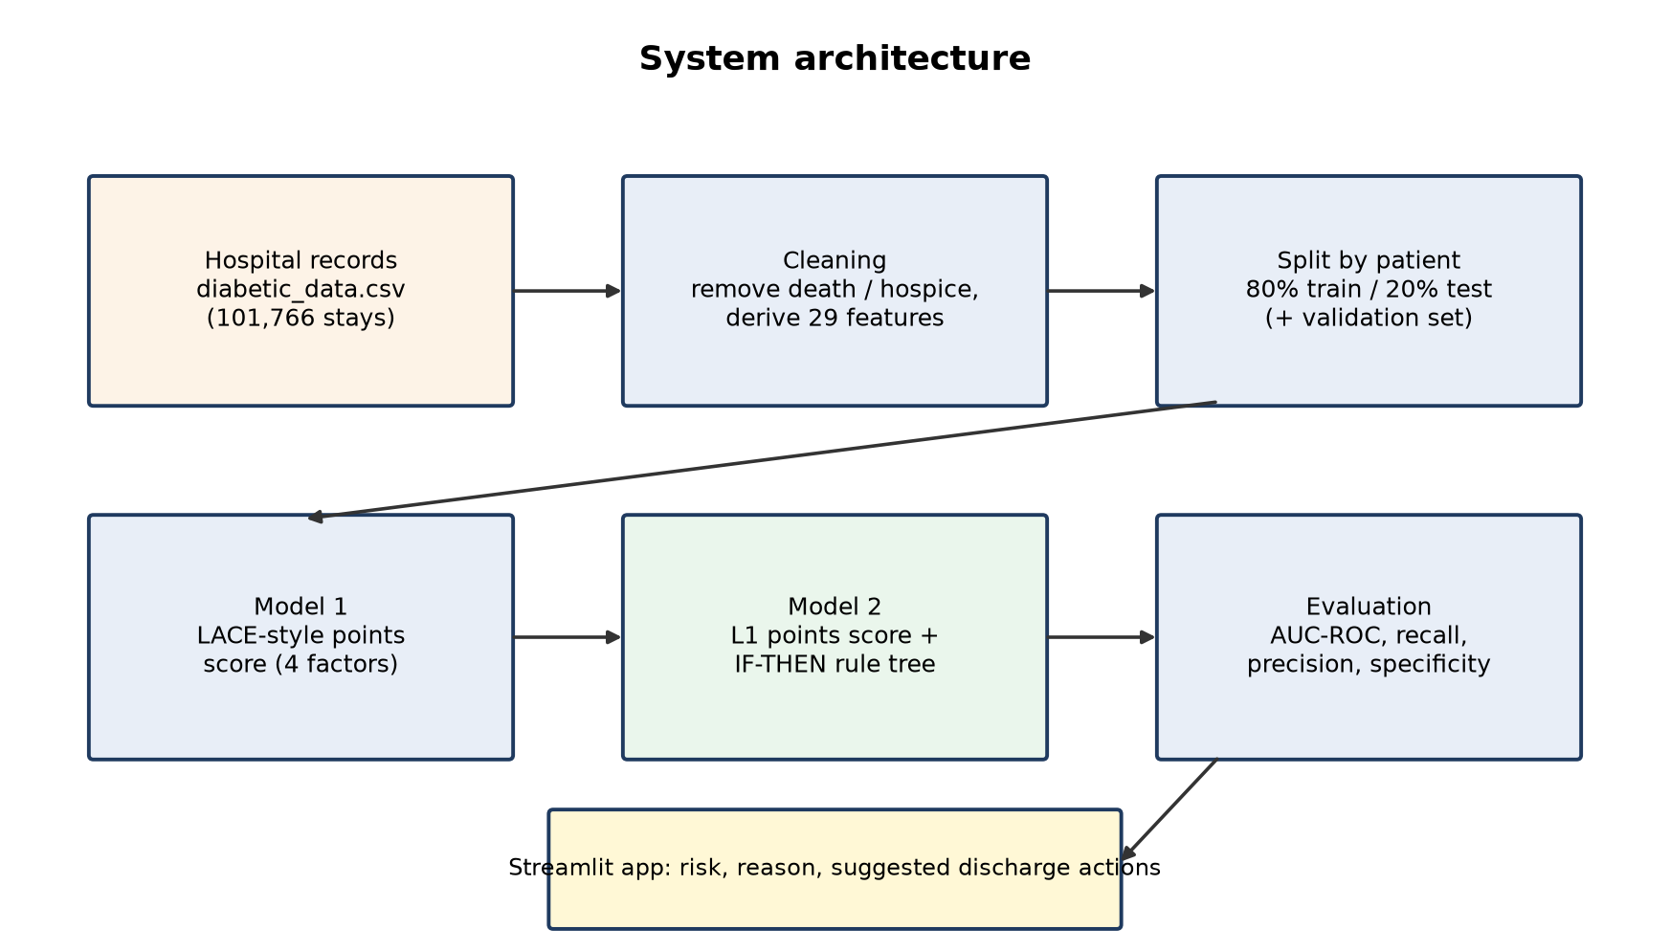
Figure 5.1: System architecture

5.2 Data Flow Diagram
The level-1 data flow diagram shows the processes (circles), data stores (open rectangles) and external entities.
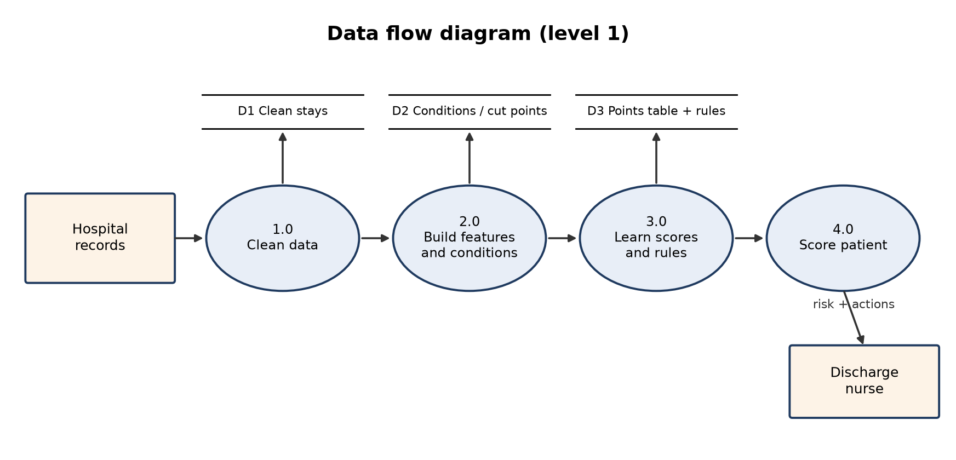
Figure 5.2: Data flow diagram (level 1)

5.3 Usecase Diagram
The use case diagram shows what the nurse or doctor and the administrator can do with the system.
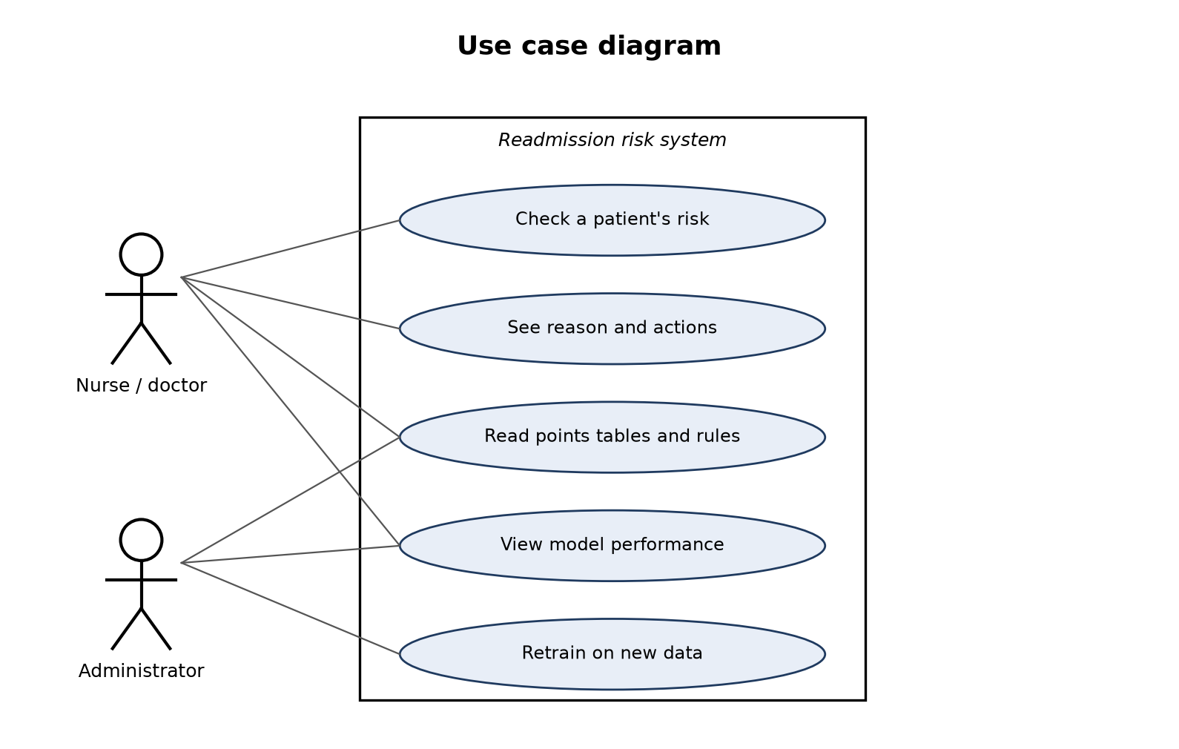
Figure 5.3: Use case diagram

5.4 Class Diagram
The class diagram shows the main parts of the implementation and their responsibilities.
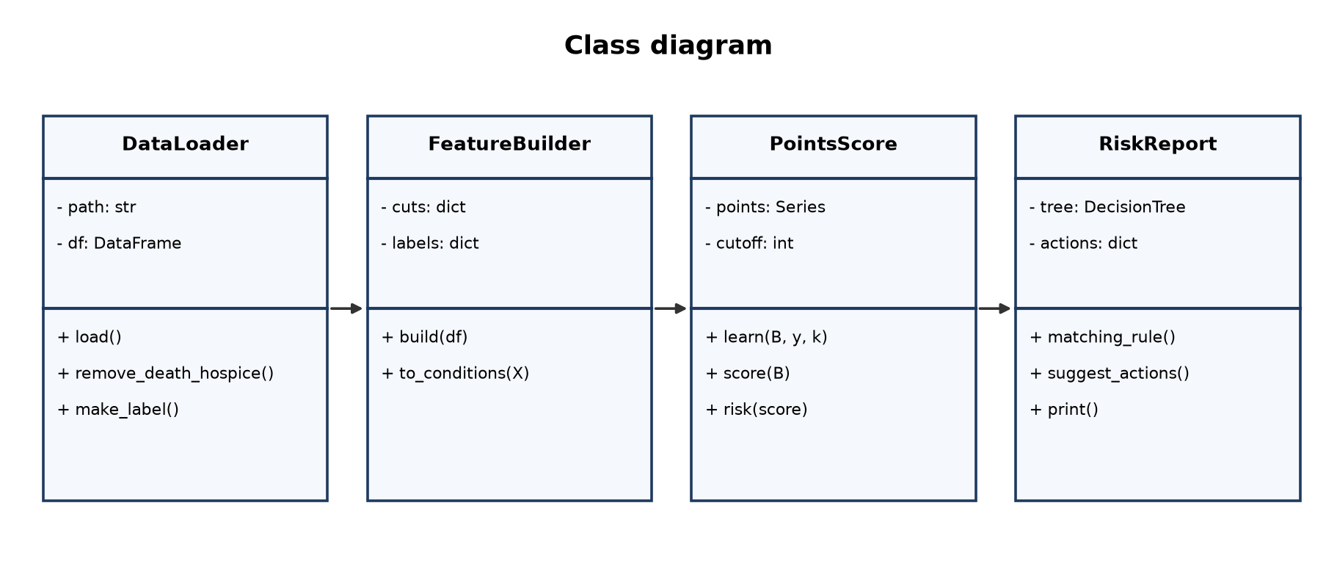
Figure 5.4: Class diagram

5.5 Activity Diagram
The activity diagram shows the complete workflow from loading the data to showing the result.
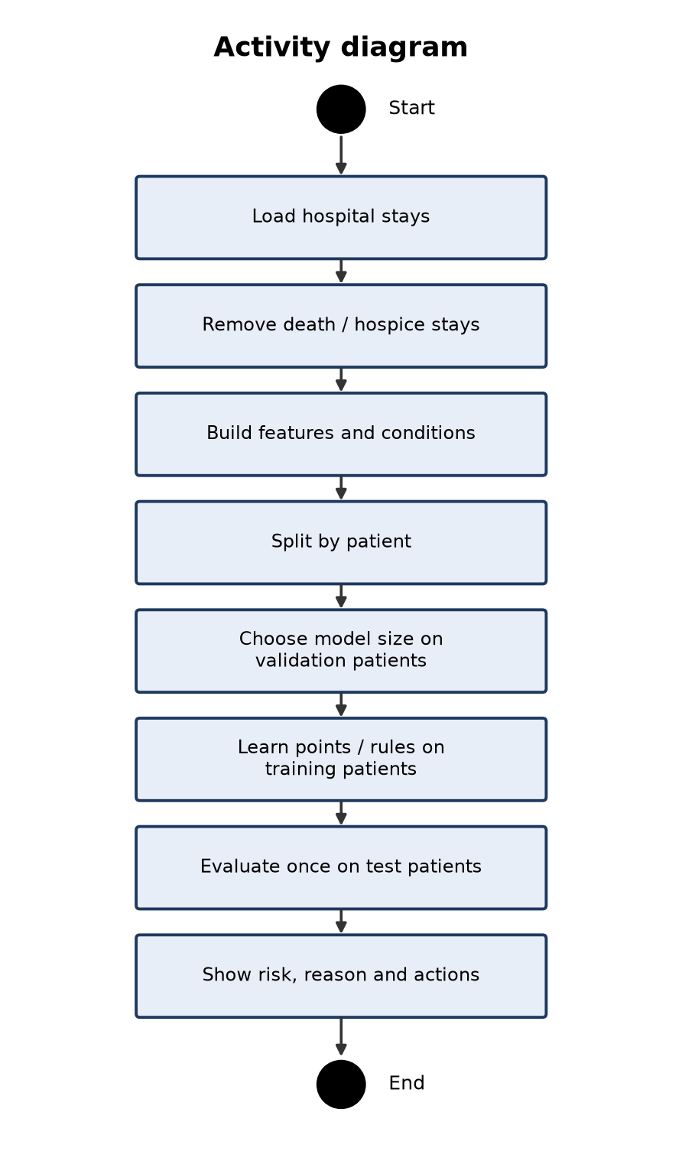
Figure 5.5: Activity diagram

5.6 Sequence Diagram
The sequence diagram shows what happens when a nurse checks a patient in the app.
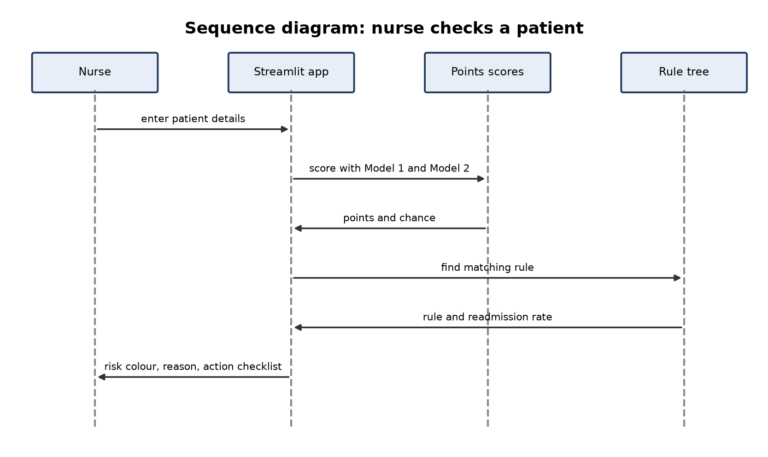
Figure 5.6: Sequence diagram

5.7 ER Diagram
A patient can have many encounters (stays), and each encounter can receive predictions from both models.
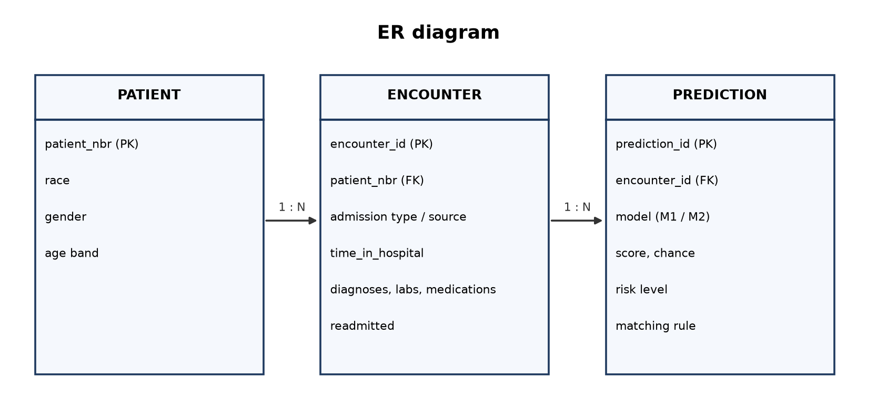
Figure 5.7: ER diagram

6. DATASET AND PRE-PROCESSING

6.1 Dataset Description
The dataset represents ten years (1999-2008) of clinical care at 130 US hospitals and integrated delivery networks [1]. Each row is one hospital stay of a diabetic patient lasting 1 to 14 days, with lab tests and medications given during the stay. It is published by the UCI Machine Learning Repository (DOI 10.24432/C5230J) under a CC BY 4.0 licence.
Table 6.1: Dataset summary
Property | Value
Stays in the file | 101,766
Columns | 50
Stays after cleaning | 99,340
Patients | 69,987
Readmitted within 30 days | 11,314 (11.4%)

6.2 Attributes
Table 6.2: Attributes of the dataset
# | Column | Group | Meaning
1 | encounter_id | Identifier | Unique hospital stay
2 | patient_nbr | Identifier | Patient ID (used to split by patient)
3 | race | Demographic | Race (not used by the models)
4 | gender | Demographic | Gender (not used by the models)
5 | age | Demographic | Age in 10-year bands, e.g. [60-70)
6 | weight | Demographic | Weight band (mostly missing; not used)
7 | admission_type_id | Admission | Admission type, 1 = emergency
8 | discharge_disposition_id | Admission | Where the patient went after discharge
9 | admission_source_id | Admission | Where the patient came from
10 | time_in_hospital | Admission | Length of stay in days (1-14)
11 | payer_code | Admission | Insurance payer (not used)
12 | medical_specialty | Admission | Specialty of the admitting doctor (not used)
13 | num_lab_procedures | Care | Number of lab tests
14 | num_procedures | Care | Number of non-lab procedures
15 | num_medications | Care | Number of distinct medications given
16 | number_outpatient | History | Outpatient visits in the past year
17 | number_emergency | History | Emergency visits in the past year
18 | number_inpatient | History | Inpatient admissions in the past year
19 | diag_1 | Diagnosis | Primary diagnosis (ICD-9)
20 | diag_2 | Diagnosis | Secondary diagnosis (ICD-9)
21 | diag_3 | Diagnosis | Additional diagnosis (ICD-9)
22 | number_diagnoses | Diagnosis | Number of diagnoses entered
23 | max_glu_serum | Lab | Glucose serum test result
24 | A1Cresult | Lab | HbA1c test result
25 | metformin | Medication | metformin: No / Steady / Up / Down
26 | repaglinide | Medication | repaglinide: No / Steady / Up / Down
27 | nateglinide | Medication | nateglinide: No / Steady / Up / Down
28 | chlorpropamide | Medication | chlorpropamide: No / Steady / Up / Down
29 | glimepiride | Medication | glimepiride: No / Steady / Up / Down
30 | acetohexamide | Medication | acetohexamide: No / Steady / Up / Down
31 | glipizide | Medication | glipizide: No / Steady / Up / Down
32 | glyburide | Medication | glyburide: No / Steady / Up / Down
33 | tolbutamide | Medication | tolbutamide: No / Steady / Up / Down
34 | pioglitazone | Medication | pioglitazone: No / Steady / Up / Down
35 | rosiglitazone | Medication | rosiglitazone: No / Steady / Up / Down
36 | acarbose | Medication | acarbose: No / Steady / Up / Down
37 | miglitol | Medication | miglitol: No / Steady / Up / Down
38 | troglitazone | Medication | troglitazone: No / Steady / Up / Down
39 | tolazamide | Medication | tolazamide: No / Steady / Up / Down
40 | examide | Medication | examide: No / Steady / Up / Down
41 | citoglipton | Medication | citoglipton: No / Steady / Up / Down
42 | insulin | Medication | insulin: No / Steady / Up / Down
43 | glyburide-metformin | Medication | glyburide-metformin: No / Steady / Up / Down
44 | glipizide-metformin | Medication | glipizide-metformin: No / Steady / Up / Down
45 | glimepiride-pioglitazone | Medication | glimepiride-pioglitazone: No / Steady / Up / Down
46 | metformin-rosiglitazone | Medication | metformin-rosiglitazone: No / Steady / Up / Down
47 | metformin-pioglitazone | Medication | metformin-pioglitazone: No / Steady / Up / Down
48 | change | Medication | Any change in diabetes medication
49 | diabetesMed | Medication | Any diabetes medication prescribed
50 | readmitted | Target | <30 days, >30 days or NO

6.3 Missing Values
Table 6.3: Missing values
Column | Missing ('?') | Share
race | 2,273 | 2.2%
weight | 98,569 | 96.9%
payer_code | 40,256 | 39.6%
medical_specialty | 49,949 | 49.1%
diag_1 | 21 | 0.0%
diag_2 | 358 | 0.4%
diag_3 | 1,423 | 1.4%

6.4 Pre-processing
- '?' is read as missing.
- Stays that ended in death or hospice are removed: those patients cannot be readmitted.
- Rows with an invalid gender are removed.
- Label: 1 if readmitted within 30 days, otherwise 0.
- Age bands are converted to their middle value; ICD-9 primary diagnoses are grouped into 9 clinical groups; discharge codes into home, home health, facility and other.
- Medication columns are summarised as the number of diabetes drugs and the number of dose changes.
Table 6.4: Model 2 features
Feature | Type | Meaning
age | Number | Middle of the age band
time_in_hospital | Number | Length of stay (days)
num_lab_procedures / num_procedures / num_medications | Number | Care intensity during the stay
number_outpatient / number_emergency / number_inpatient | Number | Visits in the past year
number_diagnoses | Number | Number of diagnoses
n_diabetes_meds / n_dose_changes | Number | Diabetes drugs given and dose changes
emergency_admission, insulin, med_change, on_diabetes_med | Yes/no | Admission and medication facts
a1c_measured, a1c_high, glucose_high | Yes/no | Lab test facts
discharge_home / home_health / facility | Yes/no | Discharge destination group
diag_diabetes ... diag_neoplasms (8) | Yes/no | Primary diagnosis group (ICD-9)

6.5 Train, Validation and Test Split
Many patients have several stays, so the split is done by patient with GroupShuffleSplit: 79,567 training stays and 19,773 test stays, with no patient in both. Inside the training set, 15,962 stays (20% of training patients) form a validation set used only to choose model sizes.

7. METHODOLOGY AND ALGORITHMS

7.1 Model 1: LACE-style Points Score
The LACE index [2] adds points for Length of stay, Acuity of admission, Comorbidity and Emergency visits. The dataset has no Charlson comorbidity index, so the number of diagnoses stands in for it.
Table 7.1: Model 1 points
Factor | Points | Max
Length of stay | 1 day = 1, 2 = 2, 3 = 3, 4-6 days = 4, 7-13 = 5, 14+ = 7 | 7
Emergency admission | Yes = 3, No = 0 | 3
Number of diagnoses | 1 point per diagnosis above 4 | 5
Emergency visits (past year) | 1 point per visit | 4

P(readmit | score) = 1 / (1 + e^-(a + b · score))
The coefficients a and b are fitted on the training patients. Patients with a score of 11 or more (about the top quarter of training patients) are flagged.

7.2 Model 2: Learned Points Score
Each numeric feature is cut at its 25th, 50th, 75th and 90th training percentiles, producing 47 candidate yes/no conditions such as "inpatient admissions ≥ 2". L1-regularised logistic regression [6] is fitted for a range of penalty strengths; the strongest setting that keeps at most k conditions is used. The weights are scaled so the largest is 5 and rounded to whole points [4]; conditions that round to zero are dropped.
minimise -Σ log-likelihood + λ Σ |β_j|, points_j = round(5 · β_j / max|β|)
Table 7.2: Choosing k on the validation patients
Maximum conditions | Conditions kept | Validation AUC-ROC
4 | 3 | 0.6321
6 | 4 | 0.6389
8 | 4 | 0.6389
10 | 6 | 0.6343
12 | 6 | 0.6343
15 | 7 | 0.6408

7.3 Model 2: IF-THEN Rules
A decision tree (minimum 200 patients per leaf) is trained with 4, 6, 8, 12 or 16 leaves; the size with the best validation AUC-ROC is kept and retrained on all training patients, giving 16 rules. Each rule reports the readmission rate of its training patients.

7.4 Black-box Reference
A HistGradientBoostingClassifier with 300 trees and learning rate 0.05 is trained on the same features. It is not used for decisions; it shows the highest accuracy this data allows, so the cost of interpretability can be measured.

7.5 Evaluation Metrics
Table 7.3: Evaluation metrics
Metric | Formula | Meaning
AUC-ROC | Area under the ROC curve | How well the model ranks a readmitted patient above one who is not (0.5 = guessing); main metric
Recall (sensitivity) | TP / (TP + FN) | Of the patients who really came back, the share flagged
Precision | TP / (TP + FP) | Of the flagged patients, the share who really came back
Specificity | TN / (TN + FP) | Of the patients who did not come back, the share not flagged
F1 score | 2PR / (P + R) | Balance of precision and recall
Accuracy | (TP + TN) / all | Misleading here: about 89% of stays are not readmitted

8. IMPLEMENTATION

8.1 Software Description

Python
General-purpose programming language used for all code.

Jupyter Notebook
Interactive environment used for the two model notebooks.

pandas and NumPy
Loading, cleaning and transforming the data.

scikit-learn
GroupShuffleSplit, LogisticRegression (including L1), DecisionTreeClassifier, HistGradientBoostingClassifier and metrics.

matplotlib
Confusion matrices, ROC curves and score charts.

Streamlit
The interactive web application for staff.

8.2 List of Modules
1. Data loading and cleaning
2. Feature engineering and conditions
3. Model 1 points score
4. Model 2 points score and rules
5. Patient report
6. Web application

8.3 Module Description

Data loading and cleaning
Reads the CSV, removes death and hospice stays and invalid gender, builds the label and the patient groups.

Feature engineering and conditions
Builds the 29 features and turns each number into yes/no conditions using training percentiles.

Model 1 points score
Adds the LACE-style points, converts the score to a chance and applies the cut-off.

Model 2 points score and rules
Selects conditions with L1 logistic regression, rounds the points, and grows the rule tree; sizes chosen on validation.

Patient report
Prints the prediction with a red, yellow or green level, the conditions that scored, the matching rule and suggested actions.

Web application
Three tabs: Check a patient, How the models work, Model performance.

8.4 Deploy
The app is started from its folder; it trains both models from the project data on first start and opens at http://localhost:8501.
cd ML11-HOSPITAL-READMISSION\ML11-final-review\app
streamlit run app.py

Table 8.1: Application tabs
Tab | Function
Check a patient | Enter details or load a test patient; see both models' scores, the matching rule and a checklist of suggested actions
How the models work | Both points tables, the score-to-risk table and all rules
Model performance | The comparison table and the charts saved by the notebooks

9. RESULTS AND DISCUSSION

9.1 Model 1
Table 9.1: Model 1 on the test patients
Metric | Value
Accuracy | 0.687
Precision | 0.141
Recall (sensitivity) | 0.346
Specificity | 0.730
F1 score | 0.200
AUC-ROC | 0.563

Table 9.2: Model 1 in plain numbers
Count | Stays
Real readmissions in test set | 2,244
Flagged as high risk | 5,502
Correctly flagged (TP) | 776
Missed (FN) | 1,468
False alarms (FP) | 4,726

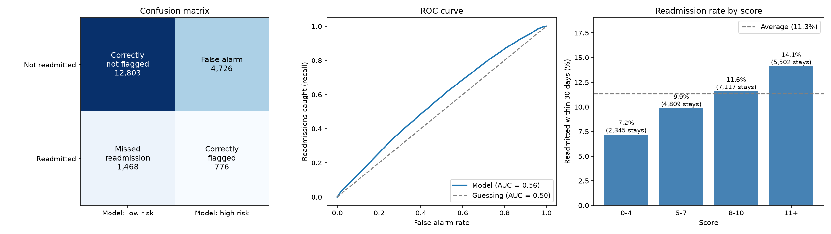
Figure 9.1: Model 1 test results

9.2 Model 2
Table 9.3: Model 2 points score
Condition | Points
Inpatient admissions (past year) >= 2 | 5
Inpatient admissions (past year) >= 1 | 4
Discharged to a care facility | 2
Emergency visits (past year) >= 1 | 1
Discharged home | -3

Table 9.4: Model 2 on the test patients
Metric | Value
Accuracy | 0.650
Precision | 0.178
Recall (sensitivity) | 0.574
Specificity | 0.660
F1 score | 0.271
AUC-ROC | 0.648

Table 9.5: Model 2 in plain numbers
Count | Stays
Real readmissions in test set | 2,244
Flagged as high risk | 7,255
Correctly flagged (TP) | 1,289
Missed (FN) | 955
False alarms (FP) | 5,966

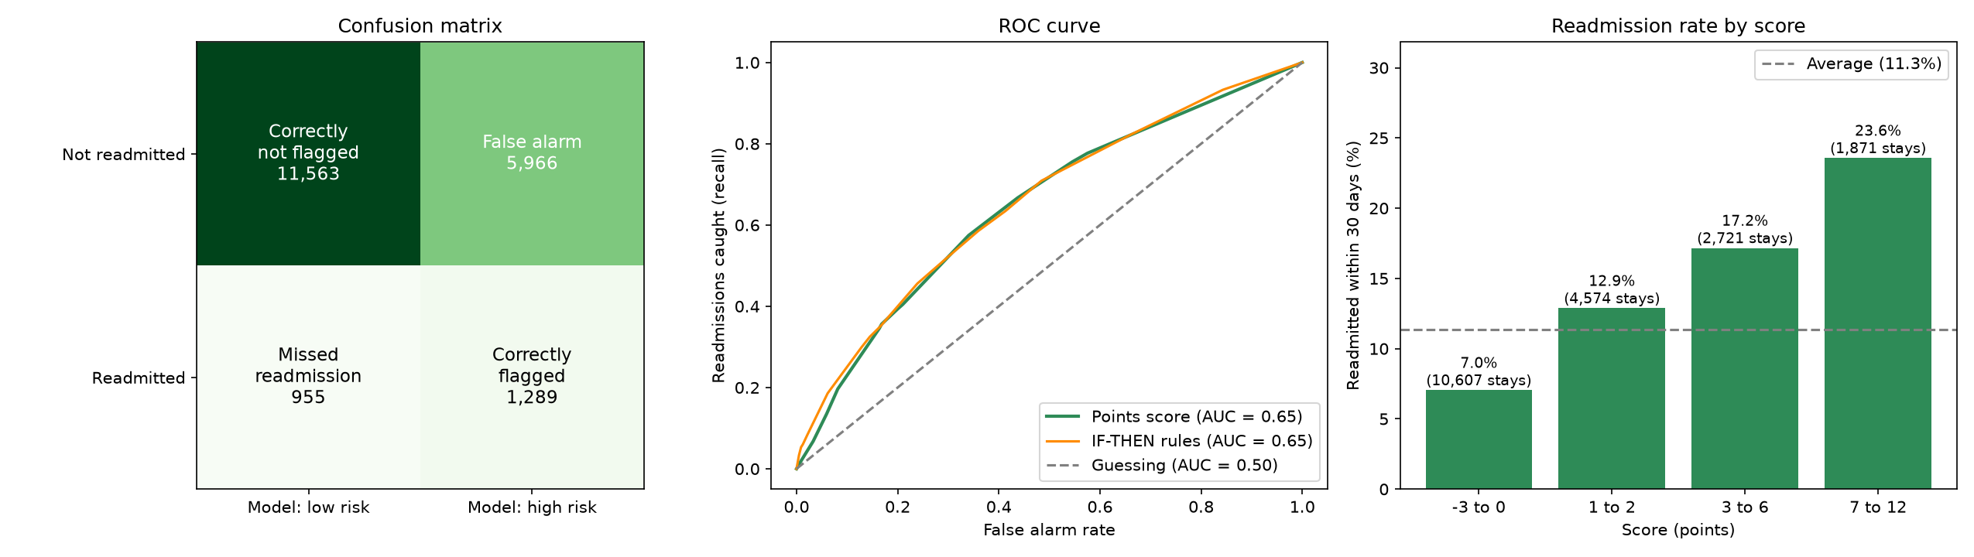
Figure 9.2: Model 2 test results
Table 9.6: Model 2 IF-THEN rules
# | IF | Readmitted | Patients | vs average
1 | Inpatient admissions (past year) >= 5 AND Emergency visits (past year) >= 1 | 42.2% | 716 | 3.7x
2 | Inpatient admissions (past year) >= 5 AND Emergency visits (past year) = 0 AND Age <= 70 | 36.2% | 567 | 3.2x
3 | Inpatient admissions (past year) >= 5 AND Emergency visits (past year) = 0 AND Age >= 71 | 26.9% | 331 | 2.4x
4 | Inpatient admissions (past year) = 1 AND Discharged to a care facility = Yes AND Age <= 80 AND Number of diagnoses <= 8 | 23.1% | 732 | 2.0x
5 | Inpatient admissions (past year) between 3 and 4 | 21.4% | 3,906 | 1.9x
6 | Inpatient admissions (past year) = 2 | 18.0% | 5,867 | 1.6x
7 | Inpatient admissions (past year) = 1 AND Discharged to a care facility = Yes AND Age <= 80 AND Number of diagnoses >= 9 | 16.6% | 1,418 | 1.5x
8 | Inpatient admissions (past year) <= 1 AND Discharged to a care facility = Yes AND Age >= 81 AND Diabetes dose changes >= 1 | 16.1% | 1,514 | 1.4x
9 | Inpatient admissions (past year) = 0 AND Discharged to a care facility = Yes AND Age <= 80 | 15.6% | 6,225 | 1.4x
10 | Inpatient admissions (past year) = 1 AND Discharged to a care facility = No AND Number of diagnoses >= 9 | 13.5% | 5,861 | 1.2x
11 | Inpatient admissions (past year) <= 1 AND Discharged to a care facility = Yes AND Age >= 81 AND Diabetes dose changes = 0 | 12.3% | 3,921 | 1.1x
12 | Inpatient admissions (past year) = 0 AND Discharged to a care facility = No AND Number of diagnoses >= 9 AND Discharged home = No | 11.1% | 4,318 | 1.0x
13 | Inpatient admissions (past year) = 1 AND Discharged to a care facility = No AND Number of diagnoses <= 8 | 10.5% | 5,823 | 0.9x
14 | Inpatient admissions (past year) = 0 AND Discharged to a care facility = No AND Number of diagnoses >= 9 AND Discharged home = Yes | 7.9% | 13,045 | 0.7x
15 | Inpatient admissions (past year) = 0 AND Discharged to a care facility = No AND Number of diagnoses <= 8 AND Age >= 61 | 7.2% | 14,245 | 0.6x
16 | Inpatient admissions (past year) = 0 AND Discharged to a care facility = No AND Number of diagnoses <= 8 AND Age <= 60 | 5.0% | 11,078 | 0.4x

Example of the patient report printed by the notebook:
READMISSION RISK REPORT patient 54679077 (age [50-60), Male)
======================================================================

1. PREDICTION
[RED] HIGH RISK of readmission within 30 days
Estimated chance: 30.0% (average patient: 11.4%)
Score: 12 points (high risk means 2 or more)

2. WHY
Conditions true for this patient:
+5 Inpatient admissions (past year) >= 2
+4 Inpatient admissions (past year) >= 1
+2 Discharged to a care facility
+1 Emergency visits (past year) >= 1
Rule this patient matches:
IF Inpatient admissions (past year) = 2
THEN 18.0% of 5,867 similar training patients were readmitted (1.6x the average)

3. SUGGESTED ACTIONS (hand-written suggestions, for clinician review)
[ ] Repeated admissions: arrange a follow-up call within 2-3 days of discharge.
[ ] Frequent emergency visits: give the patient a clear plan for who to contact first.
[ ] Going to a care facility: send a complete handover to the receiving team.

4. PATIENT SUMMARY
Length of stay: 1 days
Main diagnosis group: digestive
Inpatient admissions (1 yr): 2
Emergency visits (1 yr): 1
Medications during stay: 23
Number of diagnoses: 6

What really happened: not readmitted within 30 days

9.3 Comparison
Table 9.7: All models on the same test patients
Metric | Model 1 score | Model 2 score | Model 2 rules | Black box
Accuracy | 0.687 | 0.650 | 0.726 | 0.741
Precision | 0.141 | 0.178 | 0.196 | 0.207
Recall (sensitivity) | 0.346 | 0.574 | 0.456 | 0.454
Specificity | 0.730 | 0.660 | 0.761 | 0.777
F1 score | 0.200 | 0.271 | 0.274 | 0.284
AUC-ROC | 0.563 | 0.648 | 0.654 | 0.669

Model 2's learned points score improves AUC-ROC by +0.085 over the LACE-style score and catches 57% of readmissions instead of 35%. The black-box reference is only 0.021 higher. Model 2 is selected.

9.4 Discussion and Limitations
- Even the black box reaches only about 0.669 AUC-ROC: the data lacks social support, follow-up care, severity scores and notes.
- Many false alarms: the flagged group contains several non-readmitted patients for each real readmission.
- Old, US-only data (1999-2008); results must be re-tested before use elsewhere.
- Readmissions to other hospitals are not recorded, so some 'not readmitted' labels may be wrong.
- Suggested actions are hand-written and need clinical review.

10. CONCLUSION AND FUTURE WORK

10.1 Conclusion
This project built interpretable models for 30-day readmission of diabetic patients. A learned points score with 5 conditions raised AUC-ROC from 0.563 to 0.648 compared with a LACE-style score, within 0.021 of a black-box model, and IF-THEN rules explain each prediction. A model that staff can check by hand loses very little accuracy, which makes it suitable for clinical settings.

10.2 Future Work
- Use richer and newer data such as MIMIC-IV (lab values, clinical notes).
- Use all three diagnosis columns and earlier stays of the same patient.
- Agree a recall-focused cut-off with clinicians.
- Validate in other hospitals and review the suggested actions with clinicians.

11. REFERENCES
[1] B. Strack, J. P. DeShazo, C. Gennings, J. L. Olmo, S. Ventura, K. J. Cios, J. N. Clore, "Impact of HbA1c Measurement on Hospital Readmission Rates: Analysis of 70,000 Clinical Database Patient Records," BioMed Research International, vol. 2014, art. 781670, 2014. Available: https://doi.org/10.1155/2014/781670
[2] C. van Walraven, I. A. Dhalla, C. Bell, E. Etchells, I. G. Stiell, K. Zarnke, P. C. Austin, A. J. Forster, "Derivation and validation of an index to predict early death or unplanned readmission after discharge from hospital to the community," CMAJ, vol. 182, no. 6, pp. 551-557, 2010. Available: https://doi.org/10.1503/cmaj.091117
[3] D. Kansagara, H. Englander, A. Salanitro, D. Kagen, C. Theobald, M. Freeman, S. Kripalani, "Risk Prediction Models for Hospital Readmission: A Systematic Review," JAMA, vol. 306, no. 15, pp. 1688-1698, 2011. Available: https://doi.org/10.1001/jama.2011.1515
[4] B. Ustun, C. Rudin, "Supersparse linear integer models for optimized medical scoring systems," Machine Learning, vol. 102, no. 3, pp. 349-391, 2016. Available: https://doi.org/10.1007/s10994-015-5528-6
[5] C. Rudin, "Stop explaining black box machine learning models for high stakes decisions and use interpretable models instead," Nature Machine Intelligence, vol. 1, no. 5, pp. 206-215, 2019. Available: https://doi.org/10.1038/s42256-019-0048-x
[6] R. Tibshirani, "Regression shrinkage and selection via the lasso," Journal of the Royal Statistical Society, Series B, vol. 58, no. 1, pp. 267-288, 1996. Available: https://doi.org/10.1111/j.2517-6161.1996.tb02080.x

