Interpretable Prediction of 30-Day Hospital Readmission in Diabetic Patients
Student Guide: understanding, running and presenting the project
[Your name] · [Register number] · Guide: [Guide's name]
This guide explains every part of the project in plain words: the problem, the data, both models, the results and the web app. It ends with a demo script and the questions a guide or examiner is likely to ask, with answers.

1. The project in one minute
- Problem: predict whether a diabetic patient will be readmitted within 30 days of leaving hospital.
- Why: early readmissions are costly and often preventable; flagging high-risk patients lets staff arrange follow-up calls, medication reviews or home support before discharge.
- Approach: two models a nurse can check by hand (points scores and IF-THEN rules), compared with a black-box model.
- Main result: Model 2 improves AUC-ROC from 0.563 to 0.648 and catches 57% of readmissions instead of 35%, within 0.021 of the black-box model.
- Output: a Streamlit web app that gives the risk, the reason and suggested actions for any patient.

2. Project files
File | What it is
ML11-second-review/notebooks/M1_lace_points_score.ipynb | Model 1: clinical points score (LACE-style)
ML11-second-review/notebooks/M2_learned_points_score.ipynb | Model 2: learned points score, IF-THEN rules, patient report, comparison
ML11-final-review/app/app.py | Streamlit web app that uses both models
ML11-second-review/data/diabetic_data.csv | The dataset (101,766 hospital stays, 50 columns)
ML11-second-review/results/model1_results.csv, model2_results.csv | Test results of each model
ML11-second-review/results/comparison.csv | All models side by side
ML11-second-review/results/model1_charts.png, model2_charts.png | Confusion matrix, ROC curve, readmission rate by score
ML11-second-review/results/model2_rules.txt | Model 2 points table and all 16 rules in text form

3. The dataset
The UCI “Diabetes 130-US hospitals for years 1999–2008” dataset. Each row is one hospital stay of a diabetic patient, with age, length of stay, diagnoses (ICD-9 codes), medications, lab tests, past visits, discharge destination and whether the patient was readmitted (<30 days, >30 days, or no).

Data preparation
1. Missing values: the file uses “?” for missing values; these are read as empty.
2. Removed stays: patients who died or went to hospice (they cannot be readmitted) and rows with an invalid gender: 101,766 stays become 99,340 stays from 69,987 patients.
3. Target: 1 if readmitted within 30 days, otherwise 0. Only 11.4% are 1, so the classes are imbalanced.
4. Split by patient: many patients have several stays. GroupShuffleSplit on patient_nbr keeps each patient entirely in training (80%, 79,567 stays) or test (20%, 19,773 stays). This prevents the model from being tested on people it has already seen.
5. Validation set: Model 2 takes 20% of the training patients as a validation set to choose its settings, so the test set is used only once, at the end.
6. Fixed seed (42): every split and result can be reproduced exactly.

4. Model 1: clinical points score
Model 1 copies the style of the LACE index that hospitals use. It is the baseline: the existing manual method. Add the points for four facts; the maximum is 19.
Factor (LACE letter) | Points | Max
Length of stay (L) | 1 day = 1, 2 = 2, 3 = 3, 4–6 days = 4, 7–13 = 5, 14+ = 7 | 7
Acuity: emergency admission (A) | Yes = 3, No = 0 | 3
Comorbidity: number of diagnoses (C) | 1 point per diagnosis above 4 | 5
Emergency visits in the past year (E) | 1 point per visit | 4

- The real LACE index uses the Charlson comorbidity index; this dataset has none, so the number of diagnoses is used instead.
- A one-variable logistic regression turns the score into a percentage (score 1 ≈ 6.5%, score 19 ≈ 22.4%).
- A score of 11 or more (≈ 13.3% chance) is flagged as high risk: about the top quarter of training patients.
- Test result: AUC-ROC 0.563, recall 35%, precision 14%. Easy to use, but it separates patients poorly.
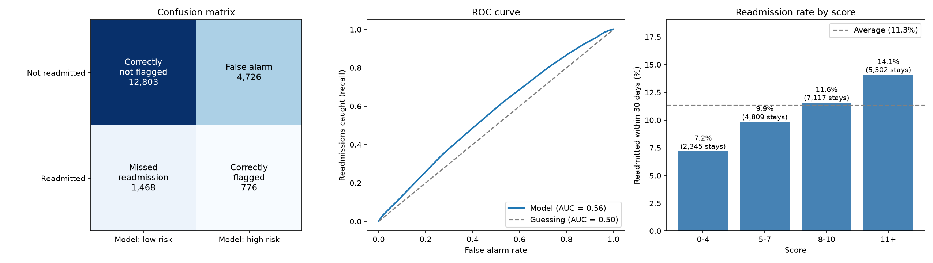
Figure 1. Model 1 on the test set: confusion matrix, ROC curve, readmission rate by score.

5. Model 2: learned points score and IF-THEN rules
Model 2 keeps the points-score format but lets the data decide which conditions matter and how many points each is worth.

Part A: the learned points score
1. Features: 29 per stay: 11 numbers (age, length of stay, lab tests, medications, past visits, diagnoses, diabetes drugs, dose changes) and 18 yes/no facts (emergency admission, insulin, HbA1c, glucose, discharge destination, main diagnosis group). Sex and race are left out.
2. Yes/no conditions: each number is cut at its 25th, 50th, 75th and 90th percentiles, e.g. “inpatient admissions ≥ 2”, giving 47 candidate conditions.
3. L1 (lasso) logistic regression: pushes most weights to exactly zero, so only the strongest conditions remain.
4. Size chosen on validation: limits of 4 to 15 conditions were tried; the best validation AUC-ROC decided the size.
5. Whole points: weights are scaled so the largest is 5 and rounded; conditions that round to 0 are dropped, leaving 5.
Condition | Points
Inpatient admissions (past year) ≥ 2 | +5
Inpatient admissions (past year) ≥ 1 | +4
Discharged to a care facility | +2
Emergency visits (past year) ≥ 1 | +1
Discharged home | −3

Scores run from −3 (7.1% chance) to 12 (30.0%). A score of 2 or more (12.0% chance) is high risk. Lesson: past inpatient admissions are by far the strongest warning sign; going home lowers the risk.

Part B: IF-THEN rules
A small decision tree on all 29 features, with at least 200 patients per leaf, gives 16 rules. Each rule says what share of similar training patients came back. Two examples:
- Highest risk: IF inpatient admissions ≥ 5 AND emergency visits ≥ 1 THEN 42.2% were readmitted (716 patients, 3.7× the average).
- Lowest risk: IF no inpatient admissions AND not sent to a care facility AND ≤ 8 diagnoses AND age ≤ 60 THEN 5.0% were readmitted (11,078 patients, 0.4× the average).

Part C: patient report
For any patient the notebook prints: (1) the prediction with a red, yellow or green risk level, (2) why: the conditions that scored points and the matching rule, (3) suggested actions, (4) a patient summary. The actions are hand-written per risk factor, not learned, and need a clinician’s review.
Test result: AUC-ROC 0.648, recall 57%, precision 18%.
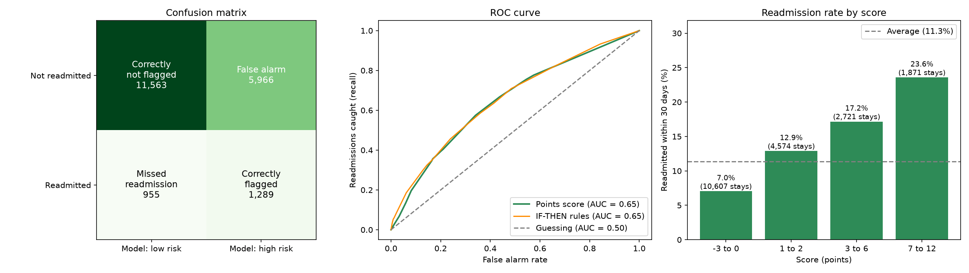
Figure 2. Model 2 on the test set: confusion matrix, ROC curves, readmission rate by score.

6. Comparing the models
Metric | Model 1 | Model 2 score | Model 2 rules | Black box
AUC-ROC | 0.563 | 0.648 | 0.654 | 0.669
Recall | 0.346 | 0.574 | 0.456 | 0.454
Precision | 0.141 | 0.178 | 0.196 | 0.207
F1 score | 0.200 | 0.271 | 0.274 | 0.284
Specificity | 0.730 | 0.660 | 0.761 | 0.777
Accuracy | 0.687 | 0.650 | 0.726 | 0.741

What each metric means
- AUC-ROC (main metric): how well the model ranks a readmitted patient above one who is not. 0.50 = guessing, 1.00 = perfect. It does not depend on the cut-off.
- Recall: of the patients who really came back, the share flagged. Most important for a hospital, because a missed patient gets no follow-up.
- Precision: of the flagged patients, the share who really came back. Low precision = many false alarms.
- Specificity: of the patients who did not come back, the share correctly not flagged.
- F1: one number that balances precision and recall.
- Accuracy is misleading here: 89% of stays are not readmitted, so flagging nobody already scores 0.89.
Why only about 0.65 even for the black box? The dataset lacks much of what drives readmission: social support, follow-up care, severity scores and clinical notes. The limit is the data, not the method.

7. The Streamlit web app
app.py trains both models once at start-up with exactly the same steps as the notebooks (about a minute), keeps them in memory, and updates the predictions instantly whenever an input changes.

How to run it
1. Open Anaconda Prompt.
2. Go to the project folder:
cd C:\Users\Thirumaleswari\100\ML11-HOSPITAL-READMISSION\ML11-final-review\app
3. Start the app:
streamlit run app.py
4. It opens in the browser at http://localhost:8501. Stop it with Ctrl + C in the prompt.

The three tabs
- Check a patient: enter details (this stay, past year, diabetes care) and see Model 1 and Model 2 side by side, the matching IF-THEN rule and a checklist of suggested actions. “Load a test patient” fills the form with a real unseen patient and shows what really happened.
- How the models work: both points tables, the score-to-risk table and all 16 rules.
- Model performance: the comparison table and the charts from the notebooks.
Colour | Meaning
Red box | High risk: Model 1 score 11+ (≈ 13.3%+), Model 2 score 2+ (12.0%+)
Yellow box | Moderate risk (Model 2 only): below the cut-off but above the typical patient
Green box | Low risk
Red / green arrow | Chance above / below the 11.4% average; separate from the risk level

8. Demo script (about 5 minutes)
1. Problem and data (30 s): 30-day readmission, 99,340 stays, 11.4% readmitted, split by patient.
2. Model 1 (45 s): open “How the models work”, show the 4-factor score; AUC-ROC 0.563.
3. Model 2 (60 s): show the 5-condition points table; explain L1 selection and the 16 rules.
4. Live demo (90 s): “Check a patient” → Load a test patient; walk through both scores, the rule and the actions. Then raise “Inpatient admissions” to 5 and show the risk turn red.
5. Results (45 s): open “Model performance”; Model 2 beats Model 1 by 0.085 AUC-ROC and is within 0.021 of the black box.
6. Close (30 s): readable models lose very little accuracy; next step is richer data such as MIMIC-IV.

9. Likely viva questions
Q: Why not use the black-box model?
A: It gains only 0.021 AUC-ROC, and nobody can check or explain its predictions. In healthcare a score staff can verify is worth more than a small gain.
Q: Why split by patient instead of by row?
A: One patient has several stays. A row split would put the same patient in training and test and inflate the results.
Q: Why is Model 2’s accuracy lower than Model 1’s?
A: Model 2 flags more patients: more false alarms, but far more real readmissions caught (57% vs 35%). On imbalanced data, accuracy rewards flagging nobody.
Q: How was the high-risk cut-off chosen?
A: The 75th percentile of training scores, so about the top quarter is flagged. It can be moved to trade recall against false alarms.
Q: Was the test set used for tuning?
A: No. The number of conditions and the tree size were chosen on a separate validation set.
Q: Why L1 logistic regression?
A: It sets most weights to zero, so it selects a small set of conditions automatically; the rounded weights become the points.
Q: Why are sex and race not used?
A: So that the score does not treat patients differently by demographics.
Q: What is the LACE index?
A: A hospital readmission score using Length of stay, Acuity of admission, Comorbidity and Emergency visits.
Q: What would improve the model?
A: Richer data (lab values, social support, follow-up, notes), newer data from other hospitals, and a cut-off agreed with clinicians.

10. Limitations and future work
- Modest accuracy (AUC-ROC ≈ 0.65): the models support staff judgment; they do not replace it.
- Many false alarms: about 4.6 per real readmission caught by Model 2.
- Old, US-only data (1999–2008): results must be re-tested before use elsewhere.
- Readmissions to other hospitals are not recorded, so some “not readmitted” labels may be wrong.
- Suggested actions are hand-written and need clinical review; not for real clinical use without validation.
- Future work: MIMIC-IV (lab values and clinical notes), using all three diagnosis columns and earlier stays of the same patient, and a recall-focused cut-off.

