Fair Student Dropout Early-Warning System using Machine Learning
First Review: Dataset, System Design and Evaluation Plan
[Student name] · [Register number] · Guide: [Guide's name] · [Department, College]

1. Introduction
Every year a significant share of higher-education students leave before finishing their degree. Dropping out costs students tuition, living expenses and years of their lives, and it lowers institutions' completion rates and funding. Most dropouts show warning signs early (failing first-semester units, unpaid fees, entering through a less preferred course), so a model that reads these signs can help advisors reach students in time. This review fixes the dataset, the system design, the algorithms and the evaluation plan.

2. Problem statement
Higher-education institutions lose a large share of their students before graduation. In this dataset 1421 of 4,424 students (32.1%) dropped out. Advisors can support at-risk students only if they know early who they are, but manual judgement is slow and inconsistent, and an automated model tuned only for accuracy can miss at-risk students of some groups more often than others. The problem is to predict dropout early and accurately while keeping the share of real dropouts caught similar across gender and age groups.

3. Objectives
1. Study the published student dropout dataset [1] and define a binary dropout label.
2. Build a baseline logistic regression (Model 1) that warns at enrolment, before any grades exist.
3. Build an improved, tuned gradient boosting model (Model 2) that also uses first-semester results.
4. Add fairness: reweighing for Model 1 [2] and equal-opportunity thresholds for Model 2 [3].
5. Evaluate both models on held-out students, overall and per gender and age band, with confidence intervals.
6. Explain the main risk factors and convert probabilities into Low / Medium / High risk levels.
7. Deliver a Streamlit web application for advisors.

4. Literature survey
# | Paper | Key idea | Use in this project
1 | Predicting Student Dropout and Academic Success (Realinho et al., 2022) | Describes the creation of the dataset used in this project from several disjoint databases of a Portuguese polytechnic institution, covering students enrolled in eight-pl... | Supplies the data, the attribute definitions and the motivation; this project narrows the task to a binary dropout label and adds fairness.
2 | Data preprocessing techniques for classification without discrimination (Kamiran and Calders, 2012) | Surveys ways of removing discrimination from training data before a classifier is learned: suppressing the sensitive attribute, changing (massaging) labels, and reweighin... | Used directly in Model 1: reweighing by gender x age band.
3 | Equality of Opportunity in Supervised Learning (Hardt, Price and Srebro, 2016) | Defines equalised odds and equal opportunity: a classifier satisfies equal opportunity when its true-positive rate is the same in every group. The paper shows that any sc... | Used in Model 2: one threshold per gender x age group so recall is similar for all groups.
4 | Evaluating the Fairness of Predictive Student Models Through Slicing Analysis (Gardner, Brooks and Baker, 2019) | Proposes slicing analysis for learning-analytics models: measuring performance separately for each demographic group, and the ABROCA statistic (area between the groups' R... | Motivates the per-group evaluation tables and recall gaps reported for both models.
5 | Algorithmic Fairness in Education (Kizilcec and Lee, 2020) | Reviews how unfairness enters educational algorithms at measurement, model learning and action stages, and explains the main statistical fairness criteria: independence (... | Guides the choice of equal opportunity (a separation criterion) as the main fairness target for an early-warning tool.
6 | LightGBM: A Highly Efficient Gradient Boosting Decision Tree (Ke et al., 2017) | Introduces histogram-based gradient boosting with gradient-based one-side sampling and exclusive feature bundling, reaching the accuracy of conventional GBDT many times f... | Provides the algorithm family used for Model 2.

5. Existing and proposed system

Existing system
In most institutions dropout risk is judged by advisors case by case, usually after a student has already failed units or stopped attending. Where data-driven tools exist, they are typically classifiers trained to maximise overall accuracy, as in the original study of this dataset [1]. Research on predictive student models [4, 5] shows that such models can perform very differently for different demographic groups even when their overall accuracy is good.
- Late detection: risk becomes visible only after poor results appear.
- Accuracy-only optimisation: errors per gender or age group are not measured.
- One threshold for everyone: in this data a single 0.5 threshold leaves an age-band recall gap of 0.283 for the gradient boosting model.
- No explanation: advisors are not told why a student is flagged, so they cannot plan an intervention.
- Imbalanced classes ignored: dropouts are the minority class, so a model can look accurate while missing many of them.

Proposed system
The proposed system predicts the probability that each student drops out and turns it into a Low, Medium or High risk level for advisors. Fairness is built in: Model 1 reweighs training examples so that every gender x age group counts equally [2], and Model 2 chooses a separate decision threshold per group so that the share of real dropouts caught (recall) is similar across groups [3]. Thresholds are always chosen on out-of-fold predictions of the training set, never on the test set. The system reports the main risk factors and a per-group fairness audit, and it is delivered as a Streamlit web application.
- Two warning stages: Model 1 at enrolment, Model 2 after the first semester.
- Recall-oriented: thresholds are set to catch most real dropouts (targets 0.75 and 0.85).
- Fair by design: recall gaps across gender and age band are measured with 95% bootstrap intervals and constrained.
- Explainable: logistic coefficients and permutation importance show which factors drive the risk.
- No leakage: the test set is used once, only for the final numbers.
- Practical: a web app with a watch list, a single-student check and suggested actions.

6. Dataset

Source and licence
Name: Predict students' dropout and academic success. Published by Realinho, Machado, Baptista and Martins with the base paper [1]; dataset DOI 10.5281/zenodo.5777339; licence CC BY 4.0 (free to use with attribution). The project copy is ML14-second-review/data/data.csv (semicolon-separated, UTF-8).
Table 1: Dataset summary
Property | Value
Rows (students) | 4,424
Columns | 37 (36 attributes + Target)
Missing values | 0
Duplicate rows | 0
Target column | Target
Label used | dropout = 1 if Target = Dropout, else 0
Dropout rate | 32.1%
Sensitive attributes | Gender; Age band (20 or under, 21-24, 25 and over)

Target distribution
Table 2: Outcome classes
Outcome | Students | Share
Graduate | 2209 | 49.9%
Dropout | 1421 | 32.1%
Enrolled | 794 | 17.9%

The classes are imbalanced: only about one student in three drops out. Accuracy alone would therefore be misleading, so recall, precision, F1 and ROC-AUC are used, and Model 2 uses balanced class weights.

Dropout rate by group
Table 3: Dropout rate by gender and age band (training notebook output)
Attribute | Group | Dropout rate
Gender | Female | 25.1%
Gender | Male | 45.1%
Age band | 20 or under | 21.2%
Age band | 21-24 | 33.7%
Age band | 25 and over | 55.4%

Dropout differs strongly between groups: older students and male students drop out more often. A model can therefore easily learn to work better for some groups than others, which is why the fairness audit is done on exactly these two attributes.

All attributes
Table 4: The 37 columns of data.csv
# | Column | Group | Type | Meaning
1 | Marital status | Demographic | Categorical code | 1 single, 2 married, 3 widower, 4 divorced, 5 facto union, 6 legally separated
2 | Application mode | Academic path | Categorical code | Entry route, e.g. 1st phase general contingent, over-23 exam, transfer
3 | Application order | Academic path | Integer 0-9 | Preference rank of this course in the application (1 = first choice)
4 | Course | Academic path | Categorical code | Degree programme, e.g. 9254 Tourism, 9500 Nursing
5 | Daytime/evening attendance | Academic path | Binary | 1 daytime, 0 evening
6 | Previous qualification | Academic path | Categorical code | Highest qualification before enrolment
7 | Previous qualification (grade) | Academic path | Numeric 0-200 | Grade of the previous qualification
8 | Nacionality | Demographic | Categorical code | Nationality
9 | Mother's qualification | Socio-economic | Categorical code | Mother's education level
10 | Father's qualification | Socio-economic | Categorical code | Father's education level
11 | Mother's occupation | Socio-economic | Categorical code | Mother's occupation group
12 | Father's occupation | Socio-economic | Categorical code | Father's occupation group
13 | Admission grade | Academic path | Numeric 0-200 | Grade used for admission
14 | Displaced | Demographic | Binary | 1 if studying away from home
15 | Educational special needs | Demographic | Binary | 1 if the student has special educational needs
16 | Debtor | Socio-economic | Binary | 1 if the student owes money to the institution
17 | Tuition fees up to date | Socio-economic | Binary | 1 if fees are paid up to date
18 | Gender | Demographic (audit only) | Binary | 1 male, 0 female; used only for the fairness audit
19 | Scholarship holder | Socio-economic | Binary | 1 if the student holds a scholarship
20 | Age at enrollment | Demographic | Integer | Age in years at enrolment; also used to form age bands
21 | International | Demographic | Binary | 1 if an international student
22 | Curricular units 1st sem (credited) | Academic performance | Numeric | 1st semester: units credited from earlier studies
23 | Curricular units 1st sem (enrolled) | Academic performance | Numeric | 1st semester: units enrolled
24 | Curricular units 1st sem (evaluations) | Academic performance | Numeric | 1st semester: unit assessments attempted
25 | Curricular units 1st sem (approved) | Academic performance | Numeric | 1st semester: units passed
26 | Curricular units 1st sem (grade) | Academic performance | Numeric | 1st semester: average grade (0-20)
27 | Curricular units 1st sem (without evaluations) | Academic performance | Numeric | 1st semester: units with no assessment
28 | Curricular units 2nd sem (credited) | Academic performance | Numeric | 2nd semester: units credited from earlier studies
29 | Curricular units 2nd sem (enrolled) | Academic performance | Numeric | 2nd semester: units enrolled
30 | Curricular units 2nd sem (evaluations) | Academic performance | Numeric | 2nd semester: unit assessments attempted
31 | Curricular units 2nd sem (approved) | Academic performance | Numeric | 2nd semester: units passed
32 | Curricular units 2nd sem (grade) | Academic performance | Numeric | 2nd semester: average grade (0-20)
33 | Curricular units 2nd sem (without evaluations) | Academic performance | Numeric | 2nd semester: units with no assessment
34 | Unemployment rate | Macro-economic | Numeric (%) | National unemployment rate in the enrolment year
35 | Inflation rate | Macro-economic | Numeric (%) | National inflation rate
36 | GDP | Macro-economic | Numeric | GDP growth
37 | Target | Outcome | Text | Dropout, Enrolled or Graduate at the end of the normal course duration

7. System architecture
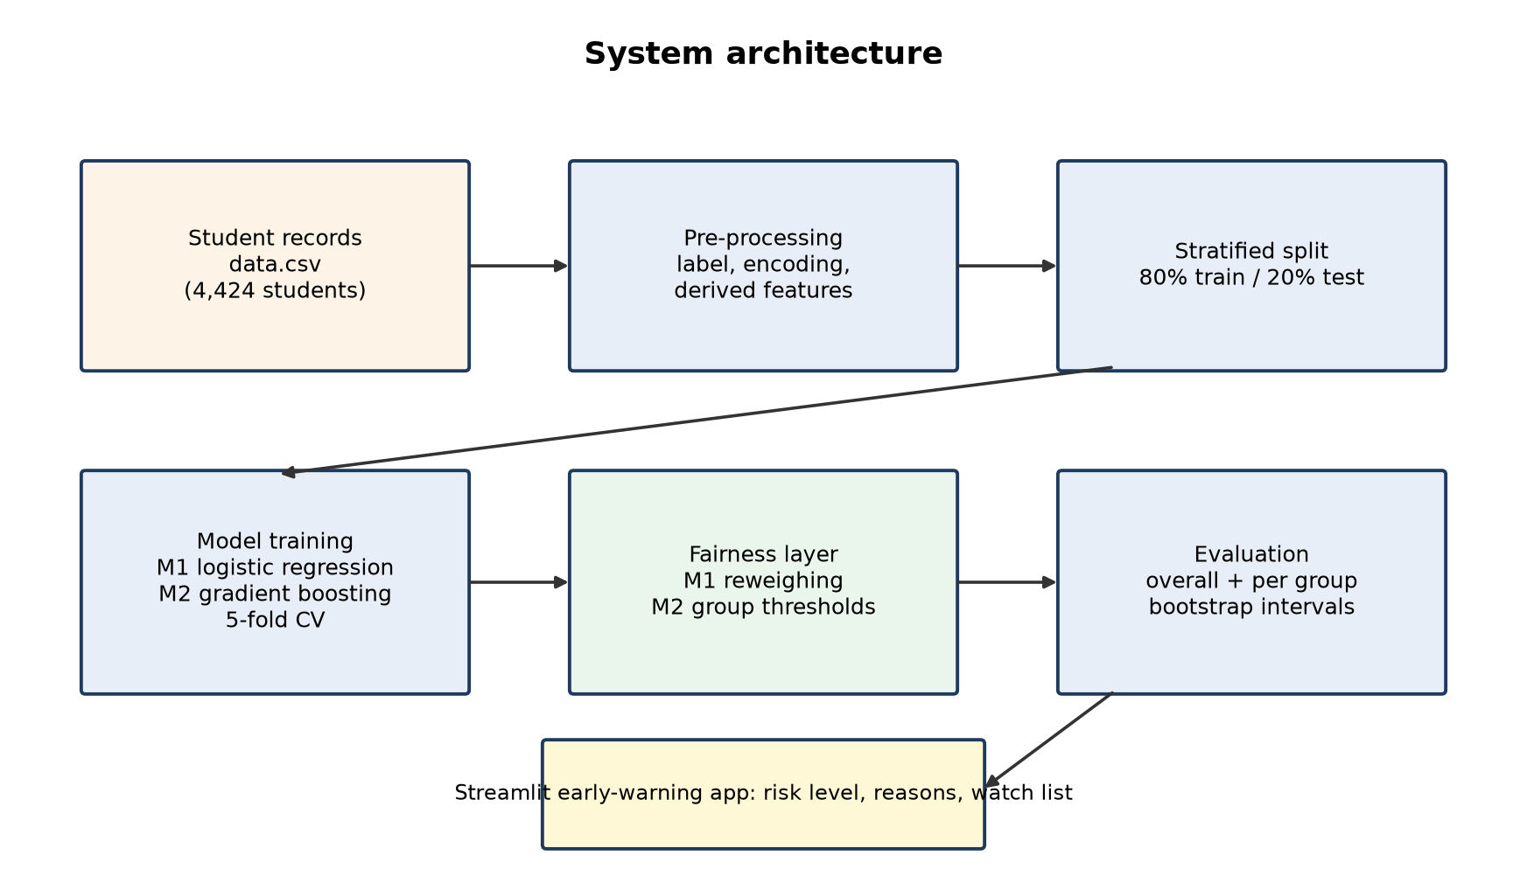
Figure 1: System architecture
- Student records: the CSV file of enrolment and first-semester data.
- Pre-processing: builds the label, the audit groups, the categorical types and the derived first-semester ratios.
- Stratified split: keeps the dropout share equal in training and test sets; the test set is locked away.
- Model training: Model 1 and Model 2 are trained with 5-fold stratified cross-validation.
- Fairness layer: reweighing (M1) or group thresholds (M2), chosen on out-of-fold predictions.
- Evaluation and app: overall and per-group metrics; the Streamlit app shows risk levels and reasons to advisors.
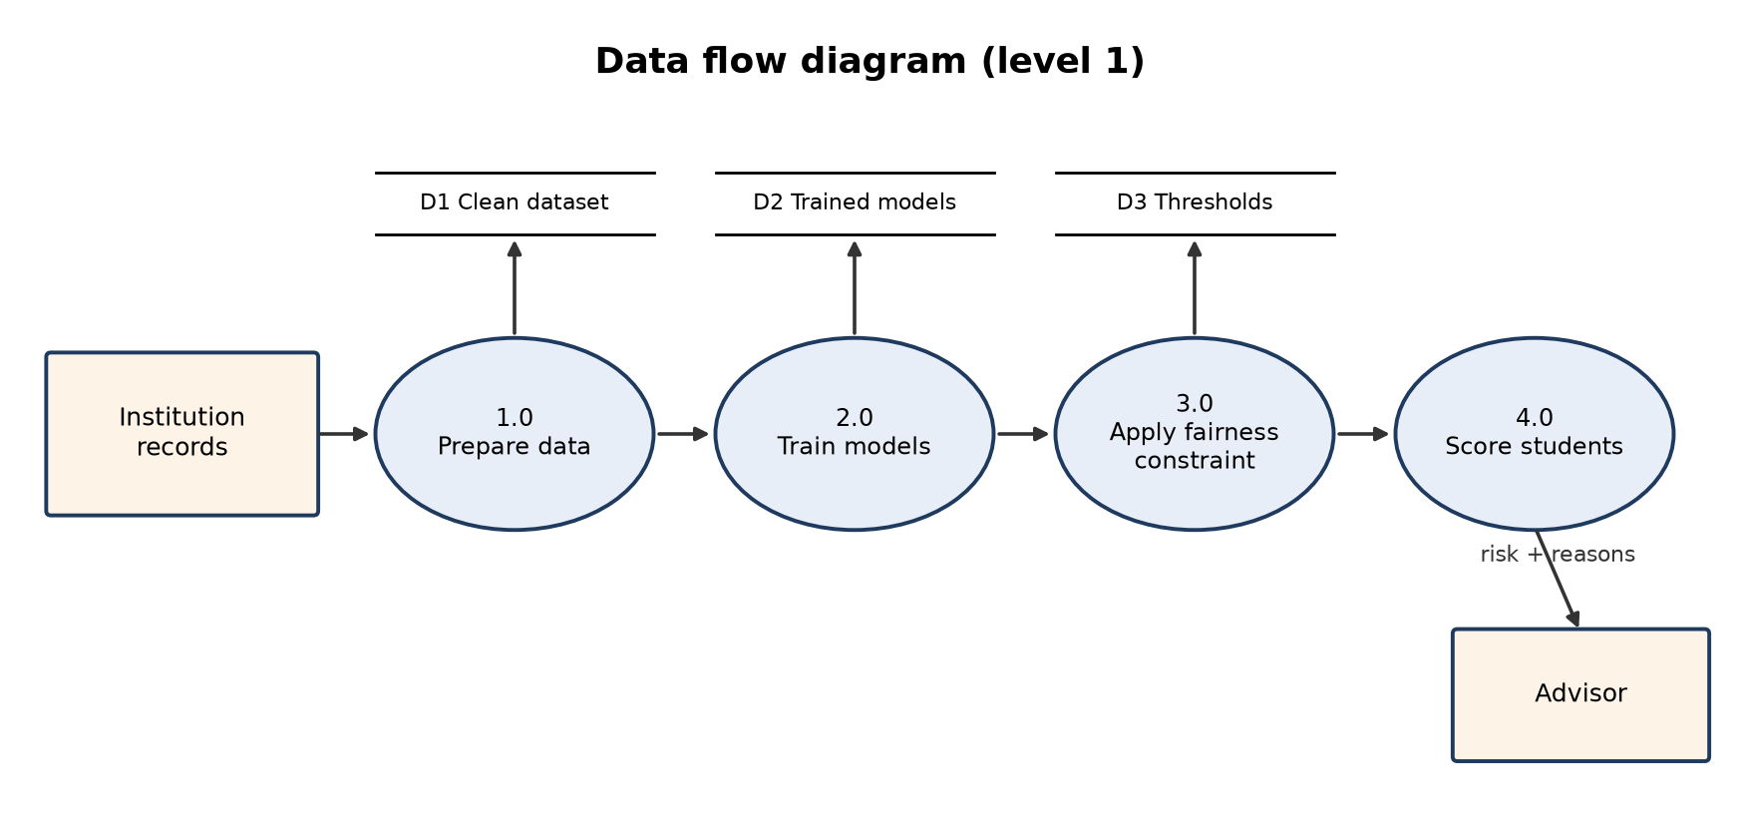
Figure 2: Data flow diagram (level 1)

8. UML diagrams

Use case diagram
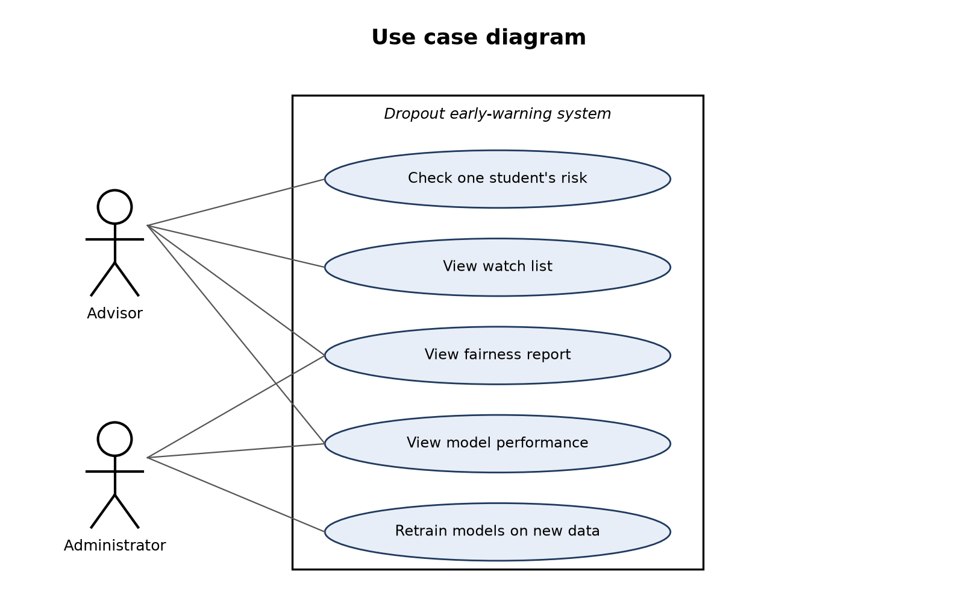
Figure 3: Use case diagram
The advisor checks individual students, browses the watch list and reads the fairness and performance reports. The administrator maintains the system and retrains the models when a new cohort's data arrives.

Class diagram
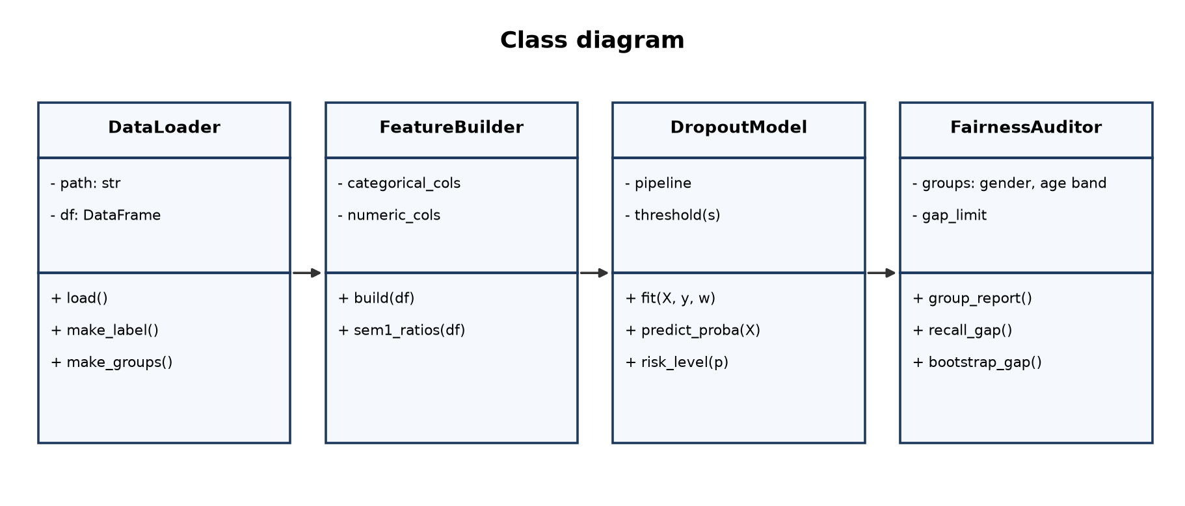
Figure 4: Class diagram
DataLoader reads the CSV and builds the label and groups; FeatureBuilder prepares the model inputs; DropoutModel wraps the trained pipeline and its threshold(s); FairnessAuditor computes per-group reports, recall gaps and bootstrap intervals.

Activity diagram
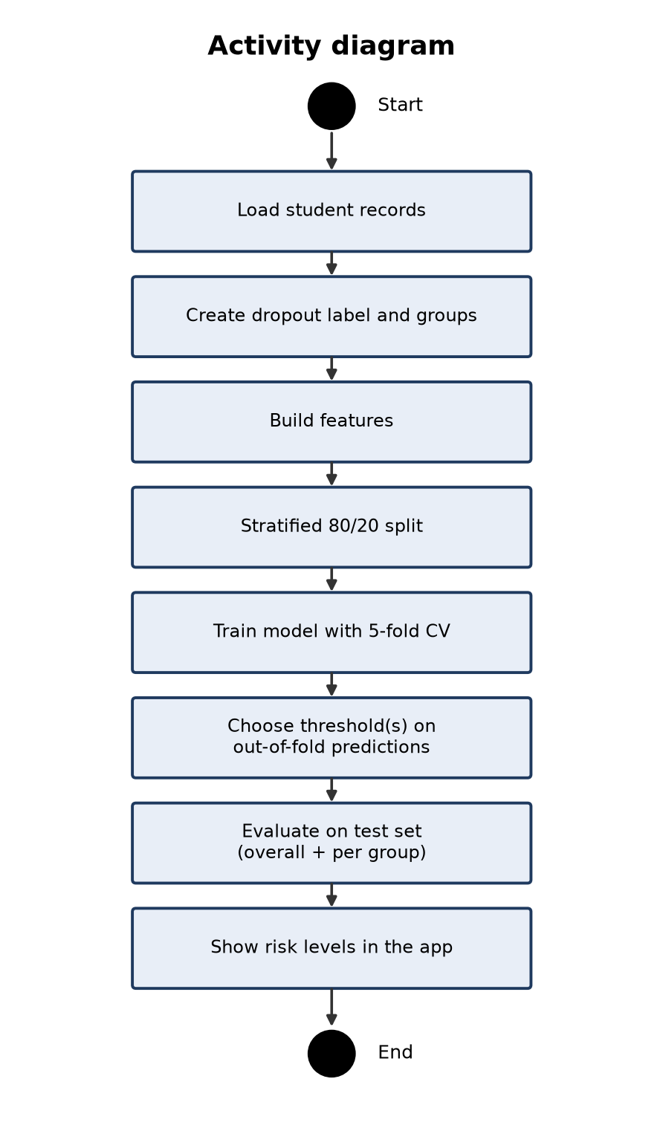
Figure 5: Activity diagram

Sequence diagram
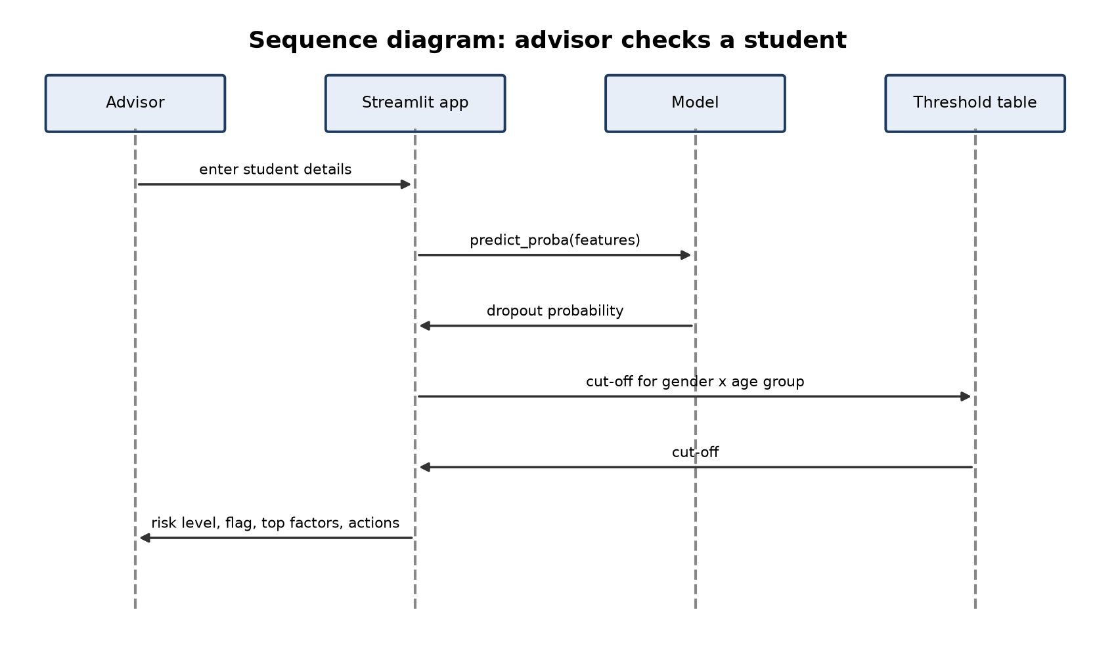
Figure 6: Sequence diagram
When the advisor enters a student's details, the app asks the model for a probability, looks up the cut-off for the student's gender x age group and returns the risk level, the flag and the factors that raise the risk most.

ER diagram
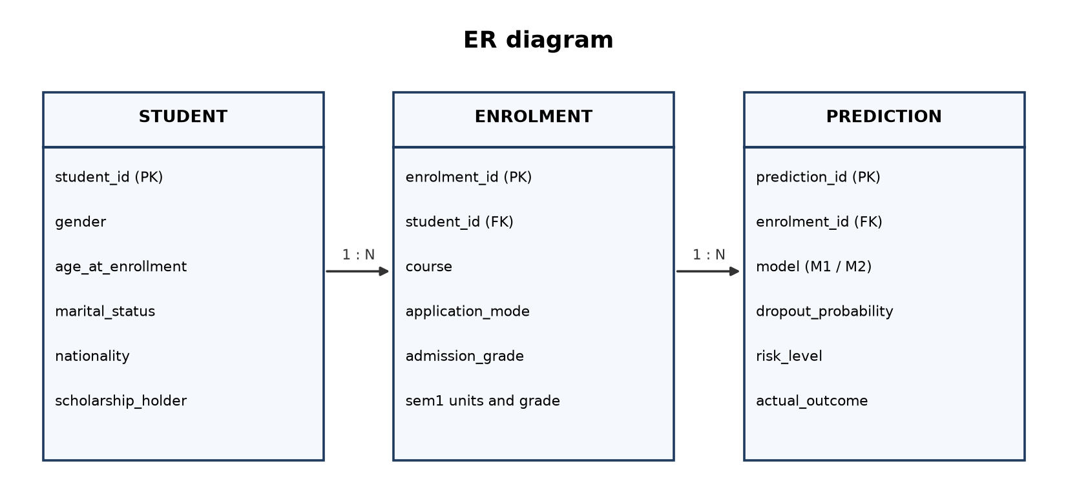
Figure 7: ER diagram

9. Algorithms

Model 1: Logistic regression (baseline)
Logistic regression computes a weighted sum of the inputs and passes it through the sigmoid function to obtain a probability between 0 and 1. Numeric inputs are standardised and categorical codes are one-hot encoded (rare categories grouped). It is fast, stable on a few thousand rows, and every coefficient can be read as the direction and strength of a factor.
P(dropout | x) = σ(β0 + β1x1 + ... + βkxk), σ(z) = 1 / (1 + e^-z)

Model 2: Histogram gradient boosting
Gradient boosting builds many small decision trees one after another; each new tree corrects the errors of the trees before it. The histogram variant bins each feature into at most 255 values, which makes training fast [6], and handles categorical codes natively. It captures non-linear effects and interactions, such as failing several units while also having unpaid fees.
F_m(x) = F_(m-1)(x) + η · h_m(x), P(dropout | x) = σ(F_M(x))

Fairness methods
- Reweighing (Model 1) [2]: weight(g, y) = P(g) · P(y) / P(g, y), computed for every gender x age group g and label y.
- Equal-opportunity thresholds (Model 2) [3]: for each group, the highest threshold whose out-of-fold recall reaches the target is used.

10. Evaluation plan
- Stratified 80/20 train-test split, random_state 42 (3,539 / 885 students). The test set is used once.
- 5-fold stratified cross-validation on the training set for tuning and for choosing thresholds.
- Selection rule: the model with the best mean cross-validation ROC-AUC, provided its recall gaps stay small.
- Fairness: per-group selection rate, recall, false-positive rate; recall gaps with 95% bootstrap intervals (2,000 resamples).
Table 5: Evaluation metrics
Metric | Formula | Meaning
Accuracy | (TP + TN) / all | Share of all students classified correctly; misleading when classes are imbalanced
Precision | TP / (TP + FP) | Of the flagged students, the share who really drop out
Recall (TPR) | TP / (TP + FN) | Of the real dropouts, the share flagged; the priority for an early-warning tool
F1-score | 2 PR / (P + R) | Balance of precision and recall
ROC-AUC | Area under the ROC curve | Probability that a random dropout is ranked above a random non-dropout (0.5 = guessing)
Selection rate | Flagged / group size | Share of a group that is flagged
Recall gap | max - min group recall | Equal opportunity difference; 0 means every group's dropouts are caught equally

11. Requirements
Type | Requirement
Hardware | Intel i3 or better, 4 GB RAM, 1 GB free disk; no GPU needed
Operating system | Windows 10/11, Linux or macOS
Language | Python 3.10+
Libraries | pandas, NumPy, scikit-learn, matplotlib, Streamlit
Tools | Anaconda, Jupyter Notebook, web browser

12. Work plan
Review | Work | Deliverables
Zeroth | Base paper, references, abstract | abstract.docx, paper links
First | Dataset, design, algorithms, evaluation plan | first-review.docx
Second | Pre-processing, Model 1 baseline, Model 2, comparison | notebooks, second-review.docx
Final | Web app, report, slides | app.py, report.docx, slides.pptx, student guide

References
[1] V. Realinho, J. Machado, L. Baptista, M. V. Martins, "Predicting Student Dropout and Academic Success," Data, vol. 7, no. 11, art. 146, 2022. Available: https://doi.org/10.3390/data7110146
[2] F. Kamiran, T. Calders, "Data preprocessing techniques for classification without discrimination," Knowledge and Information Systems, vol. 33, pp. 1-33, 2012. Available: https://doi.org/10.1007/s10115-011-0463-8
[3] M. Hardt, E. Price, N. Srebro, "Equality of Opportunity in Supervised Learning," Advances in Neural Information Processing Systems 29 (NeurIPS 2016), 2016. Available: https://doi.org/10.48550/arXiv.1610.02413
[4] J. Gardner, C. Brooks, R. Baker, "Evaluating the Fairness of Predictive Student Models Through Slicing Analysis," Proc. 9th Int. Conf. on Learning Analytics & Knowledge (LAK '19), pp. 225-234, 2019. Available: https://doi.org/10.1145/3303772.3303791
[5] R. F. Kizilcec, H. Lee, "Algorithmic Fairness in Education," arXiv:2007.05443 (chapter in Ethics in Artificial Intelligence in Education), 2020. Available: https://doi.org/10.48550/arXiv.2007.05443
[6] G. Ke, Q. Meng, T. Finley, T. Wang, W. Chen, W. Ma, Q. Ye, T.-Y. Liu, "LightGBM: A Highly Efficient Gradient Boosting Decision Tree," Advances in Neural Information Processing Systems 30 (NeurIPS 2017), pp. 3146-3154, 2017. Available: https://proceedings.neurips.cc/paper/2017/file/6449f44a102fde848669bdd9eb6b76fa-Paper.pdf

