Dynamic Flight Fare Forecasting Using Macroeconomic Regressors
First Review: Data, System Design and Evaluation Plan
[Student name] · [Register number] · Guide: [Guide's name] · [Department, College]

1. Introduction
Air travel prices matter to travellers, airlines and policy makers, and they move with the wider economy: fuel is one of airlines' largest costs, general inflation raises all costs, and jobs and consumer confidence drive demand. This project forecasts the US airline fare index from its own history and from these economic drivers. This review fixes the data, the system design, the method and the evaluation plan.

2. Problem statement
Airfares rise and fall with fuel costs, inflation and travel demand, and they collapsed during the COVID-19 pandemic. Forecasts built only on past fares cannot explain these movements, while models built only on economic indicators ignore that this month's fare is closely tied to last month's. The problem is to forecast the US airline fare index accurately, explain how the economy moves it, and measure honestly how much the economic indicators add.

3. Objectives
1. Collect the US CPI Airline Fares index and four macroeconomic series from FRED.
2. Build one monthly dataset with lags that prevent data leakage and a COVID-19 indicator.
3. Explore the relationships: correlations and the best jet fuel lag.
4. Fit a baseline linear regression on the indicators alone (Model 1) and read its coefficients.
5. Fit ARIMAX(1,1,1) (Model 2), which combines fare history with the indicators, and compare it with naive and ARIMA benchmarks on the last 36 months.
6. Test robustness: AIC order search, walk-forward retraining and forecast horizons of 1, 3, 6 and 12 months.
7. Deliver a Streamlit app that shows the forecast, the accuracy and the drivers.

4. Literature survey
# | Paper | Key idea | Use in this project
1 | Do jet fuel price movements help forecast airline fares and the demand for air travel? (Atems, Bachmeier and Williams, 2019) | Studies whether jet fuel prices help predict US airline fares and air travel demand, using in-sample and out-of-sample forecasting exercises. | Base paper: motivates jet fuel as a regressor and out-of-sample evaluation of what it adds.
2 | Another look at measures of forecast accuracy (Hyndman and Koehler, 2006) | Reviews forecast accuracy measures such as MAPE and RMSE, explains when they break down, and recommends scaled errors for comparing series. | Guides the choice of MAPE, RMSE and R², and the comparison with a naive forecast.
3 | Comparing predictive accuracy (Diebold and Mariano, 1995) | Proposes a test of whether two forecasts differ significantly in accuracy. | Named as future work to test whether ARIMAX's gain over ARIMA is significant.
4 | Spurious regressions in econometrics (Granger and Newbold, 1974) | Shows that regressing one trending (non-stationary) series on another often gives high R² and 'significant' coefficients that are meaningless. | Explains why correlations are measured on year-over-year changes and why ARIMAX models differences (d = 1).
5 | statsmodels: Econometric and statistical modeling with Python (Seabold and Perktold, 2010) | Describes the statsmodels library, which provides SARIMAX and other time-series models in Python. | Provides the SARIMAX implementation used for ARIMA and ARIMAX.
6 | Forecasting: Principles and Practice (dynamic regression) (Hyndman and Athanasopoulos, 2021) | Textbook treatment of ARIMA and dynamic regression: regression on external predictors with ARIMA errors, forecasting with predictors and evaluation on test periods. | The methodological basis of the ARIMAX model and the time-based evaluation.

5. Existing and proposed system

Existing system
Fare forecasts are commonly made from the history of the fares alone (trend and seasonal patterns), or from simple regressions on economic variables. Atems et al. [1] show that jet fuel prices carry some predictive information for US airfares, but a plain regression on trending series risks spurious results [4], and a history-only model cannot say why fares change.
- No economic explanation: history-only forecasts cannot attribute a rise to fuel or inflation.
- Slow to react to shocks: the COVID-19 collapse broke past patterns.
- Regression alone ignores time: it treats months as independent and cannot correct itself when fares drift.
- Spurious relationships: series that both trend upward look related even when they are not [4].

Proposed system
The proposed system forecasts the fare index with ARIMAX, a regression with ARIMA errors [6] that keeps fare history and adds the macroeconomic regressors. All regressors are lagged so only information available at forecast time is used, the last 36 months are held out, and the model is compared with a naive forecast and with ARIMA without regressors to isolate what the indicators add.
- Accurate: MAPE 1.771% on the test months, R² 0.923, against 11.729% for the linear regression baseline.
- Explainable: coefficients show how CPI and the COVID-19 period move fares, with p-values.
- Honest evaluation: time-based split, lagged regressors and fair benchmarks.
- Robust: checked with AIC tuning, walk-forward retraining and four forecast horizons.
- Reproducible: public FRED data that can be refreshed every month.

6. Data
All series come from FRED (Federal Reserve Economic Data, Federal Reserve Bank of St. Louis), downloaded as CSV with the Max date range. They are stored in ML06-second-review/data together with the merged table merged_monthly.csv.
Table 1: Data series
Series | FRED ID | Role | What it measures | Frequency
Airline fares | CUSR0000SETG01 | Target | US CPI Airline Fares index (seasonally adjusted) | Monthly
jet_fuel | DJFUELUSGULF | Regressor | Jet fuel price, US Gulf Coast ($/gallon) | Daily → monthly mean
cpi | CPIAUCSL | Regressor | Overall Consumer Price Index | Monthly
unemp | UNRATE | Regressor | Unemployment rate (%) | Monthly
sentiment | UMCSENT | Regressor | University of Michigan consumer sentiment | Monthly

Table 2: Date range of each download (M2 notebook)
Series | From | To
airfare | Jan 1989 | Aug 2026
jet_fuel | Apr 1990 | Sep 2026
cpi | Jan 1947 | Aug 2026
unemp | Jan 1948 | Sep 2026
sentiment | Nov 1952 | Aug 2026

The merged dataset covers Apr 1990 to Aug 2026 (437 months), limited by the start of the jet fuel series. Small gaps (such as one missing month of the fare index in late 2025) are filled by interpolation.
Note: the data-exploration notebook (M1) was run with the short 5-year jet fuel download, so it has only 437 months; the ARIMAX notebook (M2) uses the full download.

Features
Table 3: Model features
Column | Definition | Why
y | log(airfare) | Target (log, so changes are percentages)
fuel | log(jet fuel), lagged 2 months | Lag chosen by lag-correlation analysis
cpi | log(CPI), lagged 1 month | Not yet published in the forecast month
unemp | unemployment, lagged 1 month | Same reason
sentiment | sentiment, lagged 1 month | Same reason
covid | 1 from Mar 2020 to Jun 2021, else 0 | Pandemic indicator

7. System architecture
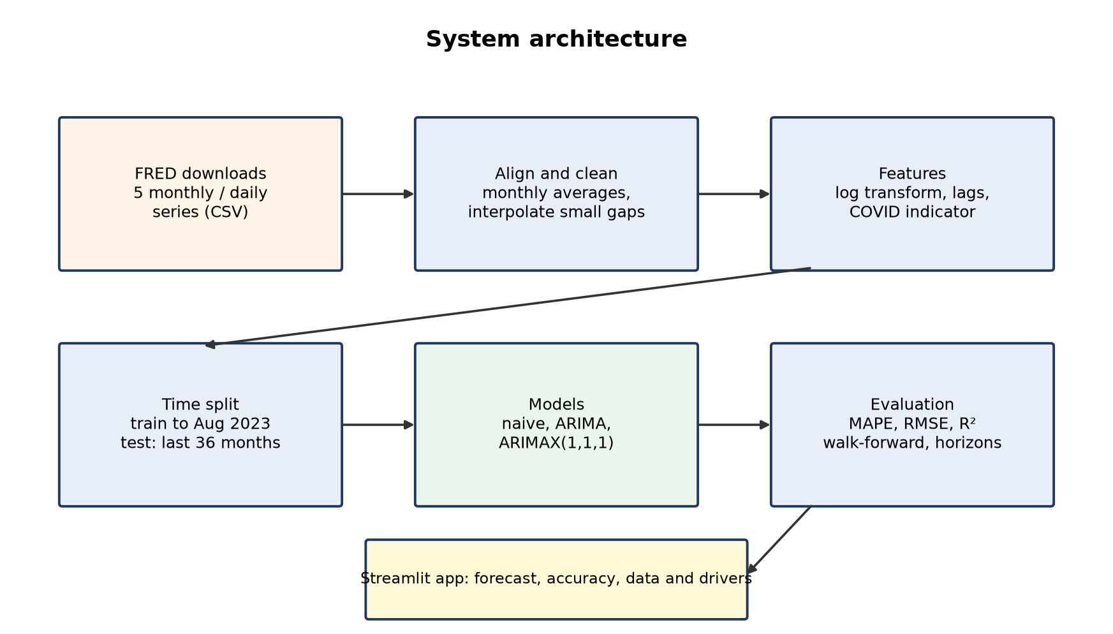
Figure 1: System architecture
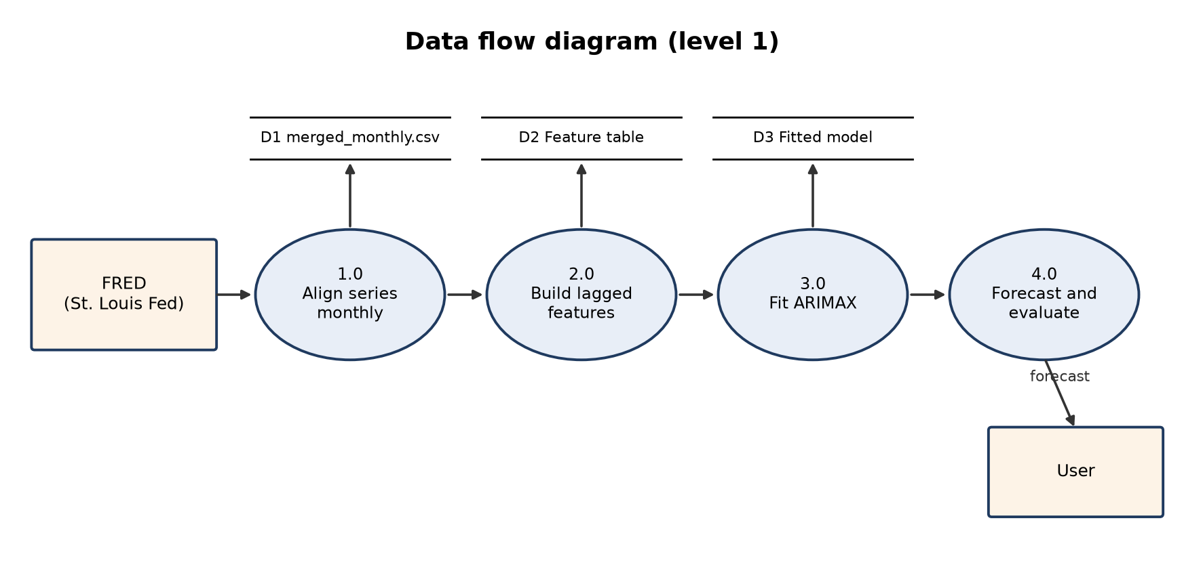
Figure 2: Data flow diagram (level 1)

8. UML diagrams

Use case diagram
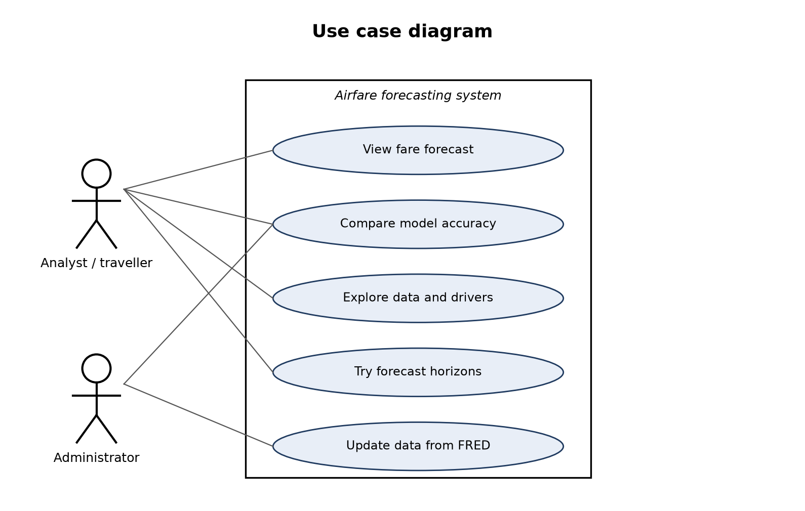
Figure 3: Use case diagram

Class diagram
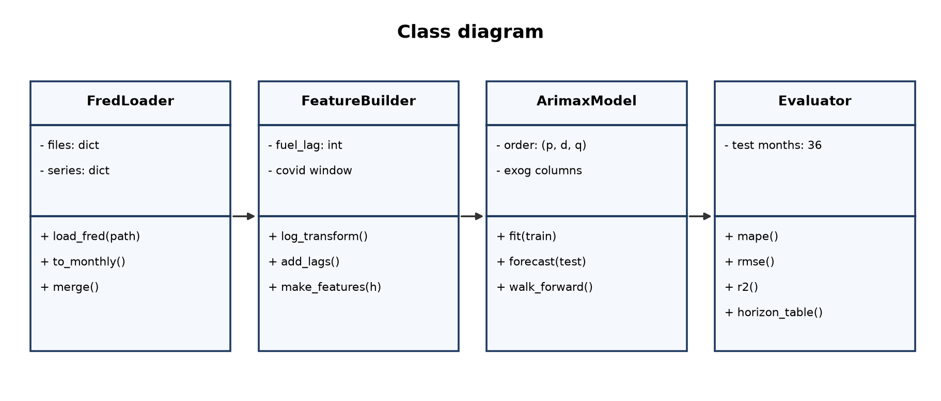
Figure 4: Class diagram

Activity diagram
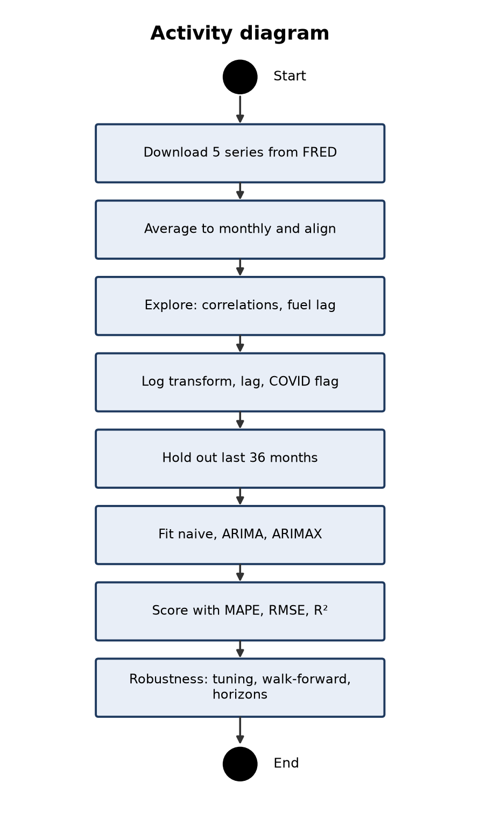
Figure 5: Activity diagram

Sequence diagram
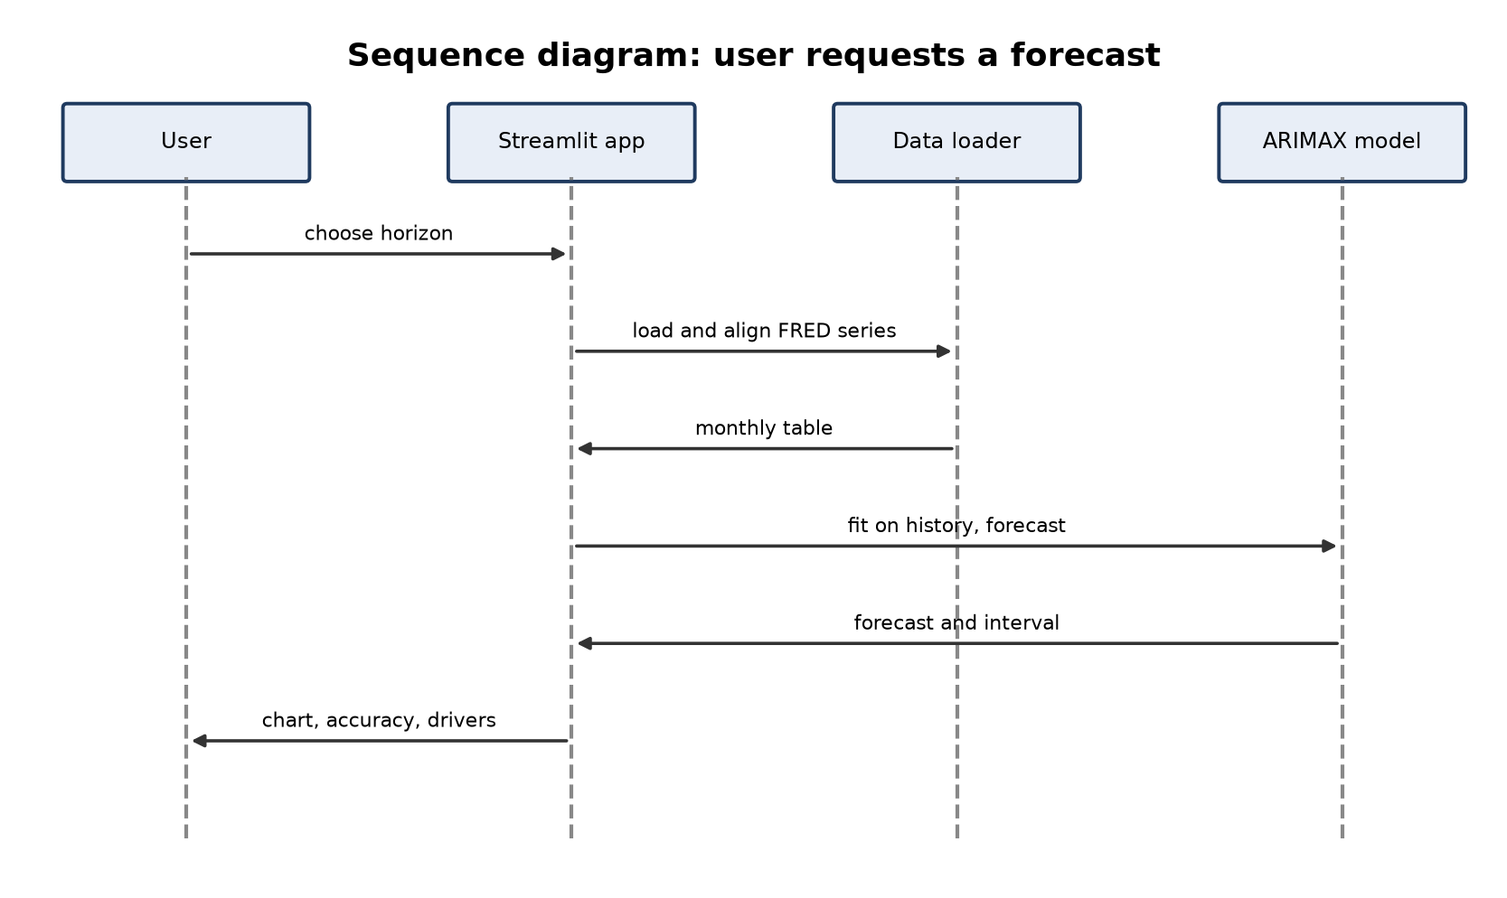
Figure 6: Sequence diagram

ER diagram
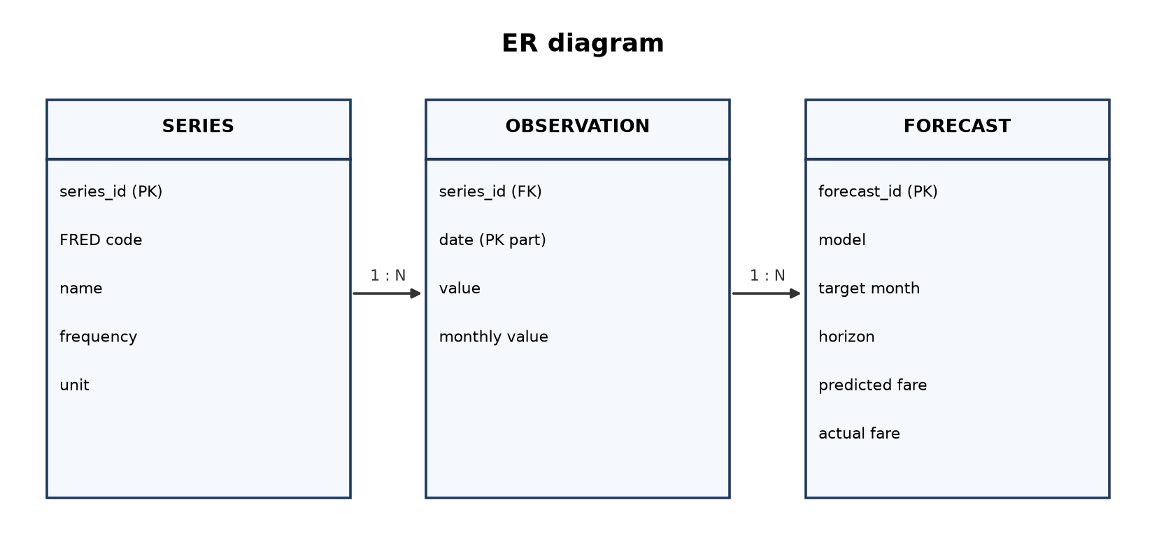
Figure 7: ER diagram

9. Method

Model 1: Linear regression (baseline)
Ordinary least squares of log fares on the lagged indicators, with no fare history. Simple and fully explainable, but it treats every month as independent.
log(Fare_t) = β0 + β1 log(Fuel_(t-2)) + β2 log(CPI_(t-1)) + β3 Unemp_(t-1) + β4 Sent_(t-1) + β5 COVID_t + ε_t

Benchmarks
- Naive forecast: next month's fare equals this month's; any useful model must beat it.
- ARIMA(1,1,1) without regressors: fare history only; the gap to ARIMAX shows what the economy adds.

Model 2: ARIMAX(1,1,1)
ARIMAX models the month-to-month change in log fares from last month's change (AR), last month's forecast error (MA) and the lagged regressors [6]. Differencing (d = 1) removes the long upward trend and avoids spurious regression [4].
Δy_t = φ1 Δy_(t-1) + θ1 ε_(t-1) + β1 fuel_(t-2) + β2 cpi_(t-1) + β3 unemp_(t-1) + β4 sent_(t-1) + β5 covid_t + ε_t

10. Evaluation plan
- Time-based split: train Jun 1990 to Aug 2023, test Sep 2023 to Aug 2026 (last 36 months). Never shuffle a time series.
- One-month-ahead forecasts over the test months; every model scored on the same months.
- Robustness: AIC search over orders (p, q) from 0 to 3, monthly walk-forward retraining, horizons of 1, 3, 6 and 12 months with regressors lagged at least the horizon.
Table 4: Evaluation metrics
Metric | Formula | Meaning
MAPE | mean(|actual - forecast| / actual) × 100 | Typical miss in percent; main metric
RMSE | sqrt(mean((actual - forecast)²)) | Typical miss in index points, punishing large misses
R² | 1 - SS_res / SS_tot | Share of variation explained (1 = perfect)

11. Requirements
Type | Requirement
Hardware | Intel i3 or better, 4 GB RAM
Operating system | Windows 10/11
Language | Python 3.x (Anaconda)
Libraries | pandas, NumPy, matplotlib, scikit-learn, statsmodels, Streamlit
Data | FRED CSV downloads

12. Work plan
Review | Work | Deliverables
Zeroth | Base paper, references, abstract | abstract, paper links
First | Data, design, method, evaluation plan | first-review.docx
Second | Exploration, ARIMAX and benchmarks, robustness | notebooks, second-review.docx
Final | App, report, slides | flight_app.py, report.docx, slides.pptx

References
[1] B. Atems, L. Bachmeier, C. Williams, "Do jet fuel price movements help forecast airline fares and the demand for air travel?," Applied Economics Letters, vol. 26, no. 11, pp. 877-882, 2019. Available: https://doi.org/10.1080/13504851.2018.1510466
[2] R. J. Hyndman, A. B. Koehler, "Another look at measures of forecast accuracy," International Journal of Forecasting, vol. 22, no. 4, pp. 679-688, 2006. Available: https://doi.org/10.1016/j.ijforecast.2006.03.001
[3] F. X. Diebold, R. S. Mariano, "Comparing predictive accuracy," Journal of Business & Economic Statistics, vol. 13, no. 3, pp. 253-263, 1995. Available: https://doi.org/10.1080/07350015.1995.10524599
[4] C. W. J. Granger, P. Newbold, "Spurious regressions in econometrics," Journal of Econometrics, vol. 2, no. 2, pp. 111-120, 1974. Available: https://doi.org/10.1016/0304-4076(74)90034-7
[5] S. Seabold, J. Perktold, "statsmodels: Econometric and statistical modeling with Python," Proceedings of the 9th Python in Science Conference (SciPy 2010), pp. 92-96, 2010. Available: https://doi.org/10.25080/Majora-92bf1922-011
[6] R. J. Hyndman, G. Athanasopoulos, "Forecasting: Principles and Practice, 3rd edition (chapter 10, Dynamic regression models)," OTexts, Melbourne, 2021. Available: https://otexts.com/fpp3/

