Interpretable Prediction of 30-Day Hospital Readmission in Diabetic Patients
First Review: Dataset, System Design and Evaluation Plan
[Student name] · [Register number] · Guide: [Guide's name] · [Department, College]

1. Introduction
When a patient returns to hospital soon after discharge, it often means that something went wrong in the transition home: medication problems, missed follow-up or lack of support. Readmissions are expensive, and hospitals are measured on them. Diabetic patients are readmitted more often than average, so identifying the high-risk ones before discharge lets staff target follow-up calls, medication reviews and home support. This review fixes the dataset, the system design, the algorithms and the evaluation plan.

2. Problem statement
About one in nine diabetic hospital stays in this data (11.4%) ends in readmission within 30 days. Hospitals need to know before discharge which patients are at high risk so they can arrange follow-up calls, medication reviews or home support. Existing clinical scores such as LACE are easy to use but separate patients poorly, while accurate machine-learning models are black boxes that staff cannot check. The problem is to predict 30-day readmission as accurately as possible with a model that a nurse can verify by hand.

3. Objectives
1. Prepare the UCI diabetes readmission dataset and define the 30-day readmission label.
2. Build Model 1: a LACE-style clinical points score representing the existing manual method.
3. Build Model 2: a points score learned from the data with L1 logistic regression, plus IF-THEN rules from a small decision tree.
4. Split the data by patient and choose model sizes on a validation set, so the test set is used only once.
5. Compare both models with a black-box gradient-boosting reference on the same test patients.
6. Deliver a Streamlit web application that shows the risk, the reason and suggested actions.

4. Literature survey
# | Paper | Key idea | Use in this project
1 | Impact of HbA1c Measurement on Hospital Readmission Rates (Strack et al., 2014) | Introduces the dataset used here: about 70,000 diabetic inpatient encounters extracted from a large US clinical database covering 130 hospitals (1999-2008), with demograp... | Supplies the data, the attribute definitions and the readmission label; this project builds interpretable predictive models on it.
2 | Derivation and validation of the LACE index (van Walraven et al., 2010) | Derives a 0-19 point index from Length of stay, Acuity of admission, Comorbidity (Charlson score) and Emergency department visits, predicting death or unplanned readmissi... | Model 1 reproduces this index in LACE style, using the number of diagnoses in place of the Charlson score.
3 | Risk Prediction Models for Hospital Readmission: A Systematic Review (Kansagara et al., 2011) | Reviews 26 readmission risk models from 30 studies and concludes that most perform poorly, especially those built on administrative data. | Explains why modest AUC-ROC values are expected and motivates learning better scores from data.
4 | Supersparse Linear Integer Models for Optimized Medical Scoring Systems (Ustun and Rudin, 2016) | Shows how to learn medical scoring systems with small integer coefficients directly from data, matching the accuracy of complex models while staying usable by hand. | Model 2 follows the same idea in a simpler way: sparse logistic regression with weights rounded to whole points.
5 | Stop Explaining Black Box Machine Learning Models for High Stakes Decisions (Rudin, 2019) | Argues that in high-stakes areas such as healthcare, inherently interpretable models should be used instead of explaining black boxes, and that the accuracy cost of inter... | Motivates comparing the readable models with a black-box reference and reporting the gap.
6 | Regression Shrinkage and Selection via the Lasso (Tibshirani, 1996) | Introduces the lasso (L1 penalty), which shrinks coefficients and sets many exactly to zero, performing variable selection. | Model 2 uses L1-regularised logistic regression to select the few conditions that make up the points score.

5. Existing and proposed system

Existing system
Hospitals commonly estimate readmission risk with simple clinical indices such as LACE [2] (Length of stay, Acuity, Comorbidity, Emergency visits), or by clinical judgement. A systematic review of readmission models [3] found that most perform poorly. Machine-learning models can be more accurate, but they are black boxes: staff cannot see why a patient was flagged [5].
- Poor discrimination: the LACE-style score reaches an AUC-ROC of only 0.563 on this data.
- Fixed, hand-picked factors: the index does not learn which facts matter for diabetic patients.
- Missing inputs: the Charlson comorbidity index needed by LACE is not in the data, so a proxy must be used.
- Black-box alternatives: gradient boosting or neural networks cannot be checked or explained at the bedside.
- No actions: a bare risk number does not tell staff what to do.

Proposed system
The proposed system keeps the points-score format that clinicians already trust, but lets the data choose the conditions and their points. L1-regularised logistic regression selects a few yes/no conditions and the weights are rounded to whole points, so a nurse can add them up by hand. A small decision tree gives IF-THEN rules that explain each prediction. Model sizes are chosen on validation patients, and the results are compared with a black-box model to show how little accuracy is lost.
- More accurate: AUC-ROC 0.648 instead of 0.563, recall 57% instead of 35%.
- Fully transparent: 5 conditions with whole-number points; every prediction can be checked by hand.
- Close to the black box: only 0.021 AUC-ROC below the gradient-boosting reference.
- Explained: each patient is matched to an IF-THEN rule with the readmission rate of similar patients.
- Actionable: the app suggests discharge actions for each risk factor.
- Honest evaluation: split by patient; validation set for tuning; test set used once.

6. Dataset

Source and licence
UCI Machine Learning Repository, "Diabetes 130-US Hospitals for Years 1999-2008", created by Clore, Cios, DeShazo and Strack with the base paper [1]; DOI 10.24432/C5230J; licence CC BY 4.0. Ten years of clinical care at 130 US hospitals. The project copy is ML11-second-review/data/diabetic_data.csv.
Table 1: Dataset summary
Property | Value
Stays in the file | 101,766
Columns | 50
Stays after cleaning | 99,340
Different patients | 69,987
Readmitted within 30 days | 11,314 (11.4%)
Target column | readmitted (<30, >30, NO)
Label used | 1 if readmitted = '<30', else 0

The classes are strongly imbalanced: only about one stay in nine is a 30-day readmission. A model that flags nobody would already be about 89% accurate, so accuracy is not used to judge the models.

Missing values
Table 2: Columns with missing values (whole file)
Column | Missing ('?') | Share
race | 2,273 | 2.2%
weight | 98,569 | 96.9%
payer_code | 40,256 | 39.6%
medical_specialty | 49,949 | 49.1%
diag_1 | 21 | 0.0%
diag_2 | 358 | 0.4%
diag_3 | 1,423 | 1.4%

Weight, payer code and medical specialty are mostly missing and are not used. Missing race or diagnosis codes are treated as 'other'.

All attributes
Table 3: The 50 columns of diabetic_data.csv
# | Column | Group | Meaning
1 | encounter_id | Identifier | Unique hospital stay
2 | patient_nbr | Identifier | Patient ID (used to split by patient)
3 | race | Demographic | Race (not used by the models)
4 | gender | Demographic | Gender (not used by the models)
5 | age | Demographic | Age in 10-year bands, e.g. [60-70)
6 | weight | Demographic | Weight band (mostly missing; not used)
7 | admission_type_id | Admission | Admission type, 1 = emergency
8 | discharge_disposition_id | Admission | Where the patient went after discharge
9 | admission_source_id | Admission | Where the patient came from
10 | time_in_hospital | Admission | Length of stay in days (1-14)
11 | payer_code | Admission | Insurance payer (not used)
12 | medical_specialty | Admission | Specialty of the admitting doctor (not used)
13 | num_lab_procedures | Care | Number of lab tests
14 | num_procedures | Care | Number of non-lab procedures
15 | num_medications | Care | Number of distinct medications given
16 | number_outpatient | History | Outpatient visits in the past year
17 | number_emergency | History | Emergency visits in the past year
18 | number_inpatient | History | Inpatient admissions in the past year
19 | diag_1 | Diagnosis | Primary diagnosis (ICD-9)
20 | diag_2 | Diagnosis | Secondary diagnosis (ICD-9)
21 | diag_3 | Diagnosis | Additional diagnosis (ICD-9)
22 | number_diagnoses | Diagnosis | Number of diagnoses entered
23 | max_glu_serum | Lab | Glucose serum test result
24 | A1Cresult | Lab | HbA1c test result
25 | metformin | Medication | metformin: No / Steady / Up / Down
26 | repaglinide | Medication | repaglinide: No / Steady / Up / Down
27 | nateglinide | Medication | nateglinide: No / Steady / Up / Down
28 | chlorpropamide | Medication | chlorpropamide: No / Steady / Up / Down
29 | glimepiride | Medication | glimepiride: No / Steady / Up / Down
30 | acetohexamide | Medication | acetohexamide: No / Steady / Up / Down
31 | glipizide | Medication | glipizide: No / Steady / Up / Down
32 | glyburide | Medication | glyburide: No / Steady / Up / Down
33 | tolbutamide | Medication | tolbutamide: No / Steady / Up / Down
34 | pioglitazone | Medication | pioglitazone: No / Steady / Up / Down
35 | rosiglitazone | Medication | rosiglitazone: No / Steady / Up / Down
36 | acarbose | Medication | acarbose: No / Steady / Up / Down
37 | miglitol | Medication | miglitol: No / Steady / Up / Down
38 | troglitazone | Medication | troglitazone: No / Steady / Up / Down
39 | tolazamide | Medication | tolazamide: No / Steady / Up / Down
40 | examide | Medication | examide: No / Steady / Up / Down
41 | citoglipton | Medication | citoglipton: No / Steady / Up / Down
42 | insulin | Medication | insulin: No / Steady / Up / Down
43 | glyburide-metformin | Medication | glyburide-metformin: No / Steady / Up / Down
44 | glipizide-metformin | Medication | glipizide-metformin: No / Steady / Up / Down
45 | glimepiride-pioglitazone | Medication | glimepiride-pioglitazone: No / Steady / Up / Down
46 | metformin-rosiglitazone | Medication | metformin-rosiglitazone: No / Steady / Up / Down
47 | metformin-pioglitazone | Medication | metformin-pioglitazone: No / Steady / Up / Down
48 | change | Medication | Any change in diabetes medication
49 | diabetesMed | Medication | Any diabetes medication prescribed
50 | readmitted | Target | <30 days, >30 days or NO

7. System architecture
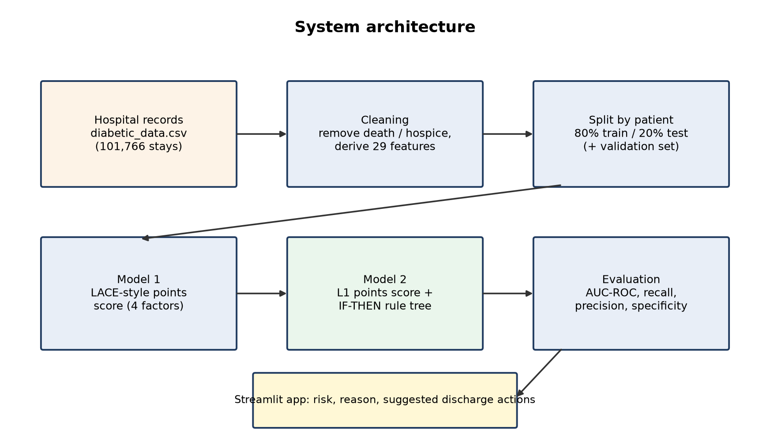
Figure 1: System architecture
- Hospital records: one row per hospital stay of a diabetic patient.
- Cleaning: stays ending in death or hospice are removed because those patients cannot be readmitted.
- Split by patient: all stays of one patient go to the same side, so the test patients are truly new.
- Model 1 and Model 2: the existing LACE-style score and the learned points score with rules.
- Evaluation and app: metrics on the test patients; the app shows risk, reason and actions.
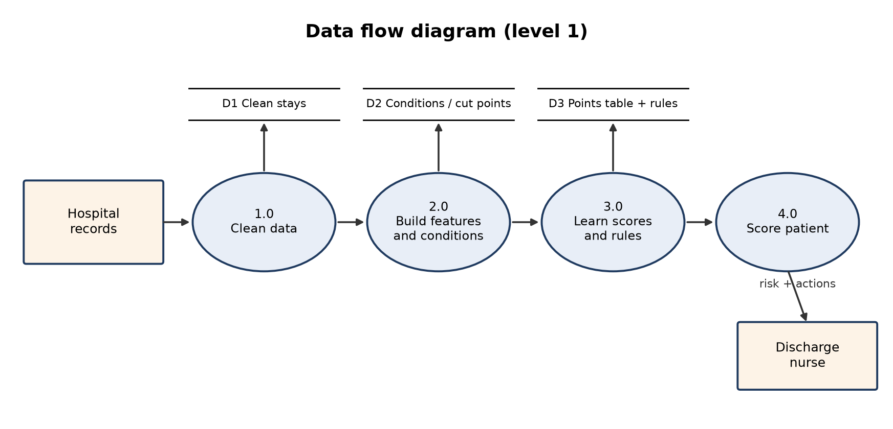
Figure 2: Data flow diagram (level 1)

8. UML diagrams

Use case diagram
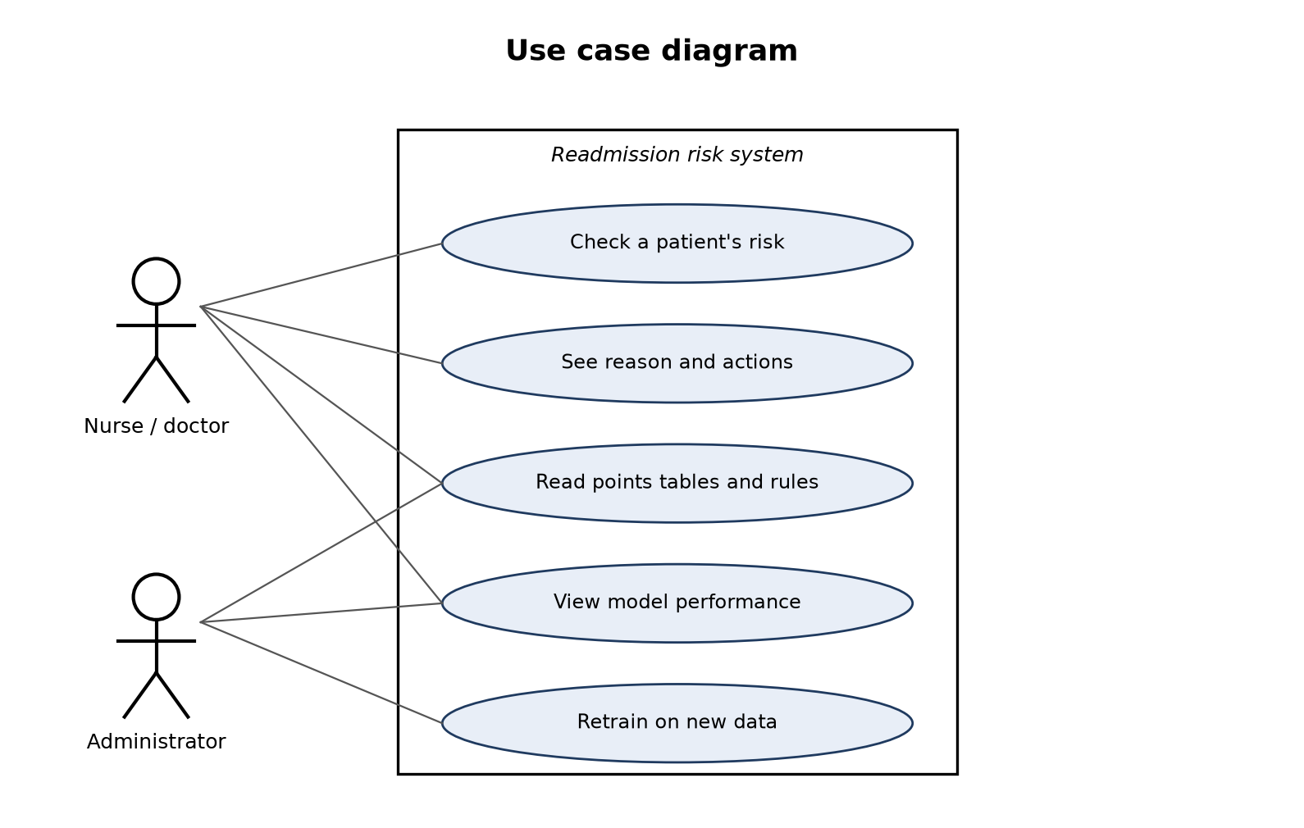
Figure 3: Use case diagram
The nurse or doctor checks a patient before discharge, reads the reason and the suggested actions, and can look at the points tables and rules. The administrator retrains the models when new data arrives.

Class diagram
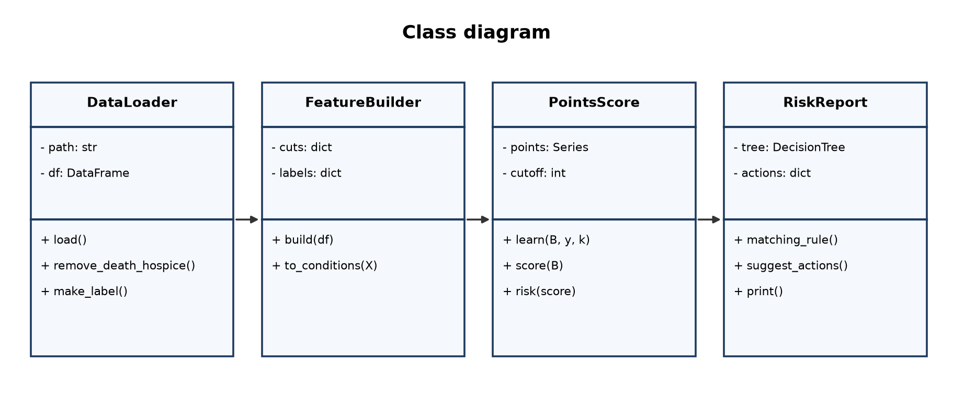
Figure 4: Class diagram

Activity diagram
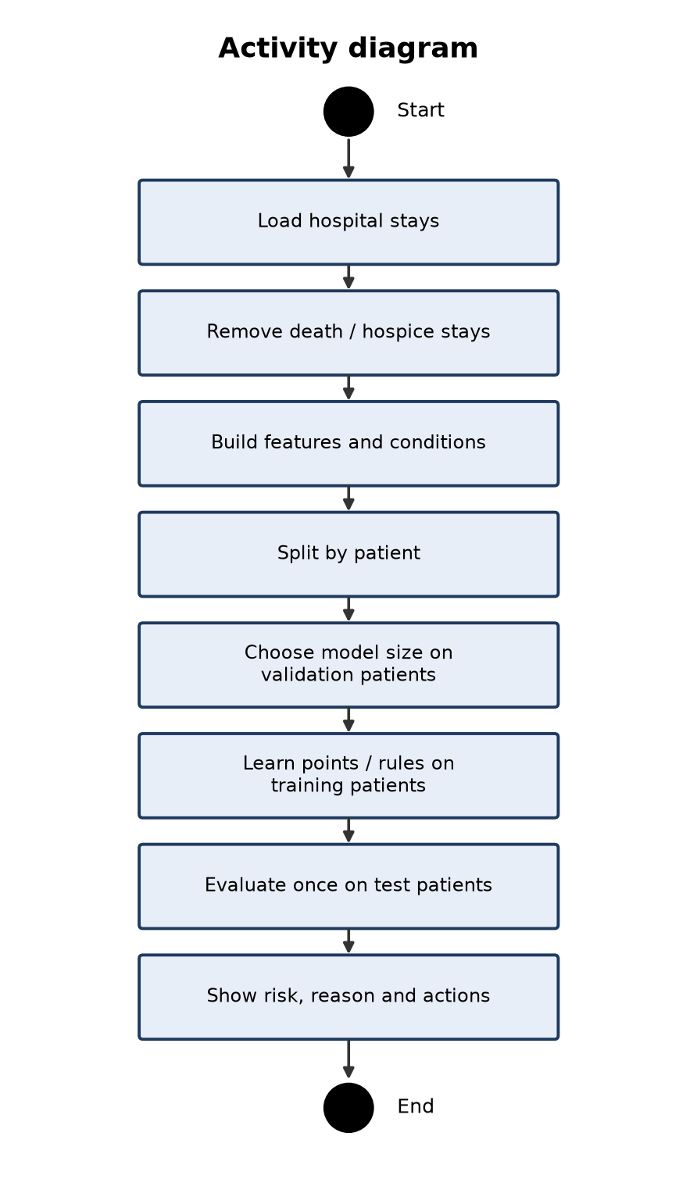
Figure 5: Activity diagram

Sequence diagram
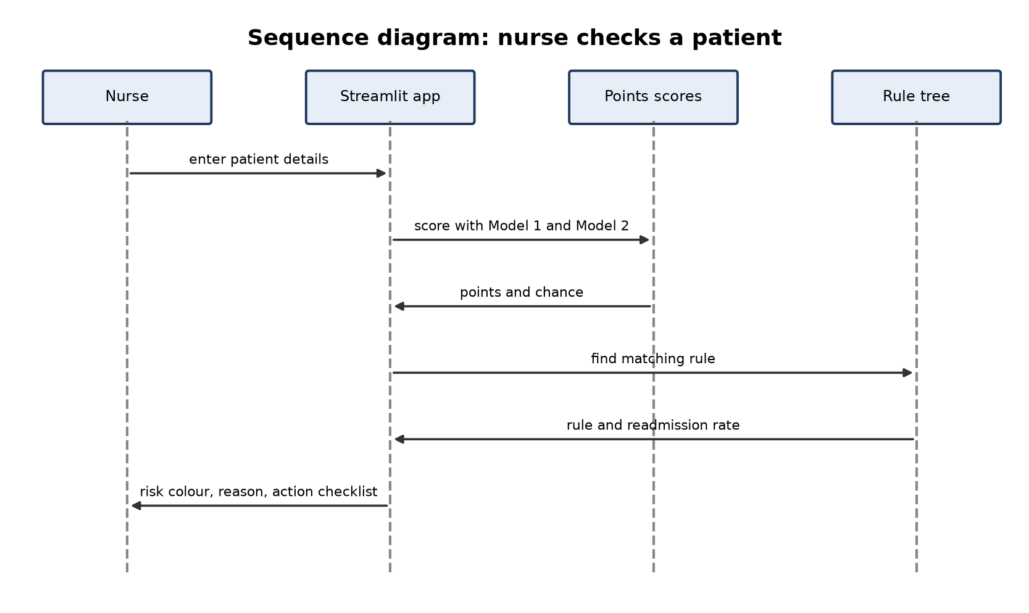
Figure 6: Sequence diagram

ER diagram
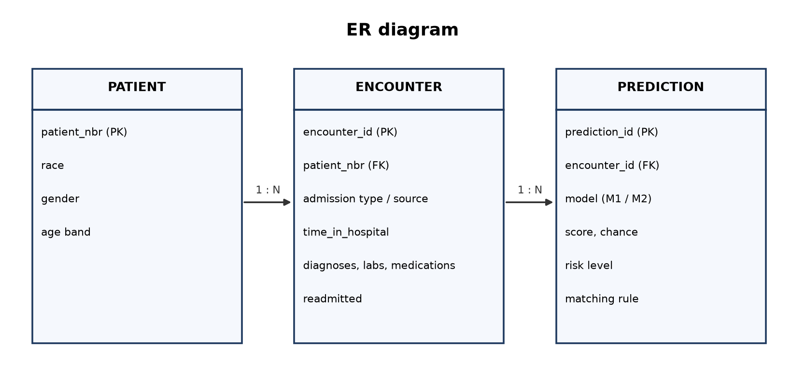
Figure 7: ER diagram

9. Algorithms

Model 1: LACE-style clinical points score (baseline)
Table 4: Model 1 points
Factor | Points | Max
Length of stay | 1 day = 1, 2 = 2, 3 = 3, 4-6 days = 4, 7-13 = 5, 14+ = 7 | 7
Emergency admission | Yes = 3, No = 0 | 3
Number of diagnoses | 1 point per diagnosis above 4 | 5
Emergency visits (past year) | 1 point per visit | 4

The total (0-19) is turned into a chance of readmission by a one-variable logistic regression fitted on the training patients. A cut-off at about the 75th percentile of training scores flags the top quarter as high risk.

Model 2: learned points score
Every number is cut at its 25th, 50th, 75th and 90th training percentiles into yes/no conditions (47 candidates). L1-regularised logistic regression [6] keeps only the strongest conditions; the weights are scaled so the largest is 5 and rounded to whole points [4]. The number of conditions is chosen on the validation patients.
score = Σ points_j · condition_j(x), P(readmit) = 1 / (1 + e^-(a + b · score))

Model 2: IF-THEN rules
A decision tree with at least 200 patients per leaf splits the patients into groups; each leaf becomes a rule with the readmission rate of the training patients in it. The number of leaves is chosen on the validation patients.

10. Evaluation plan
- Split by patient with GroupShuffleSplit (seed 42): 80% training, 20% test.
- 20% of the training patients form a validation set used only to choose model sizes.
- The test set is used once, for the final numbers.
- A HistGradientBoosting black box is trained on the same data as a reference for the best achievable accuracy.
Table 5: Evaluation metrics
Metric | Formula | Meaning
AUC-ROC | Area under the ROC curve | How well the model ranks a readmitted patient above one who is not (0.5 = guessing); main metric
Recall (sensitivity) | TP / (TP + FN) | Of the patients who really came back, the share flagged
Precision | TP / (TP + FP) | Of the flagged patients, the share who really came back
Specificity | TN / (TN + FP) | Of the patients who did not come back, the share not flagged
F1 score | 2PR / (P + R) | Balance of precision and recall
Accuracy | (TP + TN) / all | Misleading here: about 89% of stays are not readmitted

11. Requirements
Type | Requirement
Hardware | Intel i3 or better, 8 GB RAM recommended (the CSV has about 100,000 rows)
Operating system | Windows 10/11
Language | Python 3.x
Libraries | pandas, NumPy, scikit-learn, matplotlib, Streamlit
Tools | Anaconda, Jupyter Notebook, web browser

12. Work plan
Review | Work | Deliverables
Zeroth | Base paper, references, abstract | abstract.docx, paper links
First | Dataset, design, algorithms, evaluation plan | first-review.docx
Second | Cleaning, Model 1, Model 2, comparison | notebooks, results, second-review.docx
Final | Web app, report, slides | app.py, report.docx, slides.pptx, student guide

References
[1] B. Strack, J. P. DeShazo, C. Gennings, J. L. Olmo, S. Ventura, K. J. Cios, J. N. Clore, "Impact of HbA1c Measurement on Hospital Readmission Rates: Analysis of 70,000 Clinical Database Patient Records," BioMed Research International, vol. 2014, art. 781670, 2014. Available: https://doi.org/10.1155/2014/781670
[2] C. van Walraven, I. A. Dhalla, C. Bell, E. Etchells, I. G. Stiell, K. Zarnke, P. C. Austin, A. J. Forster, "Derivation and validation of an index to predict early death or unplanned readmission after discharge from hospital to the community," CMAJ, vol. 182, no. 6, pp. 551-557, 2010. Available: https://doi.org/10.1503/cmaj.091117
[3] D. Kansagara, H. Englander, A. Salanitro, D. Kagen, C. Theobald, M. Freeman, S. Kripalani, "Risk Prediction Models for Hospital Readmission: A Systematic Review," JAMA, vol. 306, no. 15, pp. 1688-1698, 2011. Available: https://doi.org/10.1001/jama.2011.1515
[4] B. Ustun, C. Rudin, "Supersparse linear integer models for optimized medical scoring systems," Machine Learning, vol. 102, no. 3, pp. 349-391, 2016. Available: https://doi.org/10.1007/s10994-015-5528-6
[5] C. Rudin, "Stop explaining black box machine learning models for high stakes decisions and use interpretable models instead," Nature Machine Intelligence, vol. 1, no. 5, pp. 206-215, 2019. Available: https://doi.org/10.1038/s42256-019-0048-x
[6] R. Tibshirani, "Regression shrinkage and selection via the lasso," Journal of the Royal Statistical Society, Series B, vol. 58, no. 1, pp. 267-288, 1996. Available: https://doi.org/10.1111/j.2517-6161.1996.tb02080.x

