Interpretable Prediction of 30-Day Hospital Readmission in Diabetic Patients
Second Review: Implementation, Results and Model Selection
[Student name] · [Register number] · Guide: [Guide's name] · [Department, College]

1. Progress since the first review
- Data cleaned and split by patient, with a validation set.
- Model 1 (LACE-style points score) implemented and evaluated: M1_lace_points_score.ipynb.
- Model 2 (learned points score and IF-THEN rules) implemented and evaluated: M2_learned_points_score.ipynb.
- All models compared with a black-box reference; results saved in ML11-second-review/results.
- Streamlit app (app.py) built for the final review.

2. Data preparation
Table 1: Preparation steps
Step | What was done | Result
Load | diabetic_data.csv read with '?' as missing | 101,766 stays
Remove | stays ending in death or hospice (discharge codes 11, 13, 14, 19, 20, 21) and invalid gender | 99,340 stays, 69,987 patients
Label | 1 if readmitted = '<30' | 11,314 readmitted (11.4%)
Split | GroupShuffleSplit on patient_nbr, seed 42 | 79,567 train / 19,773 test
Validation | 20% of training patients, again grouped by patient | 15,962 stays

Table 2: The 29 features used by Model 2
Feature | Type | Meaning
age | Number | Middle of the age band
time_in_hospital | Number | Length of stay (days)
num_lab_procedures / num_procedures / num_medications | Number | Care intensity during the stay
number_outpatient / number_emergency / number_inpatient | Number | Visits in the past year
number_diagnoses | Number | Number of diagnoses
n_diabetes_meds / n_dose_changes | Number | Diabetes drugs given and dose changes
emergency_admission, insulin, med_change, on_diabetes_med | Yes/no | Admission and medication facts
a1c_measured, a1c_high, glucose_high | Yes/no | Lab test facts
discharge_home / home_health / facility | Yes/no | Discharge destination group
diag_diabetes ... diag_neoplasms (8) | Yes/no | Primary diagnosis group (ICD-9)

3. Model 1: LACE-style clinical points score
Table 3: Model 1 points (total 0-19)
Factor | Points | Max
Length of stay | 1 day = 1, 2 = 2, 3 = 3, 4-6 days = 4, 7-13 = 5, 14+ = 7 | 7
Emergency admission | Yes = 3, No = 0 | 3
Number of diagnoses | 1 point per diagnosis above 4 | 5
Emergency visits (past year) | 1 point per visit | 4

High risk: score 11 or more. Example from the notebook: a patient with the maximum score of 19 has an estimated chance of 22.4%; a patient with score 1 has 6.5%.
Table 4: Model 1 on the test patients
Metric | Value
Accuracy | 0.687
Precision | 0.141
Recall (sensitivity) | 0.346
Specificity | 0.730
F1 score | 0.200
AUC-ROC | 0.563

Table 5: Model 1 in plain numbers
Count | Stays
Real readmissions in test set | 2,244
Flagged as high risk | 5,502
Correctly flagged (TP) | 776
Missed (FN) | 1,468
False alarms (FP) | 4,726

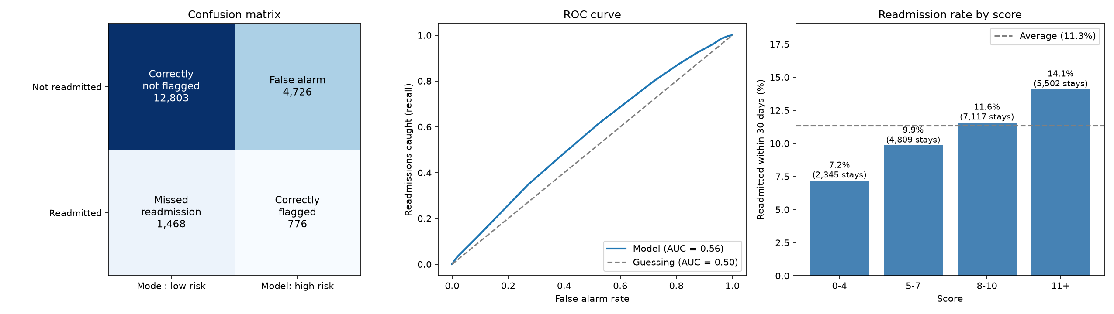
Figure 1: Model 1: confusion matrix, ROC curve and readmission rate by score

4. Model 2: learned points score and IF-THEN rules

Choosing the size on the validation patients
Table 6: Size selection
Maximum conditions | Conditions kept | Validation AUC-ROC
4 | 3 | 0.6321
6 | 4 | 0.6389
8 | 4 | 0.6389
10 | 6 | 0.6343
12 | 6 | 0.6343
15 | 7 | 0.6408

The best validation AUC-ROC came with at most 15 conditions. The final points were then learned again on all training patients; after rounding, 5 conditions keep non-zero points.
Table 7: Model 2 points score
Condition | Points
Inpatient admissions (past year) >= 2 | 5
Inpatient admissions (past year) >= 1 | 4
Discharged to a care facility | 2
Emergency visits (past year) >= 1 | 1
Discharged home | -3

Table 8: What each score means
Score | Chance of readmission
-3 | 7.1%
-2 | 7.9%
-1 | 8.8%
0 | 9.8%
1 | 10.8%
2 | 12.0%
3 | 13.2%
4 | 14.6%
5 | 16.1%
6 | 17.7%
7 | 19.4%
8 | 21.3%
9 | 23.3%
10 | 25.4%
11 | 27.6%
12 | 30.0%

High risk: score 2 or more. Past inpatient admissions are by far the strongest warning sign; going home lowers the risk.

IF-THEN rules
Table 9: The 16 rules, highest risk first
# | IF | Readmitted | Patients | vs average
1 | Inpatient admissions (past year) >= 5 AND Emergency visits (past year) >= 1 | 42.2% | 716 | 3.7x
2 | Inpatient admissions (past year) >= 5 AND Emergency visits (past year) = 0 AND Age <= 70 | 36.2% | 567 | 3.2x
3 | Inpatient admissions (past year) >= 5 AND Emergency visits (past year) = 0 AND Age >= 71 | 26.9% | 331 | 2.4x
4 | Inpatient admissions (past year) = 1 AND Discharged to a care facility = Yes AND Age <= 80 AND Number of diagnoses <= 8 | 23.1% | 732 | 2.0x
5 | Inpatient admissions (past year) between 3 and 4 | 21.4% | 3,906 | 1.9x
6 | Inpatient admissions (past year) = 2 | 18.0% | 5,867 | 1.6x
7 | Inpatient admissions (past year) = 1 AND Discharged to a care facility = Yes AND Age <= 80 AND Number of diagnoses >= 9 | 16.6% | 1,418 | 1.5x
8 | Inpatient admissions (past year) <= 1 AND Discharged to a care facility = Yes AND Age >= 81 AND Diabetes dose changes >= 1 | 16.1% | 1,514 | 1.4x
9 | Inpatient admissions (past year) = 0 AND Discharged to a care facility = Yes AND Age <= 80 | 15.6% | 6,225 | 1.4x
10 | Inpatient admissions (past year) = 1 AND Discharged to a care facility = No AND Number of diagnoses >= 9 | 13.5% | 5,861 | 1.2x
11 | Inpatient admissions (past year) <= 1 AND Discharged to a care facility = Yes AND Age >= 81 AND Diabetes dose changes = 0 | 12.3% | 3,921 | 1.1x
12 | Inpatient admissions (past year) = 0 AND Discharged to a care facility = No AND Number of diagnoses >= 9 AND Discharged home = No | 11.1% | 4,318 | 1.0x
13 | Inpatient admissions (past year) = 1 AND Discharged to a care facility = No AND Number of diagnoses <= 8 | 10.5% | 5,823 | 0.9x
14 | Inpatient admissions (past year) = 0 AND Discharged to a care facility = No AND Number of diagnoses >= 9 AND Discharged home = Yes | 7.9% | 13,045 | 0.7x
15 | Inpatient admissions (past year) = 0 AND Discharged to a care facility = No AND Number of diagnoses <= 8 AND Age >= 61 | 7.2% | 14,245 | 0.6x
16 | Inpatient admissions (past year) = 0 AND Discharged to a care facility = No AND Number of diagnoses <= 8 AND Age <= 60 | 5.0% | 11,078 | 0.4x

Results on the test patients
Table 10: Model 2 points score on the test patients
Metric | Value
Accuracy | 0.650
Precision | 0.178
Recall (sensitivity) | 0.574
Specificity | 0.660
F1 score | 0.271
AUC-ROC | 0.648

Table 11: Model 2 in plain numbers
Count | Stays
Real readmissions in test set | 2,244
Flagged as high risk | 7,255
Correctly flagged (TP) | 1,289
Missed (FN) | 955
False alarms (FP) | 5,966

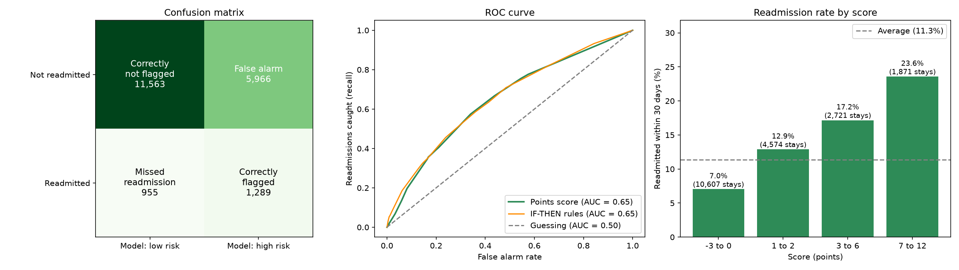
Figure 2: Model 2: confusion matrix, ROC curves and readmission rate by score

Patient report (output of the notebook)
For any test patient the notebook prints the prediction with a colour level, the conditions that scored points, the matching rule, hand-written suggested actions and a short summary. One example, exactly as printed:
READMISSION RISK REPORT patient 54679077 (age [50-60), Male)
======================================================================

1. PREDICTION
[RED] HIGH RISK of readmission within 30 days
Estimated chance: 30.0% (average patient: 11.4%)
Score: 12 points (high risk means 2 or more)

2. WHY
Conditions true for this patient:
+5 Inpatient admissions (past year) >= 2
+4 Inpatient admissions (past year) >= 1
+2 Discharged to a care facility
+1 Emergency visits (past year) >= 1
Rule this patient matches:
IF Inpatient admissions (past year) = 2
THEN 18.0% of 5,867 similar training patients were readmitted (1.6x the average)

3. SUGGESTED ACTIONS (hand-written suggestions, for clinician review)
[ ] Repeated admissions: arrange a follow-up call within 2-3 days of discharge.
[ ] Frequent emergency visits: give the patient a clear plan for who to contact first.
[ ] Going to a care facility: send a complete handover to the receiving team.

4. PATIENT SUMMARY
Length of stay: 1 days
Main diagnosis group: digestive
Inpatient admissions (1 yr): 2
Emergency visits (1 yr): 1
Medications during stay: 23
Number of diagnoses: 6

What really happened: not readmitted within 30 days

5. Comparison and model selection
Table 12: All models on the same test patients
Metric | Model 1 score | Model 2 score | Model 2 rules | Black box
Accuracy | 0.687 | 0.650 | 0.726 | 0.741
Precision | 0.141 | 0.178 | 0.196 | 0.207
Recall (sensitivity) | 0.346 | 0.574 | 0.456 | 0.454
Specificity | 0.730 | 0.660 | 0.761 | 0.777
F1 score | 0.200 | 0.271 | 0.274 | 0.284
AUC-ROC | 0.563 | 0.648 | 0.654 | 0.669

Model 2 is selected. AUC-ROC rises from 0.563 to 0.648 (+0.085) and recall from 0.346 to 0.574. The black box is only 0.021 higher, and it uses 300 trees that nobody can read. Model 2's accuracy is lower than Model 1's because it flags more patients: more false alarms but many more real readmissions caught.

6. Safeguards
- Split by patient: no patient appears in both training and test (checked in the notebook: 0 shared patients).
- Model sizes chosen on a separate validation set; the test set is used once.
- Cut points for the conditions come from training patients only.
- Race and gender are not used, so the scores do not treat patients differently by demographics.
- Suggested actions are hand-written, not learned, and need clinical review.

7. Next steps for the final review
- Finish and test the Streamlit app.
- Write the final report and slides.
- Prepare the demo and viva answers (student guide).

References
[1] B. Strack, J. P. DeShazo, C. Gennings, J. L. Olmo, S. Ventura, K. J. Cios, J. N. Clore, "Impact of HbA1c Measurement on Hospital Readmission Rates: Analysis of 70,000 Clinical Database Patient Records," BioMed Research International, vol. 2014, art. 781670, 2014. Available: https://doi.org/10.1155/2014/781670
[2] C. van Walraven, I. A. Dhalla, C. Bell, E. Etchells, I. G. Stiell, K. Zarnke, P. C. Austin, A. J. Forster, "Derivation and validation of an index to predict early death or unplanned readmission after discharge from hospital to the community," CMAJ, vol. 182, no. 6, pp. 551-557, 2010. Available: https://doi.org/10.1503/cmaj.091117
[3] D. Kansagara, H. Englander, A. Salanitro, D. Kagen, C. Theobald, M. Freeman, S. Kripalani, "Risk Prediction Models for Hospital Readmission: A Systematic Review," JAMA, vol. 306, no. 15, pp. 1688-1698, 2011. Available: https://doi.org/10.1001/jama.2011.1515
[4] B. Ustun, C. Rudin, "Supersparse linear integer models for optimized medical scoring systems," Machine Learning, vol. 102, no. 3, pp. 349-391, 2016. Available: https://doi.org/10.1007/s10994-015-5528-6
[5] C. Rudin, "Stop explaining black box machine learning models for high stakes decisions and use interpretable models instead," Nature Machine Intelligence, vol. 1, no. 5, pp. 206-215, 2019. Available: https://doi.org/10.1038/s42256-019-0048-x
[6] R. Tibshirani, "Regression shrinkage and selection via the lasso," Journal of the Royal Statistical Society, Series B, vol. 58, no. 1, pp. 267-288, 1996. Available: https://doi.org/10.1111/j.2517-6161.1996.tb02080.x

