FAIR STUDENT DROPOUT EARLY-WARNING SYSTEM USING MACHINE LEARNING
A PROJECT REPORT
Submitted in partial fulfilment of the requirements for the award of the degree of
BACHELOR OF TECHNOLOGY
in
COMPUTER SCIENCE AND ENGINEERING
Submitted by
[STUDENT NAME] ([REGISTER NUMBER])
Under the guidance of
[GUIDE NAME], [Designation]
[DEPARTMENT OF COMPUTER SCIENCE AND ENGINEERING]
[COLLEGE NAME]
[City] - [Year]

BONAFIDE CERTIFICATE
This is to certify that this project report titled "Fair Student Dropout Early-Warning System using Machine Learning" is the bonafide work of [STUDENT NAME] ([REGISTER NUMBER]), who carried out the project work under my supervision.
[Guide signature] [Head of Department signature]

DECLARATION
I hereby declare that the project report titled "Fair Student Dropout Early-Warning System using Machine Learning" submitted for the degree of Bachelor of Technology is my original work and has not been submitted for any other degree or diploma.
Place: [City]
Date: [Date] [Student signature]

ACKNOWLEDGEMENT
I thank [Guide name] for guidance throughout this project, the Head of the Department and the faculty of the [Department], and my family and friends for their support. I also thank Realinho et al. for publishing the dataset used in this work.

TABLE OF CONTENTS
1. INTRODUCTION 9
1.1 Overview 9
1.2 Data Science 9
1.3 Machine Learning 9
1.4 Fairness in Machine Learning 10
1.5 Problem Statement 10
1.6 Objectives 10
1.7 Scope of the Project 11
1.8 Organisation of the Report 11
2. LITERATURE SURVEY 12
2.1 Predicting Student Dropout and Academic Success 12
2.2 Data preprocessing techniques for classification without discrimination 12
2.3 Equality of Opportunity in Supervised Learning 12
2.4 Evaluating the Fairness of Predictive Student Models Through Slicing Analysis 13
2.5 Algorithmic Fairness in Education 13
2.6 LightGBM: A Highly Efficient Gradient Boosting Decision Tree 13
2.7 Summary of the Survey 14
3. SYSTEM ANALYSIS 15
3.1 Existing System 15
3.2 Proposed System 15
3.3 Feasibility Study 16
4. SYSTEM REQUIREMENTS 17
4.1 Hardware Requirements 17
4.2 Software Requirements 17
4.3 Functional Requirements 17
4.4 Non-Functional Requirements 17
5. SYSTEM DESIGN 18
5.1 Design Architecture 18
5.2 Data Flow Diagram 18
5.3 Usecase Diagram 19
5.4 Class Diagram 19
5.5 Activity Diagram 20
5.6 Sequence Diagram 21
5.7 ER Diagram 21
6. DATASET AND PRE-PROCESSING 22
6.1 Dataset Description 22
6.2 Attributes 22
6.3 Exploratory Analysis 23
6.4 Pre-processing 24
6.5 Train-Test Split 24
7. METHODOLOGY AND ALGORITHMS 25
7.1 Logistic Regression (Model 1) 25
7.2 Histogram Gradient Boosting (Model 2) 25
7.3 Hyperparameter Tuning 25
7.4 Reweighing 26
7.5 Equal-Opportunity Thresholds 26
7.6 Evaluation Metrics 27
8. IMPLEMENTATION 28
8.1 Software Description 28
8.2 List of Modules 28
8.3 Module Description 29
8.4 Key Code 29
8.5 Deploy 30
9. RESULTS AND DISCUSSION 31
9.1 Model 1: Logistic Regression 31
9.2 Model 2: Tuned Gradient Boosting 32
9.3 Comparison 35
9.4 Risk Levels 35
9.5 Discussion and Limitations 35
10. CONCLUSION AND FUTURE WORK 36
10.1 Conclusion 36
10.2 Future Work 36
11. REFERENCES 37

ABSTRACT
Student dropout is one of the most serious problems in higher education: it wastes students' time and money, lowers institutional completion rates and is usually noticed only when it is too late to help. This project builds a machine-learning early-warning system that estimates each student's chance of dropping out, using the public dataset published by Realinho et al. [1], which records 4,424 students of a Portuguese higher-education institution with 36 attributes covering demographic, socio-economic, macro-economic and academic information, and an outcome of Graduate (2209), Dropout (1421) or Enrolled (794). Because such a system decides which students receive an advisor's attention, the project treats fairness as a requirement: at-risk students of every gender and age group must be caught at a similar rate.
Two models were built and evaluated on the same stratified hold-out set of 885 students. Model 1, a logistic regression that uses only the 22 attributes known at enrolment, is trained with reweighing [2] so that every gender x age group carries equal weight; it reached ROC-AUC 0.796 and recall 0.761. Model 2, a histogram gradient boosting classifier [6] tuned by randomised search and also using first-semester results (34 features), obtained a mean cross-validation ROC-AUC of 0.900 and, with group-specific decision thresholds that equalise recall (equal opportunity [3]), reached test ROC-AUC 0.910, recall 0.852 and F1-score 0.682. The fairness constraint cut Model 2's age-band recall gap from 0.283 at a single 0.5 threshold to 0.054, with a gender gap of 0.006. A Streamlit web application presents each student's risk level, the factors behind it and suggested actions for advisors.
Keywords: Student dropout prediction, Early warning system, Educational data mining, Logistic regression, Gradient boosting, Algorithmic fairness, Equal opportunity, Reweighing, Learning analytics, Streamlit

1. INTRODUCTION

1.1 Overview
Higher education is a major investment for students, families and society. When a student leaves before completing the degree, the time and money already spent are largely lost, the student often carries debt without the qualification, and the institution loses funding and reputation. Studies of dropout consistently find that the first year, and especially the first semester, is the critical period: students who fail early units, fall behind on fees or entered a course that was not their first choice are much more likely to leave.
Institutions already collect most of the information needed to see these signs: application data, demographic and family background, fees and scholarships, and academic results. Machine learning can combine these signals into a single risk estimate for every student, so advisors can focus their limited time on the students who need it most.

1.2 Data Science
Data science is an interdisciplinary field that uses statistics, programming and domain knowledge to extract knowledge and insight from structured and unstructured data. A typical data-science project defines a question, collects and cleans data, explores it, builds models, evaluates them honestly and communicates the result to decision makers. This project follows exactly that cycle for student dropout.

1.3 Machine Learning
Machine learning is a branch of artificial intelligence in which a computer learns patterns from examples instead of following hand-written rules. In supervised learning each training example has a known answer (the label); the algorithm learns a function from the inputs to the label and is then applied to new examples. When the label is a category, the task is called classification. Predicting whether a student will drop out (yes or no) is a binary classification problem.
Important ideas in supervised learning used in this project are: separating training and test data so that the model is judged on students it has never seen; cross-validation, which repeats training on different parts of the training data to obtain a stable estimate; hyperparameter tuning; and choosing evaluation metrics that match the real cost of errors.

1.4 Fairness in Machine Learning
A model learns from historical data, and historical data reflects differences between groups. If dropout is harder to predict for one group, a model tuned only for overall accuracy may systematically miss at-risk students in that group, so they would receive less support. Algorithmic fairness studies how to measure and reduce such differences [4, 5]. Common criteria are demographic parity (equal flag rates), equal opportunity (equal true-positive rates) [3] and calibration. For an early-warning tool, equal opportunity is the natural choice: every student who will drop out should have the same chance of being flagged, whatever their gender or age.

1.5 Problem Statement
Higher-education institutions lose a large share of their students before graduation. In this dataset 1421 of 4,424 students (32.1%) dropped out. Advisors can support at-risk students only if they know early who they are, but manual judgement is slow and inconsistent, and an automated model tuned only for accuracy can miss at-risk students of some groups more often than others. The problem is to predict dropout early and accurately while keeping the share of real dropouts caught similar across gender and age groups.

1.6 Objectives
1. Study the published student dropout dataset [1] and define a binary dropout label.
2. Build a baseline logistic regression (Model 1) that warns at enrolment, before any grades exist.
3. Build an improved, tuned gradient boosting model (Model 2) that also uses first-semester results.
4. Add fairness: reweighing for Model 1 [2] and equal-opportunity thresholds for Model 2 [3].
5. Evaluate both models on held-out students, overall and per gender and age band, with confidence intervals.
6. Explain the main risk factors and convert probabilities into Low / Medium / High risk levels.
7. Deliver a Streamlit web application for advisors.

1.7 Scope of the Project
The project covers students of one higher-education institution described by the public dataset [1]. It predicts dropout at two moments (enrolment and after the first semester), audits fairness for gender and age, and provides a prototype application for advisors. It is a decision-support study: it does not take decisions about students and is not intended for use without validation by the institution.

1.8 Organisation of the Report
Chapter 2 reviews the literature. Chapter 3 analyses the existing and proposed systems and their feasibility. Chapter 4 lists the requirements. Chapter 5 presents the system design and UML diagrams. Chapter 6 describes the dataset and pre-processing, Chapter 7 the algorithms and methodology, Chapter 8 the implementation and modules, and Chapter 9 the results. Chapter 10 gives the conclusion and future work, followed by the references.

2. LITERATURE SURVEY
This chapter reviews the base paper and the reference papers that shaped the dataset, the algorithms and the fairness methods used in the project.

2.1 Predicting Student Dropout and Academic Success
Authors: Realinho et al., 2022 [1]
Describes the creation of the dataset used in this project from several disjoint databases of a Portuguese polytechnic institution, covering students enrolled in eight-plus undergraduate degrees. Each record joins information known at enrolment (academic path, demographics, socio-economic factors) with academic performance at the end of the first and second semesters. The authors frame the task as a three-class problem (dropout, enrolled, graduate) and show that machine-learning classifiers can identify at-risk students.
Relevance to this project: Supplies the data, the attribute definitions and the motivation; this project narrows the task to a binary dropout label and adds fairness.

2.2 Data preprocessing techniques for classification without discrimination
Authors: Kamiran and Calders, 2012 [2]
Surveys ways of removing discrimination from training data before a classifier is learned: suppressing the sensitive attribute, changing (massaging) labels, and reweighing or resampling examples. Reweighing assigns each (group, label) combination the weight expected/observed so that, in the weighted data, the label is statistically independent of the group.
Relevance to this project: Used directly in Model 1: reweighing by gender x age band.

2.3 Equality of Opportunity in Supervised Learning
Authors: Hardt, Price and Srebro, 2016 [3]
Defines equalised odds and equal opportunity: a classifier satisfies equal opportunity when its true-positive rate is the same in every group. The paper shows that any score can be post-processed with group-specific thresholds to meet this criterion, and that this is often better than simply ignoring the sensitive attribute.
Relevance to this project: Used in Model 2: one threshold per gender x age group so recall is similar for all groups.

2.4 Evaluating the Fairness of Predictive Student Models Through Slicing Analysis
Authors: Gardner, Brooks and Baker, 2019 [4]
Proposes slicing analysis for learning-analytics models: measuring performance separately for each demographic group, and the ABROCA statistic (area between the groups' ROC curves). Applied to MOOC dropout models, it shows that models with similar overall accuracy can differ in fairness.
Relevance to this project: Motivates the per-group evaluation tables and recall gaps reported for both models.

2.5 Algorithmic Fairness in Education
Authors: Kizilcec and Lee, 2020 [5]
Reviews how unfairness enters educational algorithms at measurement, model learning and action stages, and explains the main statistical fairness criteria: independence (demographic parity), separation (equalised odds) and sufficiency (calibration).
Relevance to this project: Guides the choice of equal opportunity (a separation criterion) as the main fairness target for an early-warning tool.

2.6 LightGBM: A Highly Efficient Gradient Boosting Decision Tree
Authors: Ke et al., 2017 [6]
Introduces histogram-based gradient boosting with gradient-based one-side sampling and exclusive feature bundling, reaching the accuracy of conventional GBDT many times faster. scikit-learn's HistGradientBoostingClassifier follows the same histogram design.
Relevance to this project: Provides the algorithm family used for Model 2.

2.7 Summary of the Survey
Table 2.1: Summary of the literature
Ref. | Focus | Method | Used for
[1] | Dropout dataset and prediction | Classifiers on enrolment and semester data | Data, task definition
[2] | Discrimination-free pre-processing | Reweighing, massaging, resampling | Model 1 fairness
[3] | Equal opportunity | Group-specific thresholds | Model 2 fairness
[4] | Fairness of student models | Slicing analysis, ABROCA | Per-group evaluation
[5] | Fairness in education | Survey of criteria | Choice of criterion
[6] | Gradient boosting | Histogram GBDT (LightGBM) | Model 2 algorithm

The survey shows that dropout can be predicted from routine institutional data [1], that predictive student models can be unfair even when accurate [4, 5], and that simple, well-understood methods exist to reduce this unfairness before training [2] or after training [3]. The project combines these strands in one system.

3. SYSTEM ANALYSIS

3.1 Existing System
In most institutions dropout risk is judged by advisors case by case, usually after a student has already failed units or stopped attending. Where data-driven tools exist, they are typically classifiers trained to maximise overall accuracy, as in the original study of this dataset [1]. Research on predictive student models [4, 5] shows that such models can perform very differently for different demographic groups even when their overall accuracy is good.

Disadvantages of the Existing System
- Late detection: risk becomes visible only after poor results appear.
- Accuracy-only optimisation: errors per gender or age group are not measured.
- One threshold for everyone: in this data a single 0.5 threshold leaves an age-band recall gap of 0.283 for the gradient boosting model.
- No explanation: advisors are not told why a student is flagged, so they cannot plan an intervention.
- Imbalanced classes ignored: dropouts are the minority class, so a model can look accurate while missing many of them.

3.2 Proposed System
The proposed system predicts the probability that each student drops out and turns it into a Low, Medium or High risk level for advisors. Fairness is built in: Model 1 reweighs training examples so that every gender x age group counts equally [2], and Model 2 chooses a separate decision threshold per group so that the share of real dropouts caught (recall) is similar across groups [3]. Thresholds are always chosen on out-of-fold predictions of the training set, never on the test set. The system reports the main risk factors and a per-group fairness audit, and it is delivered as a Streamlit web application.

Advantages of the Proposed System
- Two warning stages: Model 1 at enrolment, Model 2 after the first semester.
- Recall-oriented: thresholds are set to catch most real dropouts (targets 0.75 and 0.85).
- Fair by design: recall gaps across gender and age band are measured with 95% bootstrap intervals and constrained.
- Explainable: logistic coefficients and permutation importance show which factors drive the risk.
- No leakage: the test set is used once, only for the final numbers.
- Practical: a web app with a watch list, a single-student check and suggested actions.

3.3 Feasibility Study
A feasibility study checks whether the proposed system can be built and used successfully. Four aspects were considered.

Technical Feasibility
The data is tabular and small enough to process on any laptop. All algorithms are available in open-source Python libraries and train in under a minute on a CPU; no GPU or special hardware is needed.

Economic Feasibility
All software is free and open source, and the dataset is published under a CC BY 4.0 licence, so there is no licence cost. The only cost is development time.

Operational Feasibility
Advisors use the system through a web browser. The interface uses plain language (chance of dropping out, risk level, reasons, suggested actions) and needs no programming knowledge.

Ethical and Legal Feasibility
The dataset is anonymised. Gender is not used as a model input, and fairness is audited. Because group-specific thresholds treat groups differently, their use must be approved by the institution; the system is a decision-support prototype, not an automated decision maker.

4. SYSTEM REQUIREMENTS

4.1 Hardware Requirements
Table 4.1: Hardware requirements
Component | Minimum
Processor | Intel Core i3 or equivalent
RAM | 4 GB (8 GB recommended)
Hard disk | 1 GB free space
Display | 1366 x 768 or higher

4.2 Software Requirements
Table 4.2: Software requirements
Component | Specification
Operating system | Windows 10/11, Linux or macOS
Language | Python 3.10 or later
Distribution / IDE | Anaconda with Jupyter Notebook
Libraries | pandas, NumPy, scikit-learn, matplotlib, Streamlit
Browser | Chrome, Edge or Firefox

4.3 Functional Requirements
- Load and validate the student dataset.
- Train Model 1 and Model 2 and choose thresholds without using the test set.
- Predict the dropout probability and risk level for any student.
- Show the main factors behind a prediction and suggested actions.
- Show a watch list of students sorted by risk with filters.
- Report overall and per-group performance and fairness.

4.4 Non-Functional Requirements
- Performance: a prediction is returned instantly once the models are trained.
- Usability: plain-language labels and colour-coded risk.
- Reproducibility: fixed random seed 42; numbers recorded with their notebook cell.
- Fairness: recall gaps reported with confidence intervals.
- Privacy: no personal identifiers are used or displayed.

5. SYSTEM DESIGN

5.1 Design Architecture
Software design translates the requirements into a structure that can be built. The architecture of the system is shown in Figure 5.1. Data flows from the student records through pre-processing and a stratified split into model training, where the fairness layer is applied; the evaluated models are then served to advisors through the web application.
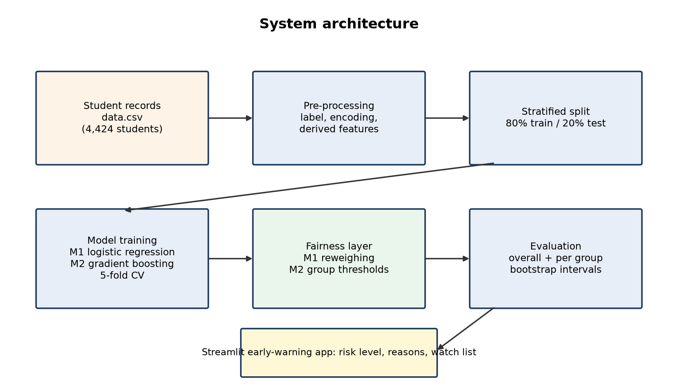
Figure 5.1: System architecture

5.2 Data Flow Diagram
A data flow diagram (DFD) shows how data moves through the system: external entities (the institution and the advisor), processes (numbered circles) and data stores (open rectangles). Figure 5.2 shows the level-1 DFD.
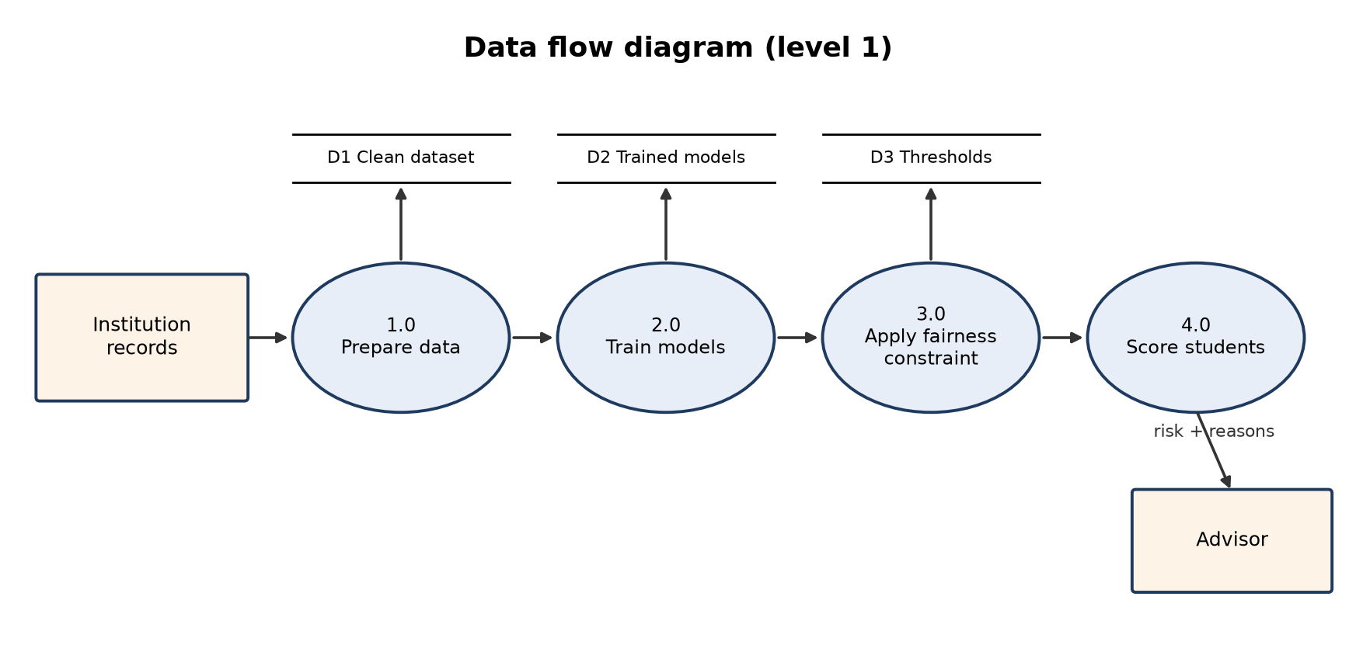
Figure 5.2: Data flow diagram (level 1)

5.3 Usecase Diagram
Use case diagrams capture the functions a system offers to its users (actors). The advisor checks students, reads the watch list and the fairness and performance reports; the administrator also retrains the models when new data arrives.
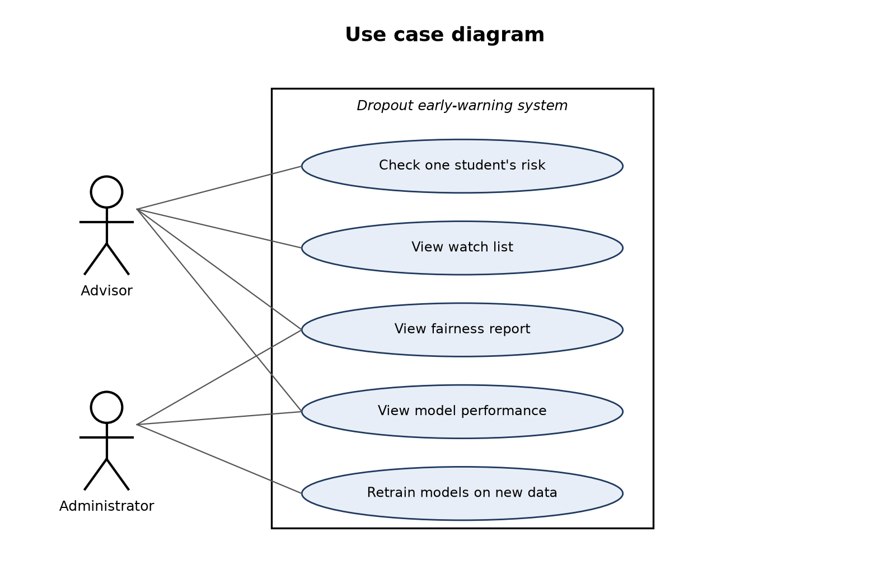
Figure 5.3: Use case diagram

5.4 Class Diagram
A class diagram shows the static structure of the system: its classes, their attributes and operations, and their relationships. Each class in Figure 5.4 corresponds to one stage of the pipeline.
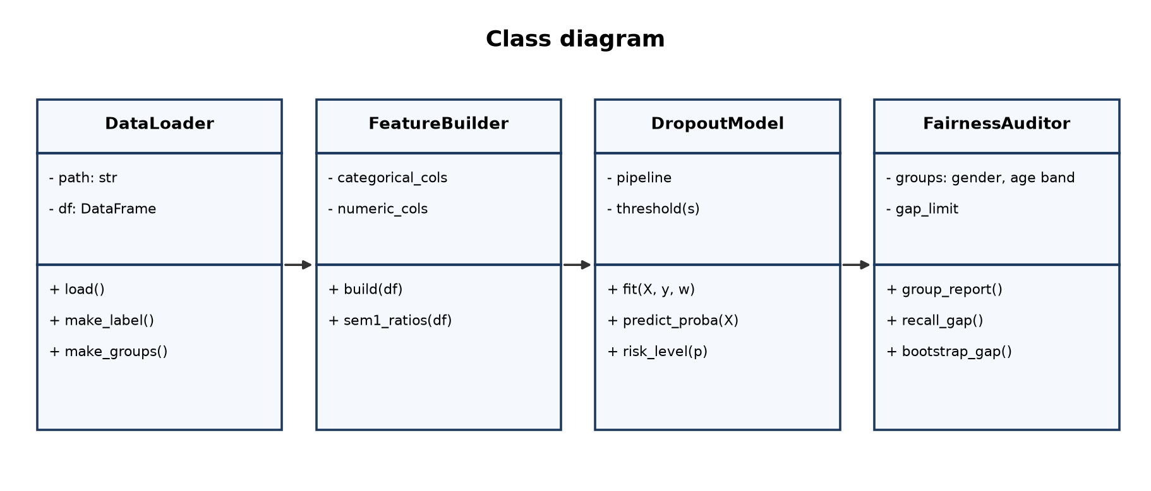
Figure 5.4: Class diagram

5.5 Activity Diagram
An activity diagram shows the flow of control from one activity to the next. Figure 5.5 shows the complete workflow from loading the records to serving risk levels.
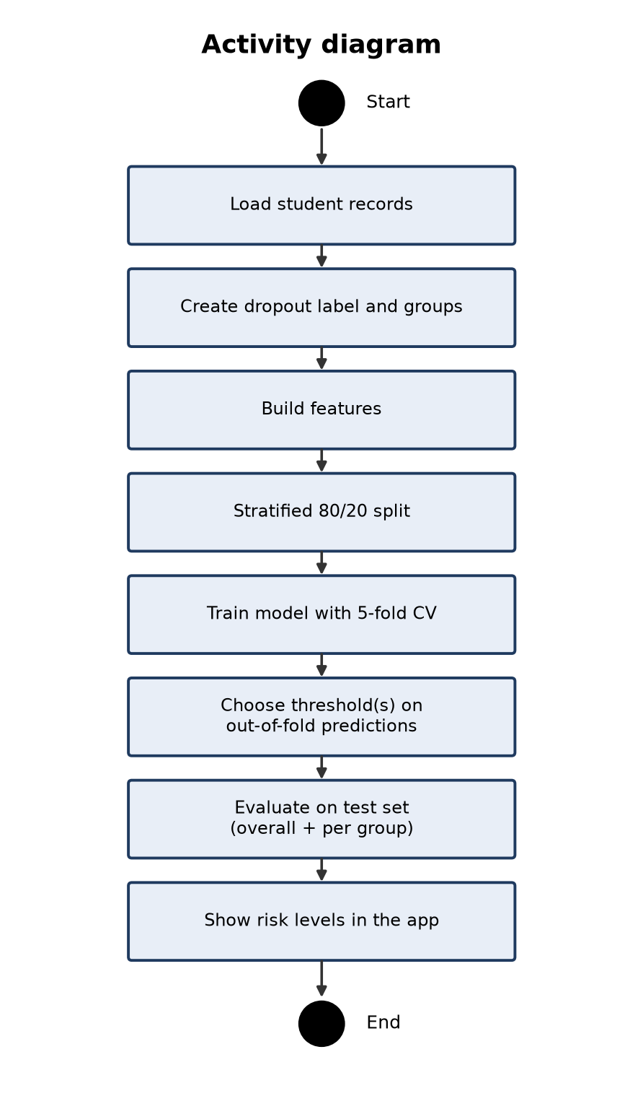
Figure 5.5: Activity diagram

5.6 Sequence Diagram
A sequence diagram shows how objects interact over time. Figure 5.6 shows what happens when an advisor checks a student in the app.
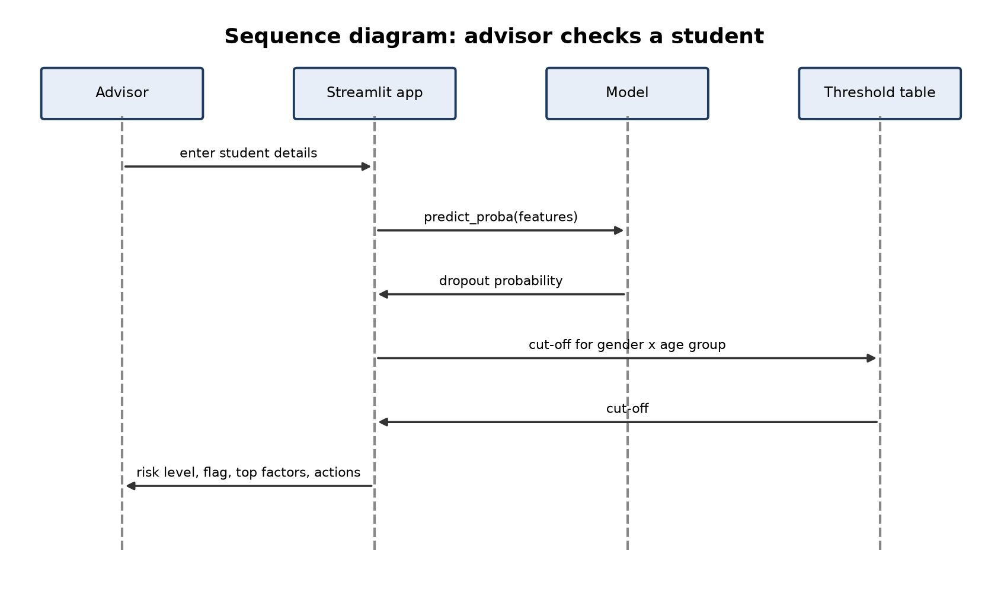
Figure 5.6: Sequence diagram

5.7 ER Diagram
An entity-relationship diagram shows the data entities and how they are related. If the system were connected to an institutional database, a student could have several enrolments, and each enrolment several predictions over time (Figure 5.7).
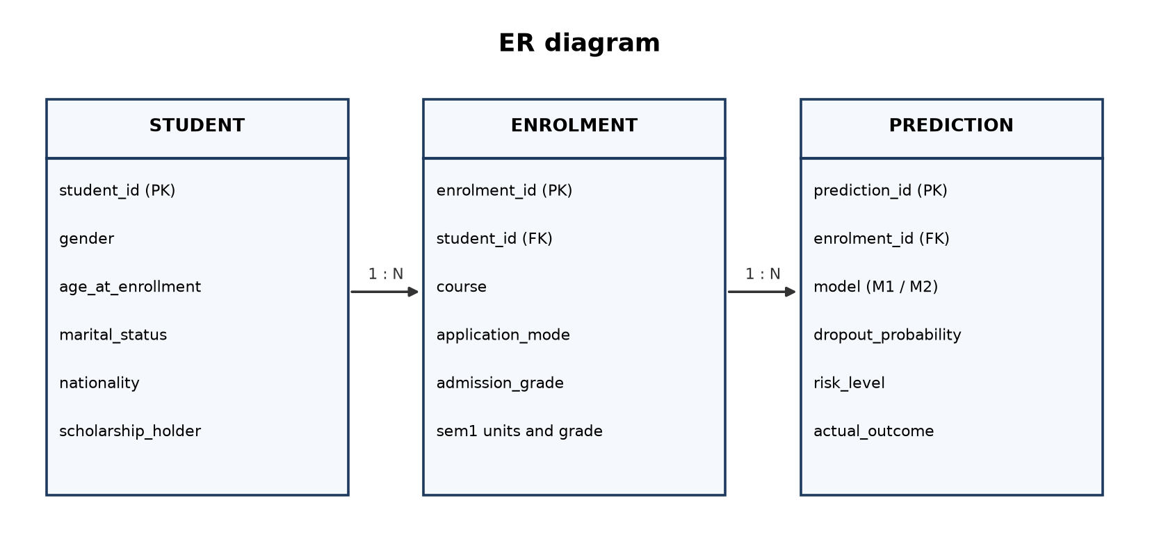
Figure 5.7: ER diagram

6. DATASET AND PRE-PROCESSING

6.1 Dataset Description
The dataset "Predict students' dropout and academic success" was created by Realinho et al. [1] from several disjoint databases of a Portuguese higher-education institution and is published under a CC BY 4.0 licence (DOI 10.5281/zenodo.5777339). Each row describes one student at enrolment and at the end of the first two semesters; the Target column gives the outcome at the end of the normal course duration.
Table 6.1: Dataset summary
Property | Value
Students (rows) | 4,424
Columns | 37
Missing values | 0
Duplicate rows | 0
Outcome classes | Graduate 2209, Dropout 1421, Enrolled 794
Dropout rate | 32.1%

6.2 Attributes
Table 6.2: Attributes of the dataset
# | Column | Group | Type | Meaning
1 | Marital status | Demographic | Categorical code | 1 single, 2 married, 3 widower, 4 divorced, 5 facto union, 6 legally separated
2 | Application mode | Academic path | Categorical code | Entry route, e.g. 1st phase general contingent, over-23 exam, transfer
3 | Application order | Academic path | Integer 0-9 | Preference rank of this course in the application (1 = first choice)
4 | Course | Academic path | Categorical code | Degree programme, e.g. 9254 Tourism, 9500 Nursing
5 | Daytime/evening attendance | Academic path | Binary | 1 daytime, 0 evening
6 | Previous qualification | Academic path | Categorical code | Highest qualification before enrolment
7 | Previous qualification (grade) | Academic path | Numeric 0-200 | Grade of the previous qualification
8 | Nacionality | Demographic | Categorical code | Nationality
9 | Mother's qualification | Socio-economic | Categorical code | Mother's education level
10 | Father's qualification | Socio-economic | Categorical code | Father's education level
11 | Mother's occupation | Socio-economic | Categorical code | Mother's occupation group
12 | Father's occupation | Socio-economic | Categorical code | Father's occupation group
13 | Admission grade | Academic path | Numeric 0-200 | Grade used for admission
14 | Displaced | Demographic | Binary | 1 if studying away from home
15 | Educational special needs | Demographic | Binary | 1 if the student has special educational needs
16 | Debtor | Socio-economic | Binary | 1 if the student owes money to the institution
17 | Tuition fees up to date | Socio-economic | Binary | 1 if fees are paid up to date
18 | Gender | Demographic (audit only) | Binary | 1 male, 0 female; used only for the fairness audit
19 | Scholarship holder | Socio-economic | Binary | 1 if the student holds a scholarship
20 | Age at enrollment | Demographic | Integer | Age in years at enrolment; also used to form age bands
21 | International | Demographic | Binary | 1 if an international student
22 | Curricular units 1st sem (credited) | Academic performance | Numeric | 1st semester: units credited from earlier studies
23 | Curricular units 1st sem (enrolled) | Academic performance | Numeric | 1st semester: units enrolled
24 | Curricular units 1st sem (evaluations) | Academic performance | Numeric | 1st semester: unit assessments attempted
25 | Curricular units 1st sem (approved) | Academic performance | Numeric | 1st semester: units passed
26 | Curricular units 1st sem (grade) | Academic performance | Numeric | 1st semester: average grade (0-20)
27 | Curricular units 1st sem (without evaluations) | Academic performance | Numeric | 1st semester: units with no assessment
28 | Curricular units 2nd sem (credited) | Academic performance | Numeric | 2nd semester: units credited from earlier studies
29 | Curricular units 2nd sem (enrolled) | Academic performance | Numeric | 2nd semester: units enrolled
30 | Curricular units 2nd sem (evaluations) | Academic performance | Numeric | 2nd semester: unit assessments attempted
31 | Curricular units 2nd sem (approved) | Academic performance | Numeric | 2nd semester: units passed
32 | Curricular units 2nd sem (grade) | Academic performance | Numeric | 2nd semester: average grade (0-20)
33 | Curricular units 2nd sem (without evaluations) | Academic performance | Numeric | 2nd semester: units with no assessment
34 | Unemployment rate | Macro-economic | Numeric (%) | National unemployment rate in the enrolment year
35 | Inflation rate | Macro-economic | Numeric (%) | National inflation rate
36 | GDP | Macro-economic | Numeric | GDP growth
37 | Target | Outcome | Text | Dropout, Enrolled or Graduate at the end of the normal course duration

6.3 Exploratory Analysis
Table 6.3: Dropout rate by group
Attribute | Group | Dropout rate
Gender | Female | 25.1%
Gender | Male | 45.1%
Age band | 20 or under | 21.2%
Age band | 21-24 | 33.7%
Age band | 25 and over | 55.4%

Dropout is strongly related to age at enrolment and differs between male and female students. This has two consequences: age is a useful predictor, and a model is likely to perform differently across these groups, so the fairness audit focuses on gender and age band.

6.4 Pre-processing
- The file is read with a semicolon separator and column names are stripped of spaces.
- A binary label is created: 1 for Dropout, 0 for Graduate or Enrolled.
- Gender and age band are stored separately for auditing; gender is not a model input.
- Eight code-valued columns are treated as categories (one-hot encoded for Model 1, native categories for Model 2).
- Numeric columns are standardised for Model 1.
- Second-semester columns are excluded to avoid using information from the future.
Table 6.4: Derived features (Model 2)
Feature | Formula | Meaning
sem1_approval_rate | approved / enrolled (0 if none enrolled) | Share of 1st-semester units passed
sem1_pass_per_exam | approved / evaluations (0 if none) | How often an attempted exam is passed
sem1_no_exam_share | without evaluations / enrolled | Share of units the student never sat
sem1_failed_units | max(enrolled - approved, 0) | Number of units not passed
fee_problem | Debtor = 1 or Tuition fees up to date = 0 | Any money problem with the institution
grade_gap | Admission grade - Previous qualification grade | Change between previous and admission grade

6.5 Train-Test Split
The data is split once into 3,539 training students (80%) and 885 test students (20%), stratified on the label so both sets have the same dropout share, with random_state 42. All tuning, threshold choice and reweighing use the training set only.

7. METHODOLOGY AND ALGORITHMS

7.1 Logistic Regression (Model 1)
Logistic regression models the log-odds of dropout as a linear function of the inputs. The sigmoid function maps the result to a probability. The coefficients are learned by maximising the (weighted) likelihood of the training labels.
P(y = 1 | x) = σ(β0 + Σ βj xj), σ(z) = 1 / (1 + e^-z)
Loss = - Σ wi [ yi log pi + (1 - yi) log(1 - pi) ]
Here wi is the reweighing weight of student i. Logistic regression is the baseline because it is simple, fast and fully interpretable.

7.2 Histogram Gradient Boosting (Model 2)
Gradient boosting builds an additive model of decision trees. Starting from a constant, each new tree h_m is fitted to the gradient of the loss (the current errors) and added with a small learning rate η. The histogram variant groups each feature into bins, which makes finding splits fast [6]. Balanced class weights give dropouts more weight to counter the class imbalance.
F_0(x) = const, F_m(x) = F_(m-1)(x) + η · h_m(x), P(y = 1 | x) = σ(F_M(x))

7.3 Hyperparameter Tuning
RandomizedSearchCV sampled 25 combinations from the space below and scored each by mean ROC-AUC over 5 stratified folds.
Table 7.1: Search space and best values
Hyperparameter | Values searched | Best
learning_rate | 0.02, 0.03, 0.05, 0.08, 0.1 | 0.02
max_iter | 200, 300, 400, 600 | 300
max_leaf_nodes | 8, 15, 31 | 31
min_samples_leaf | 10, 20, 40, 60 | 20
l2_regularization | 0.0, 0.1, 0.5, 1.0 | 0.0
max_features | 0.5, 0.7, 1.0 | 0.5

7.4 Reweighing
For each group g (gender x age band) and label y, the weight is the frequency expected if group and label were independent divided by the observed frequency [2]. Combinations that are under-represented get weights above 1.
w(g, y) = P(g) · P(y) / P(g, y)
Table 7.2: Reweighing weights used by Model 1
Group | Label | Weight
Female, 20 or under | 0 | 0.825
Female, 20 or under | 1 | 1.808
Female, 21-24 | 0 | 0.954
Female, 21-24 | 1 | 1.113
Female, 25 and over | 0 | 1.259
Female, 25 and over | 1 | 0.697
Male, 20 or under | 0 | 0.996
Male, 20 or under | 1 | 1.008
Male, 21-24 | 0 | 1.108
Male, 21-24 | 1 | 0.829
Male, 25 and over | 0 | 1.959
Male, 25 and over | 1 | 0.492

7.5 Equal-Opportunity Thresholds
Model 2 first finds a single threshold reaching the recall target and measures the recall gap on out-of-fold predictions. For attributes whose gap exceeds the limit, a separate threshold is chosen for each group: the highest threshold whose out-of-fold recall in that group reaches the target [3].
Table 7.3: Model 2 thresholds
Group | Threshold
Female, 20 or under | 0.13
Female, 21-24 | 0.27
Female, 25 and over | 0.59
Male, 20 or under | 0.21
Male, 21-24 | 0.33
Male, 25 and over | 0.60

7.6 Evaluation Metrics
Table 7.4: Evaluation and fairness metrics
Metric | Formula | Meaning
Accuracy | (TP + TN) / all | Share of all students classified correctly; misleading when classes are imbalanced
Precision | TP / (TP + FP) | Of the flagged students, the share who really drop out
Recall (TPR) | TP / (TP + FN) | Of the real dropouts, the share flagged; the priority for an early-warning tool
F1-score | 2 PR / (P + R) | Balance of precision and recall
ROC-AUC | Area under the ROC curve | Probability that a random dropout is ranked above a random non-dropout (0.5 = guessing)
Selection rate | Flagged / group size | Share of a group that is flagged
Recall gap | max - min group recall | Equal opportunity difference; 0 means every group's dropouts are caught equally

TP, FP, TN and FN are true positives, false positives, true negatives and false negatives. 95% intervals for recall gaps come from 2,000 bootstrap resamples of the test set.

8. IMPLEMENTATION

8.1 Software Description

Python
A high-level, general-purpose programming language with a large ecosystem for data science; used for all code.

Jupyter Notebook
An interactive environment that mixes code, output, charts and text; used for both model notebooks.

pandas and NumPy
Libraries for loading, cleaning and transforming tabular data and for numerical computation.

scikit-learn
The machine-learning library providing pipelines, encoders, LogisticRegression, HistGradientBoostingClassifier, cross-validation, randomised search, metrics and permutation importance.

matplotlib
The plotting library used for performance, fairness and importance charts.

Streamlit
A framework that turns a Python script into an interactive web application; used for the advisor app.

8.2 List of Modules
1. Data loading and labelling
2. Feature engineering
3. Model training and tuning
4. Fairness constraint and audit
5. Explanation and risk levels
6. Web application

8.3 Module Description

Data loading and labelling
Reads the CSV, strips column names, builds the dropout label and the gender and age-band groups used for auditing.

Feature engineering
Selects the enrolment attributes (Model 1) or enrolment plus first-semester attributes (Model 2), marks code columns as categorical and computes the derived ratios.

Model training and tuning
Builds the logistic regression pipeline and fits it with reweighing weights; tunes the gradient boosting model with randomised search over 5 folds.

Fairness constraint and audit
Computes reweighing weights or per-group thresholds from out-of-fold predictions, and reports per-group selection rate, recall, false-positive rate and recall gaps with bootstrap intervals.

Explanation and risk levels
Shows logistic coefficients or permutation importance, and maps each probability to Low, Medium or High risk relative to the student's threshold.

Web application
Trains both models at start-up and offers four tabs: Check a student, Watch list, Fairness and Model performance.

8.4 Key Code
Reweighing weights (Model 1):
def reweighing_weights(y, group):
w = np.zeros(len(y))
for g in np.unique(group):
for label in [0, 1]:
mask = (group == g) & (y == label)
expected = (group == g).mean() * (y == label).mean()
w[mask] = expected / mask.mean()
return w

Threshold that reaches a recall target:
def threshold_for_recall(y_true, prob, target):
for t in np.arange(0.95, 0.04, -0.01):
if recall_score(y_true, (prob >= t).astype(int)) >= target:
return round(float(t), 2)
return 0.05

8.5 Deploy
The application is started from the app folder with the commands below; it trains both models from the project data on first start (about 30 seconds) and opens at http://localhost:8501.
cd ML14-STUDENT-DROPOUT\ML14-final-review\app
pip install streamlit scikit-learn pandas numpy matplotlib
streamlit run app.py

Table 8.1: Application tabs
Tab | Function
Check a student | Both models' probability, flag, top risk factors and suggested actions for one student
Watch list | Test students ranked by risk, filterable by level, course and age band
Fairness | Recall gaps and per-group recall for three threshold options; Model 2's thresholds
Model performance | Metrics and confusion matrices of both models

9. RESULTS AND DISCUSSION

9.1 Model 1: Logistic Regression
Table 9.1: Model 1 test-set performance
Metric | Value
Accuracy | 0.680
Precision | 0.501
Recall | 0.761
F1-score | 0.604
ROC-AUC | 0.796
Students flagged | 48.7%

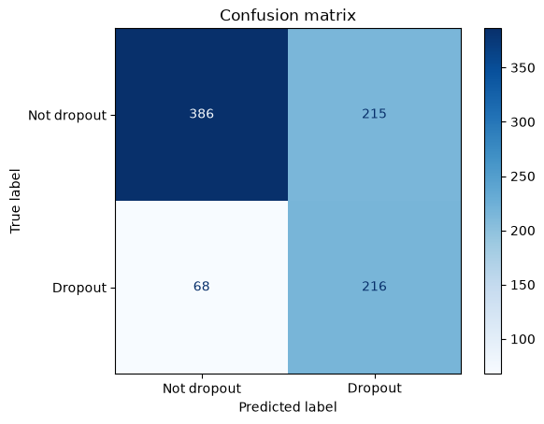
Figure 9.1: Model 1 confusion matrix and ROC curve
Table 9.2: Model 1 performance by group
Group | Students | Dropouts | Selection rate | Recall | FPR | Precision | Accuracy
Female | 564 | 138 | 0.441 | 0.754 | 0.34 | 0.418 | 0.683
Male | 321 | 146 | 0.567 | 0.767 | 0.40 | 0.615 | 0.676
20 or under | 513 | 102 | 0.423 | 0.725 | 0.348 | 0.341 | 0.667
21-24 | 139 | 51 | 0.482 | 0.765 | 0.318 | 0.582 | 0.712
25 and over | 233 | 131 | 0.631 | 0.786 | 0.431 | 0.701 | 0.691

Model 1's recall gap is 0.014 for gender (95% interval 0.002 to 0.124) and 0.061 for age band (95% interval 0.017 to 0.199).
Table 9.3: Effect of the reweighing choice
Option | ROC-AUC | Recall | Precision | Flagged | Gender gap | Age gap
No reweighing | 0.834 | 0.792 | 0.556 | 0.458 | 0.033 | 0.294
Reweigh by gender | 0.826 | 0.764 | 0.549 | 0.446 | 0.006 | 0.293
Reweigh by gender x age (used) | 0.796 | 0.761 | 0.501 | 0.487 | 0.014 | 0.061

Reweighing by gender x age reduces the age recall gap substantially compared with no reweighing or reweighing by gender alone, at some cost in ROC-AUC and precision.
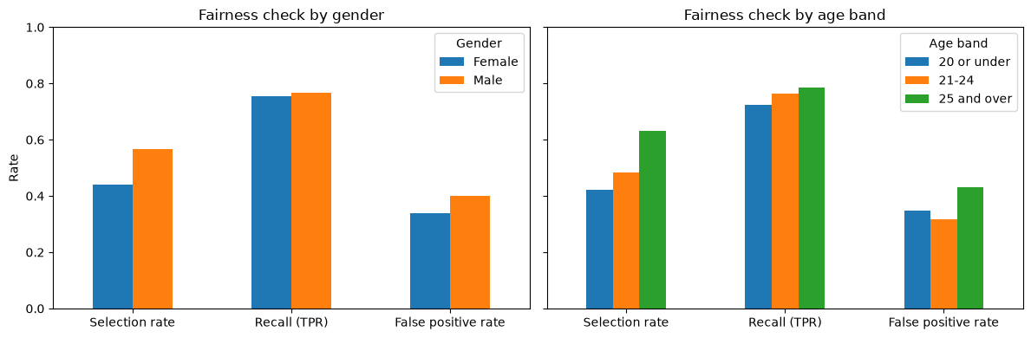
Figure 9.2: Model 1 fairness by gender and age band

9.2 Model 2: Tuned Gradient Boosting
The best setting reached a mean cross-validation ROC-AUC of 0.900.
Table 9.4: Model 2 test-set performance
Metric | Value
Accuracy | 0.745
Precision | 0.568
Recall | 0.852
F1-score | 0.682
ROC-AUC | 0.910
Average precision | 0.877
Students flagged | 48.1%

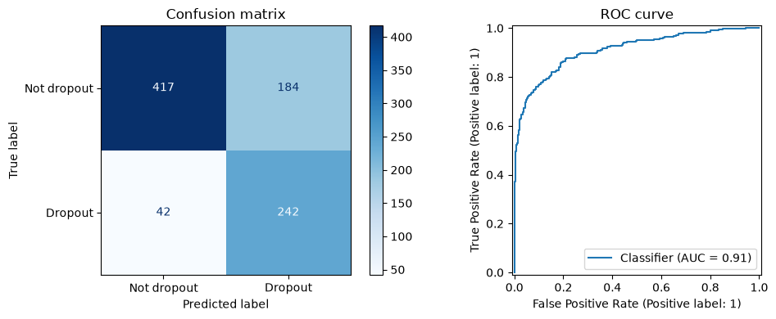
Figure 9.3: Model 2 confusion matrix, ROC and precision-recall curves
Table 9.5: Model 2 threshold options compared
Option | Recall | Precision | F1 | Flagged | Gender gap | 95% CI | Age gap | 95% CI
Single threshold 0.5 | 0.771 | 0.771 | 0.771 | 0.321 | 0.020 | 0.002 to 0.122 | 0.283 | 0.178 to 0.389
Single threshold 0.27 (same recall target) | 0.877 | 0.650 | 0.747 | 0.433 | 0.000 | 0.001 to 0.085 | 0.205 | 0.127 to 0.291
Fairness-constrained thresholds | 0.852 | 0.568 | 0.682 | 0.481 | 0.006 | 0.002 to 0.097 | 0.054 | 0.018 to 0.188

Table 9.6: Model 2 by group with fairness-constrained thresholds
Group | Students | Dropouts | Selection rate | Recall | FPR | Precision | Accuracy
Female | 564 | 138 | 0.452 | 0.855 | 0.322 | 0.463 | 0.722
Male | 321 | 146 | 0.533 | 0.849 | 0.269 | 0.725 | 0.785
20 or under | 513 | 102 | 0.446 | 0.833 | 0.350 | 0.371 | 0.686
21-24 | 139 | 51 | 0.475 | 0.824 | 0.273 | 0.636 | 0.763
25 and over | 233 | 131 | 0.562 | 0.878 | 0.157 | 0.878 | 0.863

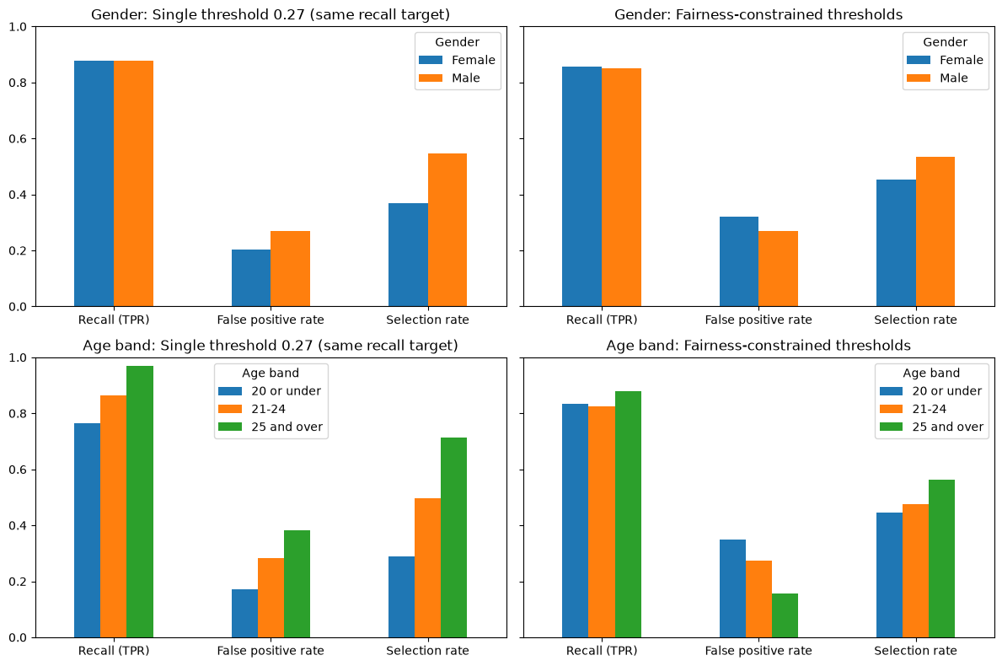
Figure 9.4: Model 2 fairness audit
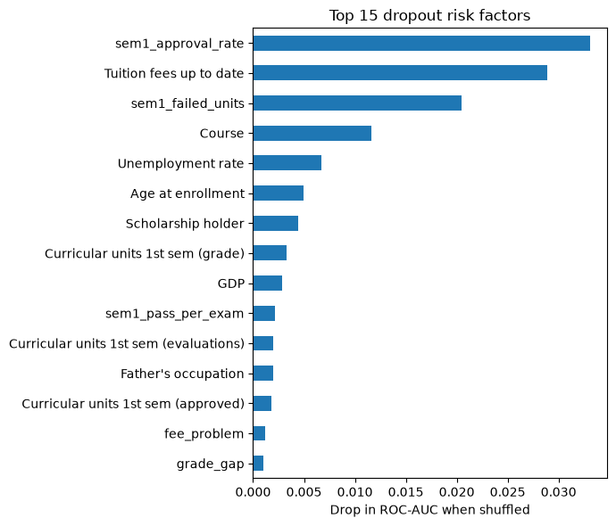
Figure 9.5: Model 2 top risk factors (permutation importance)

9.3 Comparison
Table 9.7: Comparison of the two models
Model | Features | CV ROC-AUC | Accuracy | Precision | Recall | F1 | ROC-AUC | Gender gap | Age gap
M1 Logistic regression | 22 | not printed | 0.680 | 0.501 | 0.761 | 0.604 | 0.796 | 0.014 | 0.061
M2 Gradient boosting | 34 | 0.900 | 0.745 | 0.568 | 0.852 | 0.682 | 0.910 | 0.006 | 0.054

Model 2 is selected. It has the only recorded mean cross-validation score and is better on every test metric, catching 85.2% of dropouts. Its fairness thresholds reduce the age-band recall gap from 0.283 (single 0.5 threshold) to 0.054. Model 1 remains valuable as an earlier warning because it needs no grades.

9.4 Risk Levels
Table 9.8: Model 2 risk levels on the test set
Risk level | Students | Actual dropouts | Actual non-dropouts
High | 205 | 185 | 20
Medium | 221 | 57 | 164
Low | 459 | 42 | 417

In Model 2's High-risk group 185 of 205 test students actually dropped out, so a High flag is a strong signal for an advisor.

9.5 Discussion and Limitations
- The comparison is not like-for-like: Model 2 uses first-semester results that Model 1 deliberately leaves out.
- Fairness thresholds lower precision because more students are flagged; for an early-warning tool this trade-off is acceptable.
- The test set has about 100-150 dropouts per group, so small gaps are uncertain, as the bootstrap intervals show.
- The data comes from one institution; results must be re-validated before use elsewhere.
- Model 2's out-of-fold predictions reuse the tuning folds and are slightly optimistic; the test set is unaffected.

10. CONCLUSION AND FUTURE WORK

10.1 Conclusion
This project built a fair student dropout early-warning system. A logistic regression with reweighing provides a warning on enrolment day (ROC-AUC 0.796), and a tuned gradient boosting model with equal-opportunity thresholds provides a stronger warning after the first semester (ROC-AUC 0.910, recall 0.852). Both keep the share of dropouts caught similar across gender and age groups. The results show that fairness constraints can be added to a practical early-warning tool at a modest, measurable cost in precision, and that this cost should always be reported alongside accuracy.

10.2 Future Work
- Validate the models on later cohorts and on data from other institutions.
- Add a second-semester warning stage.
- Calibrate the probabilities and monitor data drift after deployment.
- Audit fairness for further attributes such as scholarship status and nationality, and their intersections.
- Add attendance or learning-management-system activity as early signals.
- Measure, with the institution, whether advisor interventions actually reduce dropout.

11. REFERENCES
[1] V. Realinho, J. Machado, L. Baptista, M. V. Martins, "Predicting Student Dropout and Academic Success," Data, vol. 7, no. 11, art. 146, 2022. Available: https://doi.org/10.3390/data7110146
[2] F. Kamiran, T. Calders, "Data preprocessing techniques for classification without discrimination," Knowledge and Information Systems, vol. 33, pp. 1-33, 2012. Available: https://doi.org/10.1007/s10115-011-0463-8
[3] M. Hardt, E. Price, N. Srebro, "Equality of Opportunity in Supervised Learning," Advances in Neural Information Processing Systems 29 (NeurIPS 2016), 2016. Available: https://doi.org/10.48550/arXiv.1610.02413
[4] J. Gardner, C. Brooks, R. Baker, "Evaluating the Fairness of Predictive Student Models Through Slicing Analysis," Proc. 9th Int. Conf. on Learning Analytics & Knowledge (LAK '19), pp. 225-234, 2019. Available: https://doi.org/10.1145/3303772.3303791
[5] R. F. Kizilcec, H. Lee, "Algorithmic Fairness in Education," arXiv:2007.05443 (chapter in Ethics in Artificial Intelligence in Education), 2020. Available: https://doi.org/10.48550/arXiv.2007.05443
[6] G. Ke, Q. Meng, T. Finley, T. Wang, W. Chen, W. Ma, Q. Ye, T.-Y. Liu, "LightGBM: A Highly Efficient Gradient Boosting Decision Tree," Advances in Neural Information Processing Systems 30 (NeurIPS 2017), pp. 3146-3154, 2017. Available: https://proceedings.neurips.cc/paper/2017/file/6449f44a102fde848669bdd9eb6b76fa-Paper.pdf

