Fair Student Dropout Early-Warning System using Machine Learning
Second Review: Implementation, Results and Model Selection
[Student name] · [Register number] · Guide: [Guide's name] · [Department, College]

1. Progress since the first review
- Data loaded, checked and prepared; binary dropout label created.
- Model 1 (logistic regression with reweighing) implemented and evaluated: M1_logistic_regression.ipynb.
- Model 2 (tuned gradient boosting with fair thresholds) implemented and evaluated: M2_gradient_boosting.ipynb.
- Both models audited for fairness by gender and age band; Model 2 selected.
- Streamlit app (app.py) built on both models for the final review.

2. Data preparation
Table 1: Pre-processing steps
Step | What was done | Why
Load | data.csv read with ';' separator; column names stripped (4,424 rows, 37 columns) | File uses semicolons
Check | 0 missing values, 0 duplicate rows | No imputation needed
Label | dropout = 1 if Target = Dropout, else 0 | Early warning is about dropout only
Groups | Gender name (Female/Male) and Age band (20 or under, 21-24, 25 and over) | Used only for the fairness audit
Categoricals | 8 code-valued columns (course, application mode, parents' data...) | Codes are labels, not amounts
Derived features (M2) | six first-semester and fee features (Table 2) | Make early academic trouble explicit
Split | stratified 80/20, random_state 42: 3,539 train, 885 test | Same dropout share in both sets

Table 2: Derived features used by Model 2
Feature | Formula | Meaning
sem1_approval_rate | approved / enrolled (0 if none enrolled) | Share of 1st-semester units passed
sem1_pass_per_exam | approved / evaluations (0 if none) | How often an attempted exam is passed
sem1_no_exam_share | without evaluations / enrolled | Share of units the student never sat
sem1_failed_units | max(enrolled - approved, 0) | Number of units not passed
fee_problem | Debtor = 1 or Tuition fees up to date = 0 | Any money problem with the institution
grade_gap | Admission grade - Previous qualification grade | Change between previous and admission grade

Model 1 uses the 22 attributes known at enrolment: Marital status, Application mode, Application order, Course, Daytime/evening attendance, Previous qualification, Previous qualification (grade), Mother's qualification, Father's qualification, Mother's occupation, Father's occupation, Admission grade, Displaced, Educational special needs, Debtor, Tuition fees up to date, Scholarship holder, Age at enrollment, International, Unemployment rate, Inflation rate, GDP. Model 2 uses 34 features: the same enrolment attributes (except gender, nationality and second-semester data) plus the six first-semester units columns and the six derived features above.

3. Model 1: Logistic regression with reweighing

Configuration
- Pipeline: StandardScaler for numeric columns, OneHotEncoder (min_frequency 10) for categorical columns, LogisticRegression(max_iter 3000).
- Reweighing by gender x age band: weight = expected / observed frequency of each (group, label) pair [2].
- Decision threshold 0.25: highest cut-off whose out-of-fold recall on the training set reaches the 0.75 target.
Table 3: Reweighing weights (notebook cell 6)
Gender x age group | Label (1 = dropout) | Weight
Female, 20 or under | 0 | 0.825
Female, 20 or under | 1 | 1.808
Female, 21-24 | 0 | 0.954
Female, 21-24 | 1 | 1.113
Female, 25 and over | 0 | 1.259
Female, 25 and over | 1 | 0.697
Male, 20 or under | 0 | 0.996
Male, 20 or under | 1 | 1.008
Male, 21-24 | 0 | 1.108
Male, 21-24 | 1 | 0.829
Male, 25 and over | 0 | 1.959
Male, 25 and over | 1 | 0.492

Results on the test set
Table 4: Model 1 test-set performance
Metric | Value
Accuracy | 0.680
Precision | 0.501
Recall | 0.761
F1-score | 0.604
ROC-AUC | 0.796
Students flagged | 48.7%

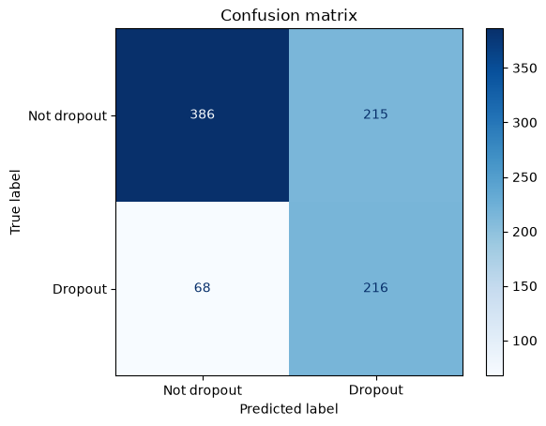
Figure 1: Model 1: confusion matrix and ROC curve

Fairness audit
Table 5: Model 1 performance by gender and age band
Group | Students | Dropouts | Selection rate | Recall | FPR | Precision | Accuracy
Female | 564 | 138 | 0.441 | 0.754 | 0.34 | 0.418 | 0.683
Male | 321 | 146 | 0.567 | 0.767 | 0.40 | 0.615 | 0.676
20 or under | 513 | 102 | 0.423 | 0.725 | 0.348 | 0.341 | 0.667
21-24 | 139 | 51 | 0.482 | 0.765 | 0.318 | 0.582 | 0.712
25 and over | 233 | 131 | 0.631 | 0.786 | 0.431 | 0.701 | 0.691

Recall gap (equal opportunity difference): gender 0.014 (95% interval 0.002 to 0.124), age band 0.061 (95% interval 0.017 to 0.199). Demographic parity difference: gender 0.126, age band 0.208. Selection rates differ because real dropout rates differ between groups; the fairness target is equal recall, not equal flag rates.
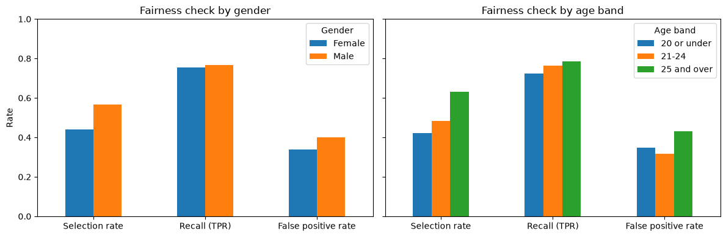
Figure 2: Model 1: selection rate, recall and false-positive rate per group

Which groups to reweigh
Table 6: Effect of reweighing choices (notebook cell 13)
Option | ROC-AUC | Recall | Precision | Flagged | Gender gap | Age gap
No reweighing | 0.834 | 0.792 | 0.556 | 0.458 | 0.033 | 0.294
Reweigh by gender | 0.826 | 0.764 | 0.549 | 0.446 | 0.006 | 0.293
Reweigh by gender x age (used) | 0.796 | 0.761 | 0.501 | 0.487 | 0.014 | 0.061

Reweighing by gender alone leaves a large age gap; reweighing by gender x age closes it, at some cost in ROC-AUC and precision. The gender x age option is used.
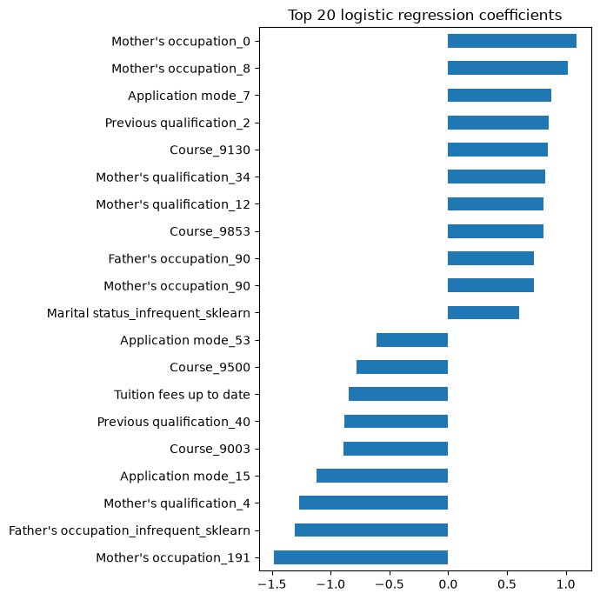
Figure 3: Model 1: strongest coefficients
Table 7: Model 1 risk levels on the test set
Risk level | Students | Actual dropouts | Actual non-dropouts
High | 120 | 107 | 13
Medium | 311 | 109 | 202
Low | 454 | 68 | 386

4. Model 2: Tuned gradient boosting with fair thresholds

Configuration and tuning
HistGradientBoostingClassifier with native categorical support, balanced class weights and no early stopping. RandomizedSearchCV tried 25 settings from the space in Table 9 with 5-fold stratified cross-validation, scoring ROC-AUC.
Table 8: Search space
Hyperparameter | Values searched
learning_rate | 0.02, 0.03, 0.05, 0.08, 0.1
max_iter | 200, 300, 400, 600
max_leaf_nodes | 8, 15, 31
min_samples_leaf | 10, 20, 40, 60
l2_regularization | 0.0, 0.1, 0.5, 1.0
max_features | 0.5, 0.7, 1.0

Table 9: Best setting found
Hyperparameter | Best value
min_samples_leaf | 20
max_leaf_nodes | 31
max_iter | 300
max_features | 0.5
learning_rate | 0.02
l2_regularization | 0.0
Best mean CV ROC-AUC | 0.900

Fairness constraint
With one threshold (0.27) for everyone, the out-of-fold recall gaps were: Gender 0.058, Age band 0.16. Both attributes were above the limit, so a separate threshold was chosen for each gender x age group to reach the 0.85 recall target.
Table 10: Model 2 decision thresholds
Gender x age group | Threshold
Female, 20 or under | 0.13
Female, 21-24 | 0.27
Female, 25 and over | 0.59
Male, 20 or under | 0.21
Male, 21-24 | 0.33
Male, 25 and over | 0.60

Results on the test set
Table 11: Model 2 test-set performance
Metric | Value
Accuracy | 0.745
Precision | 0.568
Recall | 0.852
F1-score | 0.682
ROC-AUC | 0.910
Average precision | 0.877
Students flagged | 48.1%

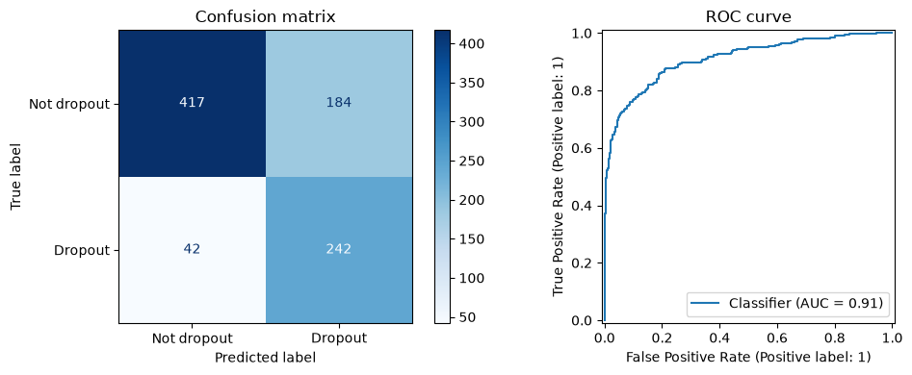
Figure 4: Model 2: confusion matrix, ROC and precision-recall curves

Fairness audit: three ways to set thresholds
Table 12: Model 2 by group: Single threshold 0.5
Group | Students | Dropouts | Selection rate | Recall | FPR | Precision | Accuracy
Female | 564 | 138 | 0.257 | 0.761 | 0.094 | 0.724 | 0.871
Male | 321 | 146 | 0.433 | 0.781 | 0.143 | 0.820 | 0.822
20 or under | 513 | 102 | 0.185 | 0.618 | 0.078 | 0.663 | 0.862
21-24 | 139 | 51 | 0.360 | 0.745 | 0.136 | 0.760 | 0.820
25 and over | 233 | 131 | 0.597 | 0.901 | 0.206 | 0.849 | 0.854

Table 13: Model 2 by group: Single threshold 0.27 (same recall target)
Group | Students | Dropouts | Selection rate | Recall | FPR | Precision | Accuracy
Female | 564 | 138 | 0.369 | 0.877 | 0.204 | 0.582 | 0.816
Male | 321 | 146 | 0.545 | 0.877 | 0.269 | 0.731 | 0.798
20 or under | 513 | 102 | 0.288 | 0.765 | 0.170 | 0.527 | 0.817
21-24 | 139 | 51 | 0.496 | 0.863 | 0.284 | 0.638 | 0.770
25 and over | 233 | 131 | 0.712 | 0.969 | 0.382 | 0.765 | 0.815

Table 14: Model 2 by group: Fairness-constrained thresholds
Group | Students | Dropouts | Selection rate | Recall | FPR | Precision | Accuracy
Female | 564 | 138 | 0.452 | 0.855 | 0.322 | 0.463 | 0.722
Male | 321 | 146 | 0.533 | 0.849 | 0.269 | 0.725 | 0.785
20 or under | 513 | 102 | 0.446 | 0.833 | 0.350 | 0.371 | 0.686
21-24 | 139 | 51 | 0.475 | 0.824 | 0.273 | 0.636 | 0.763
25 and over | 233 | 131 | 0.562 | 0.878 | 0.157 | 0.878 | 0.863

Table 15: Summary of the three options (bootstrap 95% intervals)
Option | Recall | Precision | F1 | Flagged | Gender gap | 95% CI | Age gap | 95% CI
Single threshold 0.5 | 0.771 | 0.771 | 0.771 | 0.321 | 0.020 | 0.002 to 0.122 | 0.283 | 0.178 to 0.389
Single threshold 0.27 (same recall target) | 0.877 | 0.650 | 0.747 | 0.433 | 0.000 | 0.001 to 0.085 | 0.205 | 0.127 to 0.291
Fairness-constrained thresholds | 0.852 | 0.568 | 0.682 | 0.481 | 0.006 | 0.002 to 0.097 | 0.054 | 0.018 to 0.188

A single 0.5 threshold misses many young dropouts (age gap 0.283). Lowering the single threshold to 0.27 raises recall but the age gap stays large. The fairness-constrained thresholds bring the age gap down to 0.054 and keep the gender gap at 0.006; the price is lower precision because more students are flagged.
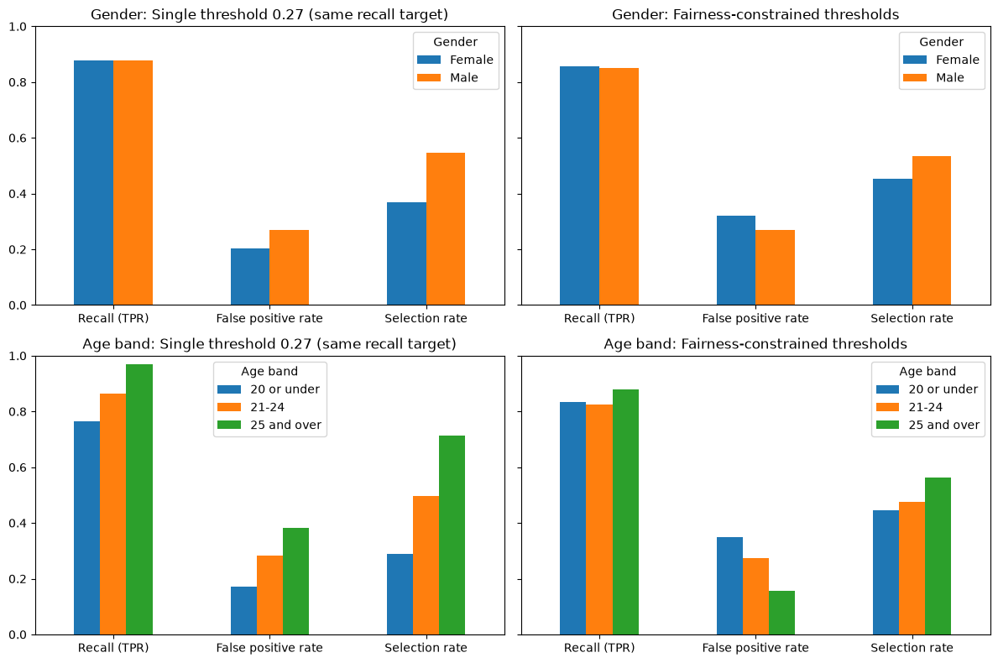
Figure 5: Model 2: recall and selection rate per group for each option
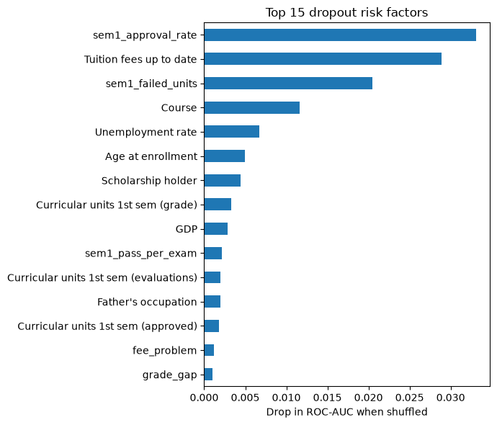
Figure 6: Model 2: top risk factors (permutation importance)
Table 16: Model 2 risk levels on the test set
Risk level | Students | Actual dropouts | Actual non-dropouts
High | 205 | 185 | 20
Medium | 221 | 57 | 164
Low | 459 | 42 | 417

5. Comparison and model selection
Table 17: Model comparison on the same test set
Model | Features | CV ROC-AUC | Accuracy | Precision | Recall | F1 | ROC-AUC | Gender gap | Age gap
M1 Logistic regression | 22 | not printed | 0.680 | 0.501 | 0.761 | 0.604 | 0.796 | 0.014 | 0.061
M2 Gradient boosting | 34 | 0.900 | 0.745 | 0.568 | 0.852 | 0.682 | 0.910 | 0.006 | 0.054

Selected model: Model 2. It is the only model with a recorded mean cross-validation score (0.900) and it is better on every test metric while keeping both recall gaps small.
Caution for the panel: the comparison is not like-for-like. Model 2 also sees first-semester results, which Model 1 deliberately leaves out so that it can warn on enrolment day. The two models are therefore used as two warning stages rather than as rivals.

6. Safeguards against data leakage
- The test set is never used for tuning, threshold choice or reweighing; it is evaluated once.
- Thresholds come from out-of-fold predictions on the training set.
- Second-semester columns are not used, because they would not be known at the time of the warning.
- Gender is not a model input; it and the age band are used only to choose cut-offs and to audit fairness.
- Note: Model 2's out-of-fold predictions reuse the tuning folds, so they are slightly optimistic; the test set stays clean.

7. How the models work
- Logistic regression: weighted sum of scaled / one-hot inputs passed through the sigmoid; coefficients show each factor's direction.
- Gradient boosting: a sequence of shallow trees, each correcting the previous ones' errors; histogram binning makes it fast [6].
- Reweighing: P(g)·P(y) / P(g, y) per (group, label), so the label is independent of the group in the weighted data [2].
- Equal opportunity: one threshold per group so the true-positive rate (recall) is similar in each group [3].
- Risk levels: High if p ≥ max(0.7, t + 0.2); Medium if p ≥ t; otherwise Low, where t is the student's threshold.

8. Next steps for the final review
- Finish and test the Streamlit app (student check, watch list, fairness and performance tabs).
- Write the final report and slides.
- Prepare the demo script and viva answers (student guide).

References
[1] V. Realinho, J. Machado, L. Baptista, M. V. Martins, "Predicting Student Dropout and Academic Success," Data, vol. 7, no. 11, art. 146, 2022. Available: https://doi.org/10.3390/data7110146
[2] F. Kamiran, T. Calders, "Data preprocessing techniques for classification without discrimination," Knowledge and Information Systems, vol. 33, pp. 1-33, 2012. Available: https://doi.org/10.1007/s10115-011-0463-8
[3] M. Hardt, E. Price, N. Srebro, "Equality of Opportunity in Supervised Learning," Advances in Neural Information Processing Systems 29 (NeurIPS 2016), 2016. Available: https://doi.org/10.48550/arXiv.1610.02413
[4] J. Gardner, C. Brooks, R. Baker, "Evaluating the Fairness of Predictive Student Models Through Slicing Analysis," Proc. 9th Int. Conf. on Learning Analytics & Knowledge (LAK '19), pp. 225-234, 2019. Available: https://doi.org/10.1145/3303772.3303791
[5] R. F. Kizilcec, H. Lee, "Algorithmic Fairness in Education," arXiv:2007.05443 (chapter in Ethics in Artificial Intelligence in Education), 2020. Available: https://doi.org/10.48550/arXiv.2007.05443
[6] G. Ke, Q. Meng, T. Finley, T. Wang, W. Chen, W. Ma, Q. Ye, T.-Y. Liu, "LightGBM: A Highly Efficient Gradient Boosting Decision Tree," Advances in Neural Information Processing Systems 30 (NeurIPS 2017), pp. 3146-3154, 2017. Available: https://proceedings.neurips.cc/paper/2017/file/6449f44a102fde848669bdd9eb6b76fa-Paper.pdf

