• Assignment 2: Technical Analysis using R, Preliminary Stage
• Name: Saravanan Gnanasekaran
• Student ID: 664425247
• Course: BDA400 — Data Science Tools and Techniques
• Instructor: Jinalben Patel
• Submission date:
• GitHub repository: https://github.com/saravanangnanasekaran85-rgb/TechnicalAnalysis

- GitHub Repository Setup.
I used my existing GitHub account to create a repository named TechnicalAnalysis for organizing my BDA400 assignments.
Figure 1. TechnicalAnalysis repository created on GitHub
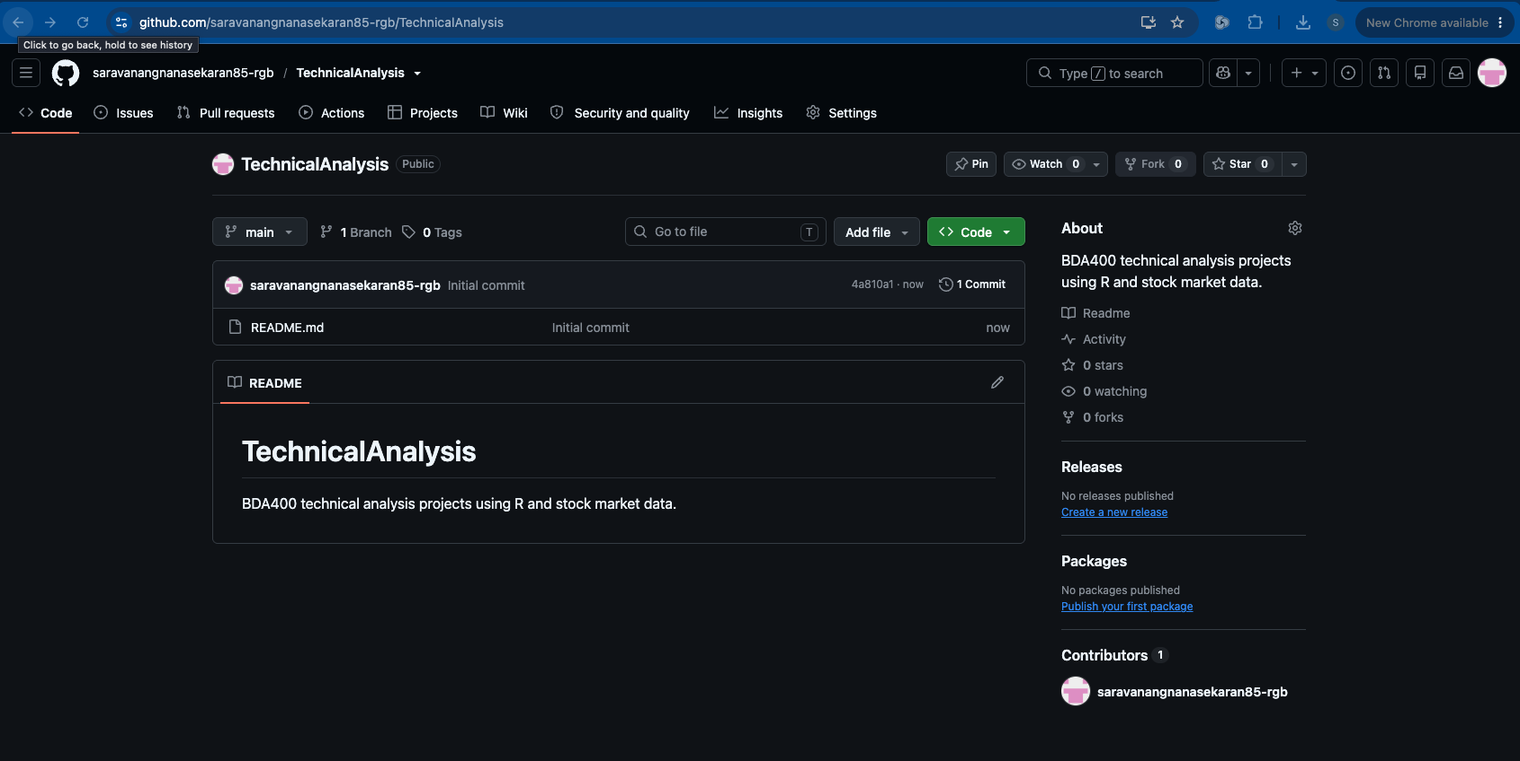

- Computer Environment
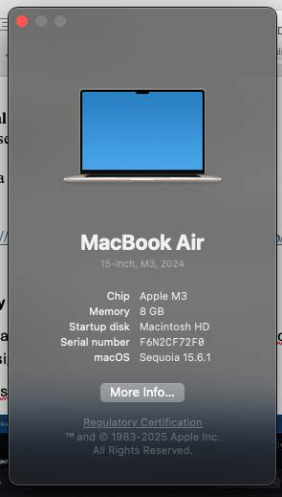

- R Installation - I installed the Apple silicon version of R on my M3 Mac running macOS Sequoia 15.6.1. I confirmed the installation by opening the R Console.

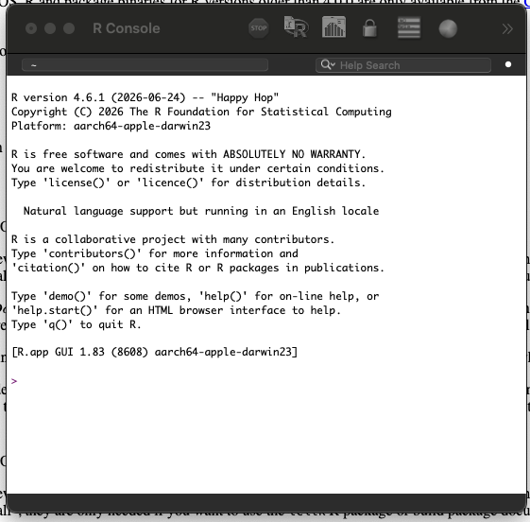

- RStudio Installation to your Word report and insert the screenshots.

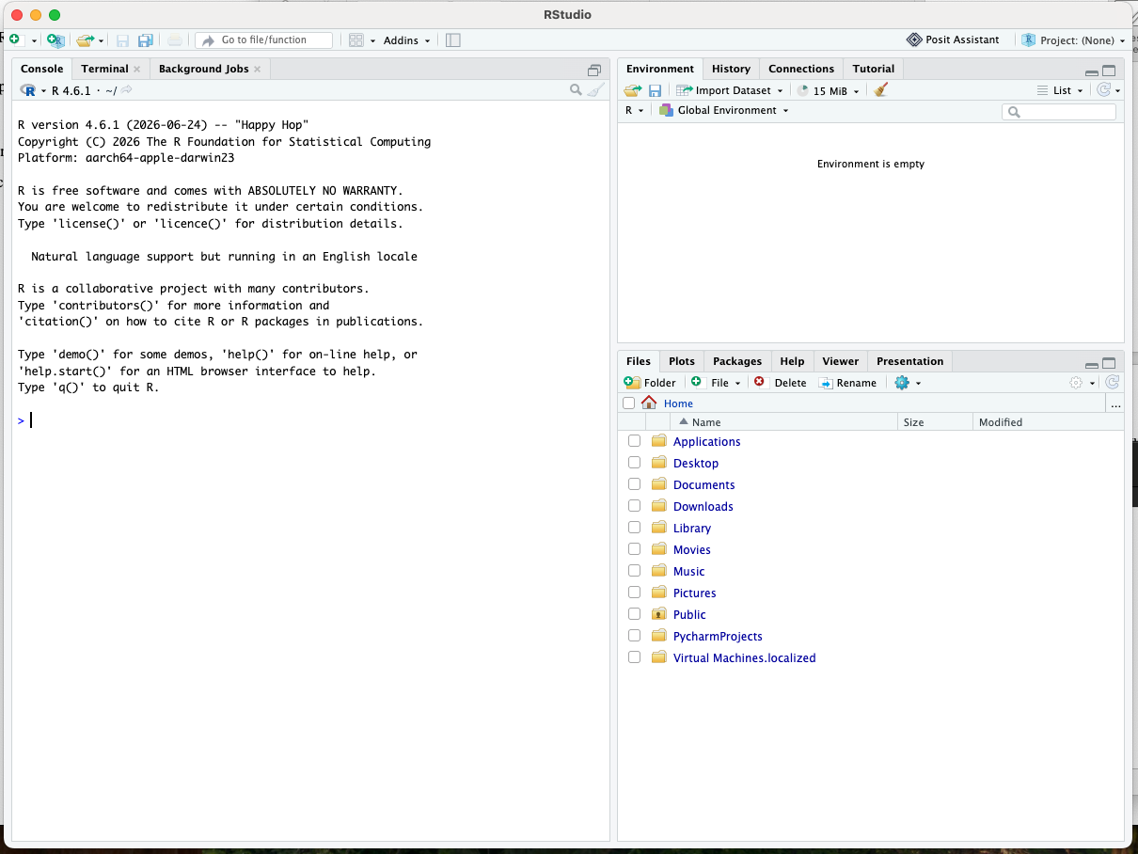

- Local RStudio Project Setup
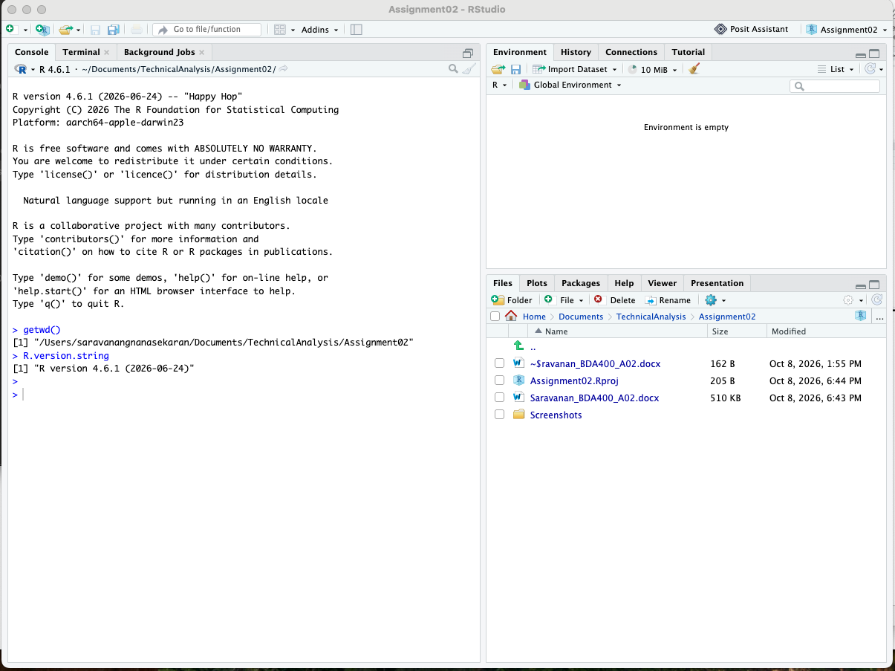

- R Package Installation

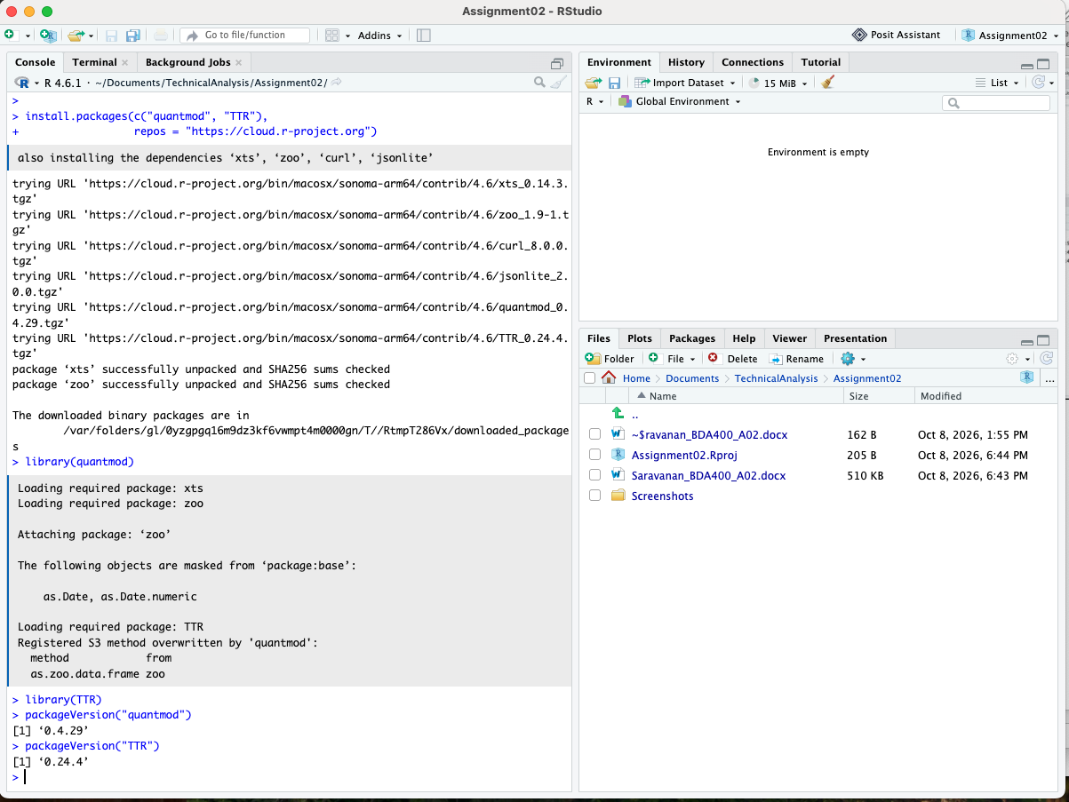

- Portfolio Configuration

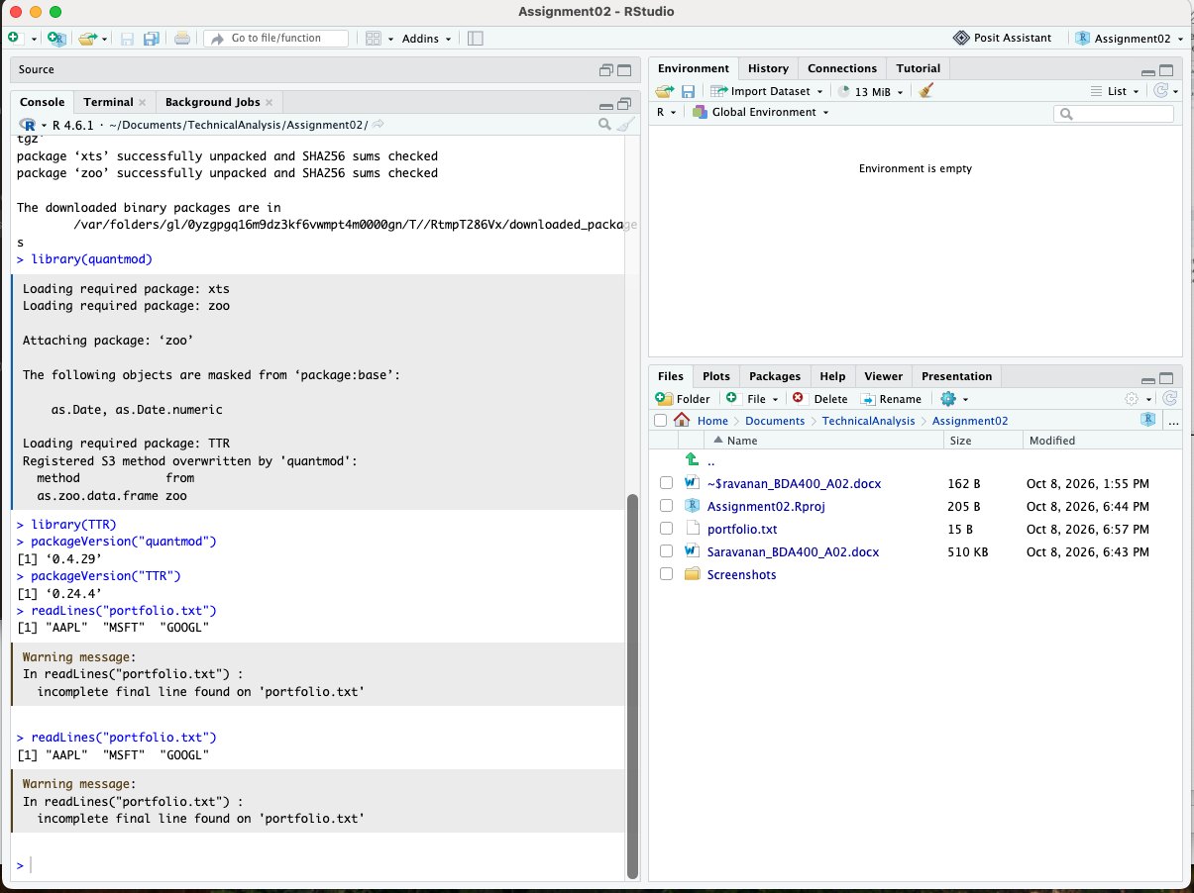

- Analysis Configuration

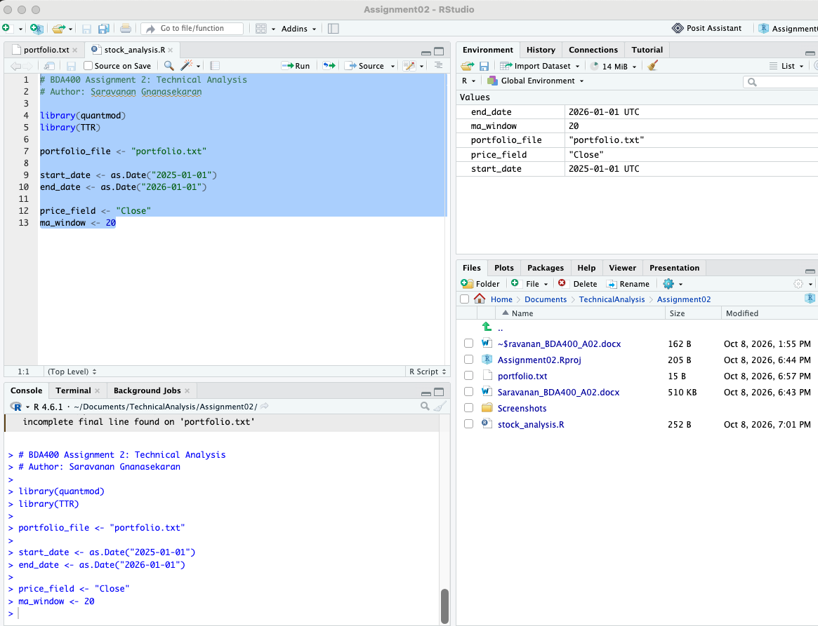

- Stock Data Loading Function.
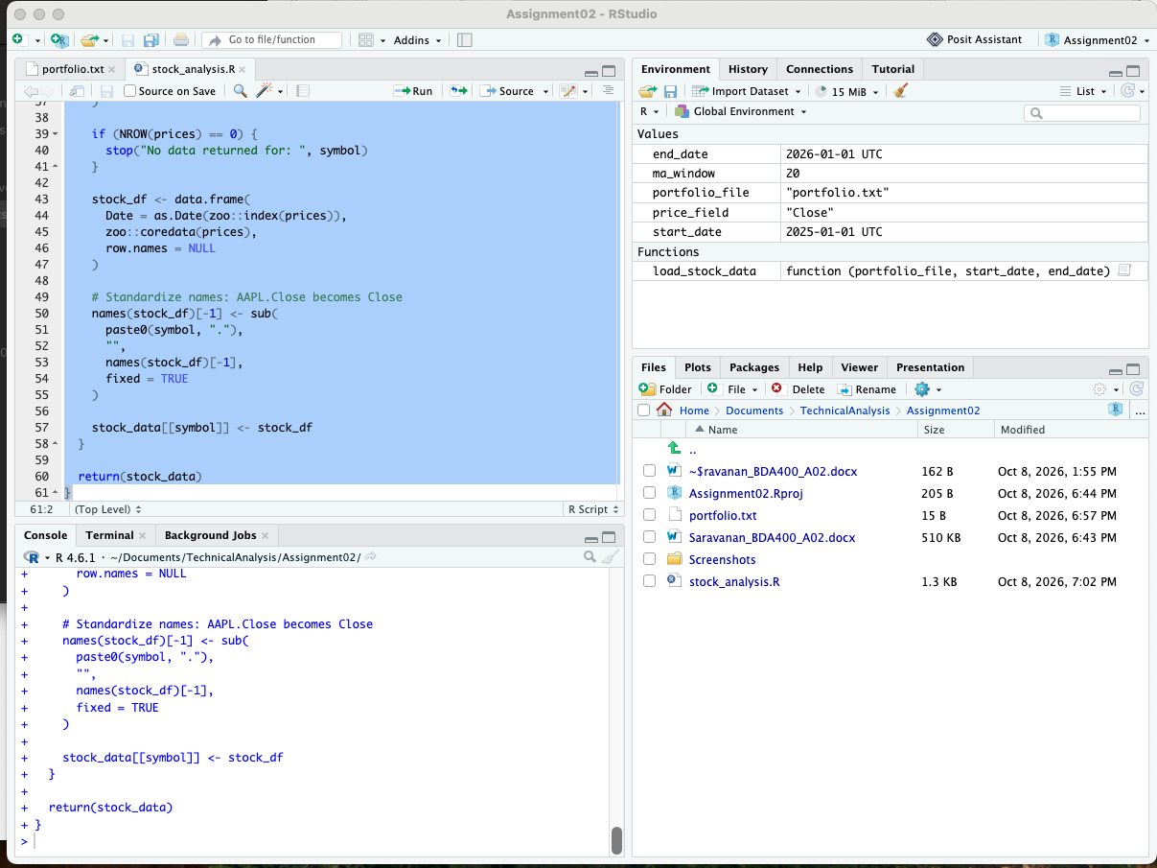

- Stock Data Import and Validation.

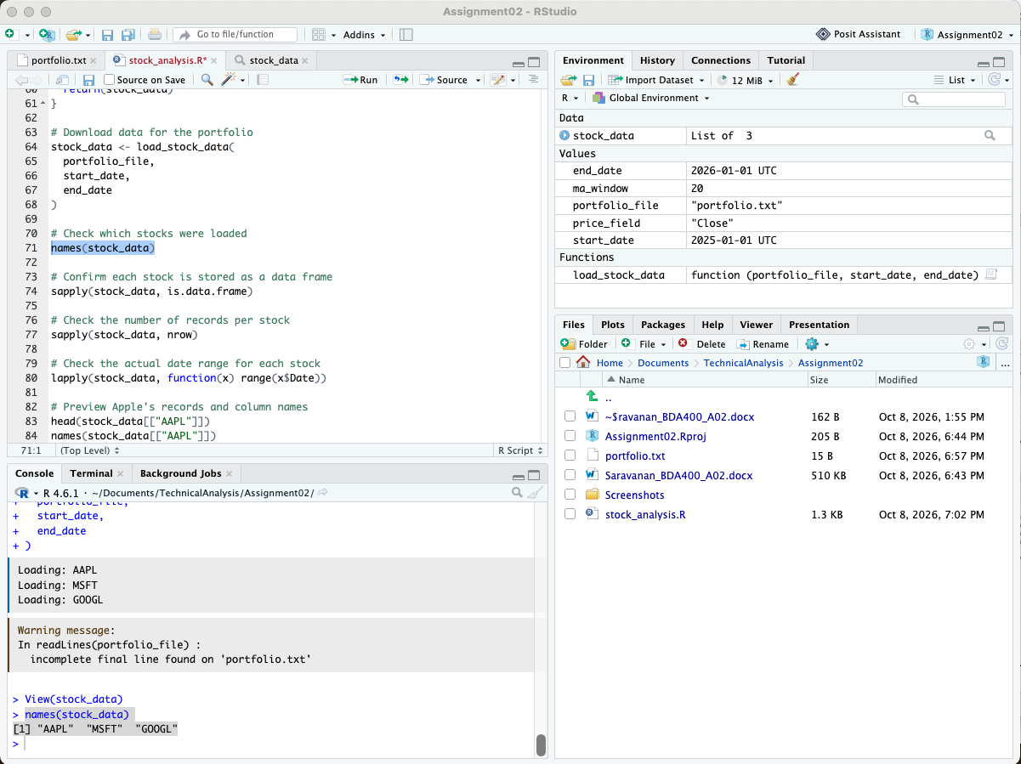

- Basic Statistics Function

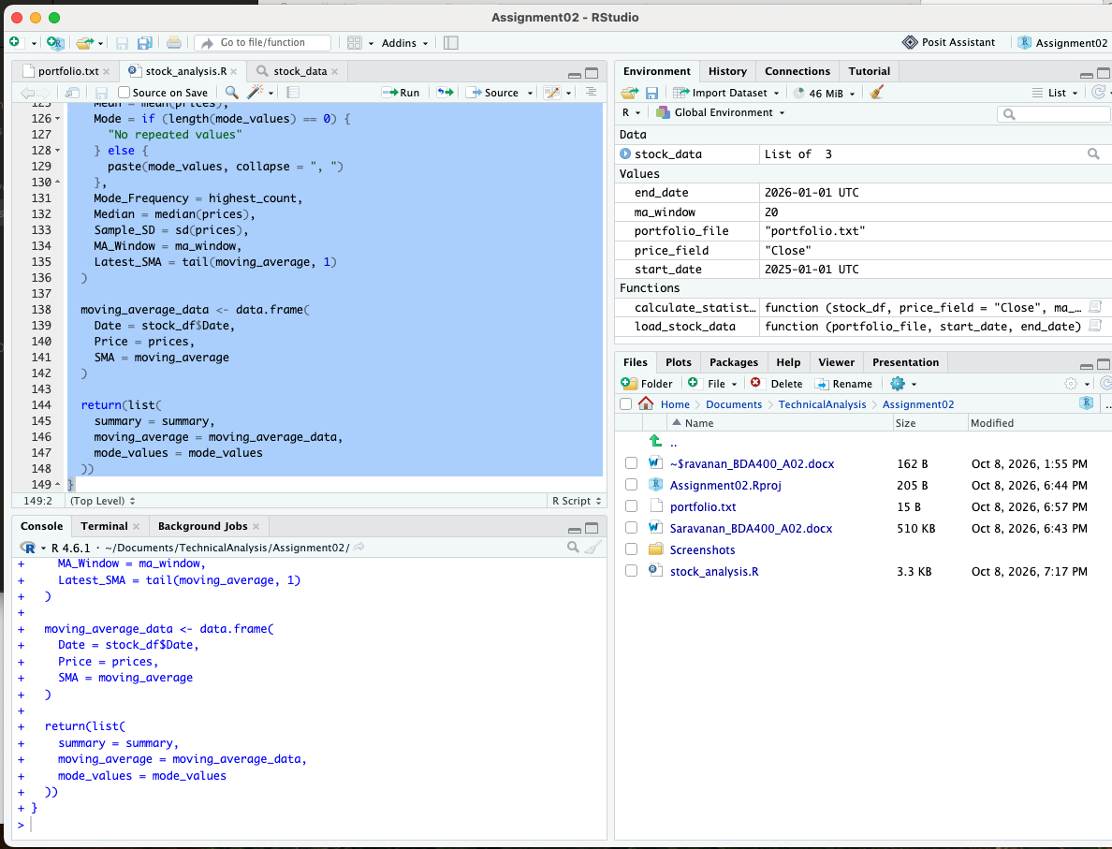

- Statistics Results and Verification

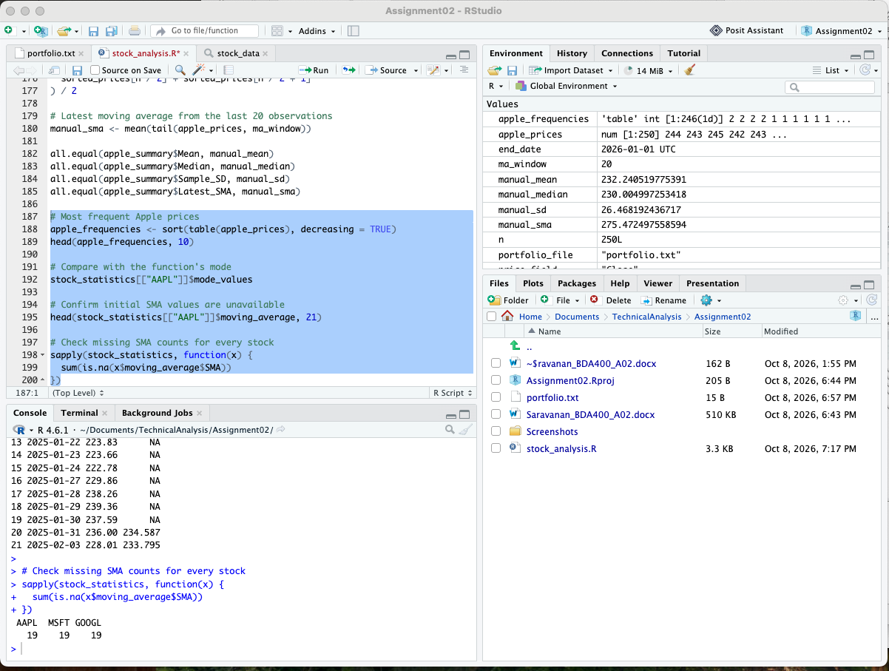

- Data Display and Visualizations.

