|  |  |
| --- | --- |
| **S.N0** | **Contents** |
| **1.** | **Introduction** |
| **2.** | **Project Overview** |
| **3.** | **Architecture** |
| **4.** | **Setup instructions** |
| **5.** | **Component documentation** |
| **6.** | **Stage Management** |
| **7.** | **Testing** |
| **8.** | **Screenshots and Demo** |

**Table of contents**

**Indroduction**

The Fitflex repository is a React-based project created using Create React App. It provides a basic setup for building and running a React web application.You can run it in development using npm start.Run tests with npm test.Build for production with npm run build.Customize the setup with npm run eject if needed.Currently, the repo doesn’t have a detailed description or extra documentation beyond the default React starter content.Do you want me to write a custom short introduction for Fitflex (like for a presentatiFitFlex – Redefining Fitness, Your Way

At FitFlex, we believe fitness should be as flexible as you are. In today’s fast-paced world, traditional workout routines often don’t fit into busy schedules. That’s why we created FitFlex – a modern fitness solution designed to help people of all ages and lifestyles achieve their health goals anytime, anywhere.

Our mission is simple: to make fitness accessible, personalized, and enjoyable. Whether you’re a beginner taking your first step towards a healthier lifestyle or an experienced athlete looking to maximize performance, FitFlex adapts to your unique journey.

What We Offer:

* Personalized Workouts: Tailored programs that adjust to your fitness level, goals, and progress.
* Flexibility & Convenience: Train at home, at the gym, or on the go – your routine moves with you.
* Holistic Wellness: Beyond workouts, we provide guidance on nutrition, recovery, and mindset.
* Community & Support: Join a growing community of like-minded individuals who inspire and motivate each other every day.

At FitFlex, we’re not just about exercise – we’re about building sustainable, healthy habits that last a lifetime. With a blend of expert knowledge, cutting-edge technology, and motivational support, we empower you to take control of your fitness on your own terms.

**FIFLEX - OUR FITNESS COMPANIAN**

**Submitted by**

**[S.B. INDHUMATHI]**

**[M. JAYASHREE]**

**[M. GAYATHRI]**

**[E.KOWSALIYA]**

Department of Computer Applications

[Dr. M. G. R. Janaki College of Arts and Science for Women]  
 Academic Year: 2025 – 2026

**Project Overview – FitFlex**

FitFlex is a dynamic fitness and wellness platform designed to provide flexible, accessible, and personalized fitness solutions for individuals of all fitness levels. The project aims to bridge the gap between traditional workout methods and the evolving lifestyle needs of modern users by offering convenience, adaptability, and holistic support.

**Project Goals**

* To create a user-friendly fitness platform that adapts to different schedules, preferences, and goals.
* To promote long-term health and wellness through personalized workouts, nutrition guidance, and motivational support.
* To build an engaging community that encourages accountability, consistency, and growth.
* To leverage technology for smarter tracking, performance insights, and progress monitoring.

Key Features

* Personalized Fitness Plans – Customized programs based on user goals (weight loss, muscle gain, endurance, or overall wellness).
* Flexibility – Options for at-home, gym, or outdoor training that fit into any routine.

**Architecture**

1. Client-Side (Frontend)

React.js Framework – Component-based UI architecture.

Functional Components & Hooks – For state management and lifecycle handling.

Routing (if added later) – Likely handled by React Router.

UI/Styling – CSS/SCSS or libraries like Tailwind/Bootstrap can be integrated.

2. Development Environment

Create React App (CRA) – Provides Webpack, Babel, and ESLint configurations.

Hot Reloading – Auto-refresh for development changes.

Testing with Jest – Unit and integration tests by default.

3. Build & Deployment

Build Process (npm run build) – Optimizes and bundles React app into static assets (HTML, JS, CSS).

Deployment – Can be deployed on hosting platforms like Netlify, Vercel, GitHub Pages, or AWS S3.

4. Backend Integration (Future Scope)

Currently, Fitflex does not include a backend, but the architecture can integrate with:

Diagram (Conceptual)

[User Browser]

│

┌─────────▼──────────┐

│ React Frontend │

│ (Components, Hooks)│

└─────────┬──────────┘

│

┌──────────▼───────────┐

│ CRA Build Tools │

│ (Webpack, Babel, Jest)│

└──────────┬───────────┘

│

┌──────────▼───────────┐

│ Hosting Platform │

│ (Netlify / Vercel / │

│ GitHub Pages / AWS) │

└──────────┬───────────┘

│

┌───────────▼────────────┐

│ APIs / Backend (Optional)│

│ (Fitness data, Auth, DB) │

└─────────────────────────┘

**Setup Instructions**

1. Prerequisites

Before you begin, ensure you have:

Node.js (v14 or later recommended)

npm (comes with Node.js) or yarn

Check versions with:

node –v

npm -v

2. Clone the Repository

git clone https://github.com/saravananindhu/fitflex.git

cd fitflex

3. Install Dependencies

npm install

(or use yarn install if you prefer yarn)

4. Run in Development Mode

npm start

Starts the app on http://localhost:3000

Hot reloading enabled for code changes.

5. Run Tests

npm test

Launches test runner in interactive watch mode.

6. Build for Productio

npm run build

Bundles the app into optimized static files for deployment.

Output goes into the build/ folder.

**Component Documentation**

1.App Component (App.js)

Role: The root component of the application.

Responsibilities:

* Initializes the app.
* Defines global layout or routing.
* Serves as the entry point for child components.

2. Header / Navbar Component (e.g., Header.js)

Role: Provides navigation across the app.

Responsibilities:

* Displays the app name/logo (Fitflex).
* Contains navigation links (Home, Workouts, Profile, etc.).
* May include login/logout buttons.

3. Footer Component (e.g., Footer.js)

Role: Persistent footer across pages.

Responsibilities:

* Shows copyright.
* Links to About, Contact, or Terms pages.

4. Home Component (Home.js)

Role: Landing page of the application.

Responsibilities:

* Introduces Fitflex.
* Can display featured workouts, welcome text, or quick navigation

5. Workout Component (Workout.js)

Role: Displays workout plans/exercises.

Responsibilities:

* Shows a list of workouts or categories.
* May allow filtering by type (Cardio, Strength, Yoga).
* Could integrate timers or progress tracking in future.

6. Profile Component (Profile.js)

Role: User profile management.

Responsibilities:

* Displays user information (name, age, fitness goals).
* Tracks progress (completed workouts, calories burned).
* Allows editing/updating personal details.

**State Management**

Since Fitflex is built with React (CRA), it can handle state at different levels depending on complexity.

1. Local State (Component-Level)

Managed with useState and useEffect.

Suitable for small UI interactions (form inputs, toggles, modal visibility).

Example:

const [workouts, setWorkouts] = useState([]);

2. Context API (App-Wide State)

Provides a way to share state across multiple components without prop-drilling.

Useful for authentication, theme, or global settings in Fitflex.

Example:

const UserContext = React.createContext();

<UserContext.Provider value={user}>

<Profile />

</UserContext.Provider>

3. Redux / Zustand (Scalable State Management)

For larger applications with complex state needs.

Helps centralize data like user progress, workout history, and goals.

Redux Toolkit simplifies reducers, actions, and async logic.

4. Server State (Data from APIs)

If Fitflex integrates with a backend:

Use React Query or Axios + Context/Redux.

Handles caching, syncing, and updating data from APIs (e.g., workout plans, diet logs).

5. Future Scalability

Authentication State – JWT or Firebase Auth context.

Workout Tracking State – Store user’s completed sessions.

Offline Storage – LocalStorage/IndexedDB for caching workouts.

Suggested Approach for Fitflex

Phase 1 (Prototype): Use useState + useEffect for local state.

Phase 2 (Growing App): Add Context API for global data (e.g., user profile, theme).

Phase 3 (Production-Ready): Introduce Redux Toolkit or Zustand for scalability.

Phase 4 (Backend Integration): Use React Query for API state management.

**Testing Guide**

1.Types of Testing

a)Unit Testing

Example:

import { render, screen } from "@testing-library/react";

import Button from "./Button";

test("renders button with text", () => {

render(<Button label="Start Workout" />);

expect(screen.getByText(/Start Workout/i)).toBeInTheDocument();

});

b) Integration Testing

Test multiple components working together.

Example: Navbar → Navigation Links → Correct Page Render.

Example:

import { render, screen } from "@testing-library/react";

import App from "./App";

import { BrowserRouter } from "react-router-dom";

test("navigates to workouts page", () => {

render(<BrowserRouter><App /></BrowserRouter>);

expect(screen.getByText(/Workouts/i)).toBeInTheDocument();

});

c) End-to-End (E2E) Testing (Optional)

Tools: Cypress / Playwright.

Simulate user flows: login → select workout → track progress.

Example Flow:

1. Visit homepage.

2. Click “Login”.

3. Enter credentials.

4. Verify dashboard loads.

2. Running Tests

Run all tests:

npm test

**Screenshot and Demo Guide**

1. Running the App Locally

Clone the repo

Zfggit clone https://github.com/saravananindhu/fitflex.gitcd fitflex

2. Install dependencies

npm install

3. Start development server

npm start

4. Open your browser at http://localhost:3000.

Taking Screenshots

While running locally:

Use Print Screen or Snipping Tool (Windows).

Use Shift + Command + 4 (Mac).

Use browser dev tools → device toolbar → screenshot for responsive views.

**Home Page**

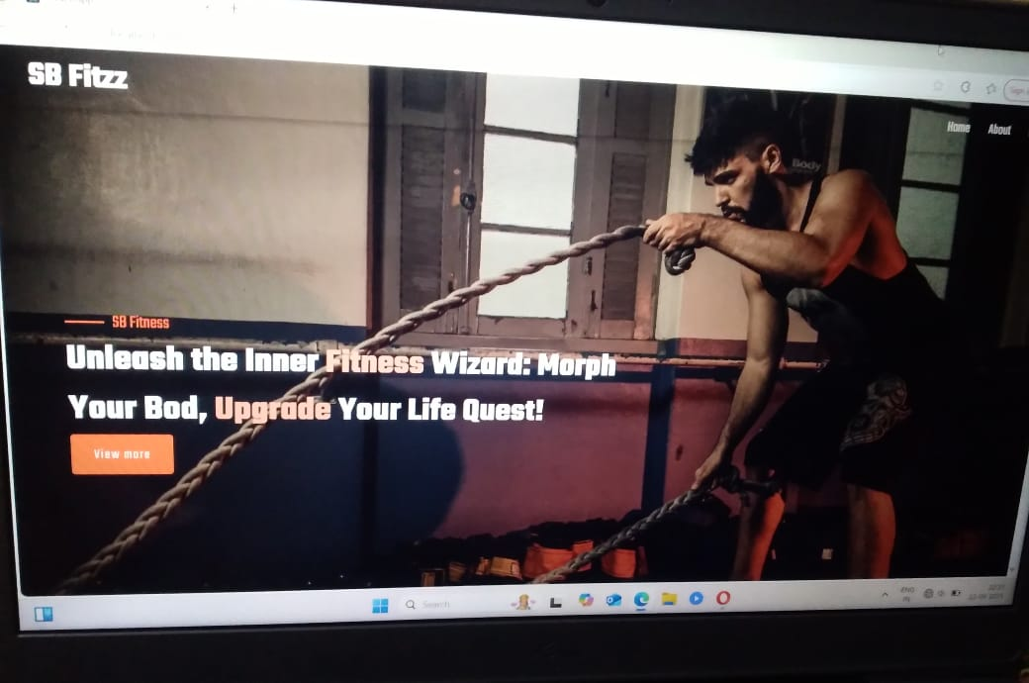

**Workout dashboard**

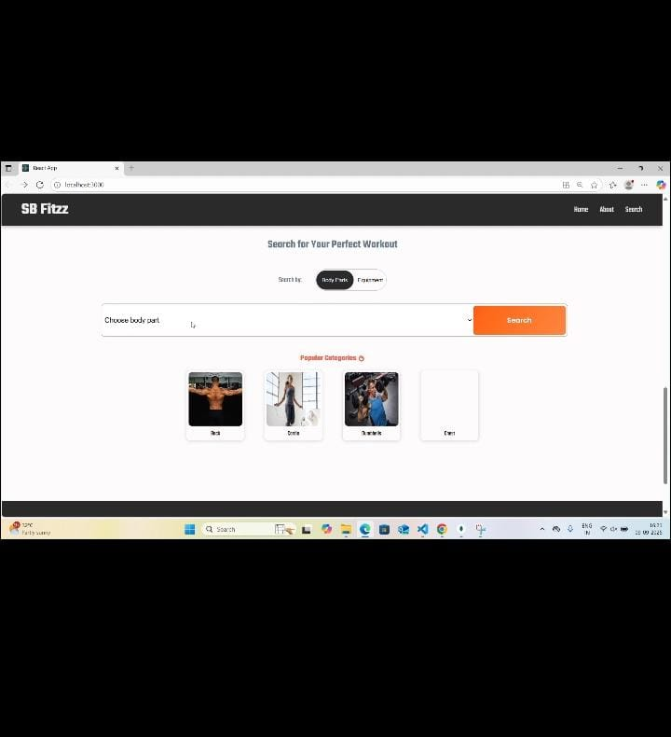

**Category**

