LOGISTICS ANALYTICS
Advanced Data Analysis and Visualization in Logistics
Week 3 Analytical Report
Exploratory Analysis, Visualization, and Operational Insights from a Simulated Logistics Dataset
PREPARED WITH
Python · pandas · NumPy · matplotlib · seaborn

1. Executive Summary
This report analyzes a simulated logistics dataset of 1,500 shipments across five regions, four carriers, and four transport modes (Road, Rail, Air, Sea) over a full calendar year. The objective is to demonstrate an end-to-end analytical workflow — data simulation, exploratory data analysis (EDA), visualization, and interpretation — applied to core logistics performance metrics: delivery time, cost, volume, and reliability.
The analysis finds that overall on-time delivery performance sits at 52.9%, masking wide variation by mode (Air: 81.8% on-time vs. Road: 42.9%) and a severe seasonal bottleneck in November–December, when on-time performance collapses to roughly 22%. Cost analysis shows Air freight costs nearly 6x more per kilometer than Sea freight, while Road — the most heavily used mode — is also the least reliable. These findings translate into concrete recommendations on mode allocation, peak-season capacity planning, and carrier performance management, detailed in Section 6.

2. Objective and Methodology
The task was to explore, analyze, and visualize logistics data using Python, drawing insights that support data-driven decision-making. The methodology followed five stages:
- Data Simulation: construct a realistic logistics dataset with interdependent variables (distance, mode, and season driving cost and delivery time).
- Exploratory Data Analysis: compute descriptive statistics, distributions, and correlations using pandas.
- Visualization: build seven charts using matplotlib and seaborn, each chosen to answer a specific operational question.
- Insight extraction: interpret each visualization in terms of operational efficiency, cost drivers, and bottlenecks.
- Documentation: consolidate methodology, code, and findings into this report.
All code was written in Python 3 and executed in a reproducible script-based pipeline (01_simulate_data.py → 02_eda.py → 03_visualize.py).

3. Data Simulation
Because a live company dataset was not available, a hypothetical but statistically realistic dataset of 1,500 shipments was generated for calendar year 2025. Costs and delivery times were derived from each shipment's distance, transport mode, and volume, with added random noise and a deliberate peak-season congestion effect (November–December) to mimic real operational behavior.

3.1 Dataset Structure
Variable | Type | Description
shipment_id | String | Unique shipment identifier
ship_date | Date | Date shipment departed origin (Jan–Dec 2025)
region | Categorical | Destination region: North, South, East, West, Central
carrier | Categorical | Carrier company: A, B, C, D
mode | Categorical | Transport mode: Road, Rail, Air, Sea
distance_km | Numeric | Shipment distance in kilometers
shipment_volume_kg | Numeric | Shipment weight in kilograms
transportation_cost_usd | Numeric | Total cost to move the shipment
fuel_surcharge_pct | Numeric | Fuel surcharge applied to base cost
planned_delivery_days | Integer | Contracted transit time
actual_delivery_days | Integer | Observed transit time
delay_days / delayed | Integer / Boolean | actual − planned; delay flag

3.2 Simulation Code (excerpt)
The excerpt below shows how mode-specific cost and speed parameters were used to generate correlated, realistic values:
mode_params = {
"Road": {"cost_per_km": 0.85, "speed_kmpd": 550, "time_noise": 0.7},
"Rail": {"cost_per_km": 0.45, "speed_kmpd": 400, "time_noise": 1.0},
"Air": {"cost_per_km": 3.20, "speed_kmpd": 3000, "time_noise": 0.4},
"Sea": {"cost_per_km": 0.20, "speed_kmpd": 300, "time_noise": 1.8},
}

base_cost = distance_km * params["cost_per_km"]
volume_cost = shipment_volume_kg * 0.35
transportation_cost_usd = (base_cost + volume_cost) * cost_noise

planned_delivery_days = distance_km / params["speed_kmpd"] + 1
peak_penalty = 0.8 if ship_date.month in (11, 12) else 0 # holiday-season congestion
congestion_penalty = 0.5 if mode == "Road" else 0 # road traffic variability
actual_delivery_days = planned_delivery_days + time_noise + peak_penalty + congestion_penalty

4. Exploratory Data Analysis

4.1 Central Tendency and Spread
Descriptive statistics for the core numeric variables (rounded to two decimals):
Variable | Mean | Median | Std Dev | Skew
Distance (km) | 758.6 | 731.7 | 337.7 | 1.10
Volume (kg) | 1,058.8 | 952.6 | 617.4 | 1.16
Cost (USD) | 1,118.6 | 866.9 | 865.8 | 2.62
Fuel Surcharge (%) | 8.0 | 8.0 | 2.5 | 0.06
Planned Days | 2.5 | 2.0 | 1.1 | 0.82
Actual Days | 3.0 | 3.0 | 1.5 | 0.79
Delay (days) | 0.5 | 0.0 | 1.1 | 0.03
Cost is the most heavily right-skewed variable (skew = 2.62), meaning a small share of high-cost shipments (mostly long-haul Air freight) pulls the mean well above the median — a pattern confirmed visually in Section 5.3. Delivery time variables show mild positive skew, consistent with delays being more common than early arrivals of equal magnitude.

4.2 On-Time Performance Breakdown
Segment | On-Time Rate
Overall | 52.9%
Air | 81.8%
Rail | 63.1%
Sea | 51.5%
Road | 42.9%
Best region — North | 55.1%
Worst region — West | 51.9%
Best carrier — Carrier C | 56.8%
Worst carrier — Carrier B | 49.4%

4.3 Correlation Analysis
A Pearson correlation matrix (Section 5.4) was computed across the numeric variables. The strongest relationships are: distance vs. planned delivery days (r = 0.65), actual vs. planned delivery days (r = 0.72), and actual delivery days vs. delay days (r = 0.67). Notably, transportation cost is negatively correlated with planned delivery days (r = -0.34) — a counterintuitive result explained by transport mode: Air shipments are fast (low planned days) but expensive, while Sea shipments are slow but cheap. This illustrates why looking at cost or time in isolation, without segmenting by mode, can mislead decision-making.

5. Visualizations
Seven visualizations were produced, each selected because it best answers a specific operational question. For each chart below: the question it answers, the Python code used, the chart itself, and the interpretation.

5.1 Distribution of Planned vs. Actual Delivery Time
Question: How is delivery performance distributed, and how far does reality diverge from plan?
sns.histplot(df["planned_delivery_days"], kde=True, stat="density",
color="#4C72B0", label="Planned", alpha=0.45)
sns.histplot(df["actual_delivery_days"], kde=True, stat="density",
color="#DD8452", label="Actual", alpha=0.45)
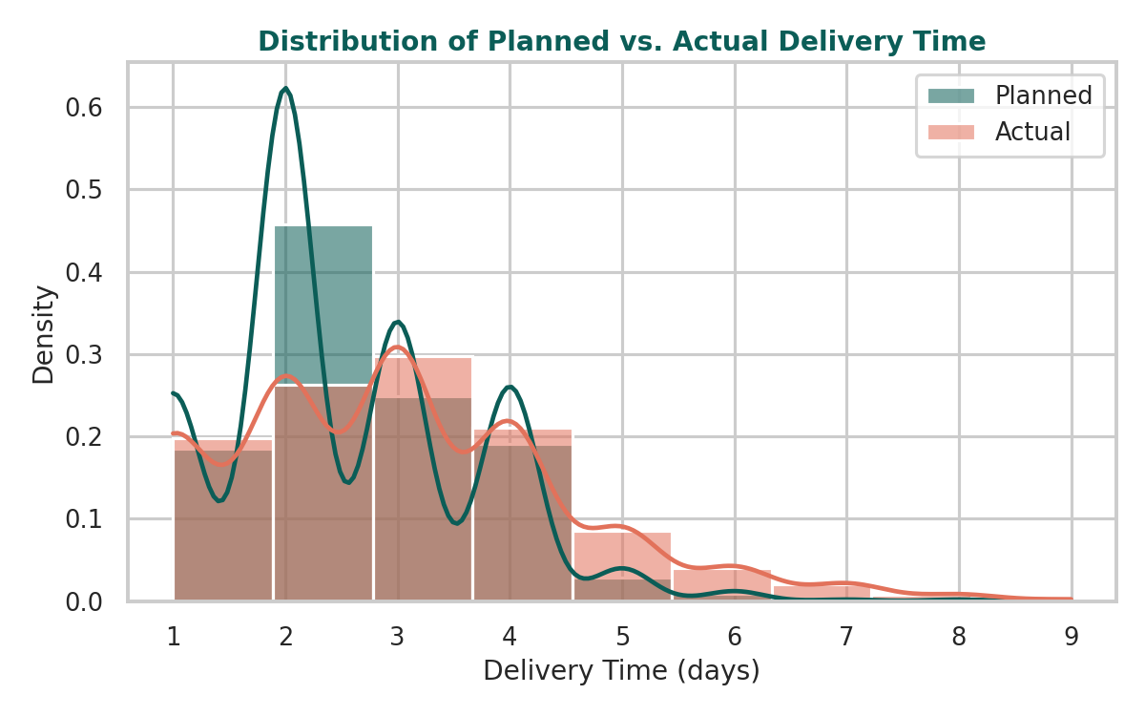
Distribution of Planned vs. Actual Delivery Time
WHY THIS CHART
An overlaid histogram with density curves is the clearest way to compare two distributions of the same unit (days) directly, showing both the shift in central tendency and the change in spread.

INSIGHT
The actual delivery distribution is shifted right and more spread out than the planned distribution, confirming that delays are systemic rather than isolated incidents — the whole distribution moves, not just the tail.

5.2 Delivery Delay by Transport Mode
Question: Which transport mode is least reliable, and by how much?
order = df.groupby("mode")["delay_days"].median().sort_values().index
sns.boxplot(data=df, x="mode", y="delay_days", order=order)
ax.axhline(0, color="gray", linestyle="--") # 0 = on-plan
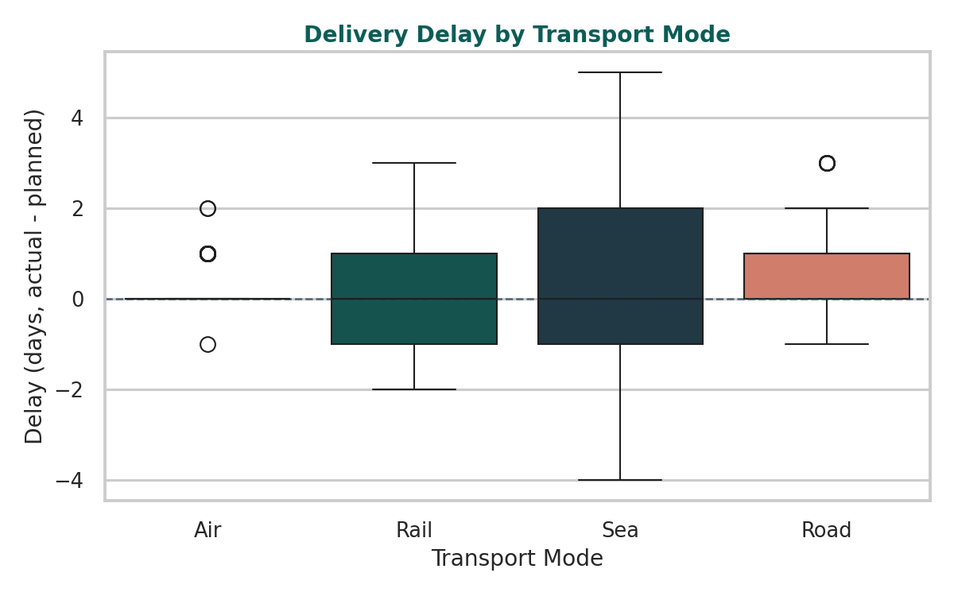
Delivery Delay by Transport Mode
WHY THIS CHART
Boxplots reveal median, interquartile spread, and outliers simultaneously — essential for comparing reliability (not just average delay) across categories.

INSIGHT
Road shows the widest interquartile range and the highest median delay, while Air is tightly clustered around zero. This indicates Road's problem is variability and unpredictability, not just average speed — a harder operational issue to fix than raw transit time.

5.3 Transportation Cost vs. Distance by Mode
Question: How does cost scale with distance, and does the relationship differ by mode?
sns.scatterplot(data=df, x="distance_km", y="transportation_cost_usd",
hue="mode", alpha=0.65, s=35)
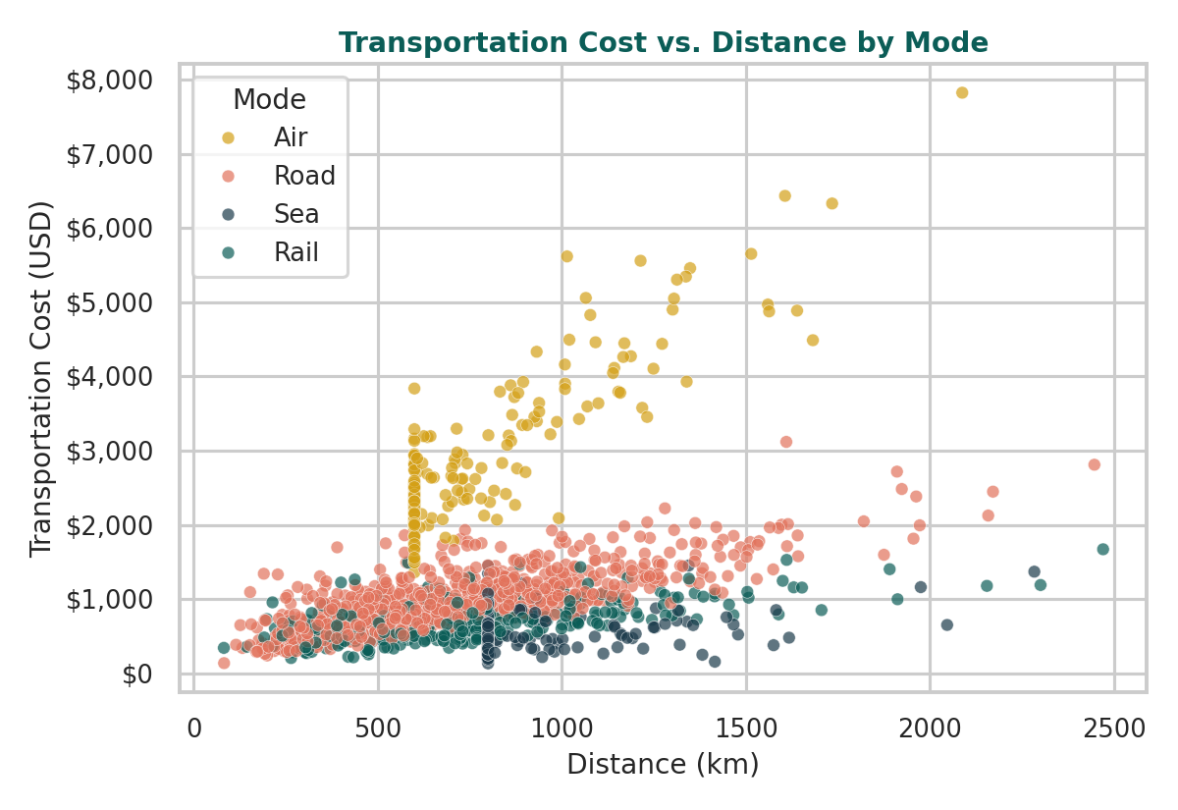
Transportation Cost vs. Distance by Mode
WHY THIS CHART
A color-coded scatterplot exposes both the overall cost-distance relationship and hidden sub-groups (modes) with different slopes — patterns a single trend line would obscure.

INSIGHT
Air (gold cluster) sits on a much steeper cost-per-km slope than Sea or Rail, confirming that mode, not distance alone, is the dominant cost driver for long-haul shipments.

5.4 Correlation Matrix of Key Logistics Variables
Question: Which operational variables move together, and which relationships are counterintuitive?
corr = df[numeric_cols].corr()
teal_gold_cmap = sns.diverging_palette(175, 40, s=75, l=45, as_cmap=True)
sns.heatmap(corr, annot=True, fmt=".2f", cmap=teal_gold_cmap, center=0, square=True)
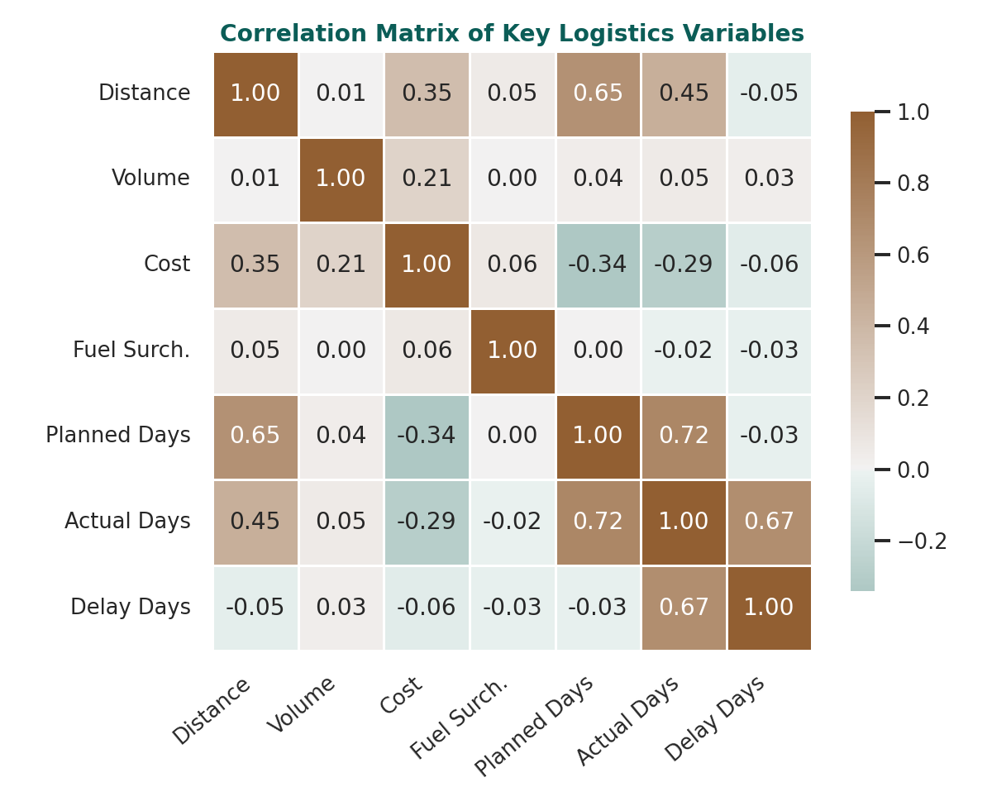
Correlation Matrix of Key Logistics Variables
WHY THIS CHART
A heatmap condenses many pairwise relationships into one glanceable view, using color intensity to draw the eye straight to the strongest (positive or negative) correlations.

INSIGHT
The negative correlation between cost and planned delivery days (-0.34) is the most actionable finding here: it warns analysts against assuming 'faster is always more expensive' without first controlling for transport mode.

5.5 Monthly Shipment Volume vs. On-Time Delivery Rate
Question: How do shipment volume and service reliability trend across the year, and do they interact?
ax1.bar(monthly.index, monthly["total_volume_kg"] / 1000) # tonnes
ax2 = ax1.twinx()
ax2.plot(monthly.index, monthly["on_time_rate"], color="#C44E52", marker="o")
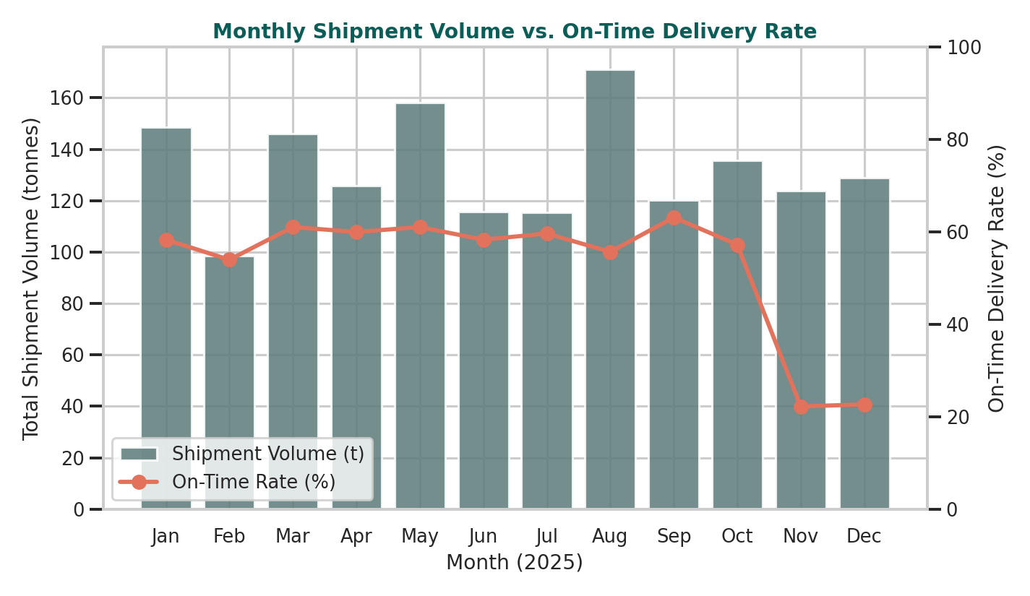
Monthly Shipment Volume vs. On-Time Delivery Rate
WHY THIS CHART
A dual-axis combination chart is appropriate here because volume (tonnes) and rate (%) are on different scales but need to be read together to see whether one drives the other.

INSIGHT
On-time performance is fairly stable (55-63%) from January through October, then collapses to ~22% in November-December — precisely the peak shipping season. This is the single clearest bottleneck in the dataset and points to a capacity, not a quality, problem.

5.6 On-Time Delivery Rate by Region
Question: Where are the biggest regional service gaps?
otp_region = df.groupby("region")["delayed"].apply(lambda x: (~x).mean()*100)
ax.bar(otp_region.index, otp_region.values)
ax.axhline(otp_region.mean(), linestyle="--") # benchmark line
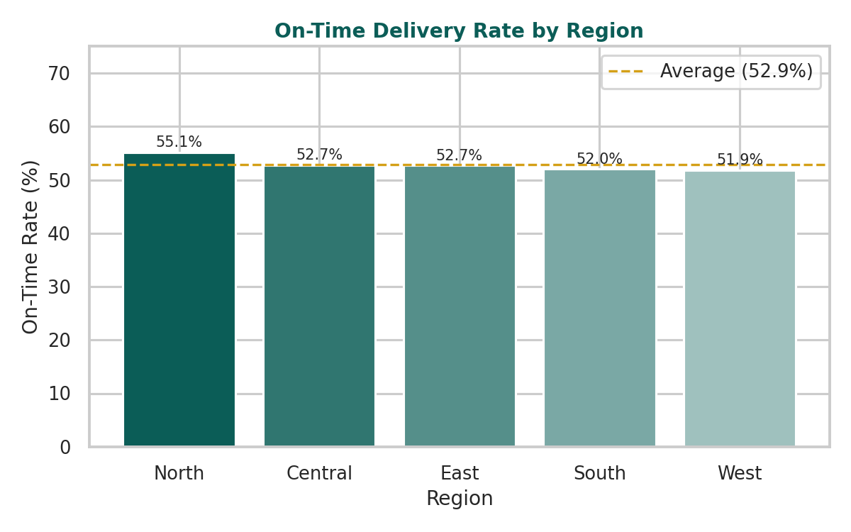
On-Time Delivery Rate by Region
WHY THIS CHART
A simple ranked bar chart with a benchmark line is the most direct way to compare a single metric across a small number of categories and flag under/over performers at a glance.

INSIGHT
Regional on-time rates are fairly close together (51.9%-55.1%), which suggests the primary driver of unreliability is mode and season rather than geography — regional-level fixes would have limited impact compared to mode- or season-level ones.

5.7 Average Cost per Kilometer by Transport Mode
Question: Which mode is most cost-efficient, independent of distance travelled?
cpk = (df["transportation_cost_usd"] / df["distance_km"]).groupby(df["mode"]).mean()
ax.bar(cpk.index, cpk.values)
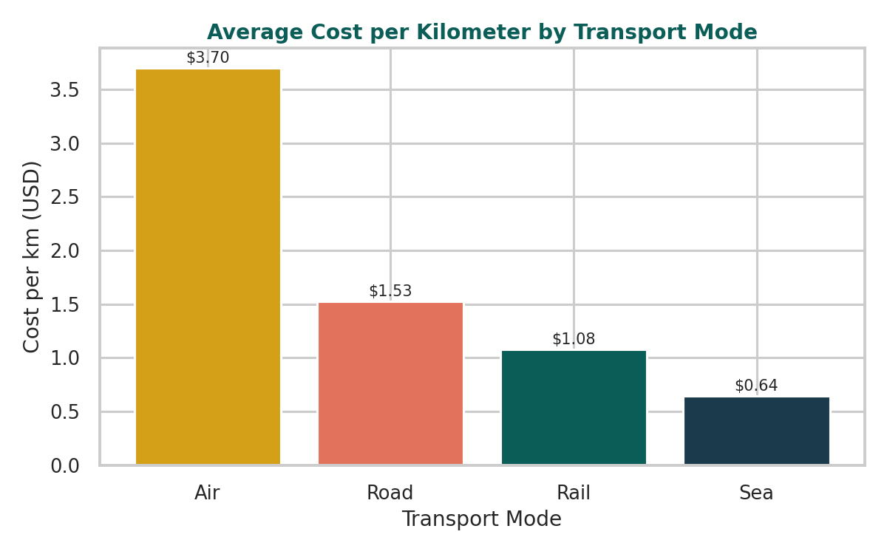
Average Cost per Kilometer by Transport Mode
WHY THIS CHART
Normalizing cost by distance (cost per km) removes the confound of shipment length, isolating the true efficiency of each mode for an apples-to-apples comparison.

INSIGHT
Air costs $3.70/km versus Sea's $0.64/km — nearly 6x. Combined with Section 5.2's reliability finding, this frames the core logistics trade-off: Air buys reliability at a steep premium, while Road offers a weak middle ground (moderate cost, poor reliability).

6. Analytical Insights and Recommendations

6.1 Key Findings
- Systemic delay, not isolated incidents: the entire actual-delivery-time distribution is shifted right of plan, indicating a structural gap between contracted and real transit times.
- Road is the weak link: 55% of all shipments travel by Road, yet Road has the lowest on-time rate (42.9%) and widest delay variability of any mode.
- Peak season is the dominant bottleneck: on-time performance falls from a 55-63% baseline to ~22% in November-December, coinciding with the highest-volume months.
- Cost and speed trade off by mode, not by distance: Air is ~6x more expensive per km than Sea but is the most reliable mode (81.8% on-time); cost decisions should be made per-mode, not on blended averages.
- Regional differences are minor: on-time rates vary by only ~3 points across regions, so mode and seasonal fixes will have far more impact than regional interventions.

6.2 Recommendations
- Add peak-season surge capacity (extra carriers or shifted freight to Rail/Air) for November-December specifically, rather than applying uniform year-round capacity planning.
- Reduce Road's share of volume for time-sensitive or high-value shipments, shifting a portion to Rail, which delivers meaningfully better reliability (63.1% vs. 42.9%) at a lower cost premium than Air.
- Investigate Carrier B specifically (lowest on-time rate at 49.4%) for root causes — driver capacity, routing, or contract SLAs — before renewing or expanding volume with them.
- Use mode-segmented cost benchmarks (cost per km by mode) rather than a single blended cost KPI, since blended averages mask the true efficiency of each mode.
- Set differentiated on-time SLAs by mode and season, since a single company-wide on-time target obscures very different underlying performance levels.

7. Conclusion
This analysis demonstrates how a structured, code-driven EDA and visualization workflow can convert raw shipment-level data into concrete operational recommendations. The most consequential finding — a severe peak-season reliability collapse layered on top of a chronic Road-mode weakness — was only visible by combining time-series, distributional, and categorical visualizations together. In a live business setting, this same workflow (simulate/ingest → EDA → targeted visualization → segmented interpretation) could be re-run monthly against real shipment data to track whether the recommended interventions are closing the gaps identified here.

8. Appendix: Full Python Pipeline
The complete three-script pipeline (data simulation, EDA, visualization) used to produce this report is included as a separate file set: 01_simulate_data.py, 02_eda.py, and 03_visualize.py. Library versions used: pandas, NumPy, matplotlib, and seaborn (all current stable releases as of analysis date).

