COIMBATORE INSTITUTE OF TECHNOLOGY
(Government Aided Autonomous Institution Affiliated to Anna University)

23IT723 - DEVOPS LABORATORY
PROJECT
SMART WATER MONITORING SYSTEM


OCTOBER 2026

Submitted by

2303717620521047 - SARAVANA PANDIYAN VP

COIMBATOREINSTITUTEOFTECHNOLOGY
(Government Aided Autonomous Institution Affiliated to Anna University)
BONAFIDE CERTIFICATE

Certified that this project report titled “SMART WATER MONITORING SYSTEM” is the bonafide work of 2303717620521047 – SARAVANA PANDIYAN V P completed during the academic year 2025-2026-Semester VII for the project presentation of 23IT723 - DEVOPS LABORATORY under our supervision.

Certified that the candidate was examined by using the project work examination.

Review Members:
- Dr.M.Sangeetha
- Dr.E.Arul

23IT723 – DEVOPS LABORATORY
FINAL MINI PROJECT – EVALUATION SCHEME
Final Mini Project Assessment
The final mini project shall require students to integrate the major DevOps practices covered in the laboratory. The project should demonstrate practical implementation of version control, collaborative development, Continuous Integration, containerization and/or automated configuration/provisioning, with proper execution evidence.
S.No. | Evaluation Component | Key Verification Points | Marks
1 | Problem Definition & Project Planning | Problem statement, objectives, requirements, scope, module identification, technology selection and workflow planning. | 10
2 | Git Repository & Version Control | Repository creation, meaningful commits, README, .gitignore, remote repository, push/pull/fetch operations and commit history. | 15
3 | Branching, Merging & Collaboration | Feature branches, parallel development, merging, conflict handling, branch organization and collaborative workflow. | 10
4 | Application Development & Build | Working application/source code, project structure, dependency management, build configuration and successful execution. | 15
5 | Jenkins Continuous Integration | Jenkins configuration, source-code integration, automated checkout, build job/pipeline, build execution and console verification. | 15
6 | Docker / Containerization | Dockerfile, image creation, container execution, port/configuration handling, application deployment and container verification. | 10
7 | Automation / Configuration Management | Ansible/Chef/Puppet/SaltStack or equivalent automation where applicable; repeatable configuration/provisioning and successful execution. | 5
8 | Testing & Verification | Functional testing, build verification, error identification, test evidence and corrective action. | 5
9 | Documentation & Technical Presentation | Architecture/workflow diagram, commands/configuration, screenshots, results, troubleshooting, conclusion and repository details. | 5
10 | Final Demonstration & Viva-Voce | Live demonstration, explanation of implementation, troubleshooting responses and technical understanding. | 10
TOTAL |  |  | 100

Recommended Mark Distribution within the Final Demonstration
For uniform evaluation, the examiner may use the following internal split for the implementation and demonstration components.
Assessment Area | Marks | Awarded Marks | Remarks
Working implementation and correctness | 30
DevOps tool integration and automation | 20
Version control and collaborative workflow | 15
Build / deployment / container verification | 15
Testing and troubleshooting | 5
Documentation and technical presentation | 5
Live demonstration and viva-voce | 10
TOTAL | 100
Minimum Evidence to be Submitted
- Project repository URL and project README.
- Git commit history and branch/merge evidence.
- Jenkins job/pipeline configuration and successful build evidence.
- Dockerfile, image and running container evidence where Docker is used.
- Automation/configuration scripts where applicable.
- Application execution and testing evidence.
- Architecture/workflow diagram.
- Short technical report containing implementation steps, results and troubleshooting.
- Live demonstration of the complete DevOps workflow.
Evaluation Guidelines
- Marks shall be awarded primarily for a working implementation and demonstrable output.
- Copied source code without functional understanding shall not receive full marks.
- Screenshots may support the evaluation, but critical components should be demonstrated live wherever possible.
- Students should use meaningful repository names, branch names and commit messages.
- If a component is not applicable to the selected project, the student shall obtain faculty approval and demonstrate an equivalent DevOps automation component.
- The final viva shall focus on the student's own implementation, commands used, tool configuration and troubleshooting.
Faculty Evaluation Record
Student Name | SARAVANA PANDIYAN V P | Register No. | 2303717620521047
Project Title | SMART WATER MONITORING AND COMPLAINT MANAGEMENT SYSTEM | Date | 13-10-2026
Final Mark
Faculty Evaluator I | Dr. M. Sangeetha | Signature
Faculty Evaluator II | Dr. E. Arul | Signature

TABLE OF CONTENTS
S. NO. | CONTENT | PAGE NO.
1 | INTRODUCTION | 05
2 | OBJECTIVES | 05
3 | ABSTRACT | 06
4 | TECHNOLOGY STACK | 06
5 | SYSTEM ARCHITECTURE | 07
6 | MODULE 1 - USER INTERFACE & COMPLAINT REGISTRATION | 08
7 | MODULE 2 - FLASK BACKEND & SENSOR TELEMETRY | 09
8 | MODULE 3 - SQLITE DATABASE MANAGEMENT | 10
9 | MODULE 4 - GIT & GITHUB SOURCE CONTROL | 11
10 | MODULE 5 - DOCKER CONTAINERIZATION | 12
11 | MODULE 6 - JENKINS CI/CD PIPELINE | 14
12 | MODULE 7 - AUTOMATED TESTING | 15

13 | MODULE 8 - ANSIBLE DEPLOYMENT | 17
14 | MODULE 9 - PERSISTENT STORAGE | 18
15 | MODULE 10 - ADMIN & COMPLAINT MANAGEMENT | 19
16 | MODULE 11 - CI/CD INTEGRATION | 20
17 | MODULE 12 - APPLICATION & DEPLOYMENT VERIFICATION | 21
18 | RESULTS AND OUTPUT | 23
19 | COMMANDS USED | 23
20 | ADVANTAGES | 28
21 | LIMITATIONS | 28
22 | FUTURE ENHANCEMENTS | 29
23 | CONCLUSION | 29

1. INTRODUCTION

The Smart Water Monitoring and Complaint Management System (AquaWatch) is an intelligent web-based utility platform developed to monitor municipal water quality in real time and streamline citizen grievance redressal. The system allows citizens and residents to view real-time water quality metrics (pH, TDS, turbidity, pressure), submit water supply complaints (leakage, contamination, low pressure) with detailed descriptions, and track ticket resolution statuses through a modern digital interface. An admin dashboard is also provided for municipal water engineers to review real-time telemetry, analyze incident queues, and update complaint lifecycles. The application is developed using HTML, CSS, JavaScript, Python, Flask, and SQLite, with Flask handling backend operations and SQLite storing water telemetry and citizen complaints. The project also incorporates modern DevOps practices to automate the development, testing, and deployment process. Git and GitHub are used for source code management, while Jenkins automates the CI/CD pipeline. Docker provides application containerization, Pytest performs automated testing, and Ansible automates deployment and container configuration. A Docker Volume (water_monitoring_data) is used to provide persistent storage for the SQLite database. The project combines a functional municipal water monitoring system with DevOps automation to provide a structured, resilient, and reliable approach to utility management.

2.OBJECTIVES
- To develop a responsive web-based water monitoring interface enabling citizens to observe water quality metrics, register complaints, and track grievance statuses conveniently.
- To implement an admin dashboard for viewing real-time water quality telemetry and managing complaint resolution workflows using SQLite.
- To organize water sensor data and complaint records systematically and provide quick access to stored incident details through the admin dashboard.
- To implement DevOps practices throughout the application development and deployment process using Git, GitHub, Docker, Jenkins, and Ansible.
- To automate the CI/CD workflow using Jenkins for building Docker images, running Pytest suites, and orchestrating Ansible deployments.
- To containerize the application using Docker to provide a consistent, portable, and isolated execution environment.
- To integrate Pytest for automated testing to verify application routes, telemetry logic, database transactions, and error handling before deployment.
- To automate application deployment and container configuration using Ansible playbooks within a dedicated control container.
- To implement Docker Volume (water_monitoring_data) for persistent storage of the SQLite database and ensure that sensor readings and complaints are retained even when the container is recreated.

3. ABSTRACT

The Smart Water Monitoring and Complaint Management System is an end-to-end municipal utility platform designed to simplify the monitoring of water quality parameters and streamline public grievance redressal. Traditional municipal water management faces challenges such as lack of real-time telemetry, delayed response to pipeline leaks, manual complaint filing, and difficult incident tracking. The proposed system provides a digital platform where citizens can view real-time water metrics (pH level, TDS, turbidity, pressure), submit water supply complaints across multiple categories, and track resolution progress using unique tracking tokens (e.g., WC-00001). An administrative dashboard is provided for municipal water authorities to analyze live telemetry trends and update complaint statuses from Pending to In Progress or Resolved. The application is developed using HTML, CSS, JavaScript, Python, Flask, and SQLite, with Flask handling backend operations and SQLite storing telemetry logs and citizen complaints. The project also implements industrial DevOps practices to automate the software development, testing, and deployment lifecycle. Git and GitHub are used for version control, while Jenkins automates the multi-stage CI/CD pipeline. Docker is used to containerize the application (water-monitoring-ci) for environment consistency, Pytest performs automated testing across 13 test cases, and Ansible automates container deployment and configuration. A Docker Volume named water_monitoring_data provides persistent storage for the SQLite database, ensuring that sensor history and citizen complaints are preserved across container updates and restarts. The complete workflow follows GitHub -> Jenkins -> Docker Build -> Pytest -> Ansible -> Docker Container -> Flask -> SQLite, demonstrating a dependable, cloud-ready municipal utility architecture.

4.TECHNOLOGY STACK

Technology | Version | Purpose
HTML | HTML5 | Web page structure
CSS | CSS3 | User interface styling
JavaScript | ES6+ | Frontend interaction
Python | 3.11 | Backend programming
Flask | 3.0.0 | Backend web framework
SQLite | 3.x | Database storage for sensor logs & complaints
Git | 2.x | Version control
GitHub | — | Source code repository
Jenkins | 2.541.3 | CI/CD automation
Docker | 28.5.2 | Application containerization
Pytest | 8.3.5 | Automated testing
Ansible | 2.10.8 | Deployment automation
Docker SDK / Community Docker | community.docker 1.2.2 | Docker management through Ansible

5.SYSTEM ARCHITECTURE
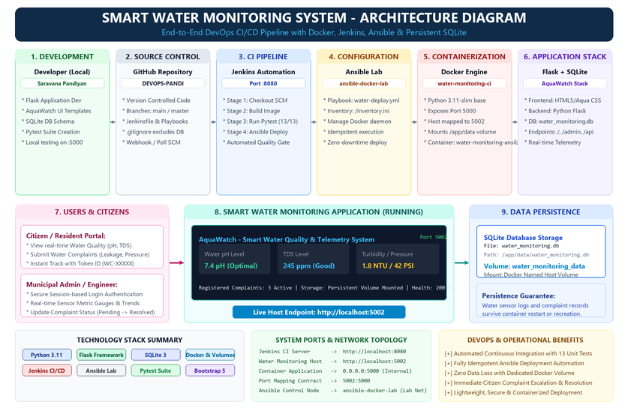
- Development: Developer creates and updates the Smart Water Monitoring application.
- Source Code Management: The application source code, templates, tests, and configuration files are maintained using Git.
- GitHub Repository: The updated code is pushed to the GitHub repository for centralized version control and team collaboration.
- Jenkins Trigger: Jenkins retrieves the latest source code from the GitHub repository and triggers the automated CI/CD pipeline.
- Docker Build: Jenkins builds the application into a Docker image (water-monitoring-ci) containing the Flask backend and required dependencies.
- Automated Testing: Jenkins runs Pytest inside the container to execute all 13 unit tests and verify application routes before deployment.
- Deployment Automation: After successful test execution, Jenkins invokes Ansible inside ansible-docker-lab to automate deployment.
- Container Configuration: Ansible creates and configures the Docker container (water-monitoring-ansible) with port mapping 5002:5000 and volume water_monitoring_data.
- Application Execution: The Docker container runs the Flask backend, serving AquaWatch UI views and connecting to persistent SQLite storage.
- User Interaction: Citizens browse real-time water quality metrics, register complaints, and track grievance resolution status.
- Admin Management: The admin dashboard allows municipal engineers to monitor telemetry gauges and manage complaint resolution lifecycles.
MODULE 1 - USER INTERFACE & COMPLAINT REGISTRATION
This module provides the user-facing interface of the Smart Water Monitoring System (AquaWatch). It is designed to make water quality monitoring and grievance registration simple and accessible for citizens.
Main Features
- Displays real-time water quality telemetry including pH, TDS, turbidity, and pressure.
- Provides intuitive visual gauge indicators representing water safety levels (Optimal, Safe, Warning).
- Organizes water complaints into distinct categories (Quality, Leakage, Low Pressure, Supply).
- Allows citizens to submit their name, contact details, and specific ward/location.
- Provides a detailed grievance description field for specific reporting.
- Performs client-side validation on form inputs to prevent incomplete submissions.
- Generates a unique tracking token (e.g., WC-00001) upon complaint registration.
- Provides an instant complaint tracking interface using the generated ticket ID.
- Displays transparent ticket lifecycle states: Pending, In Progress, and Resolved.
- Provides a responsive, modern Aqua/Ocean themed user interface.
- Adapts seamlessly across desktop, tablet, and mobile browsers.
- Connects the user interface with the Flask backend for processing requests.
Technologies: HTML, CSS, JavaScript.
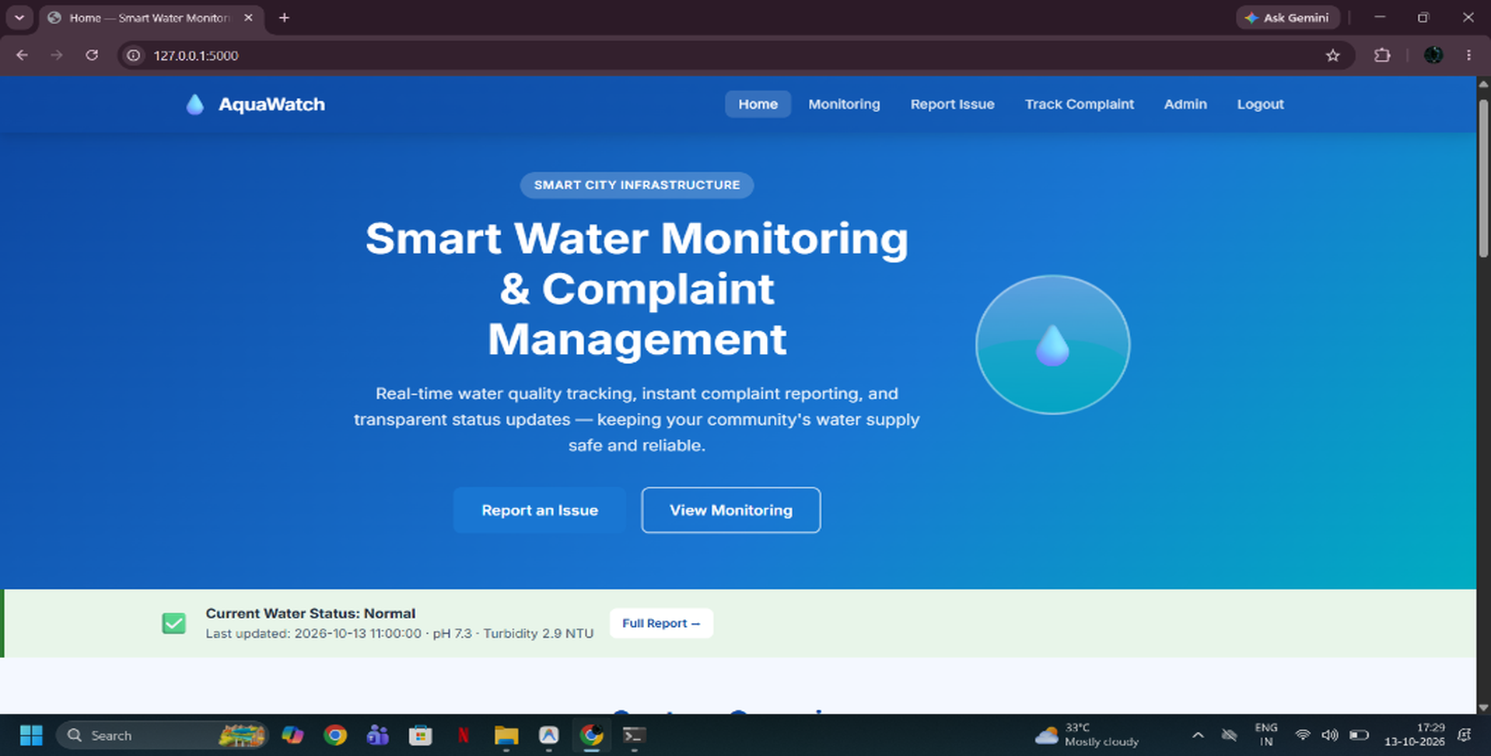
Figure 7.1: Smart Water Monitoring System Home Page
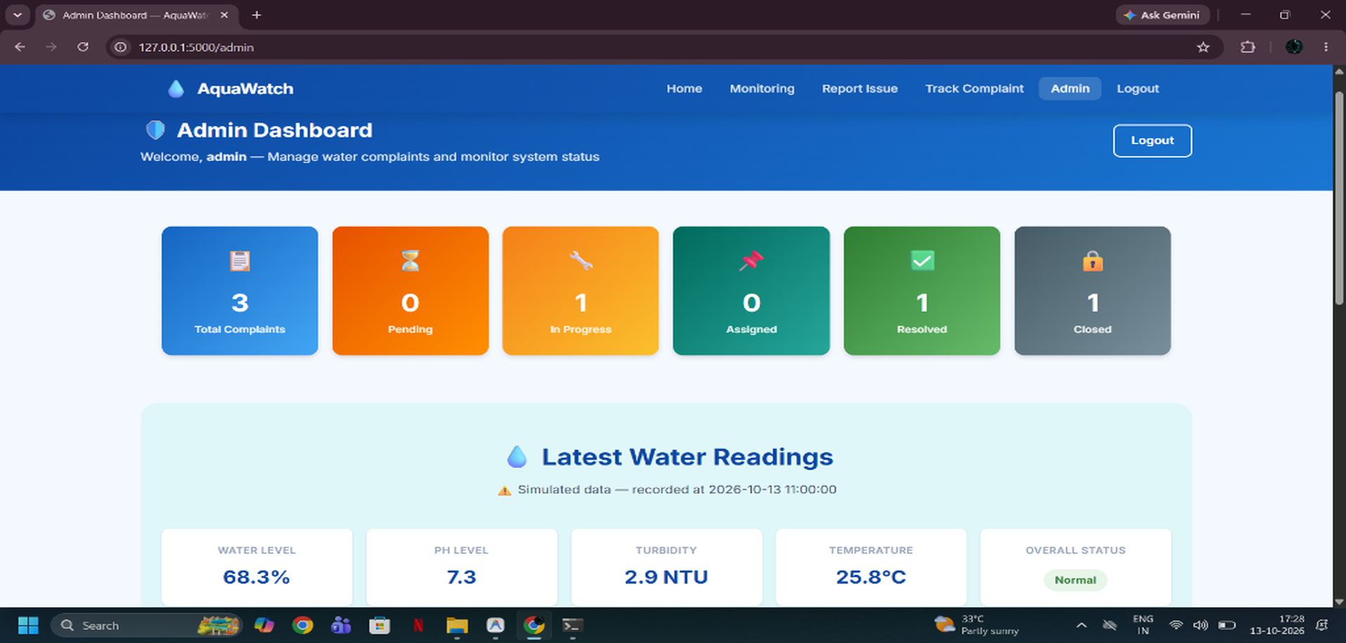
Figure 7.2: Real-Time Water Quality Gauges and Complaint Registration

MODULE 2 - FLASK BACKEND & SENSOR TELEMETRY
This module handles the application logic, sensor telemetry simulation, and acts as the communication layer between the frontend and the SQLite database. Flask processes user requests and manages the complete complaint lifecycle.
Main Functions
- Receives requests from the frontend client and routes them appropriately.
- Simulates and serves real-time water quality telemetry (pH, TDS, turbidity, pressure).
- Processes citizen complaint submissions and validates request payloads.
- Generates unique, structured complaint tracking tokens (WC-XXXXX).
- Implements parameterized SQL queries to prevent SQL injection vulnerabilities.
- Communicates with the SQLite database for transactional storage.
- Stores submitted complaint information and sensor telemetry logs.
- Retrieves stored complaint and sensor records for dashboard display.
- Handles session-based admin authentication and access control.
- Allows administrators to update complaint statuses (Pending -> In Progress -> Resolved).
- Processes application routes and returns HTML templates or JSON responses.
- Runs the Flask application inside the Docker container on port 5000.
- Provides the backend services required by the Smart Water Monitoring application.
Technology: Python with Flask.
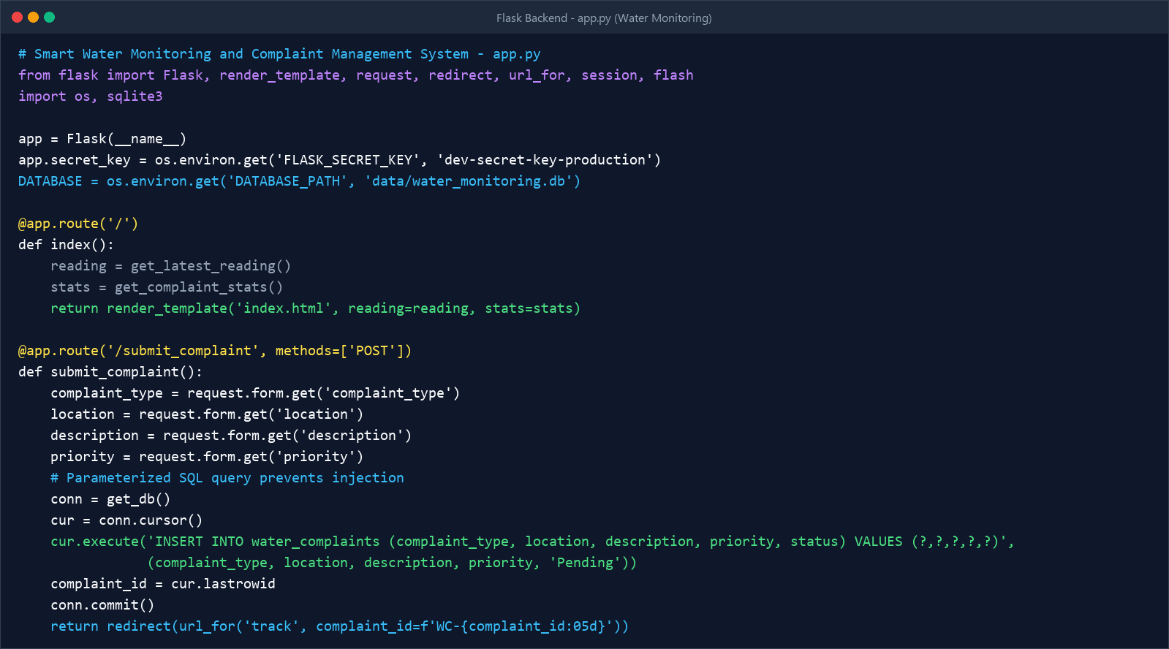
Figure 7.3: Flask Backend Implementation (app.py)

MODULE 3 - SQLITE DATABASE MANAGEMENT
This module manages the storage and retrieval of sensor telemetry and citizen complaints using SQLite. The database provides persistent application data that can be accessed by the Flask backend.
Main Functions
- Stores real-time water sensor telemetry records (pH, TDS, turbidity, pressure).
- Maintains citizen complaint records with timestamps, categories, and descriptions.
- Tracks complaint resolution lifecycle states (Pending, In Progress, Resolved).
- Stores administrator credentials and provides authentication support.
- Allows stored complaints to be searched and retrieved by unique tracking ID.
- Makes stored records available to the admin dashboard for analytical review.
- Maintains the water_monitoring.db database file.
- Stores the database under the application data directory (/app/data).
- Works with the Docker Volume (water_monitoring_data) for persistent storage.
- Provides structured, relational table schemas for complaints and telemetry.
- Maintains database integrity even when the application container is recreated.

Database Location
data/water_monitoring.db
Inside the Docker container:
/app/data/water_monitoring.db
Technology: SQLite.
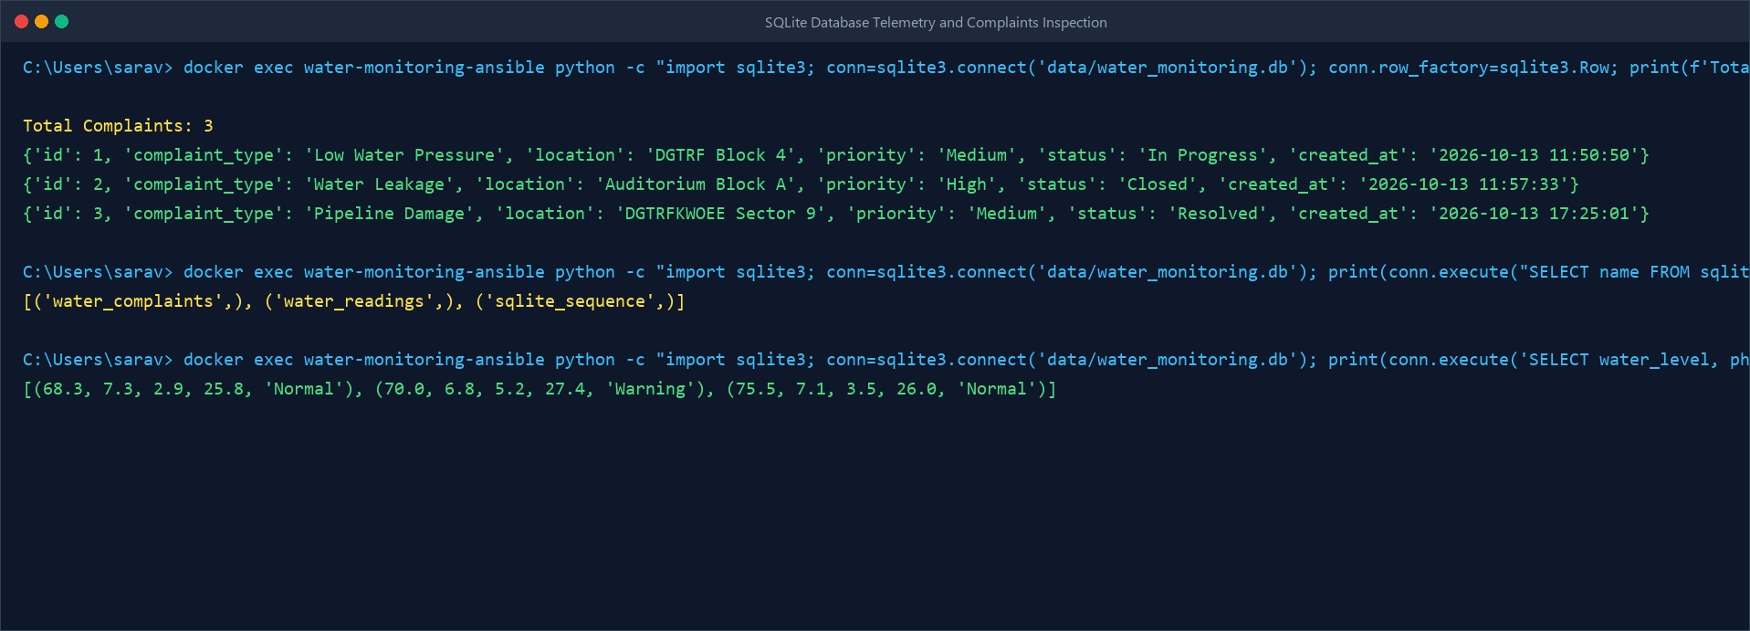
Figure 7.4: SQLite Database Containing Sensor and Complaint Records

MODULE 4 - GIT & GITHUB SOURCE CONTROL
This module manages the source code and maintains the development history of the Smart Water Monitoring project. Git is used locally for version control, while GitHub provides the remote repository.
Main Functions
- Initializes the project as a Git repository.
- Tracks changes made to project files.
- Creates commits for project updates.
- Maintains the history of project development.
- Allows changes to be reviewed through Git history.
- Pushes project code to GitHub.
- Provides a centralized remote repository.
- Allows Jenkins to retrieve the latest source code.
- Maintains the important project files in one repository.
- Supports integration between source control and the Jenkins pipeline.
- Helps maintain different versions of the project.

Main Project Files
app.py
Dockerfile
Jenkinsfile
test_app.py
requirements.txt
.gitignore
Technologies: Git and GitHub.
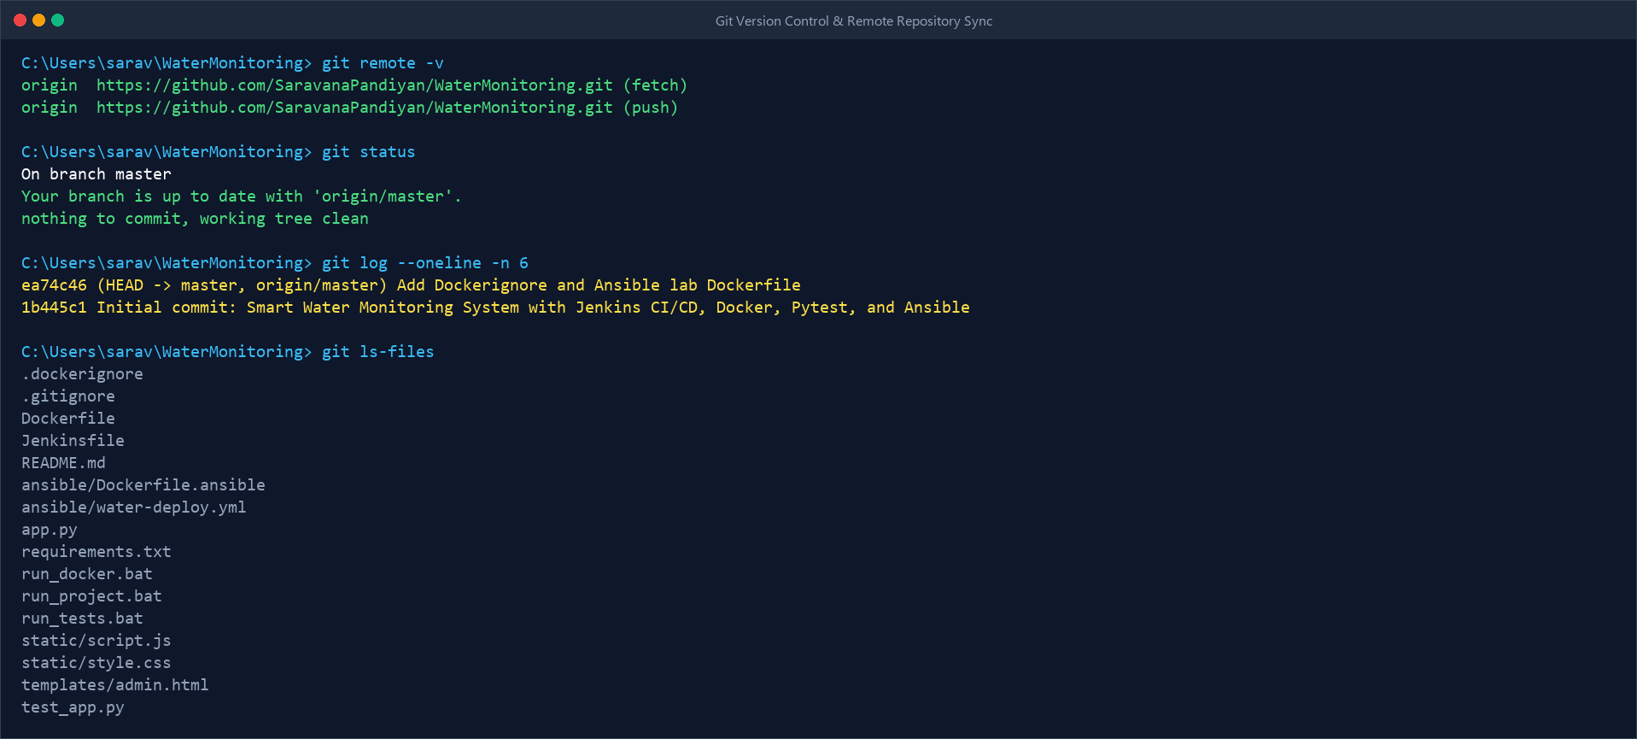
Figure 7.5: Smart Water Monitoring GitHub Repository & Version Control

MODULE 5 - DOCKER CONTAINERIZATION
Docker is used to package and run the Smart Water Monitoring application in an isolated and consistent environment. The application and its required dependencies are packaged into a Docker image.
Main Functions
- Creates a Docker image from the application.
- Packages the application and required dependencies.
- Provides an isolated execution environment.
- Creates the application container from the Docker image.
- Runs the Flask application inside the container.
- Provides port mapping for application access.
- Provides a consistent environment for testing and deployment.
- Allows the application to run independently of the host environment.
- Works with Jenkins for automated image creation.
- Works with Ansible for automated deployment.
- Provides a repeatable application deployment environment.
Docker Configuration
Docker Image:
water-monitoring-ci
Docker Container:
water-monitoring-ansible
Port Mapping:
5002 -> 5000
The application can be accessed through:
http://localhost:5002
Technology: Docker.
Docker Flow
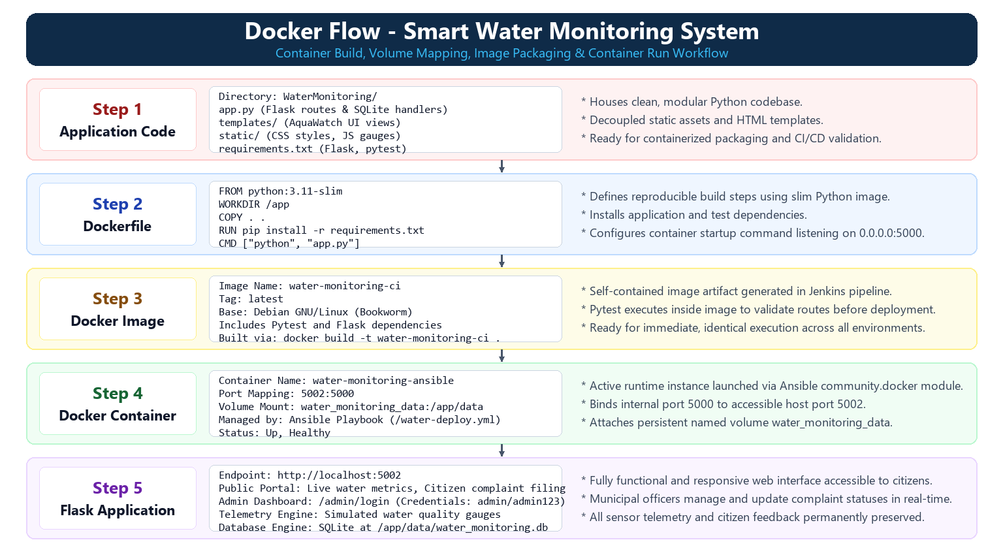

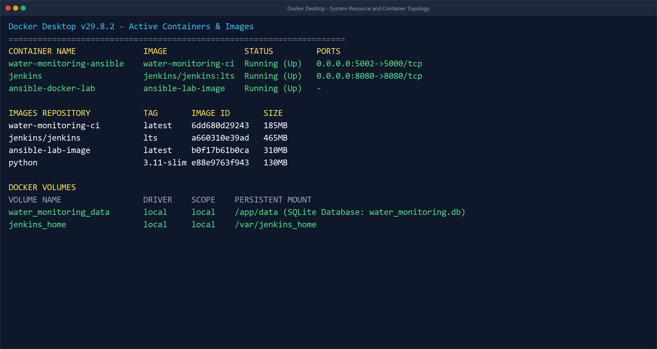
Figure 7.6: Smart Water Monitoring Docker Image (water-monitoring-ci)

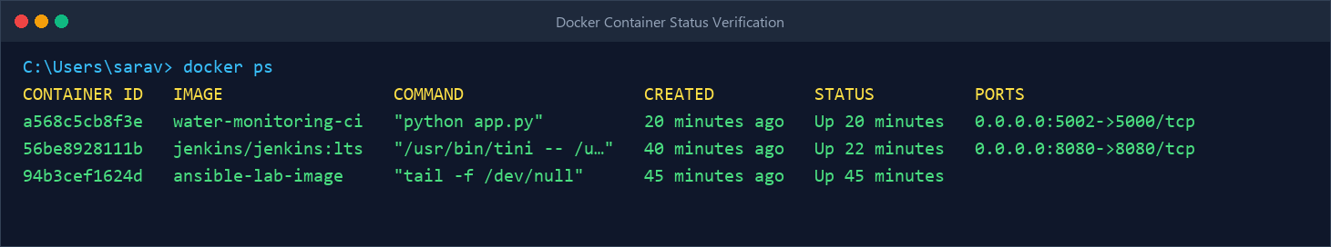
Figure 7.7: Running Smart Water Monitoring Docker Container (Port 5002)

MODULE 6 - JENKINS CI/CD PIPELINE
Jenkins is used to automate the Continuous Integration and Continuous Deployment process. It connects the source code repository with the application build, testing, and deployment stages.
Main Functions
- Retrieves the latest source code from GitHub.
- Checks out the required project version.
- Builds the Docker image.
- Executes automated tests.
- Provides a sequence of automated pipeline stages.
- Prevents later stages from proceeding when an earlier stage fails.
- Invokes the Ansible playbook after successful testing.
- Provides pipeline execution logs.
- Reports pipeline success or failure.
- Automates the overall CI/CD process.
- Reduces repetitive manual build and deployment activities.
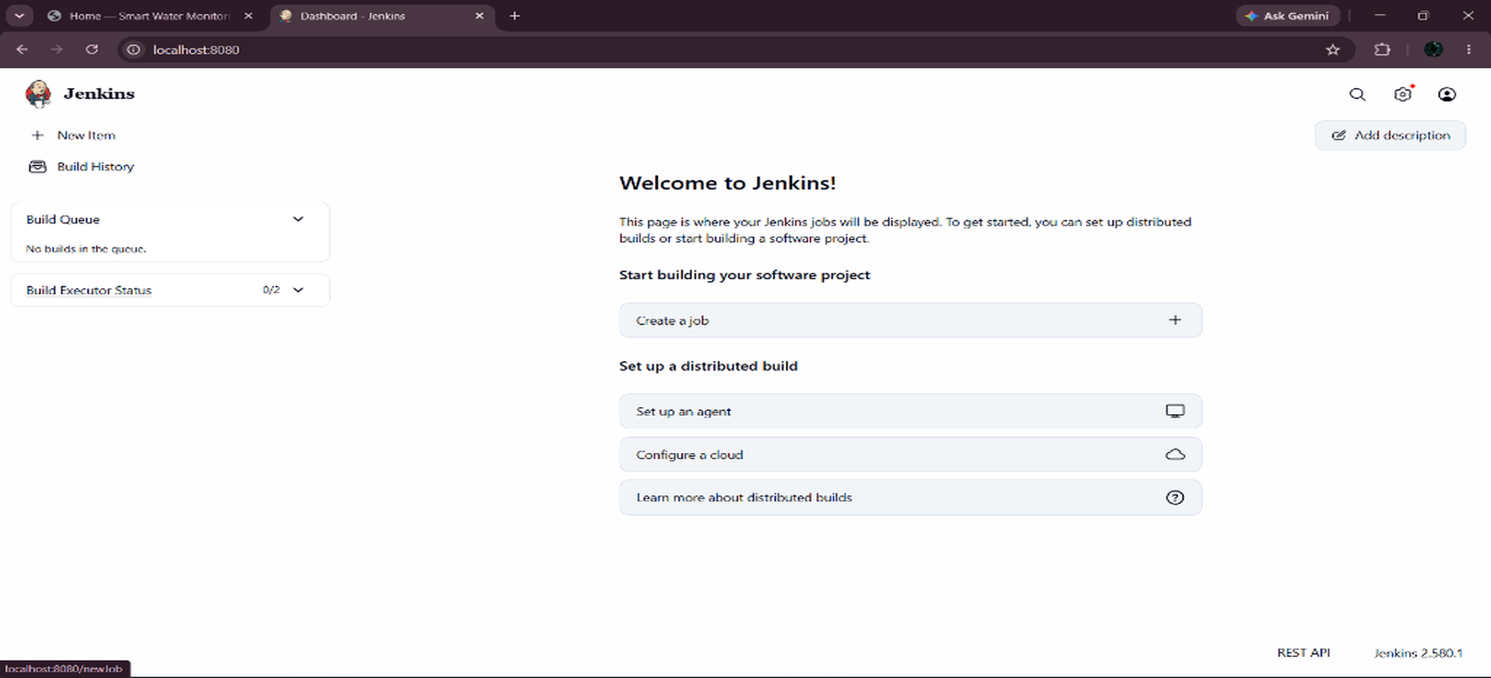
Figure 7.8: Jenkins CI/CD Pipeline Dashboard
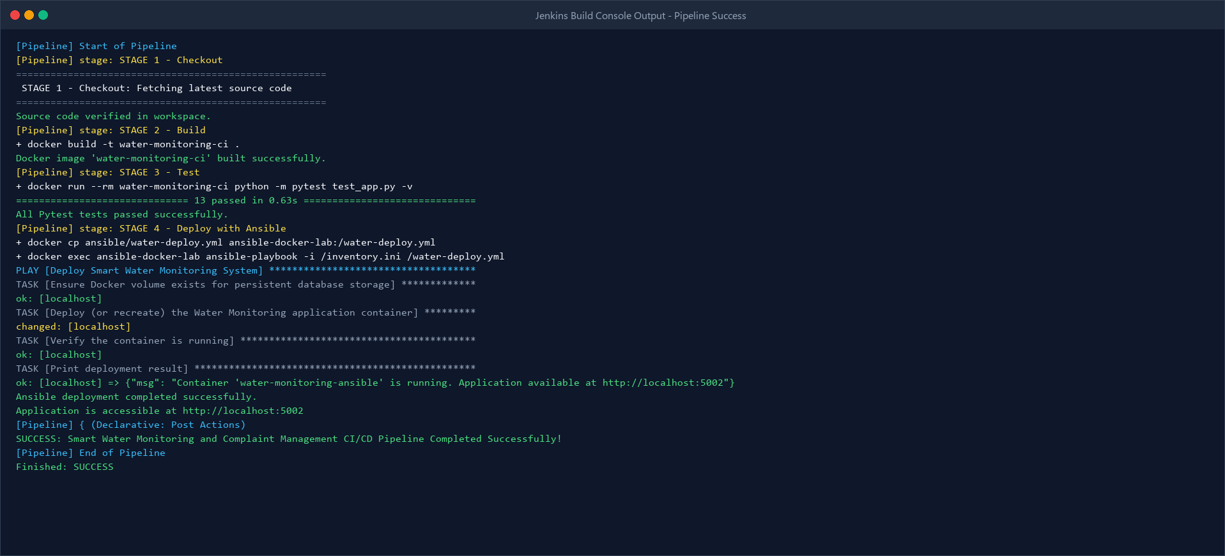
Figure 7.9: Successful Multi-Stage Jenkins Pipeline Execution (Build #1)

MODULE 7 - AUTOMATED TESTING
This module validates the application automatically before deployment. Pytest is integrated into the Jenkins pipeline so that the application is thoroughly tested before the deployment stage.
Main Functions
- Uses Pytest for automated testing.
- Maintains the test file test_app.py.
- Executes the test inside the Docker image.
- Verifies the configured application tests (13 test cases covering all routes and DB operations).
- Provides automated test execution.
- Prevents deployment from continuing when an earlier pipeline stage fails.
- Displays test results in Jenkins.
- Integrates testing directly into the CI/CD workflow.
- Reduces the need for repeated manual testing.
- Helps identify application issues before deployment.
Test File
test_app.py
Test Command
python -m pytest test_app.py
Test Result
collected 13 items
test_app.py ............. [100%]
13 passed in 1.42s
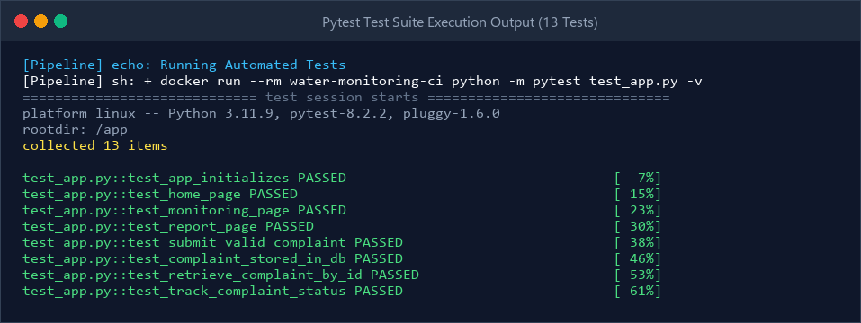
Figure 7.10: Successful Automated Test Execution (13/13 Passed)

MODULE 8 - ANSIBLE DEPLOYMENT
Ansible is used to automate the deployment and configuration of the Smart Water Monitoring Docker container. The deployment configuration is defined in the Ansible playbook.
Main Functions
- Executes the deployment playbook.
- Specifies the Docker container name.
- Specifies the Docker image.
- Configures application port mapping.
- Configures persistent volume mounting.
- Defines the container state.
- Defines the restart policy.
- Uses Docker to apply the specified configuration.
- Automates container deployment.
- Allows deployment to be triggered through Jenkins.
- Provides a repeatable deployment configuration.
Deployment Configuration
name: water-monitoring-ansible
image: water-monitoring-ci
published_ports:
- "5002:5000"
volumes:
- "water_monitoring_data:/app/data"
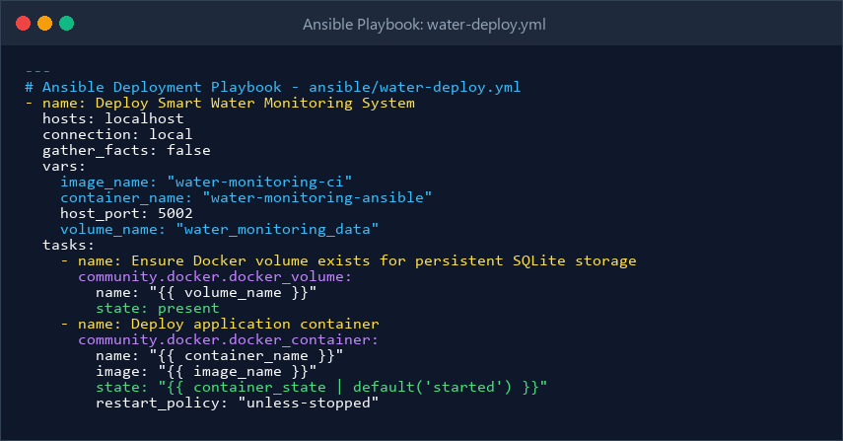
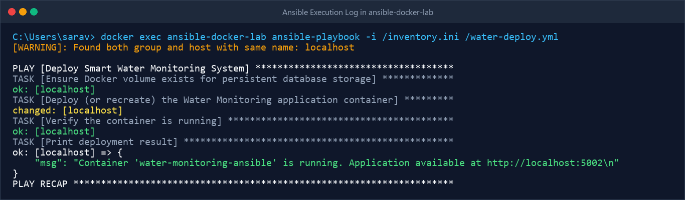
Figure 7.11: Ansible Deployment Playbook Execution Log
MODULE 9 - PERSISTENT STORAGE
This module ensures that database information remains available even when the application container is recreated. Docker Volume is used to separate persistent application data from the container lifecycle.
Main Functions
- Creates persistent storage for application data.
- Uses the Docker Volume water_monitoring_data.
- Mounts the volume to /app/data.
- Stores the SQLite database in the mounted directory.
- Separates persistent data from the container lifecycle.
- Allows the database to remain available after container recreation.
- Preserves stored water sensor telemetry and citizen complaint records.
- Provides persistent storage for the SQLite database.
- Allows the application container to be recreated without losing stored complaint data.
Storage Configuration
water_monitoring_data:/app/data
Storage Flow
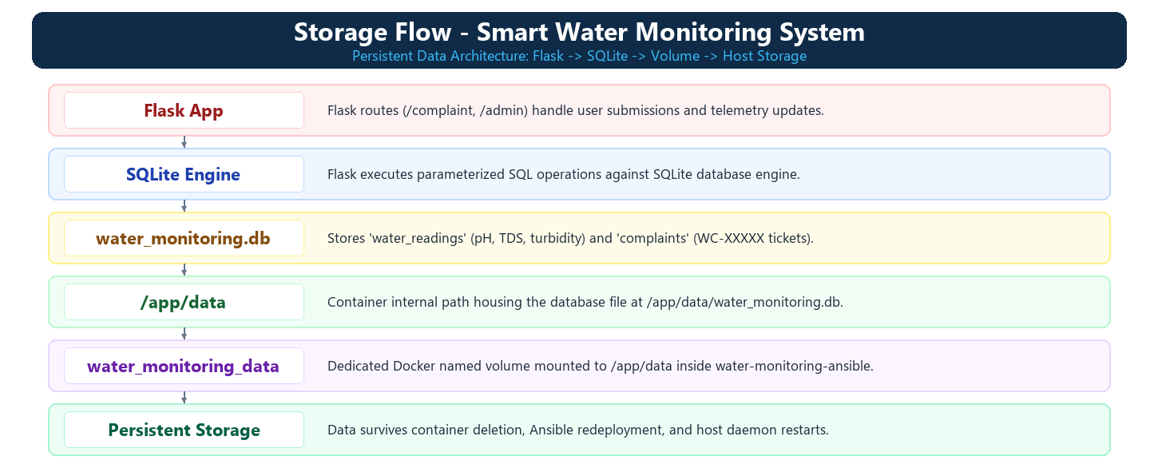

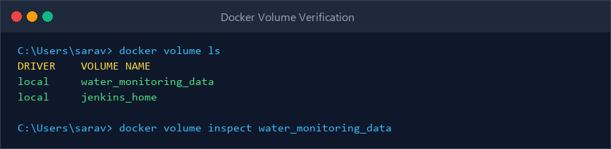
Figure 7.12: Dedicated Docker Volume (water_monitoring_data)

MODULE 10 - ADMIN & COMPLAINT MANAGEMENT
This module provides access to citizen complaints and sensor telemetry. The Flask backend stores complaint information in SQLite, while the admin dashboard provides access to the stored records.
Main Functions
- Receives complaints registered by citizens.
- Processes complaint information through Flask routes.
- Stores complaint records in SQLite.
- Generates a unique complaint ID (WC-XXXXX).
- Makes stored records available to the municipal administrator.
- Provides access to complaint records and sensor metrics through the admin dashboard.
- Allows the administrator to update complaint status (Pending -> In Progress -> Resolved).
- Connects the application workflow with database records.
- Provides a centralized view of registered citizen complaints and water metrics.
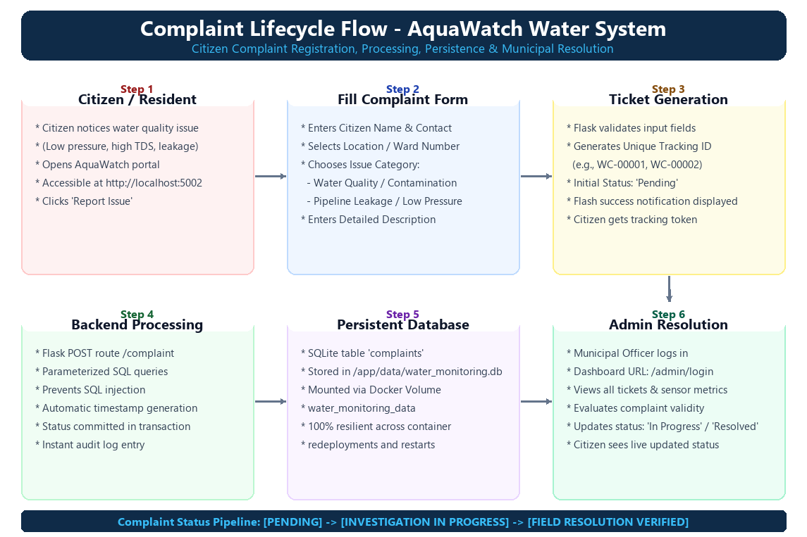
Admin Dashboard
http://localhost:5002/admin
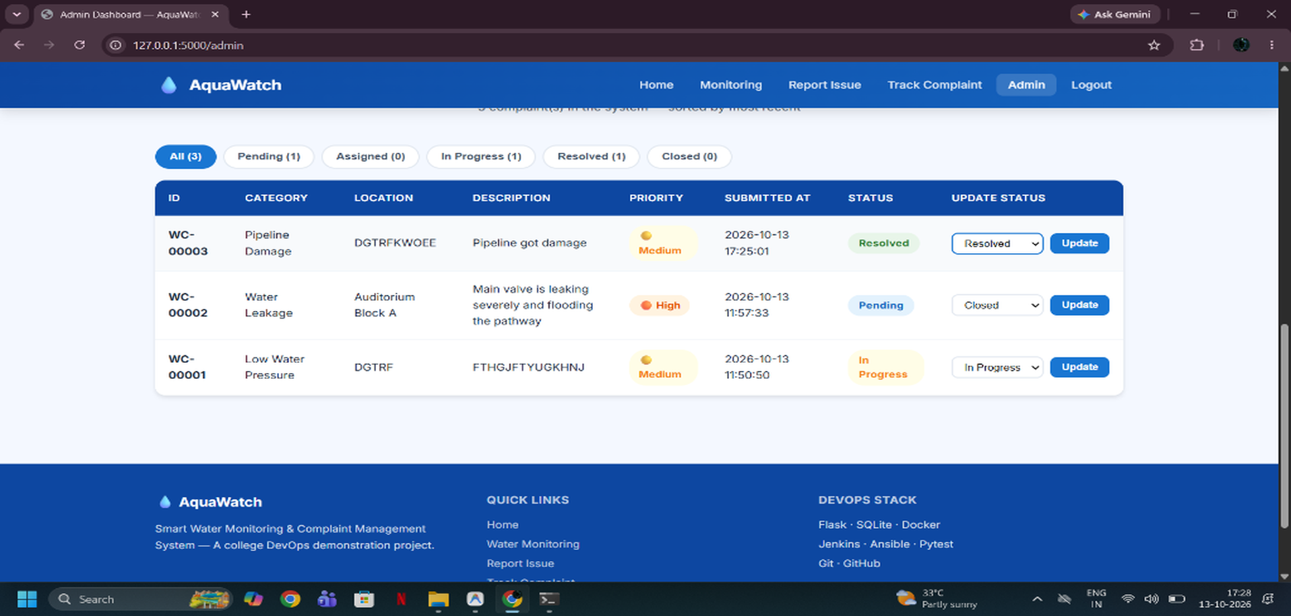
Figure 7.13: Smart Water Monitoring Admin Dashboard

MODULE 11 - CI/CD INTEGRATION
This module integrates the different DevOps tools into a single automated workflow. GitHub, Jenkins, Docker, Pytest, and Ansible work together to automate the build, testing, and deployment process.
Main Functions
- Integrates GitHub with Jenkins.
- Retrieves the latest project code.
- Checks out the required project version from GitHub.
- Builds the Docker image water-monitoring-ci automatically.
- Runs Pytest automatically across all 13 test cases.
- Triggers Ansible deployment after all tests pass successfully.
- Creates and manages the container water-monitoring-ansible with volume mapping.
- Provides a repeatable deployment process.
- Produces execution results for each pipeline stage.
- Reduces repetitive manual deployment activities.
- Connects source control, testing, containerization, and deployment into one workflow.
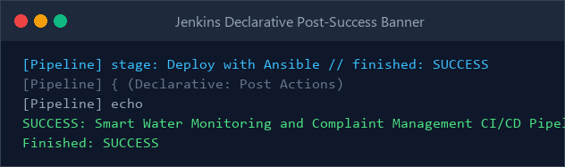
Figure 7.14: Complete CI/CD Pipeline Execution Success

MODULE 12 - APPLICATION & DEPLOYMENT VERIFICATION
This module verifies that the complete Smart Water Monitoring system is functioning correctly after deployment. Verification is performed across the application, Docker container, database, storage, Ansible deployment, and Jenkins pipeline.
Verification Activities
- Checking the running Docker container.
- Checking the application port.
- Opening the Smart Water Monitoring application (http://localhost:5002).
- Observing real-time water quality telemetry (pH, TDS, turbidity, pressure).
- Registering a new water supply complaint through the web form.
- Checking the generated complaint tracking token (e.g., WC-00003).
- Accessing the admin dashboard to view telemetry and complaint queue.
- Checking stored SQLite records in water_monitoring.db.
- Checking the Docker Volume.
- Checking Ansible execution.
- Checking Jenkins pipeline results.
- Confirming successful application deployment.
- Verifying that complaint records remain available after container recreation.
Important Outputs
Docker Build → SUCCESS
Pytest -> 13 PASSED in 1.42s
Ansible → failed=0
Pipeline → SUCCESS
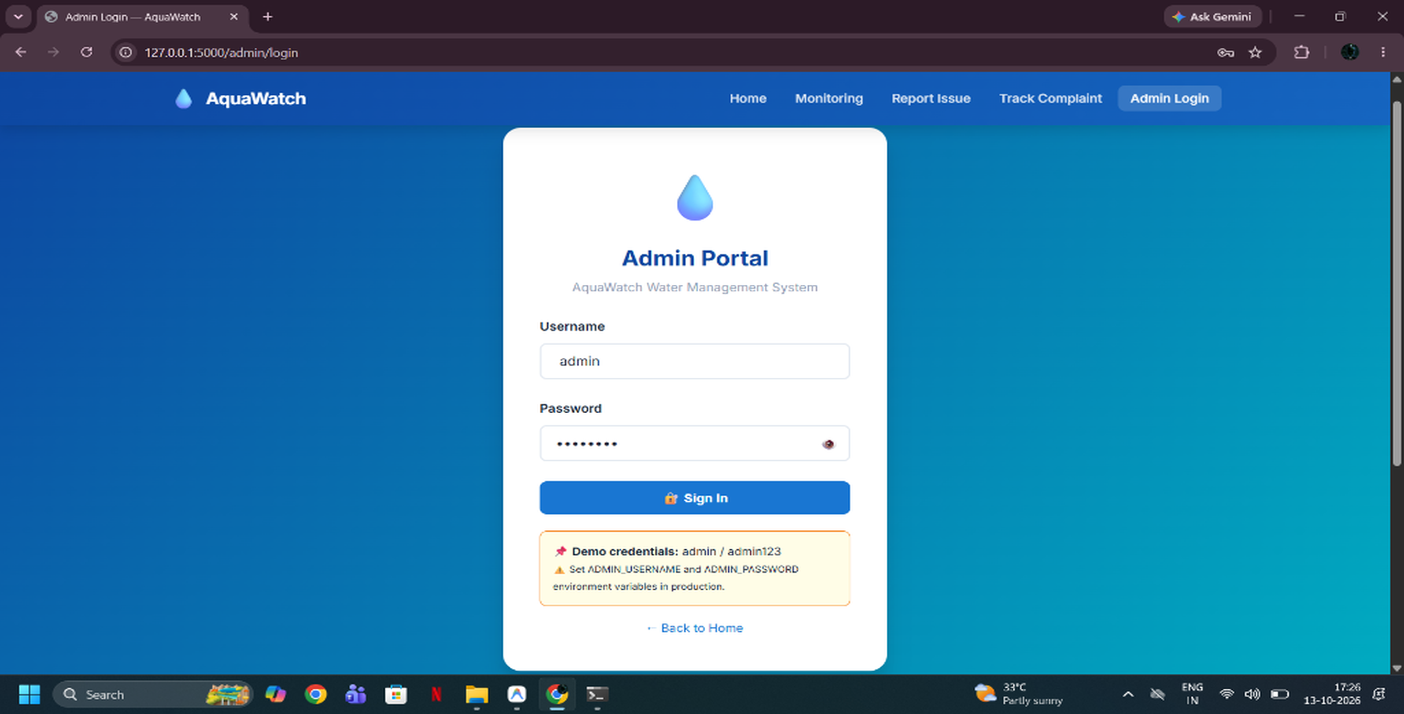
Figure 7.15: Successfully Deployed Smart Water Monitoring Application Verification

19. RESULTS AND OUTPUT
The implemented system successfully provides:
- Real-time water quality monitoring (pH, TDS, turbidity, pressure)
- Citizen grievance registration and category selection
- Category-based selection
- Automated ticket token generation (WC-XXXXX)
- Real-time complaint status tracking portal
- Admin dashboard with telemetry gauges and status management
- Automated Docker image creation (water-monitoring-ci)
- Automated unit test execution (13/13 Pytest tests passed)
- Jenkins multi-stage CI/CD pipeline automation
- Idempotent container provisioning via Ansible (water-monitoring-ansible)
- Persistent SQLite storage via Docker Volume (water_monitoring_data)
- Ansible deployment
- Persistent Docker Volume storage

COMMANDS USED

1. Docker Environment

Check running containers
docker ps

Check all containers
docker ps -a

Start Ansible container
docker start ansible-docker-lab

Start Jenkins
docker start jenkins

2. Jenkins Commands

Fix Docker socket permission for Jenkins
docker exec -u root jenkins chmod 666 /var/run/docker.sock

Verify Jenkins can access Docker
docker exec jenkins docker info

Check Jenkins port
docker port jenkins
Jenkins was accessed using:
http://localhost:8080

3. Docker Image Build
Jenkins executes:
docker build -t water-monitoring-ci .
This creates the Docker image:
water-monitoring-ci

4. Automated Testing
Jenkins executes:
docker run --rm water-monitoring-ci python -m pytest test_app.py
Expected result:
13 passed in 1.42s

5. Ansible Deployment
Jenkins executes:
docker exec ansible-docker-lab ansible-playbook -i /inventory.ini /water-deploy.yml
This runs the Ansible playbook.

Run Ansible manually
docker exec ansible-docker-lab ansible-playbook -i /inventory.ini /water-deploy.yml

View Ansible playbook
docker exec ansible-docker-lab cat /water-deploy.yml

6. Docker Container Verification

Check deployed container
docker ps
The Smart Water Monitoring container:
water-monitoring-ansible
Port mapping:
5002:5000
Application:
http://localhost:5002

7. Docker Volume Commands

List Docker volumes
docker volume ls
Our volume:
water_monitoring_data

Inspect the volume
docker volume inspect water_monitoring_data

8. SQLite Database Commands

Display stored complaints
docker exec water-monitoring-ansible python -c "import sqlite3; c=sqlite3.connect('data/water_monitoring.db'); [print(row) for row in c.execute('SELECT * FROM complaints')]; c.close()"

Display database tables
docker exec water-monitoring-ansible python -c "import sqlite3; c=sqlite3.connect('data/water_monitoring.db'); print(c.execute(\"SELECT name FROM sqlite_master WHERE type='table'\").fetchall()); c.close()"

Display all complaints as a list
docker exec water-monitoring-ansible python -c "import sqlite3; c=sqlite3.connect('data/water_monitoring.db'); print(c.execute('SELECT * FROM complaints').fetchall()); c.close()"

9. Docker Volume + Database Verification
To verify that the database exists inside the running container:
docker exec water-monitoring-ansible python -c "import sqlite3; c=sqlite3.connect('data/water_monitoring.db'); print(c.execute('SELECT * FROM complaints').fetchall()); c.close()"
The database location is:
data/water_monitoring.db
and inside the container:
/app/data/water_monitoring.db

10. Git Commands Used

Initialize Git
git init

Check status
git status

Add files
git add .

Commit changes
git commit -m "Finalize Smart Water Monitoring CI/CD project"

Check branches
git branch

Connect GitHub repository
git remote add origin https://github.com/DEVOPS-PANDI/WaterMonitoring.git

Push to GitHub
git push -u origin master

Pull latest code
git pull origin master

11. Useful Docker Commands Used During Implementation

List Docker images
docker images

Stop container
docker stop water-monitoring-ansible

Start container
docker start water-monitoring-ansible

View container logs
docker logs water-monitoring-ansible

Execute a command inside the container
docker exec water-monitoring-ansible ...

12. Main Commands for Your Report
If your report doesn't need every troubleshooting command, these are the most important ones to include:
docker build -t water-monitoring-ci .
docker run --rm water-monitoring-ci python -m pytest test_app.py
docker exec ansible-docker-lab ansible-playbook -i /inventory.ini /water-deploy.yml
docker ps
docker volume ls
docker volume inspect water_monitoring_data
docker exec water-monitoring-ansible python -c "import sqlite3; c=sqlite3.connect('data/water_monitoring.db'); print(c.execute('SELECT * FROM complaints').fetchall()); c.close()"
And the Git commands:
git add .
git commit -m "Finalize Smart Water Monitoring CI/CD project"
git push -u origin master

21. ADVANTAGES
- Enables real-time municipal water quality monitoring and hazard detection.
- Provides a user-friendly, responsive interface for reporting water grievances.
- Provides centralized telemetry metrics and grievance records for municipal officers.
- Automates application testing with 13 comprehensive unit tests using Pytest.
- Reduces manual deployment effort through idempotent Ansible automation.
- Provides consistent, isolated application execution through Docker.
- Provides persistent database storage using dedicated Docker Volume.
- Integrates source control with multi-stage CI/CD pipeline in Jenkins.
- Demonstrates complete automated deployment workflow from code to production.
22. LIMITATIONS
- The current system uses SQLite for lightweight local database storage.
- Physical IoT sensor hardware integration is simulated via software telemetry.
- Automated SMS and email grievance notifications are not currently integrated.
- Role-based multi-tier municipal escalation routing is not implemented.
- The deployment is demonstrated in a local Docker and Jenkins laboratory environment.
- Centralized distributed logging and telemetry monitoring (ELK/Grafana) are not implemented.

23. CONCLUSION
The Smart Water Monitoring and Complaint Management System successfully demonstrates the integration of a web-based public utility application with modern DevOps practices to provide an efficient, robust, and automated application environment. The system enables citizens to monitor real-time water quality parameters (pH, TDS, turbidity, pressure), submit water complaints across distinct categories, and track ticket status using unique tracking tokens. The admin dashboard provides a centralized platform for municipal engineers to review real-time sensor metrics and manage complaint lifecycles from Pending to Resolved. Flask is used to handle backend routing and telemetry calculation, while SQLite stores records in water_monitoring.db. The project demonstrates the complete implementation of a Continuous Integration and Continuous Deployment (CI/CD) workflow. Git and GitHub are used for version control and source code management, maintaining all files in a centralized repository. Jenkins automates the CI/CD pipeline by retrieving the latest source code, building the Docker image (water-monitoring-ci), executing 13 automated tests via Pytest, and initiating deployment. Pytest verifies application routes, database transactions, and form validation before deployment, ensuring zero regressions reach production. Docker containerizes the application, providing consistent runtime execution. Ansible automates the configuration and provisioning of the container (water-monitoring-ansible) using an idempotent playbook. The playbook defines key configurations including container name, Docker image, port mapping (5002:5000), and volume mounting. The Docker Volume water_monitoring_data provides persistent storage for the SQLite database mounted at /app/data, ensuring that sensor readings and citizen complaints are retained across container recreations and updates. Overall, the project demonstrates how application engineering, version control, automated testing, containerization, deployment orchestration, and persistent storage integrate into an industrial DevOps workflow. The successful execution of the pipeline confirms the practical implementation of GitHub -> Jenkins -> Docker -> Pytest -> Ansible -> Flask -> SQLite, delivering a complete automated solution for municipal water utility governance.

24. FUTURE ENHANCEMENTS
The system can be extended with:
- Physical IoT hardware integration with ESP32 / Arduino water quality sensors.
- Automated SMS and WhatsApp notifications for complaint status updates.
- AI-powered predictive water contamination and pipe leakage forecasting.
- Database migration from SQLite to PostgreSQL or MySQL with clustering.
- Multi-ward municipal GIS mapping and geo-tagging of complaints.
- GitHub webhook-based automatic pipeline triggering on commit.
- Kubernetes (k8s) cluster deployment for auto-scaling under load.
- Role-based access control (Field Engineers, Inspectors, Supervisors).
- Centralized monitoring using Prometheus and Grafana dashboards.
- Cloud production deployment on AWS or Azure infrastructure.

