

IN MEMORY OF TERMS OF USE I PRIVACY POLICY

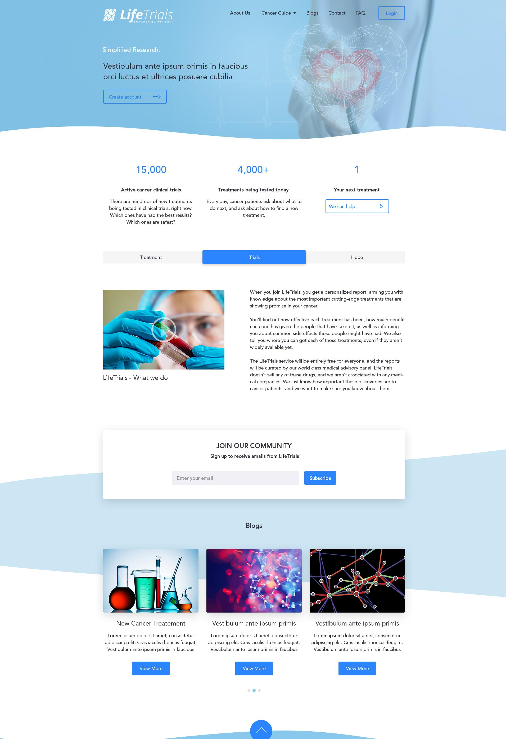

***LifeTrials***

About Us Cancer Guide ■ Blogs Contact FAQ

1

**Your next treatment**

We can help.

15,000 4,000+

**Active cancer clinical trials Treatments being tested today**

There are hundreds of new treatments Every day, cancer patients ask about what to

being tested in clinical trials, right now. do next, and ask about how to find a new

Which ones have had the best results? treatment.

Which ones are safest?

Hope

Treatment Trials

When you join LifeTrials, you get a personalized report, arming you with knowledge about the most important cutting-edge treatments that are showing promise in your cancer.

You'll find out how effective each treatment has been, how much benefit each one has given the people that have taken it, as well as informing you about common side effects those people might have had. We also tell you where you can get each of those treatments, even if they aren't widely available yet.

The LifeTrials service will be entirely free for everyone, and the reports will be curated by our world class medical advisory panel. LifeTrials doesn't sell any of these drugs, and we aren't associated with any medi­cal companies. We just know how important these discoveries are to cancer patients, and we want to make sure you know about them.

**Subscribe**

Enter your email

Simplified Research.

Vestibulum ante ipsum primis in faucibus orci luctus et ultrices posuere cubilia

LifeTrials - What we do

**JOIN OUR COMMUNITY**

**Sign up to receive emails from LifeTrials**

Blogs

New Cancer Treatement

Lorem ipsum dolor sit amet, consectetur
  
adipiscing elit. Cras iaculis rhoncus feugiat.
  
Vestibulum ante ipsum primis in faucibus

View More

Lorem ipsum dolor sit amet, consectetur
  
adipiscing elit. Cras iaculis rhoncus feugiat.
  
Vestibulum ante ipsum primis in faucibus

View More

Lorem ipsum dolor sit amet, consectetur
  
adipiscing elit. Cras iaculis rhoncus feugiat.
  
Vestibulum ante ipsum primis in faucibus

View More

Vestibulum ante ipsum primis Vestibulum ante ipsum primis

0 Leave us a message)