Generate dump file on hitting particular method in class

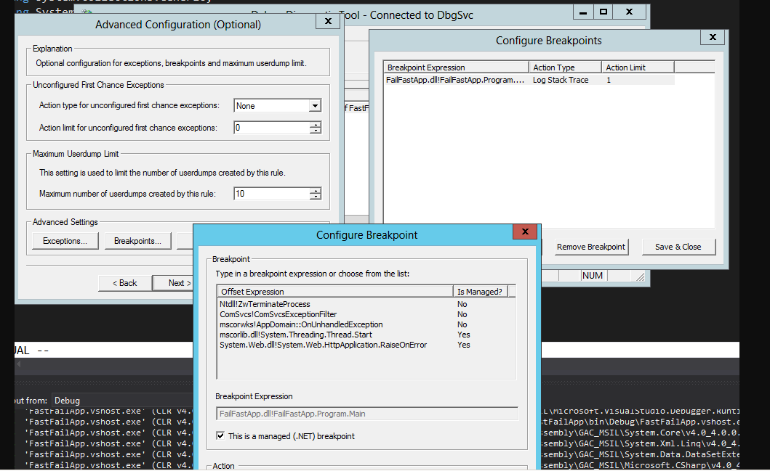

dllName.dll!NamespaceName.ClassName.MethodName

Generate dump file on particular exception