Car Rider Pickup System



Critical Design Review

The Wranglers
Haya Abusada
Jake Hewett
Jayden Pearson
Jack Uehlinger
Sara Vorhaben

Department of Computer Science
Texas A&M University

Date: 3/18/2026
Table of Contents
1 Introduction 3
2 Proposed design 4
2.1 Updates to the proposal design (if applicable) 4
2.2 System description 4
2.3 Complete module-wise specifications 6
3 Project management 10
3.1 Updated implementation schedule 10
3.2 Updated validation and testing procedures 12
3.3 Updated division of labor and responsibilities 14
4 Preliminary results 16
5 References 20

Introduction
School pickup lines in the United States have become crowded and inefficient. The overwhelming majority of students now rely on car rides. This rise results in long wait times, traffic jams on local highways, and serious safety risks for both students and drivers. Current technologies like manual apps and geofencing often depend on unreliable GPS, require active parent involvement, or consume a lot of staff time. To fill this gap, our team created an Automated School Pickup System. This modular, camera-based solution aims to simplify vehicle identification and student pickup without needing manual check-ins or constant staff support.

School pickup via the car rider line has been increasing in the US over the years leading to an increase in line length and pickup time. Now, over 70% of students are picked up from school via the car rider line. Car rider lines have become congested, posing a safety issue for both the students and other drivers. With more students attending school, car rider lines have become too slow and cause parents to wait up to over an hour in line leading to frustration. Some studies show that the car rider pick-up line starts to form 1-2 hours before school actually gets out, which leads to traffic backing up local highways and streets, and even frequent accidents. Inclement weather further slows the line, as students who ride the bus or bike to school will often be picked up by their parents in the car rider line to avoid the weather. Additionally, 5-10 staff members are required to set up and run the pickup process, diverting their time away from the education of students. An automated system is needed to streamline the pick-up process to decrease delays and safety issues.

The project's goal was to create a system that automates the car pickup process to significantly cut down on wait times and improve safety. Our objectives included making weather-resistant hardware modules, integrating License Plate Recognition and QR Code Scanning with low-power microcontrollers, building a reliable hybrid network with Zigbee and Wi-Fi, and making sure the system meets the strict safety standards of the Texas Family Code on student release

The system design has four interconnected modules: a tripod-mounted Car Entrance Module with a camera and Raspberry Pi, a Zone Pickup Module for staff management, a Main Server for database logic, and a Kids Waiting Module with a large indoor display. When a vehicle enters the line, the entrance module captures the license plate or QR code, processes the image on-site, and sends the data through a low-power Zigbee mesh network to the server. The server quickly matches the plate with the student database and updates the displays, directing the driver to a specific zone and alerting the student inside to go to that zone. The design includes 3D-printed housings that can withstand 20 mph winds and uses rechargeable battery banks, making the system portable and independent of the school’s power supply.

The system aims for key performance goals, targeting under 5 seconds of processing time from image capture to display update and a 30% reduction in overall pickup time. To ensure safety, the identification algorithms are designed to achieve 100% accuracy in matching students with authorized guardians. The hardware setup focuses on durability and modularity, allowing component replacement in less than 15 minutes.

Proposed design

Updates to the proposal design (if applicable)
The project as a whole remains unchanged from the original design. No new developments have been made in open source, free OCR software or school car rider line pickup systems. The only alternative considered has been using YOLO to detect if a car is in frame to ensure a license plate will be present in the photo, thus saving processing power, time, and energy. However, this has not been implemented since it is unclear if we would need such an optimization in general to achieve the speeds and battery life required. No changes have been made in the budget.

System description
High-Level Block Diagram:
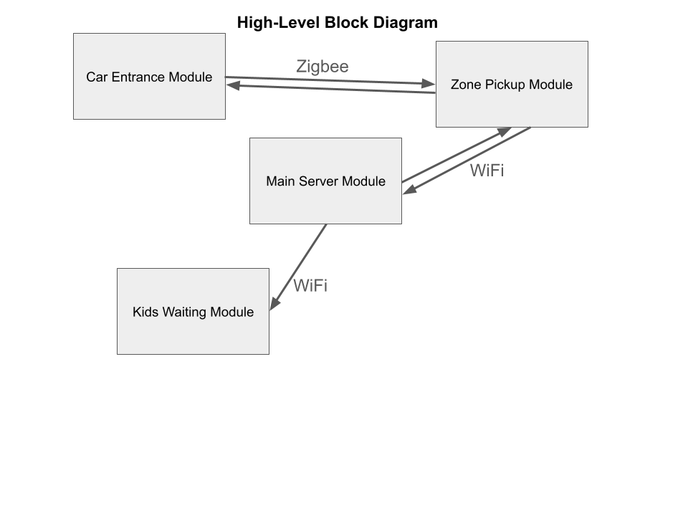Figure 1: High-level block diagram of the system. The car entrance module will communicate with the zone pickup module through a wireless network called Zigbee. The zone pickup module, main server module, and kids waiting module will all have access to WiFi while the car entrance module will relay information solely through Zigbee.

Car Entrance Module:
Functional Description:
The Car Entrance Module will be placed at the entrance of the pickup line, on the sidewalk next to the road. The side of the module that contains the display and camera as seen in figure 2 will face the road, with a clear view of the approaching cars. The camera will take a picture of the car, and the module will run recognition software to identify the parent/car. The module will send a small packet to the zone pickup module, using zigbee, that contains the identification. The module will wait for a response from the zone pickup module, and then update the display accordingly. The display will show the kid of the parent, and instructions on which zone to proceed to.

Zone Pickup Module:
Functional Description:
The Zone Pickup Module will be placed at the location of the pickup zones, which is also outside. The three main purposes of this module are to display pickup information on a screen for staff and kids to see, to act as a hub for the zigbee wireless communication, and to allow staff to update the system once a kid has been picked up. The laptop will display the website that shows the zone pickup information as seen in figure 3. This information will include each separate zone with a list of kids that are being picked up at each zone. This module will receive packets of information from the Car Entrance Module, and relay that information to our Main Server Module using WiFi. It will then relay any updates from the Main Server Module to the Car Entrance Module using the zigbee connection. The phones will be held by each zone attendant, allowing them to see information regarding their current zone. The zone attendant will press a button on the phone once a kid has been picked up from their zone, allowing the website to be updated automatically.

Main Server Module:
Functional Description:
The Main Server Module will act as the command center for all modules, and it will be hosted on a computer located in the school’s office. The main server has 4 main functions:
- Host a website that is displayed on the screens in the Zone Pickup Module and the Kids Waiting Module. The website will be updated in real time depending on the information it receives from the Zone Pickup Module. This information will include an identifier (license plate, QR code) and signals when a kid has been picked up at a zone.
- Connect to a database that contains information about the kids parents, pickup schedule, and identifier (license plate, QR code). The server will query the database when it receives an identifier, and relay the information to the Zone Pickup Module accordingly to send to the Car Entrance Module.
- Handle information update requests from parents. Parents will have the option to submit a request to update their information using the website. Once approved by an administrator, the server will automatically update the database.
- Send updates to the display in the Car Entrance Module. Once the server queries the database and finds the parent/kid matching the identifier, it will send that information to the Car Entrance Module to update the display. The way this connection works is:
  - Server ←→ WiFi ←→ Zone Pickup Module ←→ Zigbee ←→ Car Entrance Module

Kids Waiting Module:
Functional Description:
The Kids Waiting Module will consist of a large display, which will show the website. This display will be placed where the kids are waiting to be called. Once an identifier has been read, the server will update the website and a new kids name will appear under a zone. This will inform the staff and the kid which zone to go to.

Complete module-wise specifications

Car Entrance Module:
Diagram:
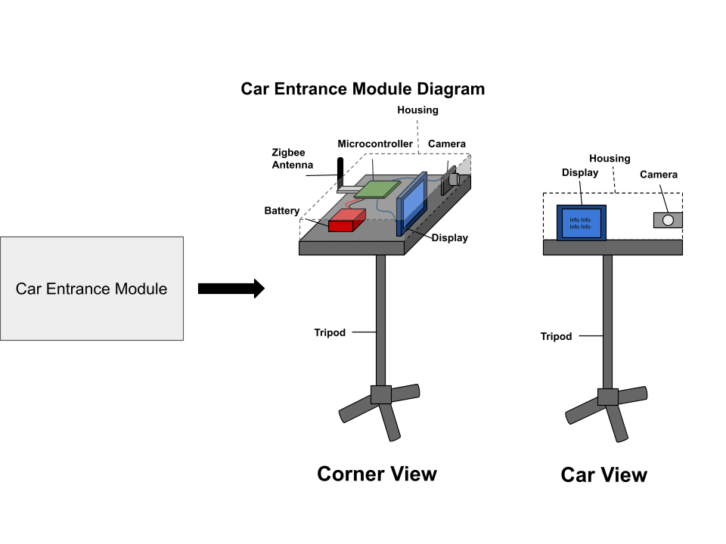
Figure 2: Blueprint for the car entrance module. The housing will be placed on a tripod, and the display and camera will be placed in view of the car line. The antenna will exit the housing from the side, while the microcontroller and battery will be fully enclosed.

Hardware:
Description: This module will not have access to external power supplies or connections such as WiFi, therefore it needs to be completely self-powered. A sufficient rechargeable battery will be used to power the module, while a microcontroller is used for processing. The microcontroller will have several inputs connected to it, each with its own distinct purpose. A camera will be connected to the microcontroller to take images, a display will be used to display information, and a zigbee antenna will be used to transmit information. All of these hardware components will be enclosed in a 3D printed housing, which will protect the components from overheating in the sun and from light rain. The housing will be mounted on top of a tripod, so the display is readable by someone sitting in a car while the camera can have a proper view of the approaching cars.
Circuit Diagram:
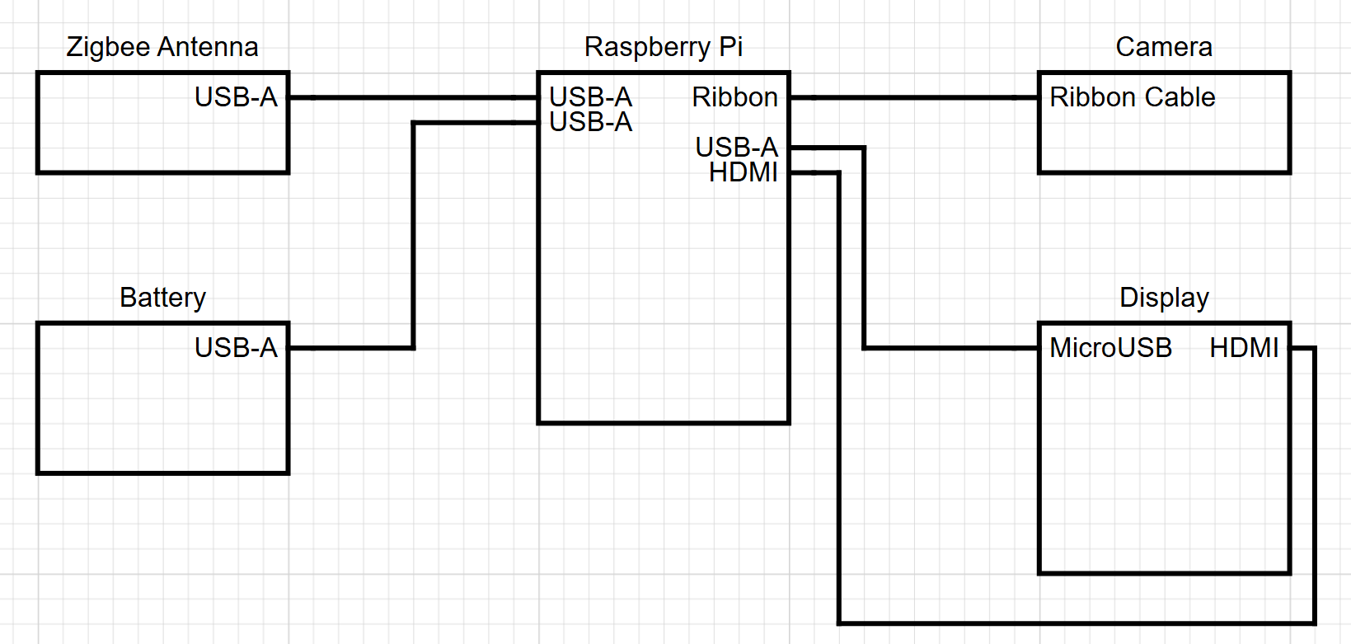
Figure 3: Circuit diagram of the car entrance module.

Software:
Description: The software will be trying to read from pictures that are frequently being taken. In order to help with plate recognition, code has been written to turn each image into an ultra-high contrast one, making darker colors in the image black, and lighter colors white. Once a string of characters recognised as a license plate is found, that plate will be sent to the server using zigbee. Directions for where the parents need to go will be received via the zigbee antenna.
Interfaces: Based on whether or not the plate is recognised, the screen will display instructions for where the parents need to go.

Parts List:
Table 1: A parts list of materials that are needed to build the car entrance module.
Car Entrance Module | Amount Needed | Cost per Unit | Total Amount
Tripod | 1 | $22 | $22
Raspberry Pi | 1 | $75 | $75
Raspberry Pi Camera | 1 | $55 | $55
Zigbee Antenna | 1 | $27 | $27
Rechargeable Battery | 1 | $40 | $40
7-inch display | 1 | $38 | $38
Mounting Screws | ~20 | $8 (600 pcs) | $8
Wires | ~5 | $10 (240 pcs) | $10
Total Cost | $275

Zone Pickup Module:
Diagram:
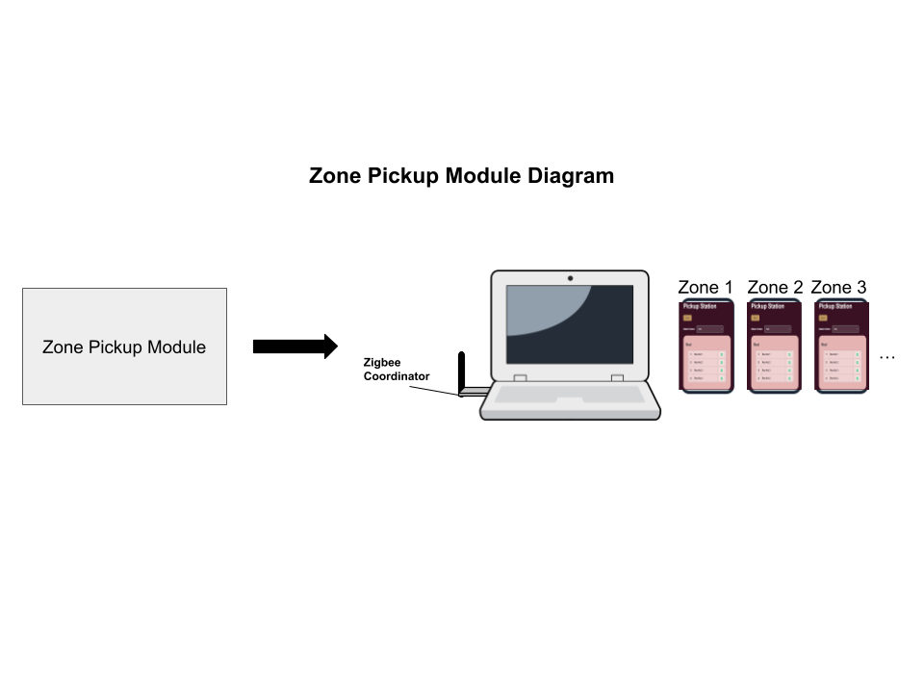
Figure 4: Blueprint for the zone pickup module. The antenna will be connected to the laptop, while the laptop displays the kids module pickup screen. The phones will be held by each zone attendant, and will display information about each specific zone.

Hardware:
Description: The hardware in this module will consist of a laptop, a zigbee antenna, and a cell phone for each zone. Because this module is also outside, it will need to be self-powered like the Car Entrance Module. The zigbee antenna will rely on power from the laptop battery, and we will assume that the laptop and phones used are fully charged when starting.

Software:
Description: Using zigbee, the license plate information will be received for the Car Entrance module, then compared to all the plates in the database. If a matching plate is found, then an algorithm will be run to determine where to send the parent to minimize wait times. The station decided by the algorithm will be sent back to the Car Entrance module. The student name associated to that plate will then be assigned to the same station. When a child is picked up, the teacher/volunteer will check off that the child will be picked up.
Interfaces: The laptop will display all of the stations along with the kids headed to each station. Each of the teachers or volunteers at the stations will have phones displaying the children that are next to be picked up at the station.

Parts List:
Table 2: A parts list of materials that are needed to build the zone pickup module.
Zone Pickup Module | Amount Needed | Cost per Unit | Total Amount
Zigbee Antenna | 1 | $27 | $27
Total Cost | $27

Main Server Module:
Diagram:
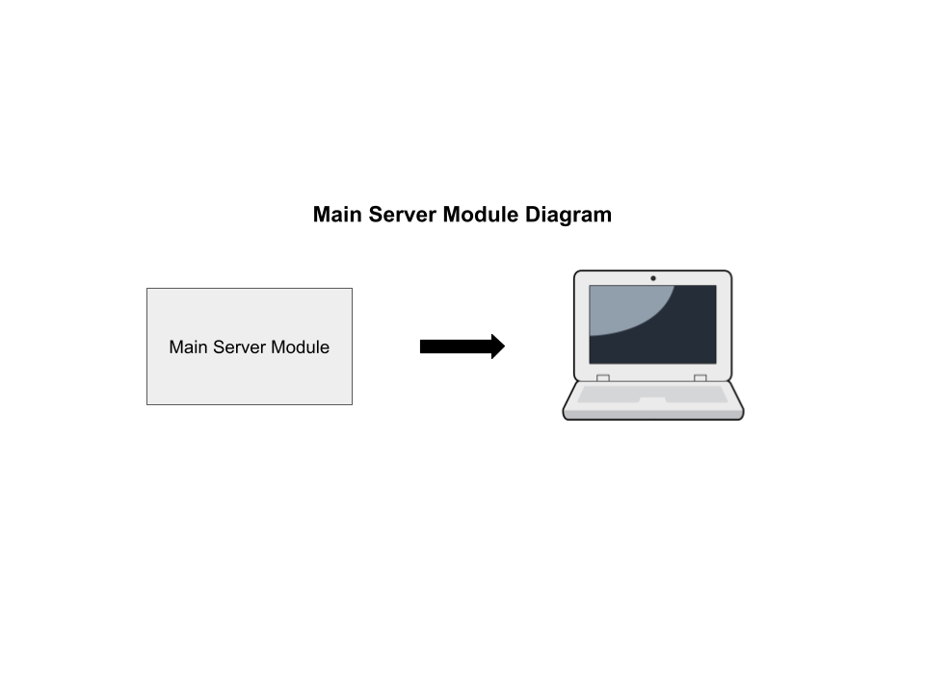
Figure 5: Rough blueprint for the main server module. The module will contain a separate computer that hosts a server and controls the different modules, for example the website displayed in the zone pickup and kids waiting module, and the display on the car entrance module.

Hardware:
Description: The hardware required for this module will consist of a single computer.

Software:
Description: This module needs to be connected to the database, as this module will be where the database will be queried, and results sent back to each of the modules.
Interfaces: This module will take in identifiers, that will assign adults to children, and information update requests from parents if the info in the database/website needs to be updated and approved.

Parts List:
The main server module will be hosted from a computer in the schools administration office, meaning that a pre-existing computer will be sufficient for this module. This results in this module's total cost being $0 as seen in Table 3.
Table 3: A parts list of materials that are needed to build the main server module.
Main Server Module | Amount Needed | Cost per Unit | Total Amount
Total Cost | $0

Kids Waiting Module:
Diagram:
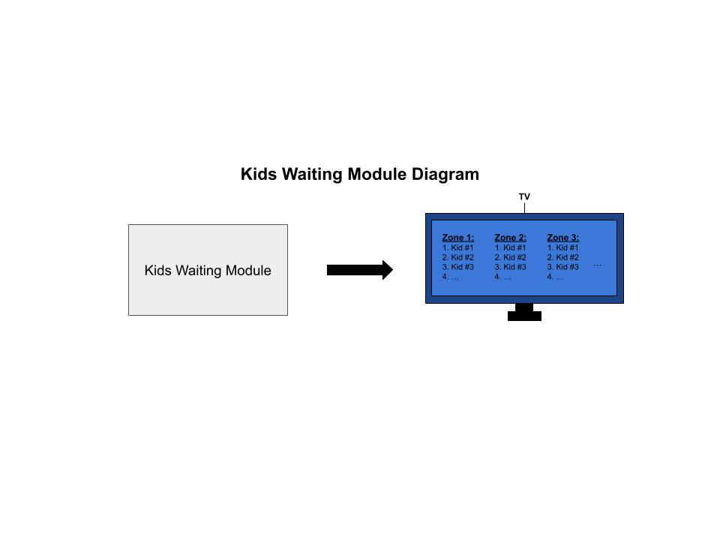
Figure 6: Rough blueprint for the kids waiting module. The module will contain a large display that displays the pick up line instructions website.

Hardware:
Description: The hardware for this module will consist of a large display such as a projector or a TV.

Software:
Description: This module will simply be displaying a page on our website that displays the queued children at each of the zones. This module will not be running any software itself.
Interfaces: This module has no inputs nor outputs, simply a display showing the website page made for it.

Parts List:
The kids waiting module will access the website and show the pick up line instructions. Assuming the kids are waiting in a gym or cafeteria, we will assume the school has access to a large display already (large projector, TV). This results in this module’s total cost being $0 as seen in Table 4.
Table 4: A parts list of materials that are needed to build the kids waiting module.
Kids Waiting Module | Amount Needed | Cost per Unit | Total Amount
Total Cost | $0

Project management

Updated implementation schedule
Since our design was updated to allow cars to scan QR codes, our schedule was updated to match these changes. In order to make this change to a QR Scanner an additional task of designing and integrating the QR scanner was added to our taskboard. The Gantt Chart that reflects these changes can be seen below.
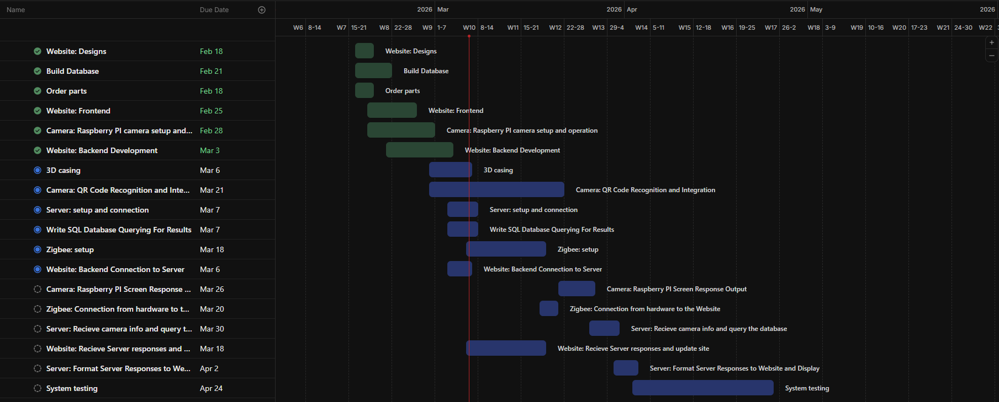 Figure 7: Gantt Chart
However, even with this adjustment, our critical path remains the same at 45 days. Additionally, the chart shows the progress that we have made to date. Tasks highlighted in green have been completed with the red line indicating today’s date The updated schedule can be found in the table below.
Table 5: Schedule of Tasks
Name | Start Date | End date | Status
Build Database | 2/16/2026 | 2/21/2026 | Done
Website: Designs | 2/16/2026 | 2/18/2026 | Done
Website: Frontend | 2/18/2026 | 2/25/2026 | Done
Website: Backend Development | 2/21/2026 | 3/3/2026 | Done
Website: Backend Connection to Server | 3/23/2026 | 3/26/2026 | Not Started
Website: Receive Server responses and update site | 3/26/2026 | 3/30/2026 | Not Started
Camera: QR Code Integration | 2/28/2026 | 3/21/2026 | In progress
3D casing | 2/28/2026 | 3/6/2026 | In Progress
Write SQL Database Querying For Results | 3/3/2026 | 3/7/2026 | In Progress
Server: setup and connection | 3/3/2026 | 3/7/2026 | Not started
Camera: Raspberry PI camera setup and operation | 2/18/2026 | 2/28/2026 | Done
Camera: Raspberry PI Screen Response Output | 3/21/2026 | 3/26/2026 | Not started
Zigbee: setup | 3/6/2026 | 3/18/2026 | Done
Order parts | 2/16/2026 | 2/18/2026 | Done
Zigbee: Connection from website the server | 3/18/2026 | 3/20/2026 | Not started
Zigbee: Connection from hardware to the Website | 3/18/2026 | 3/20/2026 | Not started
Server: Receive camera info and query the database | 3/26/2026 | 3/30/2026 | Not stared
Server: Format Server Responses to Website and Display | 3/30/2026 | 4/2/2026 | Not Started
System testing | 4/2/2026 | 4/24/2026 | Not Started

Updated validation and testing procedures
To be considered successful, the school pick up system must have a 100% accuracy rate at determining and delivering a child to their parent quickly. The system should be intuitive, easy to use, and require minimal effort for staff to set up. The system requirements are listed below.
Marketing Requirements
- Make the pickup process faster for parents
- The system should be easily updated
- The system should be low cost
- The system should be easy to use/install
- Information must be validated if updated or inserted
- Student safety should be ensured (information, physical, etc.)
- The system should be reliable

Engineering Requirements
Marketing Requirements | Engineering Requirements | Justification
1 | Pickup time should be reduced by 30% per 100 kids. The time from the car entering the view of the camera to information being displayed should be no more than 5 seconds. | Based upon an average pickup time of 45 minutes, an automated system can obtain a significant improvement. Image processing, information relay, and database queries should have little delay.
4 | 7 inch (diagonal) display screen to give station and process instructions clearly. | 7 inches is considered the perfect size for basic instructions. Most car screens range between 7-9 inches.
1, 6 | Per Texas Family Code, ensure that students are referred to authorized parents 100% of the time. | By following the code, the system will only send students to the correct cars, which guarantees the student’s safety and prevents confusion and delay.
6 | Private Information stored in the database should be encrypted using 128 bit encryption. | Encrypted communications about student data prevents possible eavesdropping of sensitive student data, contributing to the overall safety of the student.
7 | Should have a stable connection from within 1 kilometer, stable power to all components. | Connection methods (WiFi, Ethernet Bridge, IoT Data Sim) are all reliable well over 1 kilometer. A power bank will be able to provide substantial power to the hardware system.
1,6,7 | Should correctly identify/assign parents to kids 100% of the time. | Based on current AI image recognition capabilities, an accuracy of 100% is achievable.
3 | The costs for developing the system should not exceed $300. | This is based upon hardware cost analysis.
2,4,5 | The system should allow parents to submit a request to the school to update information and the school should receive the request all within 1 minute. | The modification is easy to make, as evidenced by the speed of the interaction. Since this process ends in a request, the school therefore validates the request, satisfying 5.
4 | The system should have a modular design such that failed components  can be replaced by a technician in under 15 minutes. | Minimal downtime to prevent the loss of efficiency (30% quicker pickup time).
4,7 | The system should be mounted correctly on a tripod to ensure stability and prevent hazards. Sandbag/Weights of at least 1 pound to keep it grounded. | For 20mph wind 5-15 pounds of ballast is generally needed to prevent movement.
7 | The software will comply with the Digital Millennium Copyright Act. | Compliance is required by law.
2,4,5,6 | Staff should be able to access databases with provided credentials and view all parent to children links. | Student information should be easily alterable in case of changes in student transportation methods as well as verification of student/parent information.
4,7 | The system should be able to withstand 20mph wind. | Average wind speeds in College Station are 7-10 mph.
1 | Minimum 40inch (diagonal) display screen to give station and process instructions clearly inside in the pickup . | Students should be able to see the screen to know it is their turn to leave when their parents arrive.
6 | The website must prevent unauthorized views and edits and require school approval for changes. | Student information should be protected and secure against unauthorized modification.

Safety Requirements
- The system should ensure students are referred to authorized parents 100% of the time.
- The system should require information to be updated every year

Maintainability Requirements
- The system should have a modular design such that failed components can be replaced by a technician in under 15 minutes.
- The system should be able to modify the number of stations available for pickup

In order to demonstrate proof of a working system, a video will be taken of the system in action. The video will show the full process from the car entering the pick up line to when the kid would enter the car and exit the line. Additionally, a live demonstration of a QR code scanning can be done to demonstrate the ease of use for parents and proof of a working system.

Updated division of labor and responsibilities
The Car Rider Pickup System project is being developed by a team of five members. Each member is responsible for a specific subsystem of the project to ensure efficient development and integration of hardware, software, and user interfaces. The responsibilities are divided across website development, hardware integration, database management, and mechanical design. Regular weekly meetings are used to coordinate progress and ensure that all subsystems remain compatible with one another.
Haya Abusada – Frontend Development and System Integration
Haya is responsible for the development of the user-facing components of the web system, particularly the landing page and kids pickup module interface. Her work focuses on implementing the visual layout and interactive features using React while ensuring the interface connects correctly to the backend database. She is also responsible for deploying the website and ensuring the frontend communicates correctly with the Supabase PostgreSQL database. Additionally, Haya assists with integrating the pickup station module interface used by staff to confirm student pickups.
Deliverables
- Landing page UI design and implementation – Feb 20
- Kids pickup module interface – Feb 27
- Integration of frontend with database – Mar 6
- Deployment of the web application – Mar 27
- Final UI adjustments and testing – Apr 3rd
- Implement software logic with hardware + testing - Apr 10th
- Full System testing - Apr 24th
Sara Vorhaben – Backend Development and Parent Portal
Sara is responsible for developing the backend infrastructure that supports the website and database interaction. Her work includes implementing the parent portal functionality, handling authentication, and ensuring data from the database is correctly retrieved and displayed. She is also responsible for connecting the backend services to the React frontend and managing the logic that handles student pickup requests and account management.
Deliverables
- Parent portal interface design – Feb 20
- Backend API integration with database – Feb 27
- Google authentication implementation – Mar 6
- Student pickup request logic – Mar 27
- Backend validation and testing – Apr 3rd
- Implement software logic with hardware + testing - Apr 10th
- Full System testing - Apr 24th
Jake Hewett – Database Architecture and Administrative Interface
Jake is responsible for designing and managing the database structure that stores all system data. This includes creating and maintaining the PostgreSQL tables used to track parent accounts, students, pickup status, and station assignments. He also develops the administrative interface used by school staff to manage system data. His responsibilities include maintaining database performance and ensuring secure data handling.
Deliverables
- Initial database schema design + tables – Feb 20
- Administrative website interface – Feb 27
- Administration search and edit functionalities - Mar 6th
- All software page connections/buttons complete - Mar 27th
- Database performance optimization and testing – Apr 3rd
- Implement software logic with hardware + testing - Apr 10th
- Full System testing - Apr 24th
Jack Uehlinger – Hardware and Camera Integration
Jack is responsible for the hardware subsystem of the project, particularly the integration of the Raspberry Pi and camera system. His work focuses on capturing vehicle images and preparing them for license plate recognition or QR code processing. He also manages hardware communication and ensures the system can reliably collect data for the pickup process.
Deliverables
- Raspberry Pi configuration and SSH setup – Feb 20th
- Camera hardware setup and testing – Feb 27th
- Image capture testing and automation – Mar 6th
- Integration with recognition system – Mar 27th
- Final hardware validation – Apr 3rd
- Zigbee and communication implementation + testing - Apr 10th
- Full System testing - Apr 24th
Jayden Pearson – Mechanical Design and Enclosure Development
Jayden is responsible for the physical housing and mechanical design of the system components. His work includes creating CAD models for the device housing and ensuring that the system components can be securely mounted and protected from environmental conditions. He also manages the fabrication and assembly of the physical system modules.
Deliverables
- CAD design of system housing + Measurements – Feb 20
- Set up Zigbee connections – Feb 27th
- 3D modeling and prototype enclosure – Mar 6th
- Fabrication and assembly of physical components – Mar 27th
- Final enclosure testing – Apr 3rd
- Zigbee and communication implementation + testing - Apr 10th
- Full System testing - Apr 24th
Team Coordination
The team meets weekly to review progress, address technical challenges, and plan future work. Communication is maintained through shared tools such as Discord, GitHub, and Google Drive. Each member provides weekly progress updates and documents accomplishments in weekly reports. These meetings ensure that software, hardware, and mechanical components remain compatible as the system progresses toward final implementation.

Preliminary results
Several components of the Car Rider Pickup System have already been successfully implemented and tested during the early development stages. These preliminary results demonstrate that the core architecture of the system is functional and that the individual subsystems are progressing according to schedule.
Website Development
The primary user interface for the system is a web-based application that allows parents and school staff to interact with the pickup system. The frontend for all major pages has been developed using React, including the landing page, parent portal, administrative pages, and the kids pickup module interface.
The parent portal allows authenticated users to log in using Google authentication and access their account information. Parents can register their students and update license plate information. The system connects to a PostgreSQL database hosted on Supabase, enabling real-time retrieval and storage of user data.
At the time of the Critical Design Review, the website is nearly complete and functional. The interface successfully communicates with the backend database, allowing parent and student records to be stored and retrieved correctly. Additional testing is ongoing to ensure the system performs reliably under multiple user interactions.
Link to Website
Database Implementation
A PostgreSQL database has been created and deployed using Supabase to store all system data. The database includes tables for parent accounts, student records, and relationships between parents and students. These tables allow the system to track which parents are authorized to pick up which students and to store relevant account information.
Initial database testing has confirmed that records can be successfully inserted, retrieved, and updated through the website interface. The database has also been modified to include additional fields such as student grade information and login-related attributes based on design discussions during team meetings.
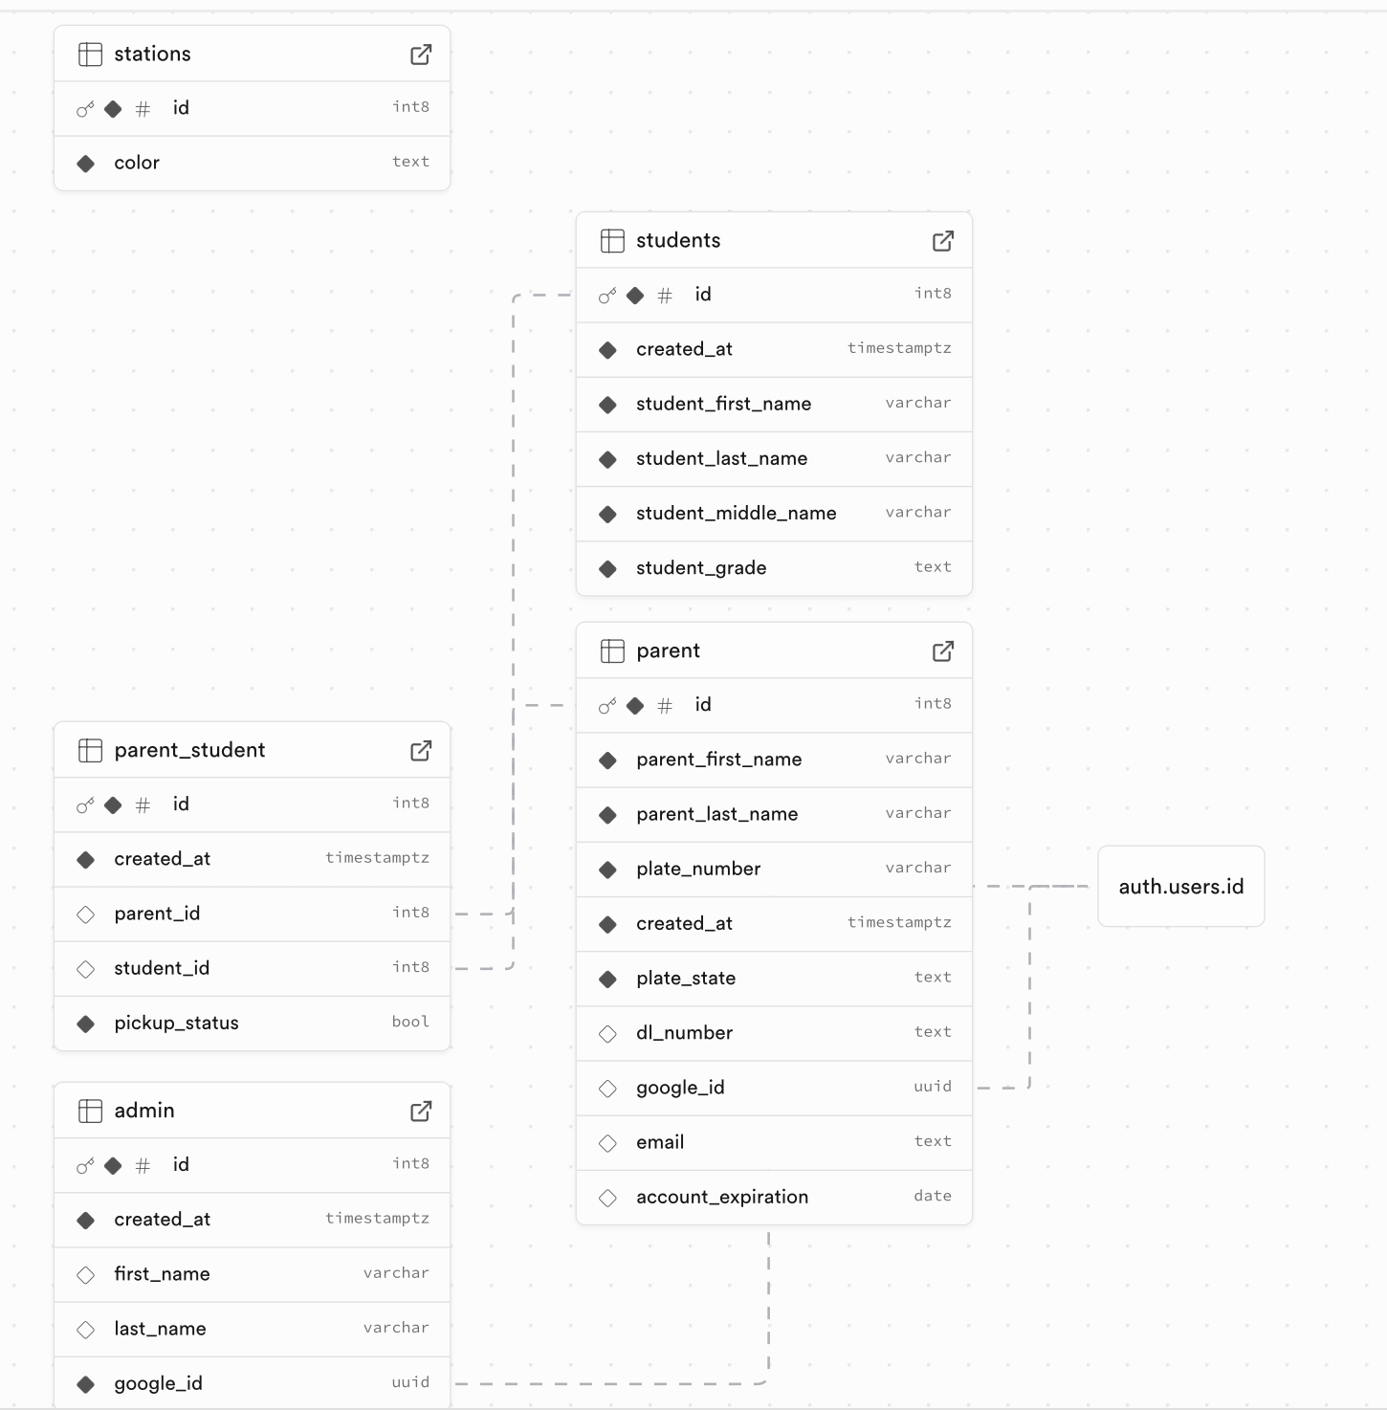
Figure 8: Database Tables and Relationships
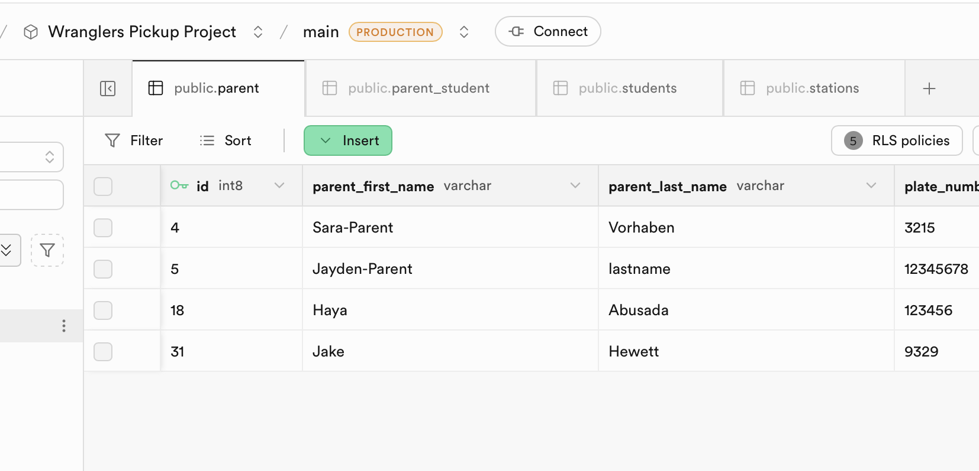
Figure 9: Database inserts connected to software
Hardware Setup
The hardware platform for the project has also progressed significantly. A Raspberry Pi system has been configured and connected to the network using SSH. The camera module has been tested successfully and can capture images that will later be used for vehicle identification and recognition algorithms.
Testing confirmed that the Raspberry Pi camera can reliably capture images and store them for processing. This capability will later be used for license plate recognition or QR code verification, depending on the final system configuration.
Below is a captured image using the raspberry pi camera.
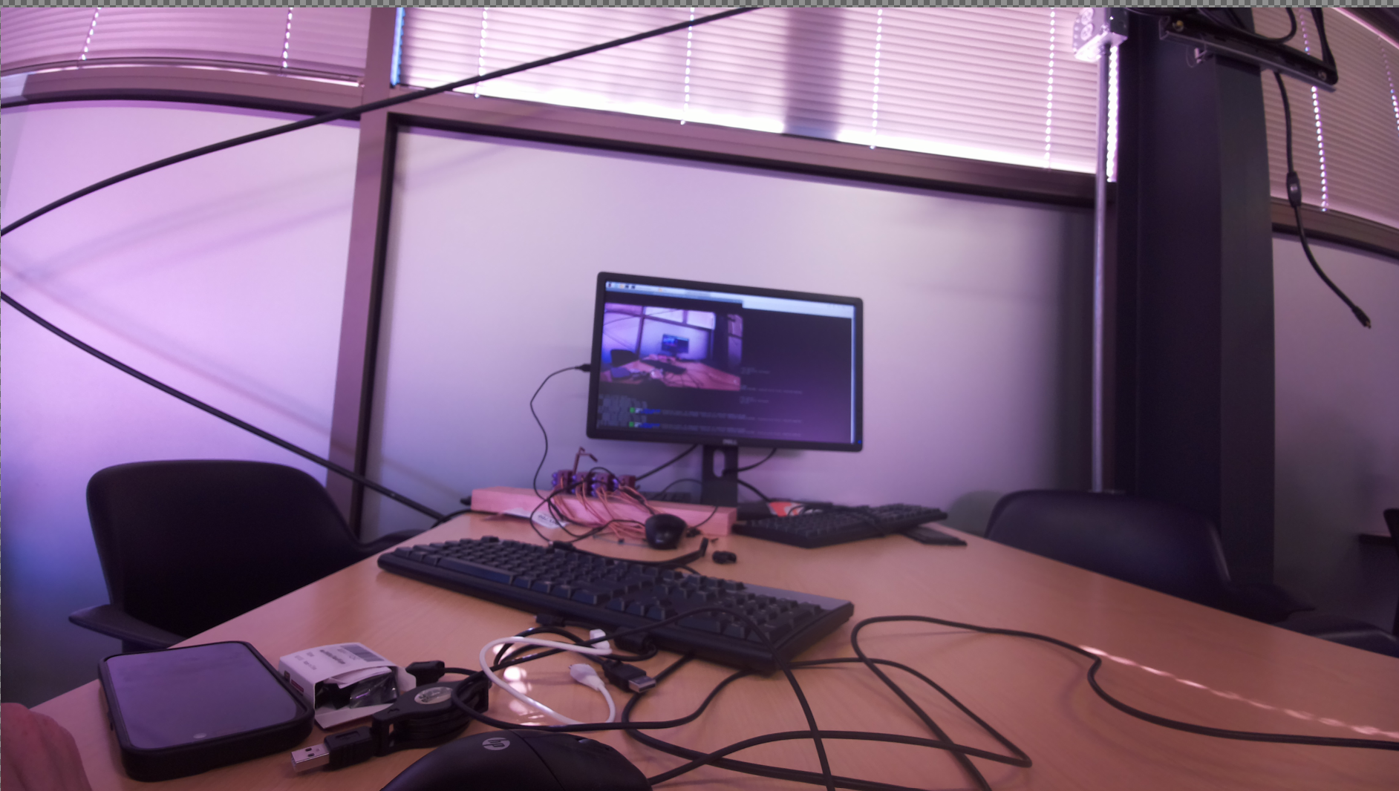
Figure 10: Image captured from camera connected to raspberry pi
And here is how license plates are picked up.
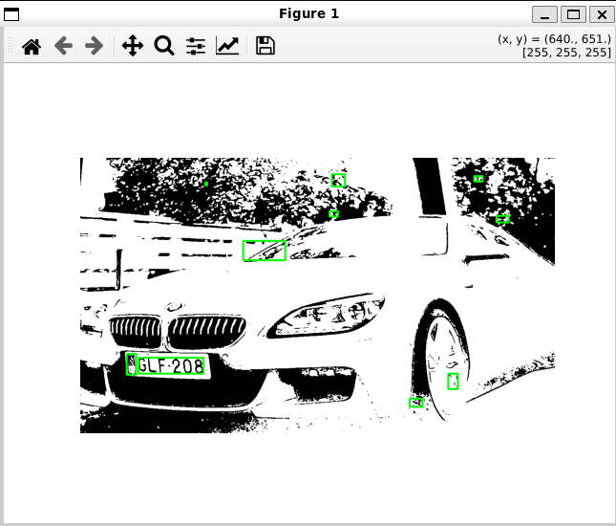
Figure 11: License plate picked up via camera on a car

Mechanical Design
The mechanical design of the system housing has begun, and CAD models for the device enclosure have been created. These models ensure that all hardware components can be securely mounted and protected. Measurements of hardware components have been completed to support the design of the enclosure.
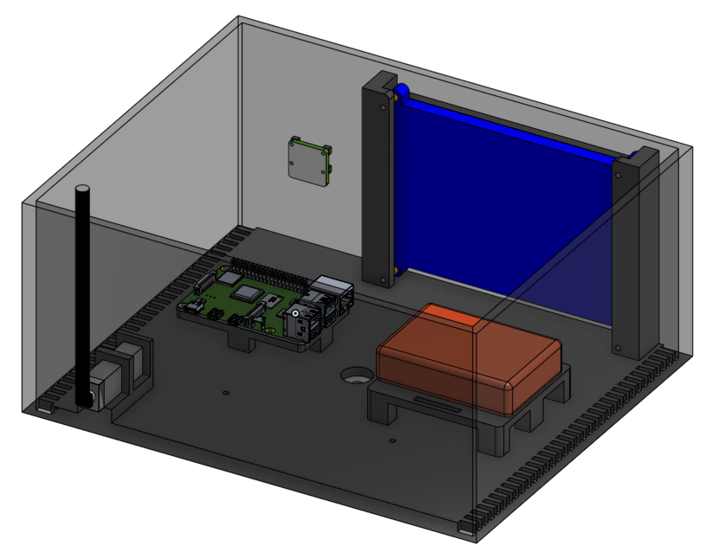
Figure 12: 3D Enclosure design
System Communication and Development Environment
The development environment for the project has been successfully established. The team has configured communication and collaboration tools including GitHub for version control, Discord for communication, and Google Drive for document sharing.
Github and Google Drive
These tools allow team members to collaborate effectively and maintain synchronized development across hardware, software, and mechanical components.
Current System Status
Overall, the project is currently progressing according to schedule. Major foundational components, including the database infrastructure, website interface have already been implemented and tested. The next phase of development will focus on integrating these components into a fully functional system capable of automating the school pickup process.

References
[1] College Towns, “The School Car Pickup Line Is a National Embarrassment”, College Towns, 2025.
[Online}. Available: https://www.collegetowns.org/p/the-school-car-pickup-line-is-a-national

