Car Rider Pickup System



Project Proposal

Team name
Haya Abusada
Jake Hewett
Jayden Pearson
Jack Uehlinger
Sara Vorhaben

Department of Computer Science
Texas A&M University

Date: 02/13/2026
Table of Contents
1 Executive summary 2
2 Introduction 3
2.1 Needs statement 3
2.2 Goal and Objectives 4
2.3 Design constraints and feasibility 6
3 Literature and technical survey 7
4 Proposed work 8
4.1 Evaluation of alternative solutions 8
4.2 Design specifications 9
4.3 Approach for design validation 14
5 Engineering standards 15
5.1 Project management 15
5.2 Schedule of tasks, Pert and Gantt charts 16
5.3 Economic analysis 18
5.4 Societal, safety and environmental analysis 19
5.5 Itemized budget 19
6 References 21
7 Appendices 21
7.1 Product datasheets 21
7.2 Bios and CVs 22

Executive summary
School pickup lines in the United States have become crowded and inefficient. Over 70% of students now rely on car rides. This rise results in long wait times, traffic jams on local highways, and serious safety risks for both students and drivers. Current technologies like manual apps, geofencing, and QR code scanners often depend on unreliable GPS, require active parent involvement, or consume a lot of staff time. To fill this gap, our team created an Automated School Pickup System. This modular, camera-based solution aims to simplify vehicle identification and student pickup without needing manual check-ins or constant staff support.

The project's goal was to create a system that automates the car pickup process to significantly cut down on wait times and improve safety. Our objectives included making weather-resistant hardware modules, integrating License Plate Recognition (LPR) with low-power microcontrollers, building a reliable hybrid network with Zigbee and Wi-Fi, and making sure the system meets the strict safety standards of the Texas Family Code on student release.

The system design has four interconnected modules: a tripod-mounted Car Entrance Module with a camera and Raspberry Pi, a Zone Pickup Module for staff management, a Main Server for database logic, and a Kids Waiting Module with a large indoor display. When a vehicle enters the line, the entrance module captures the license plate, processes the image on-site, and sends the data through a low-power Zigbee mesh network to the server. The server quickly matches the plate with the student database and updates the displays, directing the driver to a specific zone and alerting the student inside to go to that zone. The design includes 3D-printed housings that can withstand 20 mph winds and uses rechargeable battery banks, making the system portable and independent of the school’s power supply.

The system aims for key performance goals, targeting under 5 seconds of processing time from image capture to display update and a 30% reduction in overall pickup time. To ensure safety, the identification algorithms are designed to achieve 100% accuracy in matching students with authorized guardians. The hardware setup focuses on durability and modularity, allowing component replacement in less than 15 minutes. Our economic analysis shows that a prototype can be built for under $250 (not counting provided materials) and offers better features than costly commercial systems that depend on manual input.

During the project, our team employed structured engineering and project management methods, using Monday.com to track dependencies, timelines, and tasks. We defined clear roles based on individual strengths, covering areas from software and network design to hardware CAD and database management, to support efficient parallel development. We used tools like Python for image processing, Zigbee for communication, and 3D printing for quick prototyping to promote collaboration and ensure the smooth integration of the four subsystems.

Introduction

Needs statement
School pickup via the car rider line has been increasing in the US over the years leading to an increase in line length and pickup time. Now, over 70% of students are picked up from school via the car rider line. Car rider lines have become congested, posing a safety issue for both the students and other drivers. With more students attending school, car rider lines have become too slow and cause parents to wait up to over an hour in line leading to frustration. Some studies show that the car rider pick-up line starts to form 1-2 hours before school actually gets out, which leads to traffic backing up local highways and streets, and even frequent accidents. Inclement weather further slows the line, as students who ride the bus or bike to school will often be picked up by their parents in the car rider line to avoid the weather. Additionally, 5-10 staff members are required to set up and run the pickup process, diverting their time away from the education of students. An automated system is needed to streamline the pick-up process to decrease delays and safety issues.

Goal and Objectives
Goal
The goal of this project is to design and prototype a system that will help automate the car rider pick up process at schools. The system is built to reduce the amount of time necessary to pick up students from school.

Objectives
The system will allow parents to update their information (license plate numbers, approved adults for pickup, car rider schedules) via a website with approval from a staff member of the school. The system will read the marker on the car (license plate, QR code, nametag) as it enters the pickup line and send the information to a server. The server will identify the parent and child associated with the car marker, and update a display at the entrance of the pickup line to direct the car to the proper station. The laptop at the front of the school is updated to inform the students and staff which child is being picked up, and which zone to go to.

Marketing Requirements
- Make the pickup process faster for parents
- The system should be easily updated
- The system should be low cost
- The system should be easy to use/install
- Information must be validated if updated or inserted
- Student safety should be ensured (information, physical, etc.)
- The system should be reliable

Engineering Requirements
Marketing Requirements | Engineering Requirements | Justification
1 | Pickup time should be reduced by 30% per 100 kids. The time from the car entering the view of the camera to information being displayed should be no more than 5 seconds. | Based upon an average pickup time of 45 minutes, an automated system can obtain a significant improvement. Image processing, information relay, and database queries should have little delay.
4 | 7 inch (diagonal) display screen to give station and process instructions clearly. | 7 inches is considered the perfect size for basic instructions. Most car screens range between 7-9 inches.
1, 6 | Per Texas Family Code, ensure that students are referred to authorized parents 100% of the time. | By following the code, the system will only send students to the correct cars, which guarantees the student’s safety and prevents confusion and delay.
6 | Private Information stored in the database should be encrypted using 128 bit encryption. | Encrypted communications about student data prevents possible eavesdropping of sensitive student data, contributing to the overall safety of the student.
7 | Should have a stable connection from within 1 kilometer, stable power to all components. | Connection methods (WiFi, Ethernet Bridge, IoT Data Sim) are all reliable well over 1 kilometer. A power bank will be able to provide substantial power to the hardware system.
1,6,7 | Should correctly identify/assign parents to kids 100% of the time. | Based on current AI image recognition capabilities, an accuracy of 100% is achievable.
3 | The costs for developing the system should not exceed $300. | This is based upon hardware cost analysis.
2,4,5 | The system should allow parents to submit a request to the school to update information and the school should receive the request all within 1 minute. | The modification is easy to make, as evidenced by the speed of the interaction. Since this process ends in a request, the school therefore validates the request, satisfying 5.
4 | The system should have a modular design such that failed components  can be replaced by a technician in under 15 minutes. | Minimal downtime to prevent the loss of efficiency (30% quicker pickup time).
4,7 | The system should be mounted correctly on a tripod to ensure stability and prevent hazards. Sandbag/Weights of at least 1 pound to keep it grounded. | For 20mph wind 5-15 pounds of ballast is generally needed to prevent movement.
7 | The software will comply with the Digital Millennium Copyright Act. | Compliance is required by law.
2,4,5,6 | Staff should be able to access databases with provided credentials and view all parent to children links. | Student information should be easily alterable in case of changes in student transportation methods as well as verification of student/parent information.
4,7 | The system should be able to withstand 20mph wind. | Average wind speeds in College Station are 7-10 mph.
1 | Minimum 40inch (diagonal) display screen to give station and process instructions clearly inside in the pickup . | Students should be able to see the screen to know it is their turn to leave when their parents arrive.
6 | The website must prevent unauthorized views and edits and require school approval for changes. | Student information should be protected and secure against unauthorized modification.

Design constraints and feasibility
Technical & Temporal
- The system must execute image capture, processing, and display updates in < 5 seconds while maintaining 100% identification accuracy to comply with the Texas Family Code.
- Achieving this speed on low-power hardware (Raspberry Pi) without false positives is the primary engineering challenge.
Physical & Environmental
- Components must be weather-resistant and withstand 20mph winds using a modular tripod system as well as heavy rain and other inclement weather.
- The system must be fully portable, relying on a rechargeable battery bank capable of powering the Pi, camera, and display connectivity without grid access.
Economic
- The budget of $250 is the maximum amount that the university will reimburse, and is not a hard limit, but the goal is to not go over that limit, excluding the hardware that can be provided for free.
Feasibility Assessment
- The project is highly feasible using mature, documented technologies (Python image processing, Wi-Fi).
- The main concern we have is creating an entire system that is fast, accurate and reliable while staying within our budget.

Literature and technical survey
Efforts to streamline school pickup processes have led to multiple commercial and software-based solutions that use technology to reduce congestion, increase safety, and provide better communication between parents and school staff. While none of these directly use the same license-plate recognition approach proposed in this project, they provide context for existing approaches and inform design decisions.

- Existing System 1: PikMyKid Car Line Solutions
  - PikMyKid provides a digital car line management platform that helps schools organize dismissal processes through a cloud-based dashboard. Parents use the app to change pickup methods, authorize others, and "announce" their arrival, which notifies staff to send students out. With minimal setup, schools can create a daily pickup queue and generate reports that help administrators track student pickups. The system’s simplicity and low entry barrier demonstrate how digital tools can replace manual record-keeping and reduce carline confusion [2].
- Existing System 2: Beeline Smart Dismissal Platform
  - Beeline is designed to reduce congestion and improve safety by coordinating communication between school staff, parents, and student information systems. Using geofencing, it automatically detects registered cars within 50 feet, alerting staff in real-time, allowing teachers to send students to cars in order. According to the product description, schools using Beeline report reduced pickup times and improved dismissal organization, with integration into existing systems and training provided as part of the setup [3].
- Existing System 3: Car-Pool App with Geofencing and ETA Alerts
  - Car-Pool is a mobile and web-based app that uses geofencing to detect when a parent’s vehicle enters the vicinity of the school, alerting staff in real time so students can be staged and ready before arrival. This approach demonstrates how location-based services can automate check-ins without additional hardware. The platform also provides dashboards for staff to manage live dismissal flows and override settings as needed [4].
- Existing System 4: iSchoolRide PickupLine and Tracker
  - iSchoolRide is another digital carline tracking solution that uses GPS-based check-in from parents’ mobile devices. The system notifies administrators as vehicles approach so students can be released just in time. This improves safety by keeping students inside until the vehicle arrives and reduces the manual effort needed from staff to call student names or monitor carline progression [5].
- Existing System 5: QR Code-Based Pickup (Kids Pick Up App)
  - The Kids Pick Up App uses personalized QR codes assigned to each student; parents present the QR code from their dashboard or mobile device at pickup. Staff can scan these codes quickly to verify authorized pickups and send dismissal data to classroom dashboards. While QR codes are simple and inexpensive, implementation still relies on visible codes and scanning by staff [6].
Survey Summary
These solutions illustrate the range of strategies being used to address pickup line inefficiencies: simple digital queuing, geofencing with mobile check-in, GPS alerts, and QR code scanning. All designed to reduce time, congestion, and staff overhead. However, most still depend on staff scanning, parent interaction, or smartphone technologies, and they do not fully automate the identification of vehicles with minimal human involvement. The proposed system aims to build on these concepts while introducing a more automated, reliable method of vehicle identification and student association tied to real-time display systems.
Relationship to Proposed Design
While existing dismissal systems demonstrate meaningful improvements over fully manual pickup processes, they continue to rely on parent interaction, mobile applications, GPS accuracy, or staff-performed verification steps. These dependencies introduce delays during peak traffic periods and reduce reliability in poor weather or connectivity-limited environments. The proposed system distinguishes itself by emphasizing automated, camera-based identification with minimal parent interaction after initial setup. By eliminating the need for daily check-ins, QR scanning, or app usage, the proposed design targets a niche between low-cost manual systems and complex, privacy-sensitive solutions, offering a faster, more scalable, and operationally practical alternative for high-volume school pickup environments.

Proposed work

Evaluation of alternative solutions
This section evaluates five alternative technical solutions for improving school pickup efficiency, including pros and cons, and explains why a more automated recognition system is recommended.
- Alternative Solution 1: Manual Pickup Apps (PikMyKid Free Car Line)
  - PikMyKid’s free car line tool streamlines dismissal with a simple dashboard without specialized hardware [2].
  - Pros: Easy to implement, low cost, reduces paperwork.
  - Cons: Still requires staff to manage the queue, does not automate identification, and provides limited real-time detection of arriving vehicles.
- Alternative Solution 2: Integrated Dismissal Management (Beeline)
  - Beeline enhances pickup organization and integrates with school information systems [3].
  - Pros: Improves communication and reduces staff workload; integrates with existing systems.
  - Cons: Requires training, infrastructure for integration, and still depends on staff monitoring rather than automatic vehicle recognition.
- Alternative Solution 3: Geofencing-Based Systems (Car-Pool)
  - Uses GPS to detect when a parent’s vehicle approaches the school [4].
  - Pros: Real-time alerts, reduced reliance on manual check-ins, provides staff with live queue info.
  - Cons: Reliant on mobile devices having location services enabled and good GPS accuracy; may not work well in all weather conditions or areas with weak cellular coverage.
- Alternative Solution 4: GPS Check-In Apps (iSchoolRide)
  - iSchoolRide triggers automatic server updates when parents reach the pickup zone [5].
  - Pros: Keeps students inside until the ride arrives, it reduces early student staging and idle time.
  - Cons: Dependent on accurate GPS positioning and consistent parent behavior (e.g., app usage); may still need staff to verify pickups.
- Alternative Solution 5: QR Code Recognition Systems (Kids Pick Up App)
  - Parents present QR codes that staff scan to verify pickup authorization [6].
  - Pros: Simple technology, affordable, avoids mobile service requirements.
  - Cons: Requires code visibility and scanning by staff, slowing vehicles; environmental conditions (glare, bad weather) can interfere with scanning.

Alternative Solutions Summary
Each alternative offers advantages in safety, organization, and efficiency compared to manual dismissal; however, they still rely heavily on either staff input or parent interaction, and do not fully automate vehicle identification in real time. The selected solution (automatic visual recognition tied to a backend with real-time display) is designed to build on the strengths of these existing strategies while minimizing staff involvement and improving throughput during heavy traffic periods.

Justification
Although each alternative solution offers improvements over traditional manual dismissal, all evaluated approaches retain dependencies on staff input, parent compliance, or mobile device reliability. These dependencies limit throughput and introduce variability under real-world conditions such as inclement weather or peak traffic congestion. The selected solution prioritizes automated visual identification integrated with a centralized database and real-time displays, enabling faster vehicle processing and reduced staff intervention. This approach best satisfies the project objectives of minimizing pickup time, maintaining correct student-parent matching, and improving overall safety while remaining feasible within technical and economic constraints.

Design specifications
High-Level Block Diagram:
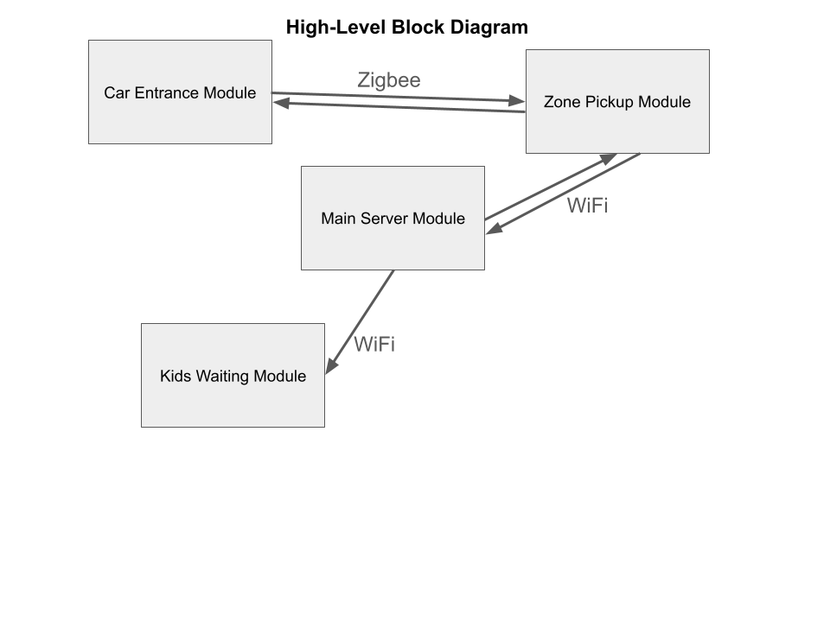
Figure 1: High-level block diagram of the system. The car entrance module will communicate with the zone pickup module through a wireless network called Zigbee. The zone pickup module, main server module, and kids waiting module will all have access to WiFi while the car entrance module will relay information solely through Zigbee.

Car Entrance Module:
The Car Entrance Module will be placed at the entrance of the pickup line, on the sidewalk next to the road. The side of the module that contains the display and camera as seen in figure 2 will face the road, with a clear view of the approaching cars. The camera will take a picture of the car, and the microcontroller will run license plate recognition software to identify the license plate number. The microcontroller will send a small packet to the zone pickup module, using zigbee, that contains the license plate number. The microcontroller will wait for a response from the zone pickup module, and then update the display accordingly. The display will show the kid of the parent, and instructions on which zone to proceed to.

This module will not have access to external power supplies or connections such as WiFi, therefore it needs to be completely self-powered. A sufficient rechargeable battery will be used to power the module, while a zigbee antenna will be used to transmit information. These hardware components will be covered by a 3D printed housing, which will protect the components from overheating in the sun and from light rain. This housing will be mounted to a tripod, so the display is readable by someone sitting in a car while the camera can have a proper view of the approaching cars.
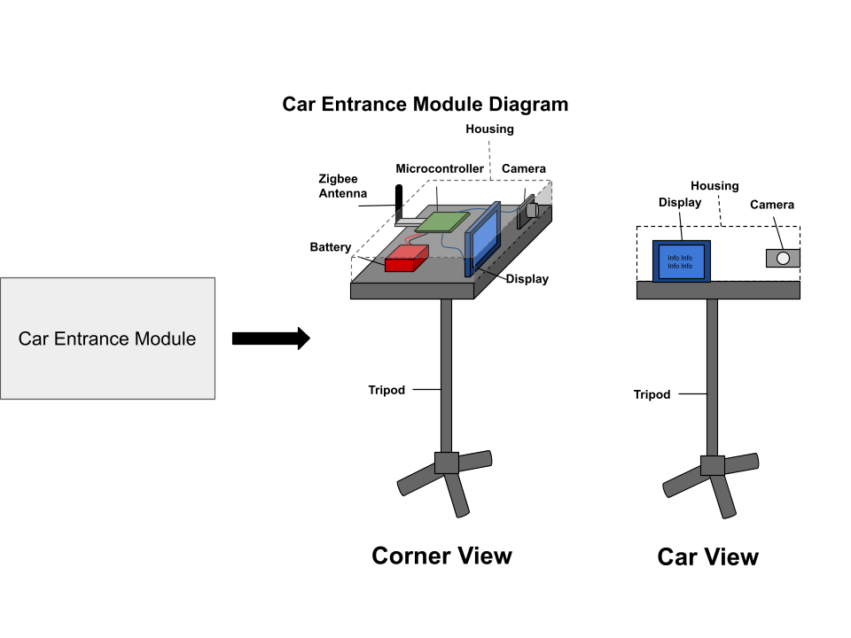
Figure 2: Rough blueprint for the car entrance module. The housing will be placed on a tripod, and the display and camera will be placed in view of the car line. The antenna will exit the housing from the side, while the microcontroller and battery will be fully enclosed.
Parts List:
Table 1: A parts list of materials that are needed to build the car entrance module.
Car Entrance Module | Amount Needed | Cost per Unit | Total Amount
Tripod | 1 | $22 | $22
Raspberry Pi | 1 | $75 | $75
Raspberry Pi Camera | 1 | $55 | $55
Camera Lens | 1 | $50 | $50
Zigbee Antenna | 1 | $27 | $27
Rechargeable Battery | 1 | $40 | $40
7-inch display | 1 | $38 | $38
Mounting Screws | ~20 | $8 (600 pcs) | $8
Wires | ~5 | $10 (240 pcs) | $10
Total Cost | $325

Zone Pickup Module:
The Zone Pickup Module will be placed at the location of the pickup zones, which is also outside. The three main purposes of this module are to display pickup information on a screen for staff and kids to see, to act as a hub for the zigbee wireless communication, and to allow staff to update the system once a kid has been picked up. The screen will be connected to the microcontroller using hdmi, and it will display the website that shows the zone pickup information as seen in figure 3. This information will include each separate zone with a list of kids that are being picked up at each zone. Since this module is also outside and close to the entrance of the pickup line, zigbee connection will be strong and reliable. This module will receive packets of information from the Car Entrance Module, and relay that information to our Main Server Module using WiFi. It will then relay any updates from the Main Server Module to the Car Entrance Module using the zigbee connection. The button submodule will consist of a button for each pickup zone, and the button will be pressed once a kid has been picked up. The microcontroller will recognize once a button has been pressed, and send the information to the server to update the list on the website.

Because this module is also outside, it will need to be self-powered like the Car Entrance Module. A rechargeable battery will be used to power the module, and a 3D printed housing will enclose the battery and microcontroller. A zigbee antenna will be connected to the microcontroller which will transmit information to the Car Entrance Module. The button submodule will be separate from the main housing, and will use GPIO pins to communicate.
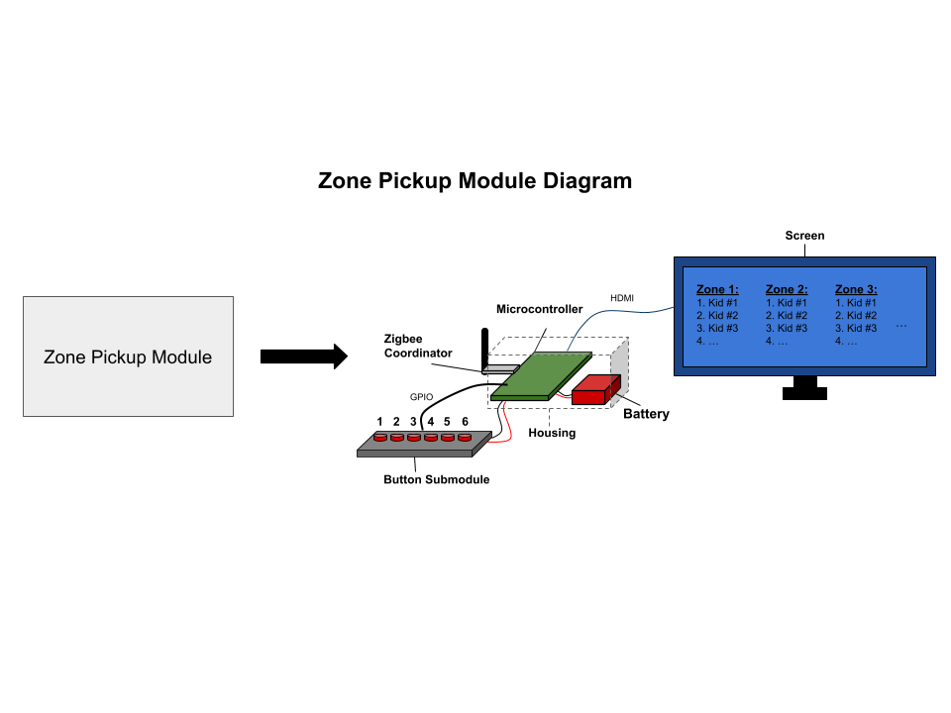
Figure 3: Rough blueprint for the zone pickup module. The housing will enclose the microcontroller and battery, while the antenna will exit the housing from the side. The screen will connect to the microcontroller using HDMI. The button submodule will connect to the microcontroller using GPIO pins.

Parts List:
Table 2: A parts list of materials that are needed to build the zone pickup module.
Zone Pickup Module | Amount Needed | Cost per Unit | Total Amount
Raspberry Pi | 1 | $75 | $75
Zigbee Antenna | 1 | $27 | $27
Rechargeable Battery | 1 | $40 | $40
27-inch monitor | 1 | $97 | $97
Push Buttons | 6 (depending on number of zones) | $11.50 (24 pcs) | $11.50
Mounting Screws | ~20 | $8 (600 pcs) | $8
Wires | ~15 | $10 (240 pcs) | $10
HDMI Cord | 1 | $4 | $4
Total Cost | $272.50

Main Server Module:
The Main Server Module will act as the command center for all modules, and it will be hosted on a computer located in the school’s office. The main server has 4 main functions:
- Host a website that is displayed on the screens in the Zone Pickup Module and the Kids Waiting Module. The website will be updated in real time depending on the information it receives from the Zone Pickup Module. This information will include license plate numbers and signals when a kid has been picked up at a zone.
- Connect to a database that contains information about the kids parents, pickup schedule, and license plate number. The server will query the database when it receives a licence plate number, and relay the information to the Zone Pickup Module accordingly to send to the Car Entrance Module.
- Handle information update requests from parents. Parents will have the option to submit a request to update their information using the website. Once approved by an administrator, the server will automatically update the database.
- Send updates to the display in the Car Entrance Module. Once the server queries the database and finds the parent/kid matching the license plate number, it will send that information to the Car Entrance Module to update the display. The way this connection works is:
  - Server ←→ WiFi ←→ Zone Pickup Module ←→ Zigbee ←→ Car Entrance Module
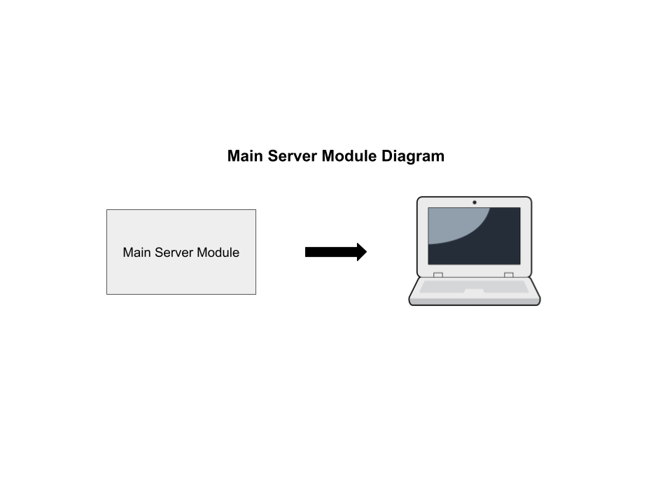
Figure 4: Rough blueprint for the main server module. The module will contain a separate computer that hosts a server and controls the different modules, for example the website displayed in the zone pickup and kids waiting module, and the display on the car entrance module.

Parts List:
The main server module will be hosted from a computer in the schools administration office, meaning that a pre-existing computer will be sufficient for this module. This results in this module's total cost being $0 as seen in Table 3.
Table 3: A parts list of materials that are needed to build the main server module.
Main Server Module | Amount Needed | Cost per Unit | Total Amount
Total Cost | $0

Kids Waiting Module:
The Kids Waiting Module will consist of a large TV, which will display the website. This TV will be placed where the kids are waiting to be called. Once a license plate has been read, the server will update the website and a new kids name will appear under a zone. This will inform the staff and the kid which zone to go to.
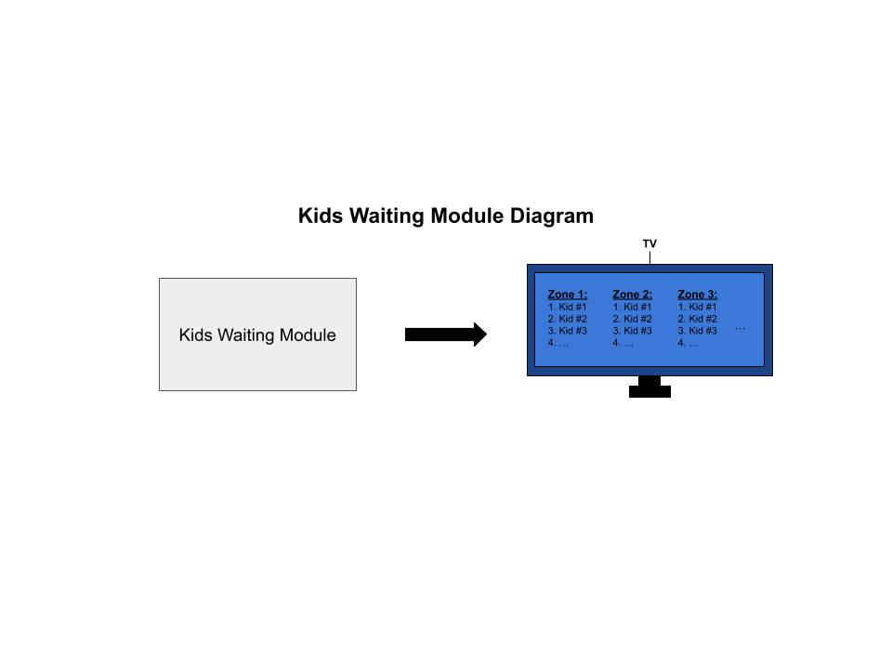
Figure 5: Rough blueprint for the kids waiting module. The module will contain a large TV that displays the pick up line instructions website.

Parts List:
Table 4: A parts list of materials that are needed to build the kids waiting module.
Kids Waiting Module | Amount Needed | Cost per Unit | Total Amount
55-inch TV | 1 | $180 | $180
Total Cost | $180

Approach for design validation
Since the system is broken up into 4 modules, validation will take place at each module first, then the interconnectedness at the end. As a reminder, the system should meet the marketing requirements, which can be done by testing the engineering requirements against the system.

Car Entrance Module
Firstly, the system needs to be able to receive camera input, and parse the resulting feed for a license plate. This can be tested by holding some text in front of the camera at different distances and at different angles, and having the program simply output the detected license plate to the screen. If the module can display the text within 5 seconds, then the module can move to the next test.
Since the module will be powered by rechargeable batteries, we will leave the module on for 2 hours and monitor its battery level. The battery level at this point should be low, but still have charge left. This will pass the requirement of stable power, as we expect the car rider line to finish faster than 1 hour, giving the battery more than double the minimum life it needs.

Zone Pickup Module
The Zone Pickup Module is the bridge between the Car Entrance Module and the Main Server Module, thus much of the testing for this module will take place during system integration. However, there are a few features that must be validated first.
Testing internet connection is a simple task. To verify an internet connection, we may open a web browser on the microcontroller and attempt to connect to any website. Next comes testing the buttons, which can have some text display on the screen when a button is pressed. Finally, the battery can be tested in the same manner as the Car Entrance Module. These tests will be fundamental to the system integration tests.

Main Server Module
Firstly, connection to the database backing up the web server must be tested. This can be done by having the web server make an update to the database, then requesting the information that was just updated, and validating the results. Next, a member of the team will access the website from their laptop/phone and request an information update. The server should respond by having an alert that a parent is requesting information change, and allow the school staff’s webpage to accept or reject the request. Accepting the request should update the database, and rejecting should not.
Additionally, only the school staff should be able to access the staff website. If members are able to enter the link of the staff page while not signed in, the server should route them to the login page, which will prevent unauthorized access to the database.

Kids Waiting Module
This module only needs to test for internet connection. Most of the validation concerning the Kids Waiting Module will take place during system integration.

System Integration
First, the Zigbee system will need to be validated. To verify the Zigbee system, the Car Entrance Module should ping the Main Server Module, otherwise, there is a break in the network. The screen in the Zone Pickup Module and the Kids Waiting Module should be able to connect to and display the current queues.
Finally, the system as a whole shall be tested. When a license plate comes into view of the camera, the directions given to the driver should appear in no more than 5 seconds. Similarly, the queues displayed on the Zone Pickup and Kids Waiting modules should be updated in no more than 5 seconds. When a student leaves the queue and a teacher presses the correct button, the queues displayed on both modules should update.

Engineering standards

Project management
All of the members of the group have experience with software development, testing, debugging, and reporting, thus everyone will share these responsibilities. Jack will be the team leader, who will ensure the team stays on pace and the team remains cohesive. Jack also has networking experience, so he will be working on networking. Jayden has experience with CAD and 3D printing, and thus is in charge of the hardware engineering. Sara has experience with web applications development, and will be working on building the web server and database. Haya has experience with control systems of many kinds, and would be able to work on the OCR technology well. Jake has experience with embedded systems and web applications, making him qualified and flexible to work on any system that is requiring more attention.
We will be using Monday for project management. Monday keeps track of action items, dependencies, project timeline, and division of labor. Members can track progress and find areas of need easily by seeing items not yet completed, and can step in to help.
Below is a general distribution of labor, according to the strengths of our group.
Haya Abusada
- Software Design
- Hardware Design
- Testing
- Technical Reporting
Jake Hewett
- Software Design
- Testing
- Technical Reporting
- Finances & Purchases
Jayden Pearson
- Hardware Design
- System (Network) Design
- Software Design
- Testing
- Technical Reporting
Jack Uehlinger
- Team Leader
- Systems (Network) design
- Software Design
- Testing
- Technical Reporting
Sara Vorhaben
- Software design
- Documentation
- Testing
- Technical Reporting
- Database

Schedule of tasks, Pert and Gantt charts
The project schedule was developed in order to ensure that all major milestones could be completed within the semester. Figure 6 shows the Pert chart, which was used to determine task dependencies and the critical path of 45 days, which is highlighted in red.

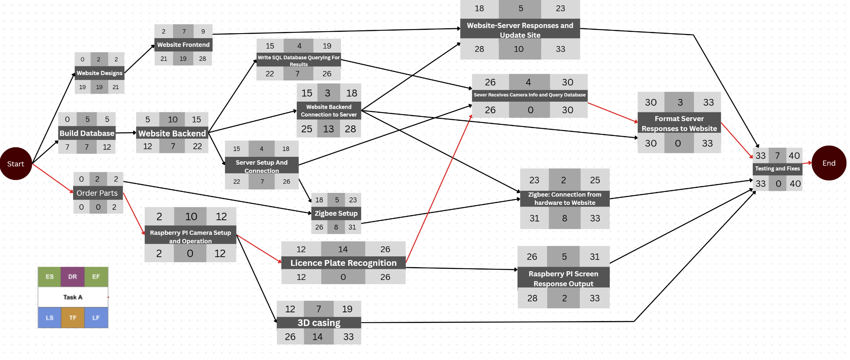
Figure 6: Project Pert Chart
The Gantt Chart shown in Figure 7 was created to visualize the timeline, duration of each task and the overlaps of events. Based on the Gantt chart, the longest time will be spent on both the Raspberry PI camera setup and the plate recognition from the image.
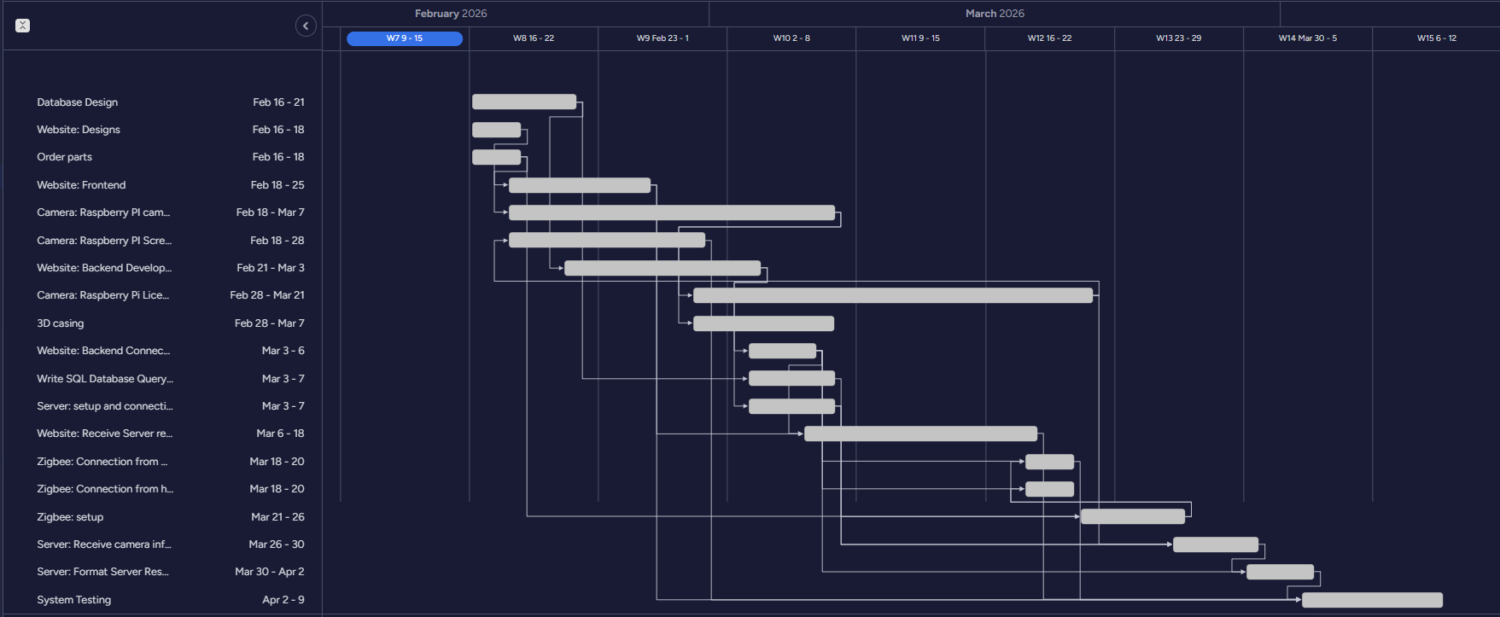Figure 7: Gantt Chart
The project can be broken down into several different subtasks. Our estimated start and end dates for each of the different tasks are listed in Table 5 below.
Table 5: Schedule of Tasks
Name | Start Date | End date
Build Database | 2/16/2026 | 2/21/2026
Website: Designs | 2/16/2026 | 2/18/2026
Website: Frontend | 2/18/2026 | 2/25/2026
Website: Backend Development | 2/21/2026 | 3/3/2026
Website: Backend Connection to Server | 3/3/2026 | 3/6/2026
Website: Receive Server responses and update site | 3/6/2026 | 3/18/2026
Camera: Raspberry Pi Licence Recognition | 2/28/2026 | 3/21/2026
3D casing | 2/28/2026 | 3/7/2026
Write SQL Database Querying For Results | 3/3/2026 | 3/7/2026
Server: setup and connection | 3/3/2026 | 3/7/2026
Camera: Raspberry PI camera setup and operation | 2/18/2026 | 2/28/2026
Camera: Raspberry PI Screen Response Output | 3/21/2026 | 3/26/2026
Zigbee: setup | 3/6/2026 | 3/18/2026
Order parts | 2/16/2026 | 2/18/2026
Zigbee: Connection from website the server | 3/18/2026 | 3/20/2026
Zigbee: Connection from hardware to the Website | 3/18/2026 | 3/20/2026
Server: Receive camera info and query the database | 3/26/2026 | 3/30/2026
Server: Format Server Responses to Website and Display | 3/30/2026 | 4/2/2026
System testing | 4/2/2026 | 4/9/2026

Economic analysis
- Economic Viability: potential marketability of the system, expected volume production costs (as opposed to prototyping costs)
According to the National Center for Education Statistics, there are 70,055 Prekindergarten, Elementary and Middle Schools [7]. Each of these schools must have some kind of school pickup system to get kids home from school, so there is a large demand for a system that works. Additionally, preschools and private schools could also implement this system further increasing the market. Since our system would provide a faster way to pick up students, parent and teacher time would be freed up, allowing them to spend their time in more productive ways. As this project expands from prototype to production, costs could go down from ordering in bulk. 3D casing could be mass produced and items ordered in bulk would cause the overall cost per unit to decrease.
- Sustainability: Are system parts available from more than one vendor? What maintenance and support will the product require?
Most of our parts are available from more than one vendor. Parts such as Raspberry PIs, Zigbee devices and rechargeable batteries can be found from many different sources. Additionally, on the software side, the frameworks being used are standard software frameworks, ensuring support will remain for a long time. For regular maintenance for our system, customers will have to charge the rechargeable battery.
- Manufacturability: what is the effect of component tolerances on system performance?, worst-case analysis, expected production yield, testability and compliance to regulations (e.g., FCC)
Camera Placement is critical to the usability of our system because the camera must be able to read the licence plate. If the camera is in the wrong position or aligned wrong the system won’t be able to process the result. To solve this, a guide would need to be included in the commercial product to ensure customers correctly position the camera. Additionally, for a commercial product, the 3D printed casing must be designed to protect against wind and rain, ensuring that the camera and electronic components remain protected.

Societal, safety and environmental analysis
The impact of our student pick up system could have several major societal benefits. By streamlining the dismissal process, students are able to be picked up in a more efficient manner, saving time for both teachers and parents. This improved pick up system will allow pickup to run more smoothly, reducing daily stress and allowing teachers to spend more time on other responsibilities. The system also requires minimal effort from the parent at pickup. They wouldn’t have to remember to carry around a number tag or pull up a QR code at pickup. However, in order for the pickup system to work, parents will have to disclose their licence plate to the school as well as any custody relationships so that the system can ensure that the correct child goes home with the correct parent. Overall, this will increase pick up security, creating a digital check to ensure that students aren’t going home with the wrong parent.
Some safety considerations that the system will have to take into consideration are the safety of the kids. From a software standpoint, the licence plate system must be highly accurate. The camera must be placed in the correct way to ensure that it can accurately read the plates and correctly determine the correct student so they can be returned to the correct parent. Additionally, the system will need to ensure the security of the database, with no unauthorized access by system users or unapproved changes by the school being allowed. Operationally, student safety must be monitored. Clear procedures must be in place to ensure that kids don’t run into the street, get lost, or go home with the wrong parent.
The potential environmental impact is a reduction of idling. Since parents won’t be spending hours sitting in line before the car rider pickup, the amount of idling will be reduced. However, if the licence plate recognition is failing, the line could be extra long. To reduce this, we will ensure that the system is consistent and works well and have a plan if a plate can’t be scanned.

Itemized budget

Module | Component | Description | Qty | Unit Cost ($) | Total Cost ($)
Car Entrance | Tripod | Tripod to support car entrance module housing. | 1 | $22 | $22
Car Entrance, Zone Pickup | Raspberry Pi | Microcontrollers to control car entrance and zone pickup modules. | 2 | $75 | $150*
Car Entrance | Raspberry Pi Camera | Camera to use license plate recognition of cars. | 1 | $55 | $55*
Car Entrance | Camera Lens | Lens for camera (camera above does not include one and it is required to have one). | 1 | $50 | $50*
Car Entrance, Zone Pickup | Zigbee Antenna | Antennas for wireless communication between car entrance and zone pickup module. | 2 | $27 | $54
Car Entrance, Zone Pickup | 10000mAh Rechargeable Battery | Batteries to give sufficient power to the car entrance and zone pickup module. | 2 | $40 | $80
Car Entrance | 7-inch display | Display to inform the parent of the car what zone to go to, and verify we have matched their car with their kid. | 1 | $38 | $38*
Zone Pickup | 27-inch monitor | Display the website at the zone pickup location, to inform staff and kids which kids go to which zone. | 1 | $97 | $97*
Zone Pickup | Push Buttons | Buttons for staff members to press once a kid has been picked up, one button for each zone. | 6 | $11.50 (24pcs) | $11.50
Zone Pickup | HDMI Cord | HDMI cord to connect the microcontroller to the display. | 1 | $4 | $4
Kids Waiting | 55-inch TV | Large TV to display the website to all kids waiting to be picked up, as well as staff members waiting with the kids. | 1 | $180 | $180*
Car Entrance, Zone Pickup | 3D printing | 3D printed housings for car entrance and zone pickup modules. |  | $75 (allotment) | $75**
Car Entrance, Zone Pickup | Mounting Screws | Screws to securely mount components to housings. | ~40 | $8 (600pcs) | $8
Car Entrance, Zone Pickup | Wires | Wires to connect components. | ~20 | $10 (240pcs) | $10
Total* (not including components provided) |  |  |  |  | $189.50
Total |  |  |  |  | $834.50
*Note: Parts listed with * next to the total cost are provided for this project.
**Note: The FEDC provides a $75 allotment for any 3D prototyping.

References
[1] College Towns, “The School Car Pickup Line Is a National Embarrassment”, College Towns, 2025.
[Online}. Available: https://www.collegetowns.org/p/the-school-car-pickup-line-is-a-national

[2] PikMyKid, “FREE CAR LINE – Simplify Your Car Line Organization,” PikMyKid, 2026.
[Online]. Available: https://www.pikmykid.com/solutions/free-car-line-invitation

[3] Beeline, “Beeline School Dismissal Management Platform,” Beeline, 2025.
[Online]. Available: https://www.beeline.school/

[4] Car-Pool, “Safer, Smarter School Pickups,” Car-Pool.
[Online]. Available: https://car-pool.app/

[5] iSchoolRide, “PickupLine and Student Dismissal Tracking,” iSchoolRide.
[Online]. Available: https://ischoolride.com/

[6] Kids Pick Up App, “Student Pick Up Management System,” Kids Pick Up App.
[Online]. Available: https://kidspickupapp.com/

[7] National Center for Education Statistics (NCES), “Fast Facts: Educational institutions,” NCES Fast
Facts [Online]. Available: https://nces.ed.gov/fastfacts/display.asp?id=84

Appendices

Product datasheets
Raspberry Pi Datasheet:
- Raspberry-pi-4-datasheet.pdf
Raspberry Pi Camera Datasheet:
- 4561+Raspberry+Pi+HQ+Camera+Product+Brief.pdf
Zigbee Antenna Datasheet:
- Introduction - SONOFF Dongle

Bios and CVs
- Team member 1: Haya Abusada
Bio-sketch
Haya Abusada is a Computer Engineering undergraduate at Texas A&M University, College Station, Texas, where she is pursuing a Bachelor of Science degree with minors in Cybersecurity and Mathematics. Her academic interests include embedded systems, secure system design, and computer vision–based automation. She has completed coursework in data structures and algorithms, digital systems design, computer architecture, microcomputer systems, and software engineering. She has industry experience as a Computer Engineering Intern at QAPCO Petrochemical Company, where she worked with cybersecurity frameworks, distributed control systems, and programmable logic controllers. She is currently contributing to a capstone project focused on designing an automated school pickup optimization system using camera-based identification and real-time database integration.
Curriculum Vitae/CV
Education
Texas A&M University, College Station, TX August 2022 – May 2026
Bachelor of Science in Computer Engineering, Minors: Cybersecurity and Mathematics
Relevant Coursework: Data Structures and Algorithms, Digital Systems Design, Computer Architecture, Microcomputer Systems, Software Engineering
Skills
Programming Languages & Tools: Python, C++, R, Java, JavaScript, HTML/CSS, Verilog, MATLAB, SQL, React.js, Node.js, GitHub
Systems: Linux/Unix Shell, Microsoft Office
Soft Skills: Problem-solving, Team Collaboration, Adaptability, Written and Verbal Communication

Experience
QAPCO Petrochemical Company — Computer Engineering Intern June 2024 – July 2024
- Worked with cybersecurity systems, distributed control systems (DCS), and programmable logic controllers (PLC)
- Supported implementation of control routines using Honeywell Experion PKS
- Analyzed IT–OT data flow and system performance

Projects
Capstone Project – School Pickup Optimization System (In Progress)
- Designing an automated pickup system using a Raspberry Pi–integrated camera
- Implementing real-time database-backed vehicle and student identification
- Incorporating fallback identification mechanisms for reliability

Full-Stack Ordering and Inventory Management System January 2025 – May 2025
- Developed a React-based frontend and SQL-backed database
- Implemented backend logic for CRUD operations and inventory tracking

- Team Member 2: Jake Hewett
Bio-sketch
Jake Hewett is a Computer Engineering undergraduate at Texas A&M University, College Station, Texas, where he is pursuing a Bachelor of Science degree with a minor in Mathematics. His academic interests lie at the intersection of embedded systems, software development, and computer architecture. Jake has built a strong technical foundation through coursework in data structures and algorithms, digital systems, circuit design, and machine learning. He has practical experience developing software solutions, including a responsive personal portfolio built with HTML, CSS, and JavaScript, and has implemented complex problem-solving algorithms using Java, Python, and C++.

Curriculum Vitae/CV

EDUCATION
Texas A&M University, College Station, Texas August 2022 - May 2026
Bachelor of Science, Computer Engineering, Minor in Mathematics

Relevant Coursework: Electronics, Digital Systems, Data Structures and Algorithms,
Computer Systems, Machine Learning, Computer Architecture

PROJECTS
P.O.S. System August 2025 - December 2025
- Worked on a team as a full stack developer to implement a customer and manager interface.
- Used and queried an AWS database using SQL to create reports and tables as well as updating inventory based on orders
- Used multiple Google OAuth as well as multiple APIs to create a better user experience

Car Rider Pickup System (Capstone Project) January 2026 - Current
- Automated pickup system using Python image recognition
- Real-time vehicle identification using a database

SKILLS
Java, Python, C++, HTML, CSS, JavaScript, Raspberry Pi, Git/GitHub, Linux, Multisim
Microsoft Word, Excel, PowerPoint

- Team Member 3: Jayden Pearson
Bio-sketch
Jayden Pearson is an undergraduate senior at Texas A&M University studying Computer Engineering. He currently plans on completing his Master of Science in Computer Engineering at Texas A&M University. His academic interests include computer architecture, design verification, and VLSI. He has experience as a software development intern where he built an admin app in React for a social fitness network company called Arrow. He is currently contributing to a team for his senior capstone project, where the team is tasked with designing and implementing an automated school car rider pickup system.

Curriculum Vitae/CV
EDUCATION
Texas A&M University College Station, Texas
Bachelor of Science - Computer Engineering | GPA: 3.83 August 2022 – May 2026

EXPERIENCE
H-E-B College Station, Texas
Customer Service Associate June 2020 – Present
- Processed 50+ sales transactions per shift with 100% accuracy, ensuring positive checkout experiences.
- Resolved customer issues to support a 10+ person team and maintain smooth store operations.

Arrow Remote
Software Development Intern May 2024 – August 2024
- Delivered an admin app supporting 1,000+ users by developing React frontend features aligned with Figma designs.
- Integrated Firestore and Firebase Database to enable real-time updates and improve data reliability.
- Partnered with a 2-person team to launch production-ready features on schedule, improving moderation workflows.
- Reduced deployment issues by streamlining workflows with Git, Jira, and Firebase.

PROJECTS
Wall-Climbing Robot College Station, Texas
Raspberry Pi | Python | Onshape CAD February 2025 - May 2025
- Designed and built a wall-climbing robot powered by a brushless motor and propeller mounted on a lightweight 3D-printed chassis.
- Integrated a Raspberry Pi running Python with an Electronic Speed Controller circuit and custom power wiring.
- Generated sufficient thrust to maintain stable wall adhesion, enabling the robot to traverse vertical surfaces.

ACTIVITIES/LEADERSHIP
Freshman Reaching Excellence in Engineering (F.R.E.E.) College Station, Texas
Social Committee Member 23’, Counselor (Service Committee) 24’ October 2022 – May 2024
- Organization oriented towards developing leadership, social, and professional skills, with additional focus in the engineering field.
- Guided members through the first year of college, by providing experience and leadership while coordinating with 15+ counselors and executives.

SKILLS
Technical Skills: Verilog, SystemVerilog, Cadence Virtuoso, Xilinx Vivado, Python, C++, React, Javascript
Relevant Coursework: Digital Integrated Circuit Design (Graduate level), Hardware Design Verification, Computer Architecture, Electrical Circuit Theory, Signals and Systems, Microcomputer Systems, Data Structures and Algorithms

- Team Member 4: Jack Uehlinger
Bio-sketch
Jack Uehlinger is a Computer Engineering major at Texas A&M University with minors in Cybersecurity and Mathematics, and is a Fellow of IEEE’s HKN. His studies focus on cybersecurity and embedded systems, which are put into practice through building secure, wireless, embedded systems. He has received academic honors such as the Dean’s Roll and Distinguished Student awards, as well as department scholarships. He worked as a contractor for DataAnnotations to help hone its AI’s software generation capability. He focused on secure coding practices, and frequently employed rigorous real world scenarios to create stronger AI. He is currently serving as the team lead of his senior capstone project, which aims to create an automated and IoT ecosystem for local schools.

Curriculum Vitae/CV
Education
Computer Engineering (BS CPEN) Projected Graduation: May 2026
Texas A&M University Aug 2022 – Present Focus: Cybersecurity – Embedded Systems – Mathematics
GPA: 3.73 out of 4.0
Academic Honors: Dean’s Honor Roll, Distinguished Student
Certifications: CISSP (April 2026), AWS CCP (April 2026)

Work Experience
Student Technician Texas A&M University Audio Visual Services Apr 2025 – Present
Verified connectivity of complex large-scale meetings using automated networking software Troubleshooted common connection errors through rebooting, refreshing, re-routing, and external communication
Maintained meeting equipment routinely

Prompt Engineer DataAnnotation Tech Jun 2024 – Jan 2025 Refined AI generated code (Python, Java, C/C++, JavaScript) to improve functionality/performance and provided feedback
Challenged AI with difficult coding queries including frontend/backend generation and large data analysis Encouraged encapsulation through multi-prompt conversations, improving scalability and utility of programs generated

Lifeguard Blue Water Recreational Services Jun 2022 – Aug 2023

Skills
Coding Languages (2-6 Years Exp.): Python, Java, HTML/CSS, JavaScript (React), SQL, C/C++, Verilog, x86, Armv8, AVR
Computer Science (2-4 Years Exp.): Full Stack Development, Networking, Linux OS, Code Optimization, Big Data Analysis
Electrical Engineering (2-4 Years Exp.): Transistor/IC/Microcontroller Design, MOSFETs, BJTs, Signals, Circuit Theory
Cybersecurity (2-4 Years Exp.): Cryptography, Vulnerability Assessment, Web Application Security, Databases, IAM

Team Projects
Wireless Robotic Hand Aug 2025 – Dec 2025 Worked as a software/hardware engineer in a team of 2 to construct a robotic hand that mirrors the actions of the user’s hand
Integrated servos and ultrasonic sensors using RPi.GPIO to read user finger movements and move the respective fingers
Increased input power though modified Xbox power supply and voltage dividers to allow for simultaneous finger movements

P.O.S. System Feb 2025 – May 2025 Worked as a full stack developer in a team of four to implement customer and company interfaces (React, HTML/CSS)
Used OAuth 2.0 API to secure sensitive company financial reports and managerial software
Queried AWS databases via PostgreSQL to create industry standard reports and tables upon request

Mouse-less Mouse Aug 2023 – Dec 2023 Replaced traditional computer mouse with a glove integrated with Arduino-based AGMT sensors
Created C++ functionality to automatically record and update user settings, resulting in refined user experience

Extracurricular Activities
Cybersecurity Club Aug 2022 – Present Competed in targeted objectives such as penetration testing, web application security, cryptography, and networking
Learned advanced concepts such as binary exploitation, reverse shells, and ARP poisoning

Eta Kappa Nu (HKN) Aug 2023 – Present IEEE honor society for electrical and computer engineers (academic 75th percentile pre-requisite)

Aggie Coding Club Aug 2023 – Present Studied common industry coding concepts such as full stack development and database management

- Team Member 5: Sara Vorhaben
Bio-sketch

Sara Vorhaben is a senior Computer Engineering student at Texas A&M University with a minor in Mathematics. She plans on pursuing a masters in Computer Science at Texas A&M. Her academic interest centers around full-stack software development, secure systems and user-focused application design. She has experience developing modern web applications using React, Node.js, Ruby on Rails and Tailwind CSS. She has experience working on a software development team at Team Up where she developed a web application called Theo.

Curriculum Vitae/CV
Education
Texas A&M University, College Station, TX August 2022 – May 2026
Skills
Java, Node.Js Python, JavaScript, C++, Ruby, React, Ruby on Rails, Git, Jira, Figma, Tailwind CSS

Experience
Theo Project Team
Apps for Good | React, Vite, Tailwind, Figma | Summer 2025 | theo.teamup.org
- Frontend Development Member of Theo, a tutoring platform to connect students with tutors
- Built and styled reusable React components based on Figma designs to streamline the front-end experience.
- Implemented responsive design techniques using tailwind to ensure usability across devices

Projects
Legion Men’s Organization Website
CSCE 431 | Ruby on Rails, Tailwind | Fall 2026 | Site Link
- Served as product owner for a 5-person project team to design the Legion Men s Organization website
- Interfaced meetings between the customer and team as well as all other stakeholders to ensure all needs were met
- Created and maintained a Jira project to track completion of tasks, deadlines, and sprint progress

Activities
Texas A&M Club Water Polo, - Treasurer(2024-2025)
- Collected and processed dues, payments, and purchases from players and external parties.
- Created and maintained an annual operating budget, ensuring alignment with team objectives.
- Applied for yearly allocation funding to secure financial resources.

