Website Vulnerability Scanner

Submitted by
SARAVANAN L
(Reg. No.: 2328C0051)

Under the Guidance of
Dr.PRIYA K, MCA.,MBA.,Ph.D.,
Assistant Professor
Department of Artificial Intelligence and Machine Learning



DEPARTMENT OF ARTIFICIAL INTELLIGENCE AND
MACHINE LEARNING

KPR COLLEGE OF ARTS SCIENCE AND RESEARCH
(Approved by Government of Tamilnadu & Affiliated to Bharathiar University, Coimbatore)

Arasur, Coimbatore – 641407

Website Vulnerability Scanner

Submitted by
SARAVANAN L
(Reg. No.: 2328C0051)

Under the Guidance of
Dr.PRIYA K, MCA.,MBA.,Ph.D.,
Assistant Professor
Department of Artificial Intelligence and Machine Learning

In partial fulfilment of the requirements for the
Award of the Degree of

Bachelor of Science

DEPARTMENT OF ARTIFICIAL INTELLIGENCE AND
MACHINE LEARNING

KPR COLLEGE OF ARTS SCIENCE AND RESEARCH
(Approved by Government of Tamilnadu & Affiliated to Bharathiar University, Coimbatore)

Arasur, Coimbatore – 641407

MARCH 2026

KPR COLLEGE OF ARTS SCIENCE AND RESEARCH
(Approved by Government of Tamilnadu & Affiliated to Bharathiar University, Coimbatore)
Arasur, Coimbatore – 641407

CERTIFICATE

This is to certify that this project report entitled
Website Vulnerability Scanner
is a Bonafide record of project work done by

SARAVANAN L
(Reg_No.: 2328C0051)

Submitted in partial fulfilment of the requirements for the Degree of
BACHELOR OF SCIENCE

____________________ ______________________
Faculty Guide Head of the Department

Submitted for Viva-Voce Examination held on _______________

______________________ ______________________

Internal Examiner External Examiner

Office Seal

KPR COLLEGE OF ARTS SCIENCE AND RESEARCH
(Approved by Government of Tamilnadu & Affiliated to Bharathiar University, Coimbatore)
Arasur, Coimbatore – 641407

DECLARATION

I SARAVANAN L (Reg.No. 2328C0051) hereby declare that the project Website Vulnerability Scanner Submitted to KPR COLLEGE OF ARTS SCIENCE AND RESERCH, partial fulfilment for the award of degree of BACHELOR OF SCIENCE is a record of original project work done by me during the academic year 2025-2026 under the supervision and guidance of Dr Priya K, MCA., MBA., PhD, Assistant Professor, Department of Artificial Intelligence and Machine Learning, KPR College of Arts Science and Research, and that it has not formed the basis for the award of any Degree/Diploma/Associate ship/fellowship or other similar title to any candidate of any University.

Signature of Student
Date :
Place : Coimbatore

ACKNOWLEDGEMENT

I wish to extend my profound gratitude to Dr. K. P. Ramasamy, Chairman of the KPR Group, for graciously providing the institutional facilities and resources essential for the completion of this project.

I would like to express our gratitude to Mrs. Gayathri Anandakrishnan, Secretary of the KPR Institutions, for her visionary leadership and for fostering an academic environment that prioritizes student excellence and research.

I sincerely thank Dr P. Geetha, Principal of KPR College of Arts Science and Research, for her constant encouragement and steadfast support throughout my academic tenure.

I am equally grateful to Dr. K. Pradeepa, Dean, School of Intelligent Systems and Data Science, for her valuable administrative oversight and the motivation she provided during the various stages of this project.

I am deeply indebted to Dr. R. Kumuthaveni M.C.A., M.Phil., Ph.D., Associate Professor & Head, Department of Artificial Intelligence and Machine Learning for her leadership and for ensuring a conducive environment that allowed me to complete my work effectively.

A special word of thanks is reserved for my esteemed guide, Dr Priya K, MCA., MBA., PhD, Assistant Professor, Department of Artificial Intelligence and Machine Learning. I have been incredibly fortunate to benefit from her scholarly expertise and patient guidance, which were pivotal in shaping this study.

I also appreciate the collective support and constructive feedback provided by the entire faculty of the AI & ML Department who contributed to my learning experience.

Finally, I offer my humble prayers to the Almighty God for granting me the strength, sound health, and mental perseverance required to successfully conclude this project journey.

SARAVANAN L
CONTENTS
CONTENTS | Pg. No.
SYNOPSIS | 6
1. INTRODUCTION | 8
1.1 Organisational Profile | 10
1.2 System Specification | 10
1.2.1 Hardware Configuration | 11
1.2.2 Software Specification | 11
2. SYSTEM STUDY | 12
2.1 Existing System | 12
2.1.1 Drawbacks | 13
2.2 Proposed System | 14
2.2.1 Features | 14
3. SYSTEM DESIGN AND DEVELOPMENT | 16
3.1 File Design | 16
3.2 Input Design | 19
3.3 Output Design | 20
3.4 Database Design | 21
3.5 System Development | 23
3.6 Description of Modules | 25
4. SOFTWARE TESTING AND IMPLEMENTATION | 27
4.1 Testing Strategies | 27
4.2 Implementation Process | 29
4.3 Quality Assurance & Debugging | 31
CONCLUSION | 32
BIBLIOGRAPHY | 34
APPENDICES | 36
A. Data Flow Diagram | 36
B. Table Structure | 37
C. Sample Coding | 39
D. Sample Input | 42
E. Sample Output | 43

Website Vulnerability Scanner

Synopsis

Web applications have become an essential part of modern digital systems, handling sensitive user data such as login credentials, personal information, and financial transactions. However, these applications are often vulnerable to various security threats such as SQL Injection, Cross-Site Scripting (XSS), Cross-Site Request Forgery (CSRF), and other common web vulnerabilities. Identifying and mitigating these vulnerabilities is crucial to ensuring data security and system reliability.

The Web Vulnerability Scanner System is designed to automatically detect security flaws in web applications using advanced scanning techniques. The system analyses web pages, forms, and URLs to identify potential vulnerabilities and provides detailed reports highlighting security risks. It helps developers and security analysts understand weaknesses in their applications and take appropriate corrective measures.

The proposed system uses techniques such as static analysis and dynamic testing to evaluate web application security. It scans input fields, URL parameters, and server responses to detect vulnerabilities like SQL Injection, XSS, and insecure configurations. The system is implemented using Python, with libraries such as Requests, BeautifulSoup, and Selenium for web crawling and interaction. A backend framework like Flask is used to manage scanning operations and generate reports.
A simple web interface allows users to enter a target URL and initiate the scanning process. The system then performs automated testing and displays the results in a structured format, including vulnerability type, severity level, and suggested fixes. This helps users quickly identify and address security issues.

The system improves web application security by reducing manual effort in vulnerability detection and providing faster analysis. It supports developers in building secure applications and helps organisations protect sensitive data from cyber threats. In the future, the system can be enhanced with features such as real-time monitoring, integration with security tools, and support for advanced penetration testing techniques.

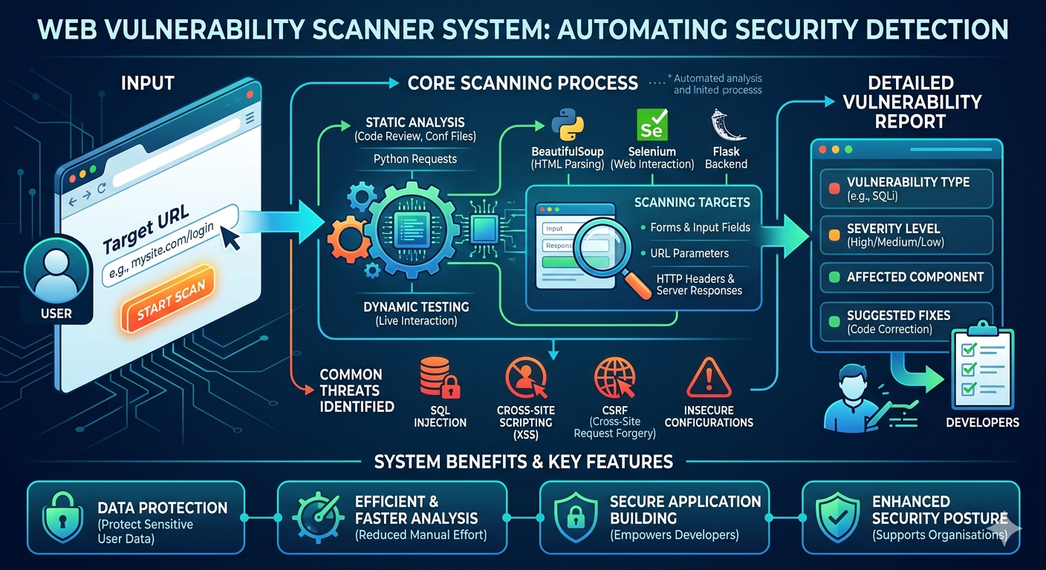

Figure 1: Web Vulnerability Scanner System Workflow

1. Introduction
Web applications play a vital role in modern digital systems by providing services such as online transactions, user authentication, data storage, and communication. These applications often handle sensitive information, including personal details, passwords, and financial data. However, web applications are highly exposed to cyber threats, making them vulnerable to attacks such as SQL Injection, Cross-Site Scripting (XSS), and Cross-Site Request Forgery (CSRF).
In many organisations, identifying security vulnerabilities in web applications is performed manually by developers or security analysts. This process involves testing different inputs, analysing responses, and checking for weaknesses, which can be time-consuming and error-prone. As the complexity of web applications increases, manual security testing becomes inefficient and may leave critical vulnerabilities undetected.
To address these challenges, the Web Vulnerability Scanner (WVS) is proposed. This system automatically scans web applications to detect potential security flaws. It analyses web pages, input fields, and server responses to identify vulnerabilities and provides a detailed report of detected issues.
The system extracts and highlights important security risks such as SQL Injection, XSS, and misconfigurations, presenting them in a clear and structured format. By automating the vulnerability detection process, the system helps developers and security professionals quickly identify and fix security issues.
By using the Web Vulnerability Scanner, organisations can improve application security, reduce manual effort, and ensure safer web environments. The system enhances the ability to detect vulnerabilities early, thereby preventing potential cyberattacks and data breaches.
Project Objectives
The primary objective of this project is to develop an automated system that detects vulnerabilities in web applications and helps improve their security.
The specific objectives include:
• Understanding Web Vulnerabilities – Study common web security threats such as SQL Injection, XSS, CSRF, and insecure configurations.
• Automated Vulnerability Detection – Develop a system that scans web applications and identifies potential security flaws.
• Input and Response Analysis – Analyse user inputs, URL parameters, and server responses to detect vulnerabilities.
• Efficient Scanning Process – Design a system capable of scanning multiple web pages and handling large-scale applications efficiently.
• Report Generation – Provide detailed reports including vulnerability type, severity level, and recommended solutions.
• Enhancing Web Security – Help developers and organisations secure their applications and prevent cyber threats.
Significance of the Project
The Web Vulnerability Scanner (WVS) plays a crucial role in improving the security of web applications. Instead of relying solely on manual testing, developers can use this system to automatically detect vulnerabilities and identify potential risks.
The system reduces the time and effort required for security testing while increasing accuracy in vulnerability detection. It helps organisations protect sensitive data, prevent cyberattacks, and maintain the integrity of their applications.
By providing quick and reliable security analysis, the system supports developers in building secure applications and enhances overall cybersecurity practices.

1.1 Organisation Profile
Introduction to KPR College of Arts Science and Research (KPRCAS)
KPR College of Arts Science and Research (KPRCAS) is a premier institution in Tamil Nadu, established in 2019 under the prestigious KPR Group. Affiliated with Bharathiar University, Coimbatore, the college is dedicated to academic excellence, innovation, and industry-oriented education. Situated in Arasur, Coimbatore, KPRCAS provides a world-class learning environment with a strong emphasis on research and practical knowledge application.
Vision and Mission
Vision
To be a globally recognised institution that imparts knowledge and life skills to students, shaping them into responsible citizens who contribute to society’s growth and development.
Mission
- To provide high-quality education that blends theoretical and practical knowledge.
- To equip students with industry-relevant skills and enhance employability.
- To promote research and development in emerging fields like Artificial Intelligence, Data Science, and Cybersecurity.
- To instil ethical values, leadership qualities, and lifelong learning habits in students.

1.2 System Specification
System specification defines the hardware and software requirements needed for the development and operation of the Web Vulnerability Scanner (WVS). It provides details about the system environment required to run the application efficiently, supports web crawling, input analysis, and vulnerability detection processes, ensures smooth performance during scanning, and helps achieve reliable and accurate vulnerability analysis.
1.2.1 Hardware Configuration
Component | Details
Laptop Model | ASUS TUF GAMING A15
Processor | AMD Ryzen 7
RAM | 16GB
GPU | NVIDIA RTX 4050
Storage | 1 TB (SSD)
Display | 14 inches

1.2.2 Software Specification
Component | Details
Operating System | Windows 11 Home
Development Environment | Google Antigravity
Programming Languages | Python, JavaScript, HTML, CSS
Libraries | FastAPI, Uvicorn, SQLAlchemy, AioSQLite, Scikit-learn, NumPy, Pandas, Httpx, Python-JOSE, Passlib, React, Vite, Tailwind CSS, Axios, Lucide-React, Recha

2. System Study
Web applications play a crucial role in modern systems as they handle sensitive information such as user data, login credentials, and financial transactions. Ensuring the security of these applications is essential to prevent cyberattacks and data breaches. However, web applications often contain vulnerabilities like SQL Injection, Cross-Site Scripting (XSS), and other security flaws that can be exploited by attackers.

In many organisations, developers and security analysts manually test web applications by checking inputs, URLs, and server responses to identify vulnerabilities. This process can be time-consuming, complex, and prone to errors, especially when dealing with large and dynamic web applications. As the number of web-based services increases, the need for efficient and automated security testing becomes more important.

This project focuses on developing the Web Vulnerability Scanner (WVS), an intelligent system designed to automatically detect security vulnerabilities in web applications. The system analyses web pages, forms, and inputs to identify potential threats and provides a clear report of detected issues, helping developers quickly understand and fix security weaknesses without extensive manual effort.

2.1 Existing System
In many organisations, web applications are widely used to provide services such as user authentication, data management, and online transactions. These applications often handle sensitive information, making security a critical concern. However, many web applications still contain vulnerabilities such as SQL Injection, Cross-Site Scripting (XSS), and other security weaknesses.
Currently, vulnerability detection is often performed manually by developers or security analysts. They test input fields, URLs, and application behaviour to identify potential security flaws. This manual process requires significant time and expertise, especially when dealing with large and complex web applications.
Although some security tools are available, many of them are either complex, expensive, or require advanced technical knowledge to operate effectively. Additionally, not all systems provide comprehensive and easy-to-understand reports for developers.
As a result, identifying vulnerabilities becomes a challenging task, and some security issues may remain undetected. This highlights the need for an automated and user-friendly system that can efficiently scan web applications and detect vulnerabilities with minimal manual effort.

2.1.1 Drawbacks
- Manual Testing Process → Developers and security analysts must manually test web applications to identify vulnerabilities.

- Time-Consuming Process → Scanning multiple web pages and inputs manually requires significant time and effort.

- Difficulty in Detecting Vulnerabilities → Identifying issues like SQL Injection and XSS can be complex and may be missed during manual testing.

- Complexity of Modern Web Applications → Large and dynamic web applications make vulnerability detection more challenging.

- Lack of User-Friendly Tools → Many existing security tools are complex and require advanced technical knowledge.

- Delayed Security Fixes → Slow detection of vulnerabilities can delay fixing issues and increase the risk of cyberattacks.

2.2 Proposed System
The proposed system improves the process of detecting web application vulnerabilities by providing the following advantages:
• Automatic Web Application Scanning → The system automatically scans web pages, forms, and URLs to identify potential security vulnerabilities.

• Vulnerability Detection → The system detects common security issues such as SQL Injection, Cross-Site Scripting (XSS), and other threats.

• Efficient Input Analysis → User inputs, parameters, and server responses are analysed to identify possible weaknesses.

• Quick Security Assessment → Developers can quickly understand the security status of their applications without manual testing.

• Reduced Complexity → The system simplifies the vulnerability detection process and presents results in an easy-to-understand format.

• Improved Web Security → The system helps developers fix vulnerabilities early, reducing the risk of cyberattacks and improving overall application security.

2.2.1 Features
- Automatic Vulnerability Scanning → The system automatically scans web applications, including web pages, forms, and URLs, to detect security issues.
- Detection of Common Vulnerabilities → Identifies vulnerabilities such as SQL Injection, Cross-Site Scripting (XSS), and other web-based threats.
- Efficient Input and Response Analysis → Analyses user inputs, parameters, and server responses to identify potential weaknesses.
- User-Friendly Interface → Provides an easy-to-use interface where users can enter a URL and initiate scanning.
- Detailed Report Generation → Displays results in a structured format, including vulnerability type, severity level, and suggested solutions.
- Reduced Testing Time → Minimises the time required to identify security flaws compared to manual testing.
- Improved Security Support → Helps developers enhance application security and prevent potential cyberattacks.

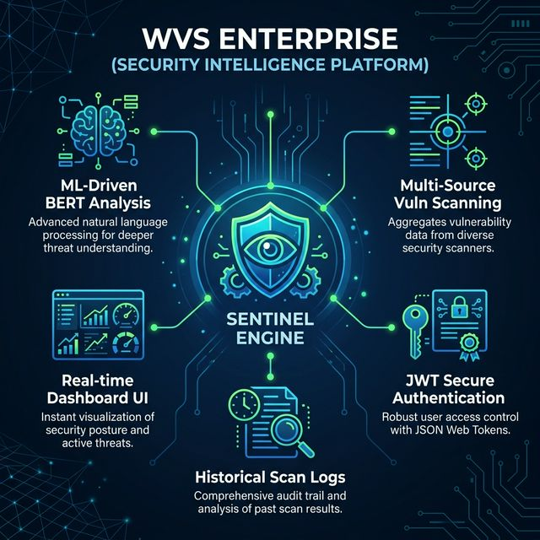
Figure 2: WVS Enterprise – Core Intelligence & Feature Ecosystem

3. System Design and Development
The system design of the Web Vulnerability Scanner (WVS) focuses on analysing web applications to detect security vulnerabilities. The system accepts a target URL as input, scans web pages, forms, and parameters, and analyses inputs and server responses to identify potential security issues. It then generates a detailed report highlighting detected vulnerabilities, helping developers quickly understand and fix security flaws without performing extensive manual testing.

3.1 File Design
The Web Vulnerability Scanner (WVS) is designed using a modular and layered file structure to ensure efficient development, scalability, and easy maintenance. The system is divided into backend and frontend components, where each file and module handles a specific functionality within the vulnerability scanning process.
1. Main Application File (main.py)
• Serves as the entry point of the backend application.
• Initialises the server and integrates all API routes.
• Manages communication between scanning modules, database, and services.
2. API Module (api/)
• Handles all client-server communication.
• Defines routes for submitting target URLs and retrieving scan results.
• Acts as an interface between the frontend and backend systems.
3. Configuration Module (core/config.py)
• Stores system configuration settings and parameters.
• Manages environment variables and application-level settings.
• Ensures consistency across all modules.

4. Database Module (db/)
• Manages storage and retrieval of scan results and reports.
• Defines database models for vulnerabilities and scan history.
• Handles database initialisation and connections.

5. Web Crawling Module (crawler/)
• Responsible for exploring the web pages of the target application.
• Extracts URLs, forms, and input fields for scanning.
• Prepares data for vulnerability testing.

6. Vulnerability Detection Module (scanner/)
• Core component of the system that identifies security issues.
• Includes detection mechanisms for:
* SQL Injection
* Cross-Site Scripting (XSS)
* Other common vulnerabilities
• Analyses inputs and server responses to detect weaknesses.

7. Service Module (services/)
• Implements the business logic of the system.
• Coordinates between crawler, scanner, and database modules.
• Generates final scan reports for users.

8. Frontend Files (React Application)
• Provides an interactive user interface.
• Includes pages such as Dashboard, Scan Input, and Reports.
• Handles user input and communicates with backend APIs.

9. Supporting Files
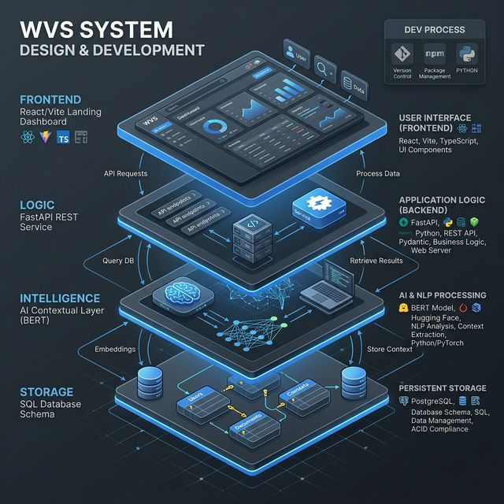
• requirements.txt – Contains backend dependencies.
• package.json – Manages frontend dependencies.
• config files (.env) – Stores environment variables.
• Sample URLs/Data – Used for testing and validation.

Figure 3: Full-Stack Architecture & Development Lifecycle

3.2 Input Design
The Web Vulnerability Scanner (WVS) receives input from users through a web-based interface. The system is designed to handle user inputs efficiently and ensure accurate vulnerability scanning of web applications.
1. Input Parameters
Users provide the following inputs to the system:
- Target URL of the web application
- Scan Type (e.g., full scan or specific vulnerability scan)
- Input Parameters (optional form data or query inputs)
2. Input Processing
The system processes user inputs through several steps:
- Validation: Ensures that the entered URL is valid, accessible, and properly formatted before scanning.
- Authentication (if implemented): Verifies user access to ensure secure usage of the system.
- URL Analysis: Breaks down the target URL to identify pages, parameters, and input fields.
- Web Crawling: Explores the web application to collect links, forms, and input points for testing.
- Preprocessing: Prepares collected data by organising URLs and inputs for vulnerability scanning.
- Data Handling: Sends the processed inputs to the scanning module for vulnerability detection.

3.3 Output Design

The Web Vulnerability Scanner (WVS) generates outputs that provide clear and actionable insights about security vulnerabilities in web applications. The system ensures that the output is well-structured, easy to understand, and useful for developers and security analysts.

- Output Information
- Vulnerability Report → Displays detected vulnerabilities such as SQL Injection, Cross-Site Scripting (XSS), and other security issues.
- Severity Level → Indicates the risk level of each vulnerability (e.g., Low, Medium, High).
- Affected URLs/Parameters → Shows the specific web pages or input fields where vulnerabilities are found.
- Suggested Fixes → Provides recommendations to resolve identified security issues.
- Scan Status → Indicates whether the scanning process is completed successfully.

- Output Display
- Users can view the scan results directly on the web interface.
- Vulnerabilities are presented in a structured and categorised format for easy understanding.
- The system highlights critical issues to help prioritise fixes.
- Users may have the option to download the vulnerability report for future reference.

3.4 Database Design
The Web Vulnerability Scanner (WVS) uses a structured database to store and manage scan results, detected vulnerabilities, and system-related data efficiently. The database is designed to ensure secure storage and quick retrieval of vulnerability information.
1. Database Tables
The main database tables include:
• Scan Results → Stores details of each scan, including target URL, scan date, and scan status.
• Vulnerabilities → Stores detected vulnerabilities such as SQL Injection, XSS, along with severity levels and descriptions.
• Affected Components → Stores information about affected URLs, parameters, and input fields where vulnerabilities are found.
• Users (Optional) → Stores user credentials and details if authentication is implemented.
• Scan Logs → Tracks system activity such as scan progress, timestamps, and error logs.
2. Data Storage
• The system uses a relational database (such as SQLite/MySQL) to store application data.
• Tools like MySQL Workbench are used to manage database operations and ensure smooth interaction between the application and the database.

3. Data Management
The database ensures:
• Secure Storage → Protects scan data and user information.
• Efficient Retrieval → Enables quick access to scan reports and vulnerability details.
• Data Consistency → Maintains relationships between scans and detected vulnerabilities.
• Scalability → Supports future enhancements such as advanced analytics and large-scale scanning.
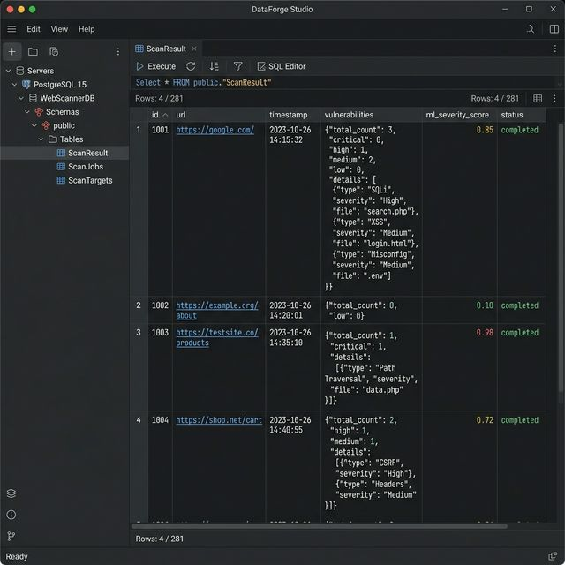
Figure 4: Security Audit Execution Lifecycle

3.5 System Development
The Web Vulnerability Scanner (WVS) is developed using a modular approach to ensure efficiency and scalability. The system uses Python with Flask for backend development and React.js for the frontend interface. It performs web crawling and vulnerability detection on target URLs and stores scan results in a MySQL/SQLite database managed using tools like MySQL Workbench. The system is tested for accuracy and performance and can be deployed on local or cloud environments for real-time security analysis.
1. Development Methodology
- The project follows a structured process including requirement analysis, system design, implementation, testing, and deployment.
- The development approach focuses on building a modular and scalable system to efficiently scan and detect vulnerabilities in web applications.
2. Technology Stack
- Programming Language: Python
- Backend Framework: Flask
- Frontend Framework: React.js
- Database: SQLite / MySQL
- ORM Tool: SQLAlchemy
- Libraries/Tools: Requests, BeautifulSoup, Selenium
- API Communication: RESTful APIs
The backend application initialises the server and integrates modules such as web crawling, vulnerability detection, and API routes for handling user requests.

3. System Configuration
- The configuration file manages application settings such as target URLs, scanning parameters, and database connection details.
- It defines environment variables and system-level configurations required for smooth execution.
4. Database Integration
- The system integrates a relational database to store scan results, detected vulnerabilities, and logs.
- MySQL Workbench is used to perform CRUD operations and manage relationships between scan data and reports.
5. Backend Development
- The backend is developed using Flask and follows a modular structure.
- Separate modules handle functionalities such as web crawling, vulnerability scanning, and business logic.
- The system processes target URLs, performs scanning, and detects vulnerabilities like SQL Injection and XSS.
- API routes handle scan requests and retrieval of results.
6. System Testing
- Unit Testing: Ensures individual modules like the crawler and scanner function correctly.
- Integration Testing: Verifies communication between frontend, backend, and database.
- Performance Testing: Evaluates the system’s ability to scan multiple web pages efficiently.
7. Deployment and Maintenance
- The application can be deployed on a local server or cloud platforms such as AWS or Render.
- Continuous monitoring ensures reliable performance and accurate vulnerability detection.
- Future enhancements may include real-time scanning, advanced threat detection, and integration with security tools.
3.6 Description of Modules
The Web Vulnerability Scanner (WVS) is divided into several functional modules, each responsible for handling specific tasks within the system. These modules work together to ensure efficient scanning, accurate vulnerability detection, and secure data management. The modular design improves scalability, maintainability, and overall system performance.
1. Input Handling Module
The input handling module manages user interactions with the system. It allows users to enter the target URL and select scanning options. The module validates the input to ensure that the URL is properly formatted and accessible.
It ensures that valid input data is forwarded to the crawling and scanning modules for further analysis, maintaining data integrity at the initial stage.
2. Web Crawling Module
The web crawling module is responsible for exploring the target web application. It collects web pages, links, forms, and input fields required for vulnerability testing.
The module systematically navigates through the website and prepares structured data for further scanning processes.
3. Vulnerability Detection Module
The vulnerability detection module is the core component of the system. It analyses web pages, input fields, and server responses to identify security flaws.
This module performs key functions such as:
- Detecting SQL Injection vulnerabilities
- Identifying Cross-Site Scripting (XSS) issues
- Analysing input parameters and responses for potential threats
4. Service (Business Logic) Module
The service module coordinates the overall workflow of the system. It acts as an intermediary between input handling, crawling, scanning, and database operations.
This module ensures proper data flow between components and manages system logic, error handling, and response generation.
5. Output Module
The output module is responsible for presenting the scan results to the user. It displays detected vulnerabilities, severity levels, affected components, and suggested fixes in a structured format.
The module ensures that results are clear, easy to understand, and accessible through the user interface. It may also allow users to download reports.
6. Database Management Module
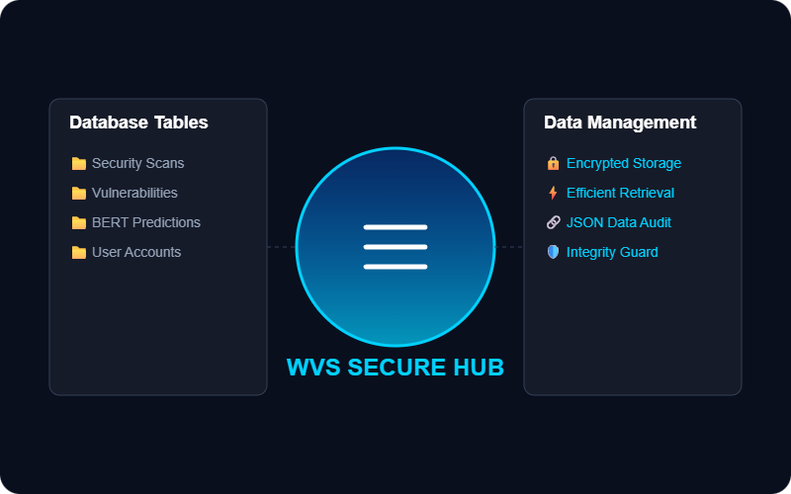
The database management module handles the storage and retrieval of system data. It stores scan results, detected vulnerabilities, affected URLs, and system logs in a relational database.This module ensures secure storage, maintains relationships between scan data, and enables efficient retrieval of information when required.

Figure 5: WVS Data Management Design

4. Software Testing and Implementation
The Web Vulnerability Scanner (WVS) is tested and implemented to ensure that it functions correctly and efficiently. Testing is performed to verify that all modules work as expected and that the system accurately detects vulnerabilities in web applications.
4.1 Testing Strategies
Testing strategies are used to ensure that the Web Vulnerability Scanner (WVS) functions correctly and produces reliable results. The system is tested using different approaches to verify the performance, accuracy, and stability of each module.
The testing process focuses on identifying errors, improving system performance, and ensuring that the application accurately detects vulnerabilities such as SQL Injection and Cross-Site Scripting (XSS). Various testing strategies are applied to evaluate different aspects of the system.
1. Unit Testing
- Tests individual modules such as input handling, web crawling, and vulnerability detection separately.
- Ensures each module performs its intended function correctly without errors.
- Helps identify bugs in early development stages.
- Improves the reliability of each system component.
2. Integration Testing
- Verifies interaction between different modules of the system.
- Ensures proper data flow between crawler, scanner, and database modules.
- Confirms that modules work together as a complete system.
- Detects errors in communication and integration.

3. System Testing
- Evaluates the complete system functionality.
- Ensures that the system meets all functional requirements.
- Tests the system using real-world web applications.
- Confirms accurate detection of vulnerabilities.
4. Performance Testing
- Measures the efficiency of the system while scanning web applications.
- Evaluates response time for vulnerability detection.
- Ensures the system can handle multiple URLs and large websites.
- Identifies bottlenecks and improves system performance.
5. Usability Testing
- Ensures that the system interface is simple and user-friendly.
- Evaluates ease of entering URLs and viewing scan results.
- Checks whether users can interact with the system without confusion.
- Improves user experience and accessibility.
6. Security Testing
- Ensures that the scanner itself is secure and does not expose vulnerabilities.
- Prevents unauthorised access to scan results and system data.
- Protects system integrity during scanning operations.
- Identifies potential risks within the application.
7. Validation Testing
- Verifies the accuracy of detected vulnerabilities.
- Ensures correct identification of issues like SQL Injection and XSS.
- Confirms that results are meaningful and reliable.
- Validates that the system achieves its objective of vulnerability detection.

4.2 Implementation Process
The implementation of the Web Vulnerability Scanner (WVS) follows a structured development approach to ensure efficient functionality and smooth deployment. The system integrates multiple components, including the backend server, frontend interface, scanning modules, and database, to create a complete vulnerability detection platform.

1. System Setup
The initial step involves setting up the development environment required for building the system.
- A Python environment is installed for backend development.
- Required Python libraries such as Flask, Requests, BeautifulSoup, Selenium, and MySQL connector are installed.
- Node.js and npm are installed for frontend development using React.js.
- MySQL Workbench is configured to manage the database for storing scan results and reports.
- Development tools such as Visual Studio Code are used for coding and debugging.

2. Backend Development
The backend is developed using Flask to handle server-side operations and API communication.
- The main application file initialises the backend server and system configuration.
- API routes are created for submitting target URLs and retrieving scan results.
- The backend processes user requests and manages communication between modules.
- Web crawling and vulnerability detection modules are integrated.
- Error-handling mechanisms are implemented to ensure system stability.

3. Frontend Development
The frontend interface is developed using React.js to provide a user-friendly experience.
- Users can enter target URLs and initiate vulnerability scans.
- The system displays detected vulnerabilities and reports.
- Components and pages are designed for smooth navigation.
- The frontend communicates with backend APIs using HTTP requests.
- The interface ensures clarity and ease of use.
4. System Integration
After developing the frontend and backend, both components are integrated.
- The frontend sends API requests to the backend server.
- The backend processes input and interacts with the crawler and scanner modules.
- The system detects vulnerabilities and sends results back to the frontend.
- Data flow is synchronised to ensure accurate and real-time result display.
5. Database Implementation
The database is implemented using MySQL and managed through MySQL Workbench.
- Tables are created for scan results, vulnerabilities, affected components, and logs.
- Relationships between tables are maintained for data consistency.
- The database securely stores scan data and reports.
- SQL queries are used for data insertion, retrieval, and updates.
6. Deployment and Maintenance
After development and testing, the system is deployed for practical use.
- The backend server is hosted on local or cloud platforms such as AWS or Render.
- The frontend application is deployed and connected to backend APIs.
- Continuous monitoring ensures efficient performance and accurate scanning.
- Regular maintenance is performed to fix bugs and improve system features.

4.3 Quality Assurance & Debugging

Quality assurance and debugging are essential to ensure that the MedSum AI – Intelligent Medical Record Summarisation System operates accurately, reliably, and efficiently. These processes help identify errors, improve system performance, and ensure that all modules function correctly when processing medical data.
1. Error Handling Mechanisms
The system implements error-handling techniques to manage invalid inputs and processing failures. Validation checks are applied during file upload to ensure that only supported medical document formats are accepted. Errors occurring during text extraction, NLP processing, or database operations are handled using exception handling mechanisms and logged for debugging purposes. This ensures smooth system operation and quick issue resolution.
2. Continuous Monitoring
Continuous monitoring is used to track system performance and detect potential issues during operation. The system monitors API requests, processing time for summarisation, and database interactions. This helps in identifying performance bottlenecks and ensures that the system remains stable while handling multiple medical documents.
3. User Feedback Integration
User feedback is important for improving the system’s usability and functionality. Feedback from users helps identify issues related to document upload, summary clarity, and interface usability. Based on this feedback, improvements and updates are implemented to enhance overall system performance and user experience.
4. Automated Testing
Automated testing is performed to ensure that core functionalities such as document processing, summarisation, and output generation work correctly after updates. Regular testing helps detect bugs early and ensures that new changes do not affect existing features. This improves system reliability and supports continuous improvement

Conclusion
The development of the Web Vulnerability Scanner (WVS) highlights the importance of automated security solutions in modern web applications. The system successfully provides a platform for detecting vulnerabilities, helping developers and security analysts identify potential security risks in web applications efficiently. By automating the manual process of vulnerability testing, the system reduces time consumption, improves accuracy, and enhances overall web security.
Key Highlights of the Project
Efficient Vulnerability Detection → The system automatically scans web applications and identifies security issues effectively.
Automated Security Analysis → Detects common vulnerabilities such as SQL Injection and Cross-Site Scripting (XSS).
User-Friendly Interface → Provides a simple and interactive interface for entering URLs and viewing scan results.
Centralised Data Management → Stores scan results and vulnerability details in a structured database for easy access.
Improved Security Support → Helps developers quickly identify and fix vulnerabilities, enhancing application security.
Reliable System Performance → Designed to efficiently scan web applications and provide accurate vulnerability reports.

Future Enhancements
Real-Time Vulnerability Scanning → Enhancing the system to provide faster and continuous real-time scanning of web applications.
Mobile Application Integration → Developing a mobile application to allow users to perform vulnerability scans and view reports easily.
Advanced Threat Detection → Integrating advanced techniques and AI-based models to detect complex and zero-day vulnerabilities.
Multi-Language Support → Enabling support for multiple languages to make the system accessible to a wider range of users.
Cloud-Based Deployment → Deploying the system on cloud platforms to improve scalability, availability, and performance.
Integration with Security Tools → Connecting the system with existing security tools such as penetration testing frameworks and monitoring systems for enhanced protection.

Final Thoughts
The Web Vulnerability Scanner (WVS) provides an efficient automated solution for identifying and analysing security vulnerabilities in web applications. By reducing the need for manual testing, the system saves time, minimises human error, and improves the accuracy of vulnerability detection. It enables developers and security analysts to quickly understand potential risks and take appropriate actions to secure their applications. With further enhancements and advanced security features, the system has the potential to evolve into a comprehensive cybersecurity tool for protecting modern web applications against emerging threats.

Bibliography
1. Book References
- Grinberg, M. (2018). Flask Web Development: Developing Web Applications with Python. O’Reilly Media.
* Guides on building backend applications using Flask, used in the MedSum AI system.
- Jurafsky, D., & Martin, J. H. (2021). Speech and Language Processing (3rd Edition). Pearson.
* Explains Natural Language Processing concepts used for medical text summarisation and entity extraction.
- Goodfellow, I., Bengio, Y., & Courville, A. (2016). Deep Learning. MIT Press.
* Covers deep learning techniques used in AI-based summarisation models.
- Beazley, D. M. (2009). Python Essential Reference. Addison-Wesley.
* Provides insights into Python programming used for backend development.
- Duckett, J. (2014). HTML and CSS: Design and Build Websites. Wiley.
* Explains frontend design concepts used in building the user interface.
- Banks, A., & Porcello, E. (2020). Learning React: Modern Patterns for Developing React Apps. O’Reilly Media.
* Discusses React.js development used for creating the frontend interface.
- Silberschatz, A., Korth, H. F., & Sudarshan, S. (2019). Database System Concepts (7th Edition). McGraw-Hill.
* Covers relational database concepts used in MySQL database design.
- Chollet, F. (2021). Deep Learning with Python (2nd Edition). Manning Publications.
* Provides practical knowledge on implementing deep learning models for NLP tasks.

- Lutz, M. (2013). Learning Python (5th Edition). O’Reilly Media.
* Covers core Python concepts used in system development.
- Jurafsky, D., & Martin, J. H. (2008). Introduction to Natural Language Processing.
* Explains fundamental NLP techniques relevant to text processing and summarisation.
2. Internet References (Web References)
- Grinberg, M. (2014). The Flask Mega-Tutorial.
* Available at: https://blog.miguelgrinberg.com/post/the-flask-mega-tutorial-part-i-hello-world
- Hugging Face. (2024). Transformers Documentation.
* Available at: https://huggingface.co/docs/transformers
- Meta Open Source. (2024). React Official Documentation.
* Available at: https://react.dev/
- TensorFlow. (2024). TensorFlow Documentation.
* Available at: https://www.tensorflow.org/
- PyTorch. (2024). PyTorch Documentation.
* Available at: https://pytorch.org/docs/
- MySQL. (2024). MySQL Official Documentation.
* Available at: https://dev.mysql.com/doc/
- OpenAI / NLP Resources (General)
* Various online resources for understanding AI-based text summarisation techniques.

Appendices

A. Data Flow Diagram
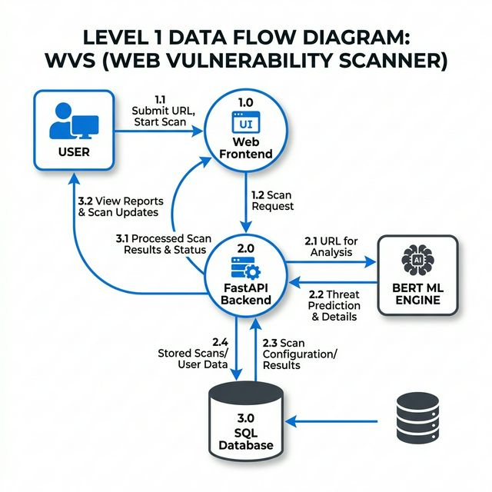
Figure 6: Level 1 DFD of WVS showing URL input, backend scanning, and result storage.

The vulnerability scanning process begins as the user enters a target URL and authenticates via the React Frontend dashboard, which sends the request to the FastAPI Backend for validation. The backend then triggers the asynchronous SENTINEL scanning engine to inspect the target's HTTP headers, banners, and source code for potential security vulnerabilities. Once the raw findings are collected, they are passed to the BERT-based Machine Learning module to calculate a contextual threat severity score. Finally, all the processed data, audit results, and real-time execution logs are persisted in the SQL database and displayed back to the user on their dashboard.

B. Table Structure
The system database stores all information related to security scans, identified vulnerabilities, and machine learning inferences. The relational structure ensures that every scan is traceable and can be used for continuous online learning through feedback loops.
Main Database Table
ScanResult
Table This table acts as the primary registry for every security audit performed by the system.

id – Unique identifier (UUID string) for each scan.
url – The target website address being audited.
timestamp – Date and time when the scan was initiated.
vulnerabilities – A structured list of identified findings (stored in JSON format).
ml_severity_score – A numerical severity rating generated by the BERT-based contextual classifier.
status – The current lifecycle state of the scan (queued, scanning, completed).
logs – Real-time execution logs for system transparency (stored in JSON).
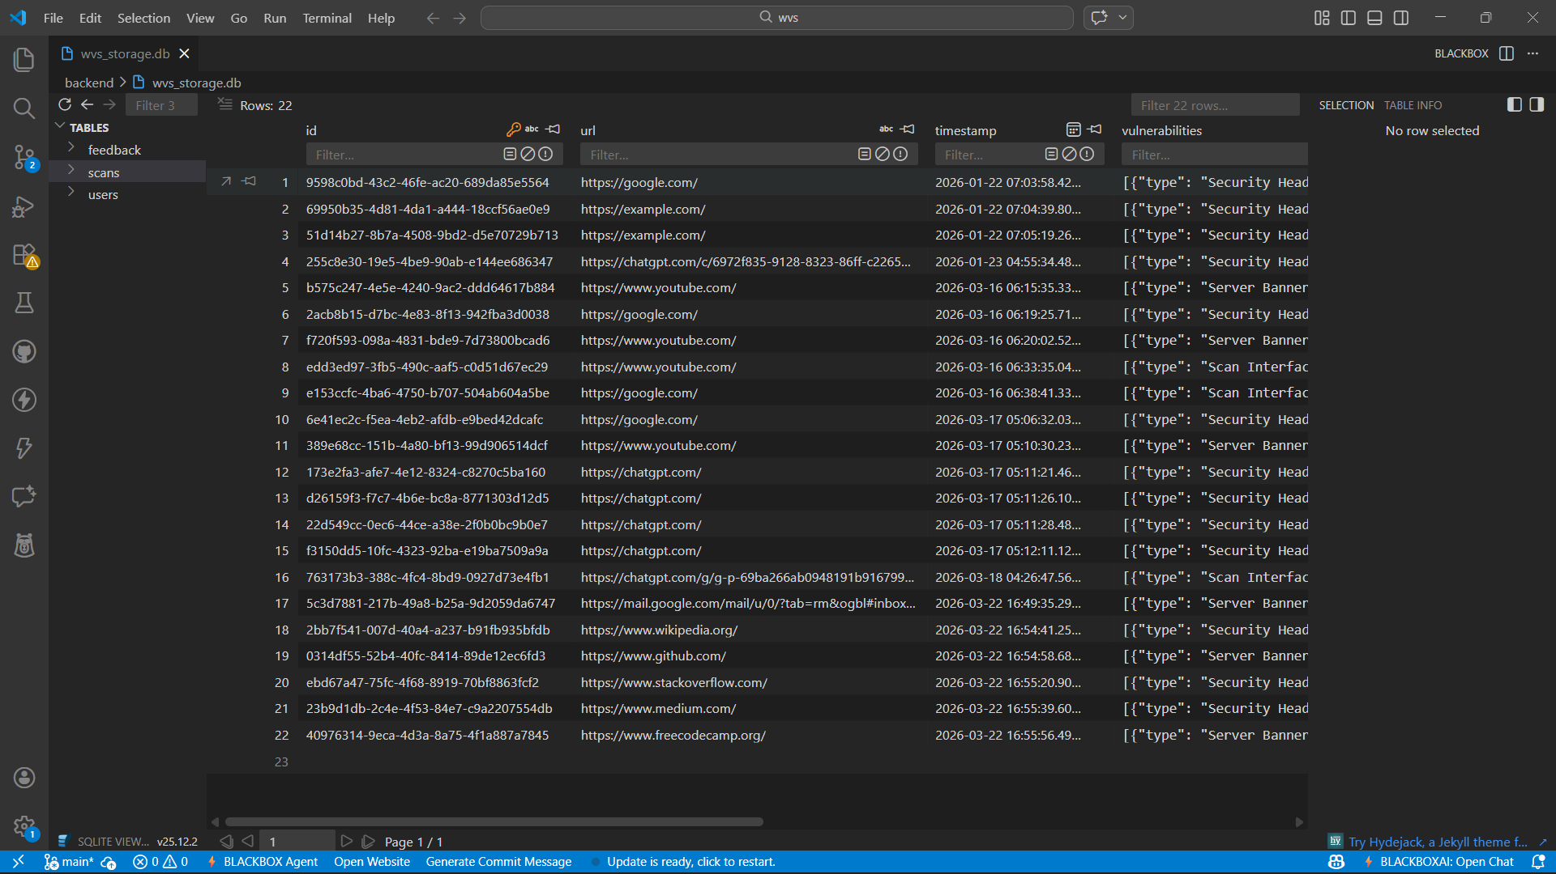
Figure 7: Scan Result Table Data Base

Table Description
The Scan Result table is the central storage component of the WVS platform. It captures the entire lifecycle of a security audit—from the initial target URL to the deep-learning-based classification of threats. By storing findings in JSON format, the system maintains flexibility for various vulnerability types, while the numerical scores allow for high-level dashboard visualization.

Database Implementation
- Engine: The system utilizes a SQLAlchemy-managed database (SQLite for development, PostgreSQL-ready for production).
- Async Support: aiosqlite is used to prevent blocking during heavy scanning operations.
- Persistence: Every finding, including evidence and pattern matches, is stored for historical analysis and trend reporting.
- Security: Authentication is handled by a separate. User table using passlib for password hashing and JOSE for JWT tokens.Database Overview

C. Sample Coding
1. Backend – FastAPI (main.py)
from fastapi import FastAPI, BackgroundTasks, Depends
from app.core.scanner import scan_target
from app.db.session import SessionLocal, ScanResultDB
app = FastAPI()
@app.post("/scan")
async def trigger_scan(request: ScanRequest, background_tasks: BackgroundTasks, db: Session = Depends(get_db)):
scan_id = str(uuid.uuid4())
db_scan = ScanResultDB(id=scan_id, url=str(request.url), status="queued")
db.add(db_scan)
db.commit()

# Asynchronous processing for long-running scans
background_tasks.add_task(run_scan_task, scan_id, str(request.url))
return db_scan
2. Scanning Module – SENTINEL Engine (scanner.py)
import httpx
from typing import List, Dict
async def scan_target(url: str) -> List[Dict]:
vulnerabilities = []
async with httpx.AsyncClient(verify=False, timeout=10.0) as client:
response = await client.get(url)
headers = response.headers

# Security Header Analysis
security_headers = {"X-Frame-Options": "Clickjacking protection missing"}
for header, desc in security_headers.items():
if header not in headers:
vulnerabilities.append({
"type": f"Security Header: {header}",
"description": desc,
"evidence": f"Missing header '{header}'",
"raw_severity": "Medium"
})
return vulnerabilities

3. Database Connection (SQLAlchemy)
from sqlalchemy import create_engine
from sqlalchemy.orm import sessionmaker
SQLALCHEMY_DATABASE_URL = "sqlite:///./wvs_storage.db"
engine = create_engine(SQLALCHEMY_DATABASE_URL, connect_args={"check_same_thread": False})
SessionLocal = sessionmaker(autocommit=False, autoflush=False, bind=engine)
def init_db():
Base.metadata.create_all(bind=engine)

4. Insert Scan Result with ML Scoring
def save_scan_result(scan_id, findings, ml_score):
db = SessionLocal()
db_scan = db.query(ScanResultDB).filter(ScanResultDB.id == scan_id).first()
db_scan.vulnerabilities = findings
db_scan.ml_severity_score = ml_score
db_scan.status = "completed"
db.commit()
db.close()
5. Frontend – React API Call (App.jsx)
import axios from "axios";
export const startScan = async (targetUrl) => {
const token = localStorage.getItem("token");
const response = await axios.post("http://127.0.0.1:8000/scan",
{ url: targetUrl },
{ headers: { Authorization: `Bearer ${token}` } }
);
return response.data;
};

D. Sample Input
Security Scan Configuration (User Input) The image below shows the user interface of the WVS Enterprise – Security Intelligence Platform, where security analysts can input target URLs and initiate deep-vulnerability audits.
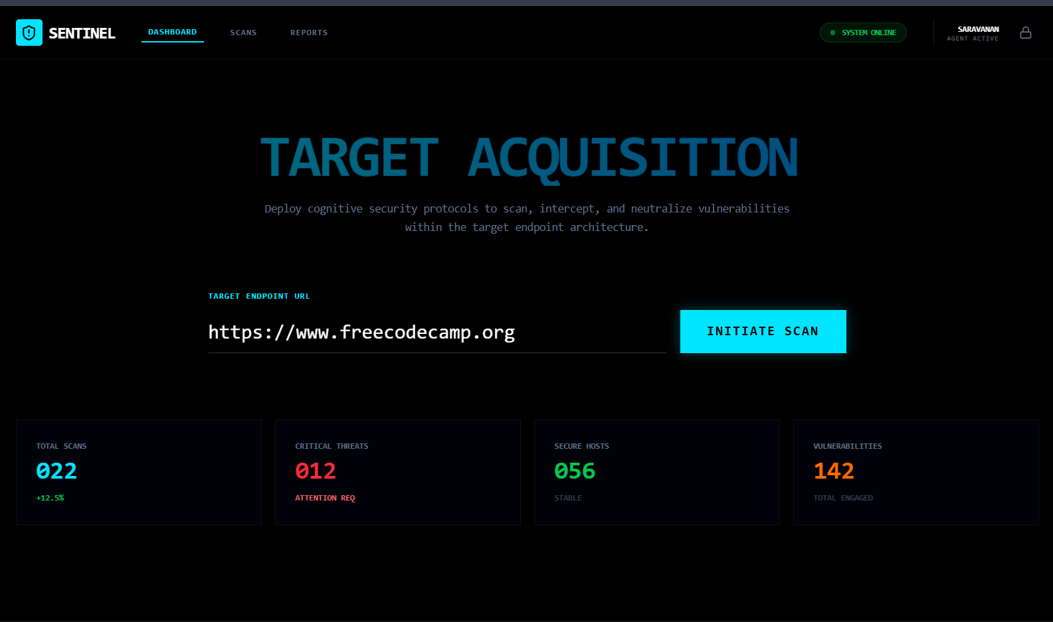
Figure 8: Sample website is given as input
Input Details Provided by User
Target URL: https://example-vulnerable-site.com
Scan Depth: Standard/Deep
Enable ML Analysis: Yes (Contextual Threat Modeling)
Authentication Token: Provided (JWT Bearer)

Interface Features
Real-time URL validation and reached-state check.
Single-click vulnerability detection across headers, banners, and source patterns.
Secure login portal for authenticated security personnel.
E. Sample Output
Vulnerability Assessment Dashboard (System Result) The image below shows the results interface of the WVS platform, displaying the identified vulnerabilities, the SENTINEL neural engine's threat score, and detailed evidence logs.
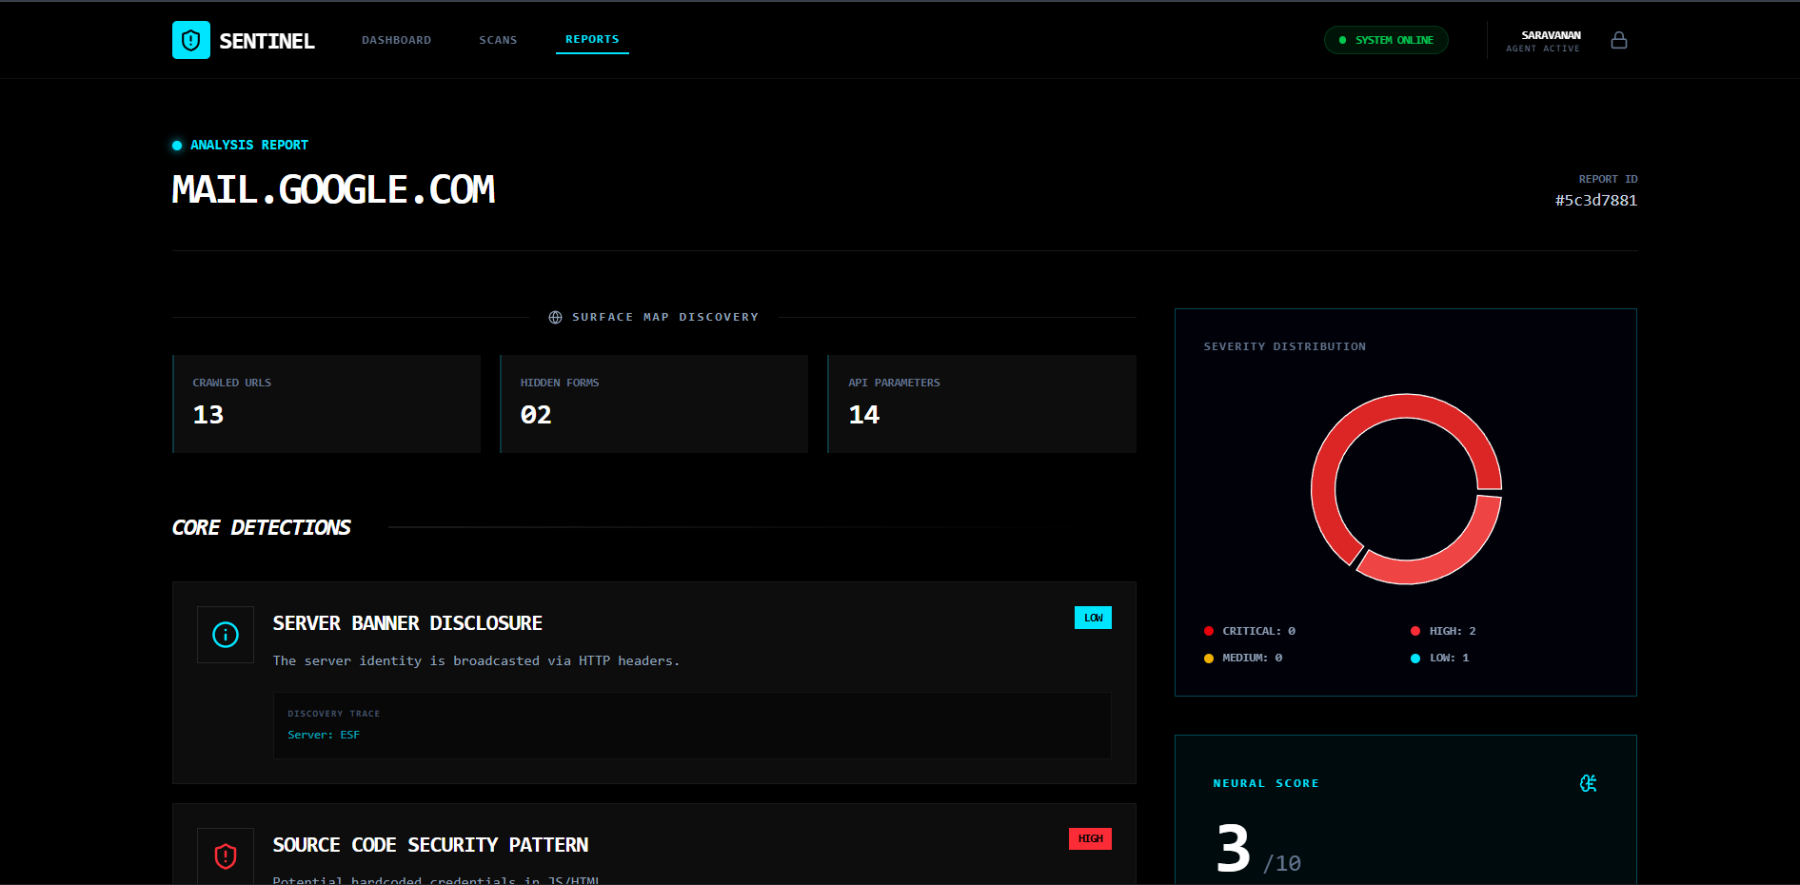
Figure 9: Final Output of the Scanner

Generated Output Details After processing the target website, the system generates the following security intelligence:
- Threat Severity: High (Score: 0.89)
- Vulnerability Type: SQL Injection / Missing CSP Headers
- Evidence Detected: Pattern 'apikey' detected in response body.
- ML Prediction: CRITICAL - Immediate Remediation Required System Behaviour

BERT-Inference: The system contextualizes findings based on previously ingested threat patterns.
Evidence Gathering: Captures raw response data as proof of vulnerability.
Feedback Integration: Allows users to mark findings as "False Positive" to retrain the ML model.

